Module Title- Management & Organisational Behaviour
Module Code - BMIH5004
Assignment 2 - Written Report
Student Name - Ionut Paul Poltz
Student ID - 2211944
Lecturer’s Name – Maggie Lan Zhang

Executive summary
The report has analysed various business aspects of the Hilton Hotel Group along with theoretical explanations. Being an international hotel chain Hilton Hotel Group wants to get a forefront position in the competitive market of the hospitality industry. The self-enclosed nature of the divisional structure allowed the business to implement unique problem-solving mechanisms, relevant behavioural codes and values among team members. Segregated nature of the divisional structure creates barriers to developing internal professional communication and bonding among employees working in different departments. Each department included in the business functions cultivates a culture of diversity and inclusiveness in the workplace. This report has highlighted the recent change initiatives for instance Property Engagement Platform implementation of Hilton Hotel Group and discussed its impact on its business. The Kottler change management theory has been added to the discussion to gain a more detailed understanding about this change. Later on, forming a proper change management plan has been identified as the strategic direction for the organisation.

Table of Contents
Introduction 4
Overview of organisation 5
Mission, vision and goals 6
Organisational structure 8
Organisational culture 11
Recent change initiatives 14
The organisation’s strategic direction 16
Conclusion 17
References 18

Introduction
Operational strategy and workplace environment play very vital roles in determining long-term success in the business organisation. The structure and culture of the organisations are majorly responsible for fostering inclusivity, transparency and accountability in the workplace. The following report will analyse various business functions of Hilton Hotel Group, the famous hospitality chain in the UK. Along with discussing structure, culture, business objectives and the currently applied change management model, the strategic direction for the business will be described. All these aspects related to the hotel chain will be incorporated with hypothetical explanations using relevant theories and models.

Overview of organisation
Hilton Hotel Group is an American multinational company operating in the hospitality industry. The brand has a widely famous portfolio managing numerous properties, hotels and resorts which are preferred by the guests to stay. The company was founded in 1919 by Conrad Hilton and led by Christopher J. Nassetta at present. The headquarters of the company is situated in Virginia, United States. Being a global hospitality company, the brand is involved in managing, franchising, owning and leasing several resorts. The hotel group has 22 hotels and resort brands spreading across different geographical locations of the world. The brand is mostly relying on franchising rather than obtaining direct ownership. The operating income of the Hilton Hotel Group has experienced significant growth during the past few years. It has built a positive reputation as a luxury brand which is committed to delivering high-quality services to its guests (Hilton, 2024 ).

Mission, vision and goals
Corporate level: The organisation is keenly focused on fulfilling its responsibility towards ensuring a sustainable future for the planet. All the managers and staff members involved with the organisation are actively engaged to support the business functions by delivering exceptional experiences to every guest every time. The brand has set its mission to emerge as a top hospitality chain which will become the first choice for the customers and employees to be with. Managing authority is consistently trying to improve the infrastructure to impress the guests, strategic partners and communities with the grandeur and warmth of services. The international hotel chain wants to get a forefront position in the competitive market of the hospitality industry (Hilton, 2024).
Individual level: The business has prioritised several factors which are included in their internal management. It always promotes righteous and ethical practices in business operations. Leaders are supportive of the employees which helps them to be involved in a collaborative team culture within the organisation. Owners of the business are open to the team members instead of being authoritative all the time.
Theoretical application
Theory of change guides a business organisation to focus on the right ideas while determining their mission, and vision and setting goals. This is the comprehensive set of elements which are needed to be considered carefully by business leaders and managers. The mission statement depicts that the organisation should first fix its purpose of being in existence. On the other side, the vision statement reflects the future aims of the business based on the purpose.
Aim: The model explains that every organisation has to choose its mission, vision and goal very wisely setting realistic, specific and achievable targets. The vision of the organisation portrays the perception for shorter as well as longer term. It is categorised into two broader groups such as objectives at the individual level and corporate level (Fayomi and Akanazu, 2024).
Implication on the company: Hilton Hotel Group has kept major importance on setting smart objectives for achieving business goals. It has finalised to gain a comparative advantage in the competitive marketplace by adding value in customer service management. It has put focus on setting separate goals both at individual and corporate levels. Along with fixing the targets for profit scale for the business, it has ensured the development of a positive workplace environment.

Organisational structure

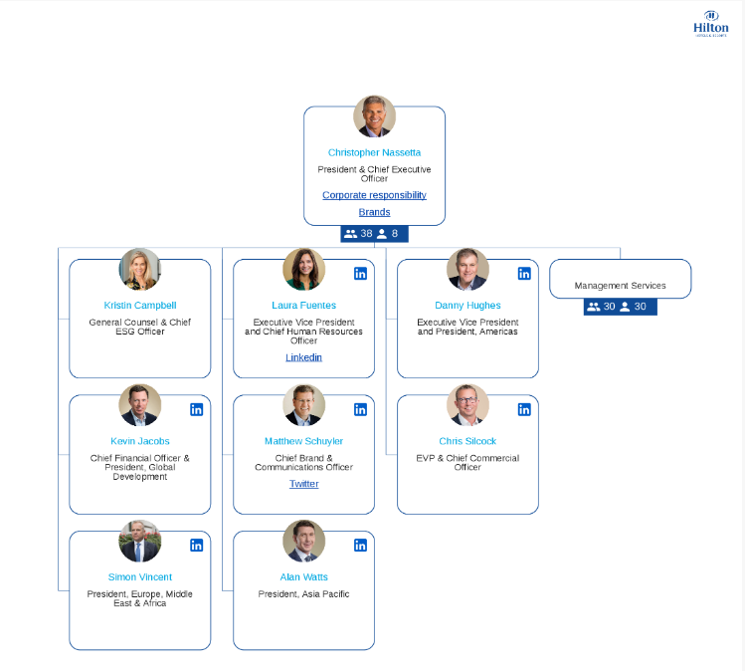
Figure: Hilton’s Organizational Structure
Source: (organimi, 2024)
Corporate level- The Hilton Hotel Group follows a divisional structure to manage its internal and external business functions. The C-suite of the Hilton is responsible for regulating and monitoring a range of business functions in vast geographic locations. The first three divisions of the organisation consist of ownership, management and franchise respectively. Operations of these subgroups come under the leadership of Hilton Hotels and Resorts. The fourth division is defined as a timeshare under Hilton Grand Vacations which has been a separate entity since the opening of Hilton Hotels Group as a trading company after 2008. The divisional structure followed by the company aims to operate each division as a semi-autonomous entity functioning independently.
Individual level - This structure has helped to facilitate better transparency within the working functions of the company boosting employee morale and job motivation. The self-enclosed nature of the divisional structure allowed the business to implement unique problem-solving mechanisms, relevant behavioural codes and values among team members. A strong and clear chain of command has helped to clear individual roles and responsibilities. Having separate marketing, finance, sales and HR teams, each division comes with high operational costs along with the pressure of hiring skilled workers. The segregated nature of the divisional structure creates barriers to developing internal professional communication and bonding among employees working in different departments. A sense of commonness becomes missing for some time which generates an unhealthy working environment leading to gradual growth in internal conflicts.
Theoretical application
Scientific management organisational theory is a useful theory widely used by business organisations to analyse workflow inside the firm following scientific metrics. The basic aim of the organisation is to improve financial performance and boost employee productivity. This theory was first proposed by Fredrick Winslow Taylor in the last phase of the 19th century (Taylor, 2023). Hilton Hotel Group follows scientific management theory while managing its organisational structure which has resulted in both benefits and limitations for controlling operational efficiency. One of the major advantages gained by the hotel brand is that it has independent and isolated business functions within the same organisations working as separate entities and better working efficiency divided into smaller groups. On the contrary, managing each department has increased the operational cost and acts as a major communication barrier for the employees. Due to lack of interaction among various departments of the organisation, creativity skills and working motivation of the employees have been reduced over the period of time (Tompkins, 2023).

Organisational culture
Corporate level- As an international hotel chain, the company has created an appealing organisational culture that plays a significant role in shaping staff behaviour and improving customer experiences. Hotels and resorts of Hilton Group have welcomed more than 3 billion guests offering them extraordinary memories and visiting experiences. The hotel chain follows a market culture which is highly profit-oriented and competitive in nature. As a corporate-minded business, leaders motivate the employees to do more hard work and derive optimal outputs. Employees are provided with challenging goals to boost their productivity and expertise potential (Kemp et al., 2023).
Individual level- The brand promotes diversity and inclusion in workforce management. Managers and team leaders of the business are keenly interested in understanding the individual perspectives of the team members to make continuous positive change in employee performance. It keeps primary focus on analysing the choices and preferences of the guests, owners, partners and suppliers. Each department included in the business functions cultivates a culture of diversity and inclusiveness in the workplace. It encourages talent while recruiting staff members for specific business functions. Due to conflicts of interest among team members, there are higher chances of exhaustion of the employees. Building long-term relationships with collaborators and partners has become limited. Market research costs have increased for the company and supply chain management has become difficult for the business (Arnould et al., 2023).
Theoretical application
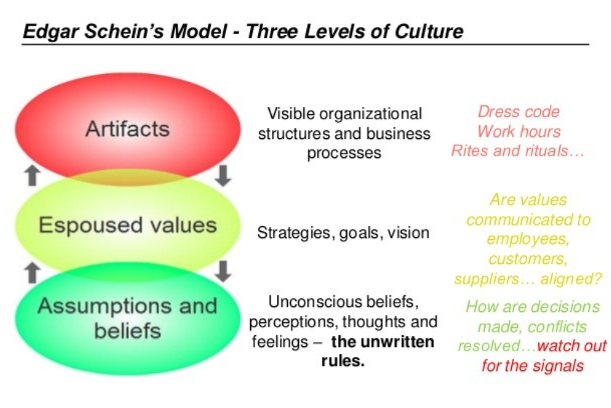
Figure: Edward Schein Framework of Organisational Culture
Source: (Somers, 2023)

The model or theory prescribed by Edgar Schein showcases three levels of culture present within an organisation. Understanding of these three levels is extremely important to obtain knowledge regarding leadership structure, artefacts, values and assumptions of the business authority. These elements build the core of culture in the workplace which directly affects organisational performance and skill growth of the employees. Carefully observing the framework, the hotel can find effective solutions to mitigate risks for long-term growth. Dress codes, working hours, goals, vision, thoughts and beliefs are considered unwritten rules of the organisation which ensures improvement in customer service management (Somers, 2023).

Recent change initiatives
Latest technology implementation for improving guest service
A growing demand for frictionless travel experiences has been observed among travellers all over the world. This has encouraged Hilton Hotel Group to implement a cloud-based hotel Property Engagement Platform to provide improved quality of service to the guests. This implementation has greatly helped the organisation to reduce the wait time for their guests alongside helping the team members to spend more time on providing personalised service to the guests (HTN, 2023).
Impact of those initiatives and their management by the organisation
The implementation of PEP has been greatly beneficial for the business of Hilton Hotel Group as it has allowed them to increase their guest satisfaction level which has led to a positive impact on their profitability. This technology has been incorporated with integrated software solutions that help streamline operations and address the needs of their team members and guests. Cost efficiency also has been archived with this implementation which has enhanced the financial stability of this organisation. The organisation has found that apart from its benefits implementing the PEP became challenging for them due to increased resistance from their existing employees. However, they have managed to incorporate it by increasing awareness about its benefits in terms of reduction of work burden from the employees (Hilton, 2023).
Theoretical application
Kotter's 8-Step Change Model
Kotter's 8-Step Change Model is one of the effective theories for the successful implementation of change in the workplace. The technological change in the form of PEP implementation within the workplace of the Hilton Hotel Group can be greatly supported by following the 8 steps of this theory. According to this theory initially, the organisation needs to rate the urgency of the technological implementation within its workplace. Therefore forming a strong coalition should be done and a vision for change should be established. The growing demand for frictionless travel experience can be used to create urgency and improving guest experience can be the vision for this change. As per the theory, the organisation needs to communicate this vision among its team members and identify and mitigate the potential challenges. Creating short-term goals building on the change and incorporating it within its corporate culture should have been the last step. This can greatly help Hilton Hotel Group to implement their PEP solution within their workplace while experiencing less resistance and other obstacles (Burke, 2023).

The organisation’s strategic direction
The Hilton Hotel Group should adhere to the structural path provided by the change management theories to ensure a successful implementation of their change initiatives. Various challenges have been posed during implementing change for instance resistance to change, limited availability of time and resources, difficulty in predicting outcomes and more. Therefore the strategic direction of the organisation should be to create a proper plan about change management and analyse the potential benefits and risks of their change initiatives before actually implementing it within their workplaces. Kolter's change management model can be effective in this aspect as it can provide them with a structured path for change along with specific milestones and auctions and increasing motivation among their employees (Ackerman, 2023).

Conclusion
The organisation Hilton Hotel Group is keenly focused on fulfilling its responsibility towards ensuring a sustainable future for the planet. Leaders are supportive of the employees which helps them to be involved in collaborative team culture within the organisation. Employees are provided with challenging goals to boost their productivity and expertise potential. The implementation of PEP has been greatly beneficial for the business of Hilton Hotel Group as it has allowed them to increase their guest satisfaction level which has led to a positive impact on their profitability. Kolter's change management model can be effective in this aspect as it can provide them with a structured path for change along with specific milestones and auctions and increasing motivation among their employees.

References
Ackerman, L.S., (2023). Development, Transition, or Transformation: The Question of Change in Organizations. Organization Development Review, 55(1).
Arnould, E.J., Thompson, C.J., Crockett, D. and Weinberger, M.F. eds., (2023). Consumer culture theory. SAGE Publications Limited.
Burke, W.W., (2023). Organization change: Theory and practice. Sage publications.
Fayomi, O. and Akanazu, H., (2024). Strategic Goal-Setting And Organisational Effectiveness In Selected Trading And Manufacturing Companies. Webology (ISSN: 1735-188X), 21(2).
Hilton, (2023). Hilton Rolling Out Technology Platform to Help Reduce the Friction of Travel for Hotel Guests, Team Members Worldwide. [Online] Available at: https://stories.hilton.com/releases/hotel-key-partnership [Accessed 27 4 2024].
Hilton, (2024). A leading global, hospitality company. [Online] Available at: https://www.hilton.com/en/corporate [Accessed 26 April 2024].
Hilton, (2024). The Story of Hilton. [Online] Available at: https://stories.hilton.com/history [Accessed 26 April 2024].
HTN, (2023). Hilton Seeks to Enhance Guest Services and Reduce Wait Times with Latest Technology Implementation. [Online] Available at: https://hoteltechnologynews.com/2023/04/hilton-seeks-to-enhance-guest-services-and-reduce-wait-times-with-latest-technology-implementation/ [Accessed 27 4 2024].
Kemp, A., Gravois, R., Syrdal, H. and McDougal, E., (2023). Storytelling is not just for marketing: Cultivating a storytelling culture throughout the organization. Business Horizons, 66(3), pp.313-324.
organimi, (2024). Hilton’s Organizational Structure. [Online] Available at: https://www.organimi.com/organizational-structures/hilton/ [Accessed 26 April 2024].
Somers, M., (2023). 5 enduring management ideas from MIT Sloan’s Edgar Schein. [Online] Available at: https://mitsloan.mit.edu/ideas-made-to-matter/5-enduring-management-ideas-mit-sloans-edgar-schein [Accessed 26 April 2024].
Taylor, F.W., (2023). the Rise of Scientific Management. The Quantified Worker: Law and Technology in the Modern Workplace, 9.
Tompkins, J.R., (2023). Organization theory and public management. Waveland Press.

