Global business environment

  - Porter’s five forces
  - Introduction
In this essay, I will be looking at Spar using porter’s five forces. This essay will start by introducing and explaining porter’s five forces. Porter’s five forces include ‘competition in the industry, potential of new entrance into the industry, power of suppliers, power of the customers, and threats of substitution’ (Anon., 2013).These are the five forces that the model is based on, each of these forces will be looked at individually with the intention of explain them in greater detail and how these forces contribute to how spar implement their strategy.
Before we look at the forces, first we look at what type of business Spar is and what type of industry they operate in. Spar is a retail company, it was founded in 1932 in the Netherlands. The organisation has over 12,000 stores intentionally operating under the brand SPAR, most of these stores operate as franchises. Although in this particular essay, the focus is on the stores operating in Britain, the number of stores in Britain including Northern Ireland is 2600. Spar’s primarily function is merchandising and marketing service. ‘The company’s syndicated services include product reordering and replenishment; ensuring products are available for distribution’ (Anon., 2018). Spar operates as a franchise, ‘a franchise is a type of license that a party (franchisee) acquires to allow them to use the business’ (the franchiser) proprietary knowledge, and trademarks in order to allow the party to sell products or provide services under the business name’ (Anon., 2017). The five forces will be dissected in the main body of the essay.
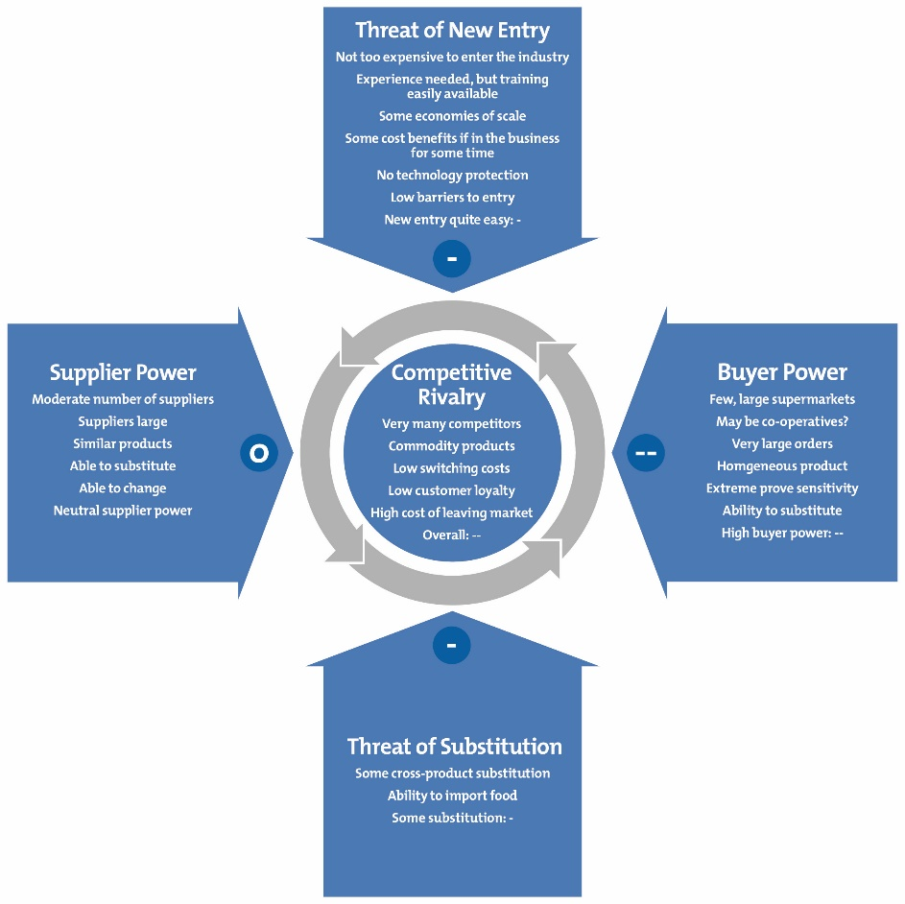
Figure 1 Porter Five Force
Spar operates in one of the most saturated industries in the world, retail. Competition in an industry can be determined by many different factors, these range from fixed costs associated with the business the number of rivalries and how they can affect your business. The more competitors the aggressive the industry tends to be. Spar operates in many sections of the retail industry from convenient stores all the way to wholesale. Their primary rivals include ‘j Sainsbury plc, booker retail partners and Tesco plc’ (Anon., 2018), these companies can compete with spar as well as being a big threat to spar’s operations. Other retail companies that compete with spar are premier, one stop and also Nisa stores. Tesco have opened more and more ‘Tesco expresses’ which can be seen as direct rivals to spar’s convenient stores as they (Tesco express) are usually smaller allowing Tesco to operate them as convenient stores. Spar has responded to this change in the market by increasing their number of independently run stores (franchisee), as they currently have 2600 in the United Kingdom. Spar has also added truck stops, to increase their market share. One of the main strengths in this field for spar is their cost of opening new stores, as they get a fee from franchisees, lowering their cost when they open a new store, all their franchisees are local to the community their serve allowing them to increase their market share. There are many ways of checking your rivals’ competitive edge, these indices include concentration ratio and Herfindahl- Hirschman. ‘CRx ratio shows the market share in that particular industry’ where as ‘Herfindahl- Hirschman, shows the size of the organisation in relation to the industry it operates in and the amount of competition’ (Anon., 2013) these indices would be used along with others would be used to look at the competition.
The number of new entries varies from industry to industry. The retail industry is a competitive industry with powerful companies operating within it. The size and power of these companies makes it difficult for new entries. Due to loyalty brands and brand awareness, and due to high start-up cost this deters people from entering the market. Spar however offers a franchise model, this allows new entries to the market whilst giving spar a greater market share. However Spar are not the only company using franchises, Premier and Nisa also use franchises. This allows a lot more new entries aided by big companies in their pursuit of larger market share. Spar is regarded as the biggest with over 12000 stores, followed by Londis. When it comes down to amount of money required to buy into a franchise spar does not fare well as they are the most expensive, where as one stop costs less, making market entries choose them (one stop), with one stop it costs ‘£50,000.00 start-up costs’ (brokerplan, 2018, p. 34) however when you look for the preferred franchise Spar is the most popular.
In order to understand this part of porter’s five forces, its best to first define the term ‘threats of substitution’, ‘substitutes are defined as products or services that can be found on other markets that offers the same benefit’ (Anon., 2013). As stated in the previous section, spar is seen as the preferred franchise, meaning they have a strong presence in the market. However their competitors are also big, thefore making the threat of substitution high. Although the customers might still be around, they could use one of their rivals instead. However spar has developed many ways off securing the market (companies in retail cannot corner the market but can be very competetive) by using local people to run local stores. This way of operating helps them as they have familiar people running local shops and taps into the local culture within those communities.
Spar as stated before, is one of the giants of the retail industry and that gives them a huge negotiating power with their suppliers. Defining suppliers would be ‘the ability for suppliers to increase the cost of their product or services’ (Anon., 2016) , spar has big negotiating power as they have spending power as well at intentionally.
Spar’s core users are customers and thus have very little in effecting their price point, however it will take a greater number of customers before spar would change their price plan.
Spar is a big company with a massive amount of power within the industry therefore

References
Anon., 2013. strategy skills. [Online]
Available at: http://www.free-management-ebooks.com/dldebk-pdf/fme-five-forces-framework.pdf
Anon., 2016. retail industry. [Online]
Available at: http://pestleanalysis.com/five-forces-analysis-of-fashion-retail-industry/
Anon., 2017. investopidia. [Online]
Available at: https://www.investopedia.com/terms/f/franchise.asp
Anon., 2018. [Online]
Available at: https://www.bloomberg.com/research/stocks/private/snapshot.asp?privcapId=407116
Anon., 2018. d&b hoovers. [Online]
Available at: http://www.hoovers.com/company-information/cs/competition.spar_(uk)_limited.27334b5411e496dc.html
brokerplan, 2018. point franchises. [Online]
Available at: https://www.pointfranchise.co.uk/I-9-retail-franchise/?gclid=EAIaIQobChMI7PzYy6282QIVC2cbCh3pMAJiEAAYAiAAEgLIVfD_BwE

