Title Page
Lab Report for Formula of Mg oxide
Author Stephen Deane
Date 24th July 2024
Student number:2307720

Contents
Contents 2
1 Introduction 3
2 Results 3
3 Discussion 4
4 Conclusion 6
5 References 6
6 Appendices 6

Figure 1 - experiment equipment set up 7
Figure 2 - Results part 2 8
Figure 3 - Results part 1 8

Table 1 - Experiment results 4
Table 2 - Mass of crucible, cover and magnesium before and after 4

Equation 1 - To solve for MgO Oxygen moles. 3
Equation 2 - To solve for MgO magnesium moles. 3
Equation 3 - Equation for mole ratio 3
Equation 4 - Moles of Oxygen for trial 1 4
Equation 5 - Moles of Magnesium for trial 1 4
Equation 6 - Moles of Oxygen for trial 2 5
Equation 7 - Moles of Magnesium for trial 2 5
Equation 8 - Mole ratio for trial 1 5
Equation 9 - Mole ratio for trial 2 5

Introduction
The purpose of this experiment is to examine the reaction between magnesium metal and oxygen. In more depth, it is to determine both the mass and mole mass of magnesium and oxygen in the compound formed by burning magnesium in oxygen (magnesium oxide MgO).
The learner’s hypothesis for this experiment is “when the magnesium is burned it will weigh more than the original weight due to the oxygen mass being taken on”. The experiment was conducting twice with two different weights of magnesium in the hope to show consistency of the MgO being a larger mass.
The controlled variable is the Bunsen burner, scale, and crucible. The independent variable is amount of magnesium chips used. The dependent variable is the percent of mass the product changes.
To complete this experiment the learner has been told that to find the mole mass of each part of the MgO they will need to use the following equations.
$$\frac{Mass of oxygen that reacted with magnesium}{M{olar mass of oxygen 32g.Mol}^{-1}}=Oxygen moles of MgO$$

Equation 1 - To solve for MgO Oxygen moles.
$$\frac{Mass of magnesium before heating}{{Molar mass of magnesium 24.3gMol}^{-1}} = Magnesium moles of MgO$$

Equation 2 - To solve for MgO magnesium moles.
Once the student has worked out the induvial moles, they then used the out coming figures to work out the molar ration in their resulting MgO.
$$\frac{Moles of Magnesium}{Moles of Oxygen }=Mole ratio$$
Equation 3 - Equation for mole ratio

Results
While completing the experiment, the leaner worked in a group with A Clarke and S Shepardson. Looking at figure or table 1 for the results table filled with the different data the learners recorded.
 | Experimental Trial 1 | Experimental Trial 2
Mass of Crucible and Cover | 67.5143 g | 67.5212 g
Mass of Crucible, Cover and Magnesium | 68.5144 g | 69.5132 g
Mass of Magnesium before heating | 1.001 g | 1.992 g
Mass of Crucible, Cover and Product post-heating | 69.0544 g | 70.6181 g
Mass of Product post-heating | 1.5401 g | 3.0969 g
Mass of Oxygen reacted with Magnesium | 0.5391 g | 1.1049 g
Moles of Oxygen | 0.0169 | 0.0345
Moles of Magnesium | 0.0412 | 0.0820
Mole Ratio of Mg: O | 0.4078 | 0.4207
Determined formula of the oxide | MgO (s) | MgO (s)
Percent by mass of Magnesium in the oxide | 65.00 (2dp) | 64.32 (2dp)
Percent by mass of Oxygen in the oxide | 35.00 (2dp) | 35.68 (2dp)
Table 1 - Experiment results
From the data in this table, it can be used to make graph 1. This graph shows that in both trials the overall weight went up which would back up the hypotheses but did not go up by as much as was expected.

Table 2 - Mass of crucible, cover and magnesium before and after

Discussion
Using the data collected and then used for calculations on the results sheet the learner can see that both trials have similar reactions being they both had mass percentage of magnesium being around sixty-four percent of the MgO whereas oxygen had only 35 percent, from this the learner can infer that the ratio was 2.4:1 magnesium to oxygen. This was worked out for both trials using equation 1 and 2 as such.
$$\frac{0.5391}{ 32.0}=0.0168$$
Equation 4 - Moles of Oxygen for trial 1
$$\frac{1.001}{ 24.3}=0.041$$
Equation 5 - Moles of Magnesium for trial 1
$$\frac{1.1049}{ 32}=0.0345$$
Equation 6 - Moles of Oxygen for trial 2
$$\frac{1.992}{ 24.3}=0.0820$$
Equation 7 - Moles of Magnesium for trial 2
Once the student has worked out the moles for oxygen and magnesium, they can use equation 3 to find out the ratio of the magnesium oxide.
$$\frac{ 0.0411}{ 0.0168}=2.4$$
Equation 8 - Mole ratio for trial 1
$$\frac{0.0820}{ 0.0345}=2.4$$
Equation 9 - Mole ratio for trial 2

The resulting mole ratios of two-point four Mg to one O leads the students to reflect on what could have gone wrong and when completing the experiment, the students did notice that the magnesium did not fully burn up while cleaning the crucible out. This was after a thirteen minuet burn time, so this may have been due to the crucible being too far away from the flame or just not a long enough burn time to react. The second trial burnt for twenty-four minuets with the lid being removed twice to stir. The stirring was added to the second trial as when cleaning the first trial the students found that the magnesium had burnt on to the inside of the crucible which was unable to be cleaned off.
The process of stoichiometry can be used in numerous ways some relating to OME (ordnance, munitions, and explosives) such as
- Disposal of chemical warfare agents and energetic materials (explosives). Reference [2] gives good detail on how this process can be used for disposals.
- The disposal of Magnesium/Teflon/Viton (MTV) flares.
Looking at the limitations for this experiment the leaner did find many things that could causes error/unusable data these being.
- When cleaning the crucible there was residue stuck to the base which will affect the weight of the second test through
- Inaccurate equipment no calibrate sticker and not leave could causes questions of if the resulting data is reliable/useable.
- The set up is considerably basic with no real measurements of how far the crucible needed to be from the flame which is believed to be a reason for why the magnesium did not fully burn up.

Conclusion
When reflecting on this experiment the learner believes that it was successful as there is evidence of the mass increasing which proves the hypothesis was in fact correct, but there are areas of improvement that could improve the resulting data. From completing this experiment along with the students research they would be interested in doing some further studies of how stoichiometry is used around disposal of different equipment and materials.

References
[1] Nuffield Foundation, “The change in mass when magnesium burns,” RSC Education, 29-Jan-2016. [Online]. Available: https://edu.rsc.org/experiments/the-change-in-mass-when-magnesium-burns/718.article. [Accessed: 18-Jul-2024].
[2] G. Begue and L. Aufauvre, “Explosive and pyrotechnic wastes management practices,” Jun. 03, 2019. https://hal.science/ineris-03237729/

Appendices
List of materials used.
- Crucible plus cover
- Ring stand
- Bunsen burner
- Heat- resistant mat
- Clay triangle
- Crucible tongs
- Analytical balance
- Magnesium chips 1- and 2-gram samples
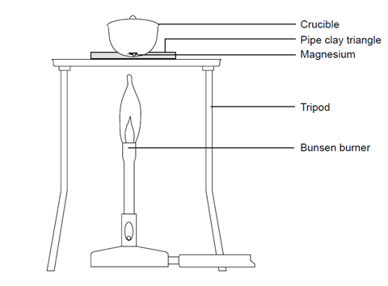
Figure 1 - experiment equipment set up
Procedure:
- Set up the Bunsen burner and ring stand on the heat resistant mat. Placing the clay triangle on top of the stand.
- Light the Bunsen burner making when flame is not in use it is places on yellow safety setting when not being used. When in use change to the non- luminous two blue cone flame.
- Ensure the crucible and lid are clean, weigh on the balance recording the value in the data table.
- Add the first sample of magnesium chips to the crucible, then weigh the combined weight of the crucible, lid and magnesium.
- Set the crucible on the triangle with the lid slightly ajar so that oxygen can get in but does not release any magnesium oxide.
- Start to gently heat the crucible with the safety flame for 1 minute, then change to the blue cone flame.
- Heat the crucible until all the magnesium turns gray-white and a powder substance. This should take around 10 minutes.
- Allow for the crucible to cool then record the mass of the crucible, cover and product of the reaction.
- Repeat procedure steps 1-8 for sample two.

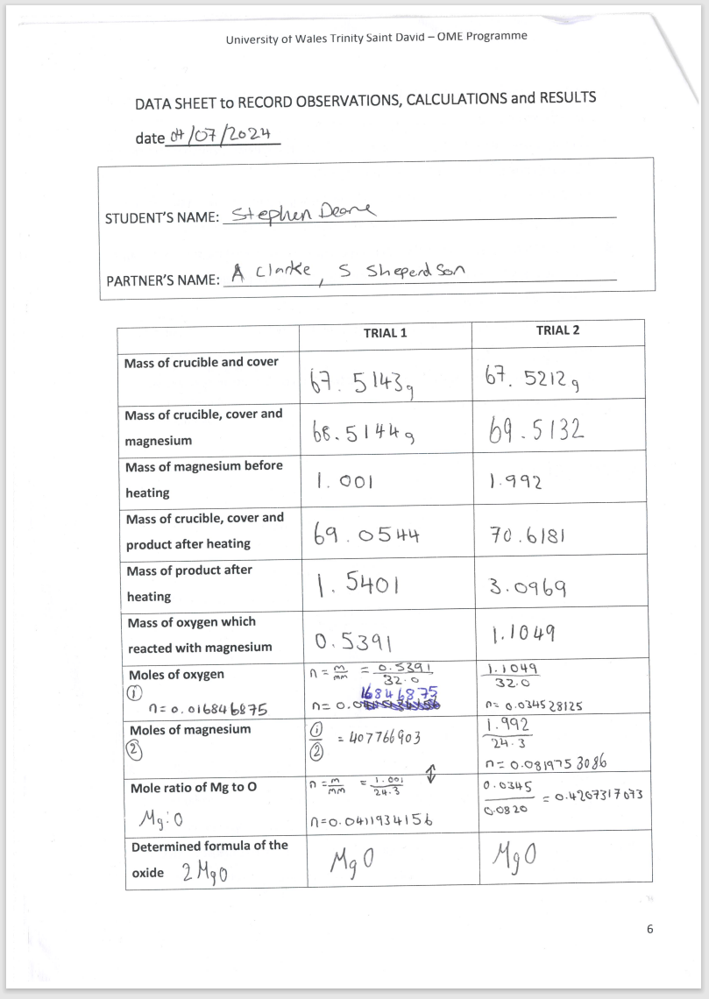
Figure 2 - Results part 2
Figure 3 - Results part 1
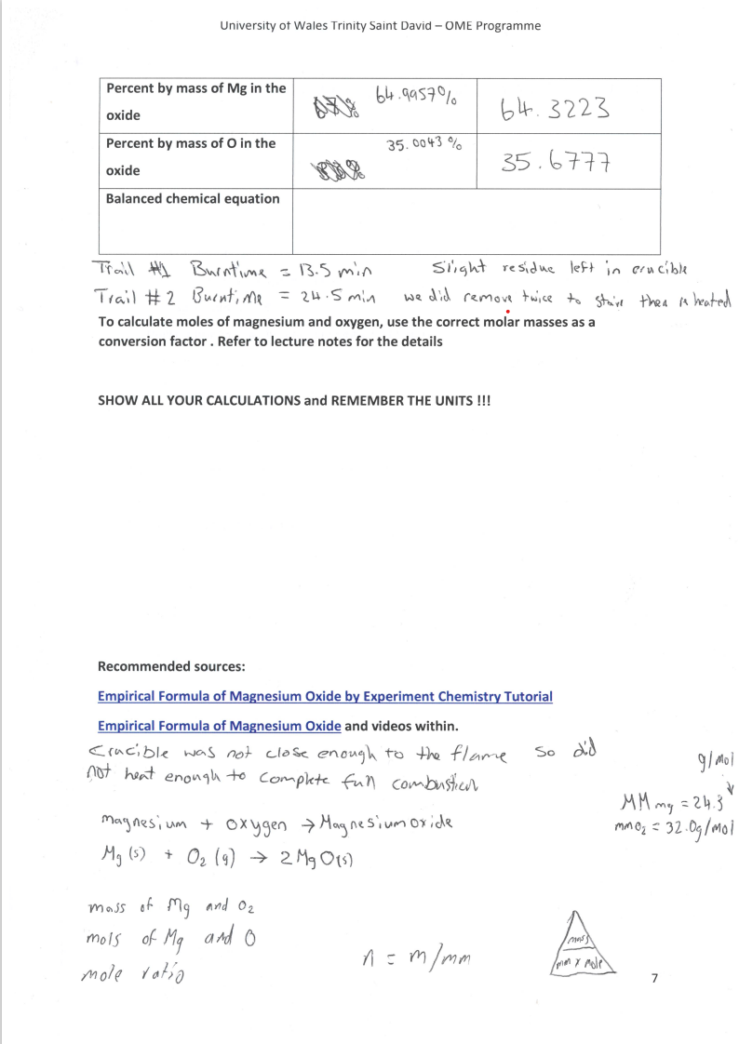
Figure 3 - Results part 2

