Blog Post
You Are Not Lazy!*
*(You probably just want to be doing something else)

These students at University of Wales have started working on the establishment of a vegetable garden in a rarely visited corner of the university grounds. They aren’t doing it to earn money, or get extra marks for their anthropology assignments. They are making a garden to produce food for themselves and others, to make use of under appreciated resources and, most of all, because they enjoy it. There is a lot to do. It’s going to be hard work. But they will put in the effort, because it’s work that they find worthwhile and fulfilling.

In modern globalised capitalist society, hard work is seen as on of humanity’s greatest virtues, and the myth of laziness has become so entrenched in our culture, that it is often used to demonise anyone with dissenting views on the necessity of selfless labour.
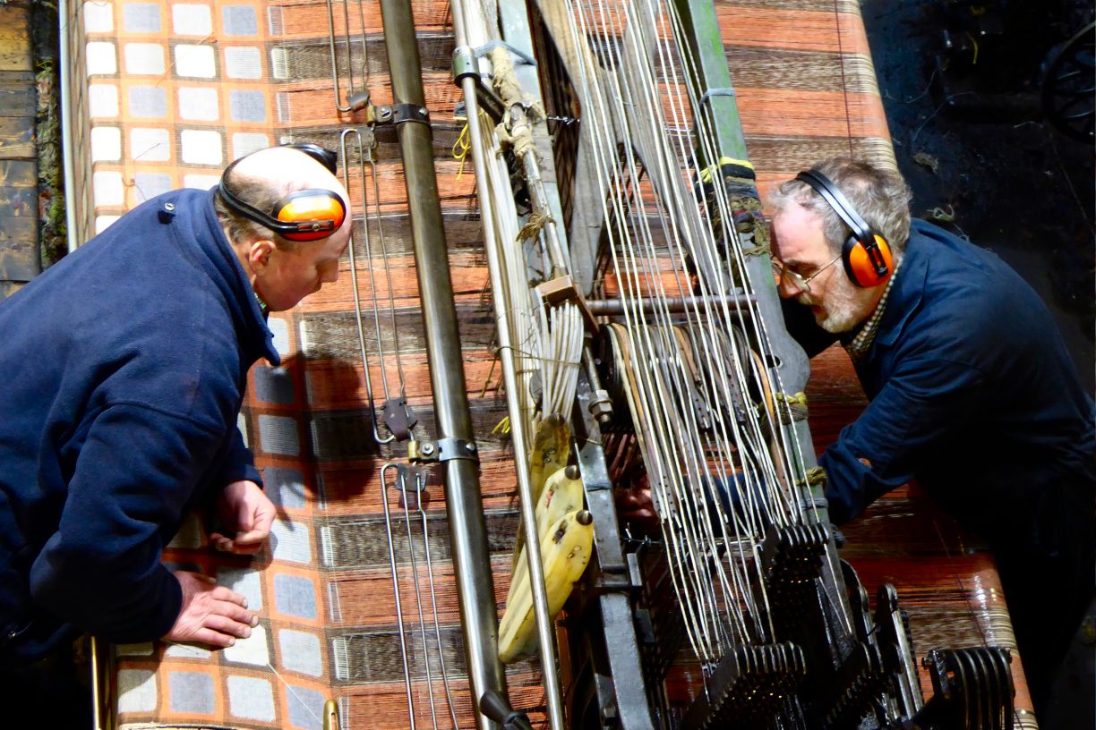
Genuinely lazy people probably don’t even exist. Most of us will put in time and effort to achieve something we consider worthwhile. We only shy away from doing things we don’t want to do. The anarchist writer Alexander Berkman (1977) argued that there is “really no such thing as laziness. What we call a lazy [person] is generally a square peg in a round hole. That is the right [person] in the wrong place” (p.334) and a person in the wrong place will always be “inefficient and shiftless” (ibid).

The two men in the photo above are volunteers at the National Wool Museum. They apply themselves conscientiously to the task of operating and maintaining historic weaving machines because they enjoy it. They feel suited the work and are good at it. It may have been a completely different experience for the workers who operated those machines 100 years ago. They may well have felt coerced to work long hours in the mill to earn a meagre wage. And they are unlikely to have been given ear defenders. The fear of being regarded as lazy, either by their bosses, or their fellow workers may well have been part of that coercion. Their working hours, conditions and rates of pay were determined by the mill owners, and the wool cloth they produced would have belonged to those same mill owners.

In the 21st century increased use of technology has meant there is less need for these unpleasant working practices, but it does exist in some places. Like this Dunbia abattoir in West Wales.



The myth of laziness has been a prominent part of the so-called Protestant Work Ethic. Calvinist attitudes to the virtue of hard work have been used to support the idea that a hard working person is a good person. The work ethic, as described by Weber (2001), has become a constant feature of capitalist culture.



The desire to promote the work ethic has even led to attempts to impose it on other cultures. Gatherer– hunter groups like these Trobriand Islanders have no need to work long hours at unwelcome tasks (Kildea and Leach, 1975). Christian missionaries were appalled to find people spending much of their time at leisure (and having far too much sex!) that they introduced them to cricket, in an attempt to keep them ‘occupied’.

So if anyone ever feels the need to call you lazy, just because you aren’t doing the kind of work they think you should be doing, don’t believe them. Just take it easy until some worthwhile work comes along.
References

Berkman, A. (1977) ‘Lazy Men and Dirty Work’, in Woodcock, G. (ed.) The Anarchist Reader. London: Fontana.

Trobriand Cricket (1975). [Film] Directed by: Kildea, G. and Leach, J. UK: Ronin Films.

Weber, M. (2001) The Protestant ethic and the spirit of capitalism. London, Routledge.
Source Analysis (Gobbet)

Source 3.

Haugerud, A. 2013. No Billionaire Left Behind. Satirical Activism in America. California: Stanford University Press. p.64.

‘Many expected much more help from their government for victims of Hurricane Katrina. These public sentiments stand in contrast to the historical shift during the 1980s and 1990s toward romanticization of the market, an emphasis on self-reliance as “freedom,” and distrust or demonization of government–the latter epitomized in an oft-quoted 2001 statement by Grover Norquist, head of the antitax group Americans for Tax Reform: “I don’t want to abolish government, I simply want to reduce it to the size where I can drag it into the bathroom and drown it in the bathtub” (Frank, 2010).

It is an irony of late–twentieth- and early–twenty-first-century American democracy that while the dismantling of the New Deal safeguards and other contemporary forms of market fundamentalism benefit mainly large corporations and the very rich, proponents portray smaller government, deregulation, and shredding of the social safety net as the route to riches for ordinary citizens. In the name of “personal responsibility” and freedom, they tout a new “ownership society”.

If individuals are to sink or swim on their own, Billionaire irony reveals that the same apparently is not true of corporations, which in the early 2000s enjoyed generous tax breaks, government subsidies, and much lower tax rates that those of the 1950s (Johnston 2003, 43).”

The quoted text from is from Angelique Haugerud’s No Billionaire Left Behind (2013) the book describes and analyses the work and cultural lives of an established group of performers, who use humour and parody to criticise the current state of United States and global politics and economics. The group dress up as stereotypical wealthy capitalists and give satirical performances based on their current political concerns. This particular segment (gobbet) demonstrates the seriousness of the Billionaires’ work, highlighting a obvious (to me at least) irony the so-called free market economy only really provides real freedom and security for those individuals and corporations who can command great wealth.

The sheer amount of time that Haugerud spent with the group makes for a very in-depth ethnography. She is clearly an admirer of their approach, enjoyed their company and shared many of their political views. However, despite her biases, she has managed to shed light on how performance and art and performance can be useful tools for political activism. From a practical anthropological point of view I found it interesting and useful to compare her approach to fieldwork, particularly participant observation, with that of Hilary Pilkington, for her ethnography of the English Defence League, Loud and Proud (2016). Despite Haugerud being sympathetic with her subjects’ political ideals and Pilkington much less so, their approaches seem to have been remarkably similar.

The Billionaires’ performances are a clear reflection of their social and political concerns. How effective their approach is in winning converts to their cause is doubtful – peoples political views tend to be fairly well entrenched and difficult to shift – but they are undoubtedly having success at encouraging people who may already share their views to become politically active, particularly those with artistic leanings like themselves. Haugerud’s ethnography demonstrates this in an inspiring and entertaining way.
References
Haugerud, A. 2013. No Billionaire Left Behind. Satirical Activism in America. California: Stanford University Press.
Pilkington, H. (2016) Loud and Proud: Passion and Politics in the English Defence League. Manchester: Manchester University Press.

