 | Targed/target | Yr hyn yr wyf wedi'i wneud yn yr aseiniad hwn  What I have done in this assignment...
Targed/Target 1 | Please consult the latest Harvard Referencing handbook to ensure consistent accurate referencing. | I have used the Harvard Referencing Handbook to double-check my referencing.
Targed/Target 2 | Please look at Academic Phrasebank (manchester.ac.uk) to develop a more academic style of writing. | I have used the Academic Phrasebank for ideas when using criticality within my writing.
Targed/Target 3

Tania Evans-Piper
2312202

ECAD7003

Learners, Schools & Communities:
Where am I teaching?

PART B

Word Count- 2497

Assignment Title

How a school develops one aspect of its SDP: a report that critically reflects on the actions, impact and evidence base.

Introduction

This assignment will examine School X's School Development Plan (SDP) and critically reflect on one aspect of the school's targets. The aim is to provide a critical reflection on the chosen target, highlighting how it has been identified and its impact on the school.

As per the guidelines set by the British Educational Research Association (BERA) for maintaining anonymity in educational research, the school will be referred to within this assignment as "School X" to ensure its identity of name, staff and students are kept confidential throughout. The assignment will adhere to the guidelines to maintain the anonymity of the school, its staff, stakeholders and pupils and respect their rights to confidentiality (BERA, 2018).

The target being addressed is Target 5 of the school development plan, which is to promote the importance of regular attendance in school. This target has been set based on the recommendations from the school's Estyn inspection report in 2018, shown in Appendix 1. The report identified that attendance levels within the school over a three-year period were lower in comparison to similar schools (Estyn, 2018).

This target has been selected as a focus as it has emerged that the impact of the pandemic has caused a decline in school attendance levels and has yet to return to pre-pandemic levels, subsequently causing concern (Welsh Government, 2023a). The target outlined in School X's development plan is shown in Appendix 2.

School X is an English medium primary school with 260 students. It has 11 classes ranging from nursery to year six and a learning resource base for students with moderate learning difficulties. The eligibility for free school meals is 34.6%, and attendance levels for 2022/2023 were 90.63%, below the school's target of 95% (School X, 2023).

Literature Review

Wales is committed to offering high-quality education to all students. The Welsh Government has significantly emphasised school development plans (SDPs) to achieve this. These plans are compulsory in all schools across Wales and guide continuous improvement of school performance designed to help identify priorities for improvement and develop strategies to address them. Furthermore, they enable schools to take action, review progress, and assess the impact of their efforts (Welsh Government, 2014a). Reviewing the school development plan (SDP) is continuous, as it is a working document requiring regular progress reviews against established milestones. The plan is updated to ensure alignment with current priorities (Welsh Government, 2021b). Appendix 3 shows a school's continuous reflection model when reviewing a school development plan (Welsh Government, 2014b). This process is similar to Kolb's experiential learning cycle, a cyclical process that emphasises the importance of reflection and learning from experience (Cherry, 2022a).

In order to improve the quality of education provided in schools, it is imperative to involve all stakeholders in the process. The Welsh Government (2021a) states that involving stakeholders is integral to school improvement. Estyn (2023) considers it a crucial aspect of self-evaluation and improvement planning. By drawing on the views and opinions of all stakeholders, schools can gain a more comprehensive understanding of their strengths and weaknesses, which can help them to identify areas for improvement and implement effective strategies for positive change. However, Schildkamp (2019) argues that different goals at different levels, such as regional, national, and school levels, can cause misalignment and negotiation between stakeholders. It has been noted that School X's development plan has considered Estyn's previous inspection report's recommendation regarding the significance of maintaining regular attendance among students in the school (Estyn, 2018). However, the Welsh Government relaxed the requirement to report pupil absence during the pandemic. As a result, students' attendance levels have decreased significantly and have yet to reach the target of 95%. Now, involving other stakeholders such as parents, carers, administration staff, senior leaders, and the Education Welfare Officer (EWO) is crucial to achieving this goal (School X, 2023).

Following the COVID-19 pandemic, there is a focus towards ensuring regular attendance in schools nationwide. Jeremy Miles (Minister for Education and Welsh Language) emphasises attendance, which is not just limited to individual schools but is also reflected in the more significant development plan of the education sector, stating that Improving school attendance must be seen as a national priority (Welsh Government, 2023d). This plan, which operates at a macro level, aims to address the challenges schools face post-pandemic and prioritise measures that ensure the safety and well-being of students, teachers, and staff. Recent data released by the Welsh Government (2024) reveals that pupil attendance in schools between 4 September 2023 and 2 February 2024 has increased slightly from 89.3% to 90.5% compared to the previous academic year of 2022/2023. However, according to Wightwick (2022), absence in schools is causing great concern with a growing crisis in student mental health. The risk of students losing their confidence due to various factors such as academic pressure, social anxiety, and other psychological pressures is a significant concern for schools.

The fourth action point listed under target number five of School X's (2023) development plan shows it plans to promote the importance of regular attendance by recognising and rewarding good class attendance each week using attendance stickers and stickers. The use of extrinsic rewards can be a valuable tool to motivate students. According to Cherry (2022b), this type of motivation drives positive behaviour, leading to intrinsic motivation if handled carefully. This is illustrated by the theory of operant conditioning developed by B.F. Skinner. According to this theory, behaviour is shaped by its consequences, and if a behaviour is followed by a positive consequence, such as a reward, it is more likely to be repeated in the future (MacLeod, 2023). It could be argued that it is not the fault of the students for their absence. Hughes (2023) suggests that student absence can be influenced by various factors such as illness, poverty, additional learning needs, and parental influence. It is probable that students affected by such factors would not be motivated by extrinsic rewards, which could lead to a decline in enthusiasm.

The School X Development Plan for 2023 aims to achieve a 95% attendance rate among all stakeholders, focusing on ensuring that students understand the importance of regular attendance. As a rights-respecting school, the students are aware of the principles of the United Nations Convention on the Rights of the Child (UNCRC), which includes Article 28, recognising every child's right to education (UNICEF, 1989).
In Wales, attending school is considered a vital aspect of the curriculum, as it plays a significant role in fostering healthy and confident individuals. The Welsh Government (2023b) places great emphasis on promoting student well-being and mental health, which are essential components of the four core purposes of the curriculum for Wales. By prioritising student health and well-being, engagement and attendance can be improved, leading to better academic outcomes and overall success.

Developing An Action Plan

School X has taken an approach towards enhancing its academic performance by devising a school development plan consisting of six primary targets over a three-year period. Each of these targets has been broken down into specific actions that require improvement, as determined by the school's headteacher and senior management team. In order to ensure and monitor progress over the period, School X has implemented a continuous self-evaluation process for each targeted area, with a set of success criteria in place for each action. The school uses a RAG (Red, Amber, Green) model to track progress and display their performance's strengths and weaknesses through colour-coded ratings. This allows the school to identify areas that require further attention and focus on improving their overall performance when necessary (Peterson, 2021). A criticism of this is that the RAG system used for monitoring work progress may not accurately represent the actual situation. According to Harrin (2003), management commonly employs a rating system to show that the work is being managed efficiently and under control, rather than to show an accurate picture. This problem has been noticed in School X's development plan, as mentioned in Appendix 2, where the RAG rating is still pending.

After conversing with the head teacher of School X, it was discovered that the school development plan is a collaborative effort driven by Estyn and the Curriculum for Wales. This involves the active participation of various stakeholders, including the headteacher, senior management team, Centra South, and partners, who all have a crucial role in driving the school towards its improvement goals. Their collective efforts ensure that the school's improvement plan is effectively executed. This is in line with the Welsh Government (2023c), who emphasise collaboration and shared commitment across the school and its development. They emphasise the role of parents as stakeholders in their children's education and recognise the importance of ensuring that the curriculum is tailored to meet each child's individual needs while also being authentic to their context. The government seeks to create a more collaborative and comprehensive approach to education and foster positive relationships by involving parents in this process (Welsh Government, 2022). The statement aligns with the approaches advocated by Estyn (2013) strategies. These strategies emphasise the importance of involving stakeholders and fostering a sense of trust and confidence to enhance practice quality. This is criticised by Kelty and Wakabayashi (2020), who raise concerns about the limited involvement of parents in children's education and state that parents are often relegated to the role of bystanders, disconnected from their children's learning journey.

The success of School X’s school development plan hinges on effective planning, with data analysis playing a crucial role. The school prioritises data-based analysis, focusing on carefully examining summative assessment data to identify areas for student achievement improvement. According to Schildkamp (2019), school management can utilise data from different sources to attain their goals effectively. Schildkamp also highlights that the iterative improvement process requires specific objectives and accurate data. These are necessary to evaluate the data effectively. Schmoker (2023), however, disagrees that educational settings should decide data, arguing that it leads to over-analysis and overload. Instead, he suggests that education settings should establish their priorities for improvement. Given this, enabling school leaders to embrace a more formative approach to data analysis and focus on their own improvement goals, they can effectively measure and evaluate the impact of their efforts without succumbing to excessive data overload and analysis. This approach enables schools to make informed decisions based on accurate and relevant information, leading to better outcomes for students and teachers.

School X has a four-stage protocol for strategic planning and management, which involves analysis, planning, implementation, and evaluation, and is highlighted in Appendix 3. This approach enables schools to improve through reflection and evaluation (Welsh Government, 2014c). These short-term evaluations are often used to track and manage long-term goals and priorities within a school improvement plan. Reflections and feedback from other stakeholders within the school prove valuable when evaluating the progress and effectiveness of identified targets. According to LinkedIn (2024), stakeholders' feedback plays a pivotal role in successfully implementing any program. It assists in monitoring the program's progress, identifying its strengths and weaknesses, and eventually improving the outcomes. However, the four-stage model does not give enough importance to involving stakeholders throughout the planning process. Although it does have a stage for consultation or involvement, this aspect could be more prominent. If teachers, administrators, parents, students, and other stakeholders are not actively engaged, the resulting plan may not be accepted and could fail to address essential concerns or issues. According to Motu’apuaka et al. (2015), involving stakeholders can be challenging due to the extra time involved and the lack of training and resources available in order for them to make a meaningful contribution.

When writing a school development plan, self-evaluation is critical. Welsh Government (2022) highlights the significance of self-evaluation and the need for evidence-based approaches, taking into consideration a broad range of perspectives from other stakeholders within the school, including students and staff.

School X's development plan includes a self-evaluation process and impact measurement using the RAG model. In this model, a green rating means no further action is necessary, an amber rating means ongoing support is required for certain aspects of the targets, and a red rating means many aspects that need attention. These RAG ratings can be updated regularly, as the school development plan period is continuous once initiated (The National Archives, 2014).

Reflection and evaluation

On reflection, School X's proposed target to improve student attendance by implementing a system of stickers and certificates is currently pending on the RAG rating. As it is still early in the spring term, the self-evaluation level regarding the strategies' effectiveness has yet to be updated. However, it is anticipated that attendance data from the autumn term will be updated before the Easter break and will be updated accordingly. The school has yet to achieve its attendance target of 95% since 2018, derived from the previous Estyn inspection. Therefore, it is likely that the RAG rating will be amber. However, the senior leadership team had anticipated challenges in achieving this target due to the decline in student attendance observed in other schools following the pandemic.

During my PTE placement at School X, I noticed that the school regularly held celebration assemblies to recognise and appreciate the achievements of its students. These assemblies were held to celebrate various events such as birthdays, ‘Pupil of the week’ and the 'Seren yr wythnos', which celebrated the students' efforts in their use of the Welsh language. However, one thing that was not observed during these assemblies was the recognition of class attendance. After a thorough evaluation, it seems plausible that School X could have benefitted by executing the strategies outlined in its development plan. However, it is essential to mention that, at present, we need more information to ascertain the efficacy of these strategies. Therefore, the outcome of implementing these strategies remains to be determined.

For future practice, I plan to implement effective measures to improve attendance levels in my school. To achieve this, I will diligently adhere to the reporting guidelines and requirements for student absences. Additionally, I will prioritise adopting any strategies outlined in the school development plan that aim to promote the significance of regular attendance in school. By doing so, I am confident that we can create a culture of punctuality and dedication, which will benefit the students and the school as a whole.

Conclusion

This assignment has been an enlightening experience for me, as it has allowed me to expand my knowledge and understanding of the processes that schools go through to plan, implement and evaluate their targets for development. Throughout this assignment, I have had the opportunity to engage with various processes and methodologies, such as self-evaluation and strategic planning, which play a crucial role in the growth and progress of a school. I have come to realise that the support of key stakeholders is paramount to the success of any development initiative. Furthermore, engaging with the literature on this topic has deepened my understanding of the process, which I believe will prove to be invaluable in my future profession as a teacher.

Appendices

Appendix 1
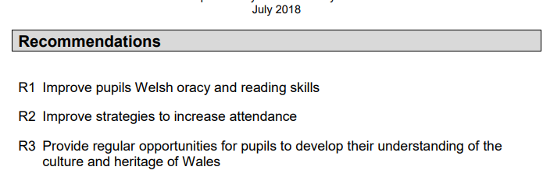
Taken from School X’s previous Estyn inspection report.
(Accessed: 12 February 2024)

Appendix 2

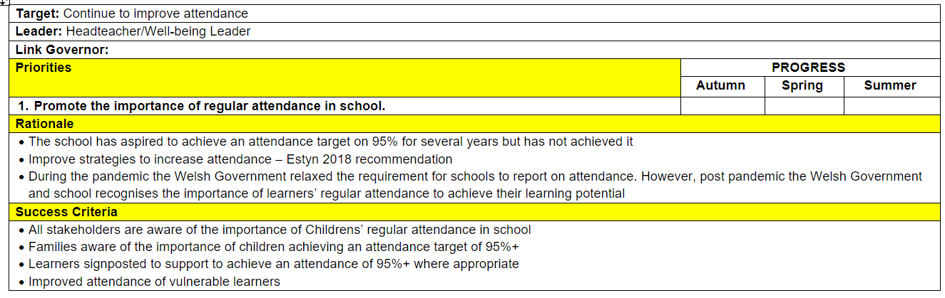
Taken from School X’s School development plan (SDP) 2023/2024
(Accessed: 12 February 2024)

Appendix 3

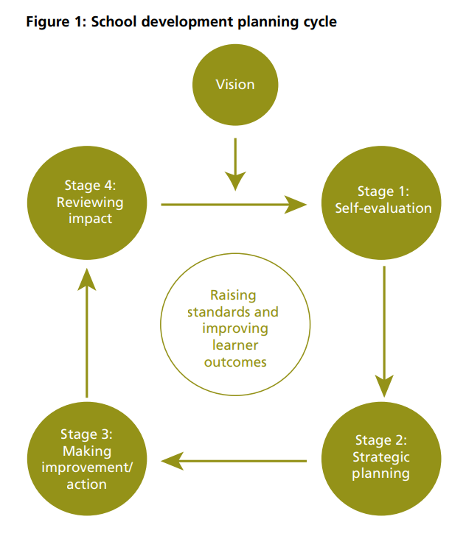
Welsh Government (2014) School development plans Guidance. Available at: https://www.gov.wales/sites/default/files/publications/2018-03/school-development-plans.pdf (Accessed 13 February 2024).

Reference list

BERA (2018) Ethical Guidelines for Educational Research, fourth edition (2018), Bera.ac.uk. British Educational Research Association. Available at: https://www.bera.ac.uk/publication/ethical-guidelines-for-educational-research-2018.
Cherry, K. (2022a) Experiential Learning Theory of David Kolb, Verywell Mind. Verywellmind. Available at: https://www.verywellmind.com/experiential-learning-2795154 (Accessed: 13 February 2024).
Cherry, K. (2022b) What Is Extrinsic Motivation?, Verywell Mind. Available at: https://www.verywellmind.com/what-is-extrinsic-motivation-2795164 (Accessed: 15 February 2024).
Estyn (2013) ‘Estyn stakeholder engagement strategy 2013-2016, October 2013’, core.ac.uk [Preprint]. Available at: https://core.ac.uk/reader/20540470 (Accessed: 16 February 2024).
Estyn (2018) A report on School X, www.estyn.gov.wales. Cardiff: Estyn, Her Majesty’s Inspectorate for Education and Training in Wales. Available at: https://www.estyn.gov.wales/system/files?file=2021-08/Bryncethin%20Primary%20School.pdf (Accessed: 12 February 2024).
Estyn (2023) Leadership and school improvement The characteristics of effective school improvement. Available at: https://www.estyn.gov.wales/system/files/2023-03/Estyn_Leadership%20and%20school%20improvement_A3%20poster%284pp%29_E%282%29.pdf (Accessed: 15 February 2024).
Harrin, E. (2023) RAG (and BRAG) status and how to use them on projects, Rebelsguidetopm.com. Available at: https://rebelsguidetopm.com/understanding-rag-in-project-management/#is-rag-reporting-reliable (Accessed: 16 February 2024).
Hughes, S. (2023) Increased school absence – how did the pandemic affect school attendance, research.senedd.wales. Available at: https://research.senedd.wales/research-articles/increased-school-absence-how-did-the-pandemic-affect-school-attendance/#:~:text=These%20include%3A%201%20Poverty%2C%20disadvantage%20and%20learners%20eligible (Accessed: 15 February 2024).
Kelty, N.E. and Wakabayashi, T. (2020) ‘Family engagement in schools: Parent, educator, and community perspectives’, SAGE Open, 10(4), pp. 1–13. Available at: https://doi.org/10.1177/2158244020973024.
Linkedin (2024) What are the challenges and benefits of collecting feedback from different stakeholders in your program?, www.linkedin.com. Available at: https://www.linkedin.com/advice/0/what-challenges-benefits-collecting-feedback (Accessed: 17 February 2024).
McLeod, S. (2023) What is operant conditioning and how does it work?, Simply Psychology. Available at: https://www.simplypsychology.org/operant-conditioning.html (Accessed: 15 February 2024).
Motu’apuaka, M. et al. (2015) ‘Defining the benefits and challenges of stakeholder engagement in systematic reviews’, Comparative Effectiveness Research, 5, p. 13. Available at: https://doi.org/10.2147/cer.s69605.
Peterson, S. (2021) What is RAG status and why it is important?, ConsultingEdge.net. Available at: https://www.consultingedge.net/strategy-and-growth/what-is-rag-status/ (Accessed: 15 February 2024).
Schildkamp, K. (2019) ‘Data-based decision-making for school improvement: Research insights and gaps’, Educational Research, 61(3), pp. 257–273. Available at: https://doi.org/10.1080/00131881.2019.1625716.
Schmoker, M. (2023) First Things First: Demystifying Data Analysis, mikeschmoker.com. Available at: http://mikeschmoker.com/data-analysis.html (Accessed: 17 February 2024).
School X (2023) School X School Development Plan. School X.
The National Archives (2014) The Education (School Development Plans) (Wales) Regulations 2014, Legislation.gov.uk. Available at: https://www.legislation.gov.uk/wsi/2014/2677/made (Accessed: 17 February 2024).
UNICEF (1989) Convention on the Rights of the Child, Unicef. Available at: https://www.unicef.org/child-rights-convention/convention-text (Accessed: 15 February 2024).
Welsh Governement (2022) Implementation and practical considerations - Hwb, hwb.gov.wales. Available at: https://hwb.gov.wales/curriculum-for-wales/designing-your-curriculum/implementation-and-practical-considerations/ (Accessed: 16 February 2024).
Welsh Government (2014a) School development plans Guidance. Available at: https://www.gov.wales/sites/default/files/publications/2018-03/school-development-plans.pdf (Accessed: 13 February 2024).
Welsh Government (2014b) School development plans Guidance. Available at: https://www.gov.wales/sites/default/files/publications/2018-03/school-development-plans.pdf (Accessed: 13 February 2024).
Welsh Government (2014c) School development plans Guidance. Available at: https://www.gov.wales/sites/default/files/publications/2018-03/school-development-plans.pdf (Accessed: 17 February 2024).
Welsh Government (2021a) Engaging with stakeholders - Hwb, hwb.gov.wales. Available at: https://hwb.gov.wales/evaluation-improvement-and-accountability/the-national-resource-evaluation-and-improvement/evaluation-and-improvement-principles/engaging-with-stakeholders/ (Accessed: 15 February 2024).
Welsh Government (2021b) Planning and implementing improvement - Hwb, hwb.gov.wales. Available at: https://hwb.gov.wales/evaluation-improvement-and-accountability/the-national-resource-evaluation-and-improvement/evaluation-and-improvement-principles/planning-and-implementing-improvement/ (Accessed: 13 February 2024).
Welsh Government (2022) School improvement guidance: framework for evaluation, improvement and accountability - Hwb, hwb.gov.wales. Available at: https://hwb.gov.wales/evaluation-improvement-and-accountability/school-improvement-guidance-framework-for-evaluation-improvement-and-accountability/#self-evaluation:-expectations-for-schools (Accessed: 17 February 2024).
Welsh Government (2023a) Belonging, engaging and participating, GOV.WALES. Cardiff: Welsh Government. Available at: https://www.gov.wales/sites/default/files/publications/2023-10/improving-school-attendance-guidance_0.pdf (Accessed: 12 February 2024).
Welsh Government (2023b) Belonging, engaging and participating Guidance on improving learner engagement and attendance Draft guidance. Available at: https://www.gov.wales/sites/default/files/consultations/2023-06/consultation-document-belonging-engaging-and-participating-guidance_0.pdf (Accessed: 15 February 2024).
Welsh Government (2023c) Curriculum for Wales continuing the journey: expectations for ongoing curriculum development and review [HTML] | GOV.WALES, www.gov.wales. Available at: https://www.gov.wales/curriculum-wales-continuing-journey-expectations-ongoing-curriculum-development-and-review-html (Accessed: 16 February 2024).
Welsh Government (2023d) National effort needed to increase school attendance post pandemic – Education Minister says, Welsh Government News. Available at: https://media.service.gov.wales/news/national-effort-needed-to-increase-school-attendance-post-pandemic-education-minister-says (Accessed: 15 February 2024).
Welsh Government (2024) Attendance of pupils in maintained schools: 4 September 2023 to 2 February 2024 | GOV.WALES, www.gov.wales. Available at: https://www.gov.wales/attendance-pupils-maintained-schools-4-september-2023-2-february-2024 (Accessed: 15 February 2024).
Wightwick, A. (2022) The huge numbers of children absent from school in Wales this year, WalesOnline. Available at: https://www.walesonline.co.uk/news/education/absence-rates-welsh-schools-latest-24575184 (Accessed: 15 February 2024).

