

Module: Community Care and Management of Longer-term Conditions
Module code: LCHS7003
Lecturer: Muhammed Khan
Assignment Title: Component 1
Information Booklet of Longterm Condition Management
Health Condition: Asthma
Names: Vidhi Chaturbhai Gondaliya
Student Numbers:2521864

Table of Contents
1. Introduction and Overview 3
2. Epidemiology and Burden 4
3. Risk Factors and Causes 6
4. Physical, Psychological and Social Impact 7
Physical Impact 7
Psychological Impact 7
Social Impact 8
Impact on Families 9
NHS and NICE Guidelines 9
Lifestyle Management and Prevention 10
Technology and Innovation 10
UK Model - House of Care 12
International Model - WHO Innovative Care for Chronic Conditions (ICCC) 12
7. Political and Policy Context 14
8. Recommendations for Improvement 15
9. Conclusion 16
References 17

1. Introduction and Overview
Asthma is a long-term respiratory disease that is mostly caused by airway structures in the pulmonary system (WHO, 2026). It is pathophysiologically mediated by chronic inflammatory processes which lead to airway edema, luminal constriction and hyperirritability (Qaid and Long, 2025). When exposed to environmental precipitants, stimulation occurs while causing wheeze, dyspnoea, thoracic narrowing, and coughing (Chou, et al., 2025). Even though a clear cure is yet to be found, controlling the disease can be traditionally performed with the help of evidence-based pharmacotherapy and holistic self-management steps.
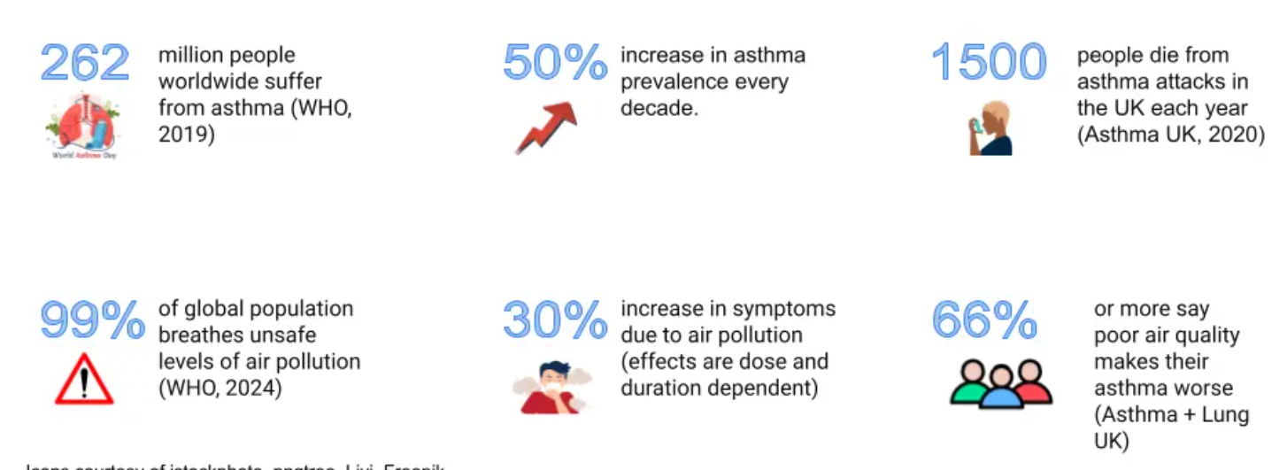
Figure 1: Prevalence of Asthma
(Source: Hicks, 2024)
One of the most common non-communicable diseases in the world is asthma. The epidemiological statistics indicate that there are about 262 million people in the world with asthma and about 455000 deaths are annually attributed to asthma-related complications (Zhang, et al., 2025). In the United Kingdom, there are approximately 5.4 million individuals undergoing a therapeutic intervention to treat asthma, both in children (one in eleven) and adults (one in twelve) (Jacobs, et al., 2023). However, regardless of the prevalence of efficient pharmaceutical treatment regimens, about three deaths per day take place in the UK that can be attributed to asthma, with several of them considered preventable.
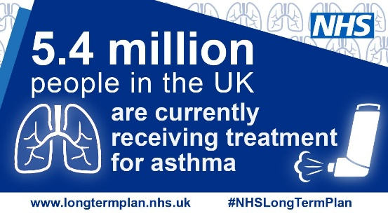
Figure 2: Asthma (Children and Young People)
(Source: LSCT Hub, 2026)
2. Epidemiology and Burden
Asthma is a significant public-health issue, including cohorts of all ages of development, but also with an early-childhood predisposition (Dharmage, et al., 2019). In many high-income countries, incidences have been proven to have increased in the past decades, most likely due to increased urbanisation, pollution of the atmosphere, and lifestyle behaviour changes (Cacciatore, et al., 2025). In contrast, the increased mortality rates are common in low and middle-income environments, which can be explained by the loss of access to pharmacological and newly developed medical care (Tfayli, et al., 2025).
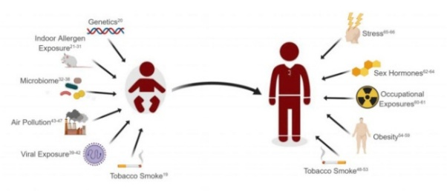
Figure 3: Asthma Epidemiology
(Source: Kuruvilla, et al., 2019)
In the UK, asthma places a very significant burden on the National Health Service (NHS). Approximately 60,000 emergency hospitalisations per year can be attributed to asthma (Simms-Williams, et al., 2024). The populations that are most affected are paediatric as asthma is one of the most prevalent causes of hospitalisation in children. The disease also causes thousands of GP visits and ED visits annually. This has been estimated at a total of about £3 billion per annum of aggregate economic cost in terms of hospital care, pharmacotherapy, reduced worker productivity and absenteeism in schools (Trueman, et al., 2017).
World wide statistics
The recent estimates on the disease worldwide further emphasise the scale of asthma as a significant public-health problem. The World Health Organisation reports that asthma is a disease that affects about 262 million people annually with an estimated 455,000 deaths each year (WHO, 2024). The Global Burden of Disease study also reveals that asthma has contributed to a few million disability adjusted life years (DALYs) every year, indicating high health and economic consequences of both developed and developing economies (Zhang, et al., 2025).
Despite the use of strong clinical asthma management guidelines in the UK, the results are not always in line with the standards. Compared to some European counterparts, the UK has relatively high rates of asthma mortality, which means that the availability of treatment is not enough (Gupta, et al., 2018). Improved prevention strategies, patient education, and stricter control over environmental triggers can become necessities to increase the level of substantive outcomes.
3. Risk Factors and Causes
Asthma pathogenesis is a result of the interaction of genetic, environmental, and socio-economic factors. Some are predisposed to this biologically, a family history of asthma, atopic dermatitis, and other allergic phenotypes increases risk (Dębińska, et al., 2025). It is also postulated that early childhood viral infections make significant contributions to disease. The influence of environmental determinants on the onset or exacerbation of asthma is very strong (Paredes, et al., 2026). Traffic-related air pollution exposure through the respiratory system is associated with an elevated rate of acute exacerbation and hospitalisation (Tiotiu, et al., 2020). Exposure to tobacco smoke in pregnancy or in childhood also increases the risk of asthma. Poor housing conditions such as dampness and mould are also other precipitants. Adult-onset asthma may be triggered by occupational exposure to aerosols, chemical agents and dust (Caporossi, et al., 2025).
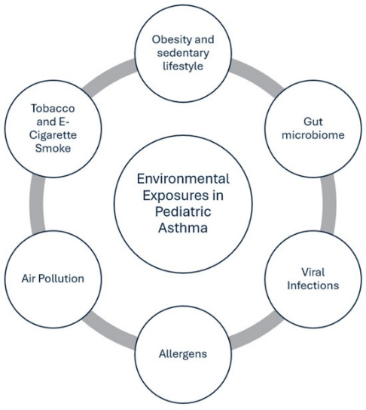
Figure 4: Risk Factors and Causes
(Source: By Author)
Obesity is another confirmed risk factor, which increases airway inflammation and poor ventilatory mechanics (Shailesh and Janahi, 2022). Climate change can further affect the epidemiology of asthma by increasing the aeroallergen levels and extending allergenic periods (Mazur and Czarnobilska, 2025). Most importantly, asthma is inseparably associated with more general social determinants of health. Children living in socio-economically deprived backgrounds tend to be admitted to the hospital. Poor housing conditions, the lack of access to green areas, and high exposure to pollutants are disproportionately prevalent in the areas of vulnerability (Tavares, et al., 2025).
4. Physical, Psychological and Social Impact
The consequences of asthma go beyond the functioning of the lungs and include physical, affective, and sociocultural effects, which often have a far-reaching effect on the family systems.

Physical Impact
Physical effects of asthma depend on the severity of the disease. Whereas some patients have mild symptoms occasionally, others suffer recurrent severe exacerbations. Acute attacks may become fatal in a short period without timely treatment, often leading to hospitalisation and in some extreme cases, intensive care unit admission. Persistent, poorly managed asthma is a risk factor for airway remodelling, which causes irreversible structural changes and deterioration of pulmonary volume (Savin, et al., 2023). This is because a considerable share of fatalities concerning asthma in the UK can be explained by poor compliance with preventive medication and excessive use of reliever inhalers.
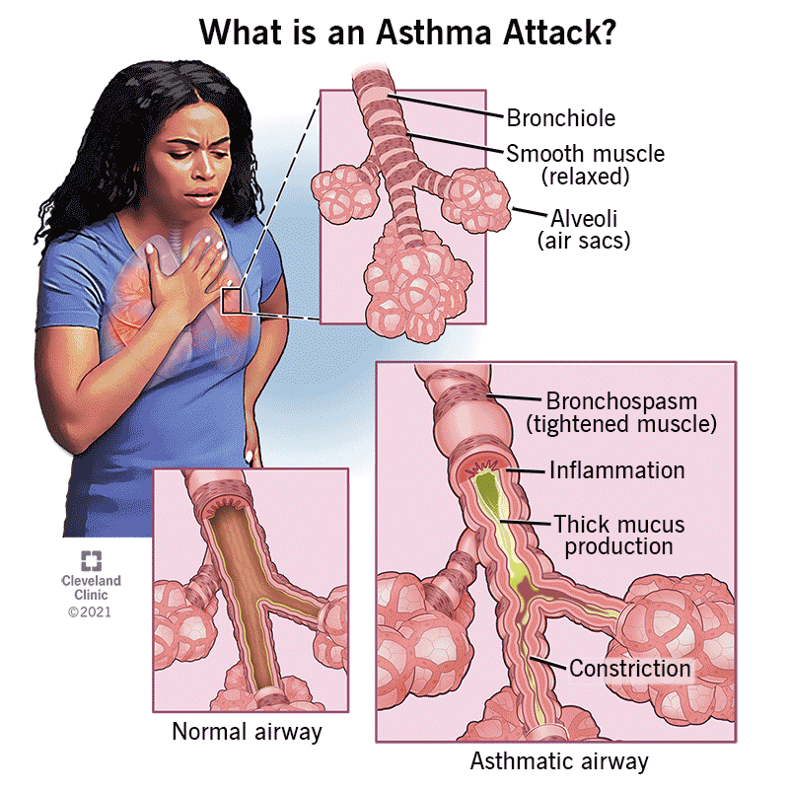
Figure 5: What Is Asthma?
(Source: Cleveland Clinic, 2025)
Although there is a strong clinical guideline that promotes the routine reviews and evaluation of the inhaler technique, there are still gaps in practise. Poor drug delivery as a result of inhaler technique is prevalent and an agent of compromised therapeutic effect (Roche, et al., 2022). The lack of health literacy, time inadequacies during primary care interaction, and lack of follow-ups undermine the best results.

Psychological Impact
Living with asthma creates significant pressure of a psychological nature, which creates anxiety and doubt (Bahra, et al., 2025). The fear of sudden attacks is often present in patients who especially fear when he/she is in a social place or when he/she is engaged in physical activity. Limitations in sports or academic activities may lead to children being psychosocially different to others. Severe asthmatics have an increased prevalence of comorbid anxiety and depressive disorders (Freitas and Novais, 2025). Sleep problems that are caused by nighttime symptoms lead to mood dysregulation and lack of concentration. Phobia of dyspnoea further limits physical exercise, which only increases harmful impacts on both somatic and mental health spheres.
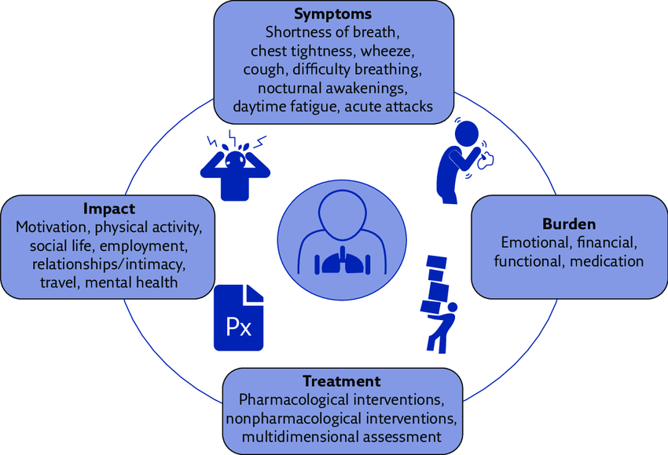
Figure 6: Psychological Impact of Asthma
(Source: Stubbs, et al., 2019)
Parental caregivers facing asthmatic children often face a lot of stress, particularly the children who have been hospitalised (Wu, et al., 2025). The inherent uncertainty of the exacerbations continues to bring about perpetual anxiety and emotional swings within the family.

Social Impact
Asthma has an impact on the social life, educational level, and employment opportunities of the affected people (Koumpagioti, et al., 2025). It is one of the leading causes of chronic illness absenteeism in the United Kingdom. Severely asthmatic children can miss school at least ten to fifteen days per year, especially when they are attacked frequently or have to be taken to the hospital (Li, et al., 2025). These frequent absences may affect academic achievement and limit involvement in academic events, and most children also avoid sports or physical education lessons in case they cause breathing problems to worsen.
In adult cases, uncontrolled asthma may reduce productivity at work and impair day-to-day functioning. Patients whose symptoms are not well controlled might have to take leave due to difficulty in breathing, tiredness or even emergency doctor visits. Asthma attacks in some cases lead to hospitalisation thus increasing work absenteeism further (Reis, et al., 2025). Certain occupations which involve contact with dust, chemicals, or intense physical work can also worsen the symptoms, thus limiting career paths.
Social participation is also impaired by asthma. Recreational opportunities are therefore restricted due to the tendency of individuals to avoid outdoor activities during an increase in the level of air pollution or pollen concentration (Kutlu, et al., 2025). Using inhalers in the open can be an embarrassment and can be used by adolescents to destroy self-confidence and hinder social interactions.

Impact on Families
Asthma is a disease that not only impacts individuals but also exerts significant strain on families and caregivers. The parents of asthmatic children often have a long-term anxiety condition concerning sudden attacks in the night, especially those when the symptoms become more severe at night (Chevalley, et al., 2025). Coughing or difficulty breathing at night regularly breaks the sleep of the child and the other family members, which leads to fatigue and stress. The typical roles that caregivers undertake include medication compliance, symptom monitoring and regular medical checkups. This position requires much time and organisational work.
Empirical research shows that parents of children with severe asthma report a high level of stress and caregiver burden with particular reference to hospital admission (Wu, et al., 2025). Besides, asthma creates a financial burden on families. The costs can include the cost of travelling to health care offices, buying medicine or equipment like peak flow metres, and the loss of work time taking care of a sick child. These duties have the ability to limit the earnings of households and disrupt normal activities.
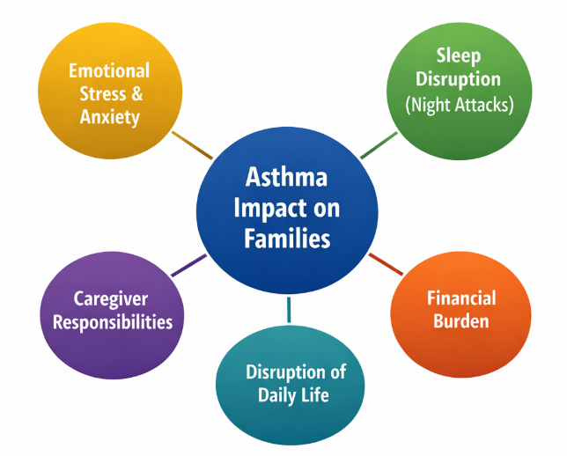
Figure 7: Impact on families
(Source: By Author)
5. Evidence-Based Management of Asthma in the UK

NHS and NICE Guidelines
Asthma management in the United Kingdom is guided by evidence-based guidance brought out by the NICE and the British Thoracic Society (BTS) (British Thoracic Society. These rules support a progressive therapeutic method according to which the intensity of the medication is prescribed depending on the severity of the disease and level of control (Maritescu, et al., 2025). Addressing symptoms, preventing exacerbations, and improving the quality of life are the major aims of treatment. Proper use of an inhaler and regular check-ups are vital in asthma management. The majority of patients are provided with reliever inhalers, which normally include short-acting beta agonists (SABA) (Amirav, et al., 2023). These agents are fast-acting bronchodilators that are not effective in addressing underlying inflammation. Preventer inhalers, which contain inhaled corticosteroids (ICS), are normally prescribed to patients to reduce airway inflammation.
Such medications reduce airway edoema and curb exacerbations in cases of regular use. In patients with a more lasting or severe disease, a long-acting beta agonist (LABA) can be used together with corticosteroids to maximise symptom control (Garcia, et al., 2025). When there is a severe exacerbation, the use of oral corticosteroids can be used to quickly limit inflammation. Asthma has a significant burden on health facilities. Millions of inhalers are being given out every year in the UK, which highlights the prevalence of the need to be treated. Studies indicate that many deaths as a result of asthma are linked to excessive use of reliever inhalers and low compliance with preventer treatment (Rayner, et al., 2025). NICE guidelines consequently support the yearly review of asthma in every patient, including determining the symptomatic level of control, the review of medication, and the test of inhaler technique (NICE, 2024).

Lifestyle Management and Prevention
Besides pharmacotherapy, lifestyle modification is very important in asthma management. Patients are encouraged to determine and avoid environmental factors that have the potential to increase symptoms (Bueno-Hernández, et al., 2025). A typical precipitant is pollen, dust mites, tobacco smoke, cold air, and air pollution. The problem of smoking cessation is of special concern because tobacco smoke may cause airway irritation and increase the risk of severe attacks.
Healthy body weight and regular exercise would help in improving the pulmonary work and general health. It is also advisable for patients to have an annual influenza vaccination because respiratory infections trigger exacerbations (Mao, et al., 2025). Environmentally, there is a need to reduce environmental threats in view of public health. Improvement of housing, decrease of indoor moisture and air pollution can significantly reduce exacerbations and hospitalisation.

Technology and Innovation
The recent developments in digital health technologies are more in favour of the management of asthma. Smart inhalers monitor the usage pattern and thus help monitor both patient and clinician adherence. Symptom tracking, peak-flow, and drug reminders are made possible through mobile applications (He, et al., 2025). Telemedicine has increased the availability of care to people with asthma via remote consultations and monitoring, which became especially helpful during the COVID-19 pandemic.
Research indicates that the use of digital monitoring systems can enhance medication compliance by 20-30% and thus enable patients to control their illness better (Wang, et al., 2025). However, the availability of such technologies can be disproportional. There are people who might not be digitally literate, own a smartphone, or be financially unable to use them (Tulcanaza-Prieto, et al., 2025). Therefore, technological advancement can be beneficial, however, health systems should make sure that all populations have equal access.
6. Theoretical Models and Frameworks

UK Model - House of Care
The NHS long-term condition management is based on the House of Care model which is widely applied in the United Kingdom (NHS England, 2026). The model prioritises coordinated care, person-centred care, where patients and clinicians work together to deal with chronic disease. One of these salient features is collaborative care planning, which gives patients a chance to actively participate in the treatment and lifestyle choices (British Heart Foundation, 2026).
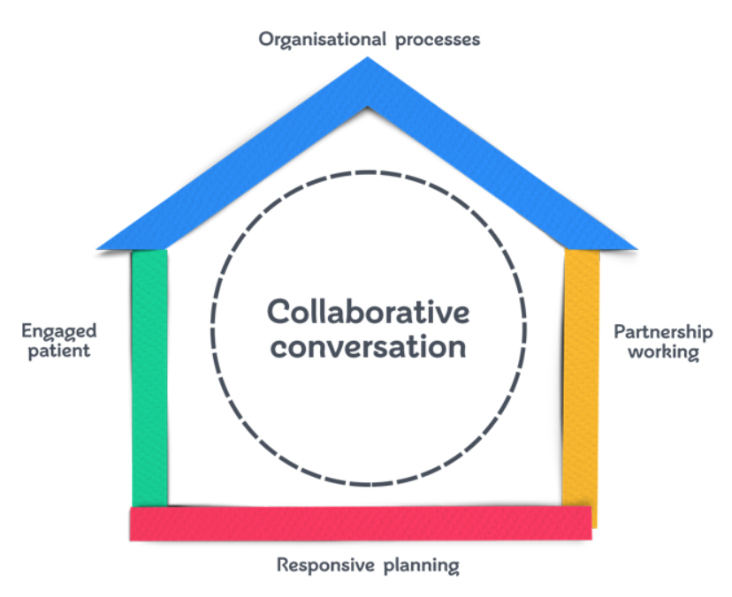
Figure 8: House of Care
(Source: British Heart Foundation, 2026)
The model has key elements that address patient engagement and self-management, professional partnerships, and organisational support systems, including combined services and infrastructure (British Heart Foundation, 2026). In asthma-related settings, the model encourages the recognition and management of triggers such as allergens, pollution, or smoking, and the development of customised action plans that patients use to react to the heightening of the symptoms. The model can however, be less efficient in disadvantaged communities. Low health literacy, language barrier and socioeconomic restrictions may hinder patient engagement and reduce the effectiveness of the shared decision-making process (Eldawy, et al., 2025).

International Model - WHO Innovative Care for Chronic Conditions (ICCC)
The WHO ICCC framework is an international outlook of disease management in the long term, which is divided into the micro, meso, and macro levels.

Figure 9: WHO ICCC Framework
(Source: By Author)
The micro level focuses on patients and families and supports education and self-management skills and networks. In the case of asthma, this involves training on proper inhaler operation, early symptoms identification and avoiding (Quinn, et al., 2025). The meso level is concerned with healthcare organisations and community partnerships that emphasise coordinated services and collaboration between professionals and community programmes. The macro level covers the policies of the country, funding, and more general approaches of the population to health (Pham and Nguyen, 2025). In comparison to the House of Care, the ICCC is more focused on the environmental and policy interventions, including air pollution reduction, housing, and healthier environments, to gain prevention.
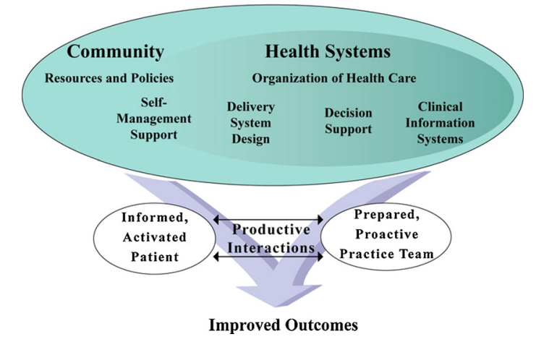
Figure 10: The Chronic Care Model
(Source: Nuño, et al., 2012)
7. Political and Policy Context
Some national health policies and public-health strategies influence the management of asthma in the United Kingdom. An example of this is the NHS Long-term Plan, which focuses on preventing and growing digital and community-based services (Matos, et al., 2025). The plan will encourage early diagnosis and better long-term condition management, such as asthma, and pursue the use of online technologies, such as remote consultations and electronic records, to improve access and monitoring. The National Asthma Audit Programme (NAAP) is a compilation of national data on the quality of asthma care in the UK which sheds light on areas of failure in care provision, including delays in treatment, poor adherence to treatment, and inequalities across regions (Sinha, et al., 2019).
The interpretation of these data guides the practise of providers that would help to strengthen patient safety and prevent death. The environmental policy also plays an important role in preventing asthma. The Clean Air Strategy in the UK aims to decrease pollution, a major trigger, and therefore, respiratory admissions could decrease (Department for Environment Food & Rural Affairs, 2019). However, the level of asthma mortality is still greater in the UK than it is among several peers in Europe, depicting disparities in access, increased exposure to pollutants in deprived localities and labour limitations in primary care that hinder timely diagnosis and follow-up.
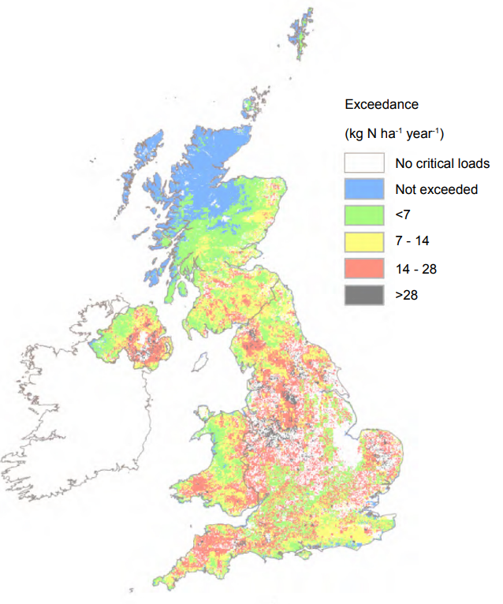
Figure 11: area of sensitive habitat in the UK
(Source: Department for Environment Food & Rural Affairs, 2019)
8. Recommendations for Improvement
Asthma management requires the combined forces of person-centred care, community involvement, and strong interventions based on the idea of public health (Rosyida, et al., 2026). Enhancing person-centred care will entail offering personalised action plans outlining symptom identification and response to such problems. Culturally sensitive communication and educational materials in more than one language will help to increase the awareness of different groups of patients.
Increasing self-management support can be done by community education programmes which will include creating awareness on triggers, proper inhaler technique and early symptom recognition (Salvado, et al., 2025).
School-based educational programmes can promote integrated settings among children with asthma and prepare teachers to deal with attacks. Parent peer groups have emotional support and practical information. It is still necessary to mitigate environmental risk factors. Air quality and respiratory health could be improved by improving housing conditions to lessen dampness and mould, increasing urban air-pollution policies and practises, and encouraging green areas and active commuting (Kurmanbekova, et al., 2025).
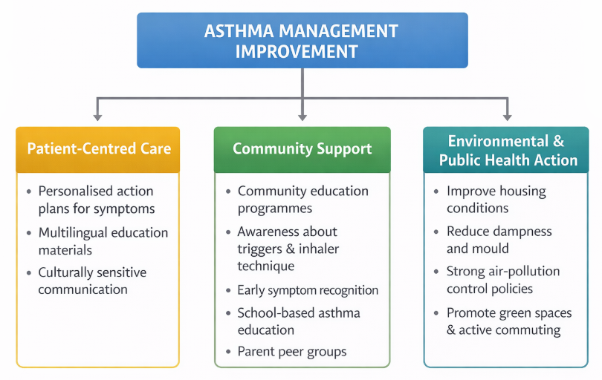
Figure 12: Recommendations
(Source: By Author)
9. Conclusion
Asthma is a relevant and prominent issue of public health in the United Kingdom and around the world. It impacts millions of people and has extensive physical, psychological, and social involvement effects. Even with the existing effective treatment and evidence-based guidelines, avoidable hospitalisations and deaths exist. This highlights the need to have better disease management, increasing patient education, and strict treatment adherence. Social inequities, in addition to air pollution and inadequate housing, further increase the outcomes of asthma, which requires more than clinical care interventions by taking into consideration the whole environment. The management of asthma should therefore take a dual emphasis on the proper pharmacotherapy with the reinforcement of the strong public-health strategies, and this should be supported by the integration of the health-care systems that focus on the broader determinants of health.

References
Amirav, I., Garcia, G., Le, B.K., Barria, P., Levy, G., Aggarwal, B., Fahrbach, K., Martin, A., Phansalkar, A. and Sriprasart, T. (2023) SABAs as reliever medications in asthma management: evidence-based science. Advances in Therapy, 40(7), pp.2927-2943.
Bahra, N., Amara, B., El Yaagoubi, S., Bourkhime, H., Othmani, N., Tachfouti, N., Berraho, M., Serraj, M., Benjelloun, M.C. and El Fakir, S. (2025) Impact of asthma on anxiety, depression, and quality of life: a Moroccan study. Exploration of Asthma & Allergy, 3, p.100976.
British Heart Foundation. (2026) Person-centred care and the House of Care. [Online]. Available at: https://www.bhf.org.uk/for-professionals/healthcare-professionals/innovation-in-care/person-centred-care-and-the-house-of-care [Accessed on: 7 March 2026].
British Thoracic Society. (2024) BTS/NICE/SIGN Asthma Guidelines. [Online]. Available at: https://www.brit-thoracic.org.uk/about-us/news/2024/new-joint-guideline-recommends-healthcare-professionals-prescribe-combination-treatments-rather-than-reliever-medications-alone-for-people-with-newly-diagnosed-asthma/ [Accessed on: 7 March 2026].
Bueno-Hernández, N., Yamamoto-Furusho, J.K. and Mendoza-Martínez, V.M. (2025) Nutrition in inflammatory bowel disease: strategies to improve prognosis and new therapeutic approaches. Diseases, 13(5), p.139.
Cacciatore, S., Mao, S., Nuñez, M.V., Massaro, C., Spadafora, L., Bernardi, M., Perone, F., Sabouret, P., Biondi-Zoccai, G., Banach, M. and Calvani, R. (2025) Urban health inequities and healthy longevity: traditional and emerging risk factors across the cities and policy implications. Aging clinical and experimental research, 37(1), p.143.
Caporossi, L., Di Renzi, S., Partenzi, E., Cavallo, D., Tomao, P. and Poli, D. (2025) Sex-and Gender-Based Differences in Asthmatic Responses to Chemical Sensitizers, Particularly in Occupational Settings: A Scoping Review. Environments, 12(10), p.382.
Chevalley, T., Dübi, M., Fumeaux, L., Merli, M.S., Sarre, A., Schaer, N., Simeoni, U. and Yzydorczyk, C. (2025) Sexual dimorphism in cardiometabolic diseases: from development to senescence and therapeutic approaches. Cells, 14(6), p.467.
Chou, C.K., Winker, R., Rebuli, M.E., Moran, T. and Rager, J.E. (2025) Respiratory health impacts from natural disasters and other extreme weather events: The role of environmental stressors on asthma and allergies. Current allergy and asthma reports, 25(1), p.25.
Cleveland Clinic. (2025) Asthma. [Online]. Available at: https://my.clevelandclinic.org/health/diseases/6424-asthma [Accessed on: 25 February 2026].
Dębińska, A., Danielewicz, H., Drabik-Chamerska, A. and Sozańska, B. (2025) Interactive Effects of Genetic Susceptibility and Early-Life Tobacco Smoke Exposure on the Asthma–Eczema Complex Phenotype in Children: 6-Year Follow-Up Case-Control Study. International Journal of Molecular Sciences, 27(1), p.346.
Department for Environment Food & Rural Affairs. (2019) Clean Air Strategy 2019. [Online]. Available at: https://assets.publishing.service.gov.uk/media/5c3b9debe5274a70c19d905c/clean-air-strategy-2019.pdf [Accessed on: 7 March 2026].
Dharmage, S.C., Perret, J.L. and Custovic, A. (2019) Epidemiology of asthma in children and adults. Frontiers in pediatrics, 7, p.246.
Eldawy, N., Kaleem, S., Jhumkhawala, V., Okwaraji, G., Jimenez, S., Sohmer, J., Mejia, M., Kitsantas, P. and Sacca, L. (2025) The Role of Sociodemographic Characteristics and Social Determinants of Health in Influencing the Perceived Quality of Patient–Provider Communication. Nursing Reports, 15(3), p.113.
Freitas, J. and Novais, F. (2025) Review on the relationship of asthma and mental disorders. Personalized Medicine in Psychiatry, 51, p.100157.
Garcia, G., Maneechotesuwan, K., Krishnan, P., Verma, M. and Roche, N. (2025) Optimizing the Use of Inhaled Corticosteroid/Long-Acting β2-Agonist Combinations in Patients with Moderate-to-Severe Asthma. Advances in Therapy, pp.1-12.
Gupta, R.P., Mukherjee, M., Sheikh, A. and Strachan, D.P. (2018) Persistent variations in national asthma mortality, hospital admissions and prevalence by socioeconomic status and region in England. Thorax, 73(8), pp.706-712.
He, X., Bian, J., Berlinski, A., Guo, Y., Simmons, A.L., Marshall, S.A., Greene, C.J., Brown, R.H., Turner, J. and Perry, T.T. (2025) Mobile Health App for Adolescent Asthma Self-Management: Development and Usability Study of the Pulmonary Education and Knowledge Mobile Asthma Action Plan. JMIR Formative Research, 9(1), p.e64212.
Hicks, W. (2024) World Asthma Day 2024. [Online]. Available at: https://www.airawarelabs.com/article/world-asthma-day-2024 [Accessed on: 25 February 2026].
Jacobs, A., Wu, R., Tomini, F., De Simoni, A. and Mihaylova, B. (2023) Strong and graded associations between level of asthma severity and all-cause hospital care use and costs in the UK. BMJ Open Respiratory Research, 10(1).
Koumpagioti, D., Moriki, D., Boutopoulou, B., Perdikaris, P. and Douros, K. (2025) Social Determinants of Health in Pediatric Asthma and Allergic Diseases: A Systematic Review. Epidemiologia, 6(3), p.56.
Kurmanbekova, M., Du, J. and Sharples, S. (2025) A review of indoor air quality in social housing across Low-and Middle-Income countries. Applied Sciences, 15(4), p.1858.
Kuruvilla, M.E., Vanijcharoenkarn, K., Shih, J.A. and Lee, F.E.H. (2019) Epidemiology and risk factors for asthma. Respiratory medicine, 149, pp.16-22.
Kutlu, D., Kasalak, M.A. and Bahar, M. (2025) Assessing climate change impacts on outdoor recreation: Insights from visitor and business perspectives. Sustainability, 17(8), p.3400.
Li, Q., Fan, Y., Luo, R., Hu, J., Wang, L. and Ai, T. (2025) Related risk factors that predict moderate to severe asthma attack in children: analysis based on logistic regression and decision tree. International Journal of General Medicine, pp.3919-3931.
LSCT Hub. (2026) Asthma (Children and Young People). [Online]. Available at: https://lscthub.co.uk/asthma-education/ [Accessed on: 25 February 2026].
Mao, J., Li, Y. and Lv, D. (2025) Impact of influenza on chronic obstructive pulmonary disease: pathophysiology, exacerbations, and preventive approaches. Therapeutic Advances in Respiratory Disease, 19, p.17534666251363307.
Maritescu, A., Pescaru, C.C., Crisan, A.F., Stoicescu, E.R., Oancea, C. and Iacob, D. (2025) The effects of progressive muscle relaxation on mental health and sleep quality in adults with cystic fibrosis: A randomized controlled trial. Journal of clinical medicine, 14(8), p.2807.
Matos, R.C.D., Nascimento, G.D., Campos Fernandes, A. and Matos, C. (2025) Health and social care integration: insights from international implementation cases. Journal of Market Access & Health Policy, 13(2), p.28.
Mazur, M. and Czarnobilska, E. (2025) Inhaled allergy diagnostics and treatment in a polluted environment. International Journal of Molecular Sciences, 26(13), p.5966.
NHS England. (2025) Long term conditions. [Online]. Available at: https://www.england.nhs.uk/ourwork/clinical-policy/ltc/ [Accessed on: 7 March 2026].
NICE. (2024) Asthma: diagnosis, monitoring and chronic asthma management (BTS, NICE, SIGN). [Online]. Available at: https://www.nice.org.uk/guidance/ng245/chapter/recommendations [Accessed on: 7 March 2026].
Nuño, R., Coleman, K., Bengoa, R. and Sauto, R. (2012) Integrated care for chronic conditions: the contribution of the ICCC Framework. Health policy, 105(1), pp.55-64.
Paredes, M., Osorio, J., García de la Fuente, A., Rodríguez, E., Picado, C., Ojanguren, I. and Arismendi, E. (2026) Severe Asthma Exacerbations: From Risk Factors to Precision Management Strategies. Journal of Clinical Medicine, 15(2), p.857.
Pham, M.T. and Nguyen, L.H. (2025) Conceptualizing the bidirectional relationship between macroeconomic stability and public health systems: A systematic analysis of feedback loops and dynamic equilibrium models. Journal of Big Data Processing, Stream Analytics, and Real-Time Insights, 15(3), pp.1-16.
Qaid, E.Y.A. and Long, I. (2025) Asthma unravelled: a comprehensive review of epidemiology, phenotypes, pathophysiology, and emerging therapies. The Egyptian Journal of Bronchology, 19(1), p.82.
Quinn, A.E., Zhao, L., Bell, S.D., Huq, M.H. and Fang, Y. (2025) Exploring Asthma as a Protective Factor in COVID-19 Outcomes. International Journal of Molecular Sciences, 26(4), p.1678.
Rayner, D.G., Ferri, D.M., Guyatt, G.H., O’Byrne, P.M., Brignardello-Petersen, R., Foroutan, F., Chipps, B., Sumino, K., Perry, T.T., Nyenhuis, S. and Oppenheimer, J. (2025) Inhaled reliever therapies for asthma: a systematic review and meta-analysis. Jama, 333(2), pp.143-152.
Reis, J.S.D., Costa, R.L., Silva, F.D.D.S., de Souza, E.D.F., Cortes, T.R., Coelho, R.H., Velasco, S.R.M., Neves, D.J.D., Sousa Filho, J.F., Barreto, C.E.C. and Cabral Júnior, J.B. (2025) Predicting asthma hospitalizations from climate and air pollution data: a machine learning-based approach. Climate, 13(2), p.23.
Roche, N., Aggarwal, B., Boucot, I., Mittal, L., Martin, A. and Chrystyn, H. (2022) The impact of inhaler technique on clinical outcomes in adolescents and adults with asthma: a systematic review. Respiratory Medicine, 202, p.106949.
Rosyida, K.A., Kristina, S.A., Ramadona, A.L. and Saini, B. (2026) Attributes and levels in discrete choice experiments for pharmacy services: A systematic review to inform asthma intervention design. Exploratory Research in Clinical and Social Pharmacy, p.100707.
Salvado, S., Grilo, E., Henriques, H., Ferraz, I., Gaspar, F. and Baixinho, C. (2025) Pulmonary rehabilitation nursing interventions promoting self-care in elderly people with chronic obstructive pulmonary disease (At home). In Healthcare (Vol. 13, No. 17, p. 2176). MDPI.
Savin, I.A., Zenkova, M.A. and Sen’kova, A.V. (2023) Bronchial asthma, airway remodeling and lung fibrosis as successive steps of one process. International journal of molecular sciences, 24(22), p.16042.
Shailesh, H. and Janahi, I.A. (2022) Role of obesity in inflammation and remodeling of asthmatic airway. Life, 12(7), p.948.
Simms-Williams, N., Nagakumar, P., Thayakaran, R., Adderley, N.J., Hotham, R., Mansur, A.H., Nirantharakumar, K. and Haroon, S. (2024) Risk factors for asthma-related hospital and intensive care admissions in children, adolescents and adults: a cohort study using primary and secondary care data. BMJ Open Respiratory Research, 11(1).
Sinha, I.P., Calvert, J., Hickman, K.C., Hurst, J.R., McMillan, V., Quint, J.K., Singh, S.J. and Roberts, C.M. (2019) National asthma and COPD audit programme and the NHS long term plan. The Lancet Respiratory Medicine, 7(10), p.841.
Stubbs, M.A., Clark, V.L. and McDonald, V.M. (2019) Living well with severe asthma. Breathe, 15(2), pp.e40-e49.
Tavares, M.S., Rodrigues, C.T., de Menezes, S.L.S. and Moreno, A.M. (2025) Health at Risk: Air Pollution and Urban Vulnerability—Perspectives in Light of the 2030 Agenda. Green Health, 1(3), p.21.
Tfayli, A.H., El‐Halabi, L.N. and Khuri, F.R. (2025) Global disparities in cancer care: Bridging the gap in affordability and access to medications between high and low‐income countries. Cancer, 131(1), p.e35590.
Tiotiu, A.I., Novakova, P., Nedeva, D., Chong-Neto, H.J., Novakova, S., Steiropoulos, P. and Kowal, K. (2020) Impact of air pollution on asthma outcomes. International journal of environmental research and public health, 17(17), p.6212.
Trueman, D., Woodcock, F. and Hancock, E. (2017) Estimating the economic burden of respiratory illness in the UK. [Online]. Available at: https://www.asthmaandlung.org.uk/economic-burden-report#:~:text=Page%204-,4,disease%20mortality%20rate%20in%20Europe. [Accessed on: 25 February 2026].
Tulcanaza-Prieto, A.B., Cortez-Ordoñez, A., Rivera, J. and Lee, C.W. (2025) Is digital literacy a moderator variable in the relationship between financial literacy, financial inclusion, and financial well-being in the ecuadorian context?. Sustainability, 17(6), p.2476.
Wang, X., Wang, B., Tew, W.Y., Yang, X., Xu, X., Gao, Y., Chen, Y. and Yam, M.F. (2025) Exploring mHealth interventions for medication management: a scoping review of digital tools, implementation barriers, and patient outcomes. PeerJ Computer Science, 11, p.e3190.
WHO. (2026) Asthma. [Online]. Available at: https://www.who.int/news-room/fact-sheets/detail/asthma [Accessed on: 25 February 2026].
Wu, P., Zhang, J. and Hu, Y. (2025) Understanding Caregiver Burden in Severe Pediatric Asthma-A Qualitative Study. Journal of multidisciplinary healthcare, pp.865-876.
Zhang, L., Jiang, H., Yang, G., Zhang, J., Yuan, S., Chen, J., Tang, M., Lin, J., Yuan, J. and Yin, Y. (2025) Global, regional and national burden of asthma from 1990 to 2021: a systematic analysis for the Global Burden of Disease Study 2021. BMJ Open Respiratory Research, 12(1).

