Kelsee Gwyther Statement
For Visual Enquiry II we were each given a book to read, I was assigned ‘The Road’ by Cormac McCarthy. I couldn’t connect with the book the first time, so I read it again, after that things started to click into place for me. I feel the book is about morality, the relationship of man and child, the relationship of human beings, religion and violence, it was the second time reading it that religion really stood out for me.
Throughout the book, God is one of the main characters, this is my first piece of key research. Faith can be found by the constant mention of ‘God’ and maybe God would be the one that saved them all, maybe not. The man doesn’t believe that God will save them but believes he has a part in the destruction around them, ‘the boy’ acts as if God exists and ultimately has all the power. With God in mind, I searched through the book for how many times God was mentioned, 43 times throughout the book, various times on one page. I started to think about how I could incorporate 43 into my work. I started with the idea of photographing 43 people in queues with God written about the along with the page number.
This idea developed slightly after finding photographer called Graham MacIndoe, who photographs posters of missing people in his series ‘Missing Persons’. Every photo has the typical rectangle with the almost anonymous photo included. In reality, they’re just another person who was let down by the main character, God. I planned to take photos of people I don’t know but I thought repurposing the photos of missing people who are still anonymous people to me. I started picking people from random from the www.missingpeople.org website to include in my video. Choosing the photographs was time consuming, I went through hundreds of pages picking missing people at random, I had the system of wherever the curser landed would be how I chose the people. When I started putting the images into Adobe Premier, I kept the time at 1.3 seconds for each photograph, so there would be some time at the end for editing if need be. While I was watching the video play through after adding the constant cross dissolves, I thought of photographer Lisa Saltzman, who’s work is about keeping people anonymous. Her images of people that don’t have a face really inspired me to edit the images in the video, so the cross dissolves are constant in keeping the images merged with each other. I also chose to look at Alexei Vassiliev’s photography about anonymous portraits, the images are extremely stimulating, I love the way they all blur together to be unrecognisable, her work also inspired the cross dissolves.
For the final edit I included a quote from the book that sums up my idea; “She said that the breath of God was his breath yet though it pass from man to man through all of time”. God didn’t help anyone in the book, he left those people to become anonymous, they are represented by the missing people in my video. I think my work is extremely relevant to past and future issues, people that go missing or disconnect from the world inevitably become anonymous. I think my video turned out really well, I believe that I think it would have been interesting to see what happened to the video when sped up. I hope to develop my inspiration from my key pieces of research in future works, it would be interesting to apply different contexts to it.
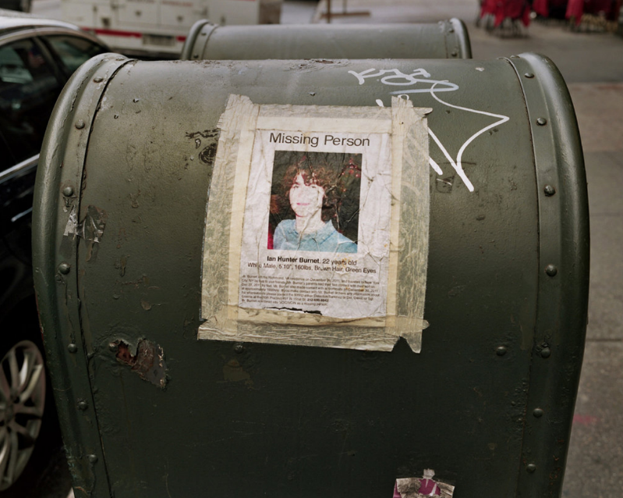
Graham MacIndoe – Missing Persons

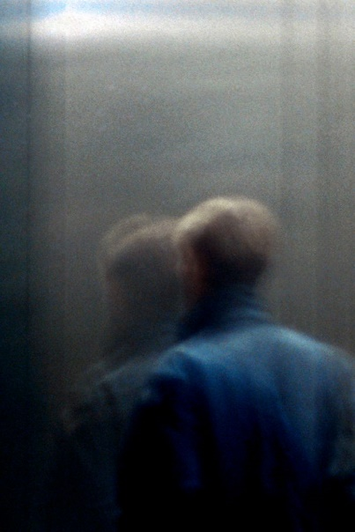
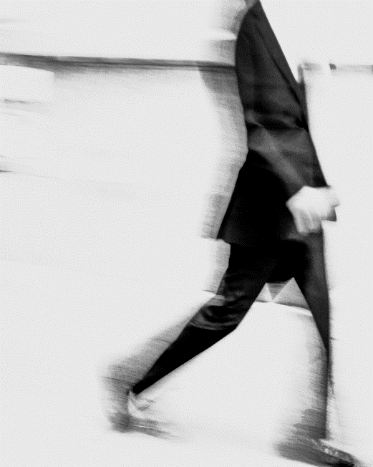

Lisa Saltzman – CITY ANONYMITY Alexei Vassiliev – Here and gone

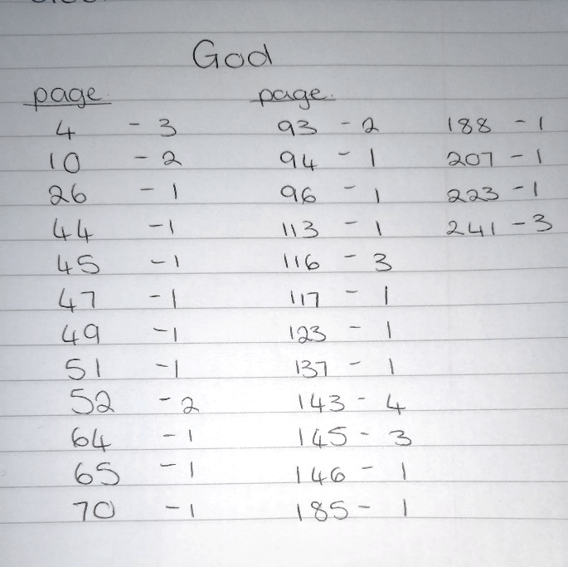
Counting God

