  Motivation and Organisational change  M5x01176 | Peter Temple (1809106) B Eng. Mechanical and Manufacturing

Executive Summary

Organisations are constantly required to change to respond to new challenges. Each change has positive and negative factors associated with it. Lewin’s force field analysis states that for a change to happen equilibrium between the driving forces and the restraining forces must be broken. The organisational change was achieved by reducing the restraining forces by getting the work force to buy into the change.
The key to reducing the restraining forces was effective and clear communication between the organisation and its work force. This helped stop rumours and misunderstanding of the change, and the reasons behind it and therefore, allowed the organisation to maintain the motivation of its employees through the change.
Lewin also developed a change model where the organisation creates the climate for the change (unfreezes), by reducing the resisting forces of the change. The next step makes the change happen (the change) and the last step makes the change stick (refreezing) by introducing new standards and reviewing them often. Throughout the change it was important that the organisation engaged with its work force and worked hard to maintain its people’s motivation, intrinsically and extrinsically. Different motivation models were used such as Maslow’s hierarchy of needs and Herzberg’s two factor theory.

Table of Contents
Executive Summary 1
Table of Contents 2
Introduction 3
Organisational Change 4
Conclusion 12
Reference list 13
Bibliography 15
Appendix 1 – The Cultural Web 16
Appendix 2 – Smart Goals 17
Appendix 3 – Tuckman’s Model 18
Appendix 4 – Maslow’s Hierarchy of Needs 19
Appendix 5 - Herzberg’s Two Factor Theory of motivation 21
Appendix 6 – Taylor’s theory 22
Appendix 7 – Kotter’s 8 Step Change Model 23

Introduction
We are living in a period of rapid and continuous change brought on by uncertain economic conditions; Globalisation and fierce world competition and rapid developments in technologies (Mullins, 2016). For an organisation to survive it must make changes to maintain success, become more effective and be competitive in its market, to obtain a competitive edge.
Change is challenging to implement successfully as the full consequences are hard to predict and track, change can also be difficult because it is all about people (Carnell & Todnem, 2014). For a company to implement change successfully it needs to use “tried and tested” change and motivation models to assist them. Trostre as like many other organisations are always having to adapt to new challenges in the market and more and more pressure to become cost effective to survive and have a viable future in this current climate so changes continually need to be made.

Organisational Change
Most planned organisational change is triggered by the need to respond to new challenges and opportunities presented by the external environment, or the potential need to adapt in the future (Mullins & Christy, 2016).
The steel industry for many years has been suffering with overcapacity in the market mainly due to cheap Chinese steel. To be able to survive in a very competitive market where there is more supply than demand the business needs to be able to adapt and change quickly to take advantage of opportunities to gain a competitive edge. One thing Trostre Steel Works, as business had to do was become more efficient and effective, to save on cost but at the same time not jeopardise quality or capacity of its output and offer new more specialised products to niche markets.
Efficiency comprises of achieving current goals with acceptable use of resources. Effective means efficiency plus adaptability (Carnall & Todenem, 2014).
To do this it was decided that Trostre would go from a three coating line plant down to two coating lines but with investment to be made to upgrade our main coating line to increase capacity thus not requiring the third coating line.
The main thinking behind this is to Make our product cheaper to produce by reducing our overhead costs. For example, less people making the same amount of product. The general way a coating line is compared is its running/Maintenance cost divided by its output which gives the company a cost per tonne. The overall objective is to reduce this cost as much as possible without jeopardising quality or customer satisfaction. (Mullins, 2016, P552) states “It is always better to lead change than react to it, because the later you leave it to react to change, the more severe your actions have to be”.
One way a company can decide on go/no go decisions is using Lewin’s Force Field analysis as shown in figure 1 below. This was created by Kurt Lewin in the 1940’s but it was originally used for Lewin’s work as a Social psychologist (Mind tools.com,2019). Lewin argued that any level of behaviour is maintaned in a condition of quasi stationary equilibrium by a force field comprimising of forces pushing for and resisting change (Hayes,2010).
In this case the forces for the change were:
- Increased competiton
- Uncertin economic conditions
- Becoming more competitivie
- Investing in new equipment
- Ensuring a viable future for the business
- Reducing costs to increase profits
The resisiting forces were:
- Demotivation of the work force due to redunancies
- Unstabilising of teams due to the change
- Potential of the change not working leading to a loss of investment
- Potential of the change not sticking leading to lack of performance and not hittng targets
- Losing highly trained experieinced people.

Figure 1
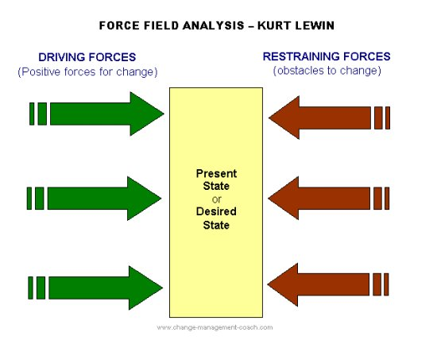
The behaviour can be changed by adding forces pushing for change or reducing the resisting forces, this then upsets the equilibruim and allows the change to happen. Both these approaches can result in change but according to Lewin secondary effects associated with each approach will be different (www.Change management.com,2019).
Hayes (2010) expands on this by saying where a change is brought about by increasing forces pushing for change (driving forces), it will result in an increase in tension, and if this rises above a certain level it can lead to aggressive behaviour towards the source of change, high emotional feeling and low levels of constructive behaviour. Where change is brought about by reducing/weakening the restraining forces the secondary effect will be a state of relativly low tension.
It was then identified that to make this change sucessful the company needed to get the workforce to accept the change by reducing the restraining forces. This would allow them to continue to be motivated in there roles so that productivity would not drop. Motivation is very important in the workplace and can be defined as “the degree to which an individual wants and chooses to engage in certain specified behaviours” (Mullins, 2016, p221).
The chartered management institute (2015) gives a more detailed definition, “Motivation is the creation of incentives and working environments that enable people to perform to the best of their ability. The aim of motivation is to engage people with the work they are doing, to achieve the best possible outcomes for individuals and the organisation as a whole”.
According to Mullins (2016) motivation can be split into simple divisions, Physiological and social motives or Extrinsic and intrinsic motivation. Ryan & Deci (2000) describes Intrinsic motivation as the doing of an activity for its inherent satisfactions rather than for some separable consequence. When intrinsically motivated, a person is moved to act for the fun or challenge entailed rather than because of external prods, pressures, or rewards.
Extrinsic Motivation on the other hand Mullins (2016), says it is related to tangible rewards such as salary and fringe benefits, security, promotion, contract of service, the work environment and conditions of work.
Due to uncertain times that the steel industry had been through and the damage that uncertainty did to the moral of the work force, the management reflected on this and knew this change must be communicated effectively and in a positive way to maintain moral and even boost it. Mullins (2016) supports this, it says the commonest reason for resistance is where people perceive a potential loss. But Hayes (2010) argues peoples experience of change can also affect their level of commitment and their willingness to support further change. By doing this it would weaken the restraining forces to the change and hence make the change happen more effectively with minimal disruption. The company knew if the work force wanted the change it was more likely to be successful.
Dwight D. Eisenhower stated that;
“Motivation is the art of getting people to do what you want them to do because they want to do it”.
(www.brainyquote.com,2019)
Mullins (2016) states a programme of planned change developed by Lewin involves the management of a three step proccess of Unfreezing, Movement/Change and finally refreeze as

shown in figure 2 below. This is also supported by (Carnall & Todnem,2014) .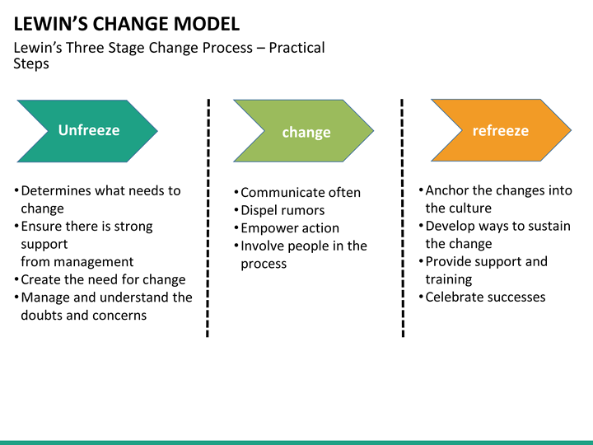
Figure 2 (kidskunst.infom,2018)

In 1947 Lewin wrote:
A change towards a higher level of group performance is frequently short-lived, after a “shot in the arm”, group life soon returns to the previous level. This indicates that it does not suffice to define the objective of planned change in group performance as the reaching of a different level. Permanency of the new level, or permanency for a desired period, should be included in the objective
(Journal of Management Studies 41:6 September 2004, P984).

Unfreezing stage –
This was done by holding regular “state of the nation” meetings where the work force could engage with senior management including directors of the business. Regular business updates were also sent out to keep the workforce updated with the business performance. This helped the work force understand the strains on the business and the importance of cost saving and being competitive.
Finally, the announcement was made to the workforce through more communication sessions. This allowed the Management to give precise information about the change and reassure the work force, this helped stop the rumour mill from turning. In these communication sessions it was explained

that due to the age demographics that there would be no hard redundancies and that this investment/change would help to safe guard Trostres future by becoming more competitive.
This really helped the workforce understand the need for the change and allowed them to buy into it, which then in turn made the change easier to achieve. These actions broke the equilibrium by reducing the restraining forces. Hayes (2010) says the unfreezing stage is an essential first step in the change process, the breaking of equilibrium creates the conditions that facilitate the transition allowing the company to move to a new state. Trostre has a long history of adapting to change and this culture has helped the business survive and develop. One way an organisation can assess its culture is by using the Cultural web model – (See appendix 1).

The Change -
The next stage of the change was to upgrade the production Line to achieve the goal of change. This was done by engaging with the work force to establish, how to improve and what needed to be improved. This was mainly done by having group feedback sessions, Management meetings, also task teams were set up with a “Cross sectional slice” of the business. This “Cross sectional slice” consisted of management, Engineers, production specialists, Production team leaders, safety representatives and union members. This helped to bring each section of business together and get a varied and balanced view point.
To implement these changes the management had to prioritise this and give clear direction on how and when this change needed to happen. A dedicated project team was set up to carry out the physical changes on the line. This team was set SMART goals to allow them to measure their performance. (See appendix 2).
Step by step the work was completed on the line. After each stage of the upgrade review meetings were held and snagging lists made. The snagging lists were a chance for the production workers to have there say and make the management aware of any issues or concerns and the review meeting was a way to measure progress against the set goals.
Also, a training matrix specifically for this change was created to make sure that the people that were leaving could be replaced, and the people moving positions or jobs could do so with minimal disruption and stress. A lot of work was put into developing standard operation procedures (best way to do a job), buying correct tools for each task and organising the work place to improve work flow. Taylor was a big influence on this process (see appendix 6). This level of detail and training made people feel wanted and appreciated this directly relates to Maslow’s hierarchy of needs (see appendix 4) and Herzberg’s Two Factor theory (see appendix 5). This also improved the team work as everyone knew their roles and responsibilities therefore enabled them to move along Tuckman’s model for change (see appendix 3).
The work force was then engaged to increase the visual standards of the line. Instead of an outside contractor coming in, the Production workers were encouraged to do the work. In return they received intrinsic motivation of being involved and creating a nicer working environment for themselves and others and the extrinsic reward of overtime payments. This really helped the production workers take pride and ownership of there area as their own hard work created it. (Great managers, 2017) also backs this up by saying that the joy of doing something is not a result in itself, it is normally achieving an extrinsic reward of some kind. Allowing a person to work on a task that motivates them intrinsically can backfire if there is no extrinsic motivator in place. (mindtools.com,2019) states as a manager the goal is to keep the team motivated and enthusiastic
about their work, so it is important to use a balance between Intrinsic and extrinsic motivators, such as pay rises and better working conditions and intrinsic motivators such as giving people tasks they enjoy.
This new working environment with new amenities such as a new kitchen and mess room, new chairs and a fully revamped operators pulpit leads to better working conditions, this relates to Herzberg’s Two factor theory of motivation (see appendix 5). Team evenings were also set up to help each production shift to bond over a meal, this was also a small thankyou from the company. Once all the work had been completed the line was then able to hit its goals.

The Refreeze –
Figure 3
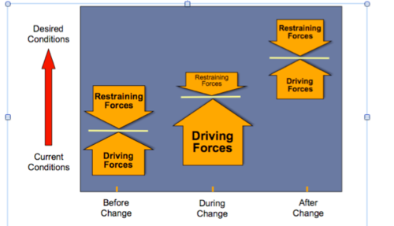
(quizlet.com, 2019)

Once the upgrade of the line had been completed and tested. The new standards and Key performance indictors (KPI) were now set, See figure 3. These now became the new line targets. These KPI’s and standards are a very clear measure of how the line needs to perform. Hayes (2010) says it’s assumed that an increase of outputs with a decrease of inputs represents greater effectiveness, but to make this assessment reference needs to be made to a standard. Daily team leader production meetings and weekly and monthly management reviews are also carried out to track the performance of the line, ensure problem solving is carried out and identify areas for improvement and making sure targets are met and customers are kept happy. Hayes (2010) states that these meeting and reviews ensure the driving force is maintained to stop the change springing back to its former state.
Weekly performance documents are sent out to the workforce to allow them to see how the Business is performing. These documents are also displayed on monitors around the plant to make them easily accessed. This communication is key to keeping the workforce engaged and up to date on the business performance.
Other theories can also be used to assist change such as Tuckman’s model Appendix 3 and Kotters eight steps to change see appendix 7.

Conclusion

Change is required to happen in organisations to allow them to develop and respond to new challenges and competition. For the organisation it is very important to manage the change properly to ensure that the change is permanent and successful.
The use of Lewin’s force field analysis allows the company to assess the driving forces and the restraining forces to the change. By reducing the restraining forces, it allows for the change to happen with minimum disruption and stress.
Lewin’s Model for change gives the organisation direction for successful change by setting clear steps to create the climate for change, implement the change and then to make the change stick. Through out change it is important for the organisation to engage with its work force and continue to keep them motivated. It is also important that the organisation continues to engage and motivate its workforce after the change to ensure that the change does not spring back to its former state. The organisation’s culture can be a big influence on how successful the change will be the cultural web is a way an organisation can evaluate its culture.

Reference list
Armstrong, M. (2005), Management and Leadership. 1st ed. London: Kogan Page Limited
www.brainyquote.com(2019), Quotes of Dwight d Eisenhower [online] available at https://www.brainyquote.com/quotes/dwight_d_eisenhower_149102
[Accessed 25th March 2019]
Burnes, B. (2004), Kurt Lewin and the Planned Approach to Change. Journal of Management Studies 41. Available at https://onlinelibrary.wiley.com/doi/pdf/10.1111/j.1467-6486.2004.00463.x.
[Accessed 28th March 2019]
Carnall, C. & Todnem, R (2014), Managing Change in Organisations. 6th ed. London: Pearson Educational Limited
www.greatmanagers.com(2017), Intrinsic and Extrinsic motivation [online] available at https://www.greatmanagers.com.au/intrinsic-and-extrinsic-motivation/
[Accessed 25th Match 2019]
Hayes, J. (2010), The Theory and Practice of Change Management. 3rd ed. London: Palgrave Macmillan
Hwang, E. (2015), Journal of Economics, Business and Management, Vol. 3, No. 11. Available at http://www.icetd.org/history/con-2014%20joebm%20v3n7.pdf
[Accessed 28th March 2019]
www.kidskunst.info (2018), Lewin’s change management model [online] available at https://kidskunst.info/34/11682-lewins-change-management-model.htm
[Accessed 28th March 2019]
www.managementcentre.co.uk (2019), Culture eats strategy for breakfast [online] available at
https://www.managementcentre.co.uk/culture-eats-strategy-for-breakfast/
[Accessed 28th March 2019]
www.Managers.org.uk(2019), Motivating your employees in a time of change [online] available athttps://www.managers.org.uk/~/media/Files/Campus%20CMI/Checklists%20First%20Management%20Role/Motivating%20your%20employees%20in%20a%20time%20of%20change.ashx
[Accessed 24th March 2019]
www.medium.com (2018), What is Change Management’s role in the Digital Transformation of SCM? [online] available at
https://medium.com/@KodiakRating/what-is-change-managements-role-in-the-digital-transformation-of-scm-35c490e95c8f
[Accessed 7th April 2019]
www.mindtools.com(2019), Motivating your team [online] available at https://www.mindtools.com/pages/article/motivating-your-team.htm
[Accessed 25th March 2019]
www.mindtools.com (2019), Taylor management motivation [online] available at htts://www.mindtools.com/pages/article/newTMM_Taylor.htm
[Accessed 26th March 2019]

www.mindtools.com (2019), Force field analysis [online] available at https://www.mindtools.com/pages/article/newTED_06.htm
[Accessed 6th April 2019]
www.mspguide.org (2012), Tuckman’s Model [online available at http://www.mspguide.org/tool/tuckman-forming-norming-storming-performing
[Accessed 28th March 2019]
Mullins, L.J. (2016), Management & Organisational Behaviour. 11th ed. London: Pearson Educational Limited
www.projectsmart.co.uk (2019), Smart Goals [online] available at https://www.projectsmart.co.uk/smart-goals.php
[accessed 28th March 2019]
www.quizlet.com (2019), Organisational change [online] available at https://quizlet.com/170175137/ob-chapter-14-organizational-change-flash-cards/
[Accessed 6th April 2019]
www.simplypsychology.org (2019), Maslow [online] available at
https://www.simplypsychology.org/maslow.html
[Accessed 26th Match 2019]
www.tutor2u.net (2018), Herzberg’s two factor theory [online] available at
https://www.tutor2u.net/business/reference/motivation-herzberg-two-factor-theory
[Accessed 26th Match 2019]
www.verywellmind.com (2019), What is Maslow’s Hierarchy of needs [online] available at https://www.verywellmind.com/what-is-maslows-hierarchy-of-needs-4136760
[Accessed 26th March 2019]

Bibliography
www.changemanagementcoach.com (2019), Force field analysis [online] available at
https://www.change-management-coach.com/force-field-analysis.html
[Accessed 6th April 2019]
Fullan, M. (2008), The Six Secrets of change. 1st ed. San Francisco: Jossey-Bass
ww.kurtlewininstituut.nl (2019), Management structure [online] available at
http://www.kurtlewininstituut.nl/kli/organization/management-structure/
[Accessed 6th April 2019]
www.moodle.uwtsd.ac.uk (2019), Course notes [online] available at
https://moodle.uwtsd.ac.uk/course/view.php?id=2297
www.oxfordreveiw.com (2018), Intrinsic motivation [online] available at
https://www.oxford-review.com/oxford-review-encyclopaedia-terms/intrinsic-motivation-definition-application/
[Accessed 25th March 2019]
www.oxfordreveiw.com (2018), Extrinsic Motivation [online] available at
https://www.oxford-review.com/oxford-review-encyclopaedia-terms/extrinsic-motivation-definition-application-2/
[Accessed 25th March 2019]

Appendix 1 – The Cultural Web

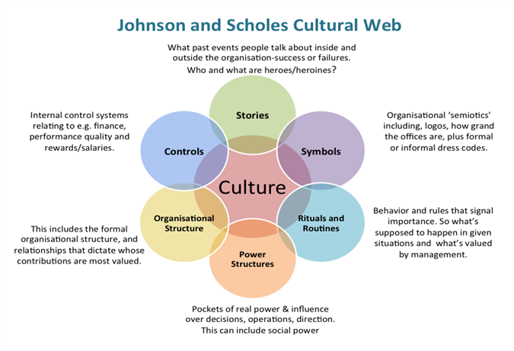
(www.managementcenter.co.uk,2019)

Appendix 2 – Smart Goals

S - specific, significant, stretching
M - measurable, meaningful, motivational
A - agreed upon, attainable, achievable, acceptable, action-oriented
R - realistic, relevant, reasonable, rewarding, results-oriented
T - time-based, time-bound, timely, tangible, trackable
(www.projectsmart.co.uk,2019)

Appendix 3 – Tuckman’s Model

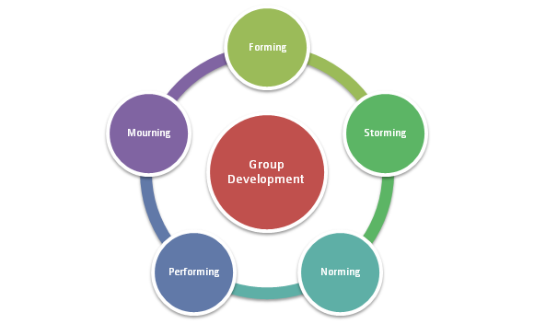

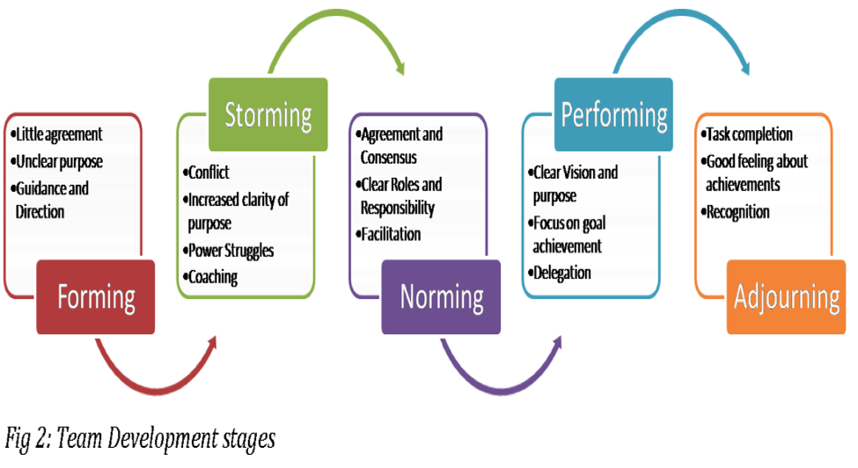
(www.mspguide.org,2012)

Appendix 4 – Maslow’s Hierarchy of Needs

Maslow developed his theory of individual development and motivation in 1943 (Mullins, 2016).

Figure 1 - Maslow’s Hierarchy of needs pyramid.
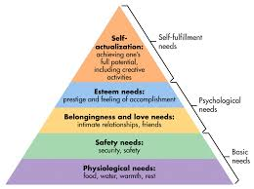

(www.simplypsyschology,2019)

Maslow proposed that human needs are arranged in a series of levels, in a hierarchy of importance. People always want and always want more and what they want depends on what they already have (Mullins, 2016).
These needs as shown in Figure 1 is as follows;

Physiological needs - These are the persons very basic needs, eating, drinking, breathing, sensory pleasures, activities and maternal behaviours etc.

Safety needs - Safety and security, freedom from attack, protection from danger and the need for orderliness and predictability.

Love/Social needs – Affection, a sense of belonging, social activities and giving/receiving of love.

Esteem needs – Self-respect, this involves confidence, strength independence/freedom and achievement. Also, reputation, prestige, recognition and appreciation are important factors.

Self-actualisation needs - Maslow’s definition is as follows, “It may be loosely described as the full use and exploitation of talents, capabilities, potentialities etc. Such people seem to be fulfilling themselves and to be doing the best that they are capable of doing. They are people who have developed or are developing to the full stature of which capable” (Very well mind, 2019).
Mullins (2016) states that once a lower need has been satisfied it no longer acts as a motivator. Only unsatisfied needs motivate a person.

Although there is a hierarchy Maslow states that even though most people have these basic needs the hierarchy is not necessary a fixed order.
Although Maslow did not originally intend this to be applied to the work place, it is very easy to see how it applies.

Appendix 5 - Herzberg’s Two Factor Theory of motivation

Another major motivational theory is Herzberg’s Two Factor theory. According to (tutor2u,2018) Herzberg had close links with Maslow. He believed that there were factors that a business could introduce that would motivate employees to work harder, which are the motivators. There were also factors that could/would demotivate workers if not present, these are hygiene factors. Hygiene factors do not directly motivate employees to work harder.

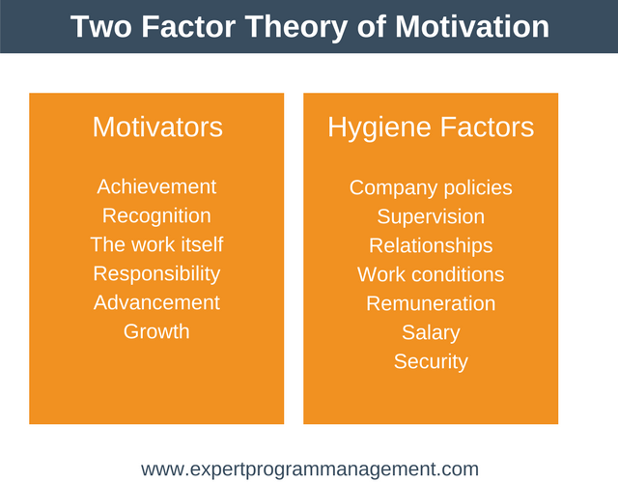

Appendix 6 – Taylor’s theory

Taylor developed an approach where “there has to be a best way to do a certain Job” in 1909. (Journal of Economics, Business and Management, 2015).
This theory believed that people where purely motivated by money (extrinsic) and there was no real motivation to work fast or efficiently, so Taylor developed a programme for a fair wage for a fair day’s work. Taylors theory also led to the worker and the manager working closer together to achieve targets.
Taylor carried out time in motion studies which allowed him to develop the best way to do tasks, this sometimes included using machines, buying the correct tools and training to carry out the job. As well as finding the best way he also learnt from these studies that certain people can work more effectively than others (Mindtools,2019). This theory although important has been criticised due to its lack of Human Factor acceptance (Journal of Economics, Business and Management, 2015).

Appendix 7 – Kotter’s 8 Step Change Model

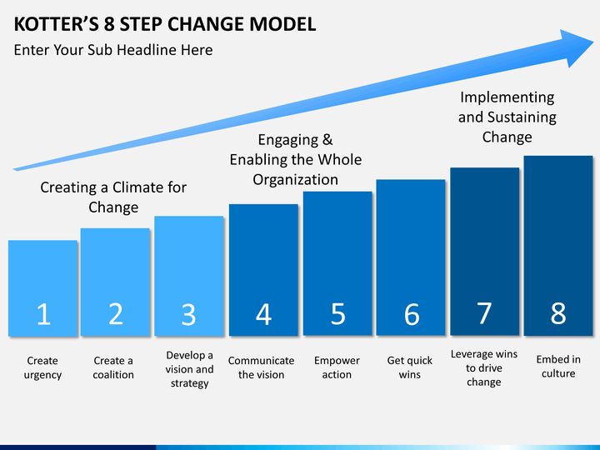
(Medium.com, 2018)

