DS 1 Template

My Screenshots/Photos

Screenshot/Photo 1
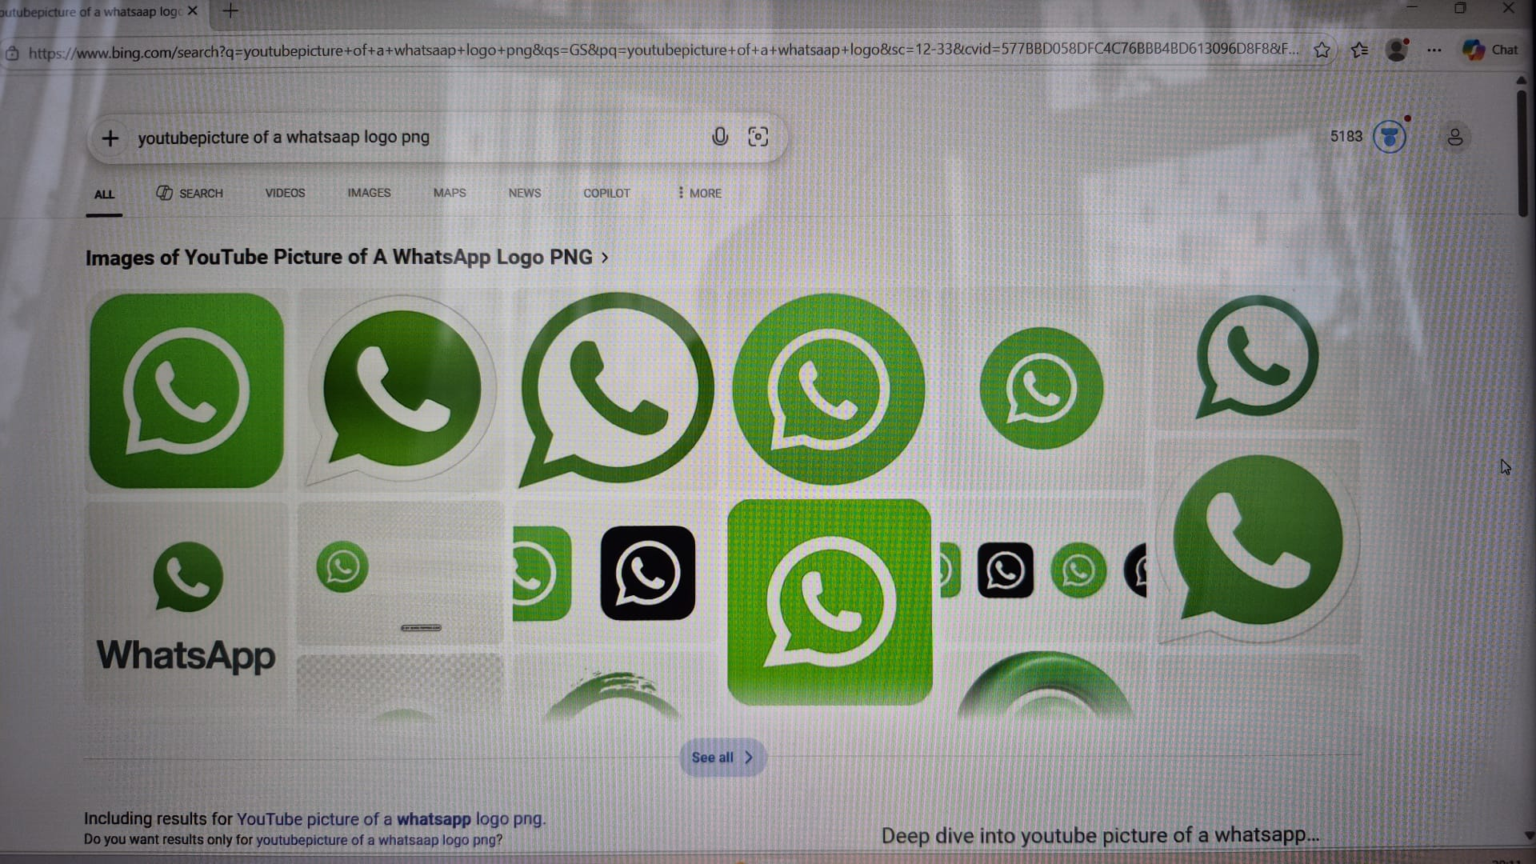
This screenshot shows that WhatsApp is my main channel of communication with my friends, family, and colleagues. It is a major component of my digital life since I can keep in touch with the people I care about on a daily basis.

Screenshot/Photo 2
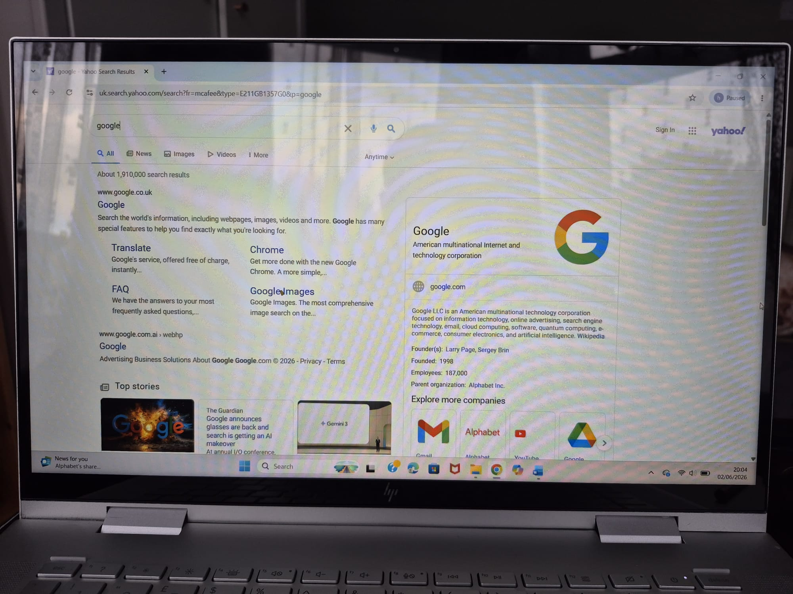
The screenshot here captures me using Google for online information hunting. Search engines are a major part of my life as they aid me in learning, research, and solving day-to-day queries.

Screenshot/Photo 3
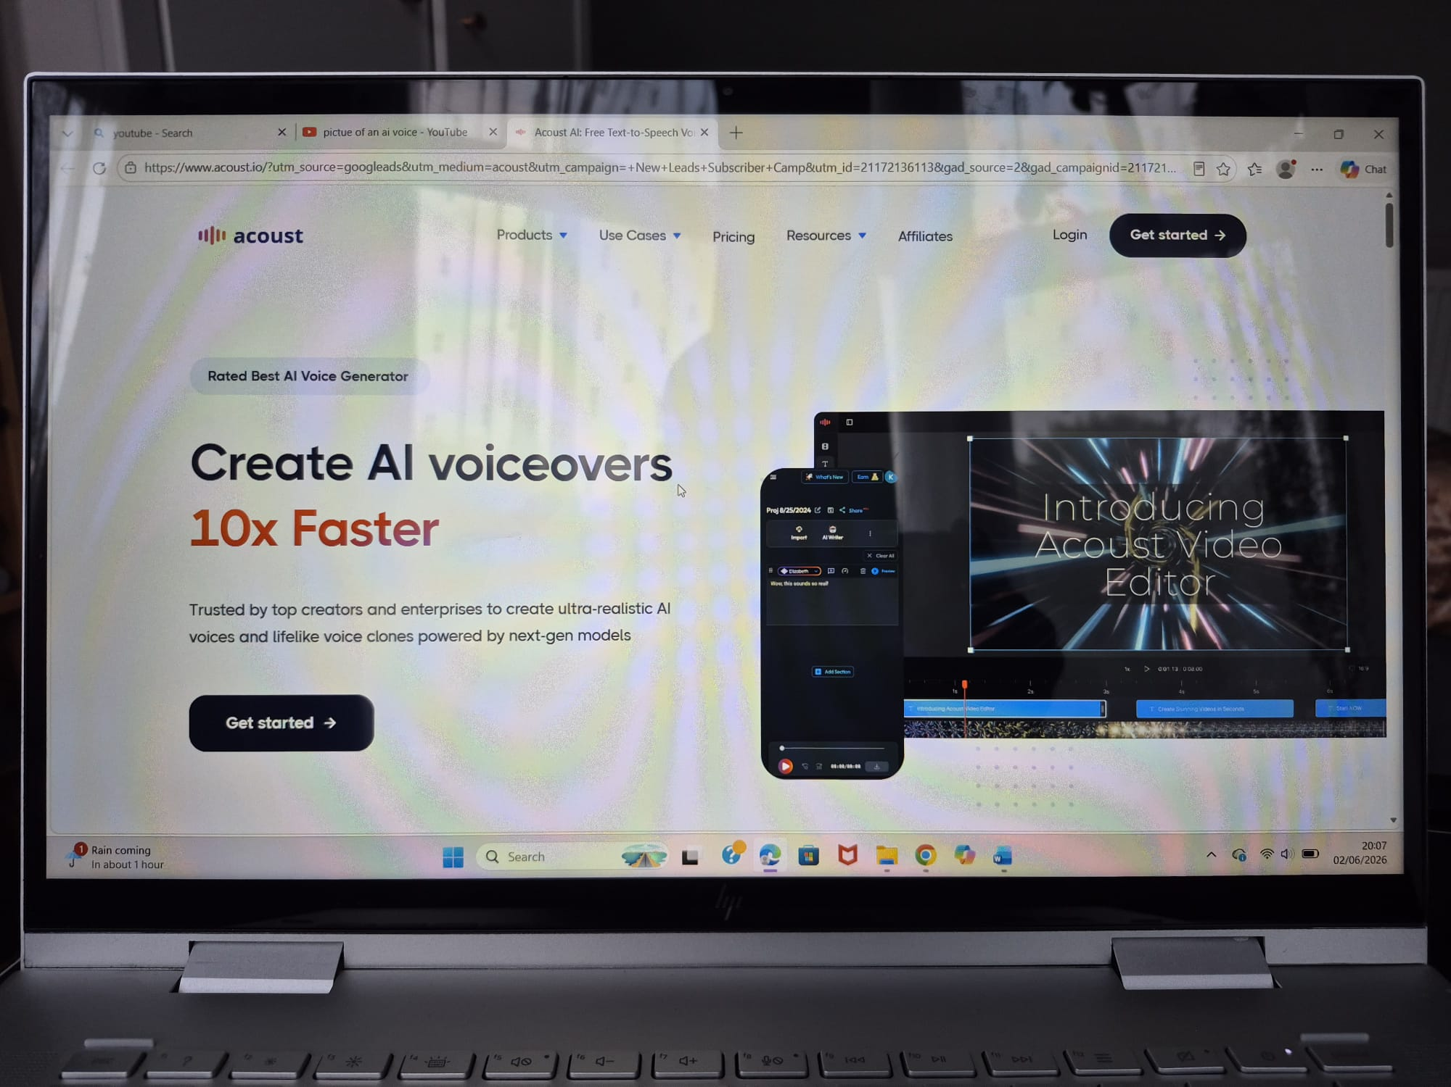
This screenshot shows an AI voice generation platform. It represents my interest in digital technology and how AI tools can support creativity, learning, and content creation.

Screenshot/Photo 4
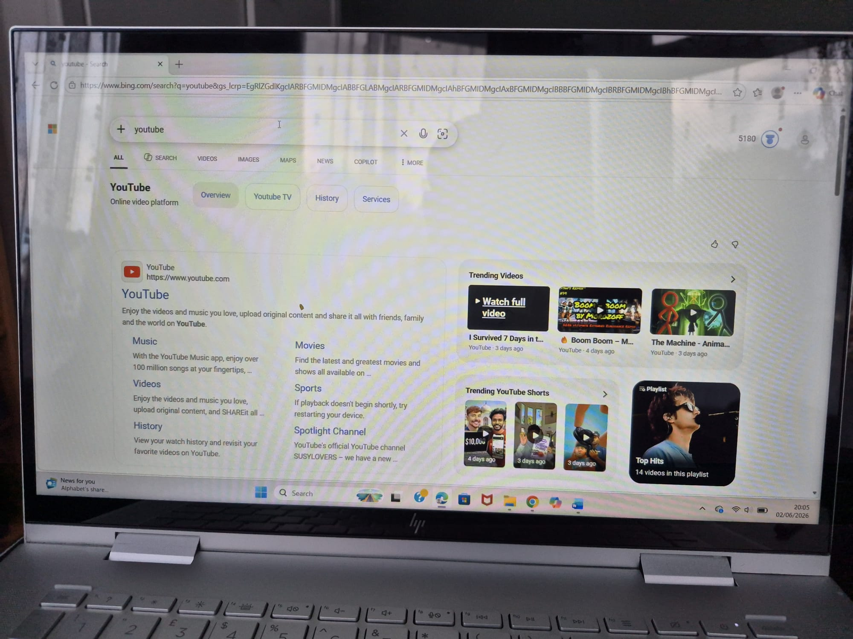
The screenshot here features YouTube, my go-to platform for entertainment, tutorials, and educational videos. It enables me to acquire new skills and be up-to-date on various topics.

Screenshot/Photo 5
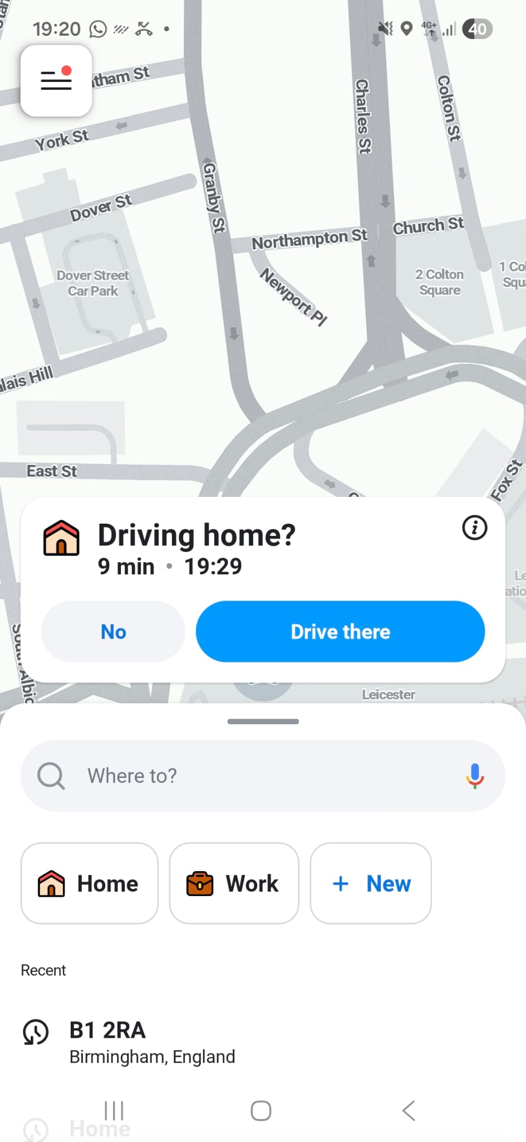
The screenshot here features a navigation app which I used to get directions. Digital maps are a blessing especially when travelling by showing the routes, the time it would take, the distances, and the locational information.

Screenshot/Photo 6
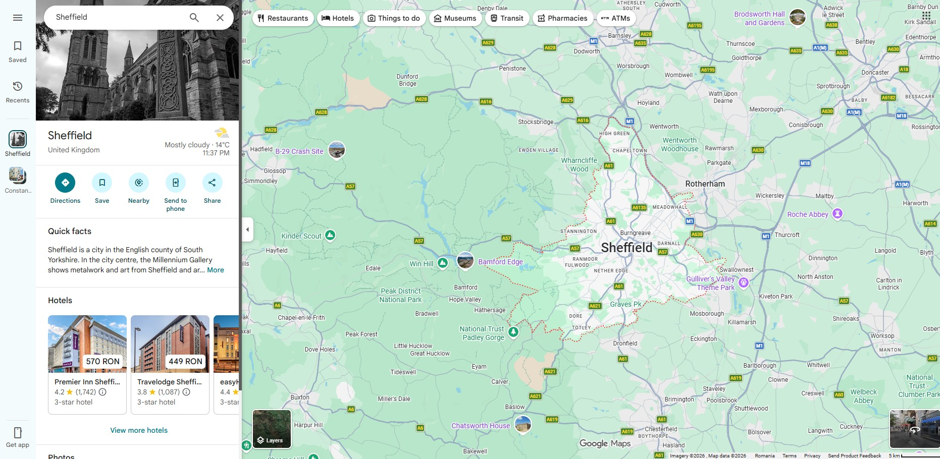
Here, the screenshot shows the use of Google Maps to scout locations and plan trips. Besides this, finding a place, discovering services around, and identifying unfamiliar places are also a few ways that this digital tool is helpful to me.

My Short Reflection
I utilize digital tools mainly to maintain communication with my loved ones, discover new information, and explore different locations.
Whenever I rely on online apps and websites for studying, talking to others, or carrying out my daily activities, I am sure of my abilities.
I am interested in upgrading my digital skills and discovering how to use AI-driven software more efficiently.
The tools that I usually engage with are: WhatsApp, Google, YouTube, Google Maps, and AI-related programs.
On some occasions, I feel a bit scared about protecting my privacy online and keeping unauthorized people away from my personal data.
I am looking forward to this lesson enabling me to gain better digital skills and continue increasing their use with high levels of confidence.
For me, having digital skills means being able to study, work, get in touch with people, and do everyday things better.

Submission Checklist
Before you submit, please check:
​​​ ☒ I added 4–6 screenshots
☒ I wrote short sentences for each screenshot
☒ I wrote my short reflection
☒ My work is my own
☒ My file opens correctly
​​☒ My file opens correctly

