Contemporary Challenges: Making a Difference. (BMTP4010)
Blogs
Lecture – Debbie Jenkins

Savannah Kitching -2205032

Blog 1- What is the biggest threat to society and the tourism industry.

From participating in the online unit 1 of contemporary challenges it covers the areas of climate change, humans health, and technology. After participating in this it has helps be understand that the impacts that society have and how it can impact the tourism industry too. Below I will be discussing keys areas that I picked up on from unit 1 on the impacts that have an impacts on society.

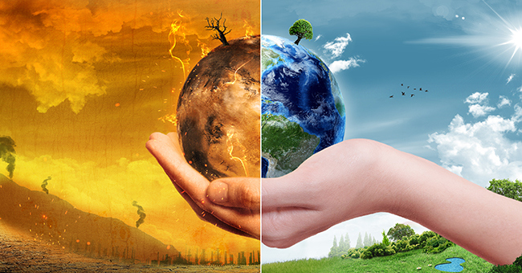
There are many different treats that will impact the society and tourism industry due to everything changing around the world and different events that have impacted it to. One of the massive impacts that will be a massive threat will be climate change. Climates change is a long term impacts that will continue to grow throughout the years as it changes. Climate changes doesn’t only effect the society and tourism industry but many other assert of human life. Due the temperatures rises and the change in wether it is effecting sea’s which is increasing sea level to rise and by the weather patterns changing it can cause droughts and flooding. “Water, energy, transportation, wildlife, agriculture, ecosystems and human health- are experiencing the effects of changing climate.”(NOAA,(2021). Following on from NOAA, it shows that it having a massive impact and this will effect the purism Inuits due to the food supply’s will be damage during the process of climate change restaurants would have to shut down and hotels wouldn’t be able to offer their customers their hospitality side of their organisation.

Image-ITU,(2020)

Animals and the wildlife is another massive impacts on society due to having Forrest fires, drought and many other environment damage events. “ wildfires can distract transportation, communication, power and gas users and water supplies.” (World Health Organisation,(2023)). Following on from the world health organisations it shows that the wildfire have massive impact on society as by this happening it effects many areas. Having wildfire happening it will cause tourism to becoming less popular in the location of the fire as it will be closed until the damage is repaired. I believe by having drought and fires it doesn’t only effect the environment but it also effect humans and animals as animals can die from being fought it and humans cans be hurt badly or even die. “50% of wildfire recorded, it is not known how they started.” (World Health Organisation,(2023)).
According to the world health organisations it shows that wildfires do not allows have or have discovered what cause the fire to prove that it in the long term.

Image, the nature conservancy(2022)
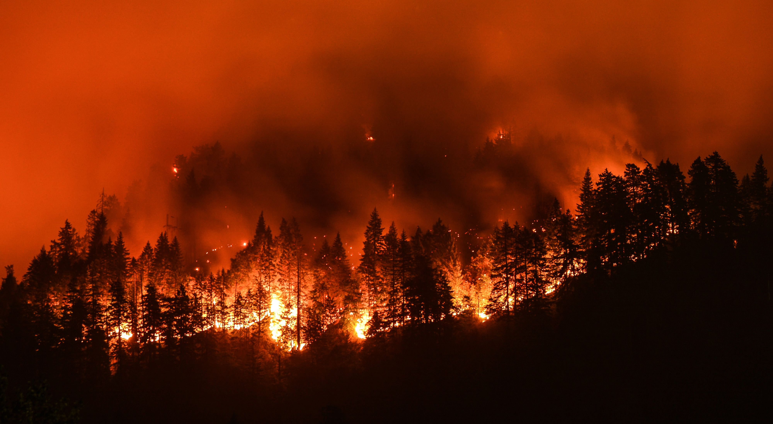

The last point I want to over of the impacts of society which can be a negative or a positives is new machines and technology being made. Over all industry’s includes the tourism sectors they are stating to use new technology to run their business. An examples of a techno plug is using phones for your key to your room instead of using a key from the hotel. This can be both positive and negative as it can be a positives as it can increase the tourism sectors revenue as it will be new and everyone will want to see it but it can also be a negative as there is a massive defeat whether by having the new techno ply will leave many staff unemployments due to them not be needed anymore sue the technology taking over. “Robots are even being used to replace humans in customer-facing roles.”(SME, (2022). As you can see by having new technology techniques in humans are no longer needed as the technology have be trained to do it.

Blog 2- the skills needed to be successful in the tourism industry

Undertaking the unit 2 in contemporary challenges (the further is human) it has made me understand different way people deal with situations and what skills are required to become successful in any industry. It’s covered the areas of critical and analytical thinking and how to deal with conflict when in a workforce.

Many skills are required to be successful in any area of the tourism believe. I believe that the skills needed and the essential skills which are thinking, observational skills, listening, taking notes and many more. When going into a tourism industry I believe that you should have many other higher skills rather than just essentials skills that are needed. Networking skills is one of the most important skills that is needed when it comes to the tourism industry as it very important to keep clients and keep building the tourism industry up. “Building a loyal clientele who are interested in returning to the hotel/restaurant/tour will, in the long run, also enhance one’s career.” (Giannotti.F , (2019)). Following on from what Giannotti.F states it’s shows be having a networking skill within the tourism industry it will build loyal customers to continue to use their businesses after a happy experiences within the organisation.

Image. Southern.M,(2019)


Guest service skills and customer service skills is on of the most important skill needed to work in the tourism industry and other fields. According to Scout.H,(2022)) customer service and guest service skill is “act of providing support to both prospective and existing customers.” I agree with this statement as proving this skill into an tourism industry it will allow all customer to feel like they know what they are doing when they are there and there is staff near by if they need assistance or need to find out more information on their stay or activity. By providing these skills is essentials as all customers are required to feel like they have employees around then in case of an emergency or something happening and that the employees can give them guidance they need when they have the guest service and customers skill. I believe by having this these skill it will allow the tourism industry flourish and customers will continue to use the organisation if these skills are provided well.

Image, Mitzi.M (2021)

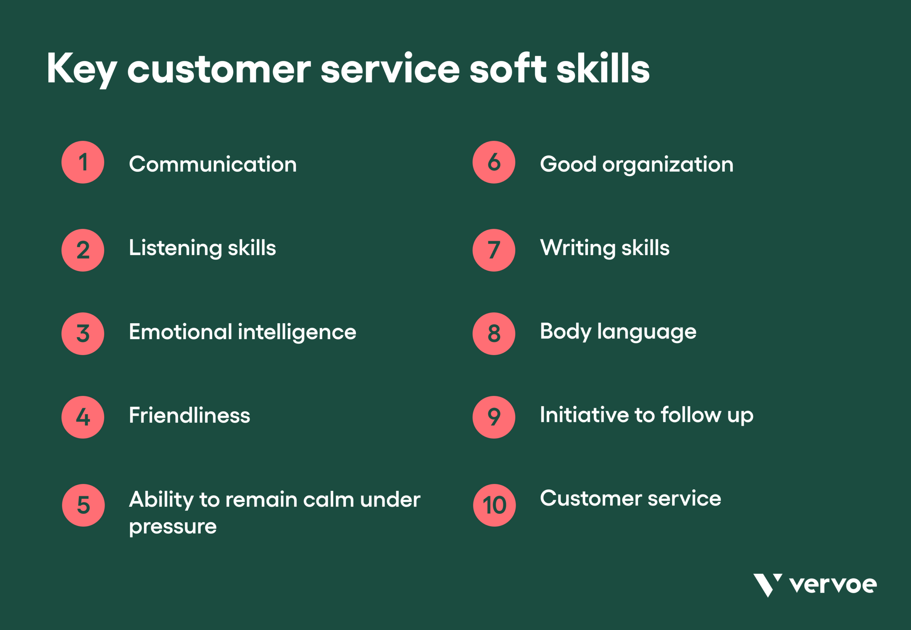

Managing to stay calm under pressure or if a conflict happening is also another skills that is needed when working in a tourism industry. “Conflict can and should be handled constructively.” (Harriet.B)
Following on from Harriet.B I agree with what has been stated as dealing with conflict and keeping calm under pressure is very informant when working in the tourism industry as tours and transport can be a challenging aspect of the tourism industry as there can be delayed and customers can be very upset or angry when this happen so having the skills to deal with conflict well and staying calm is very a essential skills and in veery industry not only tourism will deal with problems in their organisation. Having the skill to know how to deal with conflict is good as you then have the problem solving skill included which is just important as you may have to change the tour on the day so that you have a plan b to make customers feel like they are being understood and well listened to.

Blog 3 – strengths and weakness on design thinking and problem-solving in the tourism industry.

After accomplishing unit 3 of the online contemporary challenges(change by Design) I have learned many new skills on how to solve issue in many different ways. It also helped me understand there are more than one way to deal with situations and how to deal with major issuer different to simple issues. I will cover the strengthen and possibles of the finding I have learnt throughout unit 3.

Design thinking for employees is one of the major aspect they need to work in a work place. Brooks.R (2016) states that design thing “is an iterative process that offers a way to understand problems from your employees’ individual perspective.” Following on from what Brooks.R states I agree with what’s he has stated as its important that employees know who to talk to if they have a problem and then how to think to deal with the customers in their care. There is a 5 principles that they will following in the design thinking process which are empathise, define, ideate, prototype and test. By and employee following these steps it will be a strengths as when dealing with a problem they may learn and change the problem replacements and test it to see if that worked better and if it did it will allow them to pass on the process for other employees to follow to other the tourism industry develop more and become better when dealing with design thinking.

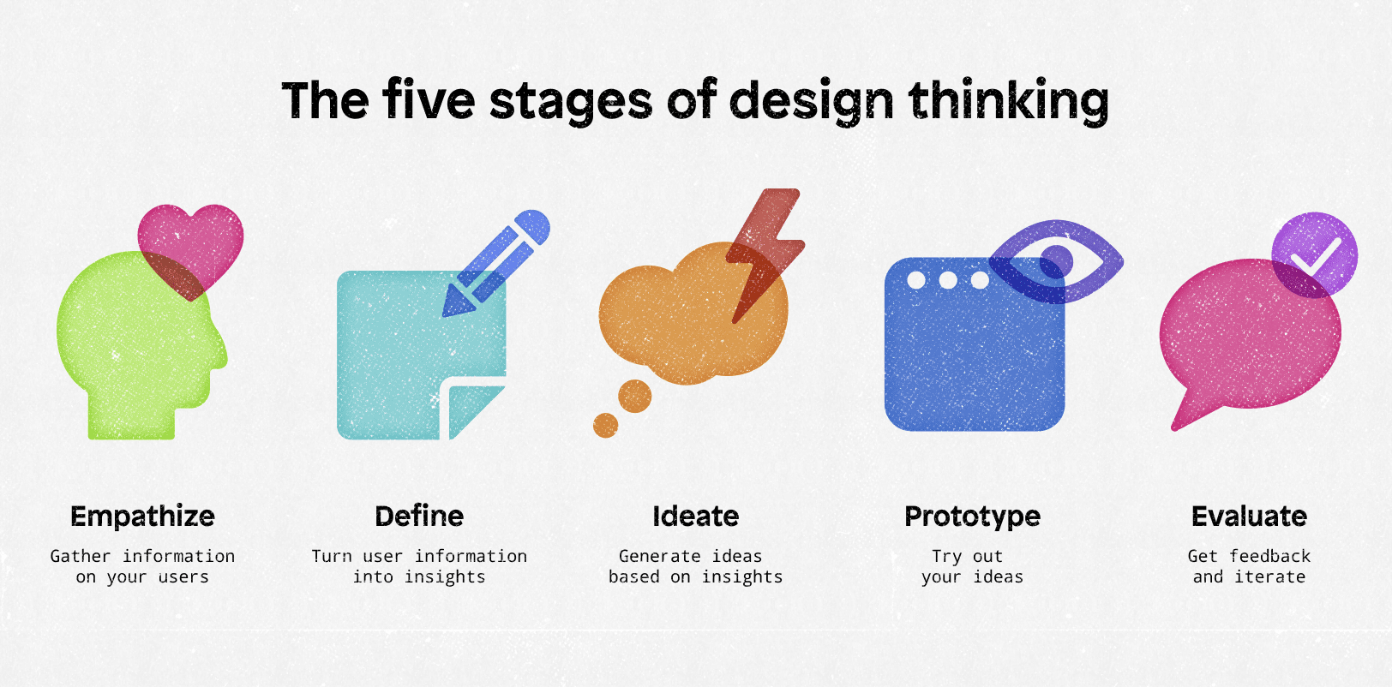
Image- DiCesare.M(2022)

Problem solving I believes is a skills that’s is a positive tools. Problem solving is an skill where you can solve an issue one the stop ad staying calm in the process. Delivering problem solving in the tourism event is very important as there can be many different situations that can accurately when working in that type of industry. An example of an issue that can happen is problem with the room you have selected in a hotel that is not at the level a customer needs and dealing with this is apologising and making sure that they have another room suitable which meets the needs of the customers. There is 7 steps when understating problem solving which are identify the issues, understand everyone’s interest, list possible solicitors, evaluate the options, select an option, document the agreement and agree on contingencies, monitoring and evaluations. By following these steps in a tourism industry will help them when dealing with different scenarios.

“The most common mistake in problem solving is trying to find a solution right away.”(Hicks.T.(2021)). Following from Hick.T statement it’s shows that problem solving has a negative side to it when working as an employee and undertaking this skill is not always and easy way to solve an issue if there is not a right soliciting that the customer is happy about which then will cause a conflict and this is where an employee in the tourism industry I believe should stay calm as possible and try and think and a solutions that makes the customers happy.

I believe that problem solving and design thinking is one of the lost important skill that an employee need when working in industry as there can come an solutions where they will need to think fast and feedback to their fellow employees so they know what is happen to make sure that everyone is on board in the tourism industry.

Images Shannon.M (2022)

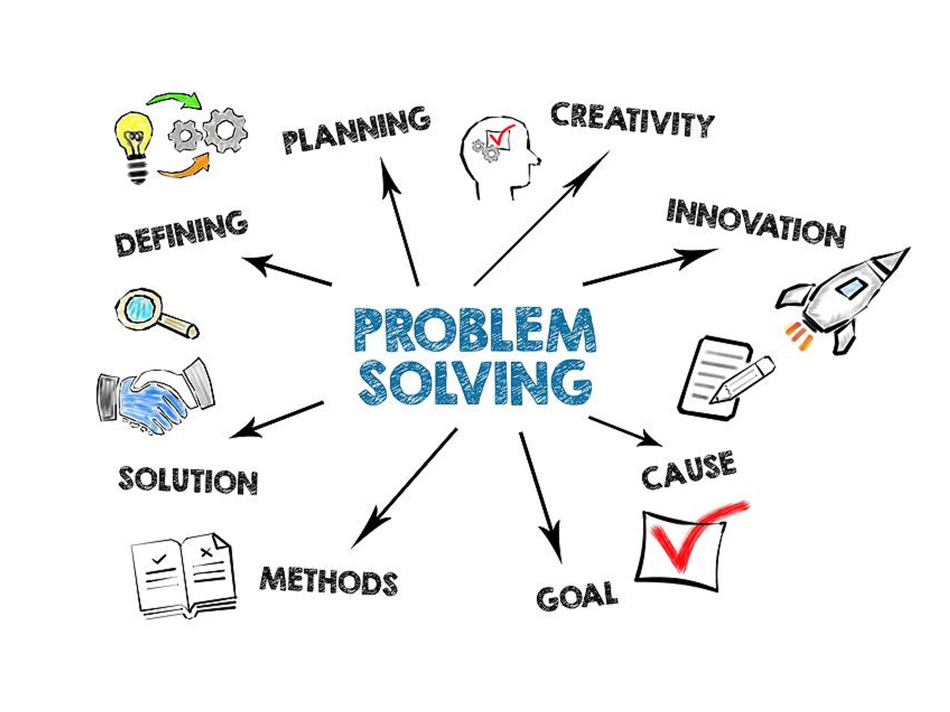
https://savannahatlanta123.wordpress.com/2023/03/10/what-is-the-biggest-threat-to-society-and-the-tourism-industry/ - Blog 1
https://savannahatlanta123.wordpress.com/2023/03/10/the-skills-needed-to-be-successful-in-the-tourism-industry/ - Blog 2
https://savannahatlanta123.wordpress.com/2023/03/10/strengths-and-weakness-on-design-thinking-and-problem-solving-in-the-tourism-industry/ - Blog 3

Username- SavannahAtlanta123
Password for blog- dob25.04.02

https://uowtsd-my.sharepoint.com/:w:/g/personal/2205032_student_uwtsd_ac_uk/EV_xwtOPAddIjAVPnLRDLw4BP1h2DCMqT2SU5zRSf_aPbw?email=deborah.jenkins%40uwtsd.ac.uk&e=TF1iOH – link to evidence

Bibliography

NOAA,2021. Climate change impacts. Available at: https://www.noaa.gov/education/resource-collections/climate/climate-change-impacts. Accessed on 8th of March 2023.
mage-ITU,(2020). Climate change. Available at:
https://www.itu.int/en/mediacentre/backgrounders/Pages/climate-change.aspx Accessed on 8th of March 2023
SME, 2022. How technology is changing the travel and tourism industry. Available at: https://smesouthafrica.co.za/how-technology-is-changing-the-travel-and-tourism-industry/ Accessed on: 8th of March 2023.
Giannotti.F,(2019. Hospitality news & business insights by EHL.. Available at: https://hospitalityinsights.ehl.edu/top-10-soft-skills-hospitality-tourism?hs_amp=true Accessed on: 7th of March 2023
Image. Southern.M,(2019). 4 ways to improve your networking skills. Available at: https://www.resumeassassin.com/4-ways-to-improve-your-networking-skills/ Accessed on: 7th of March 2023
Scout.H, 2022. 21 key customer service skills. Available at: https://www.helpscout.com/blog/customer-service-skills/ accessed on:7the of March 2023
Harriet B. Braiker, author of who’s pulling your stings? How to break the cycle of manipulations and regain Control of your Life.
Brooks.R, (2016) [ blog] how to improve employee experiences with design thinking. Available at: https://blog.workday.com/en-us/2016/employee-experience-design-thinking.html Accessed on: 7ths of March 2023.
Image- DiCesare.M(2022, Design thinking principles: the 5 stages of design thinking. Available at: https://www.mendix.com/blog/design-thinking-principles-empathy-path-mutual-value/ Accessed on:7th of March 2023
Hicks.T.(2021) seven steps for effective problem solving in the workplace.Available at: https://mediate.com/seven-steps-for-effective-problem-solving-in-the-workplace/ Accessed on: 7th of March 2023
Image, the nature conservancy(2022) let’s fight fire with fire. Available at: https://www.nature.org/en-us/about-us/where-we-work/united-states/california/stories-in-california/californias-wildfire-future/ Accessed on:7th of March 2023
Image, Mitzi.M (2021) 10 key customer service soft skills your team should master. Available at: https://vervoe.com/customer-service-soft-skills/ Accessed on:7th of March 2023
Images, Shannon.M (2022) 5-step problem-solving technique for a more innovative solution. Available at: https://www.workitdaily.com/problem-solving-technique Accessed on: 7th of March 2023

