Programme: Certificate of Higher Education in Skills for the Workplace
Assignment Title: Academic and Employability Skills (ACE)
BMSW4001
Frank Sunshine Shina
ID: 1914609
Lecturer: Anita Nan

TABLE OF CONTENTS
Introduction --------------------------------------------------------------------------------- 3
SWOT Analysis ----------------------------------------------------------------------------4
Communication Skill -----------------------------------------------------------------------4
Listening Skill ----------------------------------------------------------------------- ----- --5
Time Management Skill ---------------------------------------------------------- ------- 5
Note-Taking --------------------------------------------------------------------------------- 6
Problem Solving -----------------------------------------------------------------------------6
Decision-Making ---------------------------------------------------------------------------- 7
Personal Development Plan (PDP) ------------------------------------------------------ 8
Conclusion ------------------------------------------------------------------------------------ 9
References ------------------------------------------------------------------------------ -----10
Appendix ----------------------------------------------------------------------------------11

Introduction
The aim of this assignment is to analyse the Academic and Employability skills I have acquired since my enrolment in February 2020 for the Certificate course at the University of Wales Trinity Saint David. A wide range of published books and lectures on communication Skills, note-taking, decision-making, time management, Listening skills, Problem solving skills, and Paraphrasing has been very helpful to me in setting development plan for myself to help me identify and utilise my strengths, and work towards improving my weaknesses.

SWOT Analysis
SWOT analysis is a technique that is widely used for planning and development. It is an acronym for Strengths, Weaknesses, Opportunities and Threats. The internal factors which can be worked on are the Strengths and Weaknesses, while the external factors are the Opportunities and Threats. This technique is very useful for students aiming to achieve academic and employability success.

Strengths
Communication Skill is imparting of contemplations or insights in various manners, including, verbal, non-verbal, composed, motion or non-verbal communication to empower viability no matter how you look at it. Nonetheless, social, clamour and different obstructions, for example, distortion can impact the progress of correspondence
Students need this ability to prevail at the college and in the work environment as it empowers collaborations with schoolmates, teachers and partners. I have this ability since it is exceptionally fundamental in my ordinary dealings at the college and in my work environment.
Formal communication is utilised solely in the working environment where the progression of data is pre-characterised and very much organized. Reports, handouts, requests or demands are a few models. In any case, Informal communication is brisk and adaptable, and doesn't follow any pre-characterised channel for the transmission of data. It moves openly every which way. Sharing of sentiments between companions, easygoing conversations, tattles, family or discussion with partners are examples of Informal communication.
(Blaxell, R. & Moore, C. (2012). Connecting academic and employability skills and attributes)
(Anita, N. (2020) UWTSD In – class lecture unpublished literature)

Time Management is the way toward overseeing time adequately so as to complete more exercises or assignments in less time, utilizing different procedures, for example, prioritization, association, objective setting, and arranging. Viable time the board expertise is basic in correspondence as it helps understudies in organising undertakings. Students can prepare, put aside the time they requirement for ventures and assignments, and utilise that time.
Students face with troubles in their time the executives regularly battle to perform well in school assignment. Stalling and prioritisation are identified with the scholarly presentation of understudies, and are solid markers which influence school assignment. They become increasingly sorted out, progressively sure, and find out additional. It can likewise assist students with staying away from the feared hesitation issue, which can be a dangerous slant to pressure, disappointment, and less than stellar scores.
This aptitude is exceptionally basic for students at the college and in the working environment since they help in accomplishing objectives, oversee pressure, wipe out interruptions and improve students' capacity to decide. Preceding joining the college, I was continually dawdling and performing multiple tasks, with the expectation that I could complete things without appropriate arranging, until I learned different strategies, for example, RAC (Record Analyze Change) to oversee dire and significant assignments. The Eisenhower Matrix, a need framework which improves prioritisation of critical and significant undertakings, Pareto Analysis, – otherwise called the 80/20 which implies, by doing 20 percent of the work, 80 percent of the outcome can be created,

Listening Skill is on a very basic level about precisely accepting and deciphering messages in the correspondence procedure. Without the capacity to listen successfully, messages are effectively misconstrued and can prompt breakdown in correspondence. Powerful listening aptitudes are essential in correspondence, and can be advantageous to students and workers’ lives. This is the reason many top organisations give listening abilities to their staff since they perceive that great listening aptitudes can prompt better consumer loyalty, more noteworthy profitability with less errors, and expanded development.
In order to fully understand the speaker, it is important to avoid distractions and preconceptions, and concentrate on the messages being communicated so that they can be fully understood. Active listening is important in the workplace as it helps open up opportunities to collaborate with others, get work done quickly or start new projects.
Effective listeners understand the flow of information and ideas, and that is why organisations that follow the principles of effective listening are always informed twith changes, updates and implementations. It promotes organisational relationships, encourage product delivery and strategies, and help organisations in dealing with the diversity in the workplace.
Listening skill is very good to have at school and in the workplace. When I first came to I have this skill because it is needed for employability and academic success. And makes me more impressive when I communicate with people.

Weaknesses
Note Taking skill, as it is very difficult to remember specific details and important information that are being discussed during classroom lectures that is why note taking is a very important tool to have in order to achieve academic success. Effective note taking is good for active listening, comprehension retention resources. This is the skill I want to improve on because I am not very good at taking note in class.
This is a skill I do not have at the moment, and I want to improve on it and have discovered methods of taking note such as Mapping, which is very useful for noting down detailed information in a concise form, especially in heavy content lecture. Outline - where notes are structured by using bullet points to represent different topics and subtopics. Cornell method, a quicker way to take, review and organise notes as page layout is divided into three or four sections. Boxing or digital note-taking method with the use of ipads or mobile phone. Another method is Charting, suitable for large volume of notes such as facts and statistics, using a table or spreadsheet.
After taking note in class, it is important to follow up the next day so that important points of the lecture can be fully understood, using 5 Rs of Note – Taking. 1, Record during lecture and write all important information clearly can help active listening and retention, and better understanding of the main concepts. 2, Reduce by summarising of facts, key words and ideas after lecture. It saves time, energy and confusion. 3, Recite in terms of using my own words without looking at the notes taken in class. 4. Reflect Think about opinions and ideas as I read over notes, review them regularly and ask questions. And lastly, 5, Review before reading or studying new material by taking at least ten minutes to quickly review older notes and memorise.
(IStudy for Success: Pauk, W. August 2017)

Problem Solving Skill involves effectiveness in thinking outside the box and analyse information to develop informed solution to any challenges or problems. Students engage in problem analysis and goal specification. Alternative solutions and decision making account for a significant proportion of the variance in total worry in men compared to in women, and this can be as a result of different orientation and style.
Using initiatives and creativity to solve problems is a norm, . For example, having to change route due to traffic, solving an IT issue, or working out what to make for dinner with the ingredients left in the fridge. The challenges in professional career can be more complicated than these examples, however the skills and processes used to come up with solutions are largely the same, as they rely on ability to analyse a situation and decide on a course of action.
Problem solving and decision making are very essential for a graduate-level job, so it is important to show employers the required skills and personal resilience.
I am not good at this skill; therefore I am working to improve on it as it is very vital for my academic success. One of the techniques I use which is very fundamental is, IDEAL model of problem solving. Identify the problem, Define the problem, Examine alternatives, Act on a plan, and Look at the consequences.
(Available at: <http://myjms.moe.gov.my/index.php/JeA/article/view/3159>.) Date accessed: 03 may 2020.

Decision-Making Skill involves ability to analyse a problem, research options, weigh up the advantages and disadvantages before reaching a logical conclusion. Student need to be creative and decisive, and it may be appropriate to take some time to gather the necessary data to inform decision-making, even if the timescale is very tight. If necessary, prioritise information-gathering by identifying which information will be most important.
It is sometimes hard to make decisions, however, decisions need to be made all the time, ranging from personal issues like what to have for breakfast, or life-changing decisions like whether or not to go to the university or starting an apprenticeship, deciding marriage and many more. People often put off decision making by endlessly searching for more information or having to seek other people’s opinions or recommendations, while others simply resort to decision-making by voting, sticking a pin in a note or tossing a coin.
Improving decision skills will come from the learning gained from experiencing the consequences of making poor decisions. However, for high value decisions with significant consequences, it is vital to develop these skills in order to avoid disastrous outcomes. The goal would be to improve our decision making skills in an environment where the risk of significant negative consequences that come from poor choice is reduced or eliminated.
Students should have a validating, practical, opportunities they are interested in to make decisions about learning and education in general. Decision-making opportunities should engage students in solving genuine problems and making substantial decisions that will promote critical thinking skills.
My weakness is that I do not have this skill, and want to improve on it by making more difficult decisions and trial by error so that I can learn from my mistakes. Good decision requires both head and heart, therefore, Decision Making is a very important skill to have at the university in order to achieve academic success.
(https://www.skillsyouneed.com/ips/decision-making.html) Viewed on 02 May 2020

Opportunities
The opportunities available for me once I have completed my Level-4 Certificate in Higher Education course are enormous. I will be able to further my education, do a Degree course, and acquire more academic skills and knowledge required to compete in the competitive job market.
Furthermore, whilst still at the university, there are a wide range of materials, published literatures, journals, and articles available in the school library, and the dedicated teaching staff and the IT team are always on hand to help.

Threats
Students are impacted by a wide range of threats or challenges at the university, especially working parents who have had to combine work with studies. Moreover, in the wake of the recent global COVID-19 pandemic and the resulting lockdown means students are struggling to cope with online lectures due to poor internet connection, distractions and other interferences impacting learning.

Personal Development Plan (PDP)
Step 1; ‘Eat an Elephant’ – i.e. take one bite at a time by organising tasks into smaller bits of manageable segments, make a list and divide time.
Step 2; Adopt Pareto analysis (80/20) rule to deal with urgent and important tasks first.
Step 3; ignore the silence song by ignoring any form of distractions that is making me procrastinate.

Conclusion
In conclusion, this assignment is structured around the academic and employability skills learnt this first term, and emphasize on the need for students to be able to self-evaluate areas of strengths, draw a constructive plan to work on weaknesses, and make the most of the opportunities in terms of the available resources such as the library, published literatures and journals within the learning environment. With this in mind, I have set the above personal development plan for myself.

REFERENCES
- Available at: <http://myjms.moe.gov.my/index.php/JeA/article/view/3159>. Date accessed: 03 May 2020.
- Available at; (mindtools.com) Date accessed 02 May 2020.
- Ref; IStudy for Success: Online learning tutorials for essential college skills. Pauk, W. [2017]. Date accessed; 02 May 2020.
- Ref; “The Pen is Mightier than the Keyboard: Advantages of Longhand over Laptop Note Taking.” Mueller, P., and Oppenheimer, D. Psychological Science 25(6), April 2014.
- Study show that adult spend an average of 45 percent of their time listening, 30 percent speaking, 16 percent reading and 9 percent writing [Adler. R. Et al. 2001].
- Available at, https://www.skillsyouneed.com/ips/decision-making.html Date accessed 02 May 2020.

- Reference: Blaxell, R. & Moore, C. (2012). Connecting academic and employability skills and attributes.
- Anita, N. (2020) UWTSD In – class lecture, (Communication Skills) Unpublished literature.

APPENDIX i
- Decision- making graph
Pareto Analysis 80/20 rule
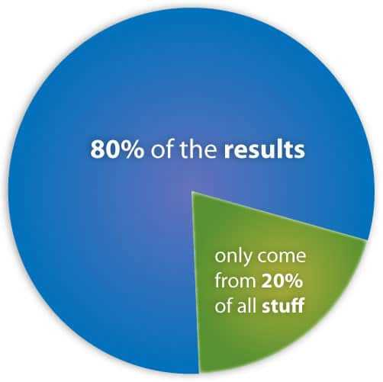

APPENDIX ii
- Types of Communication
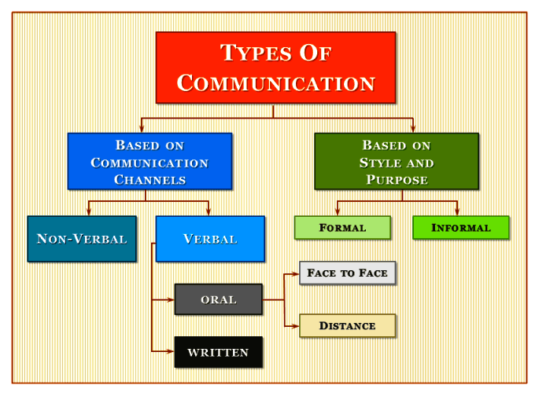
APPENDIX iii
7 C’s of Communication.


