

Student Name: Noemi Canu
Student ID: 2124164
Module Name: Digital Skills and Research Method
Module Code: LCHS4002
Lecturer Name: Patronella Ganza
Assignment Deadline: 03 January 2025

Introduction:

In my report I will discuss the issue of shortage of staff in the hospital industry. I will explain the problem, elucidating all the causes and consequences. I will also go through the “behind the scenes” of my report, showing all or various steps taken, the websites that appeared during the search, also adding two screenshots.
I will speak also about the quantitative research and the qualitative research and their differences and, finally, a conclusion about the topic and about my research. At the very end you will find the referencing list, to support my report.

Causes, Consequences and Solutions:

The principal causes of shortages of healthcare providers in hospital industries are, first, the retirement. The amount of professional hired does not exceed the number of professionals going in retirement. This creates stress and burnout among the healthcare professionals in all sectors and levels, especially in nursing. (Meelik Samel, 2024)
Another cause is, for sure, the Covid 19 Pandemic Impact. Most of the medical staff has been left overwhelmed, stressed due of the excessive amount of workload. Some healthcare workers left their positions because of the fear of contagion, reducing ulteriorly the number of workers in hospital industry. (Meelik Samel, 2024)
The low salary is another cause of the shortage of staff. The number of hours is greater than the final compensation, therefore underpaid. (Meelik Samel, 2024)

A cause to remember is also the elevate increasing of patients in every department of the hospital. (Alison Holt, 2021)
All these causes affect the quality of care provided by hospital staff to patients. (Meelik Samel, 2024)
Even the health of the staff is compromised leading to an increasing of the sickness absences of the 5% between the years 2020 and 2022. (Meelik Samel, 2024) 52% of the nursing staff decided to leave their workplace due to very stressful circumstances and overwhelming environment to protect their health and wellbeing. (SueEllen Carroll, 2023)
Some possible solutions could be improving and expanding virtual care, following the patients at home reducing stress, contagion and burnout of the healthcare providers. (PwC Global, 2017 – 2024)
Another solution is implementing technology in healthcare sector, such as robotics, Ai, 3D printing, health apps as a support of the staff, especially nurses. (PwC Global, 2017 – 2024)
Another possible solution could be to attract more people in the healthcare field, improving the recruitment management, promoting new talents and increasing salaries. (PwC Global, 2017 – 2024)

Definition of Quantitative and Qualitative Research and Examples:

The function of Quantitative research is to collect and analyse numerical data, testing hypotheses and making predictions using statistical methodologies. (Pritha Bhandari, 2023) Instead, the Qualitative research, collects data as videos, photos, audio, images, to investigate in depth a situation and subjective opinion, usually through interviews, videos, observations. Its goal is to generate precise descriptions and discover fresh insights about the examined phenomenon. (Saul McLeod, 2023)
Below are 3 examples of qualitative research:
The Interview transcripts are used when they decide to record the interview of a participant or group. They are useful to collect the direct opinions of the participants, their quotes and examples, to support the research. (Saul McLeod, 2023)
During the Observations, instead, the researcher often takes notes of what he sees, including nonverbal cues, such as body language, and other pertinent factors and sensations. The data collected during observations are used to study social behaviour, body language, indirect messages and cultural customs. (Saul McLeod, 2023)
The Unstructured interviews are interviews that are conducted by asking open – ended questions. With this method, the participant involved responds accurately and in his own words, which allows the researcher to obtain a broad and sincere view and opinion of a problem or situation from the perspective of another person. (Saul McLeod, 2023)

Below we have 3 types of quantitative research:
The Descriptive research is the research that is done to study the variables to understand a given situation. None of the variables undergo changes. Basically, this study identifies the statistical metrics to be used in the analysis of a situation. The Causal and comparative research it is the study that investigates the reasons regarding behavioural variables in a group of individuals. For determining the causal links between variables, it is one of the most popular forms of quantitative research. In the case of Experimental research, the researcher’s study is based on changing all aspects and circumstances to see how the variables will be changed and all the possible outcomes that will result. (Joe Eckel, 2024)

Examples of Qualitative and Quantitative research in healthcare:

The most widely used research in quantitative research is the focus group. Focus groups include 6 to 10 individuals and are responsible for conducting research on patient experiences in all areas of healthcare to help healthcare organizations improve their services. (Ashley Reynolds, 2023)
Healthcare organisations can use phone survey to collect information about different aspects and experiences. Data on illness prevalence, public health indicators, and health behaviours can all be gathered using phone surveys. To track trends or evaluate community needs, organisations can question participants about their habits, health status, or thoughts related on certain health issues. (Ashley Reynolds, 2023)
Establishing the incidence of prevalence of a health issue, the degree of adherence to a novel intervention by medical staff, or the degree of user satisfaction with a service are all examples of quantitative research aims. (Luisa Vazquez Navarrette, 2010) Other examples of collecting data for the quantitative research in healthcare are the number of people who are affected of diabetes, temperature, age or weight of the patients. (NIH Library, n.d.)

Report development and research method:

I opened Google Search, and I found 10 links of websites related to the shortage of staff in hospital industry. I took a few screenshots from my phone. After, I searched the same information from my laptop in Microsoft Bing and I found 18 different links. I opened the first link that appeared in Microsoft Bing, I saved the link of the website doing copy and paste in WhatsApp to use it after for the references.
I searched all the causes of the shortage of staff in healthcare in hospital environments, the consequences and the possible solutions, I wrote notes about it, summarized and paraphrased it. I saved on WhatsApp all the websites I used for my research.
After that I made research about the definition of quantitative and qualitative research and 10 websites appeared in Microsoft Bing. I saved the website that I chose, I extracted the key points of the article, translated in Italian to understand the topic and, after, summarized it and paraphrased it in English. I add also some examples and how they work. Eventually, I did a search about the use of quantitative and qualitative research in healthcare sector using 3 different articles.
I saved all the articles I used for my report’s research in my WhatsApp account, and I will use all of them for the intext-citations and references.

Conclusion:

The shortage of staff is a real problem, which creates many inconveniences, problems of different types, including health issues and affecting also the quality of care provided to the patients, and many other consequences. With my research I have been able to see that there are solutions to the problem such as, for example, the use of technology as a support in every sector of the healthcare field, or also promoting new talents and increasing salaries. In my report I have also mentioned the definition of qualitative and quantitative research, general examples of how they are used and why and some more examples of to utilise them in healthcare improving healthcare organisations.

Finally, I also described step by step how I carried out my report, explaining which search engines I used, such as Microsoft Bing, and attaching two screenshots, the intext-citation and the references as support of my research.
Thank you.

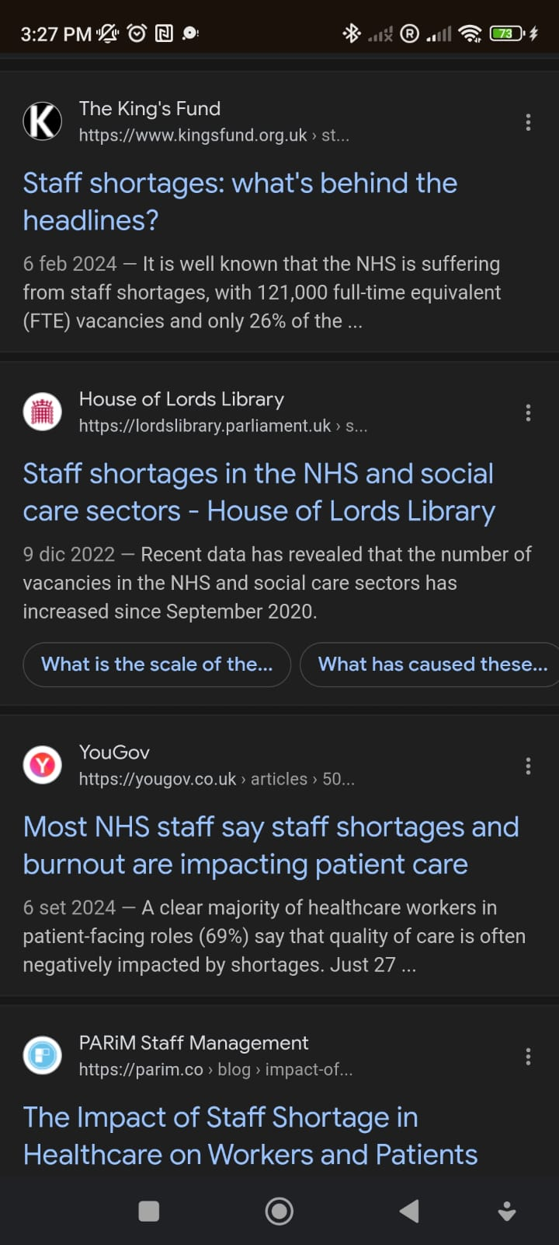

(Google, 12 December 2024)
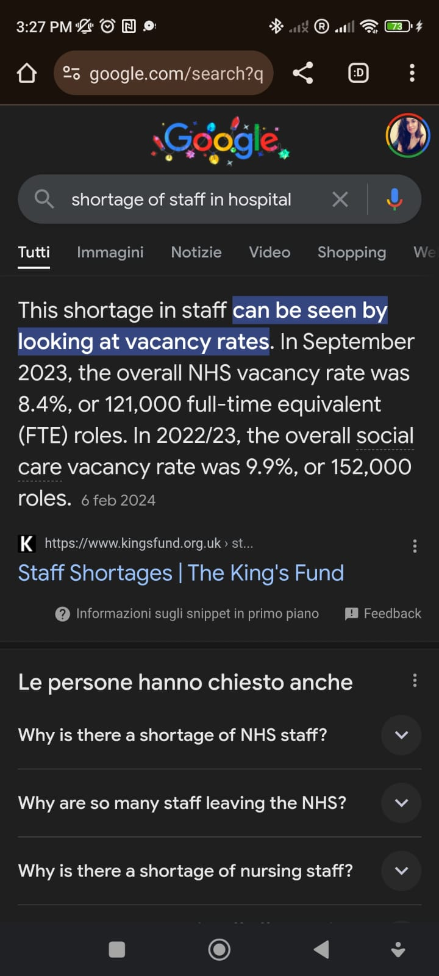
(Google, 12 December 2024)
References:
AArete (2023) Addressing the Crisis: The Cause and Effect of Healthcare Provider Staff Shortages Available at: https://www.aarete.com/insights/the-causes-and-effects-of-staff-shortages-in-healthcare/ (Accessed at: 14 December 2024)
Care Quality Commission (2022) Monitoring the Mental Health Act in 2021 to 2022 Available at: Staff shortages and the impact on patients - Care Quality Commission (Accessed at: 14 December 2024)
Drive Research (2023) Qualitative Research in Healthcare (Types, Examples, & Challenges) Available at: https://www.driveresearch.com/market-research-company-blog/conducting-qualitative-research-in-healthcare-with-examples/ (Accessed at: 19 December 2024)
International Journal of Integrated Care (2010) Qualitative and quantitative methods in health research Available at https://ijic.org/articles/10.5334/ijic.377 (Accessed at: 19 December 2024)
NIH Library (n.d.) Common Data Types in Public Health Research Available at: https://www.nihlibrary.nih.gov/resources/subject-guides/health-data-resources/common-data-types-public-health-research (Accessed at: 19 December 2024)
Parim (2024) The impact of Staff Shortage in Healthcare on Workers and Patients Available at: The Impact of Staff Shortage in Healthcare on Workers and Patients (Accessed at: 14 December 2024)
PWC (2017-2024) How to solve healthcare’s workforce shortage Available at: https://www.pwc.com/gx/en/issues/c-suite-insights/the-leadership-agenda/talent-required-for-healthcare-shortages.html (Accessed at: 14 December 2024)
Simply Psychology (2023) Qualitative Vs Quantitative Research Methods & Data Analysis Available at: https://www.simplypsychology.org/qualitative-quantitative.html (Accessed at: 18 December 2024)
Scribb (2023) What is Quantitative Research? Definition, Uses & Methods Available at https://www.scribbr.com/methodology/quantitative-research/ (Accessed at: 17 December 2024)
Study Crumb (2024) What is Quantitative Research Study: Methods & Examples Available at: What Is Quantitative Research Study: Methods & Examples (Accessed at: 18 December 2024)

