The role of the professional within the Construction Industry

Contents
1. Professionalism and Ethics in the Industry 1
2. Professional Development 3
3. Leadership 4
4. Teamwork 6
5. Personal Learning Points 6
6. References 8
7. Appendices 8

Professionalism and Ethics in the Industry
What is Professionalism? Professionalism is the “standards, practices, or motivations associated with a profession.” (Evetts, 2017). This is how the industry will judge and evaluate a person’s capability and competency in the forms of interviews, appraisals, references, examinations and assessment. Ethics is the philosophy of judging whether something is right or wrong to a “system or code of moral rules, principles, or values.” (Singer, 2022). This can relate to religious beliefs, cultural traditions and professions.
Being Professional and ethical is vitally important to the industry and the world around use. Especially when making decisions on site, in meetings or in the design office. As everyone has a duty to be professional and has a moral compass to do what they believe is the correct and right way to do something, even if it will cause yourself hassle or not end in your favour as it a matter of principle and integrity. This can be admitting your wrong and made a mistake. On sites before we’ve had those that believe in different religions such as Islam and Hindu where they have certain beliefs and choices, they’ve made which we must respect. As some can’t wear certain PPE such as Helmets due to them wearing turbans or face masks and respiratory gear due to facial hair. So, we had to respect their decisions as its ethical right and being professional allowing them to follow their beliefs as can’t stop them from doing it as it’ll be immoral. Furthermore, it can be allowing those on site who have family or certain circumstances at home which effect their lives and way they work.
The major decision makings on site which involve the wider world and public must be professional and ethical moral. This can be involving scenarios with environmental, money and the public. As ethics isn’t just about people with race, religion, beliefs and disabilities on how it affects them. Ethic can be on the environment with wildlife, plants and the area. As they have a right to live and everything we have. As for example, say you on a new road project which has bridges and culverts on the project, but you have badgers, bats and knotweed on site, but the road is going through their habitats. The ethical right thing and professional thing to do would be seeing if you reduce the amount of damage you do to the area, relocating them and making new habitats for them as their lives matter as well as they shouldn’t be sacrificed or home taken away and left homeless as its immoral. Having Knotweed on site is dangerous and harmful as being an invasive species so removal of it must be taken with proper care and the correct way as if not you can infect more areas causing damage and nuisance to others.
Measuring Professionalism can be down in many ways, but it can be very subjective. As mentioned previously there’s different ways people in the industry will assess a person. Every company has their own policies, procedures and standards which they’ll judge and assess a person’s professionalism seeing if it meets their requirements. All companies will have similarities to their standards as in the industry there’s laws, regulations and standards which we must full and use as guidelines whether being British Standards, HASAWA, CDM and Institutions. These guidelines are the bases for their standards. Please see Appendix 1 – Alun Griffiths Contractors Competency Management Policy. As most companies will carry out Job Appraisals to access the individual and see if they are meeting the standards in that profession.
In the workplace Professionalism can be answered in more than one way as it can be ethics, morality, values, opinions and more. “Professionalism refers to the attitudes and behaviours shown by employees at work.” (Amjad, 2022) They go on to discuss that “Professionalism refers to the attitudes and behaviours shown by employees at work.” (Amjad, 2022). Furthermore, they go on about how Professionalism can be divided into 10 different Elements being.
- Appearance – as how you appear and present yourself will affect how others see you.
- Behaviour – as how you act and do it work will can cause people’s opinions and thoughts on you change so being polite, refraining from gossiping and not diving into others business is seen professional whereas shouting, being annoying and up in people’s faces and rude is unprofessional.
- Communication – There’s multiple ways to communicate with someone which can be Verbal, Non-Verbal or Electronic. However, the way you speak, and email should be clear and considerate.
- Attitude – the way you feel in work reflects your Professionalism. Being positive and enjoying your work makes others wanting to work with you and co-operate with you. However, it’s the opposite if your negative and un-cooperative as no one would want to work with you and find it hard too.
- Work Ethic – a good work ethic shows to your employer how much the role means to you and you’re taking it seriously and your will put the extra effort and time into it.
- Respect – this is one of the biggest elements of professionalism as respect is earned not given. So, respecting others and respecting the company and work itself.
- Integrity – another important part of professionalism as being honest and fair is a key thing and knowing to do the right thing. To be professional you must do the right thing even if it’s the harder or more difficult option rather than the easy way out. As it can help you gain trust and respect from others.
- Accountability – owning up to your actions is a big part of being a professional as you are admitting to your mistakes and using them to learn from and being better.
- Commitment – this works hand in hand with a lot of the rest as showing your dedication and drive to the role and putting the effort into it.
- Adaptability – being able to adapt and change in different situations shows your strength and drive to be successful. As well as keeping up to the changing industry and learning about them to stay in the now.
The institutions as professional bodies that have formed to support, improve and manage the professions associated with them. The likes of ICE the Institute of Civil Engineers is an example as their a collective of Civil Engineers and those with backgrounds as Civil Engineers. They as a body will help govern and set out guidelines to the industry regarding the professionalism, standards and ethics for Civil Engineers. Please see Appendix 2 – ICE Code of Professional Conduct, The Rules of Professional Conduct.
With the institutes, they have members. These members must follow these Codes of Conduct if they want to continue being a member with them. As these bodies are recognised for their high-quality professionalism and standards so having been a member with show that you’re up to the current standards and the institute is backing you as they believe you competent. There are different grades of memberships in these bodies which to gain you must do an application and interview where they assess you to prove you meet to the standards and principles they stand for. Once gained, you’ll reserve letters behind your name which show that the body believes and has full confidence in your ability and professionalism.
Qualifications and Experience are other ways to measure Professionalism. As companies will set different requirements when they are hiring new staff in terms of experience and qualifications as this is what they believe to be the standards for that profession. A company could say must have a HNC or Higher, minimum 10 years’ experience, Computer literate and read drawings. These could be what they consider the professional standard for that profession whereas another company could say only want HNC and able use computer. When it comes to measuring someone’s professionalism its subjective and a matter of opinion. As people can say they want the qualifications over someone was 20 years plus experience or say their standards are better than that of ICE’s or governments.

Professional Development
Developing yourself is important as keeping up with the new standards and technology out there and developing industry.
With the profession I’ve chosen as a Civil Engineering Surveyor within the organisation I work for there are plenty of benefits in the business that help me. In Alun Griffiths Contractors Ltd, I’m a civil engineering surveyor so I’m staff and on the books with the company but based on site and office occasionally. I started at 16 years of age with them doing an apprenticeship with them in Engineering Surveying. As this suited me and benefitted me, as I was learning, studying and working at the same time. This helped me with doing my course work and assignments as combining my experiences, knowledge and support and others experience to my course work which helped me understand more about the industry and what their talking about and applying what I’ve done in college to site as well.
As currently, being a staff member within Alun Griffiths there is many different policies and procedures in the company which benefit me and help me with my career, lifestyle and wellbeing in work. Below are a few examples of the policies within Alun Griffiths that benefit me: -
- Sickness Absence
- Sabbatical Policy
- Inclusion and Diversity Policy
- Flexible Working
- Employee Capability
- Dignity at Work
- Competency Policy
- Training Policy
Griffiths as a company try to improve and support their employee’s as much as they can. They offer appraisals and look at promoting internally first before going externally. As providing sick leave in their Sickness Absence policy which will cover people if they are off long term with health issues or injuries from work. The Flexible Working policy is in place to help benefit the employee and company by improving “work life balance, raising morale and allowing the organisation to reduce absenteeism and retain skilled and experienced Employees.” (Ltd, 2021). This policy gives me the options to work from home when needed and if I need to leave early one day or go to do something for my personal life the procedure is in place to help me and give that re-insurance. During the Pandemic, the company paid my wages and everything as some companies let go of their staff but fortune that Griffiths kept staff on and allowed them Flexible working, provided PPE to sites and give furlough and sick leave to those affected by the pandemic. Please see attached Appendix 3 for Flexible Working Policy (Ltd, 2021). With travelling and the costs of it and petrol. Griffiths pay for the mileage I do going from home to work and work to home, as well as the fuel receipts. This helps me to cover the costs of travelling. Also, they do provide company vehicles and fuel cars to employees which removes the cost of maintenance, fuel and wear and tear on the car which the company will pay for and cover you under their insurance policies too. Alun Griffiths has an open-door policy and provide mental health support to the employees as this to make it easier and build trust with Head Office and the workforce on the ground.
The Training Policy we have in Griffiths allows me to gain my qualifications, experience and other training. As each role in the company has a required list of training they must have in that role. For myself, it’s having training such as SSSTS or SMSTS which as Supervisor/Management training, C.A.T and Genni training for detecting services, Temporary Works Supervisor, Confined space training and Site Environmental Awaraness Training Scheme (SEATS). Griffiths pay and put me on these courses as their required for the job role. Which helps better myself and develop my skills and CV. Part of the contract and Training agreement I signed with Griffiths allows me to go and study part time and work doing my ONC, HNC and HND until I’m qualified. With this I don’t have to pay anything back as its funded by Welsh Government and Griffiths pay for my day release and pay and give me the experience to be competent in the profession. They also, provide me with all the equipment and resources I need to do my course work such as laptop, works phone, PPE and Camera. When I complete the course and if I decide to do the degree and go for accreditation Griffiths will pay and allow me to do it. Which I would have to sign a new training agreement on. I do get specialised training for my job role as said previously do get general ones but will have ones that are specific to my needs such as GPS, Levelling and software training. When I was down on the A40 Narberth we were using GPS Machine Control and first site I’ve ever used it on and same for lot the other engineers. So, the site organised training for us to use the software and organised IT support with the company doing the training.
Furthermore, with the various institutes and organisations out there like Institute of Civil Engineering (ICE), Chartered Institute of Civil Engineering Surveyors (CICES) and STEM. Griffiths push their staff and apprentices to join and sign up with them. As to then have them push further into the organisations developing themselves and recognition in them. Those who want to get Chartership and Accreditation with the likes of ICE or CICES depending on their role, Griffiths as a company have a procedure in place and system that they’ll pay for the application form for the reviews and the yearly membership fee which comes with the positions CEng, IEng and EngTech. As when I went through the process of going for the EngTech with ICE, they paid for my application and membership. As well as other in the company become my sponsors for it and mentored me. Also, Griffiths offer Mentoring to the younger staff and apprentices to guide them and help them in these situations.
Please see attached Appendix 4 – My CV and Career Experience and Appendix 5 – Personal Development Plan

Leadership
In the construction industry every site has a hierarchy/team which everyone follows. Each level has its leaders and followers. In my role, I’m expected to be a leader and issue out work and supervision too. On projects, I’ve been on before I’ve seen different types of people and work ethics. Which relate to McGregor’s X and Y Theory about the different types of people you’ll get with X being lazy, unmotivated and unhappy whereas Y is the opposite being those who enjoy work and wanting to be there and motivated.
There is 3 main forms of leadership styles and personalities people tend to do or follow out of the following 3 forms of leadership in construction and most workplaces:-
- Autocratic Leadership
- Democratic Leadership
- Laissez-faire Leadership
Autocratic leaders are those who believe in the “strength of authority” (Callejas, 2023). This form of leadership comes from those with experience, arrogance and pride. Autocratic leaders will make decisions and choices on their own and skip the group discuss and go straight ahead with their choice. This is a good form of leadership as productive will become more efficient and reduces the misunderstandings people will have. However, the downfall is due to the person believing they know better and that its their way or no one’s way at all as this can hinder projects as they can make decisions without knowing the full facts and tend to not listen to others’ opinions or guidance.
Democratic leaders are those which will mediate between people to compromise and come to a decision together. Everyone involved on the team has a voice and opinion which matters. This helps everyone to contribute to the project and share their own experiences and sides. Rather than one person making all the choices. The downside of this is it can be very time consuming and hard to come out with a decision as can have spit opinions and if some is off on sick or leave can alter the decision making. This form of leadership relies on more than one leader but can be its biggest fault.
The last of the 3, Laissez-faire leaders are those which have little to do with the day to day running of a project and be more officed based. Example of this is having a Foreman and Supervisor on site but the Project Manager and Construction Manager will be more site office and come to site when they want to. This relies on trusting the employees to carry out their work to the best they can and motivated.
As an example of this was when we, were constructing a concrete retaining wall in Bronwydd Carmarthen above the Gwili train line. We had an issue with over digging on site. As the Contracts manager called us and shouting at us saying why we over digging and pouring more concrete. I then went on site and had a look at how the foreman and work force were doing it and found out the reason for over digging was due to the foreman couldn’t read a tape measure and was eyeing it through so instead of having a 1.2m dig they were digging closer to 1.5m’s. I told them to stop and asked them to check the dip they were using and came back over 1.2m’s. So, I then marked out every 3m’s on the existing carriageway Hilti nails to use as offsets for the shuttering but mainly as level control and showed the workforce with a 6ft spirit level and tape to measure off the road 1.2m for bottom of blinding. The foreman wasn't the most pleased about me telling him about this, although he did come to accept it, as they we saved on concrete and the quality of the work improved. This all happened as the foreman and his workforce didn’t want to be there, wanted to do little as possible and didn’t care or take pride in their work. See appendix 2, for Bronwydd Guide showing level control.
Before, we do any pours in Taffs Well for Floor slabs or trench walls, I walk around doing a pre-pour inspection to make sure there’s no loose shutters, holes in the membrane, no radon barrier is missing and enough cover on the steel as I set up a rotating laser to top of steel to see if we have enough cover or need to lower it. If something isn't right or missing, then I instruct the workforce to fix it or put the measures in and then take photos to send to the client as proof we've done the work. As well as doing a topo survey on top of the steel as for record keeping proving we have allowed enough cover over the reinforcement. Since on site we have sub-contractors under us doing the concrete works and groundworkers. We must give them instructions and supervise them. As it’s a hierarchy where my position is above theirs and the tasks issued are job specific which relates to Henri Fayol’s 14 Principles of Management (MindTools, Henri Fayol's Principles of Management, 2023).
On Taffs Wells, I was asked to carry out a Bolt survey to check the position and level of the bolts for the Site Agent. I surveyed the bolts that are in the 3 tracks trenches for inspecting the underside of the trains As went to look at the areas before surveying to see the best way to survey it as had limited accessibility. So I asked one of the other engineers to help me as rather than doing it on my own and trying to keep the mini-prism level on the center of the bolts then press record. I had the other engineer press record while I positioned the prism on all 800 plus bolts. The survey was done for the Site Agent to check the quality of our works and see what remedial works needed to be done. As did it with a mini prism as its more accurate as can hold it closer to the bolt and having it on a 1.6m pole can possibly lead me to being 25mm out due to the thickness of the pole. When we carried this out it relates to Henri Fayol’s 14 Principles of Management and the Y worker Theory by McGregor as we were given the task as its task specific.
The way I go about leadership and leading others is being fair and treating them with respect and equals. As when taking to my team and those around me when giving out work, activities and responsibilities I wouldn’t ask or make anyone do anything I wouldn’t do myself as if you wouldn’t do it yourself don’t force others to do it. I try to be as fair and considerate as I can of others as thinking of their well-being and health first. On site, with managing and handling conflicts and arguments with others due to them not wanting to listen or doing the work being issued, so I try to be as polite but listen to their side but if they refuse to listen or try to be awkward and making it hard to work with I just inform the management for them to sort out if I can’t come up or get a solution. As a leader, I will admit my mistakes and errors as its better to be honest and show others you’ll own up and honesty. You’ll only get that first 10 to 20 minutes of shouting and frustration at the start but after that it’s the past and it’s what we can do now to fix it or solve it. I believe that everyone makes mistakes, and we all kick ourselves for it and regret it, but we are only human so take it with a pinch of salt. Move on and walk as a team to solve. My work ethic and philosophy are to take pride and care in my work as rather check twice do it once, enjoying the work and reducing the amount of hassle and problems I get. As I want to be a leader which the workforce and everyone sees me as someone they can talk to, have their back and support them, I will at times get frustrated, but I’ll still help them out and take charge as a leader. As its to lead by example and not sit in the office on the phone telling them how to do it. I rather be there walk it through with them and show them what’s happening. Then answer any questions they may have as there’s never a stupid question and never be afraid to ask. As I’ve asked questions before, and I knew the answer but did it for others as knew they were too afraid to ask. Furthermore, I’m a member of the Tomorrows Leaders Committee with CICES as our role is to challenge and suggest ideas to the other committees in the institute. I joined the committee as we try to push and better the industry and others around us as “Before you are a leader, success is all about growing yourself. When you become a leader, success is all about growing others.” By Jack Welch (Miller, 2022).

Teamwork
A Team is “Groups of people with complementary skills who are committed to a common purpose“ (Consultants, 2004). Teamwork is what helps to drive and keep a construction project going. As on site each person has something to contribute to the project whether being extra set of hands, experience, skill and age. It’s all needed for the project to be built. Roads can’t be built without groundworkers and Plant Operatives to dig, install and do the construction work for it, engineers are needed to manage, supervise and control the position and level. As well as you can’t manage or plan a road project without Project Managers, Site Agents, Quantity Surveyors and Supervisors. Since, I started in the industry I was an apprentice and just learning from the senior engineer and going around with them setting out, surveying and paperwork. Didn’t bring much at the start as was green and completely new to the industry. Then Senior engineer would start giving me tasks to do on site and stuff to look at as to get me involved in the team and more responsibility. When I was in the Porthcawl, I carried out weekly site inspections for the Works Manager helping him out then was given more responsibility as time went on during the project. My experience and knowledge have built up since starting. Last 2 years, I’ve been running projects and engineering on my own with guidance and support from others. What I bring to the team, is my work ethic as it’s one of my greatest strengths as I want to get stuck in and do the work, my attitude towards work as I enjoy my work as I have good and bad days with it, but I look forward to going to work every day. The main and most valuable aspect about me I bring to the team and can do is my Drive and Motivation to succeed and constantly develop and improve myself. I want to be the best I can and do the best for those around me. I’ve paid and pushed myself to keep up to date with current technology and methods. As member of ICE as an Engtech and Affiliated member with CICES. Then have a commercial license and GVC Training with UAV’s.

Personal Learning Points
During the module I’ve learned about the way I learn and seen what type of person I’m in different ways which has helped me to be better.
- In the is module, I’ve learned about the ways I learn and take in information through the VARK test that I learn through all of them.
- Figured out what personality type I am as it shown me how I am as an individual and how others react and are with their personality types.
- I’ve looked at and seen the way companies have coped during the Pandemic and what their standards and what they look for and expected from people.
- It helped me to see what actually motivates me to be better and development myself in the Civil Engineering Surveyor profession.
- Learned about different ways to become a leader and how to approach it to a team and other individuals.

References
Amjad, A. N. (2022, April 9). What Is Professionalism In The Workplace – A Complete Guide. Retrieved from TheBalanceWork: https://thebalancework.com/what-is-professionalism-in-the-workplace/
Callejas, R. (2023, Feb 23). The 3 Types of Leadership Styles in Business – Which One Is Right for You? Retrieved from The 360 Blog : https://www.salesforce.com/blog/3-common-leadership-styles/#:~:text=And%20each%20successful%20leader%20develops,consider%20your%20own%20leadership%20approach.
Company, T. T. (2023, March 23). Abraham Maslow The Heirarchy of Needs. Retrieved from The Team Building Company: https://www.teambuilding.co.uk/theory/team-building-theory-maslow.html
Consultants, E. R. (2004). Effective Teamwork. Constructing Excellence.
Evetts, J. (2017, September 01). Professionalism. Retrieved from Britannica: https://www.britannica.com/topic/professionalism
ICE. (2022, October 25). Code of Professional Conduct. Retrieved from ICE: https://www.ice.org.uk/download-centre/code-of-conduct/
Last, S. (2023, March 23). 4.2 Five Models for Understanding Team Dynamics. Retrieved from BCcampus: https://pressbooks.bccampus.ca/technicalwriting/chapter/understandingteamdynamics/#:~:text=4.2%20Five%20Models%20for%20Understanding%20Team%20Dynamics%201,Conflict%20Mode%20Model%20...%205%20Lencioni%20Model%20
Ltd, A. G. (2021, June 25). Flexible Working Policy. Flexible Working Policy. Abergavenny: Alun Griffiths Contractors Ltd.
Miller, H. L. (2022, August 02). 78 Leadership Quotes to Inspire Leaders. Retrieved from Leaders: https://leaders.com/articles/leadership/leadership-quotes/
MindTools. (2023, March 23). Henri Fayol's Principles of Management. Retrieved from MindTools : https://www.mindtools.com/asjiu77/henri-fayols-principles-of-management
MindTools. (2023, March 23). Theory X and Theory Y. Retrieved from MindTools: https://www.mindtools.com/adi3nc1/theory-x-and-theory-y
Riter. (2018, June 12). 8 Models of Team Effectiveness. Retrieved from Medium: https://medium.com/@RiterApp/8-models-of-team-effectiveness-3a3b84efb3ae
Singer, P. (2022, December 23). Ethics. Retrieved from Britannica : https://www.britannica.com/topic/ethics-philosophy

Appendices

Appendix 1 - Alun Griffiths Contractors Competency Management Policy.
Appendix 2 – ICE Code of Professional Conduct, The Rules of Professional Conduct. (ICE, 2022)
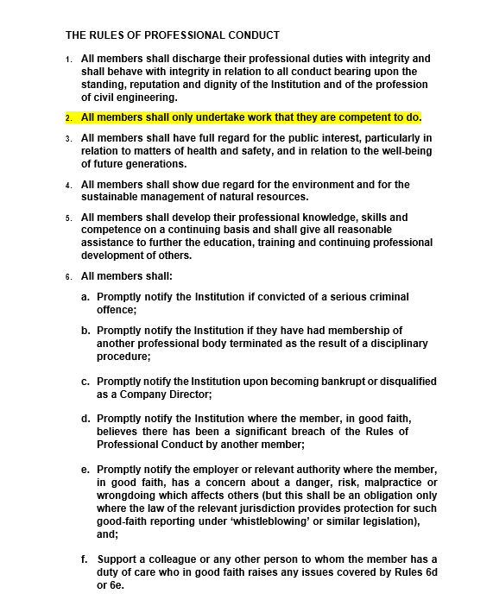

Appendix 3 – Flexible Working Policy (Ltd, 2021).
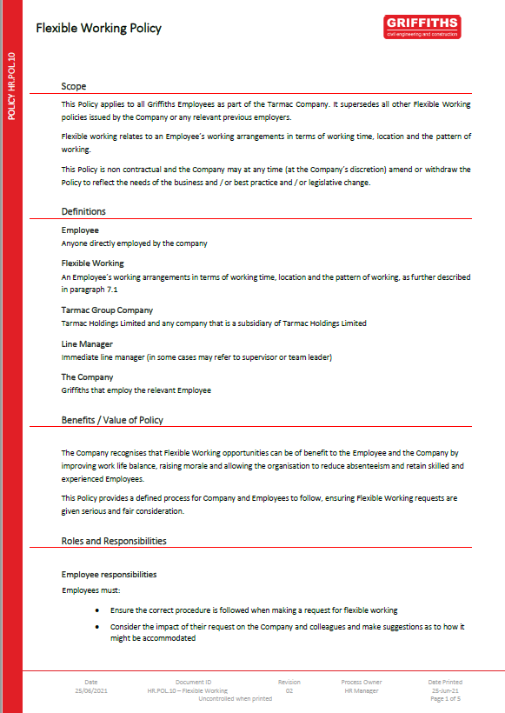
Appendix 4 – My CV and Career Experience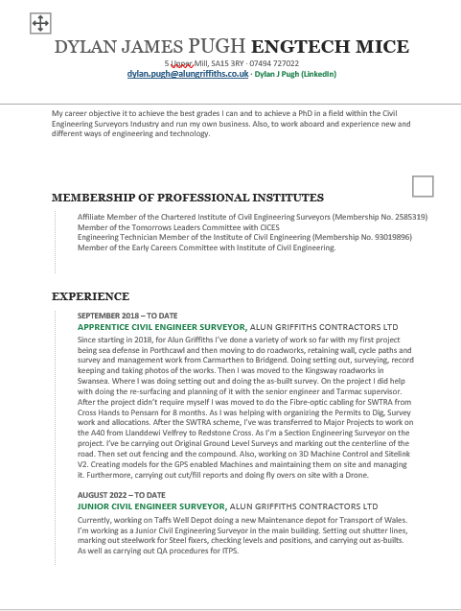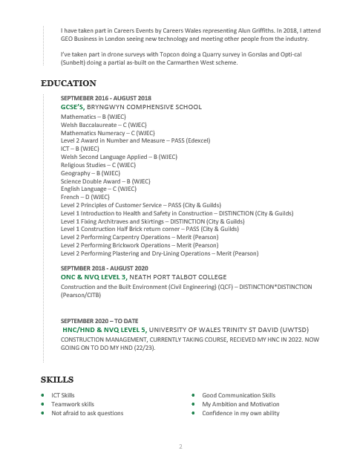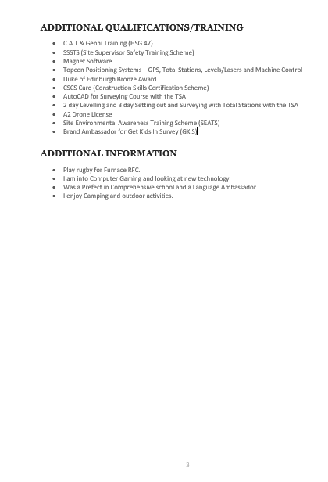

Appendix 5 – Personal Development Plan
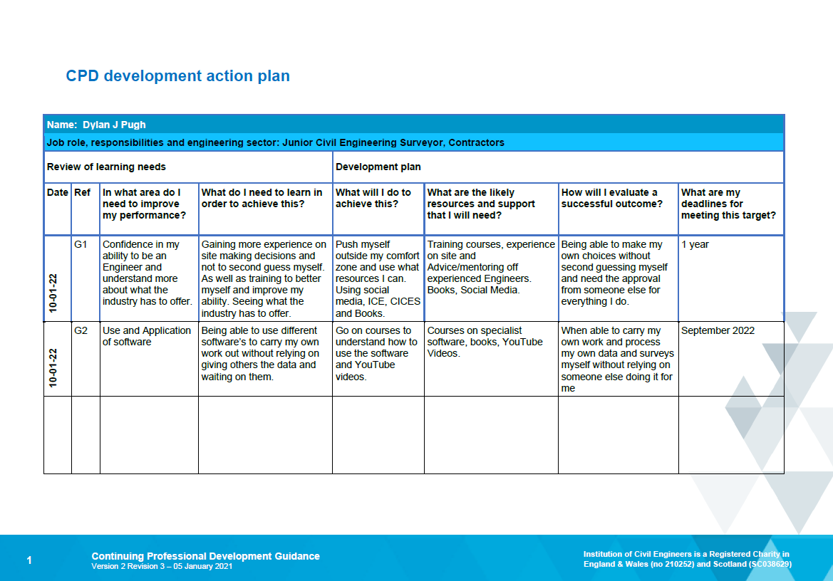
Appendix 6 - Bronwydd Guide showing level control


