Name | Student Number | Date | Lecturer’s Name | Your score
Mohsin Mahmood | 2441092 | 30/06/2025 | Daniel | To be filled by the marker  ___/40
You will have 90 minutes to complete this assessment. It is divided into three sections: note-taking, paraphrasing and writing a paragraph.
---------------------------------------------------------------------------------------------------------------------
1. Take diagrammatic notes from the passage below using the space provided:

The university experience is not just about subject knowledge, but also about developing skills that will equip you for your future life. For starters, it's impossible to graduate without a range of people skills under your belt. You'll meet new people from different backgrounds. You'll also interact with lecturers, tutors and university staff almost daily. Another life lesson that university teaches you is taking responsibility for yourself, your own schedule and learning. A lot of university study is self-directed - it's up to you to plan and organise your work, juggle multiple projects and manage deadlines – you will need to develop self-motivation if you want to succeed. Let’s not forget learning how to overcome obstacles; whether academic, work-related or personal, you'll face your fair share of hurdles as a student, but you will develop resourcefulness and resilience in the process. If you were a bit unorganised before you went to university, you won't be by the time you leave. To successfully navigate student life you'll need to handle a variety of study, work, social and personal commitments and the only way to do this is with organisation and time management. Finally, university provides plenty of opportunities to work on and boost your confidence: you'll work in groups, deliver presentations, complete assessments and maybe even become a class representative.
Adapted from: https://www.prospects.ac.uk/applying-for-university/university-life/7-life-skills-youll-learn-at-university

Space for your notes (max 12 marks):
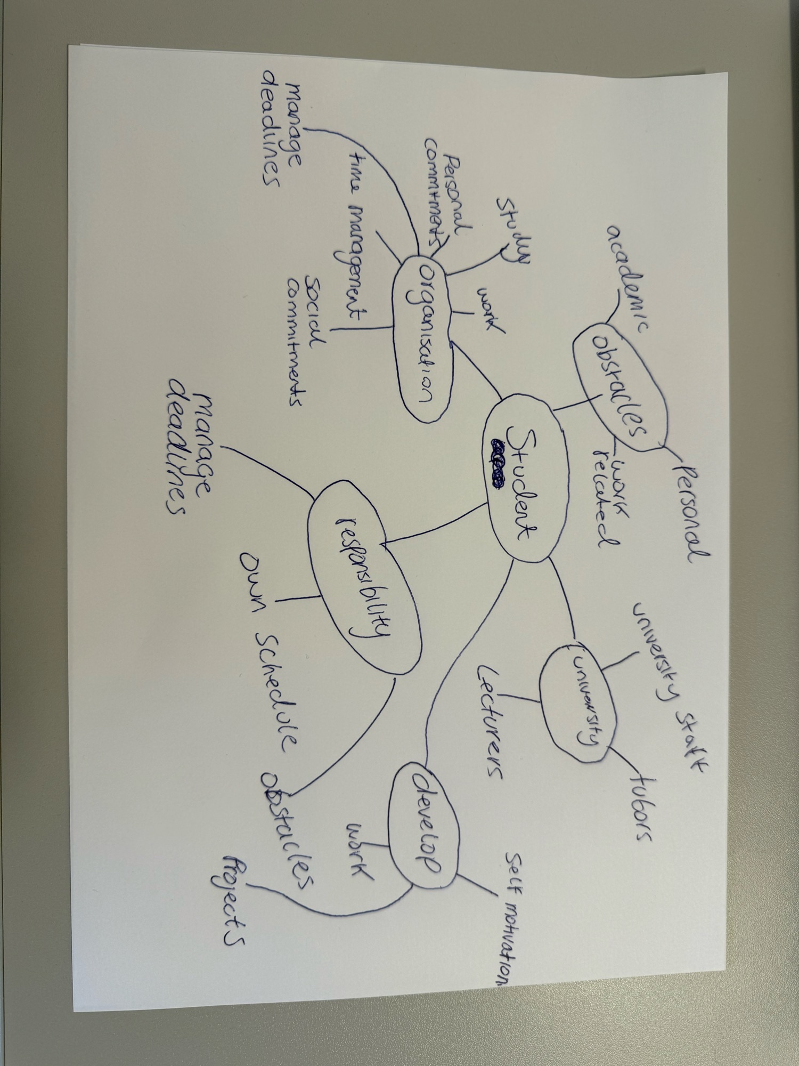

2. Paraphrase the following sentences (max 3 marks for each, max 12 marks in total):

a) To successfully navigate student life you will need to handle a variety commitments.

To adequately manage student life, you will need to grasp various commitments.

b) You will need to develop self-motivation if you want to succeed at university.
If you want to excel at university you will need to establish self-motivation.

c) Many students find it challenging to manage stress during assessment periods.
Many pupils find it difficult to oversee stress during assessment periods.

d) Frequent reading can help you become a more effective communicator.

Regular reading can assist you to becoming a more successful communicator.

3. Write a well-structured paragraph (8 sentences) on the following topic:

Effective time management techniques for university students

Your paragraph must be written in full sentences (no bullet points) and in an academic style.

(max 16 marks in total)

Effective time management techniques for university students are vital for academic success whilst managing personal commitments. Students can implement various methods for time management such as the 4 D strategy or Eisenhower decision making. Another method which could benefit students would be to take regular breaks to minimise distractions. By implementing these strategies, university students can enhance productivity, reduce stress and achieve academic success. Time management also involves setting realistic goals and understanding personal limitations. Regular reflection on time management strategies can help identify areas which need improvement. If students continue to change their approach, they can develop effective habits that will benefit them with time management. Finally, remembering time management is a skill that enhances with practise. _____________________________________________________________________________________________
______________________________________________________________________________________________________________________________________________________________________________________________________________________________________________________________________________________________________________________________________________________________________________________________________________________________________________________________________________________________________________________________________________________________________________________________________________________________________________________________________________________________________________________________________________________________________________________________________________________________________________________________________________________________________________________________________________________________________________________________________________________________________________________________________________________________________________________________________________________________________________________________________________________________________________________________________________________________________________________________________________________________________________________________________________________________________________________________________________________________________________________________________________________________________________________________________________________________________________________________________________________________________________________________________________________________________________________________________________________________________________________________________________________________________________________________________________________________________________________________________________________________________________________________________________________________________________________________________________________________

