


DETECT AND ANALYSE DDOS TRAFFIC IN SOFTWARE-DEFINED NETWORKs
Daniel James
Nitheesh Kaliyamurthy

Project submitted as part of the requirements for the award of BSc (Hons) Computing (Computer Networks and Cyber Security)

April 2025

Declaration of Originality
I, Daniel James declare that I am the sole author of this Project; that all references cited have been consulted; that I have conducted all work of which this is a record, and that the finished work lies within the prescribed word limits.

This work has not previously been accepted as part of any other degree submission.

Signed: Daniel James
Date: 28/04/2025

Form of Consent
I, Daniel James hereby consent that my Project, submitted in candidature for the BSc (Hons) Computing (Computer Networks and Cyber Security), if successful, may be made available for inter-library loan or photocopying (subject to the law of copyright), and that the title and abstract may be made available to outside organisations.

Signed: Daniel James
Date: 28/04/2025

Copyright Acknowledgement
I acknowledge that the copyright of this project report, and any product developed as part of the project, belong to University of Wales Trinity Saint David, Swansea.

Abstract

This project has investigated the detection of Distributed Denial of Service (DDoS) attacks within Software-Defined Networks (SDNs) using an entropy-based method. This project began with a systematic literature review to gain fundamental knowledge on SDN architecture, the vulnerabilities introduced by the centralised control, and the challenges of detecting DDoS attacks. Various detection methods were analysed, and the entropy-based model was chosen for its low computational requirements and suitability for real-time environments.
As a part of the experiment a simulated SDN environment was designed using Mininet and the Ryu controller, consisting of a simple topology of servers, clients, and attackers. The traffic for this network was generated using hping3 to simulate both benign and malicious activity. Moreover, an entropy-based detection system was developed to monitor the randomness of network traffic and source IP addresses, alerting the system of a potential DDoS attack when sharp drops in entropy occur. This experimental system was evaluated across five controlled runs, measuring the detection accuracy, entropy values, CPU usage, and memory usage. These results have showed a system that achieved a 100% accuracy across all runs, without any false positives, with a very minimal memory overhead and effective real-time mitigation through blacklisting attacker IPs. However, the system performed well in a small-scale experiment, limitations such as reliance on a static threshold and a simple network topology were identified.
Finally, recommendations for future work including the implementation of a dynamic threshold, scaling up the experimental environment, integrating real-world datasets, and exploring hybrid detection models has been discussed in length to improve robustness. This report has presented the full research process, including literature review, design and implementation, testing and evaluation, and reflections on the project’s conduct and outcomes.

Table of Contents

Declaration of Originality ii
Form of Consent ii
Copyright Acknowledgement ii
Abstract iii
Table of Contents iv
List of Figures vii
Chapter 1 – Introduction 10
1.1 Introduction 10
1.2 Aim 11
1.3 Objectives 12
1.4 Structure Of The Project 12
Chapter 2 - RESEARCH & REVIEW OF LITERATURE 14
2.1 Introduction 14
2.2 Methodology 15
2.2.1 Search Strategy 15
2.2.2 Inclusion Criteria 16
2.2.3 Exclusion Criteria 16
2.2.3 Search Results And Refinement 17
2.3 Summary of Results 18
2.3.1 Regional Research 18
2.3.2 Summary of Literature 18
2.3.3 Summary of Datasets 21
2.4 Background on SDNs 21
2.4.1 SDN Architecture & Key Components 21
2.4.2 Advantages & Security Challenges 22
2.4.3 Critical Appraisal 23
2.4.4 Summary 23
2.5 DDoS Threats in SDNs 24
2.5.1 Centralised Control Vulnerabilities 24
2.5.2 Types of DDoS Attacks in SDNs 25
2.5.3 Existing SDN Security Measures 27
2.5.3 Critical Appraisal 28
2.5.4 Summary 28
2.6 DDoS Detection Techniques in SDNs 28
2.6.1 Entropy-Based Detection 28
2.6.2 Flow-Based Detection 30
2.6.3 Anomaly-Based Detection 31
2.6.4 Critical Appraisal 32
2.6.5 Summary 33
2.7 Experimental Tools for SDN DDoS Detection 33
2.7.1 SDN Simulation Platform 33
2.7.2 SDN Controllers 34
2.7.3 Traffic Generation and Attack Simulation Tools 34
2.7.4 Critical Appraisal 35
2.7.5 Summary 35
2.8 Research Gaps and Justifications 36
2.8.1 Limitations of Current Detection Approaches 36
2.8.2 Challenges in Low-Rate DDOS (LDDOS) Attack Detection 36
2.8.3 Dynamic Adaption of Detection Mechanisms 36
2.8.4 Enhancing the Generalisation of Detection Models 37
2.8.5 Critical Appraisal 37
2.8.6 Summary 37
2.9 Conclusion 37
Chapter 3 - RESEARCH METHODOLOGY 39
3.1 Introduction 39
3.2 Research Overview 39
3.3 Research Philosophy 41
3.4 Research Approach 41
3.5 Research Strategy 41
3.6 Research Choices 41
3.7 Time Horizons 42
3.8 Data Collection and Analysis 42
3.8.1 Data Collection 42
3.8.2 Data Analysis 42
3.9 Contingency Plan 42
3.9.1 Experimental setup and configuration issues 42
3.9.2 Performance Limitations of Hardware and Software 43
3.9.3 Data Collection and Accuracy Issues 43
3.9.4 Technical Failures and Data Loss 43
3.9.5 Ethical and Security Concerns 43
3.10 Gantt Chart 44
3.11 Conclusion 44
Chapter 4 – Design & Implementation 45
4.1 Introduction 45
4.2 Justification 45
4.2.1 Realtime Vs Simulated 45
4.2.2 Controller 45
4.2.3 Traffic generator 46
4.2.4 Detection Algorithm 46
4.3 Design Topology 46
4.4 Implementation 48
4.3.1 Mininet Topology Python Script 53
4.3.2 Original Ryu Controller Script 53
4.3.3 Modified Ryu Controller Script 54
4.5 Conclusion 54
Chapter 5 – Testing and Evaluation 56
5.1 Introduction 56
5.2 Observed Results 56
5.2.1 Detection Accuracy 56
5.2.2 Entropy Analysis 57
5.2.3 Latency Impact 58
5.2.4 Resource Usage 59
5.2.5 Active IPs 61
5.2.6 Entropy vs Latency Correleation 61
5.3 Evaluation of Results 62
5.4 Comparison to Related Works 62
5.5 Conclusion 63
Chapter 6 - CONCLUSIONS AND RECOMMENDATIONS 64
6.1 Summary 64
6.2 Conclusion 64
6.3 Recommendations for Further Research 65
Chapter 7 – Reflections 68
7.1 Introduction 68
7.2 Reflections Against Objectives 68
7.2.1 Objective 1: Conduct a Systematic Literature Review on SDNs, DDoS attacks, and detection methods 68
7.2.2 Objective 2: Adapt a suitable research methodology, including evaluation metrics and justification for chosen detection method 69
7.2.3 Objective 3: Design and implement an SDN simulation using Mininet and the Ryu controller to test the selected DDoS detection method 69
7.2.4 Objective 4: Analyse and compare the detection method based on accuracy, latency, and resource usage, providing recommendations for future research 70
7.3 Reflections on Conduct and Progress 70
7.4 Conclusion 71
chapter 8 – REFERENCES 72
Appendices 77
Appendix A Mininet Topology Python Script 77
Appendix B Original Ryu Controller 81
Appendix C Modified Ryu Controller Python Script 83
GLOSSARY 89

ACKNOWLEDGEMENTS

I would like to express my gratitude to my supervisor, Dr. Nitheesh Murugan Kaliyamurthy, for their invaluable support, guidance, and encouragement throughout the course of this project. Their expertise and constructive feedback were crucial in positively shaping the direction and quality of this research.
I would also like to thank Ethan Hopkins for their encouragement and support during the more challenging stages of this work.
Finally, I would like to acknowledge all of those who have provided indirect support, helping me remain focused and motivated throughout this project.

Chapter 1 – Introduction

Introduction
Traditional networking operates through a distributed control plane, where each device operates and manages its own control and forwarding decisions independently. Protocols such as OSPF, BGP, and EIGRP handle routing and pathfinding between devices. In traditional networks, the control and data planes on these devices are tightly coupled within the hardware, making the modification and configuration of network devices time-consuming. This hardware-centric design limits flexibility, slows innovation, and increases the likelihood of errors when configuring or updating policies across multiple devices. [1]
Software-Defined Networks (SDN) are a modern and revolutionary architecture for networks, which operate through the separation of the control plane from the data plane. This design centralises control to a singular device, the SDN controller, which manages all other connected networking devices and traffic within the network. This approach offers much greater flexibility, programmability, and efficiency when compared to more traditional networks. However, this centralisation creates a critical vulnerability: the controller becomes a single point of failure for the entire network, an attractive target for attackers. [2] Distributed Denial of Service (DDoS) attacks exploit the architectural vulnerabilities of SDNs, potentially causing network disruptions or failure.
SDNs are becoming increasingly adopted in cloud computing, data centres, and enterprise networks due to their advantages. However, this widespread adoption increases the potential impact of an attack. These risks underscore the urgent need for effective, real-time detection and mitigation strategies to protect SDNs from DDoS attacks and ensure their reliability. [3]
Denial of Service (DoS), and its variation, Distributed Denial of Service (DDoS) attacks attempt to harm a network’s availability through exhausting system resources, such as memory, CPU cores, and network bandwidth. The goal of these attacks is to make the network unusable for normal users. [4] The major difference between these types of attack lies in how they are executed: DoS attacks originate from a singular source, whereas DDoS attacks are launched from multiple different sources, which is often coordinated through a network of compromised devices.
DDoS attacks are classified into three categories: volume-based attacks, which flood the network with traffic with the goal of exhausting bandwidth; protocol attacks, which exploit vulnerabilities in network protocols like TCP, UDP, and ICMP; and finally, application layer attacks, which target specific application’s vulnerabilities, such as web servers, by sending a high volume of seemingly legitimate requests. [5]
These DDoS attacks can have devastating consequences on businesses, such as service outages, financial losses, and reputational harm. For example, in 2016 a botnet attack was undertaken by Mirai, which disrupted major online services through an exploit in Internet of Things (IoT) devices, launching one of the largest DDoS attacks in history. [6] Although traditional DDoS detection and mitigation techniques have been widely studied, most solutions are not tailored to the centralised and programmable nature of SDNs. These traditional techniques usually fail to adapt to the more dynamic attack patterns or fail to leverage the beneficial capabilities of SDN architectures, which leaves the network more vulnerable to the increasingly more sophisticated DDoS threats. Dong, et al. [7] identified a gap in the research regarding identification and alleviation of DDoS attacks on Software-Defined Networks.
The increasing reliance on SDNs in critical infrastructure, such as cloud platforms, enterprise networks, and IoT networks, means that DDoS attacks on SDNs could have far-reaching consequences. This project will contribute to the growing knowledge and research on SDN security by exploring practical solutions for DDoS detection and mitigation. The lack of real-time DDoS detection and mitigation strategies in SDN environments presents a critical security challenge for modern networks that this project aims to investigate.

Aim

The aim of this project is to select an existing DDoS detection algorithm, implement a proof of concept within a simulated Software-Defined Network environment, and analyse and evaluate its effectiveness through experimental testing.

Objectives
The objectives are to:
- Conduct a systematic literature review on SDNs, DDoS attacks, and detection methods.
- Adapting to a suitable research methodology, including evaluation metrics and justification for the chosen detection method.
- Design and implement an SDN simulation using Mininet and the Ryu controller to test the selected DDoS detection method.
- Analyse and compare the detection method based on accuracy, latency, and resource usage, providing recommendations for further research.

Structure Of The Project
This project will be split into three distinct sections.
The first section will include a review of literature and former studies of Software-Defined Networks, Denial of Service, Distributed Denial of Service, Security of SDNs, and OpenFlow. This literature review will be used to expand the fundamental knowledge of SDN security.
The second section of the project will outline the design and implementation of the detection and mitigation measures tested and analysed. The design and implementation will be completed on a virtualised network, and metrics will be used to compare techniques. The software and hardware requirements of the project will be outlined in this section.
The final section involves the analysis of the results from the experiment. Key metrics will be examined to assess the impact of DDoS attacks. This section will also summarise the findings, conclude the entire project, and provide recommendations for future research.
The report is structured as follows:
- Chapter one delivers a background summary of the report, specifying the aim and emphasising the objectives necessary for a successful outcome.
- Chapter two reviews relevant literature on SDNs, DDoS attacks, Ryu, and OpenFlow.
- Chapter three describes the research methodology, including research philosophies, processes and methods.
- Chapter four outlines the design and implementation of the DDoS detection.
- Chapter five presents and evaluates the experimental results.
- Chapter six concludes the report, summarising key findings and suggesting directions for future work.

Chapter 2 - RESEARCH & REVIEW OF LITERATURE

2.1 Introduction
The literature review is an analysis of existing research, helping to identify patterns, gaps, and key finding. There are several different types of literature reviews, each providing different features and benefits:
- Ad Hoc Review – A general discussion of any related literature without any strict methodology.
- Case Survey – A review to gather findings from multiple case studies to help identify common patterns or trends.
- Critical Review – Analyses a selection of studies to critique a methodology or theory.
- Systematic Review – A structured approach that follows a clear methodology to search, select, analyse, and include relevant studies, ensuring a comprehensive list of unbiased results.
- Thematic Analysis – A method used to analyse and combine findings from qualitative studies to identify recurring themes and develop new insights.
- Rapid Review – A faster version of a systematic literature review.
- Systematic Mapping – Maps the research to identify trends and gaps without the need for detailed synthesis. [8]
Among these types of literature reviews is the systematic literature review, which is a thorough and structured approach which is designed to minimise bias from the researcher and ensure the comprehensive inclusion of any relevant research. It follows a rigorous and defined methodology, including an inclusion and exclusion criteria, systematically searching research databases, and critically analysing selected studies. This approach is specifically suitable for this project for evaluating and comparing DDoS detection methods within SDNs, as it will ensure a transparent, reproducible, and unbiased discussion of the existing research.
This systematic literature review aims to analyse and compare existing research on DDoS Detection in SDNs. By evaluating the different approaches, this review will identify their strengths, limitations, and effectiveness in real-world scenarios. Additionally, the review will analyse research on the experimental tools and platforms used for SDN security research, highlighting the key technologies used such as Mininet, OpenFlow controllers, and traffic generation tools.
The chapter is structured in the following:
- Section 2.2 outlines the methodology used to systematically select relevant studies.
- Section 2.3 provides background information on SDN architecture, its key components, and security challenges.
- Section 2.4 discusses DDoS threats in SDNs, including attack vectors and existing security measures.
- Section 2.5 presents and compares various DDoS detection techniques, including entropy-based, flow-based, and anomaly-based methods.
- Section 2.6 explores experimental tools for DDoS detection research, including SDN simulators, controllers, and traffic generation tools.
- Section 2.7 identifies research gaps and justifications for further investigation.
- Section 2.8 summarises key findings and transitions into the design chapter.

2.2 Methodology

2.2.1 Search Strategy
To identify relevant studies for this review, a systematic search was conducted using the IEEE Xplore database, the following search query was used:

((Software-Defined Network OR Software Defined Networking OR SDN OR Programmable Networks OR Next-Generation Networking)
AND
(Security OR Control Plane OR Control Plane Security OR Control Plane Vulnerabilities OR Network Security OR Network Threats OR Threat Detection OR Network Anomalies)
AND
(Distributed Denial of Service OR DDoS OR DDoS Attacks OR Denial of Service OR DDoS Detection OR Flooding Attacks OR Botnet Attacks OR Machine Learning Detection OR Deep Learning Detection)
AND
(Entropy-Based Detection OR Entropy OR Flow-Based Detection OR Anomaly Detection OR Statistical Analysis)
AND
(OpenFlow OR Floodlight Controller OR Ryu Controller OR POX Controller OR ONOS Controller OR SDN Controller OR Mininet OR Network Simulation OR Traffic Generation OR Attack Simulation OR SDN Testbeds OR Emulation))

This query was created to capture studies discussing SDN vulnerabilities, control plane centralisation, and DDoS attacks, with a focus on OpenFlow, Ryu, and Mininet.

2.2.2 Inclusion Criteria
To ensure relevance the following inclusion criteria was applied:
- Relevance to SDN-Based DDoS Detection – The studies must focus on DDoS detection methods within an SDN environment, including the approaches used for experiments, algorithm models, or security frameworks.
- Empirical Evidence: Only research that provides experimental results, simulations, or performance evaluations are included.
- Focus on OpenFlow and SDN Controllers: Studies that incorporate OpenFlow-based SDN architectures, or widely used controllers such as Ryu, Floodlight, ONOS, or OpenDaylight are included.
- Recent Publications: To capture only recent advancements within SDN DDoS detection, only studies published since 2020 have been included.
- Peer-Reviewed Sources: Only journal articles and conference papers published and peer reviewed are considered.
- Comparative Analysis of Detection Methods: Studies that evaluate or compare multiple detection techniques within SDNs are included.
- Performance Metrics – Research that measured detection effectiveness based on metrics such as accuracy, false positive rate, latency, or resource usage are included.

2.2.3 Exclusion Criteria
To ensure relevance to the project and research quality, studies were excluded based on the following criteria:
- Non-SDN Scope: Research primarily focused on traditional networking architecture or security mechanisms without directly applying to SDNs.
- Irrelevant Security Focus: Studies that do not specifically address DDoS detection in SDN, including those focused solely on general SDN security or DDoS mitigation strategies.
- Non-Empirical Studies – Theoretical frameworks, surveys, or reviews that do not provide experimental results, simulations, or implementation details.
- Methodological Gaps – Papers with insufficient details on methodology, evaluation metrics, or validation, making them unsuitable for analysis.
- Unrelated Attack Types – Research analysing cyber threats other than DDoS attacks, even if focused within SDN environments (e.g. insider threats, malware, botnet)

2.2.3 Search Results And Refinement
This systematic literature review initially received 538 articles from the IEEE Xplore database. The review followed a series of filtering and exclusions to refine the literature to the most relevant and high-quality studies. This process has been summarised in PRISMA diagram below.

Records published before 2020 excluded
(n = 206)
Records screened
(n = 538)

Non-journal or conference papers excluded.
(n = 13)
Reports sought for retrieval
(n = 332)

Screening

Reports excluded:
Criteria 1 – Non-SDN Scope (n = 5)
Criteria 2 – Irrelevant Security Focus (n = 191)
Criteria 3 – Non-Empirical Studies (n = 32)
Criteria 4 – Methodological Gaps (n = 23)
Criteria 5 – Unrelated Attack Types (n = 26)
Reports assessed for eligibility
(n = 319)

Studies included in review
(n = 42)

Included

2.3 Summary of Results

2.3.1 Regional Research
The map shown in Figure 1 illustrates the regional origins of the research papers included in the literature review. It demonstrates that the research on SDN security and DDoS detection is a global effort, with significant contributions from Asia.
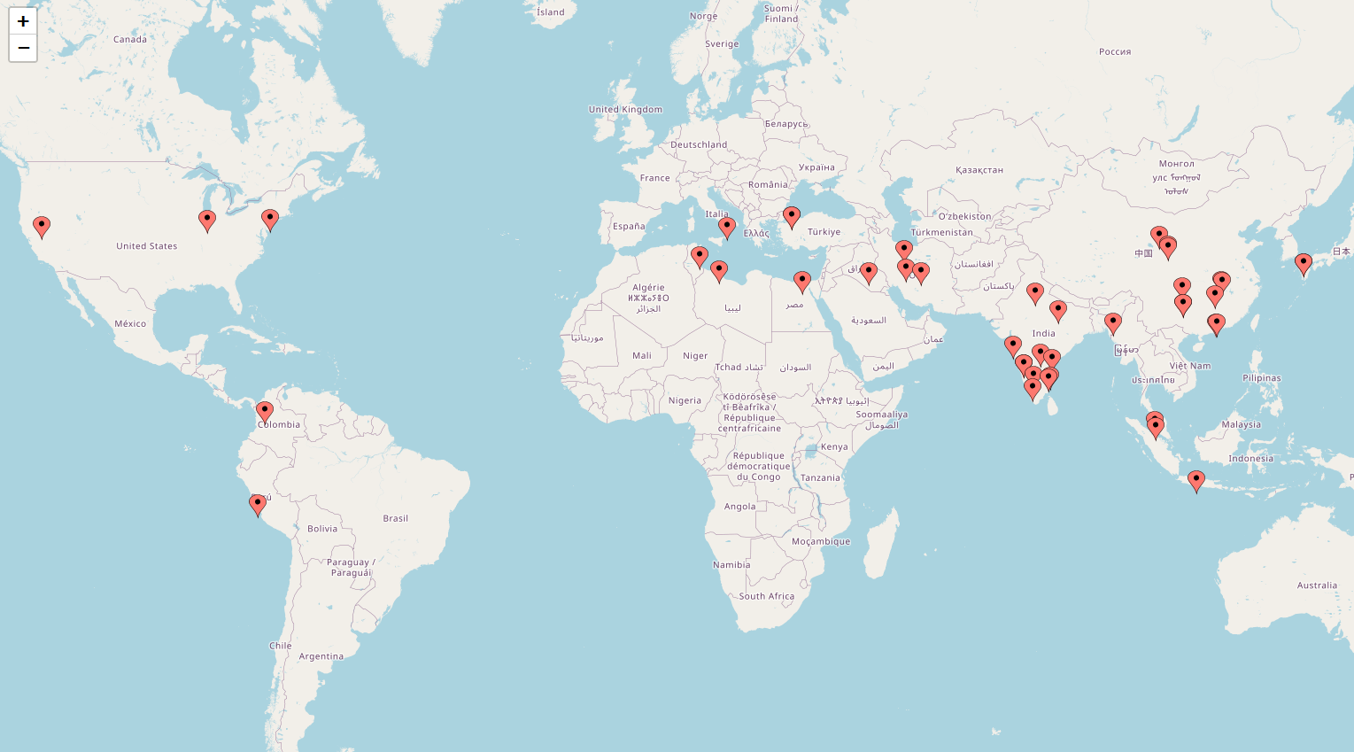
Figure 1 Distribution of research papers reviewed, highlighting the global contributions to SDN DDoS detection studies.

2.3.2 Summary of Literature
Reference | Detection Method | SDN Controller | Dataset | Dataset Commonality | Traffic Generators
[9] | - | Ryu | SDNFlow | Public | VLC Software  Selenium
[10] | Statistical Learning Method | Ryu | CICIDS2017 | Public | -
[11] | sFlow | OpenDaylight  Ryu | - | - | Hping3
[12] | Statistical Learning Method | - | - | - | -
[13] | Federated Learning | - | InSDN | Public | -
[14] | Deep Learning Model | - | KDD-CUP99  NSL-KDD  UNSW-NB15 | Public  Public  Public
[15] | Entropy based | POX | - | - | -
[16] | Entropy based | - | Generated in Mininet environment | Created | -
[17] | Machine learning | - | Flow statistics | Created | -
[18] | Machine learning | Ryu | Benign and DDoS packets | Created | Scapy
[19] | Machine learning | Floodlight | KDD-CUP99 | Public | Scapy
[20] | Entropy based | Open Network Operating System (ONOS) | Created using sFlow-RT | Created | Hping3
[21] | Anomaly based | ONOS | Created by combining datasets | Created | -
[22] | - | - | Created using Flow records | Created | Distributed Internet Traffic Generator (D-ITG)
[23] | - | Ryu | Sourced from Kaggle, exact dataset not identified | Public | -
[24] | Discrete Wavelet Transform | Ryu | Ensemble Wavelet Energy Entropy (EWEE) Dataset | Private | -
[25] | Statistical approach  Machine learning | Ryu | MAWI dataset | Public | Hping3
[26] | Entropy based | - | - | - | -
[27] | Entropy and PCA | POX | Generated a dataset through random traffic | Created | -
[28] | Entropy based | - | - | - | -
[29] | Entropy based | POX | - | - | Scapy  Hping3
[30] | Entropy based | - | CAIDA DDoS Attack 2007 | Public | -
[31] | XGBoost | Ryu | - | - | -
[32] | Machine learning | OpenDaylight | Generated by simulating an SDN in Mininet | Created | Hping3
[33] | Machine learning | Ryu | - | - | -
[34] | Machine learning | Ryu | CIC DDoS 2019 | Public | Hping3
[35] | Machine learning | Ryu | Generated specifically for the experiment | Created | Hping3
[36] | Machine learning | OpenDaylight | CIC IDS 2017 | Public | Hping3
[37] | Machine learning | Ryu | Specifically constructed for survey | Created | Hping3
[38] | Machine learning | Ryu | Benchmark and custom datasets | Private | Scapy
[39] | - | - | SUEE1 | Public | Scapy
[40] | Deep learning | Ryu | Specifically created for the study | Created | Hping3
[41] | Anomaly based | Ryu | Specifically created for this study | Created | -
[42] | Machine learning | - | InSDN | Public | -
[43] | Machine learning | Ryu | Specifically designed for this study | Created | -
[44] | Anomaly detection | - | Specifically created | Created | Hping3
[45] | - | Ryu | KDD99 | Public | Hping3
[46] | Entropy based | Floodlight | - | - | Hping3
[47] | Machine learning | Ryu | - | - | Hping3
[48] | Machine learning | Ryu | Dataset extracted from real flow table | Created | Hping3
[49] | Probabilistic Based | Floodlight | DARPA | Public | Scapy

2.3.3 Summary of Datasets
Name | Year | Attacks | Duration | Flows | Traffic Type | Format | Citation
DARPA | 1999 | 56 | 5 weeks | - | Simulated | PCAP | [50]
KDD99 | 1999 | 38 | 9 weeks | ~5M | Simulated | CSV | [51]
InSDN | 2018 | - | - | - | Emulated | PCAP | [52]
SUEE1 | 2018 | - | 24 Hours | - | Simulated | PCAP | [53]
CICIDS2017 | 2017 | 7 | 5 Days | ~2.8M | Emulated | PCAP | [54]
CICDDoS2019 | 2019 | 12 | 2 Days | ~50M | Emulated | PCAP | [55]
CAIDA DDoS Attack 2007 | 2007 | 1 | 1 hour | - | Real-world | PCAP | [56]
MAWI | 2001 - present | - | Ongoing | - | Real-world | PCAP | [57]
NSL-KDD | 2009 | 22 | - | ~147K | Simulated | CSV | [58]
UNSW-NB15 | 2015 | 9 | 31 Hours | ~2.5M | Emulated | CSV | [59]
SDNFlow | 2020 | - | 12 Hours | - | Emulated | CSV | [60]

2.4 Background on SDNs

2.4.1 SDN Architecture & Key Components
Software-Defined Networking changes how networks are managed through the separation of the control plane from the data plane, this allows for far greater flexibility and centralised decision-making. In traditional networks, each device handles its own control decisions and logic, whereas in SDNs, a centralised controller decides how traffic will flow across the network. [9]
The architecture of SDNs is typically divided into three layers: the data plane, which is responsible for forwarding packets through OpenFlow-enabled switches; the control plane, where the SDN controller applies network and security policies and manages the traffic; and the application plane, which provides additional network functions such as security and monitoring. [10] One of SDN’s biggest advantages is its programmability, allowing network administrators to adjust network and security policies in real time, optimise the resource usage, and automate security processes. This is particularly useful in dynamic environments such as cloud computing and on Internet of Things devices, where the adaptability of networking and security is essential. [12]
However, despite these benefits, the centralised control introduces major vulnerabilities, as SDN controllers become a single point of failure, making them a target for cyber-attacks. [11] Prabhu & Balamurugan [12] suggest that a model that utilises multiple SDN controllers to improve security and scalability, but their research lacks real-world testing. Deploying multiple controllers in large networks can introduce latency and synchronisation issues, which aren’t fully addressed in their study.
Similarly, while Buzzio-Garcia et al. [9] highlight the benefits of OpenFlow’s dynamic traffic management, their findings are based on simulation environments, meaning real-world deployment challenges may not have been fully considered. Niu et al. [10] provide a practical breakdown of SDN’s layered architecture, discussing how security measures can be integrated at the different layers. However, their work is more focused on attack detection techniques rather than the structural vulnerabilities of SDN itself. Meanwhile, Gupta et al. [11] explore sFlow-based traffic monitoring as a method for detecting threats in SDN environments. Their research makes a strong case for integrating sFlow into SDN controllers, but it does not fully consider the processing requirements required to analyse large-scale traffic data in real time.

2.4.2 Advantages & Security Challenges
SDN introduces several advantages, focusing on centralised security enforcement, network automation, and real-time threat response. SDN’s ability to dynamically adjust the security policies across the entirety of the network allows for faster anomaly detection and implementation of mitigation strategies, reducing the likelihood of prolonged cyberattacks. [15] The programmability of SDNs also make it easier to implement custom security mechanisms, enhancing its adaptability to emerging trends. [14]
However, this centralised control that enhances the security also introduces risks. SDN controllers serve as a single point of failure, making them a target for DDoS attacks and controller hijacking. [13] Federated Learning (FL) is a model that has been discussed by Hussain et al. [14] to decentralise the security operations, ensuring privacy and distributed threat detection, however these FL models suffer from inconsistent data distribution, limiting their ability to generalise and synchronise data across different SDN controllers.
Another key challenge is the computational requirements for advanced security mechanisms. Hussain et al. [14] propose a Deep Learning (DL) based intrusion detection system, which improves upon the attack detection accuracy, but the high resource requirements and the need for a large dataset make the implementation in real-time SDNs difficult.

2.4.3 Critical Appraisal
The background research on SDN architecture and security challenges clearly shows how beneficial centralised control can be but also highlights serious vulnerabilities. While the studies by Prabhu & Balamurugan [12] and Buzzio-Garcia et al. [9] offer valuable insights, they also mainly rely on simulations, limiting the real-world applicability and reliability. Moreover, the proposed solutions such as federated learning and sFlow show potential but often overlook issues such as resource requirements and scalability issues in real deployments.

2.4.4 Summary
To summarise, SDN offers major advantages to flexibility and security management, but also brings in new risks through the centralisation of the control plane. While the research has been made to progress solutions such as multi-controller models and federated learning, many approaches have yet to be fully tested on real-world environments, highlighting the ongoing need for practical security measures.

2.5 DDoS Threats in SDNs

2.5.1 Centralised Control Vulnerabilities
One of the major vulnerabilities of SDNs is their reliance on a centralised control plane, making the SDN controllers a single point of failure. This centralisation can be exploited in a variety of different ways, such as through DDoS attacks, rogue controllers, and flow table manipulation. In traditional networking, the control decisions are distributed throughout the different devices, which limits the impact of the attack, whereas in SDNs, an attack who disrupts the controller can compromise the entire network.
Mathew & Vidhate [16] highlight several vulnerabilities that originate from SDN’s layered architecture, particularly in the control layer. A hijacked controller can manipulate network behaviour, redirect traffic, or disable security policies. Additionally, weak authentication mechanisms between the controller and devices can lead to unauthorised access and exposure of network information. Finally, attackers can also exploit the lack of strong encryption in SDN’s north and southbound interfaces, intercepting the communications between network layers and injecting malicious policies and rules.
Macias et al. [17] discuss how SDN’s reliance on the OpenFlow-based traffic management can lead to resource overload on the controller, where excessive traffic and packet requests can overwhelm the control plane. Their paper propose ORACLE, a model that distributes the processes between the data and control planes, which reduces the burden on the controller. However, this approach still requires significant hardware resources and can introduce latency when processing large amounts of traffic flows.
Wan & Yang [18] focuses on how DDoS attacks have changed to copy normal traffic patterns, making them harder to detect. Their study highlights the challenge of differentiating legitimate traffic from malicious traffic, this is further exacerbated when attackers utilise machine learning to adapt to the SDN’s security measures. This demonstrates how traditional DDoS detection techniques are no longer enough.
Yin et al. [19] highlight a significant SDN vulnerability known as Table-Miss Attack, in which an attacker will flood the network with unknown packet types, forcing the switches to constantly query the controller. Since SDN’s architecture relies on the controller to make forwarding decisions for new and unrecognised flows, the excessive number of these requests can quickly overload the control plane, leading to performance issues and network failure. Their study implements a detection model simulated using the Floodlight Controller on a Mininet virtual machine, achieving a 99.53% detection accuracy. However, this approach relies heavily on machine learning based traffic analysis, which can be difficult to implement in real-world SDN environments due to the high computational requirements.
While all four of these papers offer valuable insights into the vulnerabilities of centralised control of SDNs, they also have a variety of limitations. Yin et al. [19] provide an effective detection model for table-miss attacks, but their reliance on machine learning detection introduces concerns about real-time feasibility. Macias et al. [17] propose a processing model but they do not fully consider the scalability and latency issues. Wan & Yang [18] accurately identify how attackers are adapting their DDoS attack techniques, but their study lacks any practical implementation. Finally, Mathew & Vidhate [16] offer a theoretical viewpoint on security risks, but their analysis and validation of their findings for their suggested countermeasures is lacking.

2.5.2 Types of DDoS Attacks in SDNs
DDoS attacks in SDN environments can be categorised into three types: volumetric attacks, protocol-based attacks, and application-layer attacks. Each of these categories exploit different vulnerabilities found within SDNs, focusing on the controller, switches, and communication channels.
Volumetric attacks, such as TCP-SYN flood, aim to exhaust network bandwidth through overwhelming the SDN controller and switches with traffic. Das et al. [21] explain that in the SDN architecture, the TCP-SYN flood attack can take advantage of the Transmission Control Protocol (TCP) handshake process. The attackers will send lots of TCP SYN packets without completing the handshake, causing the target to allocate memory for these requests indefinitely. Since the SDN controllers manage the flow of traffic dynamically, an excessive number of new malicious requests can cause a significant delay in the processing of legitimate traffic. Das et al. [21] also propose an OpenFlow based detection method that uses machine learning to differentiate between normal and attack traffic, this achieved a 98% detection accuracy in their tests. This approach relies heavily on predefined attack signatures, making it less effective against more dynamic and adaptive attack strategies.
Protocol-based attacks exploit weaknesses within the network protocols to decrease network performance. Kumar et al. [20] discuss ICMP and UDP flood, which overwhelm SDN controllers through sending many seemingly legitimate protocol requests. ICMP flood attacks, also referred to as Ping Floods, send constant ICMP echo requests to a target, requiring more processing power to handle the unnecessary responses. Similarly, UDP flood attacks work by overwhelming the SDN network through targeting random ports, causing the target system to utilise more resources while processing these invalid requests. Kumar et al. [20] demonstrate in their paper how SDN controllers struggle to differentiate between real and malicious traffic in these scenarios, this can be exacerbated further when attackers employ more sophisticated techniques such as source address spoofing to evade detection.
Application-layer attacks target the services running on SDN-based infrastructures, often targeting vulnerabilities in the HyperText Transfer Protocol (HTTP) or Domain Name System (DNS), to imitate real traffic patterns to evade detection. Alomin et al. [61] highlights how low-rate DDoS attacks are a major threat to SDN environments. Unlike high-volume attacks discussed above, these low-rate attacks slowly deplete the systems resources by sending periodic and seemingly normal requests, however they keep these connections open for an extended period. This process forces the SDN controller to constantly change and process traffic rules, eventually leading to the exhaustion of network resources. Their study demonstrated how a decision tree-based method could effectively segregate low-rate DDoS traffic patterns, achieving a 91% detection accuracy through their testing. However, it is important to note that false positives remain to be an issue in this model, especially in dynamic environments where the normal network traffic can fluctuate.
Finally, Hybrid DDoS attacks combine multiple attack vectors into one, often blending volumetric, protocol, and application-layer attacks to attempt to bypass the security measures in place in the SDN. The centralised nature of SDNs make these attacks more dangerous as a coordinated multi-layer attack can overload bandwidth, exhaust system resources, and disrupt the critical services. Nadeem et al. [22] investigate a botnet-based hybrid attack, where a large-scale botnet will launch both flooding and application-layer attacks to attempt to disrupt the SDN operations. This study demonstrates how certain deep learning techniques, notably Convolutional Neural Networks (CNNs), can differentiate between normal and malicious hybrid attack traffic. However, Nadeem et al. [22] identify challenges throughout their study, such as the scalability of deep learning-based detection systems. Their approach requires extensive training on diverse datasets for detection, and real-time classification for monitoring, which remains to be computationally expensive on larger scale SDNs.

2.5.3 Existing SDN Security Measures
The study by Bodapati et al. [23] proposes the integration of Linear Support Vector Machines (SVM) with SDN to enhance the security by detecting network attacks, with a detection accuracy of 93%. Their approach utilises a multi-controller SDN setup using the Ryu controller to improve network resilience. While this study demonstrates effective attack detection, the reliance on linear SVMs raise concerns regarding their adaptability to more complex attack patterns. Additionally, the resource usage requirements for running SVMs in real-time SDN environments have not been fully addressed in the study.
Wang et al. [24] introduce METER in their study, a Discrete Wavelet Transform (DWT) based method to detect low-rate DDoS attacks. Their approach wavelet entropy and machine learning to enhance the detection accuracy, outperforming their baseline detection methods. The study shows the advantages of DWT over more traditional detection models through improving the precision and reducing false alarms. However, the overall complexity and high computational requirements raises concerns, particularly when deployed in large scale networks.
Finally, Fouladi et al. [25] compares statistical and machine learning based detection techniques. Throughout the course of their study, they find that machine learning models, particularly those utilising CNN-based monitoring achieve a higher accuracy while also maintaining efficient resource usage. However, their findings show that integrating these detection models into SDN controllers can impact performance due to the higher processor overhead requirements. Moreover, the study highlights the challenges of optimising machine learning models without causing excessive computational requirements.

2.5.3 Critical Appraisal
The studies reviewed above highlight the vulnerabilities of SDNs to DDoS attacks, particularly focusing on their centralised architecture. While proposed solutions such as ORACLE, machine learning models, and hybrid defence mechanisms show potential, many of the methods suffer from scalability issues, high computational demands, or a lack of real-world testing. Additionally, approaches like Linear SVMs, DWT models, and CNN-based techniques have been shown to improve detection accuracy, they often come at a cost of either performance or resource usage that are not fully addressed in the papers.

2.5.4 Summary
In summary, SDNs offer significant advantages but also introduce critical security risks, particularly focusing on the centralised controller. DDOS attacks have continued to evolve, using strategies such as exploiting weaknesses in protocols and mimicking normal traffic to bypass detection for longer periods. Finally, even though there are a large range of detection methods, many remain purely theoretical or are limited by resource constraints, which highlights the need for lightweight, scalable, and adaptable solutions for SDNs.

2.6 DDoS Detection Techniques in SDNs

2.6.1 Entropy-Based Detection
Entropy-based detection is a widely used technique for identifying DDoS attacks. This method works by evaluating the randomness in network against a static or dynamic threshold to detect anomalies. DDoS attacks typically introduce variations compared to the normal network traffic, allowing these entropy values to be used for detection.
One approach to improving real-time DDoS detection is through analysing how the entropy values change during an attack. Lotfalizadeh & Kim [30] proposes a real-time entropy-based method that categorises groups network flows together based on the patterns of the packet count. Their findings showed that during a DDoS attack, the entropy value of source IP addresses increases sharply, whereas the entropy of destination IP addresses decreases, which can be used to identify the attacker.
Asgari & Akbari [29] develop an OpenFlow-based entropy detection system that combines statistics from the flow-table with entropy analysis to help detect TCP SYN, UDP, and ICMP DDoS attacks. Their method improves the accuracy by adding two monitoring components within the SDN controller. While this method effectively reduces false positives, it heavily relies on static thresholds, which can limit its ability to adapt to advanced attack techniques and traffic changes.
Tracking entropy trends in SDN traffic can provide an early warning for DDoS attacks. Fioravanti et al. [28] focus on the Packet_in message trends, finding that entropy values will drop significantly when an attacker targets a small number of destination IPs. Their approach improves the detection accuracy by optimising the size of the observation window, but this approach requires manual parameter tuning, making automation and widespread deployment more complex.
An approach using a dynamic threshold can be used to make entropy-based detection more adaptable. Hemmati et al. [26] propose a model that utilises a dynamic threshold that continuously adjusts based on real-time traffic. Their model improves the detection accuracy of an entropy-based system from 96% to 98% while also reducing the number of false positives. However, this improvement comes at the cost of higher computational requirements, which can impact the performance of larger networks.
Finally, a hybrid approach that combines entropy analysis with machine learning techniques has also been investigated. Almomin et al. [27] proposed a model using Principal Component Analysis (PCA) alongside entropy measurements to detect multi-target DDoS attacks. Their model distinguishes between normal and malicious traffic patterns to improve accuracy, but implementing PCA introduces more computational requirements, making it more challenging for larger real-time SDN deployments.

 | Algorithms | Attack Criteria
[26]  [29]  [28] | $$H\left(X\right)= -\sum_{i=1}^{N}{P\left(x_{i}\right)\log_{2}{P\left(x_{i}\right)}}$$  $$P\left(x_{i}\right)=\frac{Number of times IP appears}{Total number of packets}$$  $$T= \frac{μ_{a}-μ_{n}}{σ_{a}+σ_{n}}×σ_{a}+μ_{a}$$ | If entropy drops below the dynamic threshold, an attack is detected:  $$H<T$$
[27]  [30] | $$H\left(X\right)= -\sum_{i=1}^{N}{P\left(x_{i}\right)\log_{2}{P\left(x_{i}\right)}}$$  $$P\left(x_{i}\right)=\frac{Number of times IP appears}{Total number of packets}$$ | If entropy is near zero, an attack is detected:  $$H≈0$$  Higher entropy indicates normal traffic:  $$H>2.0$$

2.6.2 Flow-Based Detection
Flow-based detection techniques analyse the network traffic patterns in SDNs through examining the characteristics of packet flows rather than individual packets. This method is useful for detecting DDoS attacks, as the malicious traffic often have unique flow behaviour. Several studies have explored flow-based approaches, one study by Alhamami & Albermany [32] investigates how machine learning models can be used to detect DDoS attacks based on flow-level characteristics. They utilise the OpenDaylight controller within a Mininet virtual environment and apply multiple predefined algorithms, including XGBoost, Logistic Regression (LR), Support Vector Machines (SVM), Naive Bays (NB), and K-Nearest Neighbours (KNN). Their results show that the XGBoost algorithm achieves the highest detection accuracy at 99.26%, outperforming the other models detected. However, while showing strong performance, the XGBoost algorithm requires extensive training data which can be a challenge for real-time deployment in SDN environments.
Similarly, Deng et al. [31] present an online DDoS detection system that also uses the XGBoost algorithm. Their model utilises the OpenFlow Packet_in messages to detect abnormal flows, achieving a higher detection rate while maintaining an efficient resource usage.
A study by Kousar et al. [34] explores how Decision Tree (DT) based flow analysis can be used for DDoS detection in SDN environments. Their model utilises the CIC-DDOS 2019 dataset along with monitoring live packet capture from an SDN using the Ryu controller. The study compares the performance of DTs, SVM, and Naïve Bayes algorithms, concluding from their findings that DTs find the highest detection rate. The advantage of the DT approach is its interpretability and lower computational complexity when compared to deep learning methods.
Lastly, Zhang et al. [33] propose a flow-based detection model using Gradient Boosting Decision Trees (GBPT). Their approach extracts flow level features from the controller, such as packet count, flow rate, and source IP entropy. Their model achieved an average accuracy of 93.88% with a false positive rate of 0.0411, demonstrating its effectiveness at discerning between malicious and legitimate traffic. However, its computational requirements remain to be a concern, especially in large-scale deployments where processing large volumes of the flow data could introduce latency.

2.6.3 Anomaly-Based Detection
Anomaly-based detection methods in SDN focuses on identifying deviations from normal traffic to find potential DDoS attacks. These methods can utilise statistical, machine learning, and deep learning techniques to analyse network traffic to distinguish between normal and malicious traffic.
One approach to anomaly-based detection is with bi-directional recurrent neural networks (BRRNs), as explored by Itagi et al. [37]. This study introduces a real-time DDoS detection model that leverages BRNN to categorise normal and attack traffic. The model works by processing sequences of network traffic and identifies anomalies based on deviations within the packet flow behaviour. Their results showed that BRNN outperforms traditional feed-forward neural networks (FFNN) when comparing detection accuracy. However, the effectiveness of their model relies heavily on accurate training data, which can be more difficult to obtain in dynamic environments.
Another method for anomaly detection is an approach using Gini impurity and random forest, proposed by Tan et al. [36]. This model combines statistical and machine learning techniques to improve the detection accuracy. The system utilises two layers of detection, first using a Gini impurity-based trigger module to locate and identify possible anomalies, once an anomaly has been detected, a random forest classifier is used to further confirm an attack. The random forest only processing possible anomalies is highly advantageous as it reduces unnecessary processing. Results from the experiment in their study show a higher accuracy and lower false alarm rate in comparison to SVMs and DTs.
Alashhab et al. [38] proposes an online machine learning approach for detecting and mitigating low-rate DDoS (LDDoS) attacks. Their approach utilises two different approaches to classify attacks; Stochastic Gradient Descent (SGD) and Explainable Bosting Machine (EBM), which continuously updates the parameters of the model in real time, making this system much more adaptable. Their approach highlights how more traditional approaches for detecting DDoS attacks fall short while detecting LDDoS attacks as these attacks generate traffic below the thresholds required in more conventional anomaly-based detection. The proposed approach in this study is tested in an SDN environment simulated using Mininet with a Ryu controller, achieving a 99% detection accuracy on training data, outperforming existing strategies.
Finally, Sathwik et al. [35] explore the use of a supervised and unsupervised learning technique to provide enhancements to anomaly-based techniques. Their study revolved around extracting relevant network traffic, creating a classification model using supervised learning, and then finally using unsupervised techniques to detect unseen attack strategies. This hybrid strategy using supervised and unsupervised learning improves detection accuracy and helps to identify new attack patterns, improving adaptability. Their framework utilises the Ryu controller, allowing for real-time traffic monitoring in a Mininet simulated environment. While their approach strengthens SDN security, it still suffers from high computational requirements.

2.6.4 Critical Appraisal
The different detection techniques discussed above show a range of promising strategies to identify DDoS attacks. The entropy-based method offers simplicity and low resource requirements but struggles with adaptability without introducing a dynamic threshold. Flow-based and anomaly-based approaches, particularly those like XGBoost, Random Forest, and BRNNs, achieve a much higher detection accuracy, but at the significant cost to resource requirements. While each method improves on a specific aspect towards DDoS detection, concerns remain regarding the scalability, real-time deployment, and the need for large volumes of training data.

2.6.5 Summary
To summarise, entropy, flow, and anomaly-based detection techniques all offer individual strengths to detecting DDoS attacks. Entropy-based models provide a lightweight and real-time detection, whereas flow-based and anomaly-based offer a higher accuracy through machine learning. Overall, while progress has been made in the field, a balance between accuracy, adaptability, and computational efficiency must be decided to make these approaches more viable for real-world deployments.

2.7 Experimental Tools for SDN DDoS Detection

2.7.1 SDN Simulation Platform
Mininet is a widely used SDN simulation environment that provides a virtualised environment used for testing and evaluating SDN architectures, security, and attack mitigation strategies. Mininet is particularly useful for research in DDoS detection within SDNs due to its flexibility in creating and modifying network topologies and its compatibility with OpenFlow controllers. Mininet enables researchers to create a virtual SDN environment, including hosts, switches, and controllers on a single system. It allows users to run real SDN applications, use networking tools, and modify OpenFlow switches in a controlled setting. The study by Sidiq et al. [39] highlight the importance of Mininet in a research setting. This work demonstrates how OpenFlow switches can be implemented on a Mininet environment.
A key advantage of Mininet is its ability to provide an isolated test environment for repeatable experiments. The study successfully utilised Mininet to generate flow-based datasets which can be used to train detection models within real SDN environments. However, one limitation identified in their research low network speed, reporting a replay rate of approximately 25 packets per second, making it an impractical solution for simulating large-scale DDoS attacks. [39]
Another study by Fatehi et al. [40] used Mininet as their network emulator for training a Multi-Layer Perceptron (MLP) based detection model. Their work successfully demonstrated how Mininet can be used to simulate a network environment, simulating 18 hosts, six OpenFlow-enabled switches, and a Ryu controller. The traffic generation process for this study also included normal network activity as well as various DDoS attack scenarios, such as ICMP, UDP, and TCP SYN Flood attacks.
The study shows the benefits of Mininet, providing a controlled environment for testing and collecting datasets, putting emphasis on Mininet’s compatibility with OpenFlow-based monitoring. A critical limitation highlighted in this study is Mininet’s inability to replicate real-world network complexities, as it lacks features such as hardware acceleration and high-fidelity traffic generation. [40]

2.7.2 SDN Controllers
SDN Controllers are the central component that manages network traffic flows. They allow for programmability, automation, and dynamic policy enforcement, making it crucial for security. SDN controllers monitor network traffic, identify anomalies, and enforce countermeasures to detect and mitigate DDoS attacks. The study by Kaushik et al. [41] demonstrates how effective the Ryu controller is at analysing OpenFlow messages to detect DDoS traffic patterns in a Mininet simulated environment. A key feature of Ryu is its ability to extract flow statistics from OpenFlow-enabled switches, such as the source and destination IP addresses of packets, port numbers, packet rates, and byte counts, which are essential for classifying DDoS attacks. Their research identifies limitations in Ryu’s scalability, as processing a large amount of network flows can introduce latency in both detection and mitigation.
Controllers can also integrate machine learning to further enhance DDoS detection accuracy. The study by Hassan et al. [42] proposes a CNN-based intrusion detection and prevention system at the SDN controller level, demonstrating superior performance when compared to more traditional machine learning methods such as DT, Random Forest, and SVM. An advantage is the centralised visibility of the network traffic, allowing to analyse for anomalies from data in multiple switches. The study successfully trains the CNN model on a SDN dataset, achieving a high detection accuracy. However, a limitation identified in the study is the computational requirements introduced by the deep learning method.

2.7.3 Traffic Generation and Attack Simulation Tools
Traffic generators are used to create datasets that mimic both normal and malicious traffic. These datasets are then used to train machine learning models for detecting anomalies. The study by Girish et al. [44] show how Generative Adversarial Networks (GANs) can be used to create SDN traffic datasets that closely resemble real-world attack scenarios. The study argues that GAN-based data generation significantly improves the detection rate from anomaly-based detection methods that require training. Additionally, Chen et al. [43] explores a different approach to traffic generation, as their study focuses on Low-Rate Denial of Service (LDoS) attacks. The study generates traffic through a periodic comparison mechanism, which is simulates LDoS attacks well due to its low bandwidth consumption and periodic nature.
To further test the resilience of SDN security, various tools are used to simulate more advanced attack scenarios. The study by Huang et al. [45] details a setup using Mininet and Ryu to simulate DDoS attacks. The authors of the study use hping3 as a traffic generator, launching large volumetric attacks against the SDN controller. A strength of this setup is its reproducibility; it allows for systematic evaluation of different detection and mitigation methods while maintaining consistent attack scenarios. Girish et al. [44] also discuss other traffic generation tools, including Scapy, TCP Relay, and hping3. While Scapy offers more flexibility in defining the attack parameters, its performance is often hampered by system resources, making it less suitable for higher speed attack scenarios.

2.7.4 Critical Appraisal
The experimental tools reviewed offer a strong foundation for an experiment in SDN DDoS detection but also highlight some limitations. Mininet provides an accessible and flexible environment for testing but struggles in terms for realism and scalability. Moreover, the SDN controllers, such as Ryu, allow for real time monitoring and enforcement but struggle to process large amounts of traffic efficiently. Finally, traffic generation tools such as hing3 and Scapy allow for reproducible attack scenarios, though resource requirements can impact high speed or volume testing. Across all the tools discussed, there is a trade-off between flexibility and realism, particularly when scaling up the experiment to more complex or larger environments.

2.7.5 Summary
Overall, Mininet, Ryu, and the traffic generation tools form a practical foundation for DDoS experiments. While they offer significant advantages towards controlled studies, their limitations surrounding scalability, resource usage, and simulation fidelity must be considered when interpreting the results from an experiment or planning future work.

2.8 Research Gaps and Justifications

2.8.1 Limitations of Current Detection Approaches
One of the biggest gaps in SDN security research is its reliance on machine learning models for detecting DDoS attacks, which are computationally expensive. The study by Maity et al. [49] highlights how traditional machine learning solutions impact the responsiveness of SDN controllers due to increase latency from higher computational requirements. While these machine learning models generally have a high detection accuracy, the drawbacks must be considered when implementing in large-scale networks. The gap here is the need to find a balance between detection accuracy and computational requirements, while also maintaining speed and low latency within the network.

2.8.2 Challenges in Low-Rate DDOS (LDDOS) Attack Detection
Another gap can be found in the research into LDDoS attacks, which are harder to detect as they mimic legitimate traffic patterns. The study by Xiangning et al. [48] attempts to solve this issue by utilising aa Bi-directional Long Short-Term Memory (BiLSTM) model that has a higher detection accuracy for LDDoS attacks. However, despite its effectiveness in the tests, this BiLSTM model still requires significant training data before it can be deployed on a real SDN environment and similarly to the previous point, the deep learning-based technique would require high computational requirements.

2.8.3 Dynamic Adaption of Detection Mechanisms
One crucial gap in the research discussed is a DDoS detection method that leverage dynamic thresholds to adapt to changing traffic patterns. The study by Wang et al. [46] proposes an approach that adjusts the detection threshold based on analysis of the real-time network traffic. This method has been proven to improve detection accuracy and reduce the chances of false positives; however, it has not been yet tested on a large-scale or real-world SDN environment.

2.8.4 Enhancing the Generalisation of Detection Models
Most detection techniques are tested and trained in controlled environments using standard datasets such as DARPA or CIC-DDoS, which may not fully represent more realistic network traffic. The study by Li et al. [47] shows the integration of Bat Algorithm (BA) with a Back Propagation Neural Network (BPNN) to optimise the feature selection and overall improve the detection accuracy. However, this algorithm relies on offline training, which prevents it from dynamically adjusting to new attack strategies in real time. Future research on this area could focus on developing an online method to train the model continuously while the SDN is live to provide more robustness to the network.

2.8.5 Critical Appraisal
While many of the existing approaches have offered high detection accuracy, they often overlook the practical limitations of their implementations, such as computational demands, real-time adaptability, and the change to dynamic traffic environments. Furthermore, many promising methods that boast high detection accuracy remain untested in realistic and large-scale SDN environments, limiting their applicability.

2.8.6 Summary
Overall, the current research highlights the gaps in balancing accuracy with resource efficiency, detecting low-rate and adaptive attacks, and adapting thresholds dynamically based on network behaviour. Addressing these limitations is essential for developing more robust solutions.

2.9 Conclusion
This chapter provided a systematic review of existing literature on DDoS detection in SDNs, evaluating the different approaches, their effectiveness at detecting attacks, and the tools used for experimentation. The analysis explored the following detection techniques: entropy-based, flow-based, and anomaly-based. For each of the detection techniques their advantages and limitations were outlined. The review focused in on how SDN’s centralisation introduces security risks, making it a prime target for DDoS attacks, and while machine and deep learning techniques offer a higher accuracy, their computational requirements and real-time feasibility remain major challenges for implementation.
Beyond detection techniques, the chapter also examines the experimental tools that are used for SDN research, including Mininet for network simulation, OpenFlow-based SDN controller such as Ryu, and various traffic generation tools. While these tools are essential for testing and validating different detection methods, they also introduce limitations, notably in scalability and real-world applications. The review also identified several gaps in current research, including the challenges of detecting LDDoS attacks and the need for more dynamic thresholds while detecting DDoS attacks. These gaps highlight areas where there is further research and innovation required to improve SDN security.
The findings from this literature review will lay the groundwork for the rest of the design and implementation within this project, which will focus on implementing a DDoS detection model and comparing the results to the literatures found. The following chapter will build on these insights, detailing the research methodology for the experimentation chapter of the project.

Chapter 3 - RESEARCH METHODOLOGY

3.1 Introduction
This chapter outlines the overall methodology for this research project to achieve the aim and objectives, including the research design, philosophy, methodology, and methods. The research design has been created to evaluate and compare different DDoS detection methods in SDN environments. This chapter will also justify the choice of methodologies and discusses how data collection and analysis will be completed.
The aim of this chapter is to provide a foundation for conducting the research, through the explanation of the planned approaches and the reasoning behind it. As the project progresses, this design may evolve, influenced by new insights and developments.

3.2 Research Overview
This research aims to achieve the objectives outlined in Chapter 1 through a systematic process, starting with an extensive literature review and ending with an experimental evaluation. The research design will be organised into distinct phases from the research onion framework, shown in figure 2: Research Philosophy, Approach, Strategies, Choices, Time Horizon, and Data Collection and Analysis.

Figure 2 Research onion framework [62]

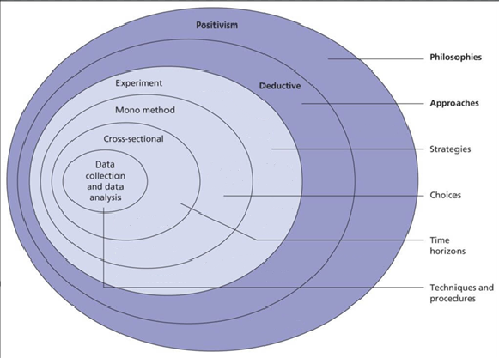
Figure 3 Research onion with choices highlighted for this project

3.3 Research Philosophy
This research will adopt a post-positivist philosophy, emphasising on the empirical observations and experimentations. Post-positivism is a suitable choice for this project as it focuses on measurable outcomes, such as detection accuracy and system performance, while also accepting that complete objectivity is difficult to achieve.
By utilising evidence-based conclusions, this research philosophy supports the project’s original aim of evaluating the solutions of DDoS detection within SDNs.

3.4 Research Approach
This project will use a deductive reasoning approach, which uses established theories on DDoS detection within SDNs and tests hypotheses using experiments. The approach will follow the sequence:
- Theory Review: Review of existing literature to show various detection methods having different performance characteristics.
- Hypothesis Formulation: Proposed result based on the research, using metrics such as detection accuracy, latency, and resource usage.
- Experimentation: A controlled SDN simulation is created to test these hypotheses.
- Data Analysis: Results are compared to expected outcomes to confirm or disprove assumptions from the literature review.

3.5 Research Strategy
The experimental section of this project includes setting up a simulated SDN environment to test detection methods. This environment will include the following key components:
- Mininet: Network emulator tool used to simulate the network topology.
- Ryu Controller: Used to manage SDN and implement OpenFlow rules.
- Traffic Generators: Tools to generate both legitimate and attack traffic.

3.6 Research Choices
This project follows a quantitative research approach, focusing on the numerical performance of detection methods. Quantitative metrics, such as detection accuracy, latency, and resource consumption provide objective evidence of effectiveness.

3.7 Time Horizons
A cross-sectional time horizon will be adopted for this project, focusing on the collection of data at a single point in time. This approach is best suited for this project to evaluate the immediate effectiveness of detection methods under specific controlled conditions.

3.8 Data Collection and Analysis

3.8.1 Data Collection
Data will be collected based on the following metrics:
- Detection Accuracy: The ability of the method to differentiate between real and malicious traffic.
- Latency: The delay introduced through the deployment of the detection method.
- Resource Usage: CPU and memory consumption of the SDN controller.

3.8.2 Data Analysis
The collected data will be analysed using tools to compare the performance of different detection methods. These results will be used to assess the effectiveness
of detection methods in real-world scenarios.

3.9 Contingency Plan
This contingency plan identifies potential risks and outlines steps to mitigate them to ensure the research remains on track.

3.9.1 Experimental setup and configuration issues
Risk: Compatibility issues between software including Mininet, Ryu controller, and traffic generation tools leading to delays in the experimental setup.
- Ensure compatibility by checking software requirements before installation.
- Use virtual environments (e.g. VirtualBox) to create an isolated environment.
- Use official documentation for troubleshooting support.
- Test individual components before combining into the full simulation.

3.9.2 Performance Limitations of Hardware and Software
Risk: Hardware constraints, such as CPU or RAM, may limit the ability to simulate larger-scale SDN environments and large volume DDoS attacks.
- Optimise simulations by reducing the number of processes running to the minimum required.
- Run experiments on cloud-based platforms if more processing power is required.
- Use lighter weight traffic generation tools to balance realism while maintaining system performance.
- Undertake experiments in phases to manage the computational load.

3.9.3 Data Collection and Accuracy Issues
Risk: Insufficient or unreliable data due to dataset size or a lack of variations in the network traffic.
- Use multiple traffic generation tools to create diverse datasets.
- Utilise real world datasets for better generalisation.

3.9.4 Technical Failures and Data Loss
Risks: System crashes, software failures, or accidental loss of results
- Regularly backup research documents, scripts, and dataset files.
- Store a copy of the data on cloud-based services for redundancy.
- Use version control to track changes.

3.9.5 Ethical and Security Concerns
Risk: Ethical considerations while simulating DDoS attacks or handling real network traffic data.
- Conduct the experiments in an isolated virtual environment.
- Ensure compliance with the University’s ethical guidelines.
- Obtain permission for any external data sources used.

3.10 Gantt Chart
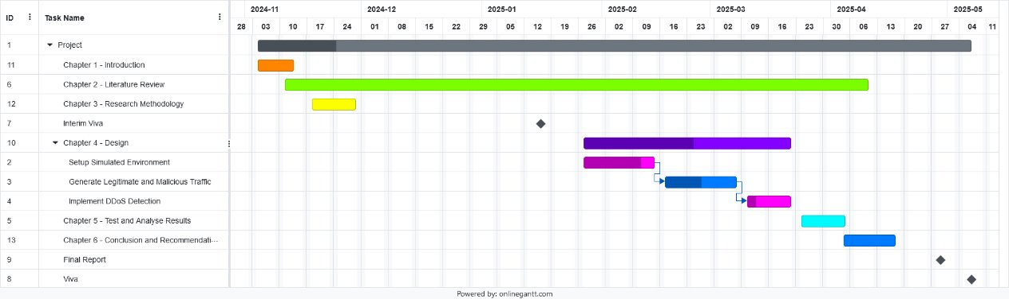

3.11 Conclusion
This chapter has outlined the research methodology, providing a framework to achieve the project’s aim and objective. A post-positivist philosophy was adopted to focus on observations and measurable outcomes, accompanied by a mixed-method approach that combines qualitative insights from literature and quantitative from experimental evaluations. Key steps include conducting a literature review, designing a simulated SDN environment, and testing detection methods against predefined performance metrics.
The chosen methodology ensures a well-rounded evaluation of DDoS detection techniques within SDNs. By integrating the theoretical and practical elements, the research remains focused on addressing the aim and objectives of the project effectively, while also ensuring reliable and actionable results.

Chapter 4 – Design & Implementation

4.1 Introduction
This chapter will outline the design and implementation of the DDoS detection model in an SDN environment. It will describe the problem and justification for the use of each of the tools and techniques in the experiment. The proposed design is based on the insights gained from the literature review in Chapter 2. The implementation details, including the software, tools, and configurations, are provided along with a step-by-step setup process to allow for replicability of the experiment.

4.2 Justification

4.2.1 Realtime Vs Simulated
A simulated environment was chosen over a real-time physical setup to reduce cost, improve the flexibility, and ensure repeatability. This choice also aligns with Sidiq et al. [39] and Fatehi et al. [40], both highlight Mininet’s effectiveness for controlled and scalable SDN experiments. The table below compares the two approaches:
Feature | Real-time Implementation | Simulated Implementation
Topology | Expensive to expand | Can be expanded at no cost for new devices
Setup | Physical devices, real cables | Virtual network using Python scripts
Flexibility | Low (changes require | High (instant reconfiguration with code)
Monitoring | Wireshark, Per device logs | Controller logs, built-in Mininet tools
Cost | High (Expensive hardware) | Low (Single virtual machine)
Scalability | Limited by quantity of hardware | Easily scalable
Testing Algorithm | Harder to iterate and test | Quick iteration, allows for script-based testing

4.2.2 Controller
Ryu was selected as the controller for this Mininet experiment due to its compatibility with OpenFlow, lightweight architecture, and ease of integration with Python. Ryu has been used extensively in literatures and studies into DDoS detection, including those by Kaushik et al. [41] and Hassan et al. [42], both of whom show Ryu’s ability to collect flow statistics and enforce security policies in real time. The widespread use in studies, modularity, and clean interface made it well suited to implement a DDoS detection algorithm while also maintaining replicability and relevance to the research.

4.2.3 Traffic generator
Rather than relying on pre-existing datasets, this project will generate its own legitimate and malicious traffic using tools such as Hping3. This decision was based on challenges encountered during the dataset integration into the experiment and further reinforced by the insights found in the literatures. As demonstrated in the studies by Huang et al. [45] and Girish et al. [44], hping3 can be used to simulate realistic DDoS traffic due to its ability to generate different types of traffic, such as TCP SYN floods, UDP floods, and ICMP floods. Generating traffic in real-time allowed for the detection algorithm to be tested under specific and reproducible conditions.

4.2.4 Detection Algorithm
This project uses an entropy-based detection algorithm, this choice is backed by the support of literatures for its efficiency, low computational requirements, and real-time capabilities. Asgari et al. [29] highlights the effectiveness of entropy methods, and Hemmati et al. [26] further improves on this by introducing a dynamic approach to assigning a threshold, that allows the system to adapt to changes in traffic.

4.3 Design Topology
The experimental topology, as illustrated below in Figure 4, consists of a single OpenFlow-enabled switch (s1) connected to a centralised SDN controller (c0), and nine hosts (h1 to h9) representing various roles within a network:
- H1 serves as a victim of the DDoS attack.
- H2, H3, H4 are DDoS attackers, generating malicious traffic using tools like Hping3
- H5 functions as a UDP server, receiving traffic from clients.
- H6 acts as a UDP client, generating legitimate UDP traffic to simulate benign network traffic.
- H7 and H8 are HTTP users, emulating an application-level network use.
- H9 is an HTTP server, responding to HTTP requests from users.
All hosts within the network are connected to the same switch, which routes traffic based on the flow rules decided by the Ryu controller. This flat and centralised topology mimics a small-scale enterprise network and provides a controlled and diverse environment to test DDoS detection with both normal and malicious traffic conditions.
This network topology supports entropy-based detection algorithms by allowing the monitoring of traffic flows, making it easier to distinguish between expected behaviours in the traffic and irregular traffic caused by DDoS attacks. This approach also aligns well with setups seen in prior research, such as those done by Kaushik et al. [41] and Huang et al. [45] who utilise a centralised topology to test SDN-based detection and mitigation mechanisms in Mininet.

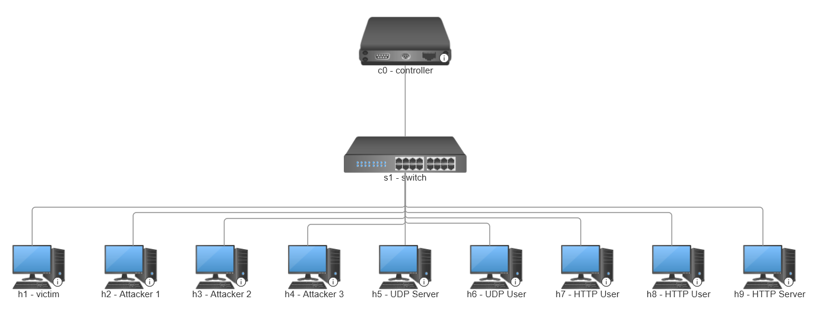
Figure 4 SDN setup with controller, switch, and hosts simulating users, servers, and attackers. [63]

4.4 Implementation
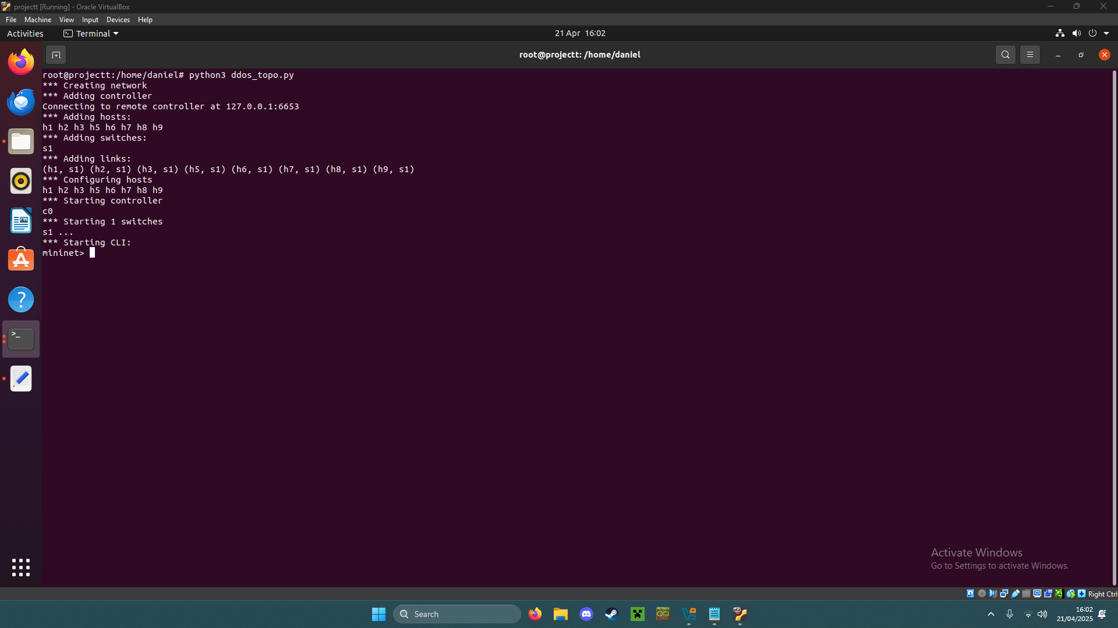
Figure 5 Mininet topology creation, the custom Python script (ddos_topo.py) creates the SDN topology and connects all hosts to the Ryu controller via a single switch.
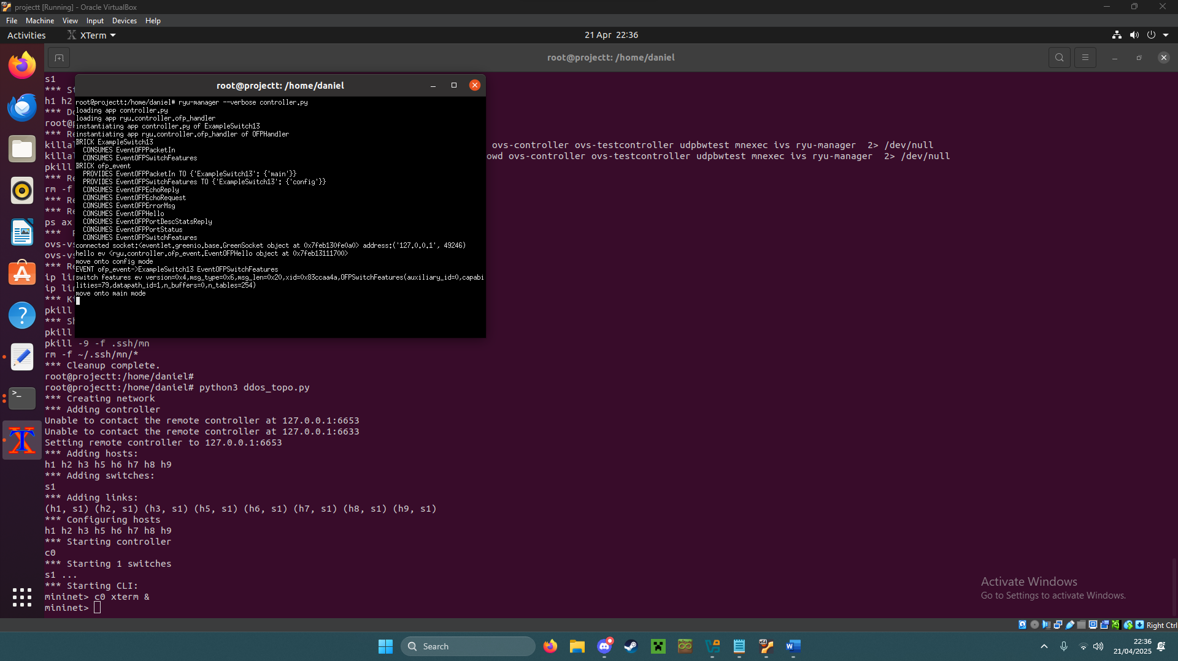
Figure 6 The Ryu controller is launched, enabling real-time monitoring and analysis of OpenFlow traffic flow from the Mininet topology.
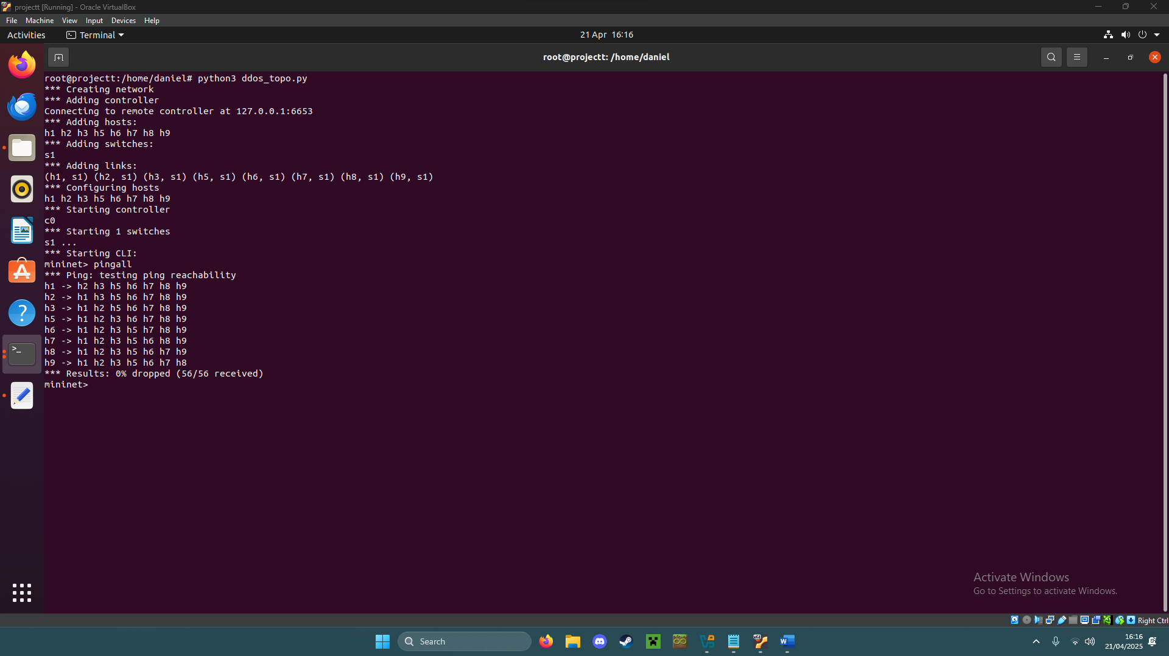
Figure 7 Network connectivity test using pingall. All hosts successfully communicate with each other, confirming that the SDN topology is correctly configured and operational.
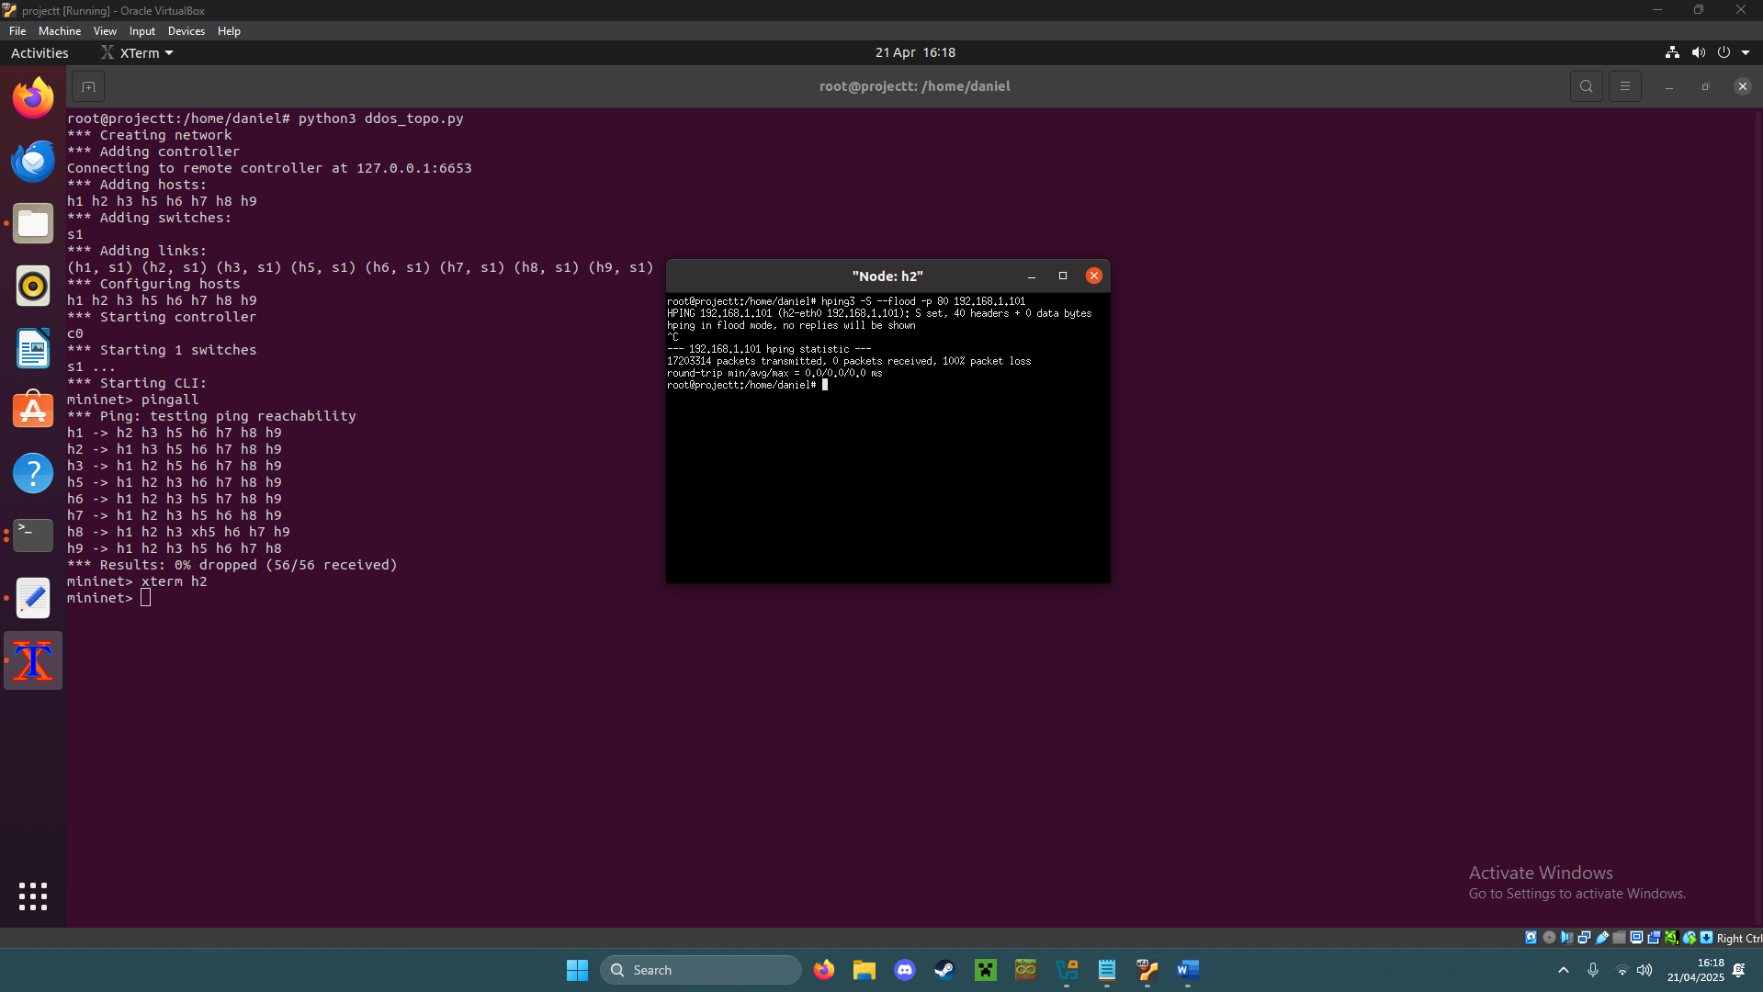
Figure 8 Simulated DDoS traffic using Hing3. An attacker node sends a TCP SYN flood attack to the victim to simulate a denial-of-service.
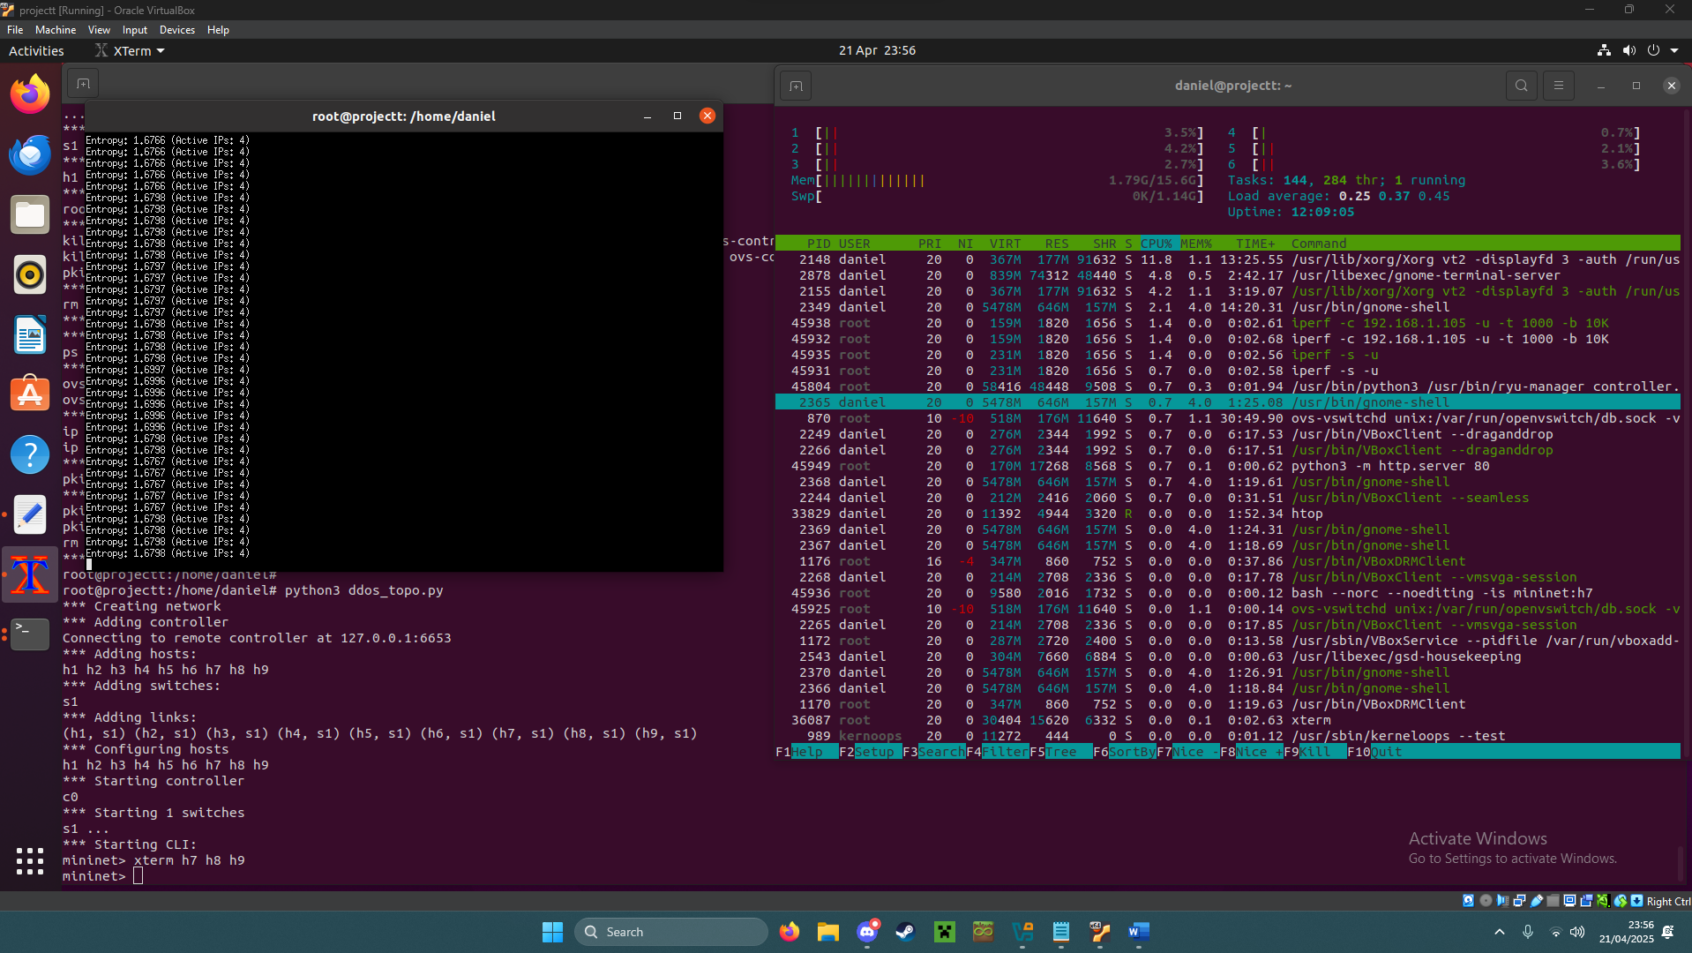
Figure 9 System resource usage under normal traffic. Htop shows a low CPU usage while benign traffic is generated, illustrating the low computational requirements of the Ryu controller and entropy-based detection method.
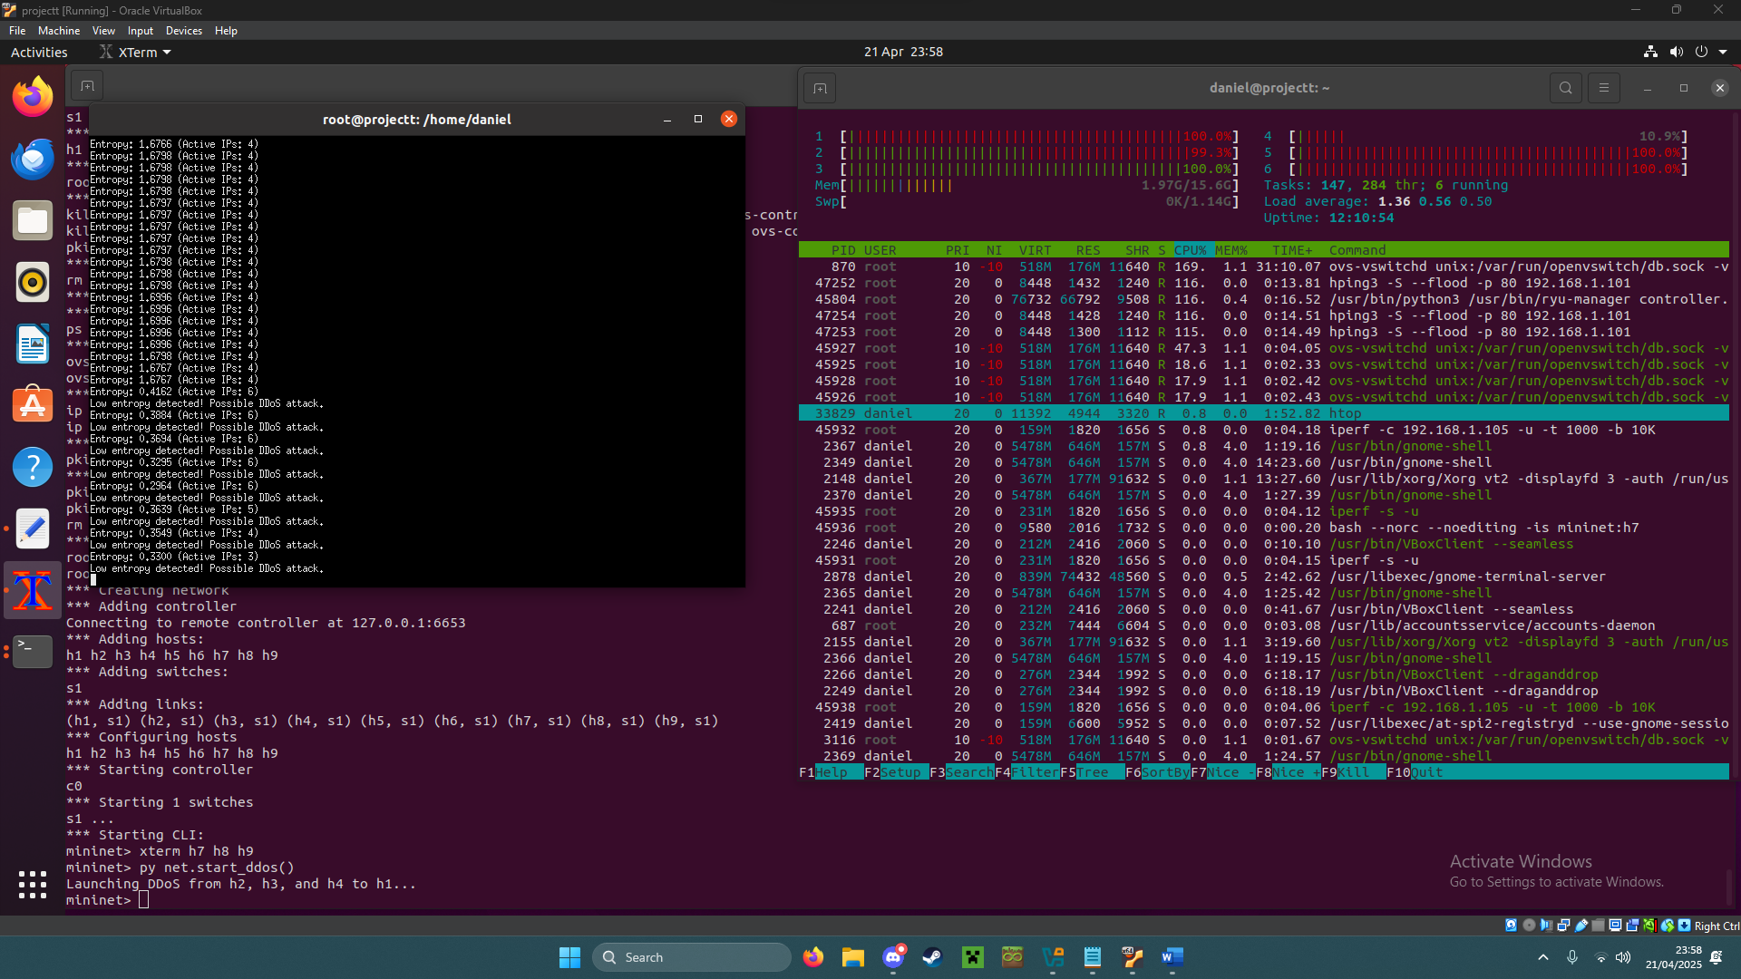
Figure 10 System resource usage during a DDoS simulation. Htop shows an increased CPU usage while Hping3 generates flood traffic, illustrating the performance impact on the system.

Figure 11 shows a video of the process of launching the Mininet topology used in the experiment using a custom Python script and starting the Ryu controller. It also captures the creation of hosts, the switch, and the controller, followed by a verification of connectivity between the devices using pingall. This verifies that all components are active and communicating before testing a DDoS attack scenario.

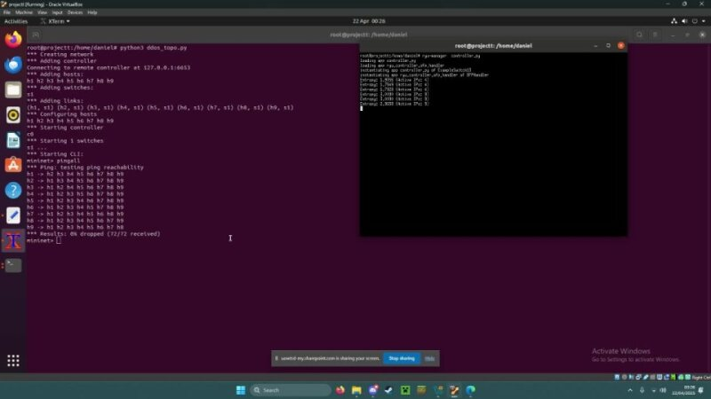
Figure 11 Mininet Topology and Ryu Controller setup
The video below, shown in Figure 12, shows a simulated TCP SYN flood attack using Hping3, launched from multiple attacker hosts targeting the victim. As the attack begins, the Ryu’s entropy-based detection algorithm monitors the traffic patterns and outputs the alerts to the terminal when the anomalies are detected. This video highlights how the system identifies the traffic in real time, responds accordingly, and stores logs of the results.

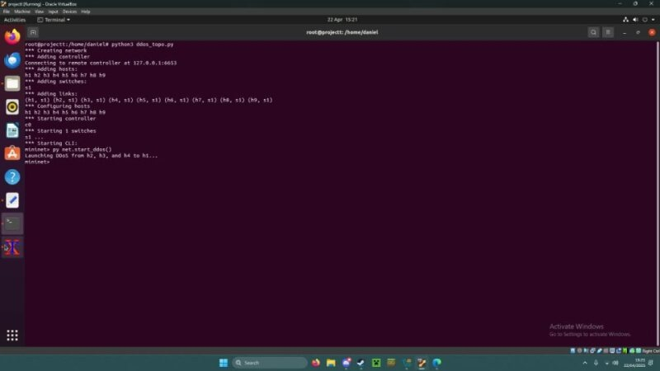
Figure 12 DDoS Traffic Simulation and Entropy-Based Detection
The video in Figure 13 demonstrates the complete 120 second automated experimented that simulates a DDoS attack in an SDN using Mininet and Ryu controller. The test begins with the launch of benign background traffic between multiple hosts, including HTTP requests and UDP streams. At the 60 second mark, a simulated TCP SYN flood attack is launched from the three attacker hosts targeting the victim. The entropy-based detection algorithm then identifies the abnormal traffic patterns by calculating the entropy value in source IP addresses, triggering an alert and automatically blacklisting the attackers. The system continues monitoring network traffic after the attack, observing the network return to normal, logging resource usage, entropy, latency, and attacker data throughout the experiment. The experiment then ends automatically after 120 seconds for consistency and repeatability.

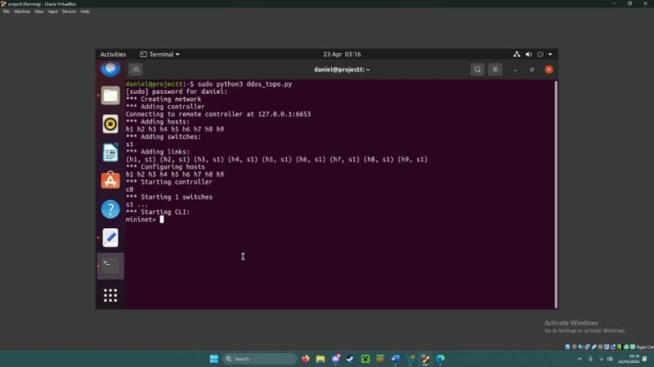
Figure 13 Full automated SDN DDoS detection experimental run

4.3.1 Mininet Topology Python Script
The Mininet topology script, as seen in Appendix A, was developed to create a simple SDN environment for testing DDoS detection techniques. It creates a custom topology consisting of a single OpenFlow switch (s1), three attacker hosts (h2, h3, h4), one victim (h1), and five normal users (h5 – h9).
This script also automates the launching of the traffic flows:
- Normal UDP traffic between users h5 and h6
- Normal HTTP traffic between server h9 and users h7 and h8
- A simulated DDoS attack from the attacker nodes after 60 seconds.
Finally, the script launches a background thread that monitors and logs the latency between hosts throughout the experiment. This is critical to test how effectively the detection mechanisms could distinguish between legitimate and malicious traffic.

4.3.2 Original Ryu Controller Script
The original Ryu script, refer to Appendix B, was based on the ExampleSwitch13 script included by default within the Ryu framework. [64] This default script includes the following basic OpenFlow 1.3 functionalities:
- Layer 2 switch behaviour through MAC address mapping.
- Handling packet-in events.
- Installing simple flow rules to forward packets.
No security mechanisms or traffic analysis is included in the original script. This provides a foundation to build upon for developing a bespoke DDoS detection algorithm.

4.3.3 Modified Ryu Controller Script
The modified Ryu controller script, shown in Appendix C, extends the base script by incorporating a real-time entropy detection mechanism. The key modifications made include:
- Packet monitoring: Collecting incoming IPv4 packets and tracking the source IP addresses within a period.
- Entropy calculation: Often calculation of Shannon entropy to detect abnormal traffic symbolising a DDoS attack.
- Automatic mitigation: IP addresses responsible for reducing the entropy value below the threshold are blacklisted, and drop rules are installed on the OpenFlow switch.
- Resource monitoring and logging: System performance (CPU and RAM usage) and detection results (entropy values, number of attackers) are logged to an external CSV file for analysis.
The modified controller maintains the layer 2 switch behaviour of the original but adds significant security capabilities required for DDoS detection within an SDN environment.

4.5 Conclusion
This chapter has detailed the design and implementation of the DDoS detection system within an SDN environment. Each design choice was made with reference to the findings from the literature review. The decision to generate traffic using Hping3 allowed for full control over the testing conditions, ensuring both normal and malicious behaviours were accurately simulated.
An entropy-based detection algorithm was implemented due to its low computational requirements and rea-time responsiveness, making it ideal for integration within a SDN environment. The experimental topology was designed to mimic a small enterprise network, enabling effective testing under different traffic scenarios. Screenshots and videos were used to demonstrate and validate the system’s setup, operation and ability to detect attacks.

Chapter 5 – Testing and Evaluation

5.1 Introduction
This chapter presents the results and evaluations of the entropy-based DDoS detection system implemented previously in Chapter 4. The experiment was executed five times using a simulated SDN environment, each of these runs consisted of benign traffic followed by a simulated DDoS attack launched at the 60 second mark. Throughout the experiments, the system recorded various metrics to evaluate the performance, including entropy, latency, CPU and memory usage, and active IP addresses.
The purpose of this chapter is to assess how effective the system was at identifying and responding to DDoS attacks. It also evaluates the impact of the detection system on CPU and memory usage, the network performance under stress, and the overall reliability of the detection algorithm. The findings are then compared to the existing research found and critically analysed for strengths and limitations.

5.2 Observed Results

5.2.1 Detection Accuracy
The system demonstrated high accuracy in all five experimental runs. In every case, the algorithm successfully detected the simulated attack shortly after it began. There were no false positives detected throughout the tests, and all attacker IPs were correctly identified and added to the blacklist. This can be seen in the table below.
Test Run | Attacks Launched | Attacks Detected | False Positives | Detection Date (%)
1 | 3 | 3 | 0 | 100%
2 | 3 | 3 | 0 | 100%
3 | 3 | 3 | 0 | 100%
4 | 3 | 3 | 0 | 100%
5 | 3 | 3 | 0 | 100%

This highlights the robustness of the approach. The logs, recorded by the controller, also confirm accurate classification and efficient mitigation responses, such as the flow rule insertion on the switches to drop packets from the blacklisted IP addresses.
Figure 14 provides a representation of the attacker IP blacklisting over the five experimental runs. Each dot marks when an attacker was detected and blocked, and the red line indicates the 60 second mark when the DDoS attack was triggered. In every run, all three attackers IPs were successfully detected shortly after the attack began, with little variation in the timing. The consistency of this detection further supports the claim of high detection accuracy and demonstrates how responsive the system is across multiple tests.
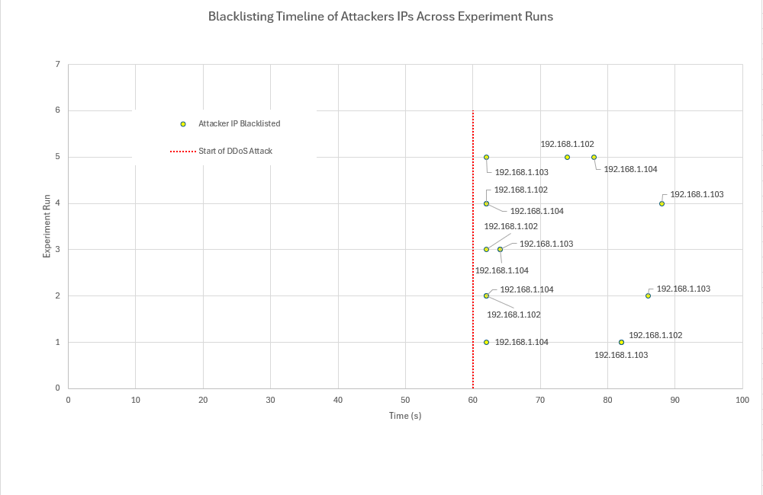
Figure 14 Attacker IP blacklisting times relative to the DDoS attack start time (red line) across five experimental runs.

5.2.2 Entropy Analysis
Throughout the experiment runs, the entropy values were stabled during the periods of normal traffic, ranging between 1.9 and 2.1. Upon the start of the attack at 60 seconds, entropy values dropped significantly, falling below 1.6, which triggered the detection and mitigation mechanisms.
As shown in figure 15, all entropy values remain high prior to the attack, confirming stable and legitimate traffic conditions. Following the attack, all five runs experience a significant drop in entropy, confirming the methods ability to detect low-entropy anomalies. While the exact shape of the graph, and the time taken to recover varied between tests, all approaches consistently dropped below the threshold after 60 seconds and returned to normal after flow rules were established, supporting the reliability of the approach.

Figure 15 Entropy values over time across five experiment runs. The red line shows the detection threshold, while the shaded area marks the DDoS attack window.

5.2.3 Latency Impact
The latency metric was used to measure the impact of the attack on the network service performance. Before the attack, the latency between the hosts remained below 5ms. During the attack phase, the latency either spiked sharply to over 100ms or resulted in the packet being dropped completely. This loss of connectivity demonstrates the dangers of DDoS attacks on SDN networks due to the controller being overwhelmed with packet-in requests. Although the latency was measured using a simple method, using ICMP ping, it still provided insight into the performance during DDoS scenarios.
Figure 16 shows the readings from all five of the experimental test runs, with the grey shaded area signifying the start of the DDoS attack at 60 seconds. The Y-axis of the graph is capped at 20ms to improve clarity and to make the graph more readable, cutting off the extreme spikes from the data. This figure illustrates how the latency remains relatively stable within the first 60 seconds. Once the experiment began, all five runs lost all network connectivity to due to congestion, as the controller regained control, several large spikes occurred. Even with detection mechanisms in place, the network latency did not immediately return to normal, demonstrating the lasting impacts of volume-based attacks.
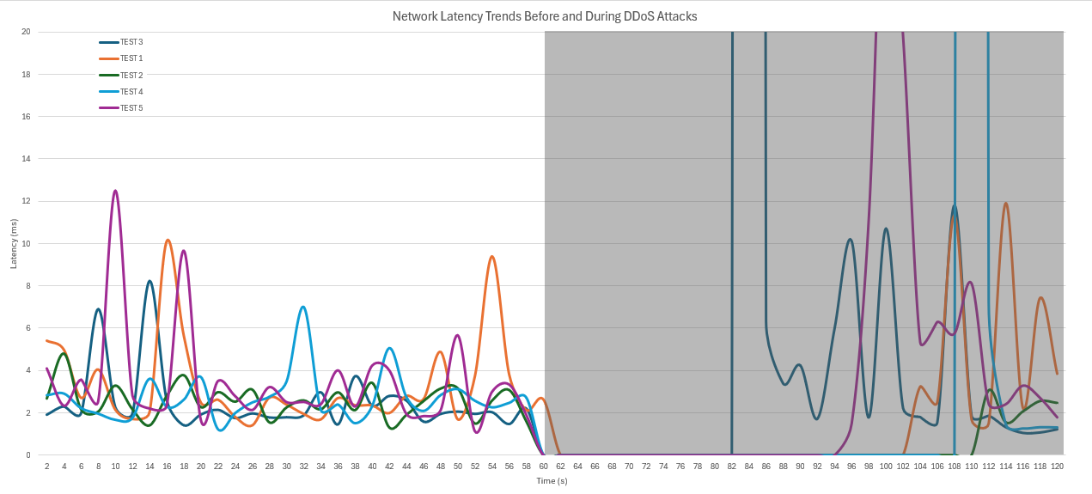
Figure 16 Network Latency Access Experiment Runs.

5.2.4 Resource Usage
The graph in figure 17 visualises the CPU load that was experienced by the Ryu controller throughout the experiment. A consistent and significant increase in CPU usage is observed starting at the 60 second mark, which aligns well with the start of the DDoS attack scenario. The controller reaches full utilisation as it attempts to process the large number of malicious packets. Each test shows a brief period of high usage, which varies slightly depending on how quickly the detection algorithm identifies attackers. Once the offending IPs are blacklisted, CPU usage creases greatly which indicates how the controller offloads the packet handling of the malicious traffic to the data plane of the OpenFlow switches.
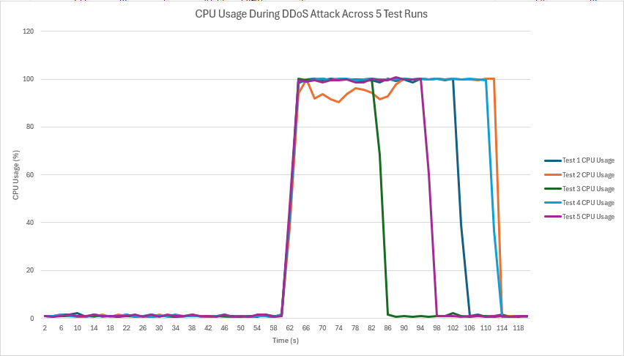
Figure 17 CPU Usage from five runs, showing an increase at the start of the DDoS attack.

As shown in the memory usage chart in figure 18, the system maintained a very consistent RAM consumption, increasing by 10MB of usage after the DDoS attack began. This indicates very low memory usage, making the detection solution suitable for lower resource environments.
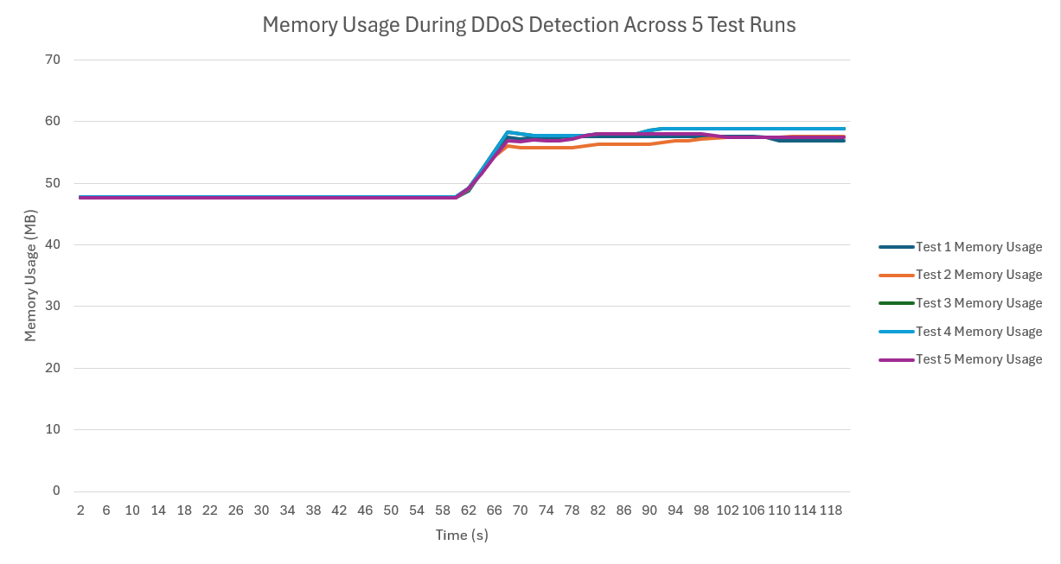
Figure 18 Memory usage from five runs, remaining stable throughout the experiments.

5.2.5 Active IPs
The number of active addresses provides insight into the entropy logic. As shown in figure 19, all five tests show a rapid increase in IP addresses after the attack begins, followed by a gradual decrease back to normal traffic as attackers are detected and blocked. This reinforces the effectiveness of entropy as a detection metric.
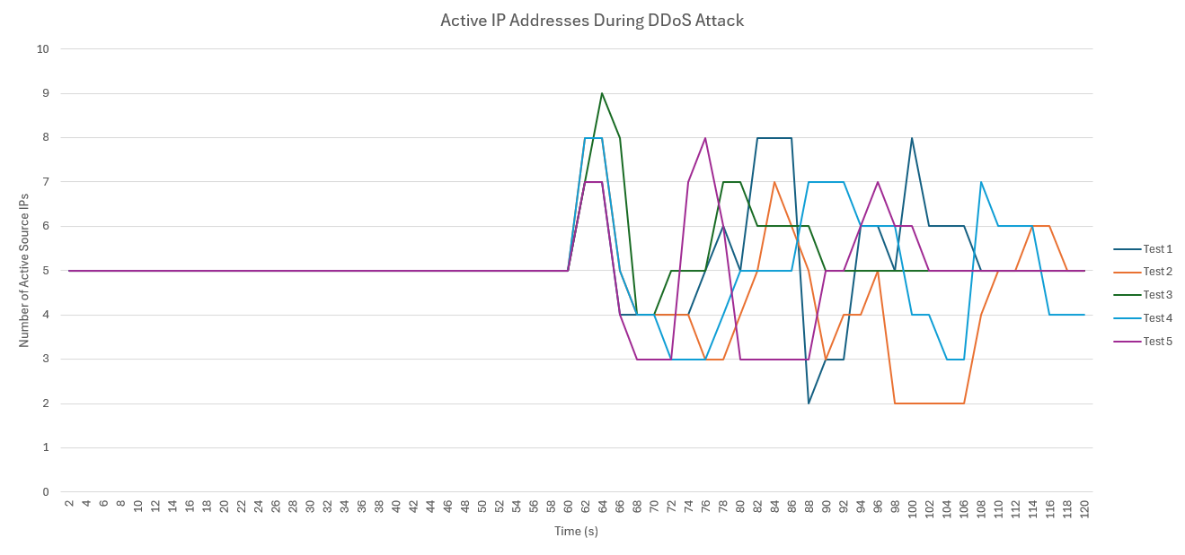
Figure 19 Active IP Count Across Experiment Runs

5.2.6 Entropy vs Latency Correleation
Figure 20 shows the correlation between entropy and latency values – an inverse trend – entropy drops during attacks as the traffic becomes less diverse, while the latency increases or packets are lost, which indicates a strain on the network.
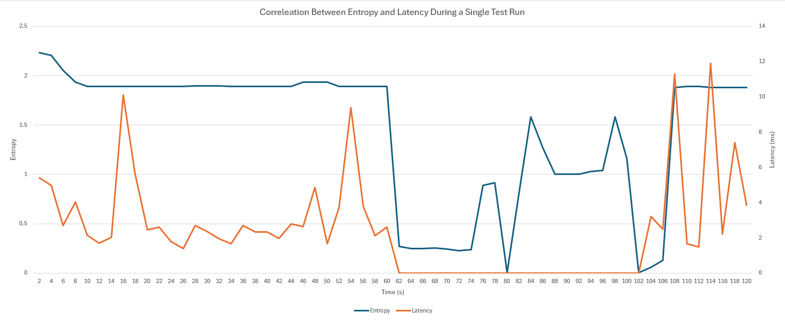
Figure 20 Graph showing the correlation between entropy and latency during a single run.

5.3 Evaluation of Results
The results from the experiments undertaken indicate that the system reliably detects DDoS attacks and initiates flow rule implementation to mitigate the attacks. The detection algorithm was accurate and efficient at handling the attack traffic with minimal resource usage. However, the use of a static entropy threshold is a limitation. While effective in this controlled environment, more dynamic and adaptive thresholds could offer improved performance in more realistic scenarios with varying traffic. The latency metric was also basic, relying on ICMP, and could be improved by implementing a more enhanced latency metric. Additionally, the tests were performed in a small-scale environment, future studies should test the system in a larger and more complex topology to further validate the scalability and generalisability of the algorithm.

5.4 Comparison to Related Works
The implemented system performs similarly to findings from literature. Asgari et al. [29] demonstrates the effectiveness of entropy detection against TCP and UDP floods, which aligns closely with this project. Similarly, Hemmati et al. [26] introduces a dynamic threshold to improve detection precision, which is an area where this system could improve. Finally, Kaushik et al. [41] utilises Ryu for an entropy-based monitoring method and reported the advantages of real-time monitoring with minimal CPU usage, which closely matches the performance from this project.

5.5 Conclusion
The experiments completed confirm that the entropy-based detection system was consistently effective. Every attack was detected with an 100% accuracy, and no false positives occurred in the five runs. The entropy value dropped during attacks and returned to normal once attackers were blocked, showing how the system was able to reliably identify abnormal traffic. Latency and CPU usage both increased under attack, but the system remained stable, the controller remained operational and responded quickly. Memory usage stayed low and consistent throughout. While the static threshold and basic latency metrics are limitations, it did not stop the system from performing well in a test environment.
Overall, the results show that this approach is reliable, efficient, and well-suited to SDN networks, especially in smaller-scale or more controlled scenarios. Future improvements can focus on adapting the threshold to a more dynamic approach and testing on larger topologies.

Chapter 6 - CONCLUSIONS AND RECOMMENDATIONS

Summary
This project set out to explore the detection of DDoS attacks within SDNs, focusing on the implementation and evaluation of entropy-based algorithms. The project followed a structured process, beginning with an in-depth investigation into SDN security, DDoS attack types, and existing detection strategies through an extensive systematic literature review in chapter 2. Based on these findings, an entropy-based detection method was chosen to be implemented within an SDN environment using Mininet and the Ryu controller. A simplistic flat network was created, with hosts designated as victims, attackers, clients, and servers. The malicious traffic to simulate a DDoS attack scenario was generated using hping3. The detection algorithm then monitored entropy from the source Ips and flagged anomalies below a certain threshold as a potential DDoS attack.
The methodology of the project and steps undertaken for the experiment were outlined in chapters 3 and 4, with justifications as to the decisions made based on the findings from the literature review in chapter 2. These justifications included the choice of detection method, network topology, traffic generation approach, and performance metrics. Finally, chapter 5 presents the evaluation of the results from the experiments undertaken across five runs. The system achieved 100% detection accuracy in each test, without any normal traffic being flagged as a false positive. Throughout the experiments, different key metrics were recorded for use in the evaluation, this included the entropy values, network latency, CPU and memory usage, and the number of active IP addresses.

Conclusion
The aim of this project was to evaluate a DDoS detection method within an SDN, which the research completed has successfully met. The main output was a functioning detection system built into an SDN using Mininet and the Ryu controller. This system was tested in a controlled and consistent test environment that included both normal and attack traffic.
Across all five of the experiment runs, the system detected the DDoS attacks shortly after it began, with the entropy values dropping below a predefined threshold. The IP addresses of the attackers were identified and blacklisted, and the basic mitigation strategies were successfully triggered by modifying the OpenFlow rules in real time. The entropy values were a reliable indicator of abnormal network behaviour; this is because during normal traffic the entropy values were consistently between 1.9 and 2.1. This changed when an attack was launched, sharply dropping below the 1.6 threshold, triggering an alert. Finally, once the IP addresses were blacklisted, the entropy values returned to normal levels, confirming the effectiveness of the entropy-based method.
Another metric utilised was the latency, which showed a sharp increase during attack periods, with many of the ICMP packets either timing out completely or spiking above 100ms. These results highly support the idea that high volume attacks severely impact SDN performance due to controller resource limits. Even though this latency metric was calculated using a relatively basic method, it still provides a very useful insight into the impact of the attack and the time taken for the network to recover after mitigations are in place.
Throughout the experiment there were no false positives recorded, as every instance of abnormal traffic detected was a genuine DDoS attack. This highlights the effectiveness and precision of this detection algorithm in a controlled environment. However, this success may not translate to larger scaled networks, where higher background noise and more variable traffic behaviour can make spikes and falls in entropy values less obvious during attacks.
Overall, these results have reinforced the potential for entropy-based detection as a lightweight solution for DDoS attacks in SDNs. The experiment’s low memory usage, ease of implementation, and high accuracy make it well-suited for environments where network and controller performance are key. While some limitations have been identified, such as a reliance on static thresholds and a simple topology, the project has shown that the underlying core approach is viable and provides the key elements for future developments.

Recommendations for Further Research
While successful, the research in this project has opened the door to several promising areas of further investigation. The following recommendations outline where the future research could focus:
- Dynamic Thresholding: One of the biggest limitations of the current system is its reliance on a static entropy threshold value. In real dynamic environments, normal network traffic fluctuates much more significantly, and a static threshold will not be able to distinguish between normal and malicious activity as reliably. One avenue for future research would be to explore a dynamic threshold that can adjust based on the current network conditions in real time. Studies such as the one by Hemmati et al. [26] have already shown an improved detection rate when using a dynamic instead of a static threshold.
- Scalability Testing: As discussed already, this experiment used a small-scale environment within Mininet. While this was well suited for initial testing, it does not reflect the complexity of real enterprise networks. Future research should focus on testing the algorithm in much larger topologies with increased hosts, more diverse traffic, and varied network behaviours. This will further help to assess entropy’s effectiveness at scale.
- Enhanced Latency and Quality of Service Metrics: The latency metric in this project was measured using ICMP ping values, and while these were useful, this method does not capture the overall performance degradation of the network during an attack. Future works could implement different methods to calculate latency measurements to assess the impact on the Quality of Service for the end user.
- Hybrid Detection Models: Entropy values are effective at detecting high-volume or obvious attacks, more adaptive attacks such as the Low-Rate DDoS attacks that have been discussed earlier may bypass the static entropy thresholds. Future research could combine entropy detection with a different method, such as flow-based or machine learning model to improve the robustness. These hybrid systems that combine multiple approaches together may offer better protection against new and evolving attacks.
- Integration with Real Datasets: This project has used traffic generated in real time through the hping3 tool, which provides full control over attacks but lacks the real-world unpredictability. Future experiments should attempt to integrate existing public datasets, such as CICIDS2017 or CICDDoS2019, to their simulation to increase the external validity of the results.
- Live Deployment Trials: Finally, completing the experiment in a testbed or semi-live environment, such as a university lab or isolated environment, could provide much more insight into the practical challenges faced while implementing a DDoS detection algorithm, like deployment complexity, false positive handling, and integration with other security infrastructures. These deployments would also help to test the stability and responsiveness of the mechanisms from unpredictable user behaviours.
By addressing one or more of these areas, future works can build on the foundation laid out in this project to develop smarter, more scalable, and adaptive detection mechanisms for SDN environments. As DDoS tactics continue to evolve and SDNs are becoming more used in critical infrastructure, the need for lightweight, accurate, and real-time detection is vital.

Chapter 7 – Reflections

7.1 Introduction
This chapter will provide a detailed reflection on the conduct, progress, and outcomes of this project. Beginning with how well the original aim and objectives were achieved, moving on to any significant challenges that occurred throughout the project, and a reflection on the lessons learned throughout the course of the project. Each of the objectives will be revisited individually to evaluate whether it has been completed, and to identify if any improvements could have been made.
The aim of the project was:

“The aim of this project is to select an existing DDoS detection algorithm, implement a proof of concept within a simulated Software-Defined Network environment, and analyse and evaluate its effectiveness through experimental testing.”

The project successfully completed this aim, as a DDoS detection system based on the analysis of entropy values was designed, implemented, and tested within a simulated SDN environment using Mininet and the Ryu controller. The developed system was able to accurately identify DDoS attacks in real time and was evaluated based on key performance metrics including detection accuracy, resource usage, and latency. Although there are opportunities to expand this project further, which have been discussed in detail, time constraints have limited these developments. Despite this, the core aim of developing and evaluating a detection method was fully achieved.

7.2 Reflections Against Objectives

7.2.1 Objective 1: Conduct a Systematic Literature Review on SDNs, DDoS attacks, and detection methods
This objective was successfully achieved in Chapter 2, as a thorough and structured search was conducted, and the relevant literature was critically analysed after a systematic approach was taken. This review provided a strong foundation for the rest of the project to be built upon, by highlighting the vulnerabilities of SDNs, the challenges of DDoS detection, and the advantages of various detection methods. The insights gained from this review helped decide which detection method should be used and parts of the experimental design. Reflecting on this stage of the project, the process was completed in a methodical and comprehensive manner, and I am confident that the depth of the review has strengthened the overall quality of the project.

7.2.2 Objective 2: Adapt a suitable research methodology, including evaluation metrics and justification for chosen detection method
This objective was fully achieved within Chapter 3 and 4. A post positivist philosophy and a deductive approach were selected, and appropriate evaluation metrics were chosen, such as detection accuracy, entropy values, latency, and resource usage. The justification for using an entropy-based detection method was linked back to the literature review in chapter 2. Reflecting on this, I believe that the chosen methodology linked well to the research aim, enabling the collection of meaningful results while allowing the project to remain within time and resource constraints.

7.2.3 Objective 3: Design and implement an SDN simulation using Mininet and the Ryu controller to test the selected DDoS detection method
This objective was successfully achieved in Chapter 4. A fully operational Mininet environment was created, with a Ryu controller managing the network traffic. Hping3 and other traffic generation tools were used to generate both normal and malicious traffic, and a custom entropy-based algorithm was implemented.
Reflecting on this objective, the experimental setup went largely to plan, apart from one significant issue faced early on when an incompatibility between the latest version of Ryu and the latest Ubuntu/Python versions. Fortunately, the contingency plan carried out earlier in the project identified the possibility of compatibility issues. The mitigation strategy identified, to use an older version of Ubuntu, was quickly and effectively implemented. This pre-planning to create a contingency plan ensured that the project stayed on schedule despite any issues.

7.2.4 Objective 4: Analyse and compare the detection method based on accuracy, latency, and resource usage, providing recommendations for future research
This objective was covered in Chapter 5, the detection method was tested across five experimental runs, recording key metrics such as detection accuracy, entropy values, network latency, CPU usage, and memory consumption. Reflecting on this stage, the analysis was thorough, and the results were consistent, confirming the reliability of the approach in a controlled environment. However, there were some limitations. Originally, I had intended to use a real-world dataset to make the evaluation more realistic, but integrating this dataset into Mininet proved to be far more complex that I originally thought and due to the project’s time constraints could not be implemented. Similarly, the initial plan was to test the detection system on a much larger topology, but once again due to time limitations this had to be scaled back. Despite the compromises, the core objective was still met, and the recommendations laid out identify areas for potential future work.

7.3 Reflections on Conduct and Progress
Overall, I believe that this project has gone well. I have managed to complete all the objectives and deliver a working DDoS detection system, complete with a thorough evaluation and analysis of the findings. One of the most significant challenges encountered was the software compatibility issues during the setup of the SDN environment. Thanks to the early identification of the risk and the contingency plan in place, the issue was resolved quickly without modifying the project timeline. This experience highlighted the importance of careful planning and risk management, even in smaller-scale research projects.
Another major adjustment made throughout the course of the project was the decision to generate traffic live using hping3 rather than a pre-existing dataset. While this change was initially disappointing, this adjustment gave me more control over the testing conditions and allowed for the detection system to be evaluated more flexibly and repeatedly.
Through the completion of this project my knowledge and skills in Software-Defined Networking have significantly improved. Before beginning this project, I had no experience with SDNs, controllers like Ryu, or network simulation tools like Mininet. Developing, configuring, and testing an SDN from scratch has massively deepened my technical understanding and has provided valuable experience that I can build upon in future studies or work.
Finally, time management was another key factor in the success of this project. Although there were moments throughout where the workload was intense, the structured breakdown of the objectives, and project overall, ensured the steady progress throughout the entire project. However, looking back, allocating more time to the experimentation phase would have allowed for more in-depth evaluation.

7.4 Conclusion
To conclude, this research successfully achieved the original aim and all objectives, and while some compromises were necessary due to time constraints and technical complexity, the project still delivered a working DDoS detection solution and provided a full evaluation for its effectiveness. Reflecting on the entire process, the project strengthened my technical knowledge, my ability to plan and manage a research project, and my problem-solving skills when unexpected challenges and difficulties occurred. It also highlighted the areas where further work could take this project even further. Overall, this research experience was both challenges and rewarding and has provided me with a solid foundation for any future works in the fields of SDN security and network-based threat detection.

chapter 8 – REFERENCES

References
[1] B. S. Evelin Zoraida and G. Indumathi, "A Comparative Study on Software-Defined Network with Traditional Networks," TEM Journal, vol. 13, no. 1, pp.167–176, 2024. doi: 10.18421/TEM131-17.
[2] M. AL-Adaileh, et al., "Detection Techniques of Distributed Denial of Service Attacks on Software-Defined Networking Controller-A Review," Access, vol. 8, pp.1, 2020. doi: 10.1109/ACCESS.2020.3013998.
[3] R. Sahay, W. Meng and C. D. Jensen, "The application of Software Defined Networking on securing computer networks: A survey," Journal of network and computer applications, vol. 131, pp.89–108, 2019. doi: 10.1016/j.jnca.2019.01.019.
[4] N. Tripathi and N. Hubballi, "Application Layer Denial-of-Service Attacks and Defense Mechanisms: A Survey," ACM computing surveys, vol. 54, no. 4, pp.1–33, 2021. doi: 10.1145/3448291.
[5] L. Zhou, et al., "A novel feature-based framework enabling multi-type DDoS attacks detection," World Wide Web, vol. 26, no. 1, pp.163–185, 2023. doi: 10.1007/s11280-022-01040-3.
[6] Z. Ahmed, et al., "Protecting IoTs from Mirai Botnet Attacks Using Blockchains," 2019. doi: 10.1109/CAMAD.2019.8858484.
[7] S. Dong, K. Abbas and R. Jain, "A Survey on Distributed Denial of Service (DDoS) Attacks in SDN and Cloud Computing Environments," Access, vol. 7, pp.80813–80828, 2019. doi: 10.1109/ACCESS.2019.2922196.
[8] P. Ralph and S. Baltes, "Paving the way for mature secondary research: the seven types of literature review," 2022. doi: 10.1145/3540250.3560877.
[9] J. Buzzio-García, et al., "Exploring Traffic Patterns Through Network Programmability: Introducing SDNFLow, a Comprehensive OpenFlow-Based Statistics Dataset for Attack Detection," IEEE Access, vol. 12, pp.42163, 2024. doi: 10.1109/access.2024.3378271.
[10] M. Niu, Y. Feng and K. Sakurai, "A two-stage detection system of DDoS attacks in SDN using a trigger with multiple features and self-adaptive thresholds," 2023-01-03. doi: 10.1109/imcom56909.2023.10035661.
[11] N. Gupta, et al., "DDoS attack defence mechanism using sFlow," 2022-10-25. doi: 10.1109/icdabi56818.2022.10041563.
[12] V. Prabhu and P. Balamurugan, "Survey on Security Based Approach to Prevent Attacks in SDN Using IoT Framework," 2023-07-19. doi: 10.1109/icecaa58104.2023.10212199.
[13] S. H. A. Kazmi, et al., "Threat Intelligence with Non-IID Data in Federated Learning enabled Intrusion Detection for SDN: An Experimental Study," 2023-12-06. doi: 10.1109/acit58888.2023.10453867.
[14] J. Hussain and V. Hnamte, "A Novel Deep Learning Based Intrusion Detection System : Software Defined Network," 2021-09-29. doi: 10.1109/3ict53449.2021.9581404.
[15] I. Sumantra and S. I. Gandhi, "DDoS attack Detection and Mitigation in Software Defined Networks,"
[16] R. R. Mathew and A. Vidhate, "Adaptive DoS Attack Detection in SDN," 2024-03-05. doi: 10.1109/esci59607.2024.10497358.
[17] S. Gómez Macías, L. Paschoal Gaspary and J. F. Botero, "ORACLE: An Architecture for Collaboration of Data and Control Planes to Detect DDoS Attacks,"
[18] L. Wan and G. Yang, "Research on DDoS Attack with Learning Ability Detection in SDN Environment," 2022-12-16. doi: 10.1109/imcec55388.2022.10020024.
[19] H. Yin and R. Duan, "Research on Table-Miss Attack Detection in SDN," 2022-08. doi: 10.1109/icfeict57213.2022.00088.
[20] C. Kumar, et al., "Intelligent DDoS Detection System in Software-Defined Networking (SDN),"
[21] T. Das, et al., "Flood Control: TCP-SYN Flood Detection for Software-Defined Networks using OpenFlow Port Statistics," 2022-07-27. doi: 10.1109/csr54599.2022.9850339.
[22] M. W. Nadeem, et al., "Detecting and Mitigating Botnet Attacks in Software-Defined Networks Using Deep Learning Techniques," IEEE Access, vol. 11, pp.49153, 2023. doi: 10.1109/access.2023.3277397.
[23] V. Bodapati, S. Kranthi and S. S. Baji, "Preventing Network Attacks using Support Vector Machine (SVM) and Software Defined Networking (SDN) Integration," 2024-02-22. doi: 10.1109/ic-etite58242.2024.10493225.
[24] C. Wang, et al., "METER: An Ensemble DWT-based Method for Identifying Low-rate DDoS Attack in SDN," 2021-10. doi: 10.1109/euc53437.2021.00020.
[25] R. Fadaei Fouladi, O. Ermis and E. Anarim, "A Comparative Study on the Performance Evaluation of DDoS Attack Detection Methods," 2022-05-15. doi: 10.1109/siu55565.2022.9864872.
[26] Z. Hemmati, G. Mirjalily and Z. Mohtajollah, "Entropy-based DDoS Attack Detection in SDN using Dynamic Threshold," 2021-12-29. doi: 10.1109/icspis54653.2021.9729355.
[27] H. Almomin and A. Abdu, "Detection of Distributed Denial of Service Attacks through a Combination of Machine Learning Algorithms over Software Defined Network Environment,"
[28] G. Fioravanti, M. G. Spina and F. De Rango, "Entropy based DDoS Detection in Software Defined Networks," 2023-01-08. doi: 10.1109/ccnc51644.2023.10059949.
[29] S. Asgari and B. Akbari, "DDoS Attack Detection in OpenFlow Based Networks," 2022-02-23. doi: 10.1109/csicc55295.2022.9780508.
[30] H. Lotfalizadeh and D. S. Kim, "Investigating Real-Time Entropy Features of DDoS Attack Based on Categorized Partial-Flows,"
[31] J. Deng, et al., "An Online Detection System for LDoS attack Based on XGBoost," 2023-12-21. doi: 10.1109/ispa-bdcloud-socialcom-sustaincom59178.2023.00174.
[32] K. Alhamami and S. Albermany, "DDOS attack detection using machine learning algorithm in SDN network," 2023-07-04. doi: 10.1109/aiccit57614.2023.10218194.
[33] R. Zhang, G. Yang and W. Zhang, "DDoS Attack Detection System Based on GBDT Under SDN," 2024-09-20. doi: 10.1109/itnec60942.2024.10733143.
[34] T. Sathwik, et al., "Detecting DDoS Attacks in Software-Defined Networking through the Utilization of Supervised and Unsupervised Learning Techniques," 2024-06-24. doi: 10.1109/icccnt61001.2024.10723853.
[35] J. Tan, et al., "DDoS detection method based on Gini impurity and random forest in SDN environment," 2021-06-18. doi: 10.1109/spac53836.2021.9539920.
[36] V. Itagi, et al., "DDoS Attack Detection in SDN Environment using Bi-directional Recurrent Neural Network," 2021-11-19. doi: 10.1109/discover52564.2021.9663667.
[37] A. A. Alashhab, et al., "Online Machine Learning Approach to Detect and Mitigate Low-Rate DDoS Attacks in SDN-Based Networks," 2023-09-12. doi: 10.1109/iicaiet59451.2023.10291787.
[38] M. F. Sidiq, et al., "Network Flow-Based Dataset Generator Based on OpenFlow SDN," 2023-12-01. doi: 10.1109/icitcom60176.2023.10442625.
[39] Z. Fatehi and A. Montazerolghaem, "DDoS Detection in SDN using Deep Learning," 2024-05-14. doi: 10.1109/sciot62588.2024.10570129.
[40] C. Kaushik, et al., "DDoS Attack Detection and Mitigation Using Mininet and RYU Controller in SDN Environment," 2024-06-24. doi: 10.1109/icccnt61001.2024.10724700.
[41] H. A. Hassan, et al., "An Efficient Intrusion Detection System for SDN using Convolutional Neural Network," 2021-07-03. doi: 10.1109/iceem52022.2021.9480383.
[42] J. Chen, et al., "Detection of LDoS System Based on Periodic Comparison and CNN," 2023-09-15. doi: 10.1109/aicit59054.2023.10277783.
[43] L. Girish, et al., "DadGAN: DDOS Anomaly Detection using Generative Adversarial Network," 2021-12-16. doi: 10.1109/csitss54238.2021.9683282.
[44] M. Huang and B. Zhao, "A DDoS attack detection algorithm based on improved grid search to optimize SVM in SDN environment," 2023-02-24. doi: 10.1109/eebda56825.2023.10090555.
[45] T. Wang, Y. Feng and K. Sakurai, "Improving the Two-stage Detection of Cyberattacks in SDN Environment Using Dynamic Thresholding," 2021-01-04. doi: 10.1109/imcom51814.2021.9377395.
[46] X. Li, et al., "BA-BNN: Detect LDoS Attacks in SDN Based on Bat Algorithm and BP Neural Network," 2021-09. doi: 10.1109/ispa-bdcloud-socialcom-sustaincom52081.2021.00050.
[47] S. Xiangning and L. Qinan, "Research on Detecting DDoS Attacks on SDN Platform Based on Bi LSTM Algorithm," 2023-12-08. doi: 10.1109/itaic58329.2023.10408809.
[48] P. Maity, et al., "An Effective Probabilistic Technique for DDoS Detection in OpenFlow Controller," IEEE Systems Journal, vol. 16, no. 1, pp.1345, -03 2022. doi: 10.1109/jsyst.2021.3110948.
[49] "1999 DARPA Intrusion Detection Evaluation Dataset | MIT Lincoln Laboratory." Mit.edu. https://www.ll.mit.edu/r-d/datasets/1999-darpa-intrusion-detection-evaluation-dataset
[50] "KDD Cup 1999 Data." kdd.ics.uci.edu. https://kdd.ics.uci.edu/databases/kddcup99/kddcup99.html
[51] badcodebuilder. "InSDN dataset." Kaggle.com. https://www.kaggle.com/datasets/badcodebuilder/insdn-dataset
[52] vs-uulm. "GitHub - vs-uulm/2017-SUEE-data-set." GitHub. https://github.com/vs-uulm/2017-SUEE-data-set?tab=readme-ov-file (accessed Mar 27).
[53] Canadian Institute for Cybersecurity. "IDS 2017 | Datasets | Research | Canadian Institute for Cybersecurity | UNB." www.unb.ca. https://www.unb.ca/cic/datasets/ids-2017.html
[54] "CIC-DDoS2019." www.kaggle.com. https://www.kaggle.com/datasets/dhoogla/cicddos2019
[55] "The CAIDA "DDoS Attack 2007" Dataset." CAIDA. https://www.caida.org/catalog/datasets/ddos-20070804_dataset/
[56] "MAWI Working Group Traffic Archive." Wide.ad.jp. https://mawi.wide.ad.jp/mawi/
[57] "NSL-KDD." www.kaggle.com. https://www.kaggle.com/datasets/hassan06/nslkdd
[58] "The UNSW-NB15 Dataset | UNSW Research." research.unsw.edu.au. https://research.unsw.edu.au/projects/unsw-nb15-dataset
[59] J. B. Buzzio-García, et al., "SDNFlow Dataset," 2023. doi: 10.21227/40v2-hh58. Available: https://search.datacite.org/works/10.21227/40v2-hh58
[60] H. Alomin, A. Gargouri and M. Ali Ghorbel, "Enhancing Network Security in SDN: Detecting Low-Rate DDoS Attacks Using Decision Trees," 2024-04-27. doi: 10.1109/ic_aset61847.2024.10596216.
[61] R. Alturki and M. Usman, "Research Onion for Smart IoT-Enabled Mobile Applications," Scientific programming, vol. 2021, pp.1–9, 2021. doi: 10.1155/2021/4270998.
[62] "SmartDraw App." Smartdraw. https://www.smartdraw.com/

Appendices

Appendix A Mininet Topology Python Script
# Import required Mininet and system modules
from mininet.net import Mininet
from mininet.topo import Topo
from mininet.node import RemoteController
from mininet.cli import CLI
from mininet.log import setLogLevel
import time, random, threading, subprocess, os

# Define global variables for the network and Ryu controller process
net = None
ryu_process = None

# Define the custom network topology for the experiment
class DDoSTopo(Topo):
def build(self):
s1 = self.addSwitch('s1')

# Add victim and attacker hosts with specific IP addresses
victim = self.addHost('h1', ip='192.168.1.101')
attacker1 = self.addHost('h2', ip='192.168.1.102')
attacker2 = self.addHost('h3', ip='192.168.1.103')
attacker3 = self.addHost('h4', ip='192.168.1.104')

# Add normal user hosts
user1 = self.addHost('h5', ip='192.168.1.105')
user2 = self.addHost('h6', ip='192.168.1.106')
user3 = self.addHost('h7', ip='192.168.1.107')
user4 = self.addHost('h8', ip='192.168.1.108')
user5 = self.addHost('h9', ip='192.168.1.109')

# Connect all hosts to the single switch
self.addLink(victim, s1)
self.addLink(attacker1, s1)
self.addLink(attacker2, s1)
self.addLink(attacker3, s1)
self.addLink(user1, s1)
self.addLink(user2, s1)
self.addLink(user3, s1)
self.addLink(user4, s1)
self.addLink(user5, s1)

# Function to run the simulation
def run():
global net, ryu_process

# Instantiate the custom topology
topo = DDoSTopo()

# Launch the Ryu controller as a separate process
ryu_process = subprocess.Popen(
["ryu-manager", "controller.py"],
stdout=subprocess.PIPE,
stderr=subprocess.PIPE
)
time.sleep(1) # Allow time for the controller to start

# Start Mininet using the topology and remote controller
net = Mininet(topo=topo, controller=RemoteController)
net.start()

# Function to launch DDoS attack traffic
def start_ddos():
print("Launching DDoS from h2, h3, and h4 to h1...")
for h in ['h2', 'h3', 'h4']:
net.get(h).cmd('hping3 -S --flood -p 80 192.168.1.101 &')

# Start normal UDP traffic between h5 and h6 using iperf
net.get('h5').cmd('iperf -s -u &') # Start UDP server
net.get('h6').cmd('iperf -c 192.168.1.105 -u -t 1000 -b 10K &') # Start UDP client

# Function to start a basic HTTP server on h9
def start_http_server():
time.sleep(2) # Allow setup delay
net.get('h9').cmd('pkill -f "http.server"') # Ensure no existing server is running
net.get('h9').cmd('python3 -m http.server 80 &') # Launch HTTP server

# Launch the HTTP server in a separate thread
threading.Thread(target=start_http_server).start()

# Clients (h7 and h8) repeatedly accessing the HTTP server to simulate normal HTTP traffic
net.get('h7').cmd('while true; do curl --connect-timeout 2 -s http://192.168.1.109; sleep 1; done &')
net.get('h8').cmd('while true; do curl --connect-timeout 2 -s http://192.168.1.109; sleep 2; done &')

# Start latency logging in a separate thread
threading.Thread(target=log_latency, args=(net,)).start()

# Schedule stopping the experiment after 120 seconds
threading.Timer(120.0, stop_experiment).start()

# Schedule the DDoS attack to start after 60 seconds
threading.Timer(60.0, start_ddos).start()

# Launch Mininet CLI for manual inspection if needed
CLI(net)
net.stop()

# Function to cleanly stop the experiment
def stop_experiment():
print("Stopping experiment...")

# Terminate the DDoS attack processes
for h in ['h2', 'h3', 'h4']:
net.get(h).cmd('pkill -f hping3')

# Terminate the HTTP server and HTTP client processes
net.get('h9').cmd('pkill -f http.server')
net.get('h7').cmd('pkill -f curl')
net.get('h8').cmd('pkill -f curl')

# Terminate the iperf processes
net.get('h5').cmd('pkill -f iperf')
net.get('h6').cmd('pkill -f iperf')

# Terminate the Ryu controller process
print("Shutting down Ryu controller...")
ryu_process.terminate()

# Stop the Mininet simulation
net.stop()

print("Experiment complete.")
# Exit the script completely (even if CLI is still open)
os._exit(0)

# Function to continuously log network latency
def log_latency(net):
h5 = net.get('h5')
h6_ip = '192.168.1.106'
start = time.time()

with open('latency_log.csv', 'w') as f:
f.write('Time(s),Latency(ms)\n')

while True:
# Ping from h5 to h6 to measure latency
process = h5.popen(f'ping -c 1 -W 1 {h6_ip}', stdout=subprocess.PIPE)
stdout, _ = process.communicate()
result = stdout.decode()
latency = "NaN"

# Extract the latency value from ping output
for line in result.splitlines():
if "time=" in line:
try:
latency = line.split("time=")[-1].split()[0]
except:
latency = "NaN"

elapsed = round(time.time() - start, 2)
f.write(f"{elapsed},{latency}\n")
f.flush()

# Wait for 2 seconds between measurements
time.sleep(2)

# Main execution
if __name__ == '__main__':
setLogLevel('info') # Set Mininet logging to informative level
run()

Appendix B Original Ryu Controller
from ryu.base import app_manager
from ryu.controller import ofp_event
from ryu.controller.handler import CONFIG_DISPATCHER, MAIN_DISPATCHER
from ryu.controller.handler import set_ev_cls
from ryu.ofproto import ofproto_v1_3
from ryu.lib.packet import packet
from ryu.lib.packet import ethernet

class ExampleSwitch13(app_manager.RyuApp):
OFP_VERSIONS = [ofproto_v1_3.OFP_VERSION]

def __init__(self, *args, **kwargs):
super(ExampleSwitch13, self).__init__(*args, **kwargs)
# initialize mac address table.
self.mac_to_port = {}

@set_ev_cls(ofp_event.EventOFPSwitchFeatures, CONFIG_DISPATCHER)
def switch_features_handler(self, ev):
datapath = ev.msg.datapath
ofproto = datapath.ofproto
parser = datapath.ofproto_parser

# install the table-miss flow entry.
match = parser.OFPMatch()
actions = [parser.OFPActionOutput(ofproto.OFPP_CONTROLLER,
ofproto.OFPCML_NO_BUFFER)]
self.add_flow(datapath, 0, match, actions)

def add_flow(self, datapath, priority, match, actions):
ofproto = datapath.ofproto
parser = datapath.ofproto_parser

# construct flow_mod message and send it.
inst = [parser.OFPInstructionActions(ofproto.OFPIT_APPLY_ACTIONS,
actions)]
mod = parser.OFPFlowMod(datapath=datapath, priority=priority,
match=match, instructions=inst)
datapath.send_msg(mod)

@set_ev_cls(ofp_event.EventOFPPacketIn, MAIN_DISPATCHER)
def _packet_in_handler(self, ev):
msg = ev.msg
datapath = msg.datapath
ofproto = datapath.ofproto
parser = datapath.ofproto_parser

# get Datapath ID to identify OpenFlow switches.
dpid = datapath.id
self.mac_to_port.setdefault(dpid, {})

# analyse the received packets using the packet library.
pkt = packet.Packet(msg.data)
eth_pkt = pkt.get_protocol(ethernet.ethernet)
dst = eth_pkt.dst
src = eth_pkt.src

# get the received port number from packet_in message.
in_port = msg.match['in_port']

self.logger.info("packet in %s %s %s %s", dpid, src, dst, in_port)

# learn a mac address to avoid FLOOD next time.
self.mac_to_port[dpid][src] = in_port

# if the destination mac address is already learned,
# decide which port to output the packet, otherwise FLOOD.
if dst in self.mac_to_port[dpid]:
out_port = self.mac_to_port[dpid][dst]
else:
out_port = ofproto.OFPP_FLOOD

# construct action list.
actions = [parser.OFPActionOutput(out_port)]

# install a flow to avoid packet_in next time.
if out_port != ofproto.OFPP_FLOOD:
match = parser.OFPMatch(in_port=in_port, eth_dst=dst)
self.add_flow(datapath, 1, match, actions)

# construct packet_out message and send it.
out = parser.OFPPacketOut(datapath=datapath,
buffer_id=ofproto.OFP_NO_BUFFER,
in_port=in_port, actions=actions,
data=msg.data)
datapath.send_msg(out)

Appendix C Modified Ryu Controller Python Script
# Import necessary Ryu core modules
from ryu.base import app_manager
from ryu.controller import ofp_event
from ryu.controller.handler import CONFIG_DISPATCHER, MAIN_DISPATCHER, set_ev_cls
from ryu.ofproto import ofproto_v1_3
from ryu.lib.packet import packet, ethernet, ipv4
from collections import defaultdict, deque
from ryu.lib import hub
import math, time, datetime, psutil, os

# Define a Ryu Application based on OpenFlow 1.3
class ExampleSwitch13(app_manager.RyuApp):
OFP_VERSIONS = [ofproto_v1_3.OFP_VERSION]

def __init__(self, *args, **kwargs):
super(ExampleSwitch13, self).__init__(*args, **kwargs)

# Initialize MAC address learning table
self.mac_to_port = {}

# Initialize DDoS detection variables
self.ip_counter = defaultdict(int) # Counts packets from each IP
self.packet_window = deque() # Stores recent (timestamp, IP) tuples
self.entropy_threshold = 1.6 # Threshold to detect abnormal traffic
self.monitor_thread = hub.spawn(self._monitor) # Start background monitoring thread
self.blacklist = set() # Set of blacklisted (attacker) IPs
self.whitelist = { # Known safe IP addresses
'192.168.1.101',
'192.168.1.105',
'192.168.1.106',
'192.168.1.107',
'192.168.1.108',
'192.168.1.109'
}
self.datapaths = {} # Keep track of all connected datapaths (switches)

# Open a log file to record controller performance and detection metrics
self.logfile = open("ddos_log.csv", "w")
self.logfile.write("Time (s),CPU (%),Memory (MB),Entropy,Active IPs,Attackers\n")
self.logfile.flush()

# Record the start time and process information
self.start_time = datetime.datetime.now()
self.process = psutil.Process(os.getpid())

@set_ev_cls(ofp_event.EventOFPSwitchFeatures, CONFIG_DISPATCHER)
def switch_features_handler(self, ev):
# Handle switch feature responses and install a default table-miss flow
datapath = ev.msg.datapath
ofproto = datapath.ofproto
parser = datapath.ofproto_parser
self.datapaths[datapath.id] = datapath

# Install default rule to send unmatched packets to controller
match = parser.OFPMatch()
actions = [parser.OFPActionOutput(ofproto.OFPP_CONTROLLER, ofproto.OFPCML_NO_BUFFER)]
self.add_flow(datapath, 0, match, actions)

def add_flow(self, datapath, priority, match, actions):
# Helper method to add a flow rule to a switch
ofproto = datapath.ofproto
parser = datapath.ofproto_parser

inst = [parser.OFPInstructionActions(ofproto.OFPIT_APPLY_ACTIONS, actions)]
mod = parser.OFPFlowMod(datapath=datapath, priority=priority, match=match, instructions=inst)
datapath.send_msg(mod)

def _monitor(self):
# Background thread that calculates entropy and logs system resource usage every 2 seconds
while True:
entropy_value = self._calculate_entropy()
self.log_state(entropy_value)
hub.sleep(2)

def log_state(self, entropy):
# Log the current CPU, memory, entropy, number of active IPs, and blacklisted attackers
elapsed = (datetime.datetime.now() - self.start_time).total_seconds()
cpu = self.process.cpu_percent()
mem = self.process.memory_info().rss / 1024 / 1024
active_ips = len(self.ip_counter)
attackers = self.blacklist

entropy_str = f"{entropy:.4f}" if entropy is not None else ""

self.logfile.write(f"{elapsed:.2f},{cpu:.2f},{mem:.2f},{entropy_str},{active_ips},{attackers}\n")
self.logfile.flush()

def _install_drop_rule(self, ip):
# Install a drop rule on all switches for the specified source IP address
for dp in self.mac_to_port:
datapath = self._get_datapath_by_id(dp)
if not datapath:
continue
parser = datapath.ofproto_parser
ofproto = datapath.ofproto

match = parser.OFPMatch(eth_type=0x0800, ipv4_src=ip) # Match packets from this IP
actions = [] # No actions means drop
inst = [parser.OFPInstructionActions(ofproto.OFPIT_APPLY_ACTIONS, actions)]
mod = parser.OFPFlowMod(
datapath=datapath, priority=10, match=match, instructions=inst,
idle_timeout=60, hard_timeout=300
)
datapath.send_msg(mod)

def _get_datapath_by_id(self, dpid):
# Helper function to retrieve datapath object by its ID
return self.datapaths.get(dpid, None)

def _calculate_entropy(self):
# Calculate entropy based on source IP distribution in the sliding window
now = time.time()
window_duration = 5 # Look at traffic from the last 5 seconds

# Remove old packets outside the sliding window
while self.packet_window and self.packet_window[0][0] < now - window_duration:
_, old_ip = self.packet_window.popleft()
self.ip_counter[old_ip] -= 1
if self.ip_counter[old_ip] <= 0:
del self.ip_counter[old_ip]

total = sum(self.ip_counter.values())
if total == 0:
return

# Shannon entropy calculation
entropy = -sum((count/total) * math.log(count/total, 2) for count in self.ip_counter.values())

# If entropy drops below threshold, trigger DDoS detection
if entropy < self.entropy_threshold:
self.logger.warning("Low entropy detected! Possible DDoS attack.")

# Identify the most suspicious IPs
sorted_ips = sorted(self.ip_counter.items(), key=lambda x: x[1], reverse=True)
for ip, count in sorted_ips:
if ip not in self.blacklist and ip not in self.whitelist:
self.logger.warning("Blacklisting IP: %s", ip)
self.blacklist.add(ip)
self._install_drop_rule(ip)

return entropy

@set_ev_cls(ofp_event.EventOFPPacketIn, MAIN_DISPATCHER)
def _packet_in_handler(self, ev):
# Handle incoming packets (packet-in events)
msg = ev.msg
datapath = msg.datapath
ofproto = datapath.ofproto
parser = datapath.ofproto_parser

dpid = datapath.id
self.mac_to_port.setdefault(dpid, {})

# Parse packet data
pkt = packet.Packet(msg.data)
eth_pkt = pkt.get_protocol(ethernet.ethernet)
dst = eth_pkt.dst
src = eth_pkt.src

# Extract IPv4 information if available
ip_pkt = pkt.get_protocol(ipv4.ipv4)
if ip_pkt:
src_ip = ip_pkt.src
now = time.time()
self.packet_window.append((now, src_ip))
self.ip_counter[src_ip] += 1

in_port = msg.match['in_port']

# Learn MAC addresses for switch learning
self.mac_to_port[dpid][src] = in_port

# Determine output port: learned port or flood
if dst in self.mac_to_port[dpid]:
out_port = self.mac_to_port[dpid][dst]
else:
out_port = ofproto.OFPP_FLOOD

actions = [parser.OFPActionOutput(out_port)]

# Construct packet_out message to forward packets
out = parser.OFPPacketOut(
datapath=datapath,
buffer_id=ofproto.OFP_NO_BUFFER,
in_port=in_port, actions=actions,
data=msg.data
)
datapath.send_msg(out)

GLOSSARY

The glossary below defines some key terms and abbreviations used throughout the report.
Term | Description
SDN | Software-Defined Networking
DDoS | Distributed Denial of Service
DoS | Denial of Service
Entropy | Statistical randomness measurement
Mininet | SDN network simulation tool
Ryu Controller | Python-based SDN controller
LDDOS | Low-Rate Distributed Denial of Service
CNN | Convolutional Neural Network
False Positive | Incorrectly classifying normal traffic as an attack
Latency | Delay in data transmission

