

Programme: Master of Business Administration
Module Code: LCMB7003
Module: Strategic Management
Lecturer: Andry Rakotovololona
Student Name: Monjurul Hasan
Student ID: 2433829
Assignment Title: Assessment component - Individual report
Word Count: 5284

Table of Contents
Introduction 4
Research Rationale 4
Research Objectives 4
Research Questions 4
Literature Review 5
Context and Overview of the Organisation 6
Extrinsic and intrinsic Environment Analysis 8
PESTEL: External Environment Analysis 8
Critical Success Factors and Strategic Challenges in Unilever’s External Environment 11
Analysing Unilever’s Internal Environment, Focusing on its Key Resources, Capabilities, and Core Competencies 12
VRIO Analysis of Unilever’s Strategic Capabilities 14
Internal Strengths contributing to Competitive Advantage 16
CSR and Sustainability Objectives 17
Comprehensive and holistic view of Unilever 18
Strategic Choices and Implementation 20
Strategic Evaluation and Recommendations 22
Strategic Evaluation using SWOT 22
Evaluation using Ansoff’s Matrix 23
Strategic Recommendations 24
Justification of Recommendations 24
Conclusion 25
Section 2: Reflective Account through the Reflective Cycle developed by Gibbs 26
References 29

Table of Figures
Figure 1: Unilever and its brands (Unilever, 2026a) 6
Figure 2: PESTEL Framework (Author) 8
Figure 3: VRIO Analysis (adapted from Barney, 1991) 14
Figure 4: SWOT Analysis (Author) 21
Figure 5: Ansoff Matrix (Author) 22
Figure 6: Gibbs Reflective Cycle (Author) 25

Introduction
Strategic management is critical for firms in competitive and rapidly evolving environments as it enables firms to align their internal resources and capabilities with the external environment (Porter, 1980; Johnson et al., 2020). The challenge for Unilever is not just maintaining their market share, but also to sustain their competitive advantage, profitability, innovation, sustainability and stakeholder relationships. This report is essential because it outlines how under these circumstances Unilever can address these challenges through its resources and capabilities, CSR strategy, balanced scorecard, strategy, selections, and future considerations. The study with Unilever is also significant for the FMCG industry because it demonstrates how multinational corporations need to constantly adjust to the changing global environment and competitive conditions (Mintzberg, Ahlstrand and Lampel, 2009).

Research Rationale
The reason why Unilever was chosen is that it is a prominent multinational FMCG firm, featuring a global brand portfolio, international operations, and sustainability strategy. Its sector is extremely competitive and includes the likes of Procter & Gamble, Nestlé, Reckitt, Colgate-Palmolive and L’Oréal (Procter & Gamble, 2025; Nestlé, 2026; L'Oréal, 2026; Reckitt, 2026). Hence, the fit of Unilever as a case to study strategic management theories in a business organisation.

Research Objectives
- To examine Unilever's internal and external factors that impact on its strategies.
- To determine the impact of Unilever's brand equity, resource, capabilities and core competencies on its competitiveness.
- To assess Unilever’s CSR, sustainability and implementation strategy.
- To provide suggestions for enhancing Unilever's competitive advantage.

Research Questions
- What are the effects of the external and internal environment on Unilever's strategy?
- In what ways do Unilever's brand and capabilities help secure its competitiveness?
- How is Unilever’s CSR and sustainability strategy linked to its business strategy?
- What suggestions can help Unilever to strategically improve its competitiveness?

Literature Review
Strategic management is the process used to analyse the environment, develop strategies and take actions to meet long-term objectives. Porter (1980) considers strategy as the process of positioning an organisation in an industry to address competitive pressures. Johnson et al. (2020) consider strategy to be the long-term direction of an organisation given its resources, environment and stakeholder expectations. The difference is that Porter emphasises the role of industry competition, while Johnson et al. take a broader firm-level and stakeholder-oriented perspective.
Competitive advantage is also a key concept. Porter (1985) defines competitive advantage as a firm's ability to deliver superior value either by lower costs or differentiation. Barney's (1991) Resource-Based View suggests that advantage results from valuable, rare, inimitable and well-organised resources, while Wernerfelt (1984) and Grant (1991) also show how firm-specific resources can explain superior performance. The approaches differ because Porter emphasises market positioning and Barney emphasises internal resources.
Brand equity is very important to Unilever. Aaker (1991) sees brand equity as the assets and liabilities associated with the brand name that add value to products. Keller (1993) looks at it from a consumer perspective and argues that brand equity is driven by brand knowledge and consumer response to marketing efforts. At Unilever, both perspectives apply since its Power Brands build customer loyalty and strategic brand value (Unilever, 2026a).
The report also focuses on CSR and sustainability. CSR, according to Carroll (1991), has economic, legal, ethical and philanthropic dimensions. Elkington (1997) defines sustainability through the triple bottom line of people, planet and profit. The distinction lies in the fact that CSR is more about corporate responsibility, whereas sustainability is more about long-term social, environmental and economic balance. Stakeholder theory also supports this view because corporate strategy should consider multiple stakeholders rather than shareholders alone (Freeman, 1984).
There is a literature gap because many articles talk about Unilever's sustainability, brand or multinational presence, but fewer studies connect them with strategic management tools such as PESTEL, VRIO, the balanced scorecard, SWOT and Ansoff's Matrix. This report addresses that gap by delivering an overview of Unilever's strategy with respect to its competitive advantage and position (Kaplan and Norton, 1992; Helms and Nixon, 2010; Johnson et al., 2020).

Context and Overview of the Organisation
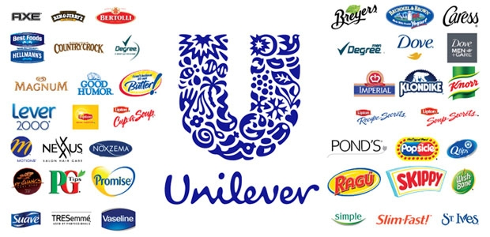
Figure 1: Unilever and its brands (Unilever, 2026a)
One of the firms that produce things that people use in their daily lives is Unilever, and its history is long since in 1929 a Dutch company producing margarine joined forces with a British company producing soap. This is significant as it demonstrates that Unilever has had the things that people need in mind at all times, creating brands and selling products all over the globe. To-day Unilever is present in 190 countries and 3.7 billion people use Unilever products every day. In 2025 Unilever made €50.5 billion (Unilever, 2026a). The majority of its sales were in those countries which are still developing. According to Unilever, it is a company that produces things that people use daily. It is specialised in producing some types of products. Unilever desires to transform the lives of the people and it desires to be the most successful company in the world to do its business in a manner that is good to the planet. Unilever does not necessarily tell what its mission and purpose are but it is evident that the company considers expanding by producing great products that sell them everywhere in the world knowing what people want coming up with new ideas and being sustainable. So Unilever business is to sell a large quantity of products with marketing taking products to stores using money on research and a group of very strong brands, which comprised the majority of Unilever sales in 2025 (Unilever, 2026a).
Unilever produces a host of products, including shampoo and soap. This is a business since there are numerous other companies producing the same products, such as Procter and Gamble and Nestle (Procter & Gamble, 2025; Nestlé, 2026; L'Oréal, 2026; Reckitt, 2026). These companies are in the process of continually attempting to sell their products at prices and this makes it difficult for Unilever to compete. Taste of people is also evolving and therefore Unilever must continue to develop ideas in order to stay ahead. Unilever is attempting to transform and improve by selling out some of its businesses such as its ice cream business and merging its food business with another company known as McCormick. This will assist Unilever to concentrate on what it can do well, and ensure that it remains a powerful company, in the future. Unilever is all these to remain competitive and ensure that it continues to sell a high volume of products (Unilever, 2026b).

Extrinsic and intrinsic Environment Analysis

PESTEL: External Environment Analysis
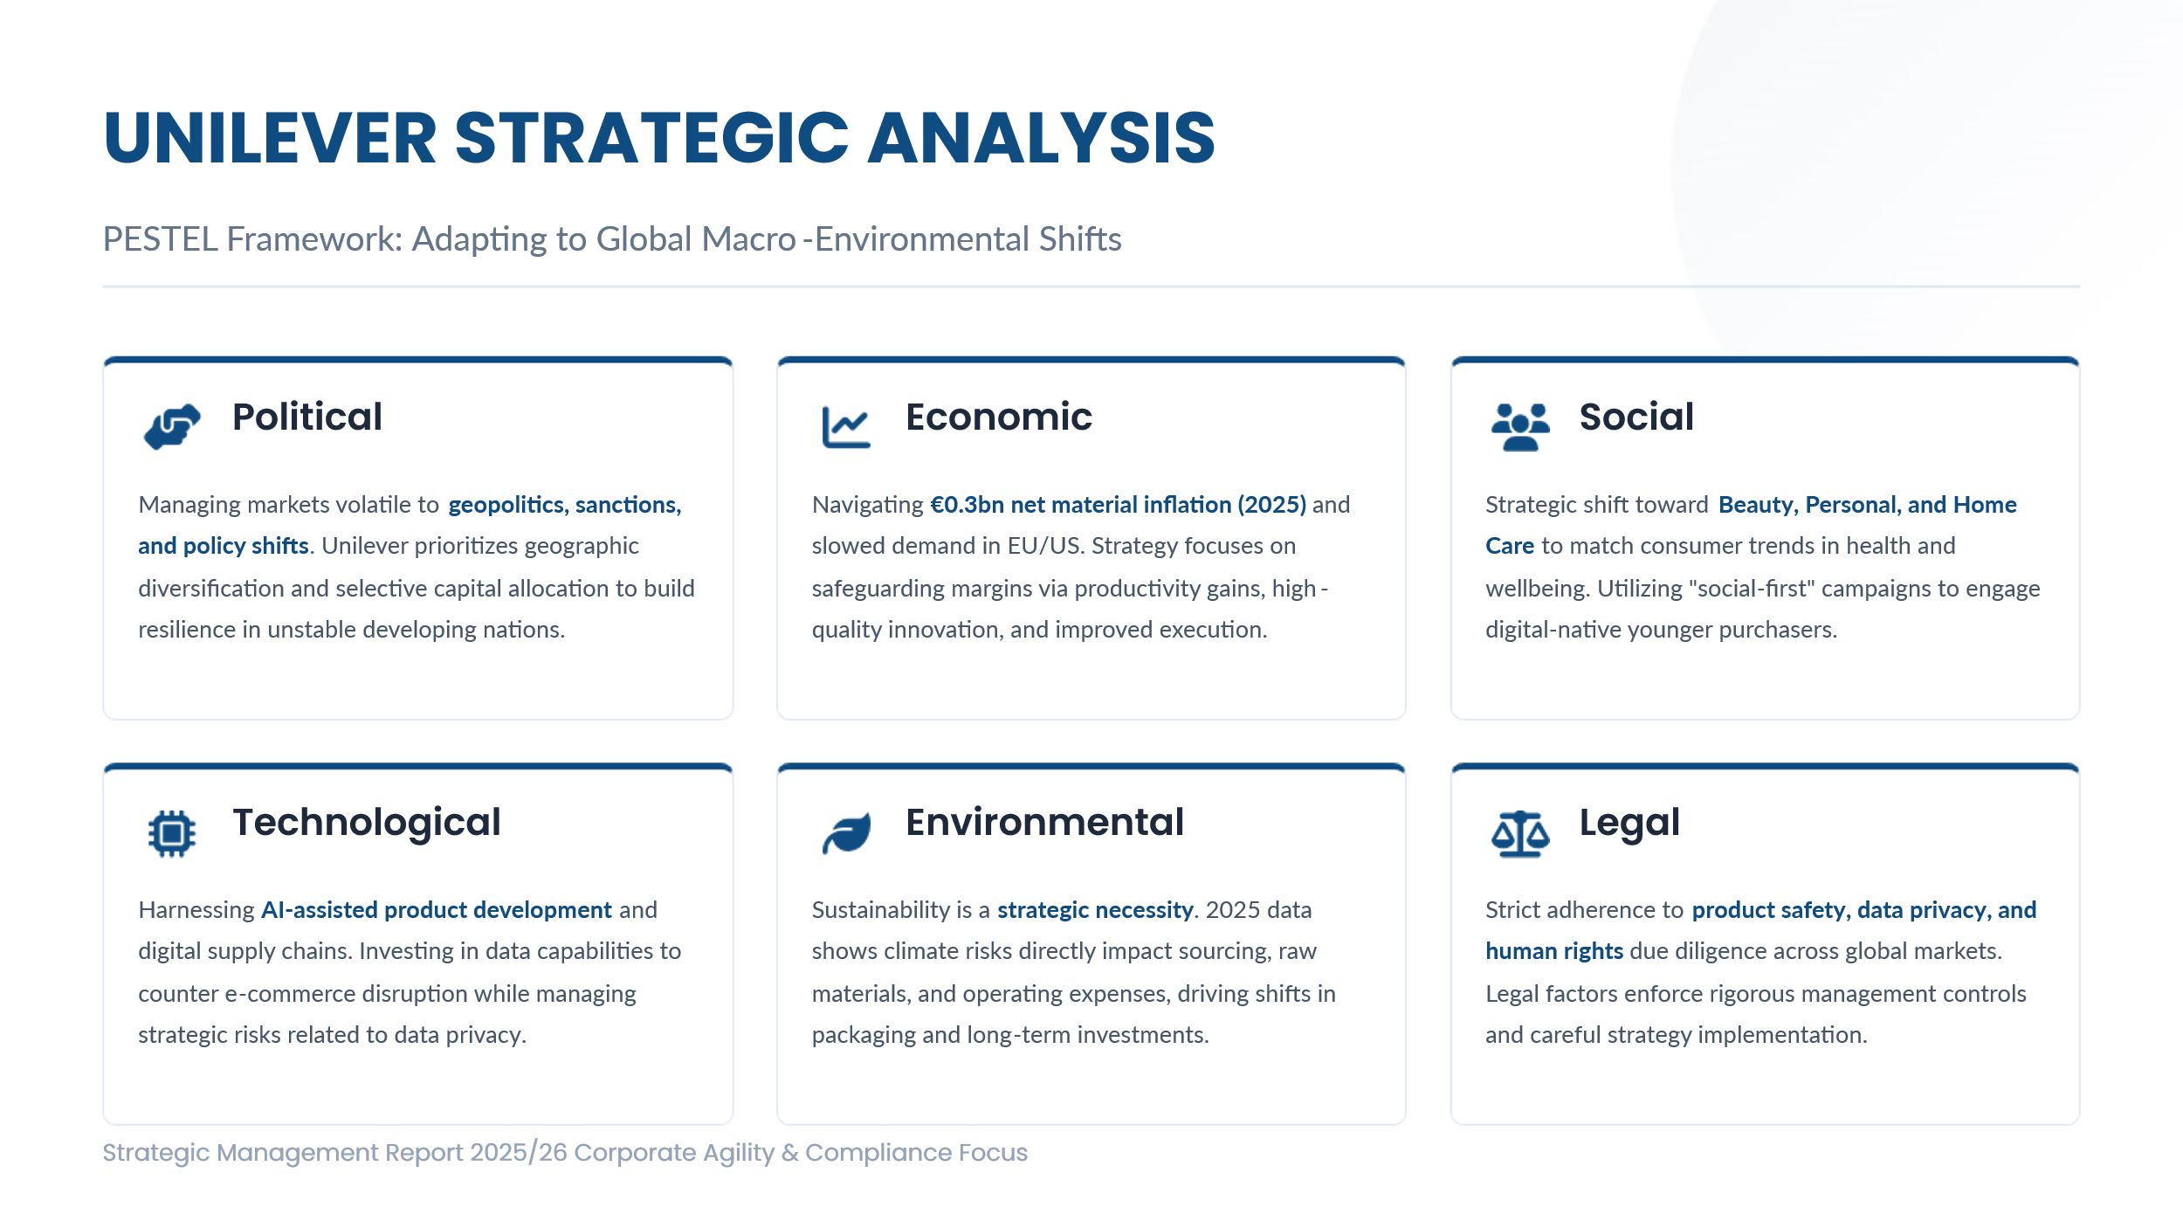
Figure 2: PESTEL Framework (Author)

Political factors
Political factors are also vital since Unilever has to deal with markets that are volatile to geopolitics, sanctions, election periods, and policy regimes. Unilever is aware of the role of political and economic instability in developing nations and this has prompted it to re-evaluate investment priorities and emphasise on resilience. This strategically guides Unilever towards geographic diversification, and a more selective capital allocation (Unilever, 2026a).
Economic factors
The economic factors have a potent impact on pricing, product mix and market decisions. Unilever experienced a net material inflation of €0.3 billion in 2025, and slower consumer demand was experienced in Europe and the US. Unilever has retaliated by relying on productivity gains, high-quality innovation, and improved execution to safeguard margins and assure volume growth (Unilever, 2026a). This indicates that profitability is threatened by economic pressure.
Social factors
The social factors also play a significant role, with consumers moving towards health, wellbeing and sustainability. This trend is reflected in the recent strategic trend of Unilever to focus on beauty, personal care, and home care since these segments are considered to be more appealing and faster-growing compared to others (Unilever, 2026a; Unilever, 2026b).
Technological factors
Competitive strategy has become dependent on technological factors. Unilever recognises technological disruption, and e-commerce as a distributive and communication forces. Today, Unilever is retaliating by investing in AI, digital content supply chains, data capabilities and accelerating the process of innovation as well as AI-assisted product development (Unilever, 2026a).
Environmental factors
Strategic decision-making is now carried out on environmental factors as opposed to being peripheral CSR issues. Unilever sees sustainability as a strategic necessity and its 2025 reporting showed that issues of climate and nature could affect suppliers, consumers, raw materials and operating expenses. Consequently, the sourcing, packaging, supply chain and long-term investment decisions are affected by environmental pressures (Hart, 1995).
Legal factors
Strategy is also determined by legal factors considerations since Unilever is required to abide by the product safety law, environmental protection, data privacy, human rights due diligence and marketing-related laws in most of the markets. This promotes a stricter management and a more careful implementation of strategies.
Thus, in strategic management terms, PESTEL shows that the competitive position of Unilever is not only based on its brand power but also the capacity to be agile, compliant and responsive to the rapidly changing global environment (Aguilar, 1967; Johnson et al., 2020).
Table 1: PESTLE Analysis Summary (Source: Author)
Factor | Key Issues | Strategic Impact Based on the PESTEL analysis
Political | Geopolitical instability, elections, difference in policies across markets | Driving Unilever towards geographic diversification and local responsiveness and flexible investment allocation.
Economic | Inflation, slower demand in some developed markets, cost pressures | Faster demand in certain developed markets, cost pressures, encourage pricing discipline, productivity growth, and growth driven by efficiency.
Social | Shifting lifestyles, trends in health and wellbeing, sustainability demands. | Helping portfolio shift to beauty, personal care and home care, and providing better brand positioning.
Technological | Digital commerce, AI, rapid innovation cycles, cyber threat | Needs to be invested in AI, digital marketing, data capabilities, and secure technology systems.
Environmental | Climate risk, biodiversity loss, carbon pricing, sustainable sourcing | Making sustainability central to supply chain, sourcing, packaging and long-term resilience decisions.
Legal | Product regulation, environmental law, data privacy, compliance demands | The growing significance of governance, risk control and a legally sound strategic implementation.

Critical Success Factors and Strategic Challenges in Unilever’s External Environment
Table 2: Critical Success Factors and External Strategic Challenges (Based on Analysis of the Report)
Critical Success Factor | External Strategic Challenge
Strong global brand portfolio | High competition by international and local FMCG companies.
Deep presence in emerging markets | The political instability, currency volatility and the uneven consumer demand.
Continuous product innovation | The cyclic nature of consumer preference and short products life cycle.
Efficient global supply chain | Inflation, raw material cost pressure, and climate-related disruption
Sustainability and responsible sourcing capability | Increasing regulatory pressure and stakeholder demands on ESG performance.
Digital and data-driven marketing capability | Rapid technological change and altering retail channel format.

A very important things all connected are what help Unilevers success in the world outside the company. First Unilever possesses numerous brands that are well known by people worldwide and trusted by them. This is indeed critical since it assists Unilever in maintaining its position in the market in case of too much competition. In 2025 Unilever indicated that its large brands contributed 78 percent of what the company generated indicating the extent to which the brands enable Unilever perform well (Unilever, 2026a).
Second Unilever operates in countries that are still developing in many. Presence in these countries also implies that Unilever has to contend with currency fluctuations, regulatory uncertainty, and political instability. Third, the importance of innovation is that the external consumer trends are changing towards health, wellbeing, high quality, convenient, and sustainability. It implies that Unilever must continue to produce products and transform what it is selling according to the desires of people. Unilever is transforming its business to do things that are good to people and make them look and feel good which explains why the company should do this to a significant amount (Unilever, 2026a; Kotler and Keller, 2016).
Fourth Unilever must be in a position to move things around without any hitched. The annual reporting of Unilever points out the impact of inflation of input costs, climate risk and operational disturbance, i.e. efficiency is not enough anymore, resilience and flexibility are now strategic requirements (Unilever, 2026a).
It is so important to Unilever now to be able to do things in a way that is good both to the earth and people. It is not simply because individuals who purchase the products made by Unilever desire it. Also because it is desired by the government, individuals that invest in the firm and the people that Unilever operates with. This is a challenge to Unilever: the company should earn more money and at the same time be good to the earth and people. The world beyond Unilever is full of opportunities to perform, on the whole. To remain ahead of the pack the company must leverage its size, the ability to make new things and the ability to change (Carroll, 1991; Elkington, 1997).

Analysing Unilever’s Internal Environment, Focusing on its Key Resources, Capabilities, and Core Competencies
Resources
Unilever possesses good tangible and intangible assets that contributes towards its strategic positioning. Its strongest assets are its global portfolios of brands, distribution, financial capabilities, research and development capabilities, and its extensive presence in the international market (Unilever, 2026a). Besides this, other intangible resources like brand reputation, consumer trust and market knowledge are especially vital in the FMCG industry. All these resources give Unilever a strong base to compete in different markets (Wernerfelt, 1984; Barney, 1991; Grant, 1991).
Capabilities
The capabilities of Unilever encompasses its efficacy of its resources in competing in the market. Unilever has good brand management skills, product innovation, supply chain coordination and adapting to local market conditions. Such capabilities assist Unilever to react to the changing preferences of customers, as well as conduct complicated global businesses, and remain efficient in its value chain. These organisational capabilities are strategically relevant since they aid Unilever in transforming resources into business sustainability (Teece, Pisano and Shuen, 1997).
Core Competencies
The competencies of Unilever are in global marketing, and distribution. Such competencies make Unilever stand out of the competition and be more effective in creating value to the customers. Its competitiveness in controlling a global brand portfolio and at the same time achieving high market penetration both in the developed and developing markets is a significant source of competitive advantage. Thus, the internal environment of Unilever can be deemed to represent a considerable strategic strength of the company since its resources, capabilities, and core competencies, all contribute to long-term competitiveness (Prahalad and Hamel, 1990; Barney, 1991).

VRIO Analysis of Unilever’s Strategic Capabilities
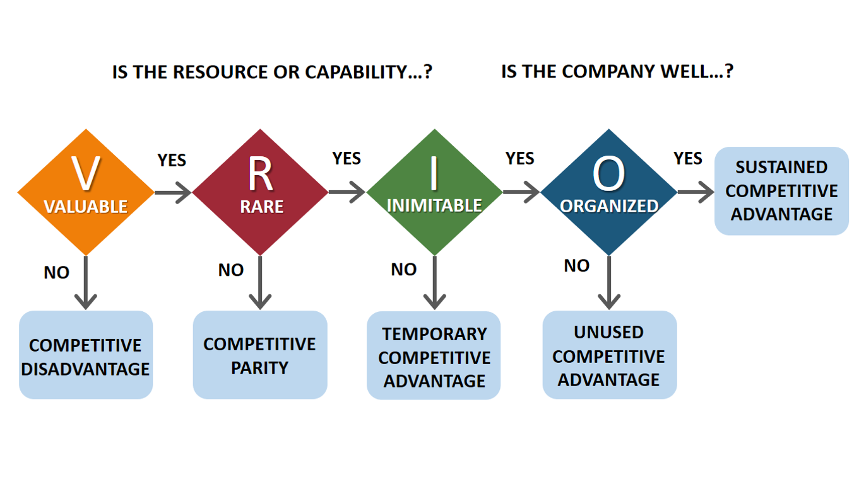
Figure 3: VRIO Analysis (adapted from Barney, 1991)

Table 3: VRIO Analysis Summary (Source: Author)
Resource/Capability | Value | Rarity | Imitability | Organisation | Competitive Outcome
Brand heritage | Yes | High | Very difficult | Yes | Sustained advantage
Power Brand portfolio | Yes | High | Difficult | Yes | Sustained advantage
International distribution system | Yes | Moderate to high | Difficult | Yes | Temporary to sustained advantage
R&D and ability to innovate | Yes | Moderate | Difficult | Yes | Temporary advantage
Existence in emerging markets | Yes | Moderate | Difficult | Yes | Temporary advantage
Marketing and consumer insight capability | Yes | High | Difficult | Yes | Sustained advantage
Scale and coordination of supply chains | Yes | Moderate | Difficult | Yes | Temporary advantage
Sustainability and responsible sourcing competence | Yes | Moderate | Moderately difficult | Yes | Temporary advantage

The VRIO framework demonstrates that Unilever possesses numerous competitive advantage-supporting strategic capabilities, but they do not grant the same level of strength. Its brand is of value, relatively scarce and can hardly be copied due to its reputation, trust and customer satisfaction which have been built over the years. This, together with its good brand portfolio and effective organisational environment, give Unilever a sustainable competitive advantage (Barney, 1991; Aaker, 1991; Keller, 1993). Its international distribution network and high presence in the emerging markets are also useful as they provide scale, extensive market coverage and stability in the developed and emerging markets. Nevertheless, other large FMCG firms are also internationally based, which is why such abilities represent a short-term competitive advantage. Another strategic resource that will be significant to Unilever is its R&D capability which enables it to develop products, respond to shifts in preferences and develop products. Innovation, though not uncommon in the FMCG sector, is so vast and integrated in the innovation processes of Unilever that it is hard to copy, and ultimately affords Unilever a temporary competitive advantage.
Thus, according to the VRIO analysis, the most enduring competitive advantages of Unilever is the brand heritage, brand portfolio, and the marketing and consumer insight capabilities, whereas its global scale, innovativeness, and market reach are strong but less lasting as the competition comes (Barney, 1991; Unilever, 2026a).

Internal Strengths contributing to Competitive Advantage
The internal strengths at Unilever have a great influence on its competitive advantage since they enable the company to generate more customer value than its competitors. One of its greatest strengths is the existence of strong brand portfolio. Established brands build the consumer recognition, trust and loyalty and this assists in minimising the buyer uncertainty and promotes the buyer to repurchase. This empowering makes Unilever to be able to compete not just based on price but also on quality, reputation and emotional appeal (Aaker, 1991; Keller, 1993; Kotler and Keller, 2016).
The other strength is its marketing ability. Unilever can identify various consumer requirements in various markets and convert this information into successful branding, positioning and promotion. This helps Unilever to be relevant in the dynamic FMCG markets. Unilever has a competitive edge based not merely on the products that they sell, but on the effectiveness with which the products are communicated to the customers (Kotler and Keller, 2016; Unilever, 2026a).
The efficient distribution of its products in the developed and developing nations provides Unilever with high market penetration and availability of the products. This gives an edge over smaller competitors, but this advantage is not entirely exclusive to this aspect since other MNCs have well-organised supply chain network as well (Porter, 1985; Procter & Gamble, 2025; Nestlé, 2026).
Moreover, the ability to innovate allows Unilever to constantly develop products and respond to emerging consumer demands. This is more so in the FMCG industry where the tastes change fast and the product life cycles are limited (Teece, Pisano and Shuen, 1997; Unilever, 2026a).

CSR and Sustainability Objectives
Corporate Social Responsibility (CSR) and sustainability no longer focus on individual activities or a Corporate Strategy and have become part of the overall Corporate Strategy of Unilever. Unilever functions in the fast-moving consumer goods (FMCG) sector, where both the environment and the society play a critical role, and CSR becomes an aspect of the long-term goal of the company to offer sustainable and profitable growth. This is mainly as a result of its sustainability approach whereby their strategy to sustainability takes place via programmes like the Unilever Compass, which is a programme that links environmental and social objectives with the business performance (Carroll, 1991; Elkington, 1997).
Environmentally, Unilever aims to minimise carbon emissions, enhance energy efficiency, advocacy of sustainable sourcing, and reduction of plastic waste. These are directly tied to its business goals as they increase its efficiency, minimise future expenses and give its brand a better standing with environmentally conscious customers. These goals, however, may drive up the cost of operation (in the short term) especially on issues like sustainable packaging and responsible sourcing, which poses a conflict between sustainability and profitability (Hart, 1995; Porter and Kramer, 2006). Unilever also focuses on social responsibility, which is improving health and wellbeing, livelihoods in its value chain, and diversity and inclusion in the organisation. These initiatives aid in its positioning in the market because of its attractiveness to socially conscious buyers and enhancing stakeholder linkages. Simultaneously, they create long-term brand loyalty and engagement in employees, which are significant towards a competitive advantage in the long term (Freeman, 1984; Porter and Kramer, 2006).
On the governance front, Unilever focuses on transparency, sourcing ethically and adhering to international standards in its supply chain. This is essential due to the intricacy of its international business and associated risks associated with labour practices and regulatory standards (Unilever, 2026a).
On the whole, the CSR strategy of Unilever has a strong relation to the company business goals because sustainability is employed as a source of innovation, efficiency and brand differentiation. But the success of this alignment will rely on whether the company is able to bring a balance between the sustainability objectives and financial performance and make a uniform consideration of various markets around the world (Carroll, 1991; Elkington, 1997).

Comprehensive and holistic view of Unilever
The balanced scorecard (Kaplan and Norton, 1992) can be used to assess Unilever's strategy given its link between financial and non-financial performance. Unilever is concerned with sustainable growth, global brand leadership and efficiency and the four perspectives of financial, customer, internal business process and learning and growth holistically portrays how strategy is put into practice and measured (Kaplan and Norton, 1992).
Financial Perspective
In terms of the financial perspective, Unilever's strategic target is to ensure consistent profitability and sustainable returns. Unilever’s approach is in line with premiumisation, cost reduction and brand portfolio optimisation, particularly with its emphasis on superior Power Brands. This enables it to focus on categories with better growth and margin opportunities.
Unilever has also divested weaker category businesses, and optimised operations. In 2025, the company's turnover, operating profit and free cash flow were EUR50.5 billion, EUR9.0 billion and EUR5.9 billion respectively (Unilever, 2026a). As such, adaptive strategies are necessary to safeguard profits.
Customer Perspective
From a customer point of view, Unilever seeks to build loyalty, access and customer engagement for brands across the world. Unilever is a global organisation operating in over 190 countries, for which the focus on customer access and brand equity is an important strategic priority (Unilever, 2026a). Metrics include brand equity, customer retention and digital.
Unilever’s customer focus is driven by product innovation, quality and cultural relevance. Digital shopping, customer marketing and category leadership are also key to its strategy. Increasing focus on sustainability, wellbeing and health has also shaped its offerings. Through customer retention and responding to emerging consumer trends, Unilever promotes engagement in the long term, also enhancing its competitive advantage (Aaker, 1991; Keller, 1993; Kotler and Keller, 2016).
Internal Business Process Perspective
Through the internal business process perspective, Unilever seeks to increase process efficiency and drive sustainable practices. Performance measures include efficiency in the supply chain, speed of innovation, cost efficiency, reduction in emissions and sourcing sustainability. To achieve these goals, Unilever has committed to a number of strategic initiatives including leveraging artificial intelligence, digital supply chains and data analytics to enhance efficiencies through better decision-making and agility.
Unilever is also reducing its environmental footprint which enhances efficiency while minimising regulatory and environmental risks. Thus, Unilever processes must be cost efficient, sustainable and adaptable to a varying world (Unilever, 2016a).
Learning and Growth Perspective
The learning and growth perspective evaluates the organisational capacities needed to ensure success. Employees are a key source of innovation and differentiation for Unilever. Key metrics are employee engagement, training and development, leadership development and digital skills.
Unilever endorses this view with leadership training, ongoing training and innovation. Its digital transformation plans also ensure workforce skills for a technology-focused business. Inclusion, diversity and well-being also contribute to productivity and culture. This approach is crucial when the sustainability of competitive advantage depends on adaptability to change and the ability to learn and innovate (Kaplan and Norton, 1992; Teece, Pisano and Shuen 1997).

Strategic Choices and Implementation
At the business-unit level, Unilever typically pursues a differentiation strategy, appropriate for the fast-moving consumer goods (FMCG) sector. It does not base its strategy on price. It also focuses on brand equity and quality, innovation and sustainability. Its strong brands foster perceived value and customer retention in various markets (Porter, 1985; Aaker, 1991; Unilever 2026a). This strategy works well in the personal care and beauty industries, where brand equity and innovation are key.
But differentiation also presents risks in terms of increasing costs in product development, marketing, research and development. This strategy would not be entirely appropriate as a pure cost leadership approach (mainly competing on price) could lower brand awareness and lead to a reduction in margins in a highly competitive market.
Unilever also uses international expansion and pruning at the corporate level. Unilever has a presence in over 190 countries, and a large proportion of its business is in emerging markets (Unilever, 2026a). This is conducive to growth as this provides an opportunity for these markets to have increased income, population and consumption. But it also risks political and economic volatility, currency issues, regulatory and country-specific differences and cultural challenges. Hence, adaptability and mitigation is important.
Unilever has also engaged in managed diversification by portfolio restructuring, moving away from declining business lines and towards fast-growing segments, such as health, beauty and wellbeing. While diversification can lead to new revenue streams, aggressively expanding into non-related businesses may compromise focus (Unilever, 2026b). Thus, the best strategic focus for Unilever is to be heavily differentiated and moderately internationalised. This will help it manage the trade-off between risk and opportunities while maintaining brand and market loyalty (Porter, 1985; Ansoff, 1957; Unilever, 2026a).
Unilever has been generally successful, albeit with challenges, in dealing with organisational change in their strategic implementation. The company has experienced a dramatic transformation over the last years mostly in response to shifting consumer preferences and technology requirements, but also because of the advent of digital disruption. Efforts to restructure the business, consolidate on a few but stronger brands, and investing in digital capabilities have enhanced operational efficiency and strategic simplicity. The changes reveal a fairly good coordination between the strategic objectives and implementation (Unilever, 2026a; Unilever, 2026b).
Limitations, there have been however. The complexity and resistance to the organisation is sometimes brought about by large-scale organisational changes and the pace at which change is executed has also posed some difficulties in executing. There is also the issue of tradeoff between short term financial performance, and long term sustainability commitments. Unilever has demonstrated its capability to change and refocus its strategy on meeting the external demands despite these challenges.
All in all, the strategic decisions of Unilever will fit its competitive setting and its change management strategy has been relatively successful. To ensure further success, it will remain strategic, yet flexible enough in order to adapt to the constant changes of the market and environmental settings.

Strategic Evaluation and Recommendations

Strategic Evaluation using SWOT
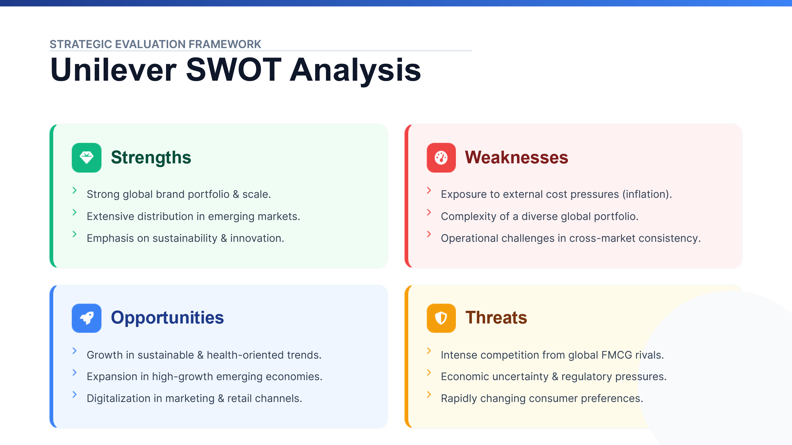
Figure 4: SWOT Analysis (Author)
A SWOT framework can be used critically to analyse the current approach used by Unilever. The company has strong global portfolio of brands, wide distribution channels and high representation in emerging markets in the sense of strength. Its focus on innovation and sustainability also enhances its competitiveness. The weaknesses enumerated, however, have high vulnerability to the outside price forces like inflation of raw materials and difficulty in managing a big and varied global portfolio. Besides this, it may also be operationally difficult to be consistent in a variety of markets (Helms and Nixon, 2010; Johnson et al., 2020).
There are opportunities for Unilever. These include the increasing consumer preference for healthy and green products, continued emerging market growth, and the adoption of digital marketing and retail. These are in line with its strategic focus. But challenges abound. There is intense competition from global FMCG players, emerging consumer trends, and regulatory and economic forces. Hence, the SWOT analysis reveals that although Unilever has a good strategy, it is in a very competitive and ever changing environment and needs to react accordingly (Unilever, 2026a; Procter & Gamble, 2025; Reckitt, 2026).

Evaluation using Ansoff’s Matrix
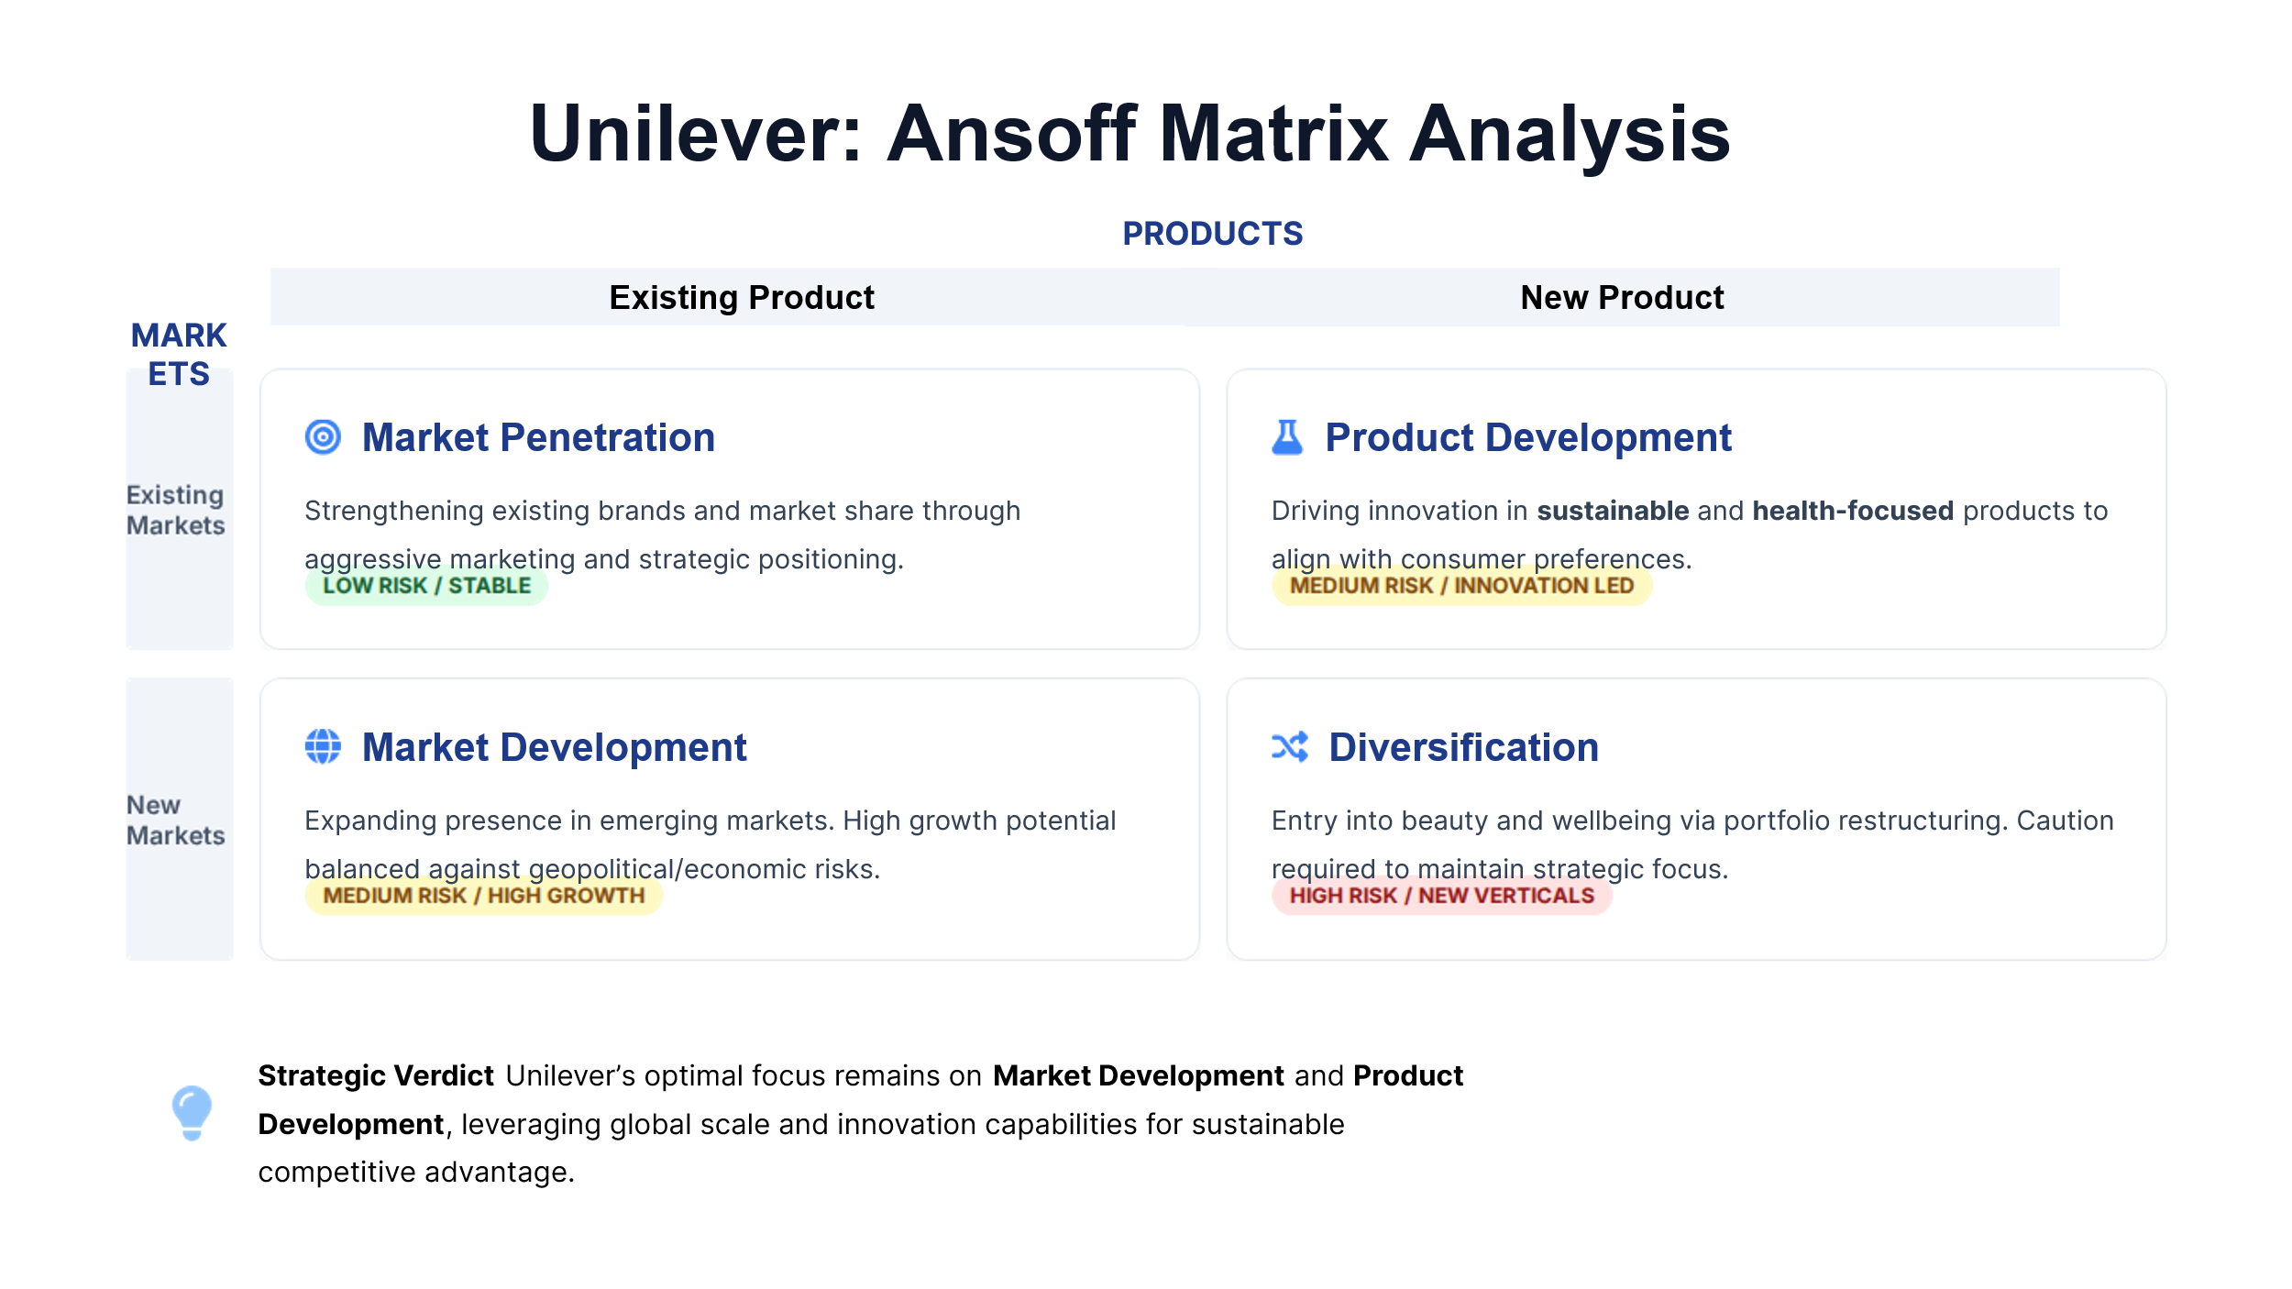
Figure 5: Ansoff Matrix (Author)
Ansoff’s Matrix can be used to analyse Unilever’s growth. It engages in market penetration, by boosting existing brands and improving market share through product positioning, marketing and distribution. This strategy is low risk, but potentially has low returns over time. With regard to market development, Unilever continues to grow in emerging markets, with higher incomes and growing populations. But with this approach, there are geopolitical, economic and regulatory risks (Ansoff, 1957; Unilever, 2026a).
Unilever also pursues product development through the development of sustainable, healthy and innovative products. This helps it to differentiate and anticipate market trends. Further, it has adopted certain diversification through portfolio shake-up and investments in fast-growing beauty and wellbeing market segments. While diversification can open new streams of opportunities, it can divert a company's attention. Thus, market development and product development seem to be the most suitable growth strategies for Unilever as they reflect the international growth opportunities and technological innovation capability that the company possesses (Ansoff, 1957; Teece, Pisano and Shuen, 1997; Unilever, 2026a).

Strategic Recommendations
The analysis suggests three ways that can improve Unilever's competitiveness.
First, Unilever should invest in Sustainable Innovation. Increasingly, consumers are also more conscious of sustainability as sustainability can be a greater point of differentiation. This involves product portfolio diversification, better packaging alternatives and supply chain transparency (Hart, 1995; Porter and Kramer, 2006).
Second, Unilever should take a more targeted risk approach to its international strategy. It should target high-potential emerging markets, while managing the political, economic and currency risks associated with these markets. By doing so, Unilever can potentially benefit from increased growth while minimising risks (Johnson et al., 2020; Unilever, 2026a).
Third, Unilever should also focus on portfolio optimisation through brand focus and portfolio pruning. This would streamline operations and focus efforts on the most strategic areas (Unilever, 2026a; Unilever, 2026b).

Justification of Recommendations
The recommendations are aligned with ideas in strategic management. The Resource-Based View theory states that sustained competitive advantage is enabled by valuable, rare and inimitable resources. Unilever can sustain this kind of advantage through the development of its brand portfolio and sustainability capabilities (Wernerfelt, 1984; Barney, 1991; Grant, 1991). Ansoff's Matrix further supports balanced growth, with product and market development prioritised over higher risk strategies like unrelated diversification (Ansoff, 1957).
These recommendations are also supported by industry practice. The strategy of successful FMCG companies like Nestlé and Reckitt have focused on health-related innovation, sustainability and stronger branding to support their position (Nestlé, 2026 and Reckitt, 2026). So Unilever currently has a great strategy, but it needs fine-tuning. Through sustainability, aggressive but selective growth and portfolio management, Unilever will be able to further its competitive advantage in a global economy (Porter, 1985; Unilever, 2026a).

Conclusion
In conclusion, Unilever has a sound strategy to manage its operations by linking its internal capabilities to the market. Its competitive strategy is primarily based on its brand and global presence, innovation and growing sustainability initiatives. The analyses using PESTEL, VRIO, SWOT and the balanced scorecard indicate that Unilever is well positioned in the competitive and evolving FMCG market. Despite the current strength of the company, cost pressures, regulatory environment and consumer demand require constant evolution. The recommended strategy for the company to focus on pursuing sustainability-related innovations, specific global expansion and portfolio adjustments offers an avenue to enhance its long-term value. Finally, Unilever's capacity to combine profitability, sustainability and flexibility of strategy will be crucial for its success in the global FMCG industry (Kaplan and Norton, 1992; Barney, 1991; Unilever, 2026a).

Section 2: Reflective Account through the Reflective Cycle developed by Gibbs
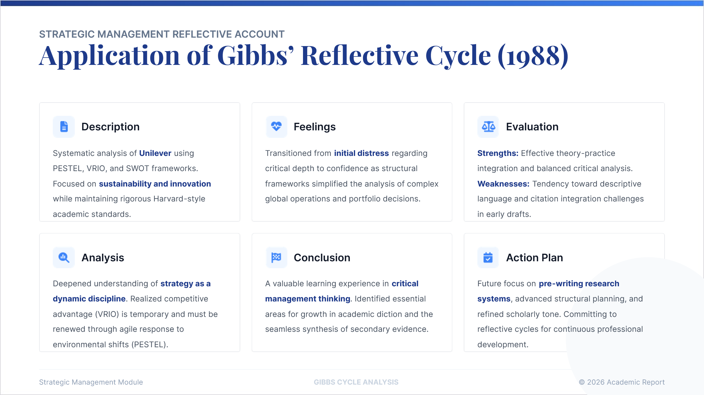
Figure 6: Gibbs Reflective Cycle (Author)
Description
The required task was to complete a strategic management analysis of Unilever, through the analysis of the PESTEL, VRIO, SWOT, Ansoff’s Matrix and balanced scorecard. The report also required me to cover CSR and sustainability, the business strategies, implementation and give recommendations. Additionally, I was required to ensure the report was well structured and cited Harvard style in-text (Johnson et al., 2020).
I first read through the task description and sectioned the report. I chose Unilever because it is a leading FMCG multinational company, it is well known, operates globally and is committed to sustainability and innovation. I then collected data from academic theories and sources from the company and wrote a report on an overview of the organisation, external and internal analysis, CSR, balanced scorecard, formulation of strategies, recommendations and conclusion.
Feelings
Initially I was a bit nervous as the task was comprehensive and had to be written in descriptive and critical modes. I was aware that a strategic management report must not only be descriptive but ideas must also be organised and used critically. The difficulty I experienced was to link Unilever’s business data with academic concepts and not to make it too descriptive (Gibbs, 1988).
But breaking the report up I felt more assured. Models helped me to structure my thinking. For instance, PESTEL helped me analyse the environmental factors, VRIO helped me determine how Unilever's resources can be used to create competitive advantage. I also found it more engaging as I recognised how the concepts of strategic management explain business decisions, like its sustainability strategy and value creation, portfolio adjustment and progress into new geographic markets.
Evaluation
A good feature in what I attempted was that I had a structure in the report. It enabled me to fulfil the assignment requirements and address key areas. I was also able to combine theory and practice. For instance, I didn't just claim that Unilever has strong brands, but I used VRIO and SWOT to examine the strength of these brands. I was also able to use the balanced scorecard to re-evaluate Unilever, not only in terms of financials, but also looking at customers, internal processes and learning and growth.
My second strength was seeing sustainability in a critical light. I was no longer assuming that Unilever's sustainability strategy is necessarily good in and of itself, since it may have conflicts with profitability, cost of implementation and market integration even across different countries. But there were drawbacks. I sometimes over-simplified or were descriptive. It was also difficult to seamlessly incorporate evidence and references, and we also started to branch out and talk about innovation, sustainability and global expansion in multiple contexts.
Analysis
This report enhanced my grasp of the discipline of strategic management. I primarily saw strategy as related to competition and growth. But I learned that strategy also deals with the resources of the organisation, how to implement strategy, sustainability, performance management and evolution.
Having a number of frameworks was helpful as each one shows something different about Unilever. PESTEL identified the impact of inflation, regulation, technology and environmental factors on strategy. VRIO highlighted not only market position makes companies successful, but also having valuable, rare, difficult to imitate and well organised resources. SWOT and Ansoff’s Matrix enabled myself to assess Unilever's existing strategy and provide more specific recommendations for growth (Aguilar, 1967; Barney, 1991; Ansoff, 1957; Helms and Nixon, 2010).
I also learnt that the strategy process is dynamic. Unilever might have successful brands, a global footprint and a strong commitment to sustainability, but these features have to be constantly refreshed and updated over time. This enabled me to realise that defining a strategy is not enough; organisational change management is also critical to achieving strategic success (Teece, Pisano and Shuen, 1997; Mintzberg, Ahlstrand and Lampel, 2009).
Conclusion
In summary, it was a good learning assignment. I enhanced my critical and practical insights into strategic management by looking at the theory through the lens of a multinational company. I think I addressed the necessary points and linked the strategic approaches to the facts of Unilever. This assignment also helped me organise a detailed assignment into relevant sections.
Action Plan
In future tasks, I will organise them earlier and decide which structure is most suitable for the different sections. More time is needed to read academic literature in order to ensure the analysis is more critical. I will also optimise how I make notes on top of each piece of evidence, so that I can make citations (Gibbs, 1988). Finally, I will now focus on building up on my academic tone, sentence structure and reflective writing, as Gibbs' model allows me to review what I have achieved, as well as how I can do things better next time around in strategic management.

References
Aaker, D.A. (1991) Managing brand equity: Capitalizing on the value of a brand name. New York: Free Press.
Aguilar, F.J. (1967) Scanning the business environment. New York: Macmillan.
Ansoff, H.I. (1957) ‘Strategies for diversification’, Harvard Business Review, 35(5), pp. 113–124.
Barney, J. (1991) ‘Firm resources and sustained competitive advantage’, Journal of Management, 17(1), pp. 99–120.
Carroll, A.B. (1991) ‘The pyramid of corporate social responsibility: Toward the moral management of organisational stakeholders’, Business Horizons, 34(4), pp. 39–48.
Elkington, J. (1997) Cannibals with forks: The triple bottom line of 21st century business. Oxford: Capstone.
Freeman, R.E. (1984) Strategic management: A stakeholder approach. Boston: Pitman.
Gibbs, G. (1988) Learning by doing: A guide to teaching and learning methods. Oxford: Oxford Polytechnic.
Grant, R.M. (1991) ‘The resource-based theory of competitive advantage: Implications for strategy formulation’, California Management Review, 33(3), pp. 114–135.
Hart, S.L. (1995) ‘A natural-resource-based view of the firm’, Academy of Management Review, 20(4), pp. 986–1014.
Helms, M.M. and Nixon, J. (2010) ‘Exploring SWOT analysis: Where are we now? A review of academic research from the last decade’, Journal of Strategy and Management, 3(3), pp. 215–251.
Johnson, G., Whittington, R., Regnér, P., Angwin, D. and Scholes, K. (2020) Exploring strategy: Text and cases. 12th edn. Harlow: Pearson.
Kaplan, R.S. and Norton, D.P. (1992) ‘The balanced scorecard: Measures that drive performance’, Harvard Business Review, 70(1), pp. 71–79.
Keller, K.L. (1993) ‘Conceptualizing, measuring, and managing customer-based brand equity’, Journal of Marketing, 57(1), pp. 1–22.
Kotler, P. and Keller, K.L. (2016) Marketing management. 15th global edn. Harlow: Pearson.
L’Oréal (2026) 2025 annual results. Available at: https://www.loreal-finance.com/eng/press-release/2025-annual-results (Accessed: 28 April 2026).
Mintzberg, H., Ahlstrand, B. and Lampel, J. (2009) Strategy safari: Your complete guide through the wilds of strategic management. 2nd edn. Harlow: Financial Times Prentice Hall.
Nestlé (2026) Full-year results 2025. Available at: https://www.nestle.com/media/pressreleases/allpressreleases/full-year-results-2025 (Accessed: 28 April 2026).
Porter, M.E. (1980) Competitive strategy: Techniques for analysing industries and competitors. New York: Free Press.
Porter, M.E. (1985) Competitive advantage: Creating and sustaining superior performance. New York: Free Press.
Porter, M.E. and Kramer, M.R. (2006) ‘Strategy and society: The link between competitive advantage and corporate social responsibility’, Harvard Business Review, 84(12), pp. 78–92.
Prahalad, C.K. and Hamel, G. (1990) ‘The core competence of the corporation’, Harvard Business Review, 68(3), pp. 79–91.
Procter & Gamble (2025) 2025 annual report. Available at: https://us.pg.com/annualreport2025/introduction-and-fy-results/ (Accessed: 28 April 2026).
Reckitt (2026) Annual report 2025. Available at: https://www.reckitt.com/investors/latest-annual-report/ (Accessed: 28 April 2026).
Teece, D.J., Pisano, G. and Shuen, A. (1997) ‘Dynamic capabilities and strategic management’, Strategic Management Journal, 18(7), pp. 509–533.
Unilever (2026a) Annual report and accounts 2025. London: Unilever PLC. Available at: https://www.unilever.com/files/unilever-annual-report-and-accounts-2025.pdf (Accessed: 28 April 2026).
Unilever (2026b) Unilever announces the combination of Unilever Foods with McCormick. Available at: https://www.unilever.com/news/press-and-media/press-releases/2026/unilever-announces-the-combination-of-unilever-foods-with-mccormick/ (Accessed: 28 April 2026).
Unilever (no date a) Leading the next era of corporate sustainability. Available at: https://www.unilever.com/sustainability/ (Accessed: 28 April 2026).
Unilever (no date b) Our history and archives: 1900–1950. Available at: https://www.unilever.com/our-company/our-history-and-archives/1900-1950/ (Accessed: 28 April 2026).
Wernerfelt, B. (1984) ‘A resource-based view of the firm’, Strategic Management Journal, 5(2), pp. 171–180.

