

Data Security, Governance and Compliance

Programme Name: MSc Cybersecurity & Digital Forensics
Module Name : Data Security, Governance and Compliance
Module code: ACCA7028
Lecturer: Dr. Dipo Dunsin
Student Name: Ansh Italiya
Student ID: 2510659

Abstract
FullerHealth is an international brand of healthy living, which is based on cloud-based, wireless, and BYOD. Nonetheless, the company does not have embedded security policies and governance, which exposes personnel, customer, and intellectual property information to a high risk. In the present report, the available resources and security frameworks, including ISO 27001, ITIL, and other frameworks that complement it, are appraised in an attempt to come up with a tailor-made information security governance framework in FullerHealth. The given plan will involve the establishment of a sound governance framework, risk management procedures, encompassing policy frameworks, and preservation and continuity processes. It will also give a roadmap of implementation phases that will conform to ISO 27001 where necessary. The most important pieces of advice will be on the need to have executive sponsorship, risk-based prioritization, continuous monitoring and periodic review of security controls and policies to meet the changing and evolving threats, changes in technology, and regulatory changes. Also, the plan will show the future upgrades, such as AI-based threat detection, automation, and orchestration to enhance security resilience at scale so that FullerHealth can remain dynamic and safe in the rapidly evolving digital environment.
Table of Contents
Abstract 2
1. Introduction 6
1.1 Background and Context 6
1.2 Purpose and Scope 6
1.3 Key Assumptions 6
2. Literature Review: Security Frameworks and Models 7
2.1 International Organization for Standardization (ISO 27000 Series) 7
2.2 Information Technology Infrastructure Library (ITIL) 8
2.3 Other Relevant Frameworks 10
2.4 Synthesis and Gap Analysis 10
3. Proposed Security Governance Framework for NatureGreen 11
3.1 Framework Design Philosophy 11
3.2 Governance Structure 11
3.3 Strategic Security Planning 12
3.4 Security Policies and Procedures 13
3.5 Risk Management Framework 13
3.6 Compliance and Legal Requirements 14
3.7 Protection Mechanisms 15
3.8 Contingency and Business Continuity Planning 15
3.9 Service Level Agreements (SLAs) 15
4. Critical Analysis 15
4.1 The Dynamic Nature of Cybersecurity Threats 15
4.2 Technological Advancement and Regulatory Adaptation 16
4.3 Benefits of Regular Updates to Standards 17
4.4 Challenges and Considerations 17
5. Implementation Roadmap for NatureGreen 17
5.1 Phased Implementation Approach 17
5.2 Success Factors and Key Recommendations 18
6. Conclusion 18
References 20

List of Figures
Figure 1: Overview of ISO 27001–27002 Framework Relationship 8
Figure 2: ITIL Service Lifecycle 9
Figure 3: Information Security Governance Structure Overview 12
Figure 4: Comprehensive cyclical framework for risk management 14

List of Tables
Table 1: ISO 27001 and 27002 domain comparison 7
Table 2: Key IT processes and security contributions 9
Table 3: Comparison of major IT security frameworks 10
Table 4: Comparison of framework insights and gaps 10
Table 5: Primary Contributions of Security Frameworks 11
Table 6: Information Security Governance Roles and Responsibilities 12
Table 7: Balanced Scorecard Perspectives for Security KPIs 13
Table 8: Key Security Policy Domains and Priorities 13
Table 9: Key Compliance Areas and Their Focus 14
Table 10: Core Components of Business Continuity Planning 15
Table 11: Regulatory needs driven by emerging technologies 16
Table 12: Phased roadmap for enhancing security maturity 18

1. Introduction

1.1 Background and Context
NatureGreen (NG) is a global brand that has been known to provide a healthy lifestyle by offering wide range of products. The company has developed a high online presence and it has many international business activities and extensive usage of the internet and social media (Infante and Rahayu Mardikaningsih, 2022). Its network which is mostly cloud-based allows it to support its workers as well as its customers with approximately 95 percent of its connection being wireless. Nonetheless, NG experiences enormous challenges in controlling the risks of Bring Your Own Device (BYOD) because employees and customers are urged to bring their own devices to use the corporate resources. This makes the process of security complicated because huge volumes of sensitive employee and customer data will be exposed, not to mention the billions worth of intellectual property. The company is not run on a formal security policy framework and disorganized in its data protection policies.

1.2 Purpose and Scope
This consultancy report is aimed at proposing a data security, governance, and compliance strategy of NatureGreen in a comprehensive way. It will be centered on the mitigation of the vulnerabilities in the current infrastructure at the company. The report is based on the known security frameworks and models, such as the ISO 27000 and ITIL, to create a specific security governance strategy of NG (Abdelkebir Sahid, 2024). It will equally discuss the dynamic nature of security regulations and standards. The key elements of the report will involve an overview of the relevant security frameworks, a recommendation of a particular NG framework, a discussion of the regulatory changes, and an implementation strategic roadmap.

1.3 Key Assumptions
The present report is founded on the data in the description of NatureGreen case and presupposes the correctness of this information as far as the current network environment of the company is concerns. It does not take a look at any prior formal security policies and governance practices other than what is said. Moreover, it will not engage vendor-specific technologies or architectures other than those specifically mentioned in the description of the case. Other assumptions will be described later as they are required.

2. Literature Review: Security Frameworks and Models

2.1 International Organization for Standardization (ISO 27000 Series)
The ISO/IEC 27000 family presents a structured, risk-based system of information security management, which is based on an Information Security Management System (ISMS). It stipulates critical management system requirements, such as context, leadership, planning, support, operation, performance assessment and enhancement, where reference controls are located in the Annex A of ISO/IEC 27001 (Manjeet Kharub et al., 2024). This is supplemented by ISO/IEC 27002, which includes specific implementation instructions of such controls that include such aspects as asset management, access control, operational security, and communications security.
Table 1: ISO 27001 and 27002 domain comparison
Domain | ISO 27001 Focus | ISO 27002 Example Controls
Organization & Governance | Information security policies, ISMS | Policy management, segregation of duties
Asset & Access Management | Asset inventory, access control | Classification, least privilege, authentication
Operations & Communications | Operations security, network security | Logging, change control, secure network architecture
Supplier & Cloud Relationships | Supplier security requirements | Security clauses in contracts, cloud service review

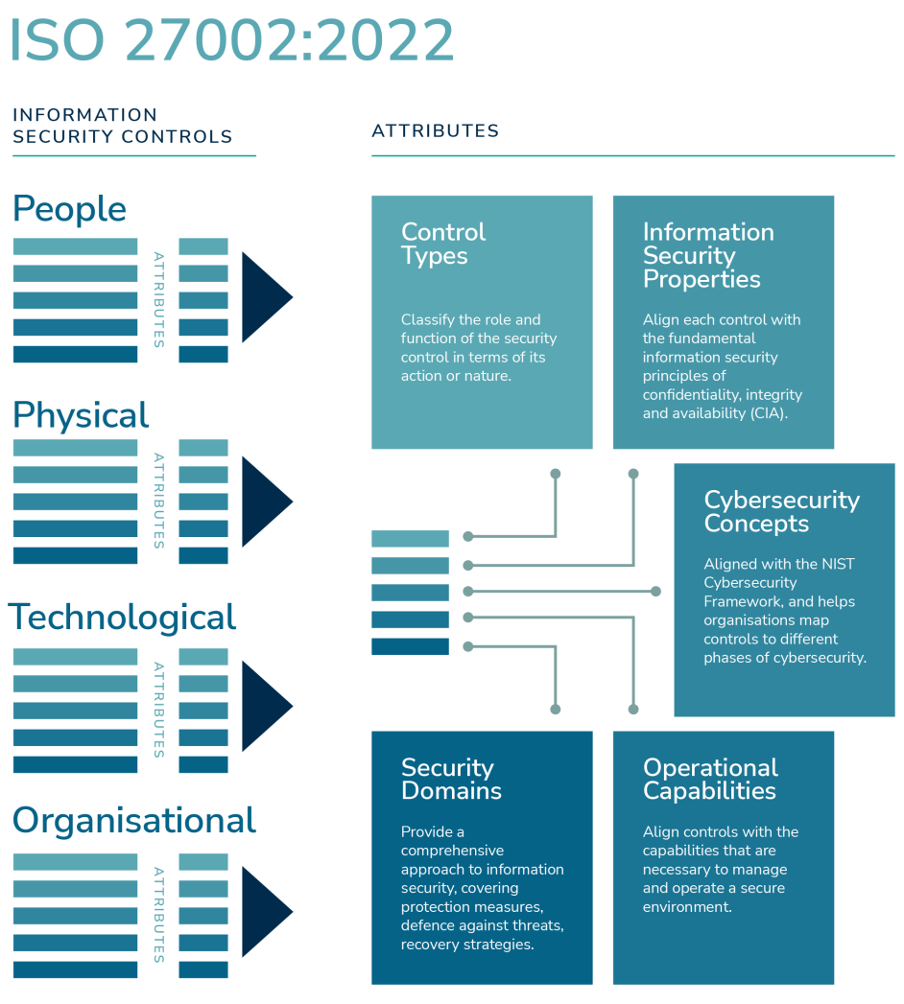
Figure 1: Overview of ISO 27001–27002 Framework Relationship
ISO 27001 and 27002 represent a holistic management of the organization such as that of NatureGreen, whose work is based on the cloud-based, wireless infrastructure and has difficulties related to the BYOD policy. Such frameworks would assist in the regulation of network, endpoint, and data security, making sure that confidential, integral, and accessible sensitive information was available but allowing the company to track and enhance its security position.

2.2 Information Technology Infrastructure Library (ITIL)
ITIL is a famous model of IT service management (ITSM), which is concerned with optimal techniques of planning, delivering, and improving IT services that contribute to business goals ṣ (Permatasari, Sulistyo and Santosa, 2024). ITIL manages processes into a system of service values and value chain, with its focus on continuous enhancement, job roles, key performance indicators and responsibility.
Table 2: Key IT processes and security contributions
Process | Objective | Security Contribution
Incident Management | Restore normal service promptly | Standardized security incident handling, reduced downtime
Change Management | Assess, authorize, and track changes | Minimizes risk from insecure or uncontrolled changes
Service Continuity Management | Ensure IT service recovery post-disruption | Enhances resilience, disaster recovery, and availability

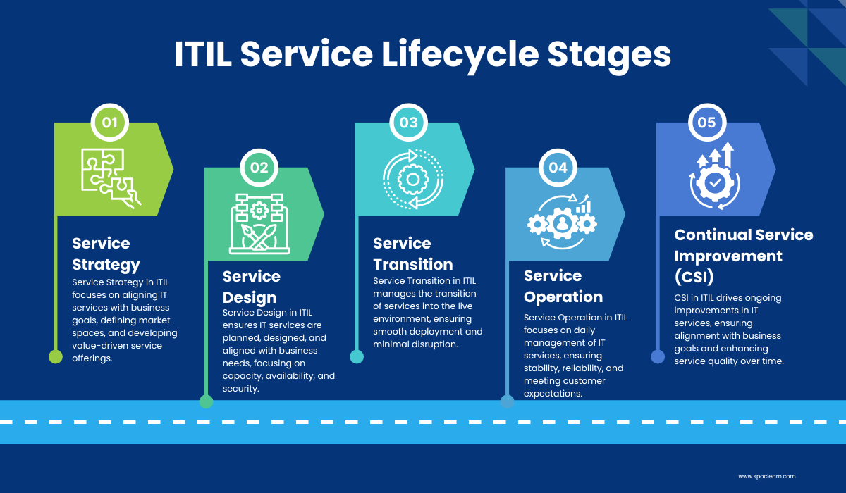
Figure 2: ITIL Service Lifecycle
When combined with the information security management, ITIL offers governance tools, including workflows, approval procedures, service-level goals, and reporting (Otari Machaladze, 2025). In the case of NatureGreen, the implementation of ITIL-based practices in the incident management system, change control, and service continuity will facilitate the process of responding to outages and security breaches, controlling changes in cloud and wireless infrastructure, and developing an official continuity plan of critical services that are being used by employees and clients.

2.3 Other Relevant Frameworks
The NIST Cybersecurity Framework (CSF) provides a risk-based framework that categorizes cybersecurity operations as 5 functions, which are Identify, Protect, Detect, Respond, and Recover. It assists in assessing the level of security maturity, developing an objective profile, and prioritizing improvements and provides a degree of flexibility and adaptability to various technologies and environments. COBIT is an IT governance and management model, which aims at ensuring that IT provides its worth in safeguarding risk and compliance (Morris and Erienika Lompoliu, 2025). Compared to the certifiable requirements of the ISMS stipulated by ISO/IEC 27001, COBIT suggests a more extensive governance framework, which can be used to supplement ISO and ITIL.
Table 3: Comparison of major IT security frameworks
Framework | Focus | Strengths | Limitations
ISO/IEC 27001 | ISMS requirements and controls | Certifiable, widely recognized standard | Prescriptive, heavy on implementation
NIST CSF | Cybersecurity risk functions | Flexible, adaptable, easy to map to other frameworks | Voluntary, lacks detailed control guidance
COBIT | IT governance and management | Focuses on value, risk, and compliance | Requires customization, less technical detail
ITIL | IT service management | Mature operational guidance | Not specifically focused on security

2.4 Synthesis and Gap Analysis
The bundling of ISO 27001/27002, ITIL, NIST CSF, and COBIT offers in-depth advice on the controls, service practices, risk management, and management. Though, NatureGreen does not have formalized security governance, structured ISMS controls as well as explicit risk posture documentation. Its security management is also a problem that needs to be addressed urgently because it has a cloud-based and wireless environment.
Table 4: Comparison of framework insights and gaps
Area | Framework Insights | Gap at NatureGreen
Governance | COBIT defines roles, oversight | No established security governance
ISMS Controls | ISO 27001/27002 outlines control sets | Controls are not formalized or risk-driven
Service Processes | ITIL manages incidents, changes, continuity | Operational security practices are disorganized
Risk Posture | NIST CSF defines risk functions | No documented risk posture

3. Proposed Security Governance Framework for NatureGreen

3.1 Framework Design Philosophy
The security governance framework to be proposed to NatureGreen will be a risk-based, tailor-made framework which will incorporate the ISO/IEC 27001 ISMS framework and ITIL service management practices. This framework is seen to have the strengths of both models, as the ISO 27001 is used as a framework to provide the foundation of control and management, and the ITIL is used to support the processes involved in the operation of incidents, changes, and continuity (Kenyon, 2020). This is to make sure that security controls are seamlessly incorporated in the day to day service provision. It is a holistic solution to ensure the security of both the cloud-based, wireless infrastructure of the organization and the security of valuable data and intellectual property and provide the organization with an effective and safe model of governance.
Table 5: Primary Contributions of Security Frameworks
Element | Primary Contribution
ISO/IEC 27001 | Risk-based ISMS and control framework
ITIL | Operationalization through ITSM practices
Risk Orientation | Prioritized treatment of material threats

3.2 Governance Structure
A robust information security governance is possible with a board and a Chief Information Security Officer (CISO) in place, which are backed by cross-functional committees. Considering the informal risk management and the governance environment of NatureGreen, it is proposed to use a hierarchical governance model. The risk appetite of the organization will be established by the Board and the business level security results will be handled by the executives. The CISO will be in charge of the overall security operations, and the Security Steering Committee, which consists of representatives of IT, legal, HR and business units, will lead the approval and prioritization of risks in the security policy. This design will provide a balance between corporate strategy and accountability on every level.
Table 6: Information Security Governance Roles and Responsibilities
Role/Body | Key Responsibilities | Reports To
Board/Executive | Approve strategy, set risk appetite | Shareholders
CISO | Lead ISMS, advise board, manage security | CEO/Executive
Security Steering Committee | Govern policies, risks, major initiatives | CISO/Executive
Operational Security & IT | Implement controls, report incidents | CISO/CIO

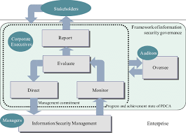
Figure 3: Information Security Governance Structure Overview

3.3 Strategic Security Planning
Strategic security planning converts general security objectives into specific objectives to be used in the process of securing information assets. The security strategy of NatureGreen will be based on business objectives, as it will contribute to the long-term priorities, including resilience, compliance with regulations, and trusted digital services (Kofi, 2025). The security vision and mission of the organization will act as a guiding factor, and the goals will be converted into key performance indicators (KPIs). These security KPIs are going to be included in the balanced scorecard of the business and are aimed at the performance of the business in terms of financial metrics, the level of customer satisfaction, internal processes, and learning and growth.
Table 7: Balanced Scorecard Perspectives for Security KPIs
Perspective | Example Security Governance KPI Type
Financial | Cost of security incidents, % security spend vs. IT
Customer/Stakeholder | Trust/satisfaction, incident impact on customers
Internal Processes | Mean time to detect/respond, policy compliance rate
Learning & Growth | Training coverage, skills maturity, culture metrics

3.4 Security Policies and Procedures
The security policies will be hierarchical whereby the organizational level strategic policies will delineate general principles, control requirements as tactical and operational procedures as to the implementation and enforcement procedures (Edwards, 2024). Since, currently, NatureGreen does not have a proper security policy framework, formal policies are necessary that will govern the use of personal devices, the management of cloud services, and the safety of sensitive employee, customer, and intellectual property information. Detailed configuration standards, monitoring and compliance processes will support these policies.
Table 8: Key Security Policy Domains and Priorities
Policy Domain | Primary Focus | Priority
BYOD & MDM | Secure personal devices, access control | High
Cloud Security | Provider responsibilities, configuration, access | High
Data Classification & Handling | Sensitivity tiers, handling rules | High
Acceptable Use | User behavior, prohibited activities | Medium
Intellectual Property Protection | Safeguarding proprietary information | High

3.5 Risk Management Framework
The risk management strategy of NatureGreen will be based on the ongoing risk identification, evaluation, and management. The assets risks will be assessed according to their effects and their probability of occurrence. Risks that do not meet the acceptable standards will either be mitigated, transferred, avoided, or accepted and constant monitoring. An Excel sheet will be used as a central risk register to document all the identified risks, their owners, and treatment plan. The heatmap will assist in prioritization and reporting the risks to the governance bodies with special focus on the wireless network vulnerabilities, cloud service threats, and BYOD risks.
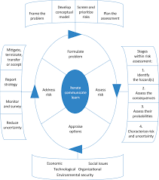
Figure 4: Comprehensive cyclical framework for risk management

3.6 Compliance and Legal Requirements
Security governance framework will be aligned to the global data protection legislations including EU General Data Protection Regulation (GDPR) and industry-specific legislations. Adherence to them will guarantee compliance with law, rights of the data subject and accountability. The policies will also concern sector-specific policies like healthcare policies or financial policies, as well as intellectual property protection (Poddar and Rao, 2024). Regular monitoring, audit, record of processing registers and audit trail will be considered to ensure compliance.
Table 9: Key Compliance Areas and Their Focus
Area | Compliance Focus
Data Protection | GDPR, local privacy laws, data subject rights
Industry Regulations | Sector-specific security and privacy rules
Intellectual Property | Protection of IP assets and licensing
Monitoring & Audit | Logs, registers, periodic audits, assessments

3.7 Protection Mechanisms
These protection mechanisms will consist of technical, administrative and physical controls that will enable the protection of the confidentiality, integrity and availability of the information assets of NatureGreen. At the network, protocols such as WPA3 and 802.1X will protect the access of the wireless network. Anti-malware tools, firewalls and mobile device management (MDM) will be used to protect endpoints. Risks will be reduced and security will be strengthened with the help of strong identity management, Cloud Access Security Brokers (CASB), and Zero Trust Architecture in the cloud.

3.8 Contingency and Business Continuity Planning
Business continuity planning has the effect of ensuring that the important services are resilient and can recover well in case of disruptions like cyber attack or destruction of the infrastructure. The plan will consist of explicit recovery objectives, incident recovery plans, backup plans, and rules on crisis communication.
Table 10: Core Components of Business Continuity Planning
Element | Key Focus
Disaster Recovery Strategy | Recovery time, recovery point, alternate sites
Incident Response Plan | Roles, triage, containment, eradication, lessons
Backup and Recovery | Regular backups, secure storage, restoration tests
Crisis Communication | Notification trees, clear messages, media handling

3.9 Service Level Agreements (SLAs)
Service Level Agreements (SLA) will establish performance and recovery goals such as uptime, response time and backup schedules to establish adherence to continuity and disaster recovery goals.

4. Critical Analysis

4.1 The Dynamic Nature of Cybersecurity Threats
The threat landscape of cybersecurity is ever evolving, as classic malware is becoming more advanced such as sophisticated ransomware attacks, long-term attacks, Advanced Persistent Threats (APTs) and fast-moving zero-day attacks which affect different platforms. Organizations unintentionally introduce new vectors of attack, in the event they combine technologies like Internet of Things (IoT) devices, cloud service providers, and mobile ecosystems. Poor configurations and poor device security increase the attack surface, and make systems more susceptible to large and distributed threats (Lukman Raimi, 2023). The recent instances of IoT botnets, APT attacks and ransomware attacks on cloud servers point to the sophistication of cyberattacks. Lateral movement, privilege escalation, and data exfiltration tend to be some of the most common attackers strategies, which require consistent monitoring and adaptation to some of these emerging threats to remain resilient.

4.2 Technological Advancement and Regulatory Adaptation
The fast digital transformation, which has occurred due to the innovations in the field of cloud computing, is changing the nature of business models and operational environment. Technological changes, however, are rapidly moving faster than the regulatory policies that are meant to control them, especially when it comes to such aspects of technology as artificial intelligence (AI) and cross-border cloud services. Such a lack of regulation brings about uncertainty and challenges in compliance and hence business can only operate using the old, fixed regulatory methods. Consequently, it is growing in support of more malleable, and risk-based compliance frameworks, including ongoing cloud compliance audits and AI-based controls. The models allow organizations to monitor technological architecture and data processing changes in close real-time and keep pace with changing regulatory needs.
Table 11: Regulatory needs driven by emerging technologies
Dimension | Technological Trend | Regulatory Response Need
Cloud Services | On-demand, global data processing | Cross-border data, security, and privacy regulations
AI and Automation | Adaptive, opaque decision systems | Auditability, transparency, and oversight
Continuous Delivery | Rapid system changes | Ongoing, automated compliance checks

4.3 Benefits of Regular Updates to Standards
Security standards are also updated frequently to deal with new threats and based on the lessons learnt due to emerging attack techniques and technologies. These updates are useful in ensuring that companies have at least some form of protection against the most recent risks as well as coming up with any security gaps. Constant updates also encourage use of international security practices which help in the interoperability and even security requirement of organizations to meet cross-border security and privacy needs. Moreover, extended standards also lead to the development of trust between the stakeholders since organizations that stay certified or stay compliant are credible (Syadali, Segaf and Parmujianto, 2023). Living by the new security models will lessen the legal and regulatory threats. In a sector where security posture is a major selection factor by the customer, partners and even by the regulator, keeping abreast with the security standards may also serve as a competitive advantage.

4.4 Challenges and Considerations
Compliance fatigue, or stress and strain induced by the frequent necessity to comply with overlapping regulations and standards is one of the biggest issues that organizations have to endure. The records and technical changes necessary to remain compliant have to be audited often, which exerts a lot of strain on organizations and the technical personnel. This unceasing drive to meet strict requirements may even slack digital initiatives, frustrate and even postpone important initiatives. It is thus necessary that the top management should create a balance between business agility and security. Good security programs must concentrate on proportional and risk-based controls which will target resources to the greatest urgency in the threats and uncertainty, as opposed to bombarding teams with more compliance requirements than necessary. Prioritization of risks allows the organizations to make the best use of their security efforts and limits the pressure on resources.

5. Implementation Roadmap for NatureGreen

5.1 Phased Implementation Approach
The implementation plan should be implemented step by step to reduce the risks of the changes, which is in conformity to the best practices of adopting ISO 27001 and security programs. The strategy encompasses the segmentation of the process into phases so that the incremental movement can be manageable.
Table 12: Phased roadmap for enhancing security maturity
Phase & Timeline | Key Focus Areas
Phase 1 (0-6 months) | Establish governing bodies, define roles, develop BYOD and cloud security policies, conduct initial risk analysis
Phase 2 (6-12 months) | Implement basic controls like MDM, network segmentation, launch security awareness training, establish incident response protocols
Phase 3 (12-24 months) | Standardize and streamline ISMS, pursue ISO 27001 certification, enhance threat detection and response capabilities, implement regular monitoring

5.2 Success Factors and Key Recommendations
To be successful in this security governance program, executive support, mandates and long time budget are essential. It is also necessary to promote a change of culture towards security, with staff education, training, and awareness that should counteract the adherence of the policy in the face of the technology. Co-operation in IT, business units, legal, HR, and external partners, is imperative in ensuring that security is entrenched in everyday activity. Last but not least, a strategy of metrics-based approach, KPIs and regular reviews assist in measuring progress, attracting investments and modifying strategies as necessary.

6. Conclusion
NatureGreen has a significant challenge caused by the reliance on cloud-based services, the prevalence of wireless connections, and intensive use of BYOD in the context of the need to secure valuable data and intellectual property in a chaotic security environment. This report suggests an overall control mechanism of governance through which the structured ISO 27001 ISMS, the ITIL processes of operating services and the risk oriented controls are integrated into a consistent and flexible system of security that meets organisational objectives. The success of attaining a strong security posture will entail long-term leadership commitment, implementation strategy, ongoing monitoring, and flexibility adapting to changing regulatory requirements. The further improvements should be also based on AI-based threat detection, automation, and orchestration, which will result in better performance without undermining the authority and supervision.

References
Abdelkebir Sahid (2024). Securing Healthcare. CRC Press eBooks, pp.196–244. doi:https://doi.org/10.1201/9781003470038-9.
Edwards, Dr.J. (2024). Security Policies and Procedures. Mastering Cybersecurity, pp.413–434. doi:https://doi.org/10.1007/979-8-8688-0297-3_12.
Infante, A. and Rahayu Mardikaningsih (2022). The Potential of Social Media as a Means of Online Business Promotion. Journal of Social Science Studies, [online] 2(2), pp.45–48. Available at: https://jos3journals.id/index.php/jos3/article/view/25.
Kenyon, B. (2020). ISO 27001 Controls - A Guide to Implementing and Auditing.
Kofi, S. (2025). Regulatory Frameworks and Digital Compliance in Green Market Orientation. IGI Global eBooks, [online] pp.291–328. doi:https://doi.org/10.4018/979-8-3693-9831-9.ch009.
Lukman Raimi (2023). Business Continuity and Disaster Recovery Strategies as Resilience Tools after Cyberattacks in Toxic Enterpreneurship Ecosystems. CRC Press eBooks, pp.349–364. doi:https://doi.org/10.1201/9781003319887-21.
Manjeet Kharub, Mondal, S., Singh, S. and Gupta, H. (2024). Evaluation of competency dimensions for employee performance assessment: evidence from micro, small, and medium enterprises. The international journal of productivity and performance management/International journal of productivity and performance management. doi:https://doi.org/10.1108/ijppm-07-2023-0379.
Morris, G. and Erienika Lompoliu (2025). Optimizing IT Governance in BTS.id: A COBIT 2019-Based Analysis of Design Factors. MALCOM Indonesian Journal of Machine Learning and Computer Science, [online] 5(2), pp.699–710. doi:https://doi.org/10.57152/malcom.v5i2.1997.
Otari Machaladze (2025). IT infrastructure management in educational institutions using the ITIL framework. International Science Journal of Engineering & Agriculture, [online] 4(2), pp.215–225. doi:https://doi.org/10.46299/j.isjea.20250402.14.
Permatasari, A.R., Sulistyo, S. and Santosa, P.I. (2024). Optimizing IT Services Quality: Implementing ITIL for Enhanced IT Service Management. 2024 11th International Conference on Information Technology, Computer, and Electrical Engineering (ICITACEE), [online] pp.296–301. doi:https://doi.org/10.1109/icitacee62763.2024.10762782.
Poddar, A. and Rao, S.R. (2024). Evolving intellectual property landscape for AI-driven innovations in the biomedical sector: opportunities in stable IP regime for shared success. Frontiers in Artificial Intelligence, 7. doi:https://doi.org/10.3389/frai.2024.1372161.
Syadali, M.R., Segaf, S. and Parmujianto, P. (2023). Risk management strategy for the problem of borrowing money for Islamic commercial banks. Enrichment : Journal of Management, [online] 13(2), pp.1227–1236. doi:https://doi.org/10.35335/enrichment.v13i2.1392.

