School Prospectus
Albatross Primary School
2020/2021



KINDNESS, HAPPINESS, MOTIVATED, SUCCESS

CONTENTS

- Welcome
- Defining the term schooling and education
- Vision and values
- School aims and objectivise
- School authority
- Always try to achieve our best
- Starting school for the first time
- The school day
- School security
- Assessments
- Pedagogy
- Fire drill
- Bullying
- Attendance
- Absences from school
- School award scheme
- PTFA
- Extra Curriculum activities
- Consultation parent/ teacher
- Additional learning needs arrangements
- School uniform
- The current school Curriculum
- The role of outdoor learning in the Curriculum
- Child protection
- Equal opportunities
- Disability discrimination Act
- Theory
- How to make a complaint?

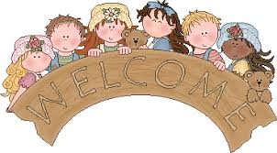

Dear Parents/ carers,
A VERY WARM WELCOME TO ALBATROS PRIMARY SCHOOL!
It gives me great pleasure to present to you this prospect handbook informing you about out lovely school. This prospectus is mainly designed to give parents and carers an outline of our school aims/ objectivise as well as what we have offer to you as well as your child.
Choosing the perfect school for your child is sometimes a tough decision for every parent/ carer but this prospectus is designed mainly to give you a clear understanding as to why our school is special and different to other schools, whether this prospect might not answer all your questions you are more than welcome to contact either myself or my deputy. We at Albatross primary school hope that you find this information helpful and useful.

Albatross primary school is passionate in offering children and young people with an exciting, stimulating and motivated education. At our school we offer Nursery to year 6 provision that allows all the children to meet the different challenges of education that will help them prepare for life in the 21st century. At Albatross primary school we use a wide range of different resources and learning styles to motivate, excite and challenge our children and young people to reach their fullest potential and become confident. We also have a speech and language specialist teaching service that is attached to the main school for children with speech, language and communication difficulties. The facility is also part of the special needs provision of the education authority
The site it self is a large scale that is surrounded by fields and woods which we think helps children explore and get to grip with nature and the natural habitat around them.

At Albatross the school governors work effectively together with the Head teacher making decisions on how the school should run. They all get together at least every once a term to share their findings. Our school governors are community representatives, parents, local council representatives, teachers and support staff members. All in which have a legal duty, ability and responsibility on how the school runs and why. Our main motive is that all governors can only act together and not individually, this is because everyone might have a different opinion and approach. The governors are chosen by other parents or existing parent governors. All parent governors serve up to three years’ period, their main role and duty is to bring views of other parents in the school to the governing body.

DEFINING THE TERM SCHOOLING AND EDUCTION
When defining the term schooling, it’s a process that takes place in school. This is when there are instructions and guidelines to be followed (Dictionary, 2020).

John Dewey defined the word education as being a process of welcoming honestly and opportunity of supporting and giving exploration time (Chambliss, 2003). He is basically stating that education is key in a child’s learning, it where they can term trial and error, where discovery expands.

VISION AND VALUES
At Albatross primary school vision and values are always at the core of the heart in everything we do. They reinforce our teaching and learning styles as well as providing a safe environment which will help prepare our children with a happy, fun, motive experiences.

SCHOOL AIMS AND OBJECTIVITES
At Albatross primary school we appreciate that when your child joins us they would have learned a basic amount of skills in their home with their families. Our aim is to build upon and further develop that starting learning. Our main aim is to provide an environment where children are happy, motivated and all feel secure to reach their highest level of achievement with no hesitation, we also give each child many opportunities and choices to have a voice and choice, where in a curriculum that develops the whole of the child.
At Albatross we aim to achieve these goals provided by:
Providing a learning environment where:
- Each child is valued and respected for what he/she brings to the school
- All opportunities are equal and fair for everyone
- There is always pleasure, in a sense of security and success
- Disciple is fair but also firm
We also aim to prove a curriculum that:
- That is adaptable enough to acknowledge the needs of children
- Can provide each child and young person for the challenges of the future

Producing a well educated and effective team who:
- Work positively well together as a team
- Use their imagination and creativity to the fullest
- Always put the children’s priority needs first

SCHOOL AUTHORITY
Our School Authority states that
At Albatross primary school:
We have the right to be safe
We have the right to have friends
We have the right to learn
We have the right to a beautiful school
We have the right to be listened to
We have the right to be respect and valued
We have the right to be the best we can be

ALWAYS TRY TO ACHIEVE OUR BEST
- Make sure that every child in included in activities and that none is left out
- Always come to school everyday making sure we are not late
- Look after school’s equipment’s and look out for one another
- Show respect and appreciation

STARTING SCHOOL FOR THE FIRST TIME
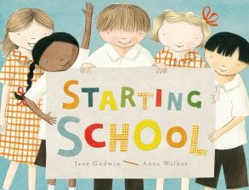
Starting school is a very important stage for you, your child and the school. We believe by working together in partnership will help make the transition even and fulfilling. The foundation phase Curriculum is focused on active learning. We believe though practical activities, meaningful play and talk, children are able to develop a clear understanding of the world around them as well as making concept that they will need later in life.

THE SCHOOL DAY
The school’s day routine is as followed below
Our staff members will be on duty in the yard from 8.40 onwards.
8.00a.m. – 8.50a.m. BREAKFAST CULB (no entry after 8.30 a.m.)
Foundation phase
Morning Session starts 8.50-11.45
Snack and playtime 10.30-10.45
Afternoon session 12.45-3.25
Key stage 2
Morning session starts 8.50-12.30
Playtime 11.00-11.20
Afternoon session 13.25-3.25
It is extremely important to note that for legal reasons we are unable to accept responsibility of your child before 8.50 a.m. and after 15.25 p.m.
The welsh government suggested that the minimum teaching time is twenty-one hours at key stage one and twenty-three hours at key stage two.

SCHOOL SECURITY

The security of the children/ young people, staff and all visitors who attend the school is one of the highest importance to the school and we make sure that every effort is made to continue the level of high security throughout all times. Surrounding the whole school and yard spaces is fitted with CCTV cameras.

VISITORS TO THE SCHOOL
In order to make sure that the environment is safe for both children and staff, all visitors coming to the school must sign in and out at the main reception desk, for extra security we also ask visitors to complete an identity badge so that they are recognised by other staff members. We also make sure that all exterior doors are always locked during the school day, and the only way of entering the building is through the main entrance in reception for the safety signing.

ASSESSMENTS
Assessments is always at the centre of a child’s experiences that is also a main feature of the National Curriculum. Undertaking assessments provides us teachers and well as parents the progress and achievement that are being taken for each child. It is also a tool that helps us pick out particular information in which might not have been picked up before during observations.
One of the main reason of teacher assessment is that it mainly builds a picture of a child’s accomplishments over the key stage that also links to the National Curriculum, so that a child’s learning in effectively moving forward. We would like to see that a teacher assessment is an everyday teaching and leaning. Attainment would automatically be recorded over the key stage. Then these records would be stored in a safe place to help us teachers plan for future work. They could also be a way of recognising a child’s achievements and accomplishments.
Parents would always be made aware of what their child will be learning at school and how they are developing. You would also be receiving an annual report to your house discussing the skills and targets on your child. After receiving the report if you would like to met up to discuss your child’s development or whether you have any concerns, then you are more than welcome to pop In.
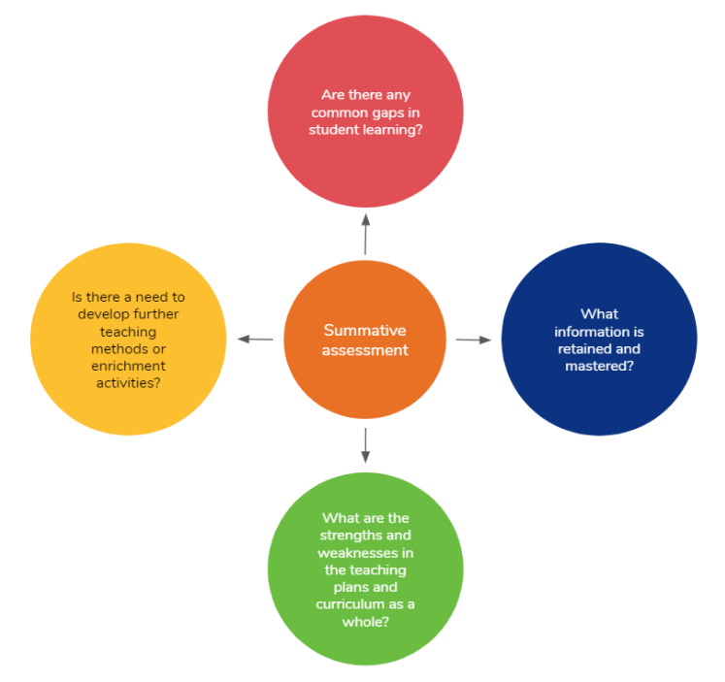

PEDAGOGY
Pedagogy is simply defined as a method or structure of teaching; it involves different teaching styles as well as teaching theory. When we are talking about pedagogy of teaching we are basically referring to the different ways that teachers at our school deliver a fulfilled of teaching of the curriculum into the classroom (Editorial, 2018).
Merriam Webster viewed pedagogy as an ‘Art’ or ‘Science or a way of teaching mainly in education. While each teacher has a different pedagogy approach to learning in their classroom, they take into account the most effective means of content delivery that is mainly based on how well the children learn best and making sure that their needs are being met. The teacher will plan a lesson before hand that will be based on their teaching preferences as well as experiences they have had.

When following this approach questions that we consider is that:
- Do children need more taught sessions or individual work?
- How do children learn best in the classroom?
- Does support need to be put in place? (Editorial, 2018).

At Albatross primary school we know that every child is different in their own unique way and that each child has a way of learning, and so finding out how children learn helps our teachers plan and observe for future lessons. A Pedagogy approach could be broken down into 4 different approaches which are:
- Behaviourism
- Constructivism
- Social constructivism
- Liberationist (Editorial, 2018).

FIRE DRILLS
Fire drills are often held each term. All children and young people are made aware of the plan of action when staring or changing classrooms during the start of the new school year. We also keep logs and have frequent inspections that are made on the fire safety equipment. From time to time guest speakers from the local fire brigade attend the school to chat to the children about fire hazards as well as displaying the use of fire engines and the safety equipment.

BULLYING
Bullying is totally unacceptable within the school and we always make sure that instant action is being undertaken to resolve the problem so that it doesn’t proceed to carry on. Even though bullying can either be verbal or physical it can sometimes be happening without the school or parent knowing. We appreciate it if you would keep an eye out for any signs or distress that your child might be experiencing.

ATTENDANCE
Attendance is an extremely important factor at our school. We look forward to children arriving at school on time, suitably dressed and all ready to learn. We appreciate it parents could school the school as soon as possible to inform their child’s absences. This consent can either be done by phoning the school at reception or sending an email. Unfortunately, we do not accept messages or notes from a friend or neighbour as it sometimes causes ciaos.

ABSENCES FROM SCHCOOL
By law parents are expected to make sure that their child attends school at all time. If for any reason your child cannot attend then we ask for you to telephone or email us on our school website. It is important to recognise that good attendance leads to an effective learning for your child.

HOME SCHOOL PARTNERHSIP
The school cannot stress the importance of setting up a positive and motivated relationship between parents and teachers. Our main aim is to encourage and develop a peaceful partnership between all those who are worried about their child’s education. This all involves parents, teacher’s, governors and the community itself where we work and live.


ALBATROS AWARD SCHEME
Every Friday, we celebrate achievements in or gold start assembly, where one child from each class is chosen by their class teacher who is called out on stage to receive their gold start. We also run a school’s dojo system where award points are rewarded to those who

PTFA
The school is very eager in proving a parents- teachers and friend’s society where every parent is welcomed to take part in its activities. We always welcome new faces. If so interested in joining our PTFA group, please ask to speak to Mrs Jones who is our chairperson.


EXTRA CURRICULM ACTIVITIES
There are many different after schools, that is open for all children. This is an opportunity for children to play netball, football, tennis and many other games, reading club, technology/art, drama and music.
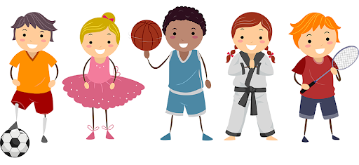

CONSULTATION PARENT/ TEACHER
We recommend that regular parent and teacher consultation are very critical and important to our educational progress for our children with us.
The school itself runs an ‘open door’ policy where parents and carers are always welcomed to come into the school to discuss any problems or issues that they may have. In the mean while, since our teachers are employed to tech, we kindly appreciate if parents could make an appointment outside teaching hours to discuss any problems or progression.
However, in addition to the above the school also holds two parent’s evenings one in October and one in March where parents have the opportunity to look at their child’s work and discuss any issues. We also offer parents the opportunity to meet with their child’s teachers after the annual report is handed out during the summer term if there are any concerns or questions.

ADDITIONAL LEARNING NEEDS ARRANGEMENT
The ALN code 2017 suggests that all children with a learning difficulty should be considered as having additional educational needs. The code highlights that, whether or not teaching takes place, there would always be additional education considered as an expression of the quality of teaching.
At Albatros primary school we are capable in offering a variety of different support for children with additional needs.

SCHOOL UNIFORM
The school has a school uniform, in which all children are required to wear

WINTER UNIFORM
Albatros black sweatshirt or Cardigan with logo
Albatros black Hoodie with logo
White polo shirt
Grey or black trousers
Grey/black skirt/ pinafore Dress
Grey/black or white socks or tights
Black/ grey shoes

SUMMER UNIFORM
Albatros Black sweatshirt with logo
Albatros black Cardigan with logo
Albatros Black Hoodie with logo
White polo shirt with logo
Black, Navy or Grey shorts
Black Gingham dress
White socks
White or black trainers
All our school uniform

THE CURRENT SCHOOL CURRICULM
- The national curriculum
- The foundation phase

The United Nations Convention on the Rights of the child (UNCRC) is always at the centre of our planning, strategies, practice and culture. The convention itself has 42 rights underling the rights that children and young people need so that they have a happy, heathy and safety upbringing (Children’s commissioner for Wales, 2020).
However, we also aim to provide more than the Curriculum. As well as having a Curriculum to follow we also want a Curriculum in which it responds to all of the needs of our children. Us as a school we believe that the Curriculum should be:
- Balanced and relevant
- Prepare children for the future
- Be carried out in ways that help children learn effectively
- Provide the opportunity for children to work at their own pace
At our respecting school, we don’t only teach children about their rights but also having the model right and respect in all relationships.
This policy is also linked to
Article 28: (right to education) ‘’Every child has the right to an education’’ (Children’s commissioner for Wales El Al, 2020).
Article 29: (goals of education) ‘’You have the right to be the best you can be. Education must help you develop your skills and talents to the full’’. (Children’s commissioner for Wales El Al, 2020).
At albatross, we aspire to prepare children for the future life. We aim to equip them with all the skills required for what their future might bring them. The abilities of literacy, numeracy, reasoning ICT are important to the promotion of leaning across all subjects by children and the growth of the capacity of a child to apply them through the larger Curriculum underpins our approach to learning through our school. We recognize that literacy is one of the core skills in the curriculum and is also essential to the child’s learning.
“Literacy is the use of language skills in daily activities, at home, at work and in the community. It involves both using literacy skills and knowing how to use English and Welsh, literacy is based on reading, writing and oral language development across all subject areas” (National Literacy and Numeracy Framework information document Et Al Page 120/2013).
The planning that takes place ensures that the children at our school have a wide range of experiences and materials that involves them to prepare for the next stage of their schooling experiences that will also help them provide a steady foundation for life long leaning. At our school the following subjects are taught
- Music
- Mathematics
- English
- Science
- History
- Computing
- Art and Design
- Geography
- Physical education
- Religious education
- Personal, social and health education

THE ROLE OF OUTDOOR LEARNING IN THE CURRICULM
At Albatros primary school we highly believe that outdoor learning is an extreme part to a good childhood that is also important in raising the bar within the school. We have recently undertaken on a outdoor programme that is set up to develop an exciting outdoor space that is used throughout the school day, including wild life areas, outdoor classroom, planting vegetables on raised beds as well as willow tunnels.
Our teachers usually use the extensive yards to incorporate an outdoor learning within their subject plan across the Curriculum.

THE FOUNDATION PHASE
The youngest children at our school will experience a curriculum that is planned and better suited to meet their needs and requirement. A wide range of hands on activities are provided for children to promote their development within 7 areas of learning:
- Personal and social development and well-being
- Language, literacy and communication
- Mathematical development
- Knowledge and understanding of the world
- Physical Development
- Creative Development
- Multi cultural and Bilingualism understanding
CHILD PROTECTION
The Statutory Basis of Child protection
- Children act 1989
- the children Act 2004
- Safeguarding children in education (the education Act 2002
- Section 176 of the Education Act 2002 states that governing body has a duty to make sure that “that their functions relating to the conduct of the school are exercised with a view to safeguarding and promoting the welfare of children....”
At Albatross primary school we strongly believe that each and every child, whatever their sex, race, belief, physical and mental abilities, has all the rights to be brought up unharmed no what what.
We believe that children should be given the opportunity to develop to their highest potential and have all their needs met. At Albatros we have a huge responsibility in making sure that all children in school are being protected against any sort of abuse. The health and safety of all children in our school is always at heart. At our school we respect all our children and make sure that they are being listened to at all times.
Every staff member at our school is responsible for child protection and all staff members are made aware of the guidelines under the child protection procedures handbook. All staff members at Albatros are also encouraged to take part in child protection training after school that is part of the school’s professional development programme.
The policy for child protection makes all staff members aware of how to recognise possible child abuse as well as what actions should be taken effectively.
Our aims of our policy is to:
- Ensure every child is safe and unharmed
- Children are always listed to effectivity
- Communication is positive between one another
- Teachers are aware of what actions needs to be taken
- concerns are dealt with effectively in an appropriate manner
what is child abuse?
There are 4 types of child abuse which includes
- Physical abuse,
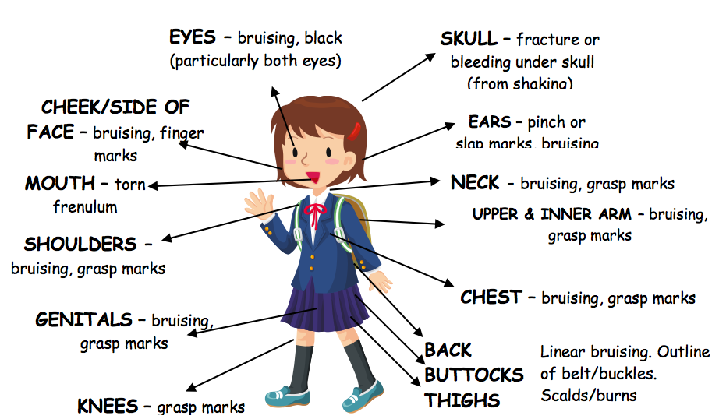

- Emotional abuse, this involves a child emotional development. Where the child is unhappy and sad that they don’t feel a sense of belonging to the world.
- sexual abuse, this involves forcing a child in sexual activities whether the child is aware or not of what’s happening.
- Neglect, this involves a child’s basic needs not being meet

PHYSICAL  Bruising  Biting  Injuries to the head  Burns or scalds | SEXUAL  Physical signs  Changes of mood and behaviour
EMOTIOANL  Isolating behaviour  Ignoring the child | NEGLECT  Running away  Poor heath and hygiene  Speech and language delay

EQUAL OPPORTUNITIES
We at Albatros acknowledge the right of equality of opportunity for all children. We believe that everyone should have an equal opportunity no matter what their ability, race, gender, age or religious beliefs is as well as having an understanding that different children might have different needs to one another.

DISABILITY DISCRIMINATION ACT
We are dedicated to providing a fully open atmosphere at Albatros primary that supports and involves all children regardless of their educational, physical, emotional and cultural needs. In addition, we encourage challenging different attitudes about disability and accessibility and developing an awarene of culture and inclusion. The school building is fitted with a ramp as well as a lift that allows accesses to the first floor.

THEORY
At Albatros we follow the Montessori education, which is a procedure of education that is mainly focused on self directed activity, hands on leaning and alongside play. We follow this theory because we strongly agree that by following this theory, children at our school get to be more imaginative as well as creative. By having an underdoing as to how children develop socially, intellectually and physically teachers are able to observe children carefully looking at the different patterns of development that children develop in.

‘’Which are found in all children regardless of their culture or the area in which they live’’ (Montessori Et Al 2020).
Our children get to work in groups as well as individually to explore and discover new findings as well as discovering the world around them. A Montessori classrooms are designed to meet each and every child’s needs. This theory was discovered by a well known theorist Dr Maria Montessori, that believed experiential learning in a classroom leads to a deeper understanding for a child language, mathematics, science, social interaction and many more. The main reason that we approach this theory in the classroom is because it also helps support many aspects of a child’s development, for example, when creating similarities between the child’s natural hobbies/ interests and the using the accessible activities.
We highly agree that children are able to learn new skills as well as gain knowledge by playing and using their own experiences at their own pace (Montessori, 2020).

‘’Dewey's influence on education was evident in his theory about social learning; he believed that school should be representative of a social environment and that children learn best when in natural social settings’’ (Journal of inquiry and action in education Et Al p1, 2017).

What Dewey was suggesting here is that children learn best through a hands on approach. At Albatross primary school we use this approach as it gives children a fair opportunity to develop and learn at their own pace as well as learning for themselves through trial and error. The reason that we do not believe in a traditional classroom setting is that at Albatros we strongly believe that a traditional classroom is not a developmental appropriate for children. As well children should be given the opportunity to interact with their environment in order to be able to adapt and learn effectively.

HOW TO MAKE A COMPLAINT?
Complaints are made from time to time, we do our best to overcome the barrier. Our complaint procedure is quite simple. You can find a copy which is available at the school or on our website.

CONCLUSION
Overall to end this prospectus, I hope that you found this information useful and hope to to see you and your child at our open evening to answer any questions or concerns you might have.
Education plays a big part of aa child’s learning we believe that our learning methods and techniques are 100% effective and enjoyable. Children at our school are given the freedom to express their thoughts and feelings, a hands on approach where they interact with the world around them as well as other classmates. The reason that we use this method of learning is that studies showed that children are more interacted and show more interest in the activities.
REFERENCE LIST
Children’s commissioner for Wales (2020) ‘Children’s Rights’ [online] Available at: https://www.childcomwales.org.uk/uncrc-childrens-rights/ (Accessed on: 22nd October 2020)
Chambliss,. J. (2003) ‘John Dewey philosophy of education’ [Online] Available at: https://docs.lib.purdue.edu/cgi/viewcontent.cgi?article=1455&context=eandc (Accessed on: 9th October 2020)
Dictionary (2020) ‘Defining schooling’ [online] Available at: https://www.dictionary.com/browse/schooling (Accessed on: 9th October 2020)
Editorial,. T. (2018) ‘what is Pedagogy’ [Online] Available at: https://www.tes.com/news/what-is-pedagogy-definition (Accessed on 10th October 2020)
Montessori (2020) ‘About Montessori Education’ [Online] Available at: https://montessori-nw.org/about-montessori-education?gclid=CjwKCAjw_sn8BRBrEiwAnUGJDuw6lJsl-zpLwGgBLSu59EMjbBh_h4GupMIkDWAz3KTWbj_7ACPDDRoCgQkQAvD_BwE (Accessed on: 20th October 2020).
National Literacy and Numeracy Framework information document (2013) ‘Curriculum for Wales’ [online] Available at: https://hwb.gov.wales/storage/46382070-e563-46ee-85b5-202e41684e3b/curriculum-for-wales-revised-areas-of-learning-and-programmes-of-study.pdf (Accessed on: 22nd October 2020)
William,. M. (2017) ‘John Dewey in the 21st century’ [Online] Available at: https://files.eric.ed.gov/fulltext/EJ1158258.pdf (Accessed on: 17th October 2020)

