An operational planning report
Elenid Marsh.
1800819.

Content.
- Introduction.
- Description of the event.
- Planning behind an event.
3.1: A Gantt chart of the schedule behind planning Cardiff’s Winter Wonderland.
4: Marketing the event.
5: A proposal for staffing and how staff, including volunteers will be managed.
- 5.1: Stakeholders, suppliers and resources required for the event.
6: Contingency plan.
7: Evaluation Strategy.
8: Conclusion.
9: References.
10: Appendix.
-10.1: Gantt chart
-10.2: Screenshot image.
-10.3: Survey.

1. Introduction.
This report is based on the operational aspect of planning an event. The report will cover the process of planning, organising and managing the delivery of a local event including its evaluation. While this report will include a detailed description of the event, including its location and size, it will mainly concentrate on the project management techniques.
The event that will be discussed in this report is ‘Cardiff’s Winter Wonderland’.
2. Description of the event.
Cardiff’s Winter Wonderland is a festive event that is held annually in the capital city from the 8th of November to early January. It is classed as a major event as it welcomes thousands of visitors each year by increasing additional attractions for the public to enjoy. “More than 250,000 people are expected to attend”. [Price.K (2018)].
This event is based just outside Cardiff City Hall. The space transforms into a large Ice Skating rink, which also includes food and drink stalls. They have recently enhanced facilities and included fairground rides. The strength of this event is that it does not have one target audience as it appeals to people of all ages who can enjoy the event annually, therefore it does not bear the pressure of pleasing a certain someone. The order of this event is quite simple, it opens in the afternoon, offering a variety of activities to the public, where people can choose to skate, shop at stalls or enjoy some lunch. The event then closes at 10pm, and re-opens the following day. The event is open seven days a week.

3. Planning behind the event.
Planning any event must include a clear structure. In order to ensure this, the project planning must be incredibly detailed. It should focus directly on the needs and wants of the attendees.
The model by Masterman (2003) illustrates the full process of planning an event. It includes different factors which creates a clear structure to follow and ensure success, “Determine why the event is to be held, what it is to achieve, who and how to benefit….any processes should be considered as early as this stage.”[Masterman.G. Strategic Sports Event Management: Third edition. Pg72. (2014)].
As Winter Wonderland is an annual event, the planning behind the city’s attraction is clearer than ever and very well structured. It is essential that every event company follows the correct legalisation to throw a public event. They achieve this by work in partnership with the local authority, in this case Cardiff City Council to ask for permission and to agree and co-plan the event. This ensures a clear understanding of what can and can’t be achieved. From this point they can set budgets in order to know their constraints.
In Partnership, meetings are held between Health and Safety staff, planning teams and finance etc. to work out the details of the plan. Initial plans includes financial forecasts, agreeing the scope of the project such as how many attendees they believe is a safe number to attend within the size of the area, the structure of the actual event, closing and opening times, planning site facilities and all within the agreed budget.
In larger events, event managers tend to follow a procurement process where companies are invited to tender for the work. These would normally include the food providers, fairgrounds etc. By inviting suppliers to tender you can ensure value for money and companies that can provide the required service for an agreed price that is within an agreed budget. This process can take up to two months to achieve. “For larger events, the planning will be done in much greater depth and with more people involved” [Owen.S (2013)].
The next step would be to hire staff. Before beginning the process of hiring staff for Cardiff Winter Wonderland, the budget must be understood in order to understand the number staff required for the event, this then allows the Project Manager to begin the recruitment process of advertising and interviewing. Once the right staff are appointed, you need to ensure you stay connected with the team throughout the event, by holding regular team meetings to ensure they can evaluate and feel comfortable with their roles.
Once the initial plans are in place a marketing strategy is vital to raise awareness and ensure that the event is a success. The use of advertisements are crucial in this case. “Advertisement is one of the most predominant and traditional event promotion techniques.” [Hoyle. L. Event Marketing pg 43 (2002)]. Advertisements will include details of the actual event such as times and location and also the details on ticket prices. The price of the tickets will create the income that is needed to sustain the event.
Last but not least, the set up plan on the day of the event should be entirely structured to ensure that each element of the plan is implemented and members of the team are aware of their roles and responsibilities.
3.1 A Gantt chart of the schedule behind planning Cardiff’s Winter Wonderland.
Planning the schedule for an event and using monitoring tools such as a Gantt chart (as shown in appendix 10.1), will show a clear structure that enables you to hold a successful public event by following the strict deadlines and targets. “The easiest and most applicable kind of chart that event organisers can adopt from the project management sphere is the Gantt chart” [Shone.A, Parry.B. Successful Event Management 2nd ed.pg 167. (2004)]. If the organiser fails to meet a deadline, it will cause delay in the next part of planning, and therefore cause setbacks. The role of the Events Manager is integral in ensuring that the planning is on track and that each target within the plan is completed carefully. Regular team meetings and clear communication is necessary to ensure its success and monitor progress against the plan.
4. Marketing the event.
Marketing an event is the most important part of planning. If you decide not to market your event, how will the public know that the event happening? The main and popular way to advertise these days is through Social Media. This can pose a risk, as social media does not target all of the public who would potentially attend the event. “What Social media is all about, and especially applied to marketing, is the smart use of the natural conversational channels that develop between individuals”. [Evans. D. Social Media Marketing 2nd ed. (2012)].
It’s evident that Cardiff’s Winter Wonderland has a wide range, yet inclusive, marketing strategy where the event is advertised through traditional methods i.e. the media, press articles, local radio stations, sponsorships, word of mouth, leaflets and posters which targets individuals from wider age groups or backgrounds as well as the more modern methods such as Local Authority websites, social media etc. Social media is the event’s most used method of marketing.
Cardiff’s Winter Wonderland has an easy accessible website – (http://cardiffswinterwonderland.com/) which includes everything you need to know about the event, such as the exact times and location. “From 8th November 2019 ’til 5th January 2020, you can join us for the ultimate winter experience.” [http://cardiffswinterwonderland.com/. (No date)]
This website has a friendly, festive feeling about it which creates an element of excitement and Christmas cheer. It even has one page that includes a countdown to the event happening to create excitement and momentum amongst the public, ensuring the Winter Wonderland is the most talked about event at the end of the year.
5. A proposal for staffing and how staff, including volunteers will be managed.
As Winter Wonderland has grown into such a large and popular event, a range of different staff are required. These vary from hospitality staff, individuals to man the rides, security, police and health and safety staff. There is then the event management team who helps plan this festive event, which also includes the entertainment team and even people who desires to gain experience and volunteer. “Staffing is the process of determining human resource needs in an organisation and securing sufficient quantities of qualified people to fill those needs” [Donald. L, Gail. D, et al. staffing the contemporary organisation. 3rd ed (2009)].
Even though it may be possible to volunteer at Cardiff Winter Wonderland, such opportunities are not advertised. It is such a large event in the city, which they ensure they have enough qualified/ experienced staff in the first instance who can contribute towards running the event smoothly and safely.
It is important to monitor staff throughout the whole event. This would be achieved by holding regular team meetings to keep teams updated on the information that’s needed.
5.1 Stakeholders, suppliers and resources required for the event.
As you begin planning for an event, it’s important to identify the resources that are available to you, such as stakeholders, suppliers, people, and equipment. Without identifying and involving your stakeholders e.g. the public and your funders, your resources including staff, partners and your required equipment and suppliers the event will not go ahead. Therefore the importance of these resources are major. “The results show clearly that key stakeholders take multiple roles affecting the organization”. [Getz.D. Event Management. (2006)].
The main method of identifying the right suppliers is to simply ask the right questions.
The suppliers needed for Cardiff’s Winter Wonderland would be the entertainment suppliers and the companies that hire the ice rink, food/ drink stalls and the fun-fair attractions. The use of different planning tools such as Gantt charts are an integral part of planning the event and monitoring that targets are being met within the timescales and nothing is forgotten.
6. Contingency planning.
However well planned an event may be, they do not always go to plan. Having a contingency plan is crucial. It provides an effective response as an alternative action if the first plan fails. Failures could include bad weather, a supplier not turning up, technical problems etc. It is less likely that the public will be aware of an error if there is a contingency plan in place compared to if there is only one plan that can no longer go ahead. Failure in delivering an event can create a negative effect on the company’s reputation and may lose customers in the future. “When developing contingency plan, always plan for the worst-case scenario as many different and disastrous outcomes as possible”. [Yeoman.I et al. Festival and events management (2004)].
Businesses must ensure that the internal staff as well as the external are aware of the contingency plan. To ensure everyone is aware, they must have regular updates. This could include, regular meetings face to face or weekly emails.
Cardiff’s Winter Wonderland’s contingency plan would be rather difficult as its main attraction is the ice rink itself. Should there be difficulties with the main attraction, the event can still focus on other facilities such as the fun fair and stalls while the ice rink problem is being resolved. Even though it will create a negative impact, it would be less as there are other facilities provided that will have the similar festive feeling with plenty to do in the short term.
7. Evaluation Strategy.
It is important to evaluate events to determine their success in relation to the objectives, and to also enable feedback. Evaluating your event is measured by asking ‘was the event successful?’, ‘what were your targets before the event?’, ‘did you achieve your targets and reach your goals?’ and ‘what could be improved?’ “Understanding the way a management system is evaluated creates a system that can be evaluated” [Bowdin.G, Allen.J et al. Events management. 2nd ed. (2011)].
Evaluation is based on how well your performance was as an event planner by comparing actual data against estimated figures such as number of attendees and operational efficiency.
There are three forms of evaluating which include, before the event, during and after the event. To evaluate smaller events, it’s possible to use the SMART strategy and to make observations during or after the event. “The key challenge is for evaluation to become ‘what we do’ rather than ‘something else we have to do’”. [Sharples. L. Crowther.P. et al. Strategic Event Creation. Pg 225 (2014)]. There are many ways to gain feedback, such as surveys or questionnaires. You could ask the public anything you’d like to know in order to improve next time. (Appendix 10.3)
Cardiff’s Winter Wonderland evaluates its event by receiving feedback from the public who attend, monitoring media mentions, use of hashtags and by comparing their event to relevant competitors such as Swansea’s Christmas Ice skating.
Cardiff Winter Wonderland could compare the number of attendees from previous years to try and compete with itself. To do this, they update their attractions every year to allow the consumers to have a different experience than last year. This year they have included ‘The Alpine Trail’, where you can skate along the open air Ice Trail through the ‘Gorsedd Gardens’.
8. Conclusion.
To conclude, this report has outlined the process of planning, organising and managing an event and how to deliver it successfully. It has proven that it takes much more than just delivering the event, such as the marketing and the staffing procedures behind the planning. Without the partnerships and the stakeholders the event would not be possible to go ahead. This report also illustrates the importance of monitoring tools such as the Gantt charts and surveys to have a clear structure as well as people’s feedbacks. One of the main importance of this report was the evaluation. Without any evaluations of an event, they will not know of the targets they set to improve for next time to therefore reach their further goals.

9. References.
Bowdin.G, Allen.J et all. Available at Events management second edition. Accessed on the 11th of November.
Cardiff Winter Wonderland. Available at http://cardiffswinterwonderland.com/ Accessed on the 10th of October.
Donald. L, Gail. D, et al. Available at Staffing the contemporary organisation. Third edition. (2009) Accessed on the 11th of November.
Evans. D Available at Social Media Marketing Second edition. Accessed on the 12th of November.
Getz.D. Available at Event Management. (2006) Accessed on the 23rd of October.
Hoyle. L. Available at Event Marketing page 43 (2002) Accessed on the 14th of November.
Masterman.G. Available at Strategic Sports Event Management: Third edition. Pg72 (2014) Accessed on the 23rd of October.
Owen. S Available at The complete guide to Events management (2013). Accessed on the 11th of Novemeber.
Price.K Available at https://www.walesonline.co.uk Accessed at 9th of October.
Sharples. L. Crowther.P. et al. Available at Strategic Event Creation Page 225 (2014). Accessed on the 14th of November.
Shone.A, Parry.B Available at Successful Event Management page 167. Accessed on the 12th of November.
Yeoman.I Available at Festival and events management 1st edition (2004) Accessed on the 4th of November.

10. Appendix.
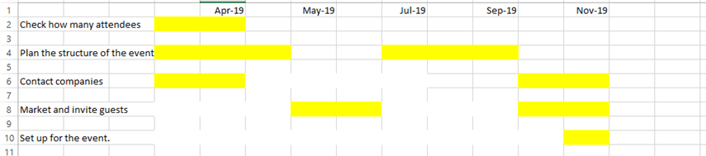
10.1

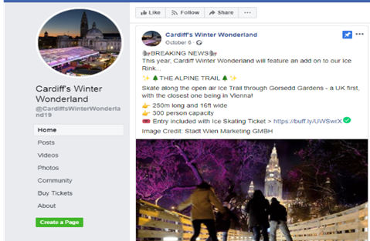
10.2

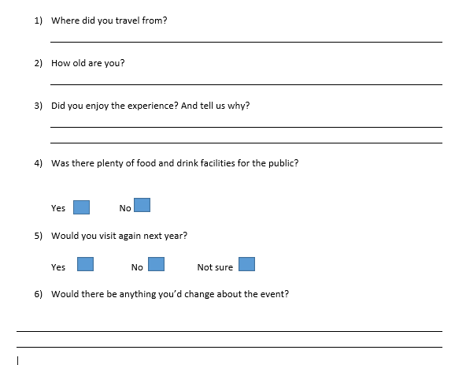
10.3

