Innovative Service Plan
Course Work


Canstockphoto & 123RF (2022)

Student Name | Deon Rose Lobban
Student ID | 1919079
Module name | Developing Innovation and Creativity for Business Advantage
Module Code | BMSW6102_Birm
Lecturers Name | Khaza Ahmed

Contents

Introduction......................................................................................3
Online EBusiness application..........................................................4
Innovative service idea: Allergy alert app scanner.......................4,5
Disruptive innovation V sustaining innovation.....................5
Satell...................................................................................5
Innovative matrix framework.............................................. 6
Unique selling point..........................................................5,6
Marketing strategies…....................................................................7
Target market......................................................................8
Customer benefit..............................................................8,9
Christenson.........................................................................9
Competitive advantage...................................................................9
Allergy Alert App Scanner Swot.....................................9,10
Niche market.....................................................................11
Allergy Alert App Scanner Platform.................................. 11
Payment structure........................................................11,12
Customer charge plan.......................................................12
Finances.......................................................................12,13
Long-term sustainability................................................................13
Conclusion....................................................................................14
References..........................................................................15,16,17

Introduction
The purpose of this report is to introduce an innovative service idea. This proposal will be an online E-business service offering customers, a unique undiscovered platform, via App, to help work alongside venerable customers with medical conditions, and even possible save lives, by providing essential information and improving communication within the medical community throughout the word.
This report will also focus on the vital details of what the service provides and what is needed to aid the success of the service. This includes detailed insight in the service idea and how the business will operate. The best platform for this kind of service, the required target market, unique selling point of the service, detailed swot analysis, marketing strategies used to help promote the service and how it will benefit the customer, also Identifying competitors and the sustainability of the service.

Online business application
An E-business is an online electronic business which provides relevant information to customers over the Internet and does not necessarily need an office or shop front to operate as the services are solely online and is a quick uncomplicated way to communicate can develop a close productive relationship between its users/customers and suppliers, allowing for a faster response, reduced costs, marketing, and flexibility.
“E-Businesses are now using various mediums available on the Internet to interact with the audience and market their brands, products, or services to the public. These mediums help businesses to widen their reach further and to better their audience. Companies that have adopted EBusiness how a faster product development cycle, enabling them to respond quickly to market needs “(Steer et al., 2019). The Allergy Alert App Scanner is an E-Business which allows people with allergies and medical issues, who find it difficult to accessing medical information when travelling abroad to take full advantage of its services.

The Innovative Service Idea: Allergy Alert App Scanner (AAA Scanner)
Allergies are caused by sensitivity to foods, environmental issues, and lifestyle. This problem is not going away anytime too soon. In the meantime, customers need some form of comfort or reassurance to help with the problem. “Allergy is the most common chronic disease in Europe. Up to 20% of patients with allergies live with a severe debilitating form of their condition and struggled daily with the fear of an asthma attack, anaphylactic shock, or even death from an allergic reaction” (EAACI, 2016. Cited in Allergy UK, 2022).

The Allergy Alert App Scanner (AAA Scanner) is designed to bridge that gap, offering the customer more peace of mind, whether on the move, shopping, dining out or travelling abroad, it can be hard to detect which foods may cause harm to individuals with allergies. It is even harder to obtain one's own medical records or medical information, in many cases taking months to retrieve/access due to out-of-date technology, incompetence, laidback or unreliable staff, causing serious delays which can be very time consuming especially in the event of emergencies when essential information is needed. “A staggering 44% of British adults now suffer from at least one allergy and the number of sufferers is on the rise, growing by around 2 million between 2008 and 2009 alone. Almost half (48%) of sufferers have more than one allergy- that is around 10 million people “(food Matter, 2010. Cited in Allergy UK, 2022)
The AAA Scanner is a food allergy awareness and detection app, which can be downloaded on to any native mobile app platform, e.g., Apple iOS, Google Android, hello ING food labels or medical information to be scanned using a unique innovative scanning technique, automatically displaying the customers personal list of harmful allergic ingredients within foods, drinks, or medical substances. Once in contact with appointed label, the app will indistinctively start bleeping and flashing red, at the same time displaying any harmful ingredients present in the product, saving the need to read labels which can also be time consuming.
The AAA Scanner Will also include the options of displaying the customers for medical details which can be accessed anywhere in the world by the app user at their discretion. This can also be an advantage, not only to the client but the medical profession if the client can display their own information as a quick response when attending private treatments, hospitals, GP practises, dental surgeries or when travelling abroad, sending vital information directly to medical professions anywhere in the world. “Companies that have adopted E-business have a faster product development cycle, enabling them to respond quickly to market needs” (Steer et al., 2019, p1)
Disruptive innovation v sustaining innovation
The innovation matrix frame shows the Allergy Alert App Scanner (AAA Scanner) Is classed as basic research, travelling toward sustainable innovation as seen in figure 1 below. Satell (2017. P2) stated “I found that every innovation strategy fails eventually, because innovation is, at its core, about solving problems- and there are as many ways to innovate as they are types of problems to solve. There is no one” true” path to innovation.”

Figure 1.
Innovative Matrix Framework
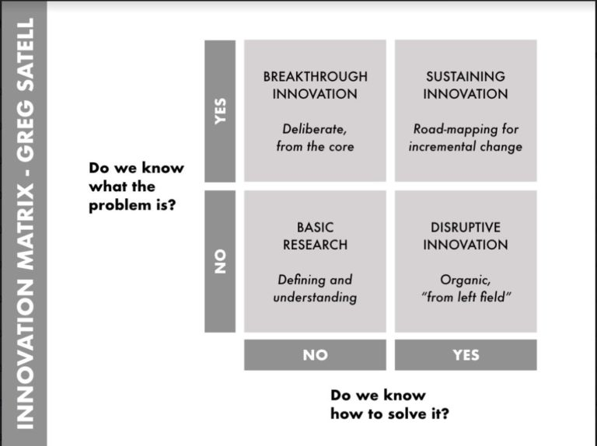

According to the indeed editorial team [2022] “An innovative matrix is a strategic tool that can help business leaders identify and prioritise opportunities for innovation in their organisations. It provides a framework for analysing and evaluating potential opportunities, we can help them focus on the most promising approach for growth.”
Unique selling point
The AAA Scanners’ Unique selling point is it meets the customers' needs with its own distinctive futuristic features not found within any other app, allow users the ability to discard food labels with possible harmful ingredients which may affect vulnerable allergy sufferers. Customers can also update or upgrade the app by pressing the option button. Once downloaded this amazing app will provide a much-anticipated service given the choice of storing information with added scanner or the use of the scanner alone.

The Covid 19 epidemic has forced the world to rely heavily on the Internet to connect, communicate and transmit information around the globe. It has changed the work culture for many businesses, most importantly the medical profession, in which quick access to emergency help, medication and medical information have declined due to shortage of employees, leaving available staff inundated with work and unable to answer the phones, thus leading to inefficiencies throughout the workforce. The AAA Scanner will help ease the pressure and worry when travelling, ensuring access to the relevant information needed is already at hand. “The outbreak of the Corona virus [COVID-19] has led to unprecedented changes in the work and behaviour of general practises” (NHS 2022))

Market strategies
The AAA Scanner will use the Google platform, one of the largest in the world with specialist app developers within the app store to helping build an audience database. In 2021, Google's ad revenue amounted to 209.49 billion U.S. dollars. The company generates advertising revenue through its Google Ads platform, which enables advertisers to display ads, product listings and service offerings across Google’s extensive ad network (properties, partner sites, and apps) to web users. (Statista, 2022)
The AAA Scanner will be launched with the help of advertising sponsorships, this is a powerful and effective marketing tool, which exposes new opportunities within the market field, widening the business scope. Also, hypo-targeting customers on social media websites which will be the beginning of the customer journey through Facebook, Instagram, Pinterest and YouTube, which will include detailed demo videos with insight to the AAA Scanner and its available services. Advertising space will be available to rent, encouraging potential customers to sign up to the AAA Scanner. “Marketing is the management process responsible for identifying, anticipating and satisfying customer requirements profitably” (Chaffey et al., 2009, p10)

Target market
The main target audience would be the NHS hospitals, care homes, private hospitals, pharmacies. Adults, teenagers, and young children are prone to allergies as there is no discrimination or age barrier when it comes to chronic diseases, this also includes,
- Celiac
- Severe food allergy
- hypersensitive to drugs

Customer Benefits
The AAA Scanner as stated before, would be of huge benefit to people travelling abroad being unable to access medical records in emergency or when the need arises to see a doctor or medical profession anywhere in the world, saving the customer time and money or carrying delicate confidential information from country to country. Other customer benefits include, but are not limited to, the following.
- Quick access when abroad to medical files emergency
- GPS consent information to customers/patience, access results
- Quick automatic download
- The customer can download their medical history without doctor's permission
- Availability of different languages at the customer's request
- Personal automated receptionist
- Can also be accessed direct from company website
- Family package, parents signature required for users under 16 years
- Next of kin added
- Customer would pay a monthly service charge fee (Varies)
- Complaints can be made via e-mail or virtual office

Competitive Advantage
The Allergy Alert App Scanner (AAA Scanner) provides a professional customer service with a strong competitive advantage which outperform any other App on the market. According to Terzieva (2020) “The competitive advantage relates to the characteristics or properties of a product or brand that give the firm superiority over direct competitors”.
As mentioned in the Online E-business Application section, customers will have global access to documentation, which otherwise would have been inaccessible. Further advantages include multiple options for storing information with a distinctive scanning technique. A functionable reliable fuss free App simple to use, helping build customer loyalty, leaving users less inclined to seek the appointed available services elsewhere
Terzieva also states (2020) “The company can overtake its competitors on the market only if it manages to distinguish itself from other companies and consolidate this difference to its advantage”

The Allergy Alert App Scanner (AAA Scanner) enhances the concept but including a versatile scanner capable of reading QR codes and barcode which has never been available before
within the app platform. 20th century theorist Clayton, M, Christensen (2013, p. xv) states “What sustaining technology having common is that they improve the performance established products, along the dimensions of performance the mainstream customers in major markets have historical value”. Clayton Christensen was an accredited theorist, who was known for his theory of disruptive innovation. In 1997 he authored the book” The innovators dilemma” born in the 1950s Christensen would have experienced the coming of age of the Internet and the development of the App Store in the 1990s, compared to the theories born before this time.

Allergy Alert App Scanner (AAA Scanner) Swot
A SWOT analysis framework shown in figure 2 was used to identify the strengths, weaknesses, opportunities, and threats of the allergy alert app scanner (AAA Scanner), giving a clear view of internal and external factors which may have an impact on its performance as seen in the table below. Berry (1996) explained “Points of a Swot Analysis is to help you develop a strong business strategy to make sure you have considered all of your business strengths, weaknesses, as well as the opportunities and threats it faces in the marketplace”.

Figure 2.
S  Strengths | - Strong security  - Global access  - Customer can download own medical records  - Personal allergies list included  - Allergy free restaurant finder included  - Nearest hospital finder included  - Preferred language available  - Ingredient name variant translator  - Customer feedback,  - minimum competitors  - No roaming charges
W  Weaknesses | - Limited resources  - Security issues  - No human interaction  - Customer relations problems  - Fraud  - Customer complaints  - Monthly fee
O  Opportunities | - Government subsidies  - Press/media coverage of the service  - Future growth  - No geographical boundaries  - Lack of competition  - Emerging need for the service
T  Threats | - Changing regulatory environment  - New competitors entering the market  - Negative media/press coverage  - Increased/emerging competition  - Changing customer attitude towards the company

Niche market
As stated in the dictionary [2022] “a niche is a place or position that's particularly appropriate for someone or something, especially due to being very specific and different from others”. The Swot analysis shows the strength and opportunities of this niche service to be a positive and encouraging outcome, whereas the weakness and the threats are issues which can be addressed according to the situation as it arises, along with strategic forward planning and professional advice.
There are small number of medical apps available on the market, but none with the detailed information and personal storage as to what the allergy alert app scanner (AAA Scanner) offers its customers, making this a niche service within this market field.
The other apps on the market e.g., Medi App, Med App and Medisafe App offer.
- advice and support for medical conditions
- Help to find doctors
- Caregiver assistance
- Prescriptions
Others are there to offer emergency and medical assistance.

AAA Scanner Platform
The Google platform will be the most viable choice with most of the base functionality readily available, this would also include maintenance, security, user management and data privacy. Users would login to either the website or mobile app, receiving regular updates to combat any new security threats, As stated by Ceci [2022] “When comparing the platforms, Google Play generates the largest amount of worldwide app downloads”.
Payment structure
Payments will be processed via PayPal, (payment gateway) which are PCI (Paycard industry compliant), a 24hr fast, straightforward way to secure online payment for customers. The Payment Card Industry Data Security Standard (PCI DSS) is a standard mandated by the card schemes to increase controls on cardholder data to reduce the risk of fraud. It applies to small businesses as well as larger service providers including PayPal. (PayPal, 222). Figure 3 below shows the customer charge plan and the services on offer.

Figure 3. Customer Charge Plan
AAA Scanner  Service plan | Family group 4 persons | Family group 4 persons + 1 | 16yrs+ | Student
Level 1
Free sign-up & basic allergy scanner

Level 2
Free sign-up, Store information & health profile
Level 3
Free sign-up, Advance scanner, hospitals & doctors,
next of kin
Level 4
Free sign-up, advanced scanner, store information, hospital & doctor location, next of kin

Figure 4. Finances
Figure 4 shows start-up costs, which will be acquired through government grants, funds, and investments.
Administration fee | £20 per month per 5 - 10 users
Staff required | 1 admin (per 2500 users)
Implementation costs | £100,000 - 200,000
Licence cost (GBP) | £0.00
Other technical costs e.g., server | £0.00

The app is not a new concept as the Nokia 6110 produced one of the first apps back in 1997. Now there are hundreds of new apps appearing on the market every year as the demand for a more innovative mobile application development is on the increase. The diagram below, figure 5, shows how popular apps have become. According to Ceci (2022) “The number of mobile app downloads worldwide has been Increasing constantly from 2016 onwards, surpassing 200 billion in 2019. In the most recently measured year, consumers downloaded 230 billion mobile apps to their connected devices, by more than 63% from 140.7 Bing app downloads in 2016”.

Number of mobile app downloads worldwide

from 2016 to 2021 In billions
Figure 5.
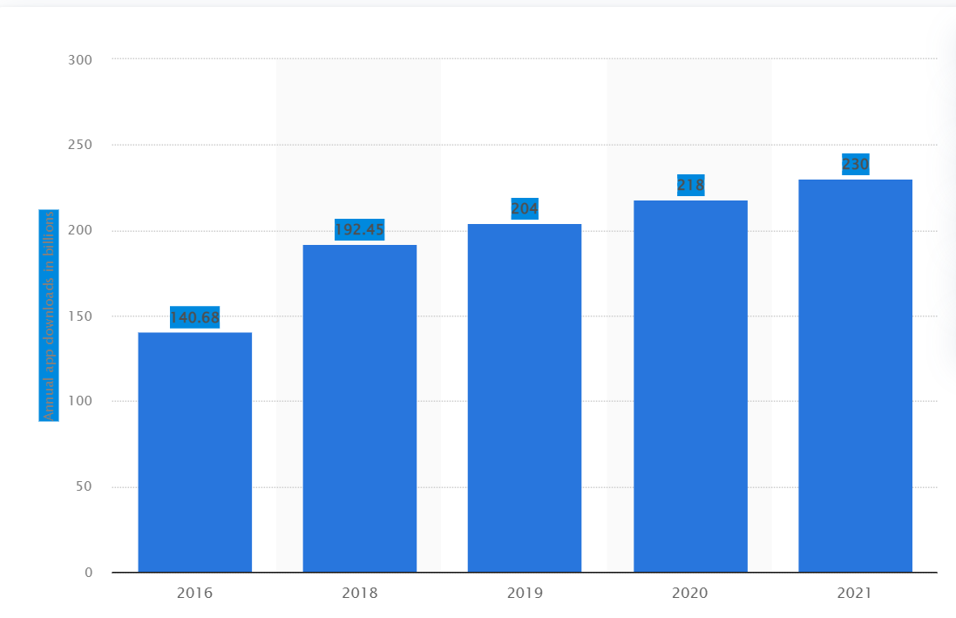
Statista (2022)

Long - term sustainability
Sustainability is an important part of any business; this is imperative for the future development of the Allergy Alert App Scanner (AAA Scanner) using vital technology and incorporating strategies to maintain continuous success but include paying close attention to the issues listed below.
- communicate effectively with service users
- Monitor app performance
- Ensure app support
- Solve technical issues quickly
- Keep app updated
- Listen to feedback and complaints
By implementing the points made above will help fulfil the needs and expectation of the customer without compromise.

Conclusion
The Covid 19 pandemic has forced the world to rely heavily on the Internet to connect, communicate and transmit information around the globe. It has changed the work culture for many businesses, more importantly the medical profession, making it harder to obtain one's own medical records or medical information.

The Allergy Alert App Scanner (AAA Scanner) is designed to offer its users Peace of Mind when travelling abroad by allowing access to medical records in emergencies or when the need arises to see a doctor or medical professional anywhere in the world. Once downloaded on to any native mobile app platform, food labels or medical information can be scanned, which otherwise would have been inaccessible. AAA Scanner has its own distinctive futuristic features not found within any other app, making this a niche service within this market field.

References
123RF (2022) creative thinking ideas brain innovation concept. Available at: https://www.123rf.com/photo_105210802_creative-thinking-ideas-brain-innovation-concept-light-bulb-on-white-background-with-drawing-head-hu. (Accessed 17/11/ 2022)
Allergy UK (2022) statistics and figures Available at; https://www.allergyuk.org/about-allergy/statistics-and-figures/ (Accessed 10/11/ 2022)
Berry, T. (2017) What is a SWOT Analysis? Available at: https://www.sobtell.com/images/questions/1499828304-SWOT%20Analysis%20-%20printable.pdf (Accessed 10/11/2022)
Canstockphoto (2022) idea concept with head and light bulb. Available at: https://www.canstockphoto.com/idea-concept-with-head-and-light-bulb-47649529.html (Accessed 17/11/ 2022)
Ceci, L (2022) Statista Research Development Available at: https://www.statista.com/statistics/271644/worldwide-free-and-paid-mobile-app-store-downloads/ (Accessed 15 /11/ 2022)
Ceci, L (2022) Statista, Mobile App Usage – Statistics and fact Available at: https://www.statista.com/topics/1002/mobile-app-usage/#dossierKeyfigures (Accessed 15/11/ 2022)
Chaffey, D., Ellis- Chadwick, F., Mayer, R, and Johnson, K. (2009) Internet marketing strategy, implementation and practise 4th edition. Available at: https://www.google.co.uk/books/edition/Internet_Marketing/HcoRl2EZXiwC?hl=en&gbpv=1&dq=marketing+strategy+implementation&pg=PR13&printsec=frontcover (Accessed 17/11/ 2022)

References
Christensen, C, M, 2013, The Inventor's Dilemma, when new technologies caused great firms to fail. Sustainable various disruptive technologies. Harvard Business Review: Boston Massachusetts. [online] Available at: https://www.google.co.uk/books/edition/The_Innovator_s_Dilemma/K6FrJTWeUssC?hl=en&gbpv=1 (Accessed 14/11/ 2022)
Dictionary.com (2022) Oxford languages. Available at: https://www.dictionary.com/browse/niche (Accessed 17/11/ 2022)
Indeed Editorial Team 2022 what is the innovation matrix? (Plus Types of Innovations) Available at: https://ca.indeed.com/career-advice/career-development/what-is-innovation-matrix#:~:text=An%20innovation%20matrix%20is%20a,most%20promising%20approach%20for%20growth (Accessed 17//11 20/22)
NHS (2022), Appointments in general practises - 2020 available at: https://digital.nhs.uk/data-and-information/publications/statistical/appointments-in-general-practice/april-2020#summary (Accessed 17/11/2022)
PayPal (222) safeguard credit and debit card information by becoming PCI DSS compliant- Available at: https://www.paypal.com/uk/webapps/mpp/pci#:~:text=PCI%20compliance%20handled%20by%20PayPal,%2DAssessment%20Questionnaire%20(SAQ). (Accessed 20/11/22)
Satell, G (2017). The 4 types of innovation and the problems they solve. Harvard Business Review, 11, pp. 2-9 Available at: https://www2.mvcc.edu/shn/pdf/presentations/4-types-of-innovation.pdf (Accessed 17/11/2022)

References
Statista Advertising Revenue of Google from 2001 to 2021, (2022) published by Statista research department – Available at: https://www.statista.com/statistics/266249/advertising-revenue-of-google/ (Accessed 20/11/2022)
Steer, K., Gerg, L., Prakash, V. and Gupta, V. (2019) ‘SWOT analysis of E-Marketing for E-business', International Journal of Innovative Technology and Exploring Engineering (IJITEE), 8(3), pp. 153-159. Available at: https://www.researchgate.net/profile/Vijay-Soni/publication/338116572_SWOT_Analysis_of_e-Marketing_for_e-Business/links/5f7ad9ef458515b7cf67a001/SWOT-Analysis-of-e-Marketing-for-e-Business.pdf (Accessed 15/11/2022)
Terzieva, R.G, 2020 Types of Competitive Advantages. Available at: DOI:10.34671/SCH.SVB.2020.0402.0011 https://www.researchgate.net/publication/342886139_TYPES_OF_COMPETITIVE_ADVANTAGES (Accessed 15/11/2022)

