

University of Wales Trinity Saint David
School of Engineering

Alexandre Bierley
1901530

Automotive Materials and Sustainability
ACHA6012
BEng Motorsport Engineering
Lecturer: Abigail Summerfield
Word Count: 2919 words

Contents
List of figures 2
Introduction 3
Research 3
What is Vehicle to grid technology? 3
Different types of smart charging existing: 3
Current grid infrastructure: 4
Different types of electricity production: 6
Existing Power storage systems: 6
Batteries 6
Battery technology 7
Battery material: 7
UK transition to EV: 8
Conclusion 9
References 10
Appendices: 12
Other types of energy storages: 12
Pumped Hydroelectric: 12
Compressed air power storage: 12

List of figures
Figure 1 Simplified UK Electrical Power transmission system (roymech.org, n.d.) 4
Figure 2 Detail of electricity supply UK (Power Technology | Energy News and Market Analysis, 2017) 5
Figure 3 Simplified compressed air power plant (Canadian firms NRStor and Hydrostor partner up on utility-scale adiabatic compressed air storage, 2017) 13

Introduction
This report is a research based project on the implementation of vehicle to grid (V2G) in regards of the current and future electric vehicles market. The report will focus on the current domestic applications available and will comment on the feasibility of applying V2G to existing market. It will also point out the strengths, weaknesses and potential economic and political issues that may occur. In order to help to understand the market, a description of what is V2G will be given. The report will also look at the different types of smart charging currently in place as well as a quick description of the Grid capacity in the UK. Now, to help in the decision if V2G implementation is a worthwhile project, the report will, show the different types of electricity production, give a description of the existing power storage systems, give a brief description of how battery technology/material resources and will then finish by commenting on the current transition to electric vehicles in the UK.

Research

What is Vehicle to grid technology?

Vehicle to grid technology or “V2G” is an innovative concept where the energy of an electric vehicle (EV) battery is sent back to the power grid. The idea behind the V2G technology is to use the stored power from an electric vehicle battery and send it back to the power distribution network to help balance up the difference between energy produced and energy needed in each area. The V2G technology will use what is left of energy in the battery to push energy back to the grid and will then allow the battery to be recharged at a more suitable time when power demand is lowered. That means, thanks to the V2G technology, electric vehicles will be participating to cover or even lower the extra energy produced by power sources during peak time. It will help reduce the load on power sources and prevent the need of firing another power station for example during high energy demand. (www.virta.global, n.d.)

Different types of smart charging existing:

There are other types of smart charging technology available as well such a V2X. V2X means vehicle to everything which means that same as V2G, the EV battery will send energy back to the electricity network but only to a dedicated target like a house (V2H) or to a building (V2B). It allows the user has the ability to lower the need of energy from the grid, which indirectly reduces the need of energy being produced by power plants.
Another, much simpler way of smart charging is by charging an EV battery at a more suitable time when off peak power demand. In another way, when getting back from work, the user puts the EV on charge as usual. Smart charging will not start charging the vehicle’s battery until the peak of general energy demand in the area is lowered. The charging process will then start more than likely when everyone is asleep and power demand is low. Same as V2G, smart charging allows to balance the general repartition of power demand between peak times and off-peak times. It then prevents energy production companies to stabilise the amount of energy produced.
According to (Bulb Energy, 2021) for England and Wales, the off peak time is usually from 12:30 am to 7:30 am in normal Greenwich mean time. It gives a 7-hour window to recharge EV battery when considering the owner is using a smart charging point like V2G or V2X type. (pod-point.com, n.d.).
In the meantime, looking at this article from, (pod-point.com, n.d.), a conventional home charging point gives a charging rate capacity between 3.6KW to 7KW. Taking a look now at this article from Pod-point (2018), a tesla which has an estimated range of 396miles and a battery capacity of 75KWh, from fully discharged, will need to be charged for 21 hours until fully charge at 3.6KW charging rate. (Tesla, 2019). From fully discharged to fully charged at the 7KW rate, the Tesla battery needs 11 hours of charging. Now considering that the driver uses V2G or a smart charging technology, during the 7-hour window of potential charge, at a rate of 3.6KW, the Tesla will be charged to 34% when off peak period ends from a completely flat battery. Same conditions but at a rate of 7KW charge, the Tesla will be charged to 49% at the end of the off-peak period, again from a flat battery. The driver will obviously have to deal with a non-fully charged battery for the next day. Are users ready to do the commitment?

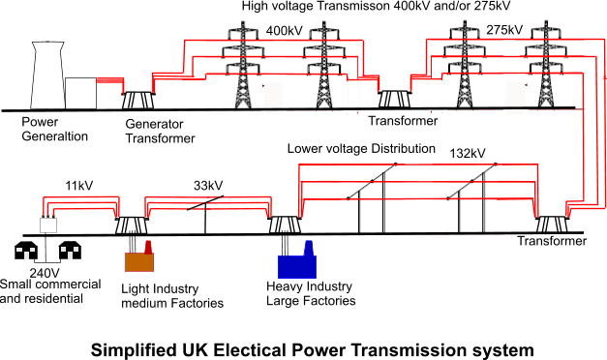
Current grid infrastructure:

Figure 1 Simplified UK Electrical Power transmission system (roymech.org, n.d.)

Looking at (GOV.UK, n.d.), in 2020, the overall electricity demand in the UK was up to 280.48TWh. For the same year, the net electricity produced in the UK was 295.81TWh. Adding and extra 17.91TWh of power imported brings the total electricity available to 313.72TWh. Also taking in account 26.31TWh in transmission losses means that 287.42TWh of actual electric power available for UK users. It leaves an extra 2% of unused energy.
EVs have a large variety of battery sizes available. Some models can have around 30kWh for the smallest ones, some can be at 100kWh for the largest ones. (Pollard, 2020) If taking an average of 65kWh for battery capacity, also taking a domestical charging capacity at 7kW, the average time to recharge a car is 9.2 hours from fully discharged to fully charged. According to (Racfoundation.org, 2018), there will be 23.2 million EVs on the UK roads by 2030. That represents a potential storage of 1.5 GWh if all EV users plug their car on a V2G system by 2030.

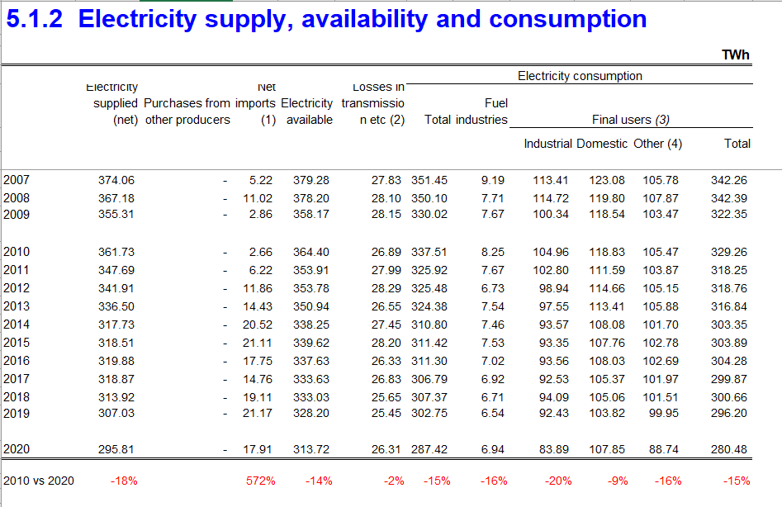
Figure 2 Detail of electricity supply UK (Power Technology | Energy News and Market Analysis, 2017)

Different types of electricity production:

According to (grid.iamkate.com, n.d.), between 2020 and 2021 the average 30.3GW of power used in the UK came from 40.3% of Fossil fuels (1.8% Coal, Natural Gas 40.3%), 23.3% from Renewable energy (3.9% Solar, 18.1% Wind, 1.3% Hydroelectric) and finally 25% from other type of energy (7.1% Biomass, 16.5% Nuclear, 0.7% Pumped storage, 0.7% other energy).
Although, there is not much information on the internet about Geothermal power production capacity in the UK, (Largue, 2021) announces that 4 Geothermal plants will be installed and running in the UK by 2026. All 4 plants together will have a potential of producing around 5MWe (Megawatts electric) of power that will go straight to the grid, and a potential of 20MW of heat energy that will power heating systems in houses and buildings for the local area.
The UK also has a great capacity of producing electricity from Tidal power. However, due to cost and nuisance to marine habitat, tidal power plants are such delicate subject as it has enormous power production capacity, but it also has big impacts. As for now, Tidal power is still a developing project that needs tweaking to be a completely viable source or energy for the UK. (BBC Science Focus Magazine, n.d.)

Existing Power storage systems:

Electricity cannot be stored as easily as the general opinion thinks. Electricity will need to be converted in other forms of energy prior storing which makes the process complex. It will obviously also need to be reconverted back to electricity when needed for usage. As per today, it exists a large variety of energy storages for electricity production purpose. Fossil fuels is a form of energy storage. Raw petrol for instance, is extracted from the ground, converted to a usable liquid (fuel), and will more than likely be burned to produce electricity. Same process for natural gas and Coal. These examples are obviously non-renewable energy storages and will one day, due to over extraction, run out of capacity. However, there are more advanced and modern forms of electricity storage.

Batteries
Batteries are a good example of electrical storage. A battery uses an internal electrochemical reaction to create electricity. Conventional batteries like lithium-ion Batteries have a 95% efficiency, which means, the amount of energy put it, is nearly equal to the amount of energy that can be retrieved from it. (Powertechsystems.eu, 2015)
Large scale battery systems seem to suit the application when combined with power generation systems. They help smoothing the variability and fluctuations of power from solar or wind systems for short period of time. As power generation from wind or solar systems can be quite inconsistent with the weather conditions, the battery system is then combined with it to offer a more stabilised and consistent power source to the grid. There are different types of battery that can be used in this application such as Lithium-ion batteries, Sodium-Sulphur Batteries or Redox flow cell batteries. The efficiency of power delivery vs power input may all differ from one battery type to another however, the purpose remains the same as explained earlier. (world-nuclear.org, n.d.)
It exists more forms of energy storage like Pumped Hydroelectric, compressed air energy storage (See appendices), Thermal storage, Hydrogen storage technology (world-nuclear.org, n.d.).

Battery technology:
Over the history, batteries have proven to be one of the most popular way of storing electricity. Lithium-ion batteries (LIBs) are, out of all types of battery, the most efficient ones and the most expensive to produce. (Powertechsystems.eu, 2015), claims that LIBs have an efficiency rated between. LIBs internal cells have the capacity to deliver 3 times the voltage of a more conventional battery making it an interesting choice for high power demanding devices (EV). They also have a greater energy density has they are smaller and lighter than most other types of batteries. The low maintenance factor is also playing a big role in why EV manufacturers and engineers are choosing LIBs over other types of battery. They also have a very low self-discharge rate over time due to newer designs allowing less internal resistance.
However, some concerns about LIBs have been raised in the past years. Safety is the first concern, due to large amounts of users reporting about LIBs catching on fire or even exploding. (A review of lithium-ion battery safety concerns: The issues, strategies, and testing standards, 2021), claims that LIBs have safety issues only under precise circumstances. These batteries are sensitive to heat. Overheating battery cells could end up creating undesirable parasitic reactions internally, which would cause thermal runaway. Uncontrolled thermal runaway leads to battery explosion. Thermal runaway could occur even quicker under mechanical damage, electrical damage, or thermal abuse. (A review of lithium-ion battery safety concerns: The issues, strategies, and testing standards, 2021)
Lithium-ion batteries also suffer from ageing. In this case, ageing does not mean over a certain period of time but over a certain amount of charge/discharge cycles. First generation of LIBs started losing efficiency after 500 to 1000 charge/discharge cycles. Newer generation of LIBs found in EV for example, can withstand from 1500 to 2000 charge cycles before the degradation process begins, states (dxiang, 2021)
Another factor that could affect the battery capacity is charging at a high rate. Although, rapid charging might be more common in EV application, if happening frequently, fast charging can affect the battery longevity by a noticeable amount. This phenomenon is simply due to the battery internal components being more stressed and exposed to heat compared to a lower rate charging cycle. (dxiang, 2021)

Battery material:
Battery technology has always been evolving, allowing more efficiency and better power density results, that suits more modern applications. Lithium being the main component in LIBs, this section is going to focus on that material. When it comes to Lithium-ion battery production, as the number of EV on roads raises, the demand in structural materials for producing LIBs obviously raises as well. First of all, the global production of lithium per year has tripled between 2010 and 2018 passing from 28,100 tonnes/y in 2010 to 85,000 tonnes/y in 2018. (Development, 2020)
(www.spglobal.com, n.d.) announces that, due to the rapidly growing market of EV, the global Lithium production should triple again by 2025. The other big concern being that 21% of the countries where Lithium mines are based are still developing countries. Are the extraction methods in these countries as modern and environment friendly as other countries? Zimbabwe which represents 2% of the world production of Lithium is known for Child labour as well. (Dol.gov, 2018)
Same political and environmental problems are applied to the other components present in LIBs.

UK transition to EV:

EV have experience great success with around 675,000 electric vehicles on the UK roads in 2021, including hybrid plug-in models. Also In 2021, the UK has 32 million cars registered on the roads. EV represents then 2% of the entire UK vehicle market. (Racfoundation.org, 2018) states that, in order to achieve its goal of Net Zero emissions by 2050, the UK government will need to cut 70% of the emissions from transportation by 2030. In order to reach that target, the number EVs on the road should dramatically increase to 23.2 million by 2032 (representing 55% of all vehicles), and by 2050, the entire fleet of vehicle in the UK should by Electric. However, a full transition to EV is not an easy task and would take years.
Electric vehicles need to become a standard for the UK road users. Here are few examples on where EVs are still not fully standardised. First of all, charging connectors. Charging connectors could be completely different between two EV brands. Where Tesla uses its own connector (J1772 type connector), Nissan uses a more conventional connector (Type 2).
Also, the Car to charger communication protocols could be a problem especially when using a different charging point with a different charging rate. Charging payment complexity and transparency is another issue raised from EV users.
The overall price of EVs is another reason why drivers are still not switching. Impact.economist.com, n.d. states that the UK has one of the largest cost differentials between EVs and conventional vehicles.
All these issues are, slowing the development of EV market. When easier to use and convenient to the drivers, EVs will become part of a normality. Drivers will be less hesitating to switch to EV. (Climate Change Committee, n.d.).

Conclusion

In conclusion, V2G is a brilliant idea overall, when the infrastructure will allow it to be efficient. Here are the reasons why:
PROS:
V2G is a step in the future for better overall energy efficiency. It will allow energy companies to limit and even reduce their production of electricity during peak demand periods, allowing a smoother repartition of energy production.
V2G is using what is left of energy from EVs battery and sends it back to the grid. As seen earlier, the production of lithium is relatively pricey and tedious. Also, bigger scale Lithium-ion battery storage systems are far more dangerous and expensive to build (safety and cooling issues). It makes absolute sense to use an already existing storage device from EV batteries instead of building high scale storage points.
Cons:
As stated earlier, EV batteries starts losing their initial efficiency after around 1500 to 2000 charge/discharge cycles. When V2G is enabled by the user, the battery will push energy back to the grid and recharge again during the night, putting more cycles on the battery. It automatically shortens the overall battery lifespan. If V2G was not enabled, the driver would not need to plug the vehicle every night, the battery would keep its remaining charge level and will perhaps need to be charge in 4 days, instead of 1 charge cycle every day when V2G enabled.
The current sources of energy in the UK depends a lot on fossil fuels rather than renewable sources (40% fossil fuels vs 23% renewable). The point taken from V2G is to store energy for peak demand periods, however it is still storing half clean energy. Instead of focusing 100% on making all road vehicles fully electric by 2050, the UK government should try to reduce Coal and Gas power plants and switch to more renewable’s sources.
Furthermore, there are not enough EVs on the UK roads at the moment to represent a big enough storage capacity, that would make an actual difference. As announced earlier, the UK should see the population of electric cars exploding in the next decades. With more cars on the road and all users playing the game of plugging their cars every night, V2G will make a massive difference in terms of balancing peak and off peak demand periods.
To finish, pv magazine International, n.d. announces that the production of Lithium has increased massively since the new trend for EV (+25%). They also say that at this rate, the earth would run out of Lithium around 2100, which is alarming. In this case the process of recycling Li-ion batteries is a must for the future of EVs.

References

- pod-point.com. (n.d.). Charging an Electric Car at Home | Pod Point. [online] Available at: https://pod-point.com/guides/driver/charging-electric-car-at-home. [Accessed 22 Nov. 2021].
- Pod-point (2018). Pod Point. [online] Pod-point.com. Available at: https://pod-point.com/guides/driver/how-long-to-charge-an-electric-car. [Accessed 22 Nov. 2021].
- Tesla (2019). Model S. [online] Tesla. Available at: https://www.tesla.com/en_gb/models.
- roymech.org. (n.d.). Electrical national Grid - Roy Mech. [online] Available at: https://roymech.org/Related/Electrics/Electrical_transmission.html. [Accessed 22 Nov. 2021].
- GOV.UK. (n.d.). Digest of UK Energy Statistics (DUKES): electricity. [online] Available at: https://www.gov.uk/government/statistics/electricity-chapter-5-digest-of-united-kingdom-energy-statistics-dukes. [Accessed 22 Nov. 2021].
- Power Technology | Energy News and Market Analysis. (2017). What’s driving the fall in UK energy demand and can it last? [online] Available at: https://www.power-technology.com/features/featurewhats-driving-the-fall-in-uk-energy-demand-and-can-it-last-5819050/. [Accessed 22 Nov. 2021].
- grid.iamkate.com. (n.d.). National Grid: Live Status. [online] Available at: https://grid.iamkate.com/. [Accessed 22 Nov. 2021].
- Largue, P. (2021). Four deep geothermal plants announced for UK. [online] Power Engineering International. Available at: https://www.powerengineeringint.com/renewables/four-deep-geothermal-plants-announced-for-uk/ [Accessed 22 Nov. 2021].
- BBC Science Focus Magazine. (n.d.). Why hasn’t tidal power taken off yet? [online] Available at: https://www.sciencefocus.com/science/why-hasnt-tidal-power-taken-off-yet/.
- Powertechsystems.eu. (2015). Lithium-ion Battery Charging & Advantages – PowerTech Systems. [online] Available at: https://www.powertechsystems.eu/home/tech-corner/lithium-ion-battery-advantages/.
- world-nuclear.org. (n.d.). Electricity and Energy Storage - World Nuclear Association. [online] Available at: https://world-nuclear.org/information-library/current-and-future-generation/electricity-and-energy-storage.aspx#:~:text=Electricity%20cannot%20itself%20be%20stored.
- A review of lithium-ion battery safety concerns: The issues, strategies, and testing standards. (2021). Journal of Energy Chemistry, [online] 59, pp.83–99. Available at: https://www.sciencedirect.com/science/article/pii/S2095495620307075#b0185 [Accessed 4 Mar. 2021].
- dxiang (2021). Do Electric Car (EV) Batteries Degrade Over Time? [online] Midtronics. Available at: https://www.midtronics.com/2021/07/26/do-electric-car-ev-batteries-degrade-over-time/ [Accessed 22 Nov. 2021].
- Development, U.N.C. on T. and (2020). Commodities at a Glance: Special Issue on Strategic Battery Raw Materials. [online] www.un-ilibrary.org. United Nations. Available at: https://www.un-ilibrary.org/content/books/9789210048293 [Accessed 22 Nov. 2021].
- Dol.gov. (2018). Findings on the Worst Forms of Child Labor - Zimbabwe | U.S. Department of Labor. [online] Available at: https://www.dol.gov/agencies/ilab/resources/reports/child-labor/zimbabwe.
- Climate Change Committee. (n.d.). The UK’s transition to electric vehicles. [online] Available at: https://www.theccc.org.uk/publication/the-uks-transition-to-electric-vehicles/.[Accessed 22 Nov. 2021].
- www.virta.global. (n.d.). Vehicle-to-Grid (V2G): Everything you need to know. [online] Available at: https://www.virta.global/vehicle-to-grid-v2g. [Accessed 22 Nov. 2021].
- Off-peak hours for 2 rate, Economy 7 meters. (n.d.). [online] Available at: https://help.bulb.co.uk/hc/en-us/articles/360015855172-Off-peak-hours-for-2-rate-Economy-7-meters [Accessed 22 Nov. 2021].
- Canadian firms NRStor and Hydrostor partner up on utility-scale adiabatic compressed air storage. (2017). Energy Storage News. [online] 30 Mar. Available at: https://www.energy-storage.news/canadian-firms-nrstor-and-hydrostor-partner-up-on-utility-scale-adiabatic-compressed-air-storage/ [Accessed 22 Nov. 2021].
- Proctor, D. (2019). The POWER Interview: Cryogenic Energy Storage Technology. [online] POWER Magazine. Available at: https://www.powermag.com/the-power-interview-cryogenic-energy-storage-technology/ [Accessed 22 Nov. 2021].
- Pollard, T. (2020). Electric car batteries: everything you need to know. [online] CAR Magazine. Available at: https://www.carmagazine.co.uk/electric/ev-car-battery-capacity-tech/. [Accessed 22 Nov. 2021].
- impact.economist.com. (n.d.). the rEV index. [online] Available at: https://impact.economist.com/sustainability/project/the-rev-index/executive-summary/ [Accessed 22 Nov. 2021].
- pv magazine International. (n.d.). How long will the lithium supply last? [online] Available at: https://www.pv-magazine.com/2020/09/15/how-long-will-the-lithium-supply-last/. [Accessed 22 Nov. 2021].
- UK Electricity Production. (n.d.). Interconnects. [online] Available at: https://electricityproduction.uk/from/interconnects/?t=1y [Accessed 22 Nov. 2021].

Appendices:

Other types of energy storages:

Pumped Hydroelectric:

Pumped Hydroelectric power plants are another way of electricity storage. The principle is simple. Same as a normal Hydroelectric dam, it uses altitude difference and the natural flow of water passing through turbines that then generates electricity. However, Pumped Hydroelectric is as way of storing electricity as it pumps water back to the reservoir behind the turbines, which then refills the capacity of creating energy with the turbines. (world-nuclear.org, n.d.) says that pumped hydroelectric storage has a 70% efficiency as the pump that bring water back to the reservoir is obviously electrically powered. The interesting point of this form of storage is that the water can be released to generate power during high demand peaks. Also, the water reservoir can be programmed to start refilling during off-peak power demand, balancing the difference between peaks and off peaks periods. The water itself in the reservoir is not the power storage. The storage is in the potential energy the water has when brought to a higher altitude than the lower water collection point. Another advantage of Pumped Hydroelectric dams is that they are more than likely based on an existing hydroelectric dam unit based on an actual flowing river. (world-nuclear.org, n.d.)

Compressed air power storage:

Compressed air is another form of energy storage. It uses gas-fired or electric compressors to force and compress air into a big enough container like a cavern or sealed old mines creating stored potential energy. When needed, that previously stored compressed air is then released, passing through a gas turbine with the help of additional fuel burn which then spins the turbine. The turbine itself is connected to a generator which produces electricity when spinning. Electricity is sent to the grid during peak demand periods. The initial air electric compressor could be getting power from grid or from a nearby wind or solar power plant. The compressor is also being programmed to be switched on only during off peak periods with also helps balancing the difference between peak and off-peak power demand periods. (world-nuclear.org, n.d.), claims that Compressed air power plants have an efficiency rated at 70%.

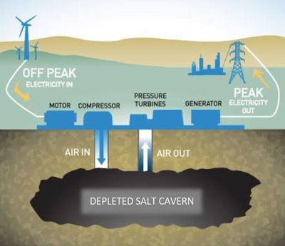
Figure 3 Simplified compressed air power plant (Canadian firms NRStor and Hydrostor partner up on utility-scale adiabatic compressed air storage, 2017)

