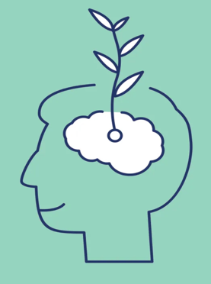
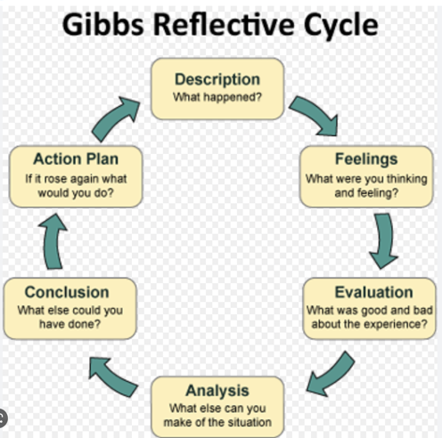
Theories and Models of reflection
To help with reflection we can look at theories of reflection and models that guide through the process step by step.
Donald Schön theorised that professional practitioners need to be able to reflect by trial and error, intuition and tacit knowledge. Schön’s(2008) theory ‘knowing-in-action’ and ‘reflection-in-action and reflection-on-action’ suggested that professional practitioners need to reflect while doing something and after having done it. Schön theorised that practitioners have the knowledge and ability to carry out certain tasks without thinking too much about them, an example of this ‘knowing-in-action’ within early years could be the nappy changing procedure of a setting, a practitioner would automatically follow the procedure without having to think too much about it. Reflection-in-action in an early years setting could be looking at a situation that has arisen with the setting, analysing it and learning from the experience to improve outcomes if the situation was to arise again, this can be done independently or as a group. Reflection-on-action is a way of thinking proactively about future events, this involves looking for other ways to improve professional development.
Another influential theorist on reflection was John Dewey, he theorised that to work out the meaning of what has occurred we need to reflect back over what we have done. Dewey observed that “We do not learn from experience…we learn from reflecting on experience” (1933).
Dewey argued that practitioners who work with children need to think carefully and continuously reflect how they work to avoid introducing prejudice and out-dated practice. By effectively reflecting on their work they should be able to ensure that their practice is both ethical and responsible.

A model of reflection is a series of steps that can be used by individuals or groups to guide reflection.
A model that can be used for reflective practice is Driscoll’s (2007), this model asks 3 main questions; What? So what?, and What now? The first step of this model looks at what exactly happened, what the practitioner did and whether the experience was good, or bad and why. The second stage of Driscoll’s model looks at how the practitioner felt and how they reacted to the experience. The last stage of this model looks at what the practitioner has learnt from the experience and what they could do differently next time to improve outcomes.
The advantages to this model are that it is a simple framework which makes it easy to remember and use in practice.
The simplicity of the model can be a weakness of the model also. It does not give regard to ethics and it was not developed to be used in early years settings.

Similarly Gibbs (1998) reflective cycle is a more detailed framework that helps the process of reflection through specific steps. The first step in Gibb’s model asks for a description of what has happened, this leads on to the second step which asks how the practitioner felt during the event. The third step is an evaluation of the activity, what went well and what did not go so well. Following the evaluation step the model has a conclusion step that looks at what the practitioner has learnt from the experience and what they could have done differently. The last stage of this model looks at the knowledge, skills and experience of the practitioner.

A practitioner that has good knowledge, experience and up to date skills can use these models, or their own model of reflection, to organise their own thinking and critical thinking skills.

It can take trial and error to find what works best for practitioners at an early years setting. They may need to try different methods and tools of reflection to find a way that suits them best. Tools that may help are notebooks, learning journals, mind maps and lists.

Driscoll’s Model of Reflection
/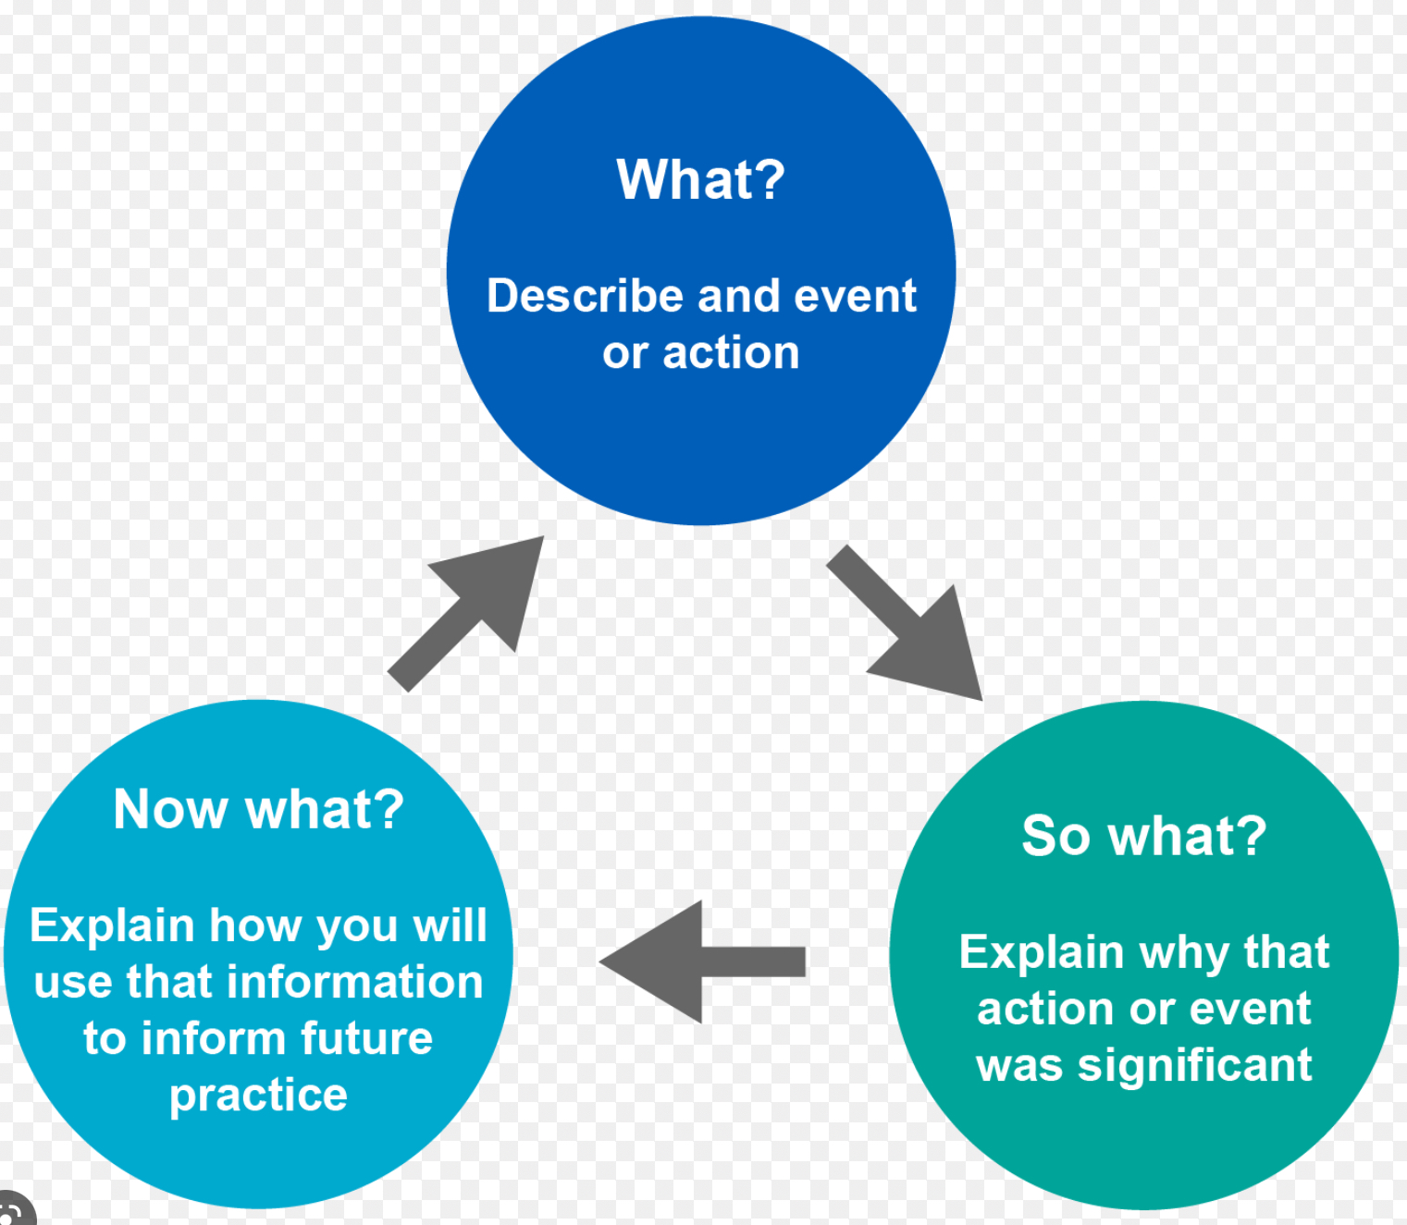

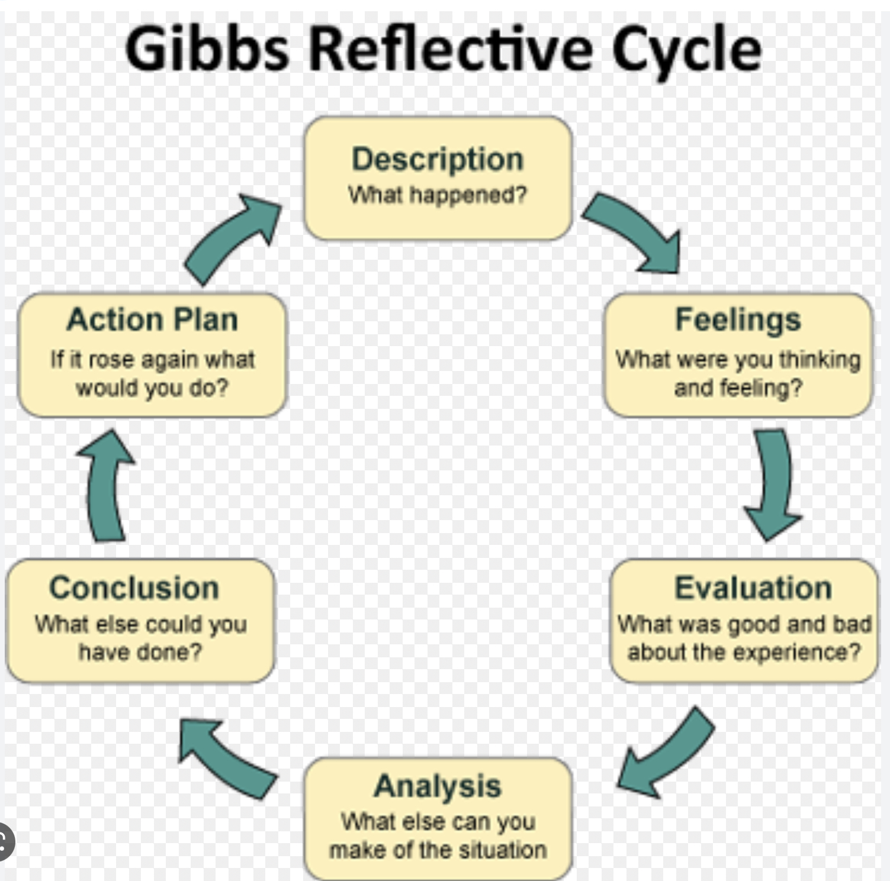
Reflection and professional practice in the Early years
Reflection is important in everyday practice in early years education to ensure that we are providing quality provision that gives the children in our care the best learning experiences that are both enjoyable and appropriate for their stage of learning.
As early years practitioners we are always looking to improve outcomes for the children, we continually look back on the experiences we encounter and the experiences we give the children each day.
Early years education is ever-changing, with new curriculums being introduced in England and Wales practitioners need to be open-minded to current ideas and ways of thinking.
As early years practitioners, reflecting on what we do means that we need to critically evaluate how we react to situations, look at the consequences of what we did and think about how we will react differently next time a situation arises. Characteristics of reflective practice being used effectively in an early years setting are excellent communication with colleagues and other professionals, a commitment to ensuring that children's progress is monitored and planned for effectively and the capacity to make informed decisions using evidence and knowledge.

What is reflective practice?
Reflective practice is a way of thinking that involves looking back at experiences and analysing your own actions to improve your practice. By reflecting critically on what went well and what did not go well we can continuously learn from these experiences and develop our own knowledge.
Reflective practice encourages professionals to challenge and change their practice to improve the way children learn and develop.
Finlay (2008) says that reflective practice “is learning through and from experiences towards gaining new insights of self and practice”.

The purpose of this document is to develop understanding of reflective practice and its value in improving quality service provision within and children's outcomes within the early years workforce.

