Acknowledgment of use of AI in assessment form.
I acknowledge the use of Bing AI assistant to support my research on the 29.10.25 using the prompt(s):
1.’What is the medieval period is it the same as the Middle Ages?’ Bing AI assistant.
2.’ What is the period of The Enlightenment? ‘Bing AI assistant. https://www.britannica.com/event/Enlightenment-European-history
3.’What is The Early Modern period?’ Bing AI Assistant. https://www.britishmuseum.org
I acknowledge the use of Primo research assistant in library search screenshots in Task 3 on 29.10.25 to support my work using the prompt 1. ‘Melancholia in Psychology.’

I confirm that I have not presented any AI generated text as my own work. I confirm I have copies of my drafts, notes, and other resources I used before, and after the use of AI tools which I may be asked to provide in evidence.

Title of assessment:
Component One E-portfolio (3 elements).
Study Skills for Psychology ECPS 4018 Level 4.
BSc. Psychology & Counselling 2024.
Lecturer: Stuart Jones.

Name: Student anonymised.

Contents list:
Acknowledgment of use of AI in assessment form........................................................1.
Title of Assessment page. ............................................................................................2.
Contents Page. .............................................................................................................3.
Task one: e-portfolio assignment-Summary of article.................................................4,5.
References List. Task one. .........................................................................................6,7.
Task two: e-portfolio assignment-Create Reference list in APA (7th ed.) style..........8, 9.
Task Three e-portfolio assignment –Essay Plan……………….......10,11,12,13,14,15,16.
Library Search Screenshot and Summary of sources: ……………………….....17,18,19.
Bibliography:(Potential sources for essay not quoted in plan. Online reading list.) ………………………………………………………………………………......................20,21.

Task one: e-portfolio assignment-Summary of article.
Title of chosen journal article
How to Succeed in your degree, with psychology...
Dr. Paul Penn, School of Psychology,
University of East London.
(400 +-10% word - Count 432 words).
The article by Penn suggests that many psychological research studies can advise students on effective study methods.
In a survey Karpicke et al. (2009, as cited in Penn, 2019) 83% use rereading of which 54% claim as their first choice, but it was found less effective than ‘Retrieval practice’ (RP) or self-testing. Only 10% use (RP) as part of their repertoire and only 1% as a number one strategy. A research study by Karpicke, (2017, as cited in Penn 2019) found that the self-testing is a more effective method of memory retention than rereading.
(RP) involves reading, closing the book, notetaking from memory and asking questions to test comprehension of the text, this improves recall (Pressley et al., 1987 as cited in Penn 2019). Subsequently, this creates readymade material for preparing written work. Notetaking in one’s own words promotes academic integrity and good paraphrasing and prevents plagiarism (Oppenheimer, 2006 as cited in Penn 2019). Also, metacognition (ability to learn) is self-monitored rather than assuming knowledge is absorbed (Krüger& Dunning,1999 as cited in Penn 2019).
The (RP) method and spacing out study sessions for a topic to test recall is more effective (Karpicke et al., 2017 as cited in Penn 2019). It appears more difficult but creates a ‘desirable difficulty’ to make for durable learning (Bjork & Bjork, 2011 as cited in Penn 2019). Revision by cramming or short-term memory gain ‘is not a reliable indicator of long-term learning ‘(Soderstrom & Bjork,2015 as cited in Penn 2019).

Students in their written work can be tempted to ape the style of textbooks and journals writing in terms to impress, instead of aiming for clarity and simplicity, that can be understood by a non-expert audience avoiding ‘The Guru effect’, (Sperber, 2010 as cited In Penn 2019).
Procrastination as a problem can be addressed by using ‘implementation intentions’ which are five times more effective than goal-based intentions (Gollwitzer & Sheeran, 2006; Gollwitzer et al., 2008 as cited in Penn 2019).
For group activities and assignments using the technique of making each individual accountable through peer evaluation overcomes the effect of individuals of a group putting in less effort (Brooks et al., 2003; Gibbs. 2009; Latane et al.,1979 as cited in Penn 2019).
For presentations use the method of ‘Assertion/ Evidence’ which will give a clear purpose to each title page, with statements to back up each assertion, cutting out unnecessary detail (Alley et al., 2006; Kosslyn et al., 2012, as cited in Penn 2019).
For any student not just in the discipline of Psychology, Penn’s advice does give a valuable guidance on how to conduct study.

References List. Task one:
All authors below as cited in Penn, P. (2019) How to succeed in your degree with psychology.
The Psychologist, The British Psychological Society, BPS.
https://www.bps.org.uk/psychologist/how-succeed-your-degree-psychology

Alley, M., Schreiber, M., Ramsdell, K. & Muffo, J. (2006).
How the design of headlines in presentation slides affects audience retention.
Technical Communication, 53(2), 225–234.

Bjork, E. L. & Bjork, R. A. (2011). Making things hard on yourself, but in a good way:
Creating desirable difficulties to enhance learning. In M. A. Gernsbacher, R. W. Pew,
L. M. Hough & J.R. Pomerantz (Eds.), Psychology and the real world: Essays
illustrating fundamental contributions to society (pp. 56–64). Worth Publishers.

Brooks, C. M. & Ammons, J. L. (2003). Free riding in group projects and the effects of
timing, frequency, and specificity of criteria in peer assessments. Journal of Education for Business, 78(5), 268–272.

Gibbs, G. (2009). The assessment of group work:
Lessons from the literature. Assessment Standards Knowledge Exchange
(Centre for Excellence in Teaching and Learning in Higher Education, Oxford Brookes University).

Gollwitzer, P. M., Gawrilow, C. & Oettingen, G. (2008). The power of planning:
Effective self-regulation of goal striving. New York University, manuscript.

Gollwitzer, P. M. & Sheeran, P. (2006). Implementation intentions and goal achievement:
A meta-analysis of effects and processes. Advances in Experimental Social Psychology, 38, 69–119.19.

Karpicke, J. D. (2017). Retrieval-based learning: A decade of progress.
In J. T. Wixted (Ed.), Cognitive Psychology of Memory, Vol. 2 of Learning, and memory:
A comprehensive reference (J. H. Byrne, Series Ed.) (pp. 487–514). Academic Press.

Karpicke, J. D., Butler, A. C. & Roediger III, H. L. (2009).
Metacognitive strategies in student learning: Do students practise retrieval
when they study on their own? Memory, 17(4), 471–479.

References List. Task one: Continued.

Kosslyn, S. M., Kievit, R. A., Russell, A. G. & Shephard, J. M. (2012).
Power-Point presentation flaws and failures: A psychological analysis. Frontiers in Psychology, 3, 1–22.

Kruger, J. & Dunning, D. (1999). Unskilled and unaware of it: How difficulties in recognizing one's own incompetence led to inflated self-assessments. Journal of Personality and Social Psychology, 77(6),1121–1134.

Latane, B., Williams, K. & Harkins, S. (1979). Many hands make light the work:
The causes and consequences of social loafing. Journal of Personality and Social Psychology, 37(6), 822–832.

Oppenheimer, D. M. (2006). Consequences of erudite vernacular utilized irrespective of necessity: Problems with using long words needlessly. Applied Cognitive Psychology: The Official Journal of the Society for Applied Research in Memory and Cognition, 20(2), 139–156.

Pressley, M., McDaniel, M. A., Turnure, J. E., Wood, E. & Ahmad, M. (1987).
Generation and precision of elaboration: Effects on intentional and incidental learning. Learning, Memory, and Cognition, Journal of Experimental Psychology 13(2), 291–300.

Soderstrom, N. C. & Bjork, R. A. (2015). Learning versus performance: An integrative review. Perspectives on Psychological Science, 10(2), 176–199.

Sperber, D. (2010). The guru effect.
Review of Philosophy and Psychology, 1(4), 583–592.

Task two: e-portfolio assignment-Create Reference list in APA (7th ed.) style.

Reference List:
Davis, E. R. & Clarke, M. J. (2022) Modern marketing strategies.
Business Books Publishing.

Department for Environment, Food & Rural Affairs [DEFRA]. (2020).
UK climate change risk assessment 2020. https://www.gov.uk/government/publications/uk-climate-change-risk assessment-2020

Garcia, M.T. (2022, Mar 5th) Climate change impacts on coastal cities.
The Global Times. https://globaltimes.com/climate/coastal-impact

Kim, Sang H., Patel, Raj, & Wilson, John D. (2021)
Virtual reality in education: A meta-analysis. Educational Technology Research
and Development 69(2),1105-1123. http://doi.org/ 10.1007/s11423-020-09834-7

Lee, A.M. (2020) Cognitive development in early childhood.
In Brown, P & Green, L. (Eds.) Child Development Theories, 45-67. Springer.

Ling, Z. (2019) Proceedings of the International Conference on Human-Computer
InterAction: Enhancing user experience in mobile apps, 102-110.
ACM Press. http://doi.org/10.1145/3313831.3376310.

Martinez, S. L. (2022, October 14). The International Symposium on Sustainable Energy: Advances in renewable energy storage. Berlin.

Morgan, D.S. (2021). Machine learning applications in healthcare diagnostics.
[Dissertation University of Edinburgh]. ProQuest Dissertations & Theses Global. Accession Number: 12345678.

NHS Greater London Trust (2022) Annual patient satisfaction survey report.
[unpublished report]. NHS

Nguyen, H. P. (2018) Blockchain technology in finance.
In Singh, R.& Cohen, A. (Eds.) Innovations in Financial Technology.
(eBook),122-139.Wiley Online Library.

Task two: e-portfolio assignment-Create Reference list in APA (7th ed.) style.

Reference List: continued.

Nguyen, L. T., O' Connell, M. A., Li, S. J., Rivera, P. M., Adams, F. R.,
Chen, H.Y., Bailey, T. K., Jones, A. R., Walker, C. L., & Ahmed, S. E. (2022). Journal of Experimental Psychology151(4). Cognitive flexibility and executive function in early adulthood, 789–805. http://doi.org/10.1037/xge0001223

Patel, S. R. (2020) The rise of digital therapy. The Psychologist -
British Psychological Society [BPS] 33(6), 48-53.

Reynolds, Katie M. (2023) How mindfulness improves productivity.
Mindful Living. https://mindfulliving.com/how-mindfulness-improves-productivity

Smith, J.A. (2019). Understanding Psychology (3rd ed.)
Academic Press.

Thompson, R. E. (2018). Social media effects on adolescent mental health.
Journal of Adolescent Health 62(4). 410-417.
https://doi.org/10.1016/j.jadohealth.2017.11.290

University of Oxford [UoO] (2022) Referencing and citation guide. https://www.ox.ac.uk/students/academic/referencing

U.S. Department of Education (2017). National education technology plan 2017
(ED-ICT-17-01). https://tech.ed.gov/netp

Williams, J.L. (2020).] Exploring sustainable urban development.
[Doctoral dissertation University of California]. https://escholarship.org/uc/item/7gp4v2cd

World Health Organization [WHO] (2023). Mental health and COVID-19. https://www.who.int/mental_health/covid-19

Task three: Essay Plan (outline). Title of Essay-(b) as given in study skills.
Essay title: ‘Discuss how our understanding of melancholia and approaches to treatment have changed over time.’
ESSAY PLAN TEMPLATE Given by mentor C. Harding UWTSD (1448 words.)

Introduction  Statement of intent and Purpose: Make a CLEAR PLAN of how you will approach this essay! Introduction: (c.150 words)  Set the scene, tell the audience who, what, where, when, and how the essay will proceed as per interpretation of essay title.  Originating with Hippocrates and the four humours.  Define Melancholia as it would be today -Oxford Dictionary of Psychology  and APA DSM5. | General  introductory  I will Aim to write 350 words, as 100 words will only give to narrow an introduction.  Interpretation of the essay title: What is the question being asked?  ‘Discuss’ (instruction what is to be done)?  How? (meaning to explain)  ‘The meaning ‘(The What1?)  Melancholia ‘(what 2?)  AND’ treatments’ (The how?)  ‘Have changed over time ‘(The When?)  In the context of medical treatment, Philosophy and Psychology overtime in the historical range of the course ‘History of counselling’ ancient Greco-Roman and eastern cultures.  Deadline:  Tuesday 4th November 2025 by no later than 23:59pm, via FINAL Turnitin portal. | This essay will discuss ‘melancholia’ and how it was treated and understood through time from ancient Greece up to the present day.  ‘The word comes from the Greek ‘melas’ meaning black, chole, bile and ‘ia ‘, a condition or quality.’ (Colman, A.M. 2015). ‘The doctrine of four humours (temperaments) which attributed depressive states as being caused by an excess of black bile in the body.’ (Colman, A.M. 2015).  ‘Historically it originates with Plato (428-348 BCE) credited with the first mention of ‘melancholy’ (Plato, Timaeus, p.322 which as a condition was then fully described by Hippocrates as Cited In Tyson et al. 2020) Today ‘Melancholia’ is considered ‘a severe form of depression more specifically, a major depressive episode. Involutional melancholia or involutional depression.’ (Colman, A.M. 2015).
Paragraph 1  Make use of PEE  Make an opening Assertion and back it up from support material.  Ancient philosophers (Socrates, Aristophanes, Plato, Aristotle, Hippocrates, Galen) western and eastern cultural perspective.  Main body: Present in paragraphs in chronological order. (Word count Total! BE AWARE1500 +- 10% = 150 OVER MAX.). | Topic sentence  The Hippocratics, asserted that gods or demons were not the cause of madness. (Scull, A. 2020 p32.) | Humoral imbalance was understood at the times by the physicians that ascribed to the Hippocratic teachings.  Melancholia was understood as a separate disease from the mania, hysteria, or epilepsy. melancholia was recognised as a type of what today would be called a ‘depressive state' being withdrawn, quiet, loss,  sadness, grief, lacking joy or even unresponsive.  They broke away from the traditional beliefs of the masses and even the educated elites that followed ‘practitioners of temple medicine.’ (Scull, A. 2020) Support  Scull, A. (2020, p32.) cites Hippocratic writings-’On the sacred Disease’ “It is thus with the regard to the disease called Sacred: it appears to me to be nowise more divine nor more sacred than other diseases but has a natural cause [blocked phlegm] from which originates like other affections. It disparages that various forms of epilepsy and hysteria as ‘sacred' the treaties encompassed the manic and melancholic disturbances of the spirit.” Other affections refer to all the forms of disease including the mental of which Melancholia was recognised as one.  But it is still the position that the hippocratics were to all purposes still radicals in their medical view and at a time of low literacy and education. The masses attitudes still held that all forms of madness escaped explanation and accepted it as the wrath or gift of the gods.
Hippocrates stated that when in excess black bile which had the properties of cold and dry resulted in melancholia. Today known as depression. He described the symptoms as despondency, sleeplessness, loss of appetite, irritability, restlessness, and an inability to speak. (Tyson et al. 2020 p.44)
Aristotle (384-322 BCE) the first philosopher to associate genius and depression believing that melancholic traits were intrinsic. (Simon 1978 as cited In Tyson et al. 2020). ‘He accepted Humoral theory’ but refined the idea on the nature of ‘black bile’ believing ‘temperature’ determined ‘the type of affliction.’ Hot black bile ‘could present as cheerfulness or in extreme manic states. Cold and it became ‘withdrawal or fearfulness.’ (Simon 1978 as cited In Tyson et al. 2020) Today this is comparable to MMD or bipolar disorder. Hellebore was applied as a purgative to induce vomiting and diarrhoea, thought to expunge bile from the intestines. Keeping the sufferer in warmth, hot baths, and dietary regimen of non-dry and hot foods such as moist meat and fish or soups.
Treatments for madness in ancient Greece and Rome Infanticide may have been culturally acceptable for children that exhibited physical or psychological behaviour problems. Adults afflicted it was a duty to care, as Plato states, 'a madman is to be guarded by his relatives and is not allowed to go about the city’ (Plato, Laws, p.150 as cited In Tyson et al. 2020) This at face value may have been an idealist view, despite the title of his writings ,as perhaps only the wealthy elite could obey it.

Paragraph 2  Medieval period 476 CE to1500 Renaissance and Age of Discovery1492. (Avicenna, Ibn Sina. the Arab, and Muslim writers, Chinese –Sino and Indian) (Scull, A .2020) | Topic sentence  The divine or demonic influence  supernatural explanation persisted.
Support
(Scull A.2020)
The humoral theory of ancient and medieval. (Jackson, S. W. 1986).

Paragraph 3  The Renaissance to Early modern times.  Early modern. (late1500 -1700) Richard Napier. The Reformation and the Renaissance. (C15th -C16th) The fashion of melancholia-Robert Burton (1640) | Topic sentence Humoral theory still accepted but modified.  discusses the variety of therapeutics proposed in each era: the purgatives, bloodletting, and other evacuative remedies that prevailed for so long; the theories that called upon the strengthening virtues of iron and steel, the replenishing of depleted states, | It is misconceived today that the treatment in medieval times involved cruelties, witch hunts, persecution, and the inquisition. These did happen but were not consistently the treatment nor commonplace.  (Samson,1995 as cited in Tyson et al. 2020)  Planning note chapter, Medieval madness, and witchcraft p.50.  ‘John Weyer (1515-1588) ...opposed the’ notion ‘of witchcraft ‘and believed that ‘physical disease(melancholy) was an explanation for hallucinations experienced by witches’ (Mc Carthy-jones,2012; Pietikainen,2015 as cited In  Tyson, P.J., Davies, S.K., Torn, A. 2020  p.52)
Support

(Jackson, S. W. 1986).

Peer Reviewed
‘Abstract from journal to support’
This book—the first comprehensive history of depression in English—addresses the ways in which depression has been defined over time, the explanations proffered for its causes, and the various approaches used to treat the sufferers.
Stanley W. Jackson, a psychiatrist, psychoanalyst, and historian of medicine, here traces both the many changes and the remarkable continuity in this clinical disorder over the past 2,500 yrs. Dr. Jackson explores the terminology and some of the metaphors inherent in the language of dejected states

Paragraph 4  The Modern era. The enlightenment 1680–1820,  (C17th-C18th). Philosophy becomes the science, Psychology. 1879 William Wundt.  Paragraph 5. Post modern (20th Century to today).  Pharmacological, Medical model and Psychiatry linking learning from Conceptual and historical issues in Psychology. | Topic sentence  ‘The chemical schemes of the seventeenth century, the mechanical explanations of the eighteenth century.’  the cerebral-circulation and nerve-disorder ideas of the nineteenth century, the psychodynamic concepts’  (Jackson, S. W. 1986). ‘(PsycINFO Database Record (c) 2016 APA, all rights reserved) | . For each historical period, he studies the theories called upon to explain such conditions: the humoral theory of ancient, medieval, and renaissance times, the chemical schemes of the seventeenth century, the mechanical explanations of the eighteenth century, the cerebral-circulation and nerve-disorder ideas of the nineteenth century, the psychodynamic concepts and the biogenic amine hypotheses of today. And he discusses the variety of therapeutics proposed in each era: the purgatives, bloodletting, and other evacuative remedies that prevailed for so long; the theories that called upon the strengthening virtues of iron and steel, the replenishing of depleted states, and the stimulation of anergic conditions; the many psychological interventions; and the psychotherapies and antidepressants used today. ‘(PsycINFO Database Record (c) 2016 APA, all rights reserved)  (Jackson, S. W. 1986).
Support (Jackson, S. W. 1986). The biogenic amine hypotheses of today.

the stimulation of anergic conditions; the many psychological interventions; and the psychotherapies and antidepressants used today. ‘
Conclusion:  Highlight the main point in each paragraph to ensure the information is duplicated in the conclusion. Conclusion: (C.150 WORDS?)  Summarise the arguments of discussion in the main body and  How the aim given in the introduction has been achieved. | Summary of main ideas summarise points made above and draw arguments together. | Conclusion: Superstition and religious belief would persist for many centuries to come as would the humoral temperament theory, although somewhat modified well into the 19th century. The progression of a more literate and education of the masses slowly progressed understanding but also was a driver for greater ‘scientific’ prejudices and misconceptions. Melancholia as with the other forms of madness or mental health issues still are debated and remain unsatisfactorily explained.

Reference list Task 3.:

Colman, A.M. (2015) Oxford Dictionary of Psychology (4th ed.) Oxford University Press.
Jackson, S. W. (1986). Melancholia and depression: from Hippocratic Times to Modern TImes. Yale University Press.

Scull, A. (2015). Madness in Civilization: A Cultural History of Insanity, from the Bible to Freud, from the Madhouse to Modern Medicine.
https://doi.org/10.1515/9781400865710

Tyson, P.J., Davies, S.K., Torn, A. (2020) Madness: History, Concepts and Controversies. Routledge.

Library Search Screenshots.
Historical context of treatments from 1750 to present.
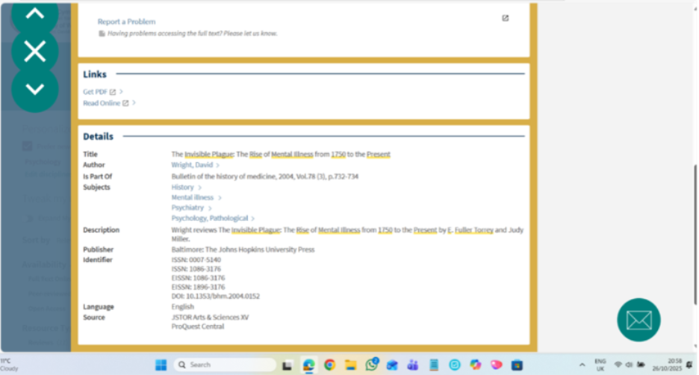

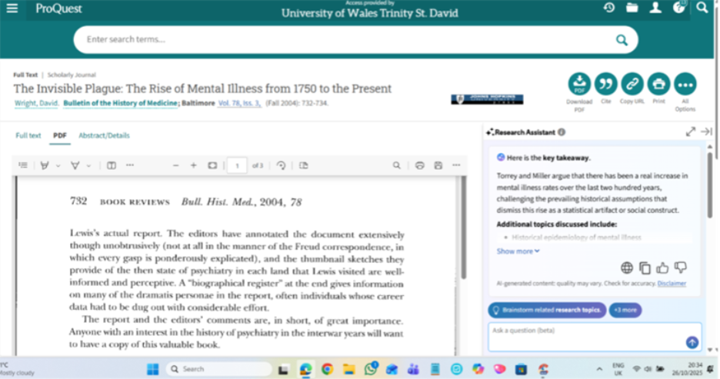



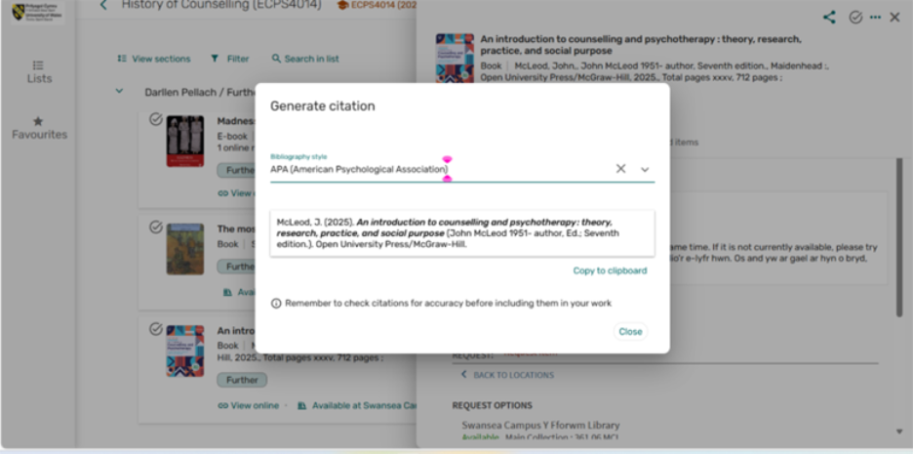


(ABOVE) Advanced search, further reading.

Summary of sources:
How will you decide which sources are appropriate to use?
Used as a search term the ‘Online reading list ‘recommended by course lecturers and library. Initially the search word ‘Melancholia’ returned many irrelevant sources from the arts, but could be used in Discussion of, ‘The Fashion of Melancholia’ in the 16th century. This would relate to social meaning but not of treatment. Deeper search using the terms ‘Melancholia in Psychology' gave promising articles.
Ensuring that the source is specifically referring to Melancholia melancholy or melancholic (in the classical Hippocrates Black bile sense or, depression and mood disorder developed into modern times.
Use sources with the purpose, highlight discussion points comparing Melancholia from one period to the next.
Paraphrase and do not rely on direct quotations so much in the actual essay to avoid plagiarism and score higher marks.

Bibliography:(Potential sources for essay not quoted in plan. Online reading list.)

Howard, A. (2000). Philosophy for counselling and psychotherapy: Pythagoras to postmodernism. Macmillan.

Jansson, Å. (2020, April 30). Melancholia and Depression.
Oxford Research Encyclopaedia of Psychology. Retrieved 27 Oct. 2025, from https://oxfordre.com/psychology/view/10.1093/
acrefore/9780190236557.001.0001/acrefore-9780190236557-e-623.

Jones-Smith, E. (2021). Theories of counselling and psychotherapy: an integrative approach (3rd ed.). SAGE.

McLeod, J. (2025).
An introduction to counselling and psychotherapy: theory, research, practice, and social purpose (7th ed.). Open University Press/McGraw-Hill.

Nelson-Jones, R. (2011). Theory and practice of counselling and therapy (5th ed.). SAGE.

Nelson-Jones, R. (2014) theory and practice of counselling and psychotherapy /
(6th ed.). SAGE Publications Ltd.

Scull, A. (1993). The most solitary of afflictions: Madness and Society in Britain
1700-1900 Yale U P.

Scull, A. (2022). Desperate remedies: psychiatry’s turbulent quest to cure mental illness.
The Belknap Press of Harvard University Press.

Torrey, E. F. (2003). The invisible plague the rise of mental illness from 1750 to the present. Rutgers University Press.

