Student name: ANDREI DUMITRASCU
Student number: 1921558
Module title: LCBB4004 MARKETING FUNDAMENTALS
Assignment title: Blogging to communicate - Assessment 1
Lecturer: Tushara Balendran

MARKETING FUNDAMENTALS

Company background

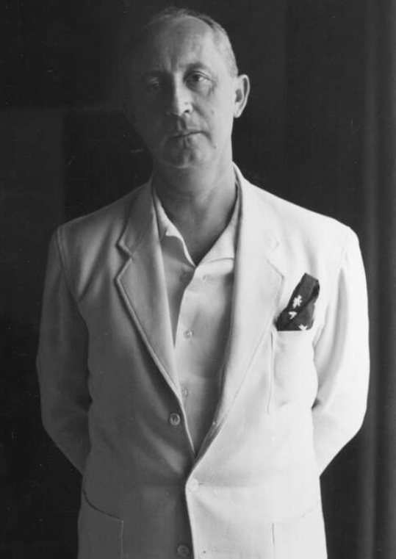
Christian Dior: The founder of Dior SE
(Source: LVMH, 2020)
History and key people
Dior SE is a French luxury company that is founded about seventy-three years ago in the year 1946 by Christian Dior. Bernard Arnault is the current chairman of the company and he is a businessman too (Dior, 2015a). The other key people of the company are:
- English Fashion Designer, Kim Jones: Creative Director
- Italian Fashion Designer, Maria Grazia Chiuri: Creative Director
- Sidney Toledano: CEO and Vice-Chairman

Bernard Arnault: Current Chairman of Dior
(Source: Forbes, 2020)
Employees, financial performance, mission and vision,
According to the annual report of 2019, the company has more than 163 thousand employees in its worldwide operations. LVMH is the most valuable subsidiary of the company and its performance in the year 2019 is given below:
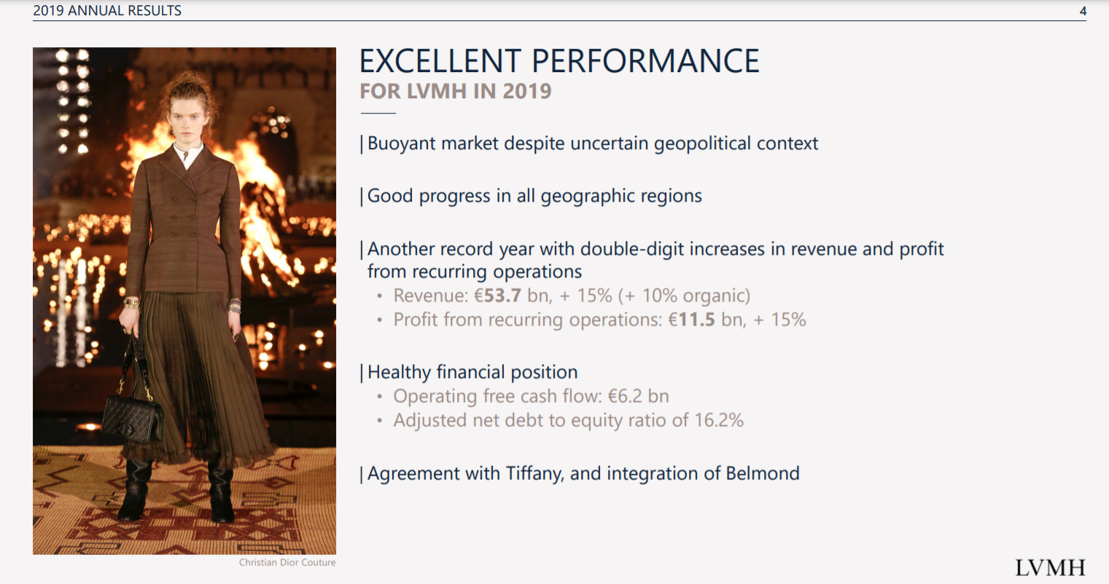
Financial performance of Dior SE
(Source: Dior Finance, 2020)
The mission of the company reflects the mission of the founder Christian Dior which is excellence in everything and making all clients especially the women happy, fulfilling their dreams together with making them beautiful.
The vision of the company is to become the most popular brand in the world for all of the products that improve lifestyle.
Competitors and partners
Top competitors of Dior SE are Gucci, CHANEL, and Burberry though; it has competitors in all of the countries in the world. That means, it faces competitions from local companies as well as from global organizations. Though, the company make partnership with different organization such as Belmond, and Tiffany (Dior Finance, 2020).

Products

Dior is a luxurious brand and the products of the company are focused to satisfy high class consumers. This has three different sections such as Dior Label for men, Dior Homme for men and Baby Dior for children. Dior also found Haute-Couture which became famous in its very first year of 1947.
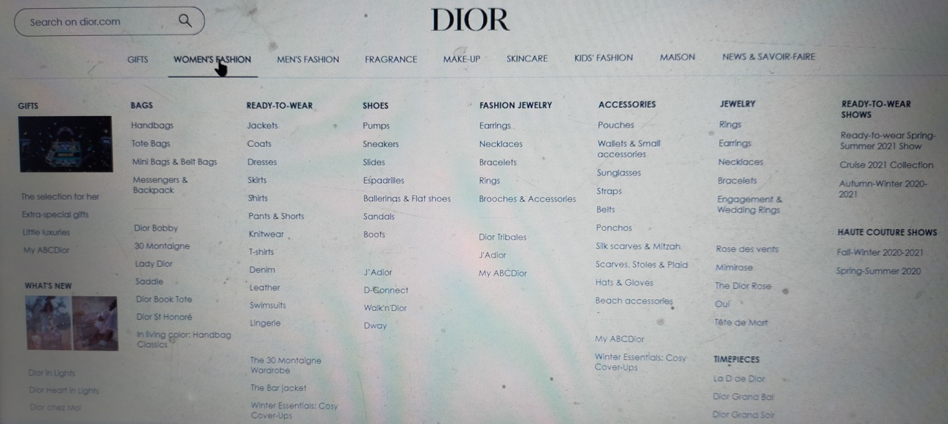
Types of Women Fashion Products in DIOR
(Source: Dior, 2020)
The organization has variety of products such as footwear, ready to wear, leather items, fragrance, makeup, jewelleries and other fashion products. There are several fragrances that are designed for both men and women. For example, Jules, Higher Cater, and Sauvage are designed for men. On the other hand, some popular perfumes designed for women are Poison and Miss Dior. There are no doubts that the company apply its creativity to name the products in such a way that the names of the products attract the attention of consumers, especially from women.
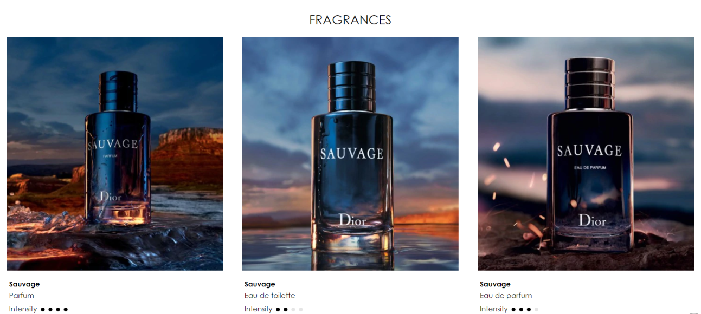
Types of Sauvage: Men perfume
(Source: Dior, 2020)
Apart from these products, the company produces other range of products under different categories such as lipsticks under make up kits, tonners, and scrubber under skincare. The company also provide categories such as gifts, and maison where the consumers can get collection of notebooks, papers, and books.

Price

The price of the product of Dior is high as it is focused on high income group and high class consumers. The products are luxurious and Dior adopted a premium pricing strategies for the same. The organisation has high-end consumers who helped it to survive and develop the quality of the products continuously. The consumers do not hesitate to invest on Dior products as the products are exclusive and meet their demands as well. The company made a brand that encourage consumers to pay extra as they know that the quality of the products is something to give them value for their money so far.
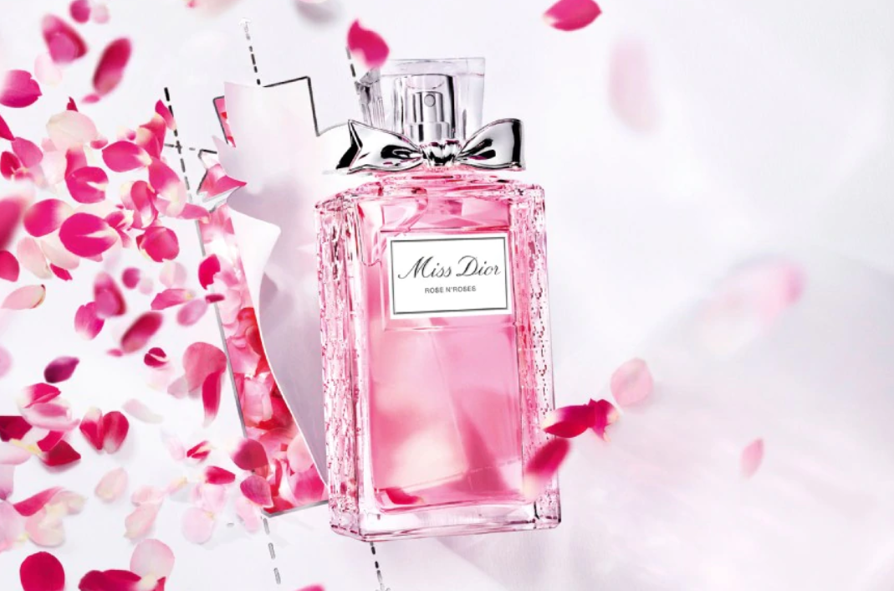
Miss Doir: A premium fragrance for women
(Source: Dior, 2020)

The price of the products is also high as it serves multiple functions, for example, Dior Forever is a foundation that has skin care ability as well.

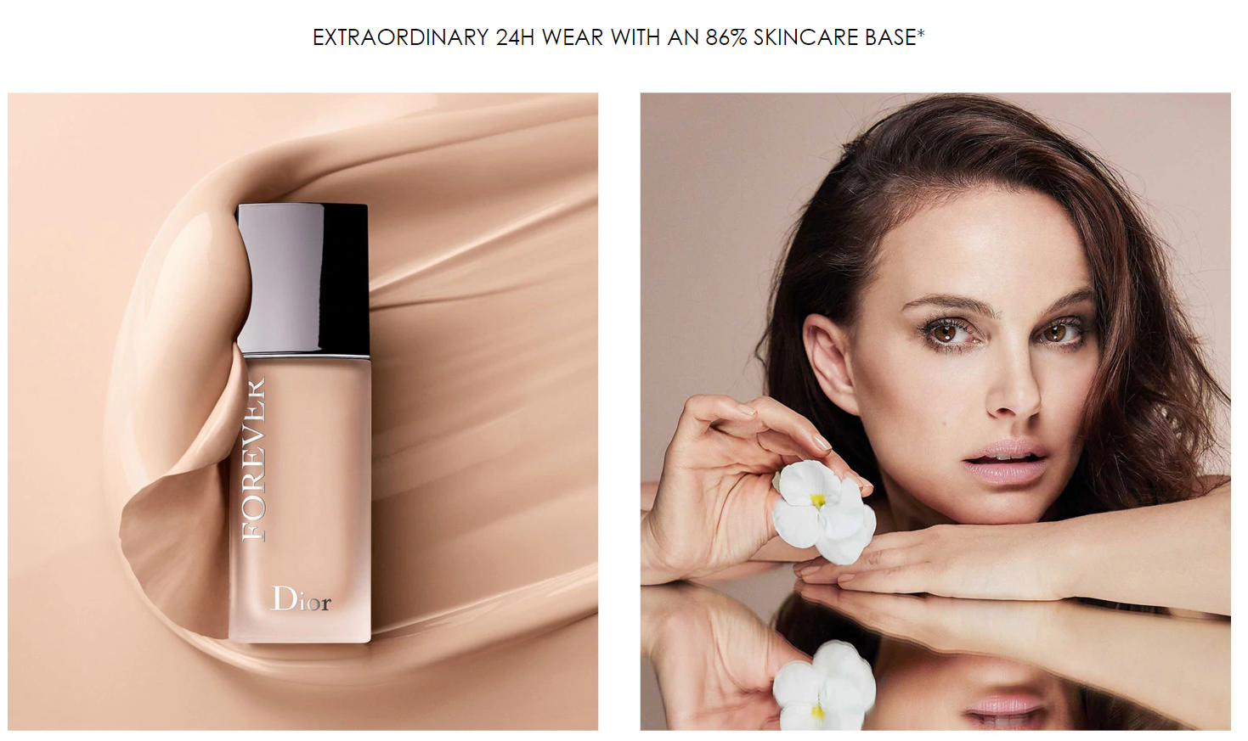
Dior Forever: Foundation to wear 24 hours with 86% skincare
(Source: Dior, 2020)

Therefore, it can be seen that the quality of the products and the multiple benefits from a single product encourage consumers to pay extra for them.

Place

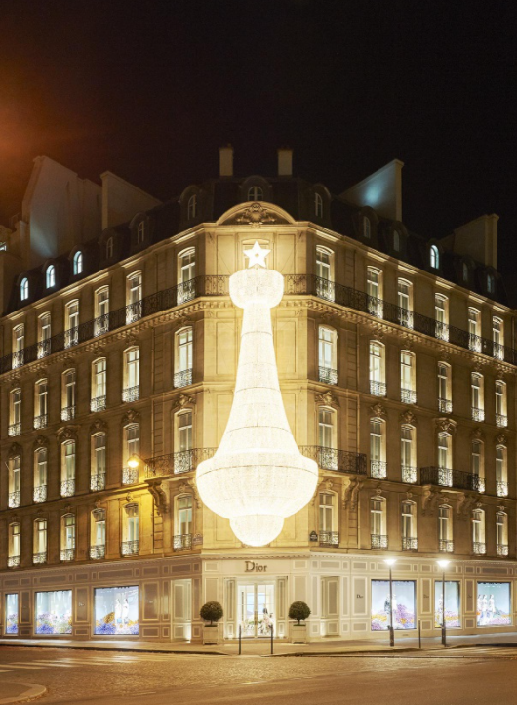
Headquarter of Dior @ 30 Avenue Montaigne
(Source: SENATUS, 2015)
Dior products are very original and exclusive therefore the company believes in direct and offline selling as well. The company has more than 200 offline stores throughout the world and most of them are located in Asian countries. Even more than half of the offline stores of the company are located in Asia. Next it has more than forty-four stores in both North America and Europe. There are more than five stores in Oceania and South America. Beside this, it has one store each in Caribbean and Africa with these, Dior make its presence in all of the five continents in the world. The number of stores in Africa and Oceania showed that the company did not focus on population and size of the continents but on the buying capability and presence of the high income groups in those continents. Though, that does not mean, the company only doing business offline. The company also distributed its products through online stores like its official site dior.com. Moreover, it started to sell watches and give a hard competition to market leaders such as Rolex, Swatch, and others.

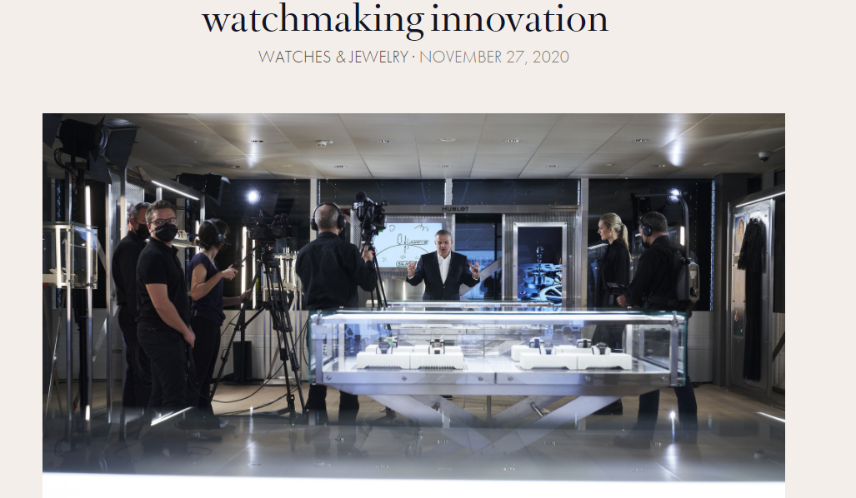
Dior store: Watch and Jewellery launch in 2020
(Source: LVMH, 2020)

The retail outlets of the company are comfortable and decorated to provide a beautiful ambiance to the consumers. There are more than fifty variants in which the stores are decorated. Though, all of the stores are decorated in a grey scale so the store of Dior can be identified easily. The company knows that place plays an important role in marketing of the organisation. Every consumer is treated individually in the stores and that is why; they need to make a prior appointment through phone calls.

Promotion

Dior promotes its brand though different offline and online means. For example, it sends emails to its regular customers about the latest news as the launching of a new product. However, it also provides invitations to few selected, regular and loyal buyers. The company also advertise its products where models are hired to promote the products. One of the such advertisement can be found in the link below:
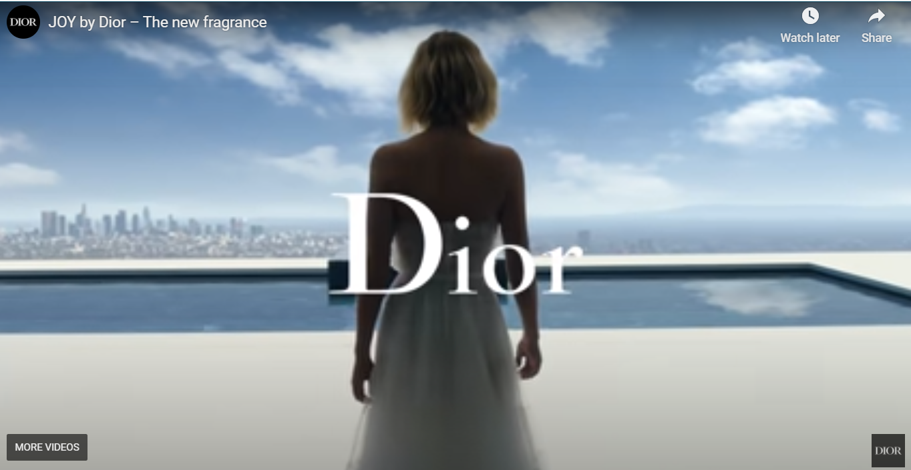
Promotion: Promotional video of Dior
(Source: Dior, 2018)
The company not only tries to promote its brand, but the class of the product as it is a well-known luxury goods organisation in the world. Though, it not only depends on paid advertisements as celebrities like Madonna, Blake Lively, and Ziyi Zhang.

The commercial of the company are published in both the electronic and social media. Moreover, it also used magazines like Vogue which is read by high class people. Dior knows that promotion is one of the big aspects of marketing and that is why it invests much on promotions. The strategies that are used by the company to promote the brand are Sales promotions.

Personal selling
Personal selling is one of the oldest methods of promotion and advertisement yet it is still effective in the 21st century (Patapau, 2020, p. 19). Dior mainly used this method for selling its fragrances. Consumers feel valued when a salesman of Dior approach them with personalised service. This is a worth method for Dior as the consumers are premium clients who can pay the premium price of the products.

Direct marketing

Direct marketing method is used to sell new items and strengthen the relationship with the buyers. Dior used it when it launches new products like it launched watches forty years ago and invite potential buyers through emails and other means.

Social media
In order to reach consumers for twenty-four-into-seven, Dior tries to reach its consumers through social media like Facebook and other SM accounts (Liu et al., 2019, p. 13). The social media account of the company is shown below:
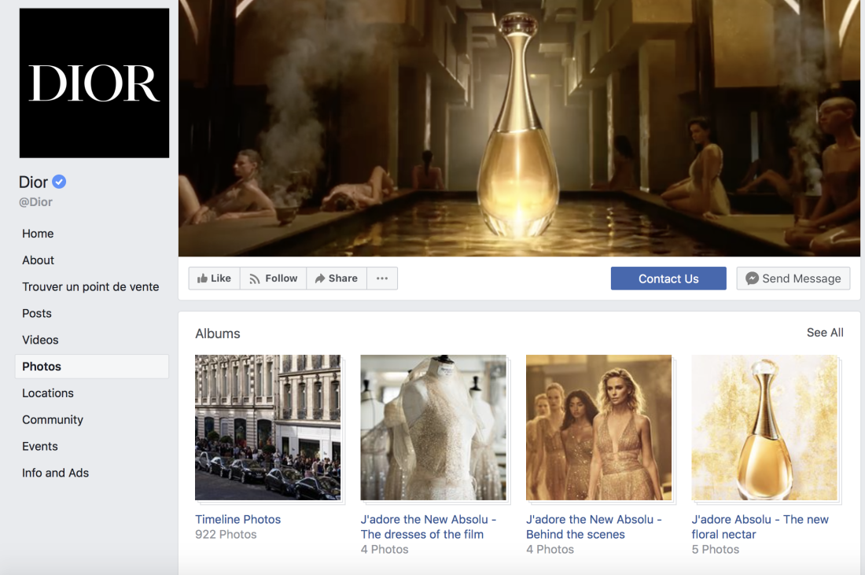
Dior: Facebook account
(Source: Dior, 2020)

Public relations
Public relationship is one of the major promotional strategies used by Dior, especially during its famous fashion shows. (Pouillard, 2018, p. 121). Celebrity endorsement is used by the company specifically in launching new products. Though, celebrities are selected according to their personalities. For example, Charlize Theron is known for her glamour and brave personality. Therefore, Dior endorsed her for the perfume J’adore.

Charlize Theron with her child: Selected to represent J’adore perfume of Dior
(Source: Mandy Mayfield, 2018)

People

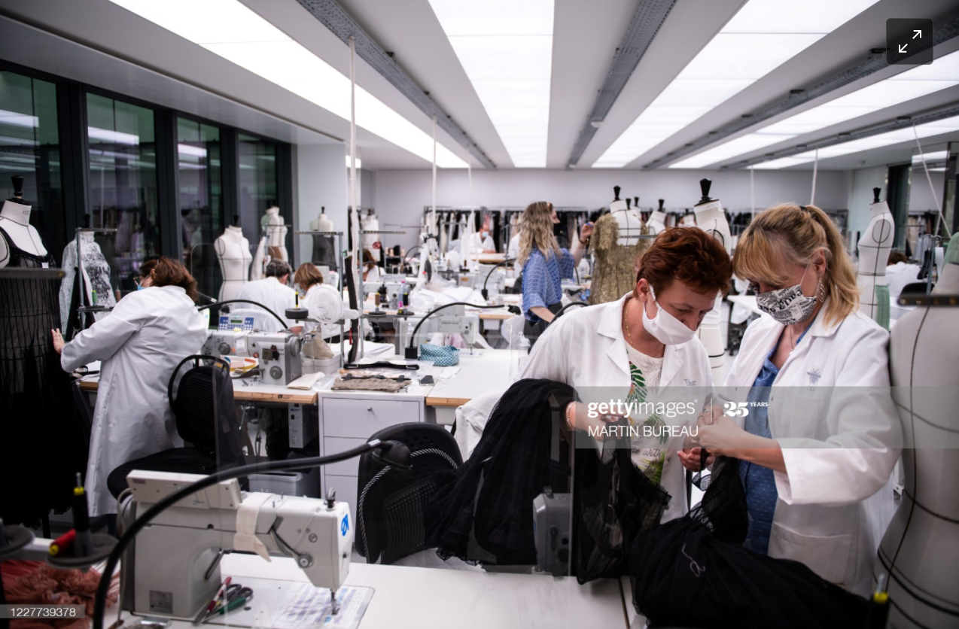
Employees at Dior: Working in cloth department
(Source: gettyimages, 2020)

People are the key for success of any global company like Dior. There are more than 163 thousand employees working in the company throughout the globe. The employees are responsible to give personalised service to the consumers. Moreover, Dior promotes its products through personal selling procedures where the employees know the products very well. The employees get support from the advanced technology used by the company and management. Dior recruits many women as the company is focusing on women products highly.

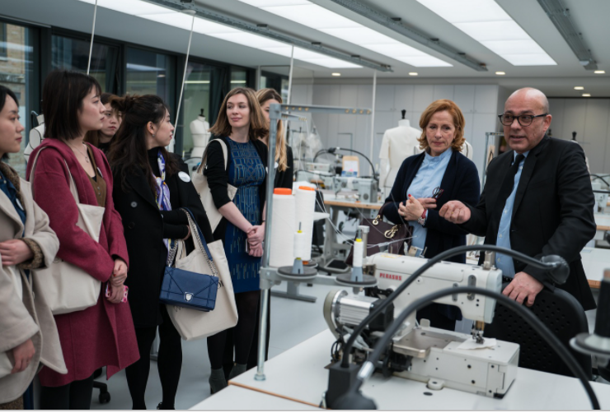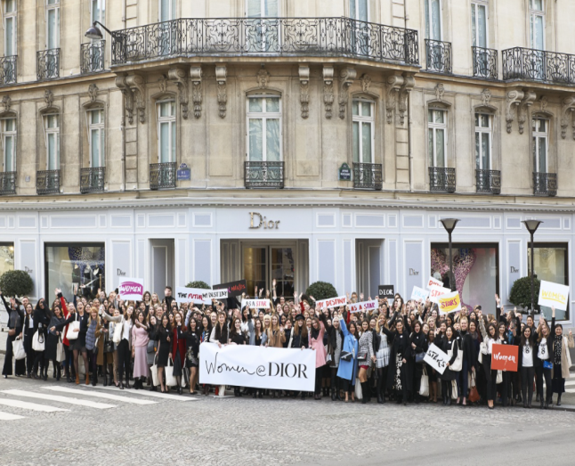
Women at Dior: Empowering young women
(Source: Dior and Chiuri, 2018)

Packaging

Dior provides customize and interactive options for packaging especially in case of gifts. There are several options available for the consumers such as classic packaging, Gorgeous gift box, shoe packaging and many more. There is different price according to the types of packaging.
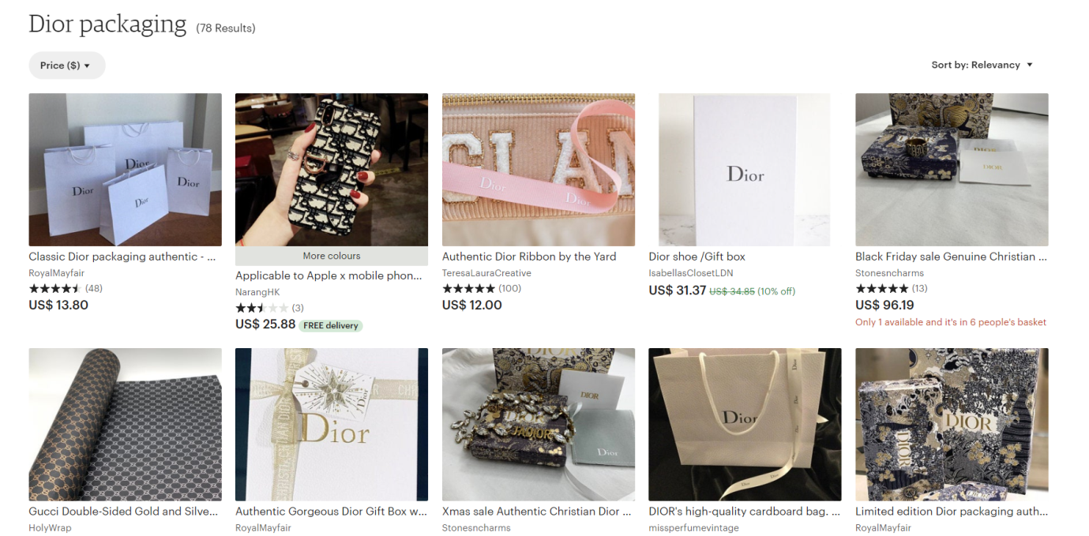
Dior packaging with price
(Source: Etsy, 2020)

Positioning

The company is clear about making the brand one of the most costly but reliable brand in the world. Though, it also holds an ethical position to its consumers through showing its concerns about the environment. For example, it focused on the water management system to produce wine without wasting much water.

Christian Dior
“To become the world’s most popular brand in all products that enhance their lifestyle”

References
Dior (2020) [Facebook] 1 December. Available at: https://www.facebook.com/Dior/ (Accessed: 1 December 2020).
Dior (2020a) About Dior.com site. Available at: https://www.dior.com/en_int/faq-couture#about-the-dior-com-site-discover-news-from-dior (Accessed: 1 December 2020).
Dior (2020b) Sauvage. Available at: https://www.dior.com/en_int/fragrance/mens_fragrance/sauvage (Accessed: 25 November 2020).
Dior (2020c) DIOR Forever. Available at: https://www.dior.com/en_int/products/beauty-Y0063000-product (Accessed: 1 December 2020)
Dior Finance (2020) LVMH. Available at: http://www.dior-finance.com/en-US/Documentation/InformationsReglementees/01,02_RapportsFinanciers.aspx/ (Accessed: 23 November 2020).
Dior, C. (2018) JOY by Dior: Discover the film of the House of Dior new fragrance, starring Jennifer Lawrence [video]. Available at: https://www.youtube.com/watch?v=1CRihg1X89A&feature=youtu.be (Accessed: 23 November 2020).
Dior, C., and Chiuri, M., Z. (2018) Women at Dior: A Mentorship Programme Empowering Young Women. Available at: http://www.fashionela.net/lifestyle/events/women-at-dior-a-mentorship-programme-empowering-young-women/ (Accessed: 22 November 2020).
Etsy (2020) Dior Packaings. Available at: https://www.etsy.com/market/dior_packaging (Accessed: 28 November 2020).
Forbes (2020) Bernard Arnault & family. Available at: https://www.forbes.com/profile/bernard-arnault/?sh=a62f31266fa4 (Accessed: 22 November 2020).
Liu, X., Shin, H. and Burns, A.C., 2019. Examining the impact of luxury brand's social media marketing on customer engagement​: Using big data analytics and natural language processing. Journal of Business Research.
LVMH (2020) PARFUMS CHRISTIAN DIOR. Available at: https://www.lvmh.com/houses/perfumes-cosmetics/parfums-christian-dior/ (Accessed: 24 November 2020).
LVMH (2020) watchmaking innovation. Available at: https://www.lvmh.com/news-documents/news/hublot-celebrates-40-years-of-watchmaking-innovation/ (Accessed: 22 November 2020).
Mandy Mayfield (2018) Charlize Theron mulls leaving America to protect her black children from racism. Available at: https://www.washingtonexaminer.com/tag/donald-trump?source=%2Fnews%2Fcharlize-theron-mulls-leaving-america-to-protect-her-black-children-from-racism (Accessed: 28 November 2020).
Martin BUREAU (2020) FASHION-FRANCE-DIOR-CROISIERE. Available at: https://www.gettyimages.co.uk/detail/news-photo/employees-work-on-a-clothe-for-the-christian-diors-news-photo/1227739378 (Accessed: 1 December 2020).
Patapau, M., 2020. The main differences between responses to personalized advertising among generations.
Pouillard, V., 2018. Christian Dior-New York: French Fashion in the Luxury US Market. In Global Luxury (pp. 111-131). Palgrave, Singapore.
SENATUS (2015) The Dior Chandelier at 30 Avenue Montaigne. Available at: https://senatus.net/tv/the-dior-chandelier-at-30-avenue-montaigne/ (Accessed: 23 November 2020).

