THE GLOBAL BUSINESS ENVIRONMENT

ASSESSMENT 1: CAR MANUFACTURING INDUSTRY

NAME: MIHAELA MUSAT
SUDENT NUMBER: 1915928
MODULE LECTURER NAME: SYED JAFFERY
Table of Contents
Introduction 2
Major Forces Shaping Business Environment 3
PESTLE 3
Porter’s Five Forces 6
Analysis of the modern changes in the automobile industries 7
Critical Assessment of Opportunities and Challenges for Competitive Advantage 9
SWOT Analysis 9
Product Life Cycle 10
Porter’s Value Chain Analysis 11
Conclusion 13
References 14

Introduction
The onset of globalisation has led to the development of the business world globally, with the internationalisation of the local industries on the global level as well. This in turn has hugely influenced the global economy of the entire world. This assessment will discuss the Global business Environment in Car manufacturing companies. The assessment will discuss the major forces that influence the structure of the Car manufacturing industries in the global environment. In addition, the PESTLE and SWOT analysis based on the global scenario and the Car manufacturing industries respectively. Additionally, the assessment will also discuss the various opportunities and challenges that car manufacturers might face to gain a competitive advantage. Additionally, a brief overview of Porter's five forces, product life cycle and Porter's value chain analysis will also be discussed in the following assessment.

Major Forces Shaping the Business Environment

PESTLE Analysis
Political- According to the opinion of Kozubikova et al., 2019, the political elements can be a major force for the business environment. It has to be noted that, the political situations across the world can differ to a great degree, which can create complications for the companies such as Toyota, Volkswagen, Honda and other car manufacturing companies. The current political scenario of UK is chaotic as an immediate result of Brexit. There have been political conflicts among the cabinet and opposition regarding the whole decision of Brexit, leading to complications for car manufacturing companies to operate freely (Bailey and De Propris, 2017). In the case of India as well, there are constant political conflicts, which has a great influence for various business industries including the car manufacturing industry. However, in the case of the American market the political condition is stable to a certain degree, thereby enabling the car manufacturing companies such as Toyota and Tesla to have a smooth operation.
Economic- The economic conditions of different countries can be a sever issue for any kind of business ventures. Countries like India, Pakistan and Bangladesh belong to the group of developing countries, which suggests that they have lower economical conditions compared to countries such as UK, USA and Japan (Hertati et al., 2020). These developed countries have a strong economy, which enables car-manufacturing companies such as Toyota, Ford and Tesla to expand their markets in countries like the UK, Japan and USA and gain a better scope for their organisational operations by having more customers.
Social- For the growth of a business such as an automobile manufacturing sector, the social condition proves to be beneficial. In the European countries and USA, majority of social groups have higher preferences for owning vehicles, which helps companies such as BMW, Volkswagen and Toyota to operate in a position of market demand (Elias et al., 2019). However, the social spheres in Africa and the majority of Asia prefer public transport, thus companies such as Tata, Honda and Tesla will have a hard time creating a large customer base.

Figure 1: Elements of PESTLE Analysis
(Source: Created by the learner)
Technological- In terms of technology, Japan, Germany, USA, Australia and UK are all well developed and this creates a great opportunity for car manufacturing companies to create a stronghold in the markets of these countries (Haseeb et al., 2019). On contrary to this, most of the African countries and some of the Asian countries are yet to have a well-developed technological infrastructure, which limits the automobile manufacturing companies such as Toyota and Jaguar to create a strong base in these countries.
Legal- It has to be noted that, in terms of legalities related to business operations, almost every country gives a great emphasis on the employment laws. Hence, every organisation operating within the automobile industry will have to keep a proper track of their employment policies and the HRM practices (Yong et al., 2020). Moreover, there are various legalities related to business-related activities, which has to be abided by car manufacturing companies irrespective of their area of operations.
Environmental- Every organisation operating in the automobile manufacturing industry are faced with the challenge of emissions caused by manufacturing hubs as well as the finished products, which are cars. Due to the great increase in environmental pollution, the United Nations had passed environmental regulations, which has to be abided by every country and the manufacturing industries within them (Aragon-Correa et al., 2020). These regulations for protecting the environmental conditions across the world have to be considered by companies such as Toyota, BMW, Honda and Ford while operating in different countries.

Porter’s Five Forces
Business organisations to understand their targeted market, it is extremely important to analyse the various factors that might affect their position in the global market place. Porter’s five forces analysis is one such model that helps the industries to gather information and knowledge about the various scenarios that they might face in the market place (Chesula and Kiriiny, 2018). The following part of this assessment will discuss the five major factors that affect the industrial position in the global market place.
Threats from new entrants: There is an impossibly low chance for new Automobile industries to obtain a striving position in the market place. The beginning of the new automobile industry will require a huge amount of capital investment and the chances for that organisation to strive in the competitive environment are very low (Cozzolino and Rothaermel, 2018). The Car manufacturing industries thus have a low probability of being threatened, our by the arrival of new rival industries.
Bargaining power of Supplier: The bargaining power of the suppliers can be considered as a weak factor that might affect the position of certain car manufacturing industries (Desai, 2020). The abundant availability of resources and the high alternatives of the Suppliers in this industry make the bargaining power of the suppliers frail to threaten the position of the industry.
Bargaining power of Consumer: The buyers play a very important role in positioning the industry and supporting it to maintain the brand image in the global market (Ariffin and Sahid, 2018). The customers generally price sensitive and opt for alternatives at a rapid phase. Customer satisfaction is an important and strong factor that helps car manufacturing industries to retain a loyal base of customers.
The Threat of Substitutes: The other mode of transportation can surely be adapted by environmentally concerned individuals. However, according to Kompalla, et al., (2017), the use of those modes of travel fails to provide the consumer with the same sort of comfort and contentment. This makes the threat of the substitutes range from moderate to low in automobile industries.
Competitive rivalry: the automobile industry is mostly compacted with a low number of organisations striving and successfully providing services to its customers. The competitiveness of the already present car manufacturing industry is high and continuously tries to drag the customer’s focus from one automobile industry to another (Kauerhof, 2017). It can be derived that the threat from the competitors strongly affects the performance of the different automobile industries providing a similar sort of service.

Figure 2: Porter’s Five Forces Analysis
(Source: Created by the Learner)

Analysis of the modern changes in the automobile industries
In the recent era, the automobile industries have observed many new developments that have not only provided immense support to the growth of automobile industries but also have helped the industries to contribute in the maintenance of the climate and sustainability of the concerned place. The major development that has been noticed in the recent period is the development of an autonomous emergency braking (AEB) (Koglbauer, et al., 2018). This has supported and has provided the customers with an easy and pleasant driving experience. The use of AEB is supported with radars technology or cameras that are used to attain information about the road ahead and helps the cars from avoiding any possible collisions or faces any hazardous situations.
In addition, another major change that has been observed in the cars manufactured recently is their technology to use solar energy, CNG or batteries in place of fossil fuels. The recent changing environmental situations have given rise to several complexities and one of the major reasons for it being the immense carbon emission from the automobiles (Sundar, Mishra and Naresh, 2018). The automobile industries have therefore started performing and developing their manufacturing technologies by developing environmentally sustainable cars, to support the CSR of society.

Critical Assessment of Opportunities and Challenges for Competitive Advantage

SWOT Analysis
Strengths | Weaknesses
- The automobile industries can be critically described as a constantly developing industry  - The industry has an immense chance to develop and implement innovation in its product range (Zhikang, 2017)  - The developing countries provide an immense opportunity to the automobile industries to expand and spread their brand image | - The bargaining power of the consumer strongly affects the yearly turnover of the automobile industries  - The constant rules and regulations inserted by the government, regarding the environmental factors and the industrial concerns strongly affects the position of the automobile industries (Wang, et al., 2017)  - The elevated employee turnover might cause a complex scenario in the organisational happenings
Opportunities | Threats
- The organisation can start opting towards the development of fuel-efficient services (Kushwaha and Sharma, 2016).  - The automobile industries have an opportunity to completely alter the lifestyle of their customers by providing them a satisfying travel experience  - The organisation has an immense opportunity to expand its market place in the dynamic stage of the global market | - The constant competition from the already present rivals and the new entrants acts as a major threat to the development of the automobile industries (Aamodt, 2016).  - The slow rise or flat economic progression of the industry without any unexpected rising makes the automobile industry fell threatened increase of unexpected scenarios, like the covid-19 pandemic  - The high pricing of the fuels and their adverse effect on the environment makes many individuals opt for cheaper and environmentally friendly substitutes (Aamodt, 2016).

Table 1: SWOT analysis

Product Life Cycle
According to Ali, et al., (2019), the Product life cycle can be described as the continuous rotation seen from the time of the product launching in the global market until the time it is completely swiped off from the market places. In a business environment, a series of strategies are followed by the concerned when the product is present in the market place. The product life cycle is comprised of five successive stages. The lifecycle begins with the development of the product (Jian, Cai and Chen, 2017). This phase is one of the most important stages as it leads to the creation of the product and is followed by the introduction of the product in the market place.
This stage is followed by the growth of the product and expansion of the product name among the customer base. As suggested by Hachuła and Schmeidel (2016), this phase is followed by the maturity of the product after a continuous number of sales of the product, leading to the last stage, the decline when the abundance of the product and the development of latest technologies aid the customers to shift their focus to the newer products. According to Ostroukh, et al., (2019), the Automobile industries generally follows the Smartphone business models as a product developed in these industries loses their position within 4 to 6 years of their creation.
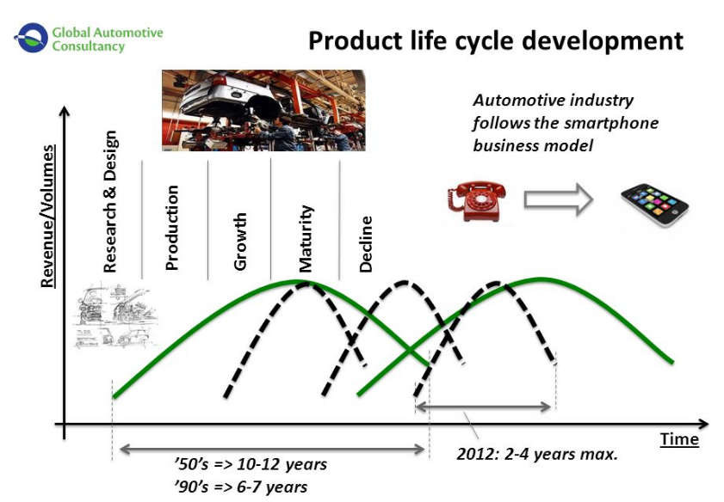
Figure 3: The product life cycle of products in Automobile industries
(Source: Ostroukh, et al., 2019)

Porter’s Value Chain Analysis
According to Ruan, (2020), Porter’s value chain analysis is a technique used to link the organisation with the actions performed by the organisation and the effect it has on the costs and the profits of the organisational performance. The value chain analysis helps the organisation to have a placid idea about the value of the sources and the products and the possible losses or profits that the organisation might face in the future. The value chain analysis can mainly be categorised in two parts the primary activities and the support activities. According to Loving, (2019), the inbound logistics used in the development of products by automobile industries includes the raw materials that are possibly required for the creation of the vehicles, their storage and distribution. The outbound logistics includes the storage, transport and distribution of the finished goods (Rajahonka and Bask, 2016). The other primary activities involve the production of the service (automobile), there efficient marketing that allows diversifying the concerned organisation in the global market and the service provided to the consumers that aids the industry to maintain its brand image in the global market.
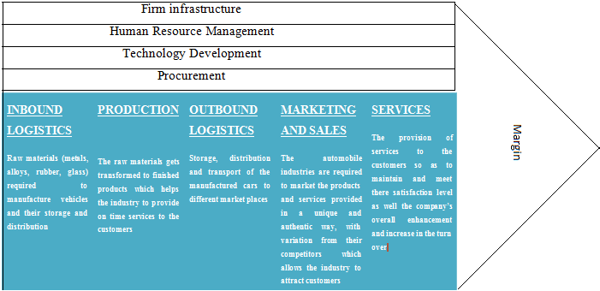
Figure 4: Porter’s Value Chain Analysis in Automotive Industry
(Source: Created by the learner)
The support activity plays a major role in providing support to the primary activities that help the organisation to maintain its position in the international market (Pal and Altay, 2019). The maintenance of the firm infrastructure helps the automobile industries to develop a smooth flow in the administrative system. The provision to Human resource management helps support the organisation by maintaining a pleasant working environment and satisfying experience amongst the employees. The HRM department works to provide satisfaction amongst the workers that helps boost the overall performance in the workplace (Hauret, et al., 2020). Technology development and procurement help support product development and meet customer needs. The development of technology helps the automobile industries to enhance the productivity of the product produced that in turn supports the needs and satisfaction of the customers.

Conclusion
The global business environment strongly affects the position of various Automobile industries. In the given assignment, a brief overview of the PESTLE analysis based on the developed and the developing countries are provided. In addition, Porter's five forces analysis model is also described. The recent developments in the car manufacturing sectors are analysed. The project also discusses the SWOT of the automobile industries along with the identification and description of the product life cycle. The assignment is summed up with an analysis of the automotive industries made concerning Porter's Value chain analysis.

References
- Aamodt, I., 2016. Impacts of import-substitution on the automobile industry in Brazil: SWOT analysis of repercussions of the policy 1990-2014 (Master's thesis, Norwegian University of Life Sciences, Ås). pp 1-55.
- Ali, M.M., Rai, R., Otte, J.N. and Smith, B., 2019. A product life cycle ontology for additive manufacturing. Computers in Industry, 105, pp.191-203.
- Aragon-Correa, J.A., Marcus, A.A. and Vogel, D., 2020. The effects of mandatory and voluntary regulatory pressures on firms’ environmental strategies: A review and recommendations for future research. Academy of Management Annals, 14(1), pp.339-365.
- Ariffin, A.S. and Sahid, M.L.I., 2018. Competitiveness analysis of ASEAN automotive industry: a comparison between Malaysia and Thailand. Journal of Science, Technology and Innovation Policy, 3(2).
- Bailey, D. and De Propris, L., 2017. Brexit and the UK automotive industry. National Institute Economic Review, 242(1), pp.R51-R59.
- Chesula, O.W. and Kiriiny, S.N., 2018. Competitiveness In The Telecommunication Sector In Kenya Using Porters Five Forces Model. International Journal of Research in Finance and Marketing (IJRFM), 8(7), pp.1-10.
- Cozzolino, A. and Rothaermel, F.T., 2018. Discontinuities, competition, and cooperation: Coopetitive dynamics between incumbents and entrants. Strategic Management Journal, 39(12), pp.3053-3085.
- Desai, H.B., 2020. Study on the Automotive Car Industry in India: scenario analysis and new future Business models (Doctoral dissertation, Politecnico di Torino). https://webthesis.biblio.polito.it/secure/cgi/set_lang?lang=it&referrer=https%3A%2F%2Fwebthesis.biblio.polito.it%2F16102%2F
- Elias, H., Alexopoulou, P., Scholes, L. and Hughes, M., 2019. Social capital of family businesses: The influence of critical events in the macro-environment. pp 1-8.
- Hachuła, P. and Schmeidel, E., 2016. The Model of Demand and Inventory in a Decline Phase of the Product Life Cycle. Folia Oeconomica Stetinensia, 16(1), pp.208-221.
- Haseeb, M., Hussain, H.I., Ślusarczyk, B. and Jermsittiparsert, K., 2019. Industry 4.0: A solution towards technology challenges of sustainable business performance. Social Sciences, 8(5), p.154.
- Hauret, L., Martin, L., Omrani, N. and Williams, D.R., 2020. How do HRM practices improve employee satisfaction?. Economic and Industrial Democracy, p.0143831X20962199.
- Hertati, L., Widiyanti, M., Desfitrina, D., Syafarudin, A. and Safkaur, O., 2020. The Effects of Economic Crisis on Business Finance. International Journal of Economics and Financial Issues, 10(3), pp.236-244.
- Jian, X., Cai, S. and Chen, Q., 2017. A study on the evaluation of product maintainability based on the life cycle theory. Journal of Cleaner Production, 141, pp.481-491.
- Kauerhof, A., 2017. Strategies for Autonomous, Connected and Smart Mobility in the Automotive Industry. A Comparative Analysis of BMW Group and Tesla Motors Inc. GRIN Publishing. http://www.ciando.com/img/books/extract/3668412855_lp.pdf
- Koglbauer, I., Holzinger, J., Eichberger, A. and Lex, C., 2018. Autonomous emergency braking systems adapted to snowy road conditions improve drivers' perceived safety and trust. Traffic injury prevention, 19(3), pp.332-337.
- Kompalla, A., Geldmacher, W., Just, V. and Lange, S., 2017. Tailored Automotive Business Strategies in the Context Tailored Automotive Business Strategies in the Context of Digitalization and Service-Oriented Models. Quality-Access to Success, 18(156).
- Kozubikova, L., Kotaskova, A., Dvorský, J. and Ključnikov, A., 2019. The impact of political factors' perception on suitability of international business environment: the case of startups. Economics & Sociology. pp 1-50.
- Kushwaha, G.S. and Sharma, N.K., 2016. Green initiatives: a step towards sustainable development and firm's performance in the automobile industry. Journal of cleaner production, 121, pp.116-129.
- Loving, V.A., 2019. Enhancing the Value Chain to Increase Customer Satisfaction and Build Successful Breast Imaging Practices. Journal of Breast Imaging, 1(1), pp.56-59.
- Ostroukh, A.V., Subbotin, B.S., Borisevich, V.B., Ryabchinskii, A.I. and Prikhod’ko, V.M., 2019. Life-Cycle Approaches in Computerized Vehicle Design and Additive Technology. Russian Engineering Research, 39(8), pp.705-709.
- Pal, R. and Altay, N., 2019. Identifying Key Success Factors for Social Enterprises Serving Base‐of‐Pyramid Markets through Analysis of Value Chain Complexities. Journal of Business Logistics, 40(2), pp.161-179.
- Rajahonka, M. and Bask, A., 2016. The development of outbound logistics services in the automotive industry. The International Journal of Logistics Management.
- Ruan, S., 2020, April. Research on Strategic Cost Management of Enterprises Based on Porter’s Value Chain Model. In Journal of Physics: Conference Series (Vol. 1533, No. 2, p. 022056). IOP Publishing.
- Sundar, S., Mishra, A.K. and Naresh, R., 2018. Modeling the impact of media awareness programs on mitigation of carbon dioxide emitted from automobiles. Modeling Earth Systems and Environment, 4(1), pp.349-357.
- Wang, X., Li, C., Shang, J., Yang, C., Zhang, B. and Ke, X., 2017. Strategic choices of China’s new energy vehicle industry: An analysis based on ANP and SWOT. Energies, 10(4), p.537.
- Yong, J.Y., Yusliza, M.Y., Ramayah, T., Chiappetta Jabbour, C.J., Sehnem, S. and Mani, V., 2020. Pathways towards sustainability in manufacturing organizations: Empirical evidence on the role of green human resource management. Business Strategy and the Environment, 29(1), pp.212-228.
- Zhikang, L., 2017. Research on development strategy of automobile reverse logistics based on SWOT analysis. Procedia engineering, 174, pp.324-330.

