2412742 Assignment 3 Photo Essay HPHP4018

This assignment asks for a reflective account of my visit to the Carmarthenshire Museum in Abergwili, Wales. The subject matter will be in response to my selected discipline, which is Philosophy. I have also been asked to supply photographs of the exhibited items I selected as having connections to local Philosophy. In this regard I have selected the essay title as “The dissemination of knowledge and philosophical information in the Ceredigion culture” as the main thread of this work and I will focus mainly on the Eisteddfod, an important part of local bardic Welsh culture.

The first known celebration and competitive festival of poets and bards was held at the home of Lord Rhys at Cardigan castle in 1176 and was split into two parts, one for poetry and the other for music. The festival attracted and invited poets and musicians from Wales and other places outside of Wales. However, the first festival called ‘Eisteddfod’ was held here in Carmarthen in 1450. In the original festivals the winning candidates would receive an invitation to sit at Lord Rhy’s table at the banquet that evening and because of this the chair is still awarded as the prize to the victor.

The first photograph below shows one of these chairs made for the Carmarthen Eisteddfod by a very well-known and skilled cabinet maker David Morley. This chair is the earliest chair awarded to the poet Gwallter Mechain in the revival of the Eisteddfod in the 1700’s as the original Eisteddfod’s were phased out during the reign of Henry VIII. The image of the harp on the back of the chair being a symbol of the bardic, musical tradition. A tradition which still, to this day is involved in the dissemination of local folklore and philosophical writings, such as the Mabinogi and the tales of King Arthur. In the museum this chair was displayed next to a placard informing the viewer of the chair’s history, which I found very useful in ascertaining the kind of time frame that this festival has been a central feature in Welsh culture. It is good to know that this festival still exists to this day.

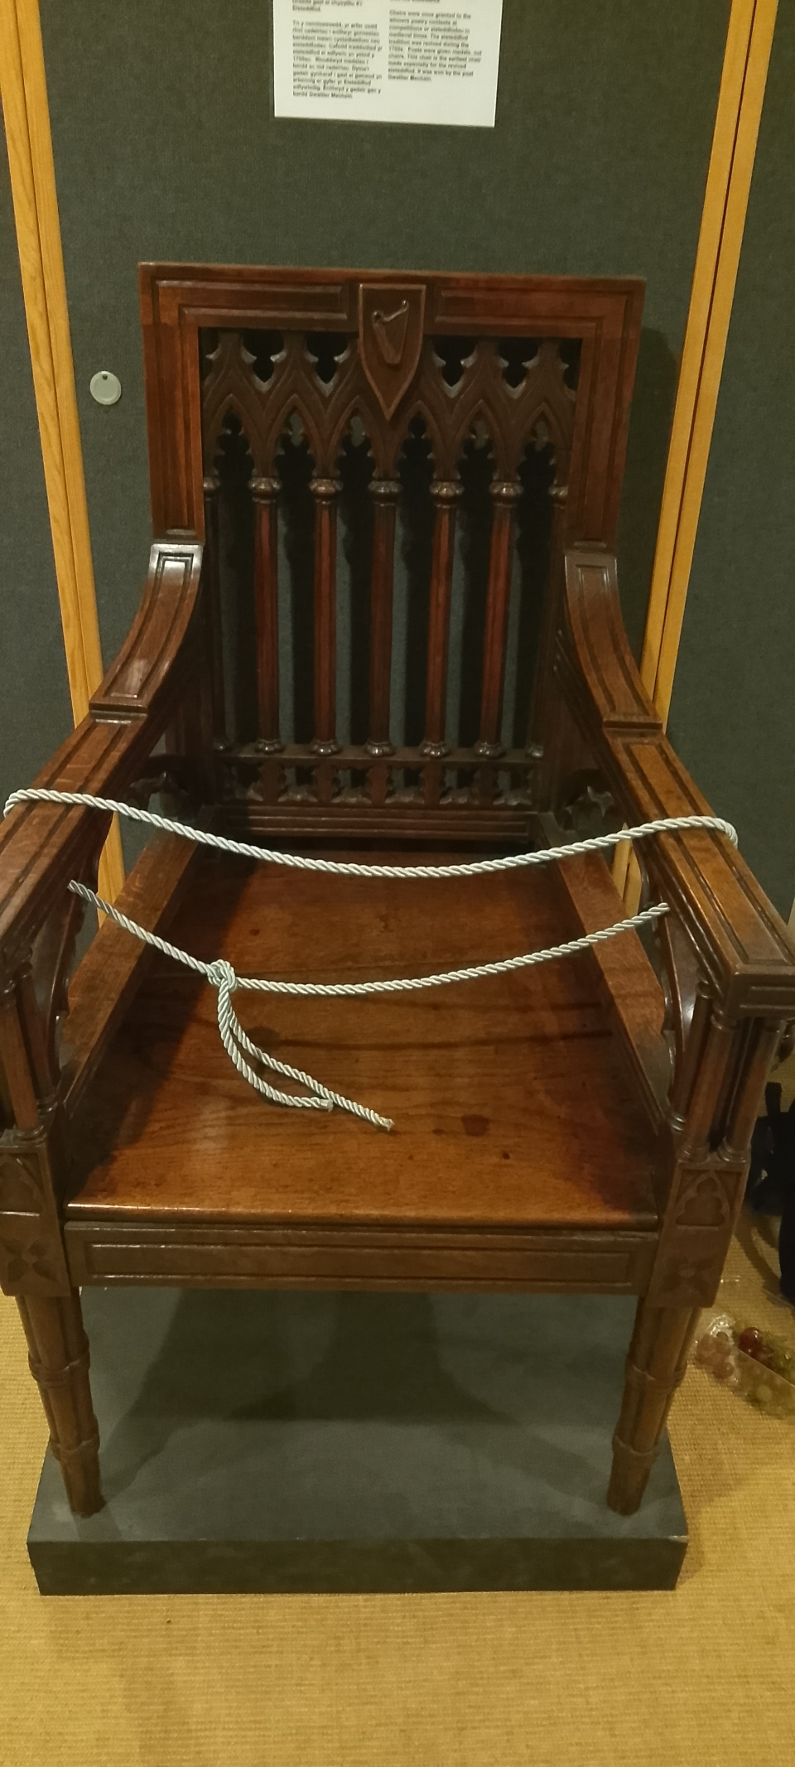
(Authors own photograph taken on 03/10/2025)
In July 1819 at the Ivy Bush Hotel, the Dyfed Eisteddfod was held, and this was the first time that a Gorsedd Ceremony was associated with the Eisteddfod. So, let us look at what a Gorsedd Ceremony was and how it may have happened alongside the Eisteddfod.

“The Gorsedd, established in 1792 by Lolo Morgannwg, is an integral part of the Eisteddfod festival. Lolo Morgannwg devised the Gorsedd’s rituals based on the Druids, but with a strong Christian influence to emphasise the fact the culture and heritage of the celts belongs to the Welsh. The first Gorsedd was held at Primrose Hill in London during the summer solstice of 1792, and the first connection between the Eisteddfod and the Gorsedd took place at the 1819 Carmarthen Eisteddfod” taken from ‘library. Wales’ online.

Here then we can see the revivalist branches of Celtic traditional philosophy, poetry and music reasserting the emphasis on Welsh Celtic heritage, with the Eisteddfod being how the information was being spread publicly. Indeed, the word Eisteddfod means ‘sitting together’ from ‘eistedd’ meaning ‘to sit’. So here we have the setting by which this important information was to be given, to all and everyone in the Celtic heritage and tradition.

The means by which philosophical information was spread also changed in its dissemination as time moved on through the years by the advent of the radio, and we can see an exhibit (pictured below) in the Carmarthenshire Museum that depicts this change in the way a household, from the era of the early wartime radio days, may have looked. A person could listen to local radio from the relative comfort of the front room. Of course, the philosophy from the wartime period would have differed greatly in its overall message. Morality would have taken the form of ‘keep Mum’ or ‘Mums the word’ enforcing modes of conduct aimed at keeping Britain safe from the threat of attack from Germany, maintaining food rations and pulling together to make sure we could survive and win the war. However, I am only making a guess here that the Eisteddfod’s were not celebrated in the war years.

The history of the Eisteddfod festival during the war years has not been depicted in the Carmarthenshire Museum and I can only assume that those years were taken up with the war effort.
(Authors own photograph taken on 03/10/2025)
(Authors own photograph taken on 03/10/2025)

I found all the information in the Carmarthenshire Museum quite easy to put together for my chosen discipline topic and although my peers thought that the museum was laid out in an odd way in regard to the passage of time, I found it helped to reinforce my own topic as there are two exhibits which concentrate upon the Eisteddfod in two different places, which, when viewing the second prize chair I was reminded of my focus for the topic of this essay. So, for me, it worked well, and my overall experience of the museum was a positive one. The signs that displayed the information about the chairs and other Eisteddfod items in the exhibits gave me enough information to get started with my assignment, giving me clear pointers that I could elaborate on via the use of the internet. The only thing that lacked in my opinion was access to a study area, chairs and tables outside of the cafeteria but this is in no way a complaint as I managed to complete this with the use of my e14 Motorola mobile phone, by taking pictures of the items and also the information boards.

There was also a wealth of other exhibits which were showing us how life may have looked in those early times, such as the costumes ladies used to wear in the folk custom of those times, also how a traditional Welsh kitchen looked along with various dairy making equipment and tools from the day, all of this would have tied in with the topic of the Eisteddfod but one thousand words is not that much and I reckon that I am probably just about there this very sentence.

References and Bibliography

All photographs taken by my Moto E14 on location at Carmarthenshire Museum, Abergwili (03/10/25)

-historic.uk.com/HistoryUK/HistoryofWales/The-National-Eisteddfod-of-Wales
(General information about the meaning of the Eisteddfod and history of the Eisteddfod)

-Library.wales/discover-learn/education/learning-resources/the-national-eisteddfod-of-wales/gorsedd-of-the-bards
(General information regarding the Gorsedd being held at Carmarthen for the first time)

-All information pertaining to the prize chair on exhibit is taken from the information boards next to the item in the Carmarthenshire Museum.

