

Assignment Title: Individual Blog Marketing Fundamentals Analysis and Evaluation

Name: Milena Ilieva
Student ID: 2231625
Module code: LCBB4004
Module name: Marketing Fundamentals
Lecturer: Tushara Balendran

Introduction
Marketing fundamentals are a subject that has evolved over the years. Current marketing fundamentals are defined by the American Marketing Association. Marketing is a complex business process that creates attractive offers for customers, sellers, entrepreneurs and society. Marketing is also the process of business activities that move goods and services from producers to consumers. Marketing is one of the elements of business management and commerce. Through marketing, a marketer reaches out to a business (B2B) and a consumer (B2C). To whom and how easily a marketer will reach the consumer depends on the market strategy and this strategy will be determined by the marketer. Marketing mix is ​​an outline of how a product will be sold, how to reach the customer easily, how to keep the product quality at a low price. The product is promoted and marketed when the marketing mix is ​​determined. In this blog report, it is going to critical analysis the segmentation of Unilever. It will also explain the marketing mix as well as targeting and positioning factors in the context of Unilever.



Overview of the Company
Unilever is a British multinational consumer goods company headquartered in London, England. On 2 September 1929, Dutch margarine producer margarine and British soap company Lever merged to form Unilever. Unilever is a diversified product manufacturing and marketing company whose products include consumer goods, food, spices, baby food, cold drinks, ice cream, cleaning materials, toothpaste, soaps, various cosmetics, medicines, al-care products. Unilever is one of the largest producers of soap in the world. Unilever products are very popular and available in more than 190 countries around the world (DeSarbo el at., 2019). Unilever's products are generally divided into 3 categories: refreshments and food, beauty and home care, consumer goods and cosmetics. Unilever has research centers in the US, UK, India, China and the Netherlands In this research institute they are researching how to improve the quality of their products and create new products which are very needed by people.

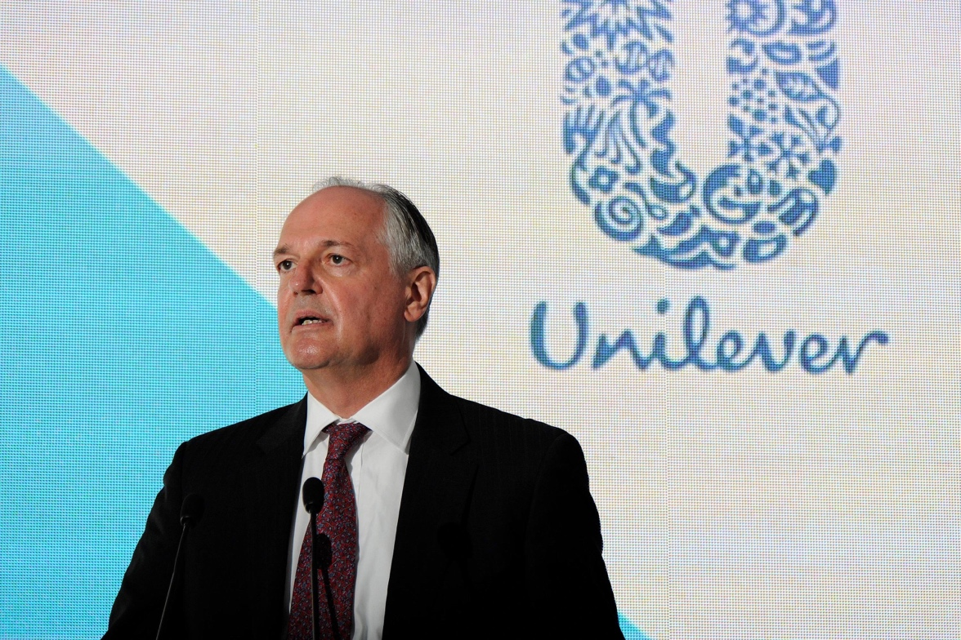

Analysis the various segmentation variables of Unilever
Market segmentation is an essential process that helps a company to identify the right customers and understand the customers better. If you are a seller, market segmentation helps you determine the right market for your product and makes your marketing more effective. Market segmentation depends on various factors including geographic segmentation, demographic segmentation psychographic segmentation and behavioral segmentation (Kalam, 2020). The market segmentation factors including geographic segmentation, demographic segmentation and behavioral segmentation of my selected company Unilever are explained below. 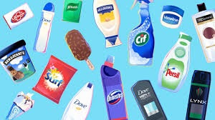
Geographical segmentation
Geographical segmentation is a very useful and basic segmentation strategy. Geographic segmentation is segmentation based on location. Geographic segmentation is based on customer location, climate, region, ethnic differences. Also geographical segmentation takes into account population density, villages and towns. A customer's position helps a company to understand the needs and produce products according to the demand. Unilever's market Unilever divides its operations geographically based on the location of its customers worldwide. Keeping in mind the customer needs, Unilever has several research institutes in different countries of the world with geographical variation.

Demographic segmentation
Demographic segmentation is one of the common forms of market segmentation. This segmentation process is based on observable, human-based differences. This segmentation includes factors such as age, marital status, sex, occupation, household type, education level, income pattern, race and religion. Unilever being a multinational company gives importance to its demographic segmentation. Unilever differentiates their products based on age, income, gender, nationality, religion (Islam, 2021). For example, a middle-income group must consider how to produce and market their products while maintaining quality and demographic segmentation accordingly. Thus, a company helps to survive and improve in a competitive market.

Behavioral segmentation
A company can segment the market based on consumer behavior towards its products. It is possible to meet customer needs and easily develop products based on the behavior that customers display on your product. Find out what customer behavior is about your product on internet, website, app. Unilever is a multinational company based in the United Kingdom. People in different regions have different behavior (Schlegelmilch, 2022). That is why Unilever takes behavioral segmentation very seriously and operates according to the behavioral needs of customers.
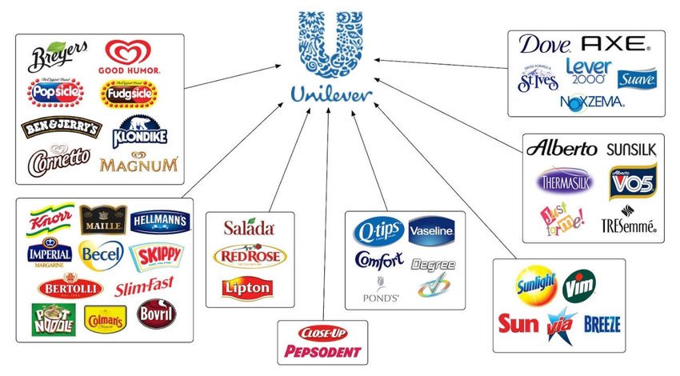

Critical discussion the current targeting and positioning strategies of Unilever
Unilever is a strong reputed group with a worldwide reputation. Unilever has been adopting various targeting and positioning strategies to attract and retain its customers towards their products which are critically discussed below.

Targeting strategy
It is very important to consider what kind of market you want to target in any marketing strategy. Segmentation and targeting are survival and success strategies in competitive markets. Let's talk about Unilever's marketing targeting, it is different from segmentation marketing which is the next step in segmentation strategy. Where targeting is done according to location, age, needs of people. Basically, it is important to assess the attractiveness of each segment to determine the targeting strategy and how to target it. Unilever uses 4 primary targeting strategies which are Undifferentiated Marketing, Differentiated Marketing, concentrated Marketing, Micro-marketing.

Positioning Strategy
According to Unilever's president it will move forward by putting "vitality" at the center of all its band positioning. In today's competitive market any brand positioning and value positioning are critical to success. The final step in the 'STP' process is positioning. Positioning is how customers evaluate your product over others in a competitive market. The better the positioning of a company, the more successful that company is. So customer perception or evaluation affects the band's positioning (Yaakub, el at., 2018) Unilever builds their products in such a way that their services carry a specific identity in the mind of the customer. Unilever is further improving its band positioning to drive cost savings in personal, household and consumer products. As a result, the band became a first class success worldwide.
Although market segmentation, targeting and positioning (STP) has many advantages but STP has many disadvantages of which some notable ones are mentioned. Due to multiple (STP) a band has to make many versions of a product or service. As a result, the band requires different manpower, different technology, which increases the cost of the band. Different versions of a band product have to be promoted separately which increases the cost of the band.Explain the current Marketing Mix Strategies for Unilever with examplesThe marketing mix is ​​used as part of a comprehensive marketing plan. The marketing mix usually refers to a category of 4ps which are: product, price, place and promotion. The marketing mix contributes greatly to the growth of a band. Marketing mix helps in new products and modification of existing products (Andaleeb, 2016.).

Product strategy
Unilever is a multinational company that has been expanding its products over the years and currently has a mix of over 400 products in this band. This band manufactures products according to the needs of the people which mainly consists of 4 categories.
- Food

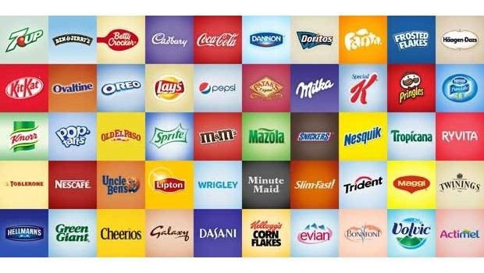

2. Refreshments (drinks and ice cream)
3. Family care
4. Personal care
Products indicate that the band's marketing mix is ​​diverse. This type of marketing mix results in prioritizing customer needs. As such, the band won the World Best Food Award in 2000. The band has an organizational structure that reflects diversity in this product mix.

Price strategy
Pricing strategies are determined according to product quality and type in this category of marketing mix. Unilever then sets prices based on product type product quality and position positioning. Unilever usually sets significant prices for consumer products. Unilever's pricing strategies are as follows: Pricing is a market based strategy; Premium Pricing Strategy; Single unit strategy in pricing.
Market-based pricing is determined based on the market for consumer goods. For example Unilever prices its products close to their market competitors. On the other hand, a premium pricing strategy involves pricing higher than competitors. Also Unilever sometimes offers lower price or cashback in single unit product pricing strategy. Unilever's pricing strategy for this product is varied and appreciated (Lancaster and Withey, 2016).Place strategy
In this section of the marketing mix a band deals with the positioning strategy of their product with the customer. Unilever has expanded its consumer products worldwide. Unilever uses the following locations to market their products and get them easily within the reach of customers or consumers:
Retailer (Primary)
The kiosk
Shop
A retailer of Unilever is the main point of sale of the product. For example, Walmart and many other supermarkets, online platforms are the largest retail outlets for these consumer goods. Unilever sometimes uses kiosks for personal sales and product introductions to customers. Unilever sells certain of its products through stores. Unilever considers this segment in the marketing mix very important.

Promotion strategy
We know that the present time is the age of technology, in this era we have to advance through intense competition. In this competitive market Unilever has to promote the product to reach their customers. This section of the marketing mix deals with the strategy of how to reach customers with messages about the product. Promotion strategy of Unilever is mentioned below
Advertising (Primary)
Sales promotion
Public Relations
Personal Selling
Direct marketing
Unilever uses many models, television and online platforms to promote their products. The band sometimes grabs consumer attention by offering discounts on their products. Sometimes Unilever does personal relations as part of product promotion. Also sells products at retail and personally and shares information about products with consumers. The band does various promotional activities to promote it which makes customers interested in using their products (Verhage and Visser, 2018).

Conclusion
Unilever differentiates itself from others in the world through a complex marketing mix. Its marketing mix reflects the 4Ps (product, place, promotion and price) strategy. Also market segmentation (geographic segmentation, demographic segmentation and behavioral segmentation), targeting and positioning strategies have brought success in their marketing. As a result of which Unilever is today a well-known multinational company in the world.

References
Lancaster, G. and Withey, F., 2016. Marketing fundamentals. Routledge.
Verhage, B. and Visser, M., 2007. Marketing fundamentals. Wolters-Noordhoff..
Stone, M.A., 2017. Fundamentals of marketing. Routledge.
Maljers, F.A., 2012. Inside Unilever: The evolving transnational company. Harvard Business Review, 70(5), pp.46-52.
Tien, N.H., 2019. Comparative Analysis of Multidomestic Strategy of P&G and Unilever Corporation. International journal of foreign trade and international business, 1(1), pp.5-8.
Yaakub, N.S., Mohd Susaimi, N.D. and Mohd Salleh, N.N., 2008. Unilever Company.
Andaleeb, S.S., 2016. Market segmentation, targeting, and positioning. In Strategic Marketing Management in Asia (pp. 179-207). Emerald Group Publishing Limited.
Natter, M., Mild, A., Wagner, U. and Taudes, A., 2008. Practice prize report—Planning new tariffs at tele. Ring: The application and impact of an integrated segmentation, targeting, and positioning tool. Marketing Science, 27(4), pp.600-609.
Schlegelmilch, B.B., 2022. Segmenting targeting and positioning in global markets. In Global Marketing Strategy: An Executive Digest (pp. 129-159). Cham: Springer International Publishing.
Islam, M.M., 2021. Segmenting, targeting and positioning in Islamic marketing. Journal of Islamic Marketing, 12(7), pp.1385-1404.
Kalam, K.K., 2020. Market segmentation, targeting and positioning strategy adaptation for the global business of Vodafone Telecommunication Company. International Journal of Research and Innovation in Social Science, 4(6), pp.427-430.
DeSarbo, W.S., Blanchard, S.J. and Atalay, A.S., 2017. A new spatial classification methodology for simultaneous segmentation, targeting, and positioning (STP analysis) for marketing research. In Review of marketing research (pp. 75-103). Routledge.
Goi, C.L., 2009. A review of marketing mix: 4Ps or more. International journal of marketing studies, 1(1), pp.2-15.
Dominici, G., 2009. From marketing mix to e-marketing mix: a literature overview and classification. International journal of business and management, 4(9), pp.17-24.
Goi, C.L., 1970. Marketing Mix: A review of'P'. The Journal of Internet Banking and Commerce, 10(2), pp.1-11.

