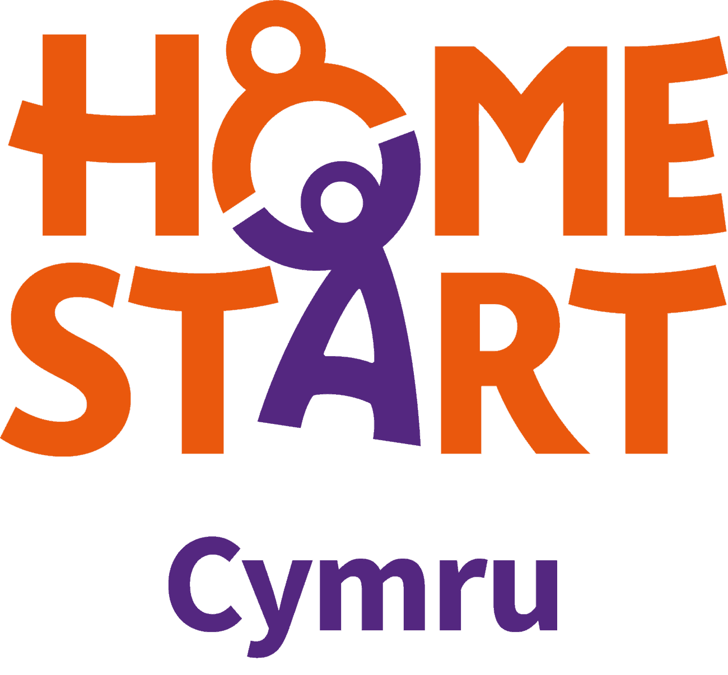
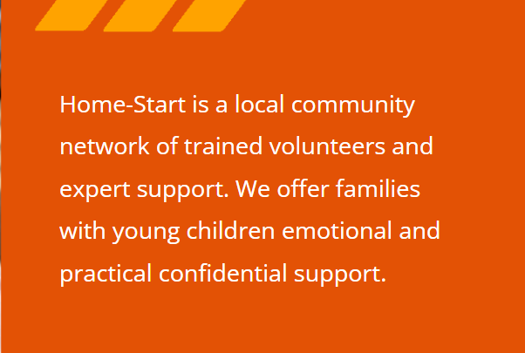
info@homestartcymru.org.uk

Table of Contents.

Table of Contents. 2
Reflective Commentary. 3
References. 6
Portfolio of evidence. 7
Evidence 1: Background Information. 8
Evidence 2: Reflective Logs. 10
Evidence 3: Volunteering Opportunities. 15
Evidence 4: Reports an additional information. 18
Appendices. 24
References. 27

Reflective Commentary.

A volunteer placement was acquired to gain experience within the care sector. I will reflect on the skills and attributes utilised for this experience to demonstrate skills and personal knowledge that can be applied to future job opportunities (Dickson & Midwinter, 2015). The Gibbs reflective cycle will allow me to reflect on this experience (Gibbs, 1988). Once I had secured a volunteer placement with Home-Start Cymru (Home-Start Cymru, 2022), I began participating in work-related tasks specific to the volunteer role.
I began my volunteer journey by feeling anxious and excited. I was apprehensive about being part of a large organisation and making home visits. The training was to be conducted online, and I was nervous about various technical issues that could arise this way. I was excited and confident to utilise my previous experience and knowledge of working in the childcare sector where I worked alongside children and families for Flying Start (Bridgend County Borough Council, 2023). I was also confident in my ability to plan, organise and manage my time efficiently with volunteering alongside attending university.
Home-Start is a parenting support program where families can request weekly support from a volunteer (Van Aar et al., 2015). It aims to promote positive short-term changes that have long-term sustainability. I was matched with a family to support and I was surprised that mum was welcoming and accepting. I feel this was due to the support being allocated from a self-referral by the family. Online education is a preferred training method as it allows the organisation and volunteers to access the training when convenient for them (Hoon & Wilkins, 2018). Working in groups encourages various discussions that can be learnt alongside the specific taught aspects. The training allowed me to view things from the family's perspective on how a home volunteer would appear to them. A challenge of being a volunteer home visitor that became apparent through training was how maintaining professional boundaries can be difficult when working closely with families, especially in their home environment. The reasons for self-referral are varied and could result from experiencing domestic violence. Specific training in this area led me to challenge my understanding of domestic violence and the myths that surround this. Group discussions in training allowed for varied input and to see things from another's perspective broadening my knowledge and understanding. During training, we briefly covered the significance of attachment and the importance of play. To expand my understanding of these topics, I will examine attachment theory and why play is so significant. It is essential as a volunteer to get the parents to engage with the importance of play (Rathunde & Isabella, 2020). There is substantial evidence that play contributes to a child's cognitive, physical, and social development and creative and scientific thinking (Waters et al., 2022). Attachment Theory identifies parenting as fundamental to children's behaviour and emotional development (Fearon & Roisman, 2017). Social conditions affect children and families. Supported is offered through childcare, early education programs (Flying Start), and home visitation services, such as Home-Start Cymru (Thompson et al., 2022). Attachment Theory influences these services and emphasises the quality of relationships, and how we can support families. Confidentiality and all family information aspects are essential in this volunteer position. I was concerned about maintaining safety entering the family's home alone. However, following the organisation's policies and procedures made me feel more at ease. For instance, I must check in with my coordinator before I enter the property and again once I have left. On my first visit, I was nervous about getting lost and not finding the correct address. To address this potential problem, I decided to save the family's number but maintain confidentiality. I saved the number in a way that was not identifiable to anyone else but myself. Information from my visits would be shared directly with my area coordinator.
Background information about the family is shared with me through my coordinator. Following the organisation's health and safety policies are essential to ensure my safety and the family's. For example, when contacting the family to arrange a time to visit, my number must be withheld to protect my privacy. Home visits require many transferrable skills, for instance, establishing trust, confidence, and rapport with the family. The organisation completes regular supervision and feedback from the families supported on my progress and skills. Supervision allows volunteers and those who work for the organisation to reflect and work effectively with families (Bostock et al., 2022). I was confident in the support available from the organisation as they provide a free counselling service that is accessible to all staff and volunteers of Home-Start Cymru.
My previous knowledge and skills in working with children and families have been instrumental in allowing me to be matched with families with various reasons for requesting support. These transferrable skills were welcomed by the organisation and utilised to be beneficial for the support needed. For instance, my knowledge of child development, ability building rapport with families asking for support, confidence in self-management, working as part of a large team, and my willingness to learn and develop further.
The family I was initially matched with no longer required support. I asked my coordinator if there was anything I could do while waiting for the family to reply being proactive. However, my coordinator said they have a procedure to follow for closing a request. Once this has been completed, she will actively look to match me with another family. If any training became available, I could access that while waiting. Fathers play a significant role in their children's development. However, home visitation programs often overlook them. I am also keen to understand more about the new initiative called Dad's Matter that Home-Start Cymru is championing. A pilot study in the united states identified significant evidence that fathers play an essential role in the child's development and that fathers need to be included in home visiting services (Guterman et al., 2018). I will continue my commitment to the organisation because they have invested time in my training and DBS. I will continue building relationships within the company and learning new skills from being matched with other families.

References.

Bostock, L., Patrizio, L., Godfrey, T., & Forrester, D. (2022). Why does systemic supervision support practitioners’ practice more effectively with children and families? Children and Youth Services Review, 142, 106652-. https://doi.org/10.1016/j.childyouth.2022.106652
Bridgend County Borough Council. (2023). Flying Start—Bridgend CBC (Worldwide). https://www.bridgend.gov.uk/residents/children-and-young-people/flying-start/
Dickson, J & Midwinter, R. (2015). Embedding counselling and communication skills: A relational skills model. Routledge.
Fearon, R. P., & Roisman, G. I. (2017). Attachment theory: Progress and future directions. Current Opinion in Psychology, 15, 131–136. https://doi.org/10.1016/j.copsyc.2017.03.002
Gibbs, G. (1988). Learning by doing: A guide to teaching and learning methods. FEU.
Guterman, N. B., Bellamy, J. L., & Banman, A. (2018). Promoting father involvement in early home visiting services for vulnerable families: Findings from a pilot study of “Dads matter”. Child Abuse & Neglect, 76, 261–272. https://doi.org/10.1016/j.chiabu.2017.10.017
Home-Start Cymru. (2022). Because childhood can’t wait. https://homestartcymru.org.uk/
Hoon, S., & Wilkins, P. (2018). Adult Learning and the Advantages of the Online Learning Experience. Westcliff International Journal of Applied Research, 2(2), 31–36. https://doi.org/10.47670/wuwijar201822PWSH
Rathunde, K., & Isabella, R. (2020). Engaging Parents About the Importance of Play: The Impact of a Brief, Arts‐Informed Community Presentation. Family Relations, 69(2), 351–364. https://doi.org/10.1111/fare.12422
Thompson, R. A., Simpson, J. A., & Berlin, L. J. (2022). Taking perspective on attachment theory and research: Nine fundamental questions. Attachment & Human Development, 24(5), 543–560. https://doi.org/10.1080/14616734.2022.2030132
Van Aar, J. V., Asscher, J. J., Zijlstra, B. J., Deković, M., & Hoffenaar, P. J. (2015). Changes in parenting and child behavior after the home-start family support program: A 10year follow-up. Children and Youth Services Review, 53, 166–175. https://doi.org/10.1016/j.childyouth.2015.03.029
Waters, G. M., Tidswell, G. R., & Bryant, E. J. (2022). Mothers’ and fathers’ views on the importance of play for their children’s development: Gender differences, academic activities, and the parental role. British Journal of Educational Psychology, 92(4), 1571–1581. https://doi.org/10.1111/bjep.12520

Portfolio of evidence.

Evidence 1 – Background Information.

- Home-Start Cymru Mission Statement.
Home-Start Cymru mission statement is to support families and empower them into becoming the best versions of themselves and for their families. https://homestartcymru.org.uk/

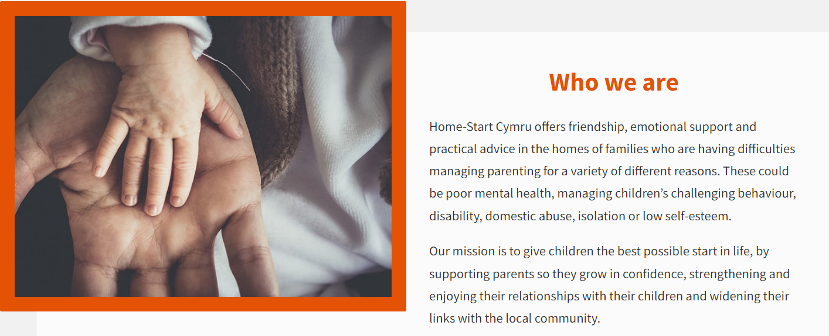
- Values and Aims.
Volunteers support families in strengthening relationships with their child/children, improving the child’s and parents emotional and physical health, learning new parental skills, supporting families who are lonely or isolated, reducing family conflicts, and supporting families to engage in the wider community. The importance of attachment (Fearon & Roisman, 2017).
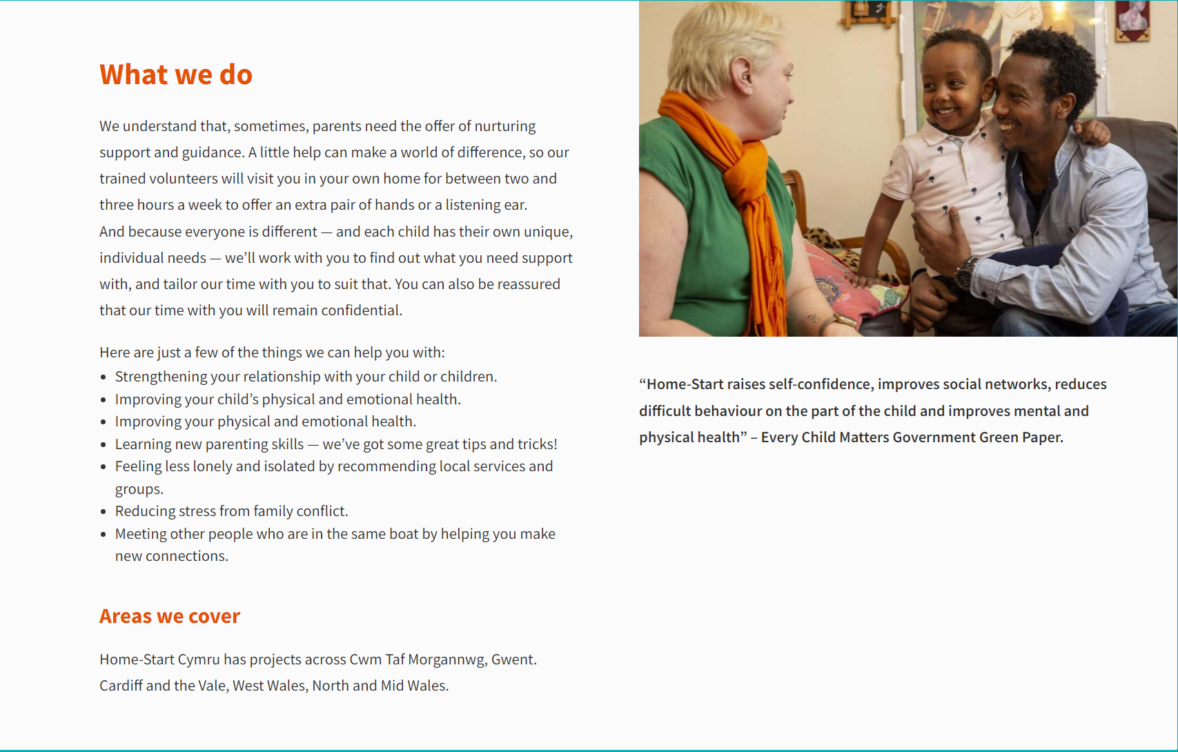

- Information sheet.
Home-Start Cymru information leaflet. https://homestartcymru.org.uk/

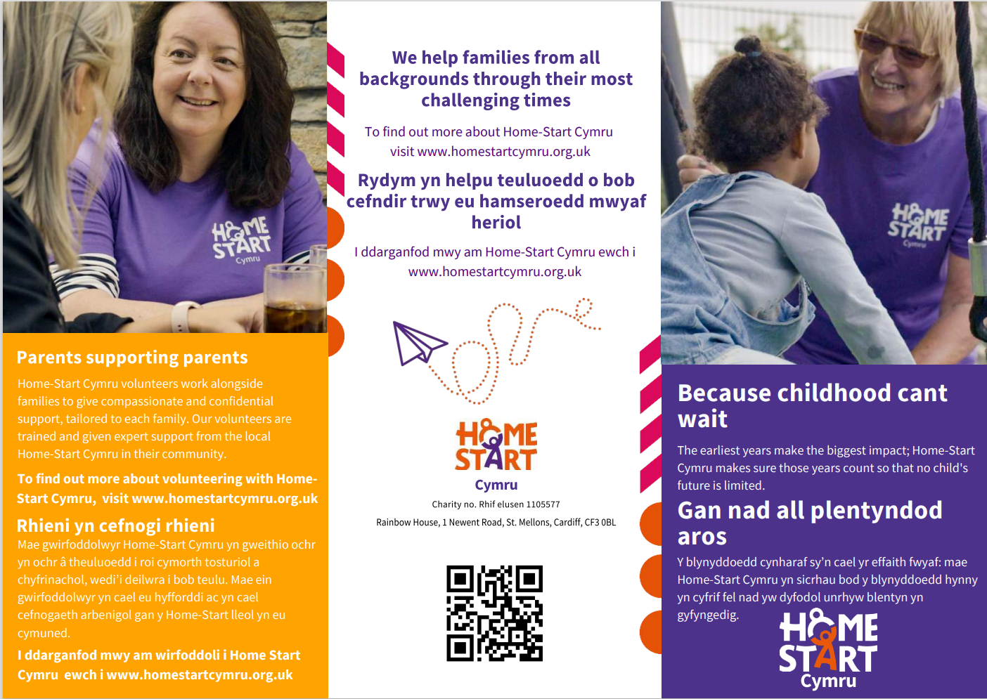
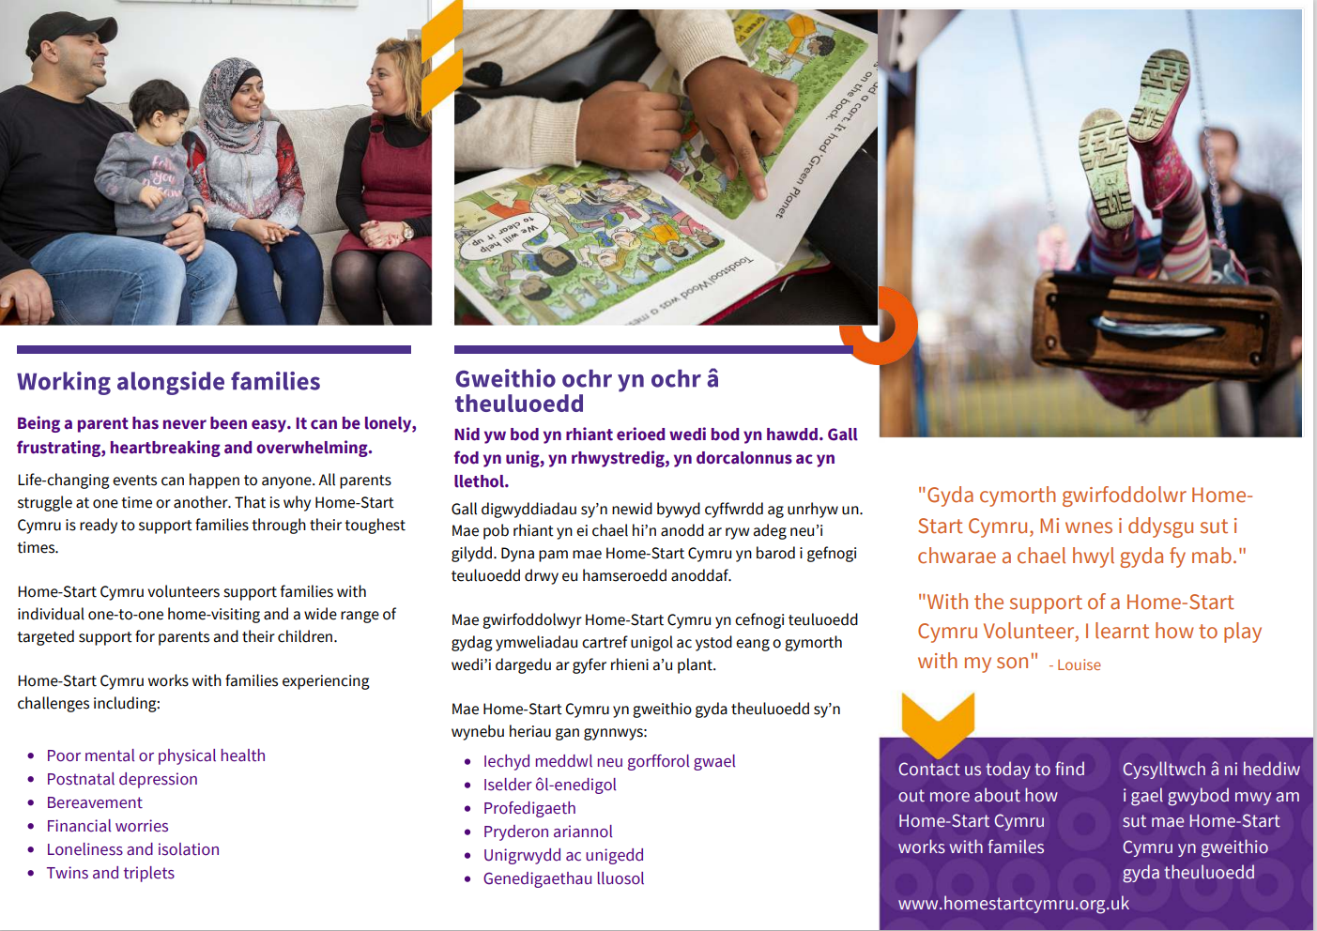

Evidence 2 – Reflective Logs.

Student Work Placement Log Book

HSC Log Book
Student Name: | Ceri Anne Johns
Name of Host Employer: | Home-Start Cymru.

Record of project work carried out (add more entries as needed)
Date: | 17/6/2022
Tasks completed: | Informal interview.  Informal interview call with a volunteer recruitment officer. The application process was explained, the role of a volunteer was outlined, and I completed an expression of interest form online. The conversation outlined my background, skills, and reasons why I wanted to become a volunteer for Home-Start Cymru. I was then informed that my application would be looked at and they would be back in touch.
Reflection: | I felt confident in my knowledge of Home-Start Cymru and their key aims. My work for Flying Start allowed me to gain transferrable skills for this volunteer position. Initially my application was to become a remote befriender (making weekly check-in calls with families). As the conversation progressed the recruitment officer identified that my skills could be more beneficial to families if I became a doorstep volunteer. I was happy to proceed with this position and comfortable because all Covid-19 regulations and guidance was in place by the organisation to maintain my safety.

Date: | 23/6/2022
Tasks completed: | DBS completed online.
Reflection: | I completed my DBS online with Liz the volunteer recruitment officer. It was my first time completing a DBS this way but Liz talked me through the application and how to send the relevant documents over. Once this had been complete I arrange to attend three training sessions provided by the organisation to prepare me for becoming a doorstop volunteer.

Date: | 21/7/2022
Tasks completed: | Online training sessions 5&6.  Training covered –  Safeguarding children and young people.  Home-visiting.
Reflection: | I was nervous as this was my first volunteer training session and it was online. The course providers were very friendly and welcoming and so were the other volunteers. As well as completing the required training it was also a valuable opportunity to network with other co-ordinators from other areas, and volunteers that had experience of making doorstop visiting. There was opportunities to ask questions, work through case scenarios, have group discussions, and identify any further support that may be required. The emphasis was placed on if you had any concerns when visiting a family contact your co-ordinator. Explored the effects of ACE's and looked at case studies. I had background knowledge of this previously from my experience in the childcare sector. However, it was outlined that any decisions were made by the co-ordinator and it was my role to inform them of any concerns or changes.  Looking at how it may feel from the families perspective to have volunteers come into their home was very interesting because I had been focused on my feelings and have not considered the other perspective. For instance, how would you feel if a volunteer fetched some washing in from the garden? We discussed how this may come across to the family, possibly grateful for the help but could also come across as judging them, do they think I'm a bad parent, have I done something wrong.  The importance of keeping professional boundaries was highlighted. I was aware of boundaries as I have previously conducted home visits through Flying Start. However, I had not considered how entering the home on a 1:1 could easily take a turn towards friendship away from a supporting volunteer role. For example, I live close to you, shall we meet up after school so the kids can play?

Date: | 3/8/2022
Tasks completed: | Online training sessions 3&4.  Training covered –  Mental health awareness.  Domestic abuse.
Reflection: | I felt that I had a good understanding of mental health conditions. However, when discussing facts and statistics on mental health and the demand for child and adolescent mental health support I was unaware of the exact significance of support needed.  Domestic abuse was a sensitive topic for me from personal experience. I had completed regular training on the signs of abuse. One section of the training identified statements that were either true or myths. Some of these challenged my understanding from my experience and what I hoped the correct answer was. Lots of additional support was outlined for us to access as volunteers for families but also for us as volunteers (Counsellor available at all times and regular supervisions).

Date: | 4/8/2022
Tasks completed: | Online training sessions 1&2.  These training sessions covered –  Introduction to Home-Start Cymru.  The role of the Home-Start volunteer.  Family life and meeting the needs of the children.  Confidentiality.
Reflection: | It was interesting for me to now focus on the needs of the parents as my experience had been with children as the focus. Developing trust with a parent is essential to allow them to open up. I identified through this training that I was not going there to 'fix' things but to support and enable the parents to make changes themselves. Empowering the parents to make the changes they want to see. Links to Attachment theory were outlined and the importance of play. This is essential in identifying why children behave in certain ways.  Confidentiality policy was addresses. I was aware of keeping personal information safe, ensuring the families right to privacy, but also in keeping myself safe. We also discussed scenarios of where confidentiality may have to be broken.

Date: | 4/10/2022
Tasks completed: | Online meeting with my area Co-ordinator.  First meeting online with my area co-ordinator. We discussed that she had been making multiple visits to families and had plenty of referrals to work through and was confident that she could match me with a family within the next week or two. She informed me of what days she worked and the paperwork that would need to be completed once I began visiting families. I learnt that as a volunteer I will undergo regular supervision with my co-ordinator at 6 weeks and then again at 10-12 weeks. Feedback would also be gained from parental feedback and addressed through supervision with my co-ordinator.
Reflection: | I was excited that I could get matched with a family quite quickly and was confident this was because of my experience of working with families and young children in my career as a nursery nurse and working for Flying Start. Although I was confident in my knowledge and skills I was apprehensive about entering the home for the first time as I would be on my own. However, I was reassured when I became aware of the check in and out procedure they held.

Date: | 11/11/2022
Tasks completed: | Check in with co-ordinator.  Brief discussion on the families background, the reasons they wanted support. It was identified that mum wanted emotional support and company for the children's appointments if dad was unavailable. We then briefly discussed how to complete the relevant paperwork (The volunteer dairy sheet, expenses form, the contact numbers for check in and out and also a copy of the doorstep guidance).
Reflection: | I felt prepared for the first home visit although I was slightly unsure where the address was exactly. However, I made sure that I saved the families number to my mobile in case I got lost I could call for directions (number was saved as 303 so not recognisable to anyone else to maintain confidentiality).

Date: | 16/11/2022
Tasks completed: | Introductory call to family CP-DC-303.  Called repeatedly but no answer.
Reflection: | I followed the check in procedure by contacting my co-ordinator to log that I had tried to contact the family numerous times but with no answer. The co-ordinator said she would contact the family the following day and get back to me.

Date: | 18/11/2022.
Tasks completed: | Check in call with co-ordinator.  Mum had finally been contacted and unfortunately was dealing with an incident with one of her children which was why she was unable to answer. Arranged for me to make an introductory call the following week and then arrange for the first home visit.
Reflection: | Updated my notes and prepared for the following week by looking over the volunteer diary sheet and the doorstep guidance sheet outlined by the organisation. This ensures that I have all the knowledge to be prepared for the visit.

Date: | 23/11/2022
Tasks completed: | Introductory call to family CP-DC-303.  Spoke to mum who apologised for being unable to answer the week before. I introduced myself, explaining that I was a volunteer, that the co-ordinator had given be some background information about what time of support the family would like. Mum confirmed that they have a very busy household with five children with additional needs, dad works very long hours and she mainly wants some emotional support for her mental health and well-being. She was looking forward to my visit and we arrange for this to take place on Monday 28/11/2022 1-3pm.
Reflection: | I was confident that I had followed the organisations policies and procedures by ensuring that my number was withheld when contacting the family. I also checked in with my co-ordinator to update her on how the call had gone and that we had arranged a date for my first visit. Feedback from my co-ordinator was that she was pleased the call had gone well, reminded me of the doorstop policy, and the need to check in by text with the on duty co-ordinator before I entered the property and once I had left.

Date: | 25/11/2022
Tasks completed: | Check in call with co-ordinator.  Quick call to see how I was feeling about attending my first home visit. Ensured I had all the relevant contact numbers to check in and out. Asked if there was anything I was concerned or unsure about.
Reflection: | I felt nervous and anxious as this was going to be my fist home visit. However, I felt prepared by my co-ordinator, was aware and had access to all the policies and procedures, and from my previous call with mum she seemed very open and welcoming of the support. This helped put me at ease that I was fully prepared.

Date: | 28/11/2022
Tasks completed: | First home visit.  Unable to attend as I was unwell with a chest infection.
Reflection: | Followed the organisations health a safety policy. From being unwell I contacted the co-ordinator in charge that day to report my absence. They then confirmed that they would contact the family on my behalf and my area co-ordinator would check in with me later in the week.

Date: | 1/12/2022, 2/12/2022, 6/12/2022
Tasks completed: | Check in texts from co-ordinator.  Confirming that still no reply from family to arrange a date for me to visit.
Reflection: | Made note of this update and awaiting to hear from the co-ordinator again. Checked with the co-ordinator if there was anything I could do in the meantime (demonstrating pro-active approach) and she replied that there was nothing until she hears back from the family.

Date: | 9/12/2022
Tasks completed: | Check in with co-ordinator.  Confirming that still no reply from family to arrange a date for me to visit.
Reflection: | Made note of this update and awaiting to hear from the co-ordinator again. Checked with the co-ordinator if there was anything I could do in the meantime (demonstrating pro-active approach) and she replied that there was nothing until she hears back from the family

Date: | 16/12/2022
Tasks completed: | Check in with co-ordinator.  Confirmed still no reply from the family. Trying to contact them through mobile and letter. If still no reply after Christmas the family will be removed from the list and my co-ordinator will match me with another family to begin visiting.
Reflection: | Made note of the update and will await the call from my co-ordinator in the new year (Annual Leave till 3rd January 2023).

Evidence 3: Volunteering Opportunities.
- Volunteer opportunities.
Information about volunteering for Home-Start Cymru is available on their website. If interested there is an expression of interest form online to complete and then someone will contact you back for an informal phone interview.
https://www.home-start.org.uk/volunteering

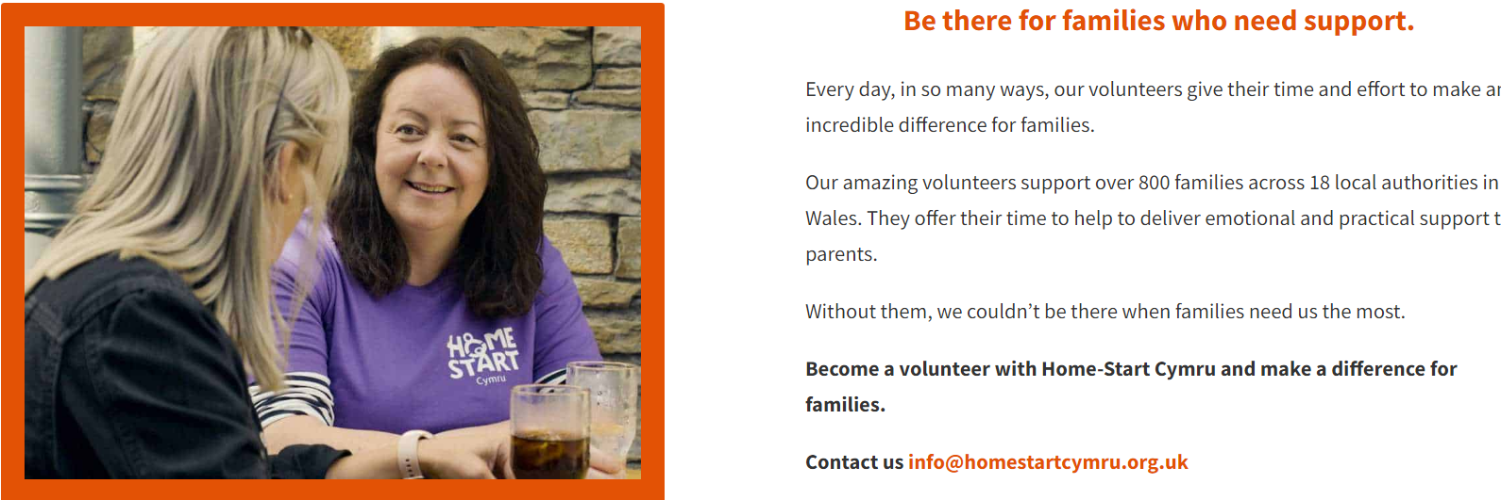

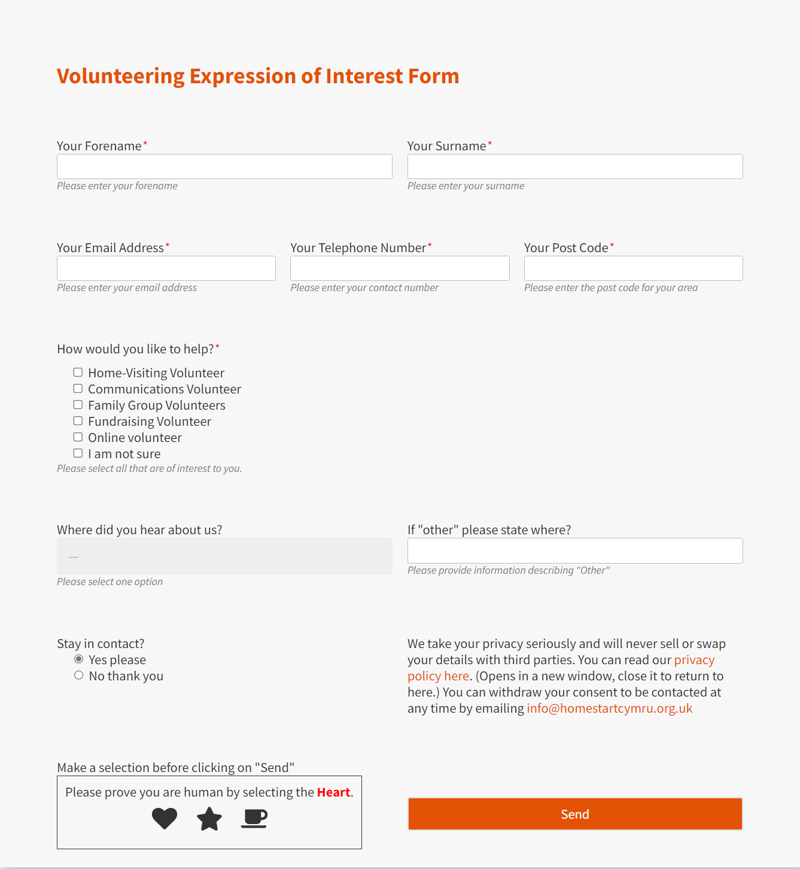
Screenshot of the volunteer expression of interest form that I completed online. This was then followed by an informal phone interview.

- Application/Interview process.

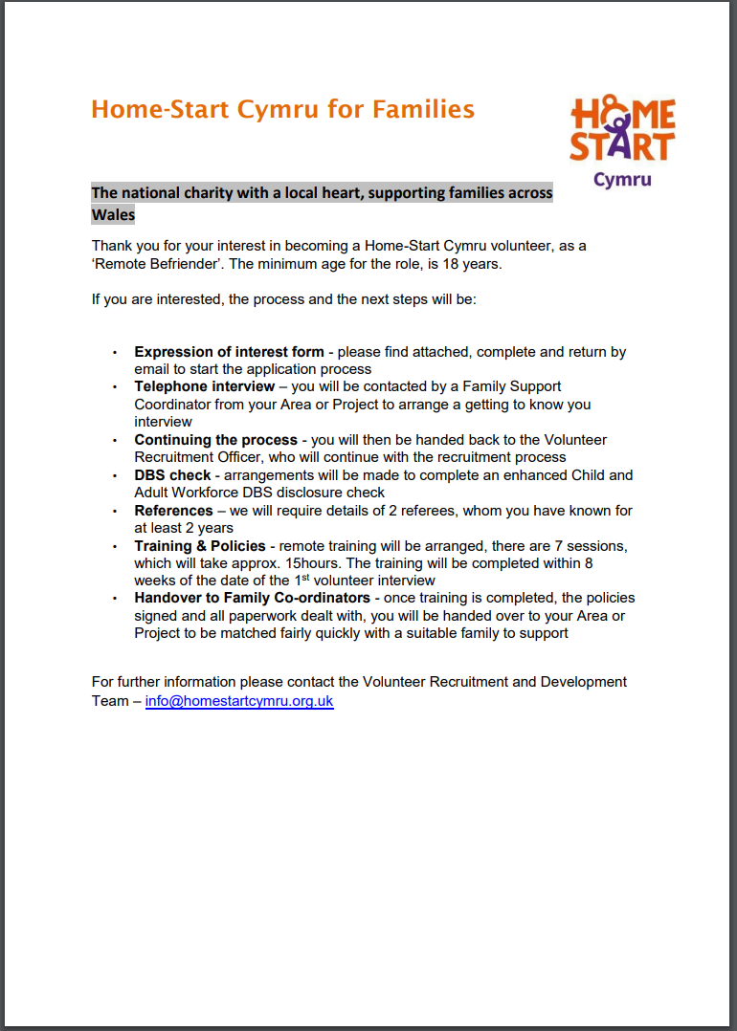
After completing the expression of interest form online I was contacted by one of the recruitment officers. They emailed me the application procedure and a copy of the role description.

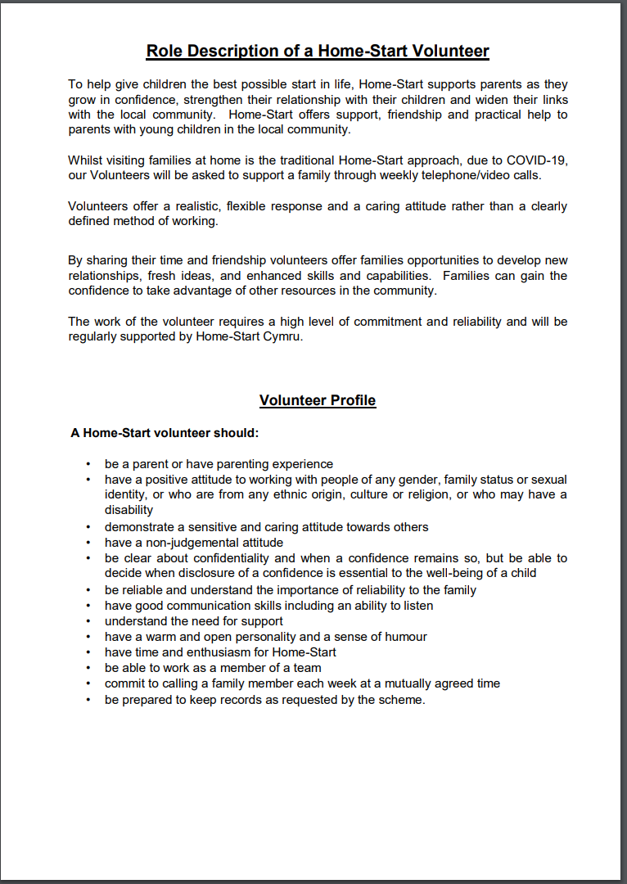

- Training.

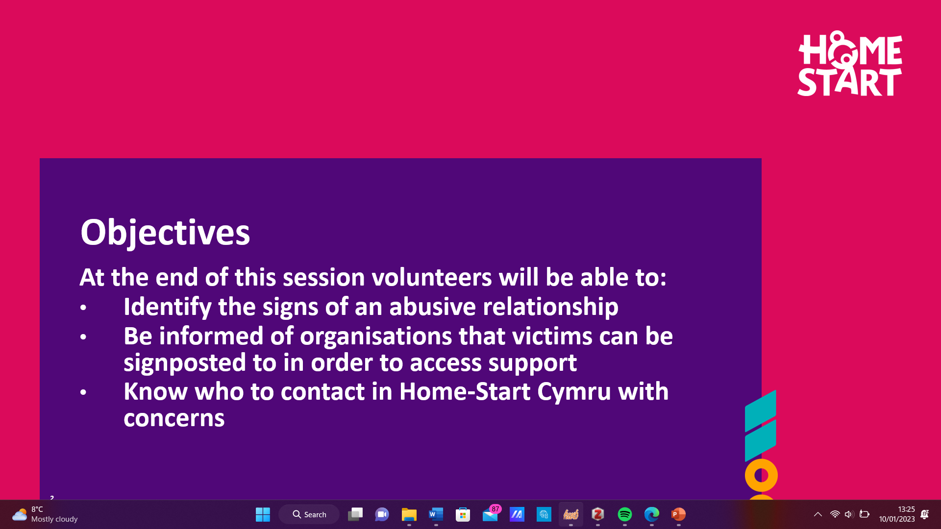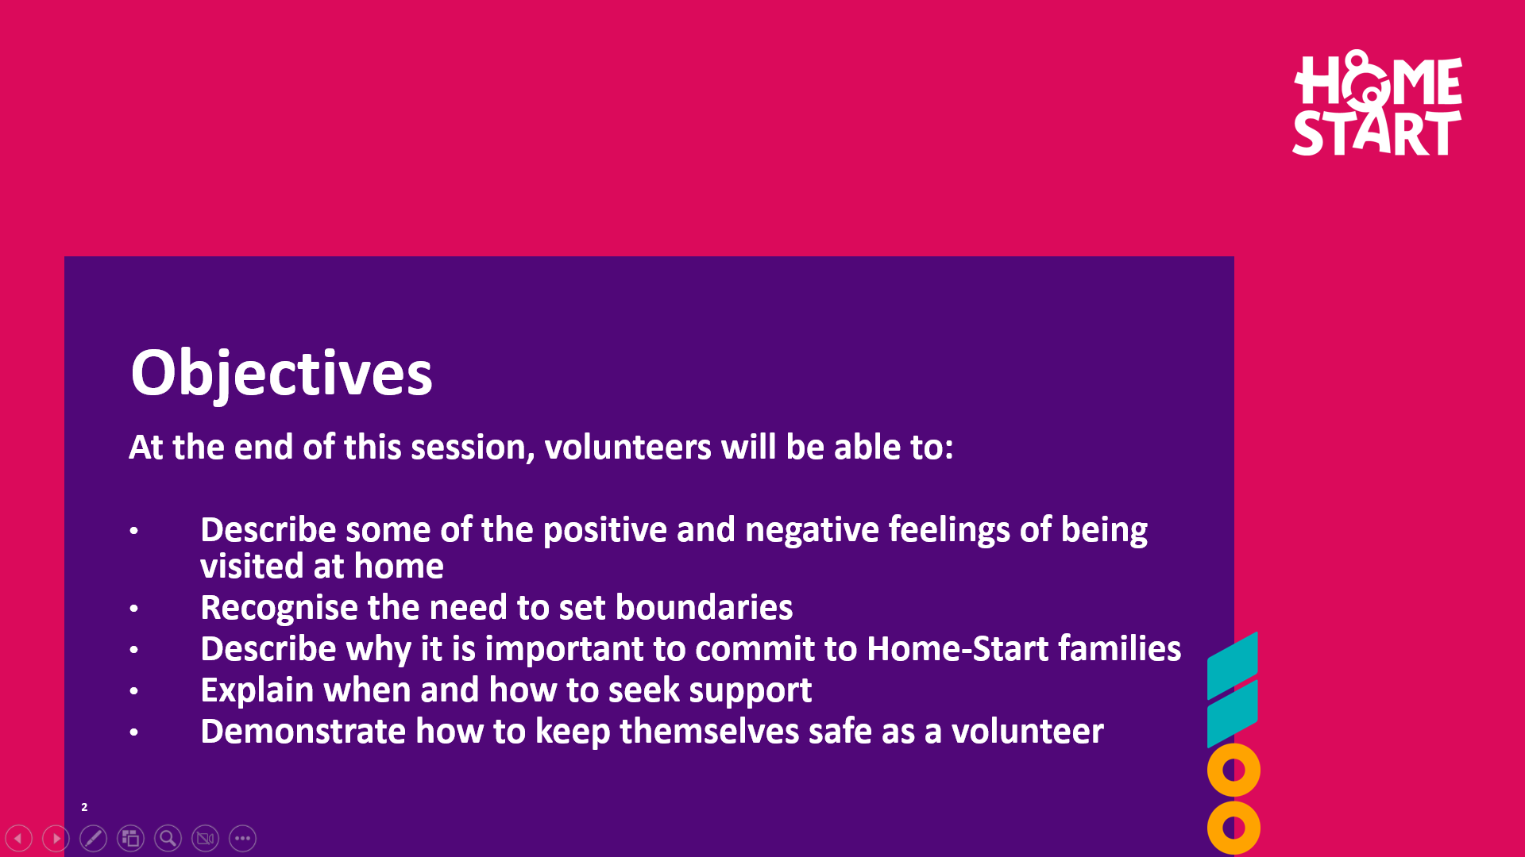
Example of the topics covered in my training where I identified areas I needed to develop and research further. For instance, the importance of play (Rathunde & Isabella, 2020).

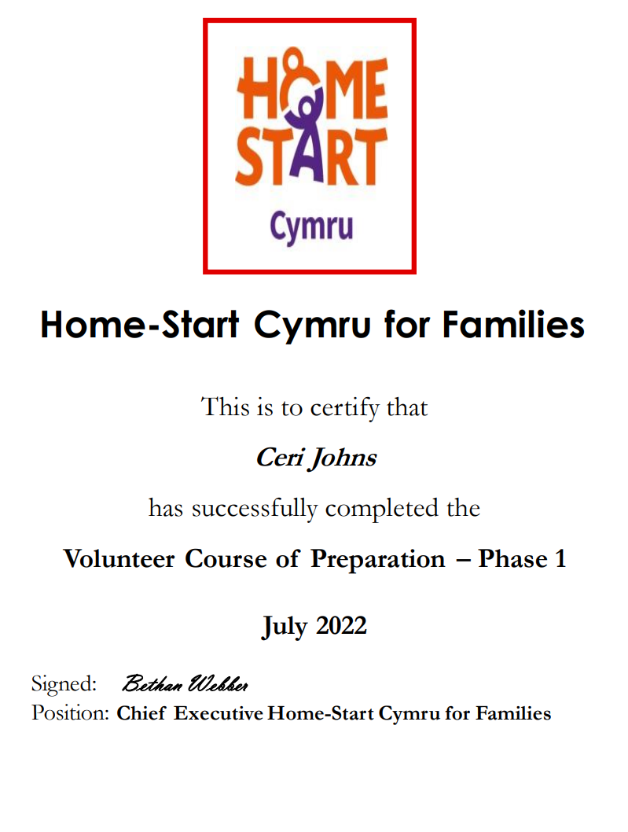
Certificates of the training completed to become a volunteer for Home-Start Cymru. Topics included, the role of the home-start volunteer, confidentiality, meeting the needs of the family and children, safeguarding, domestic violence, and mental health awareness.
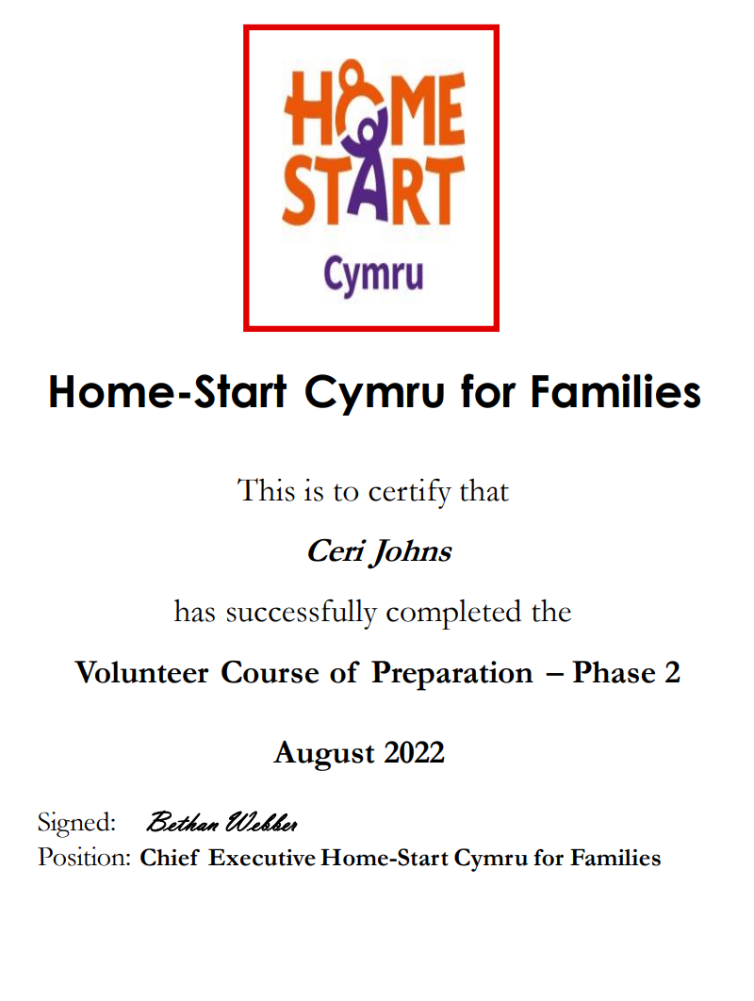

Evidence 4: Reports an additional information.

- Media information and examples.
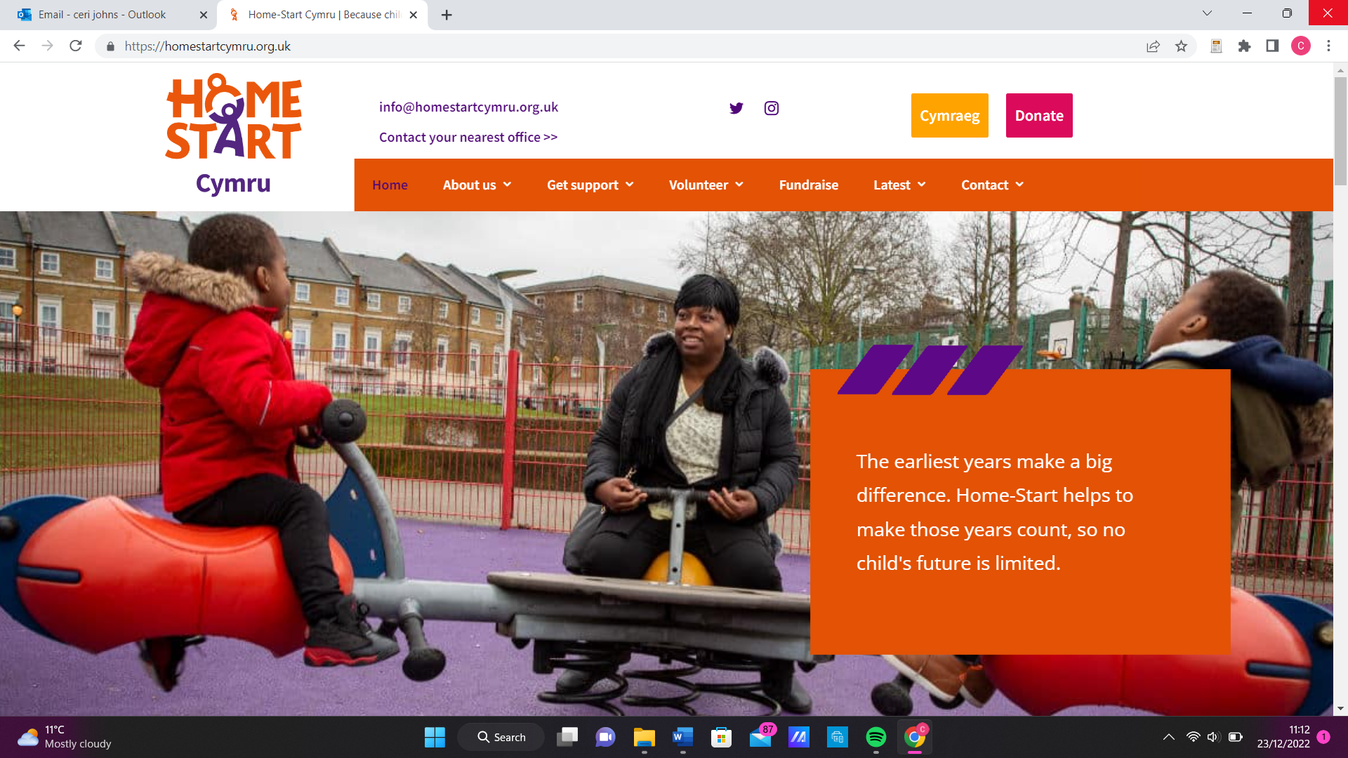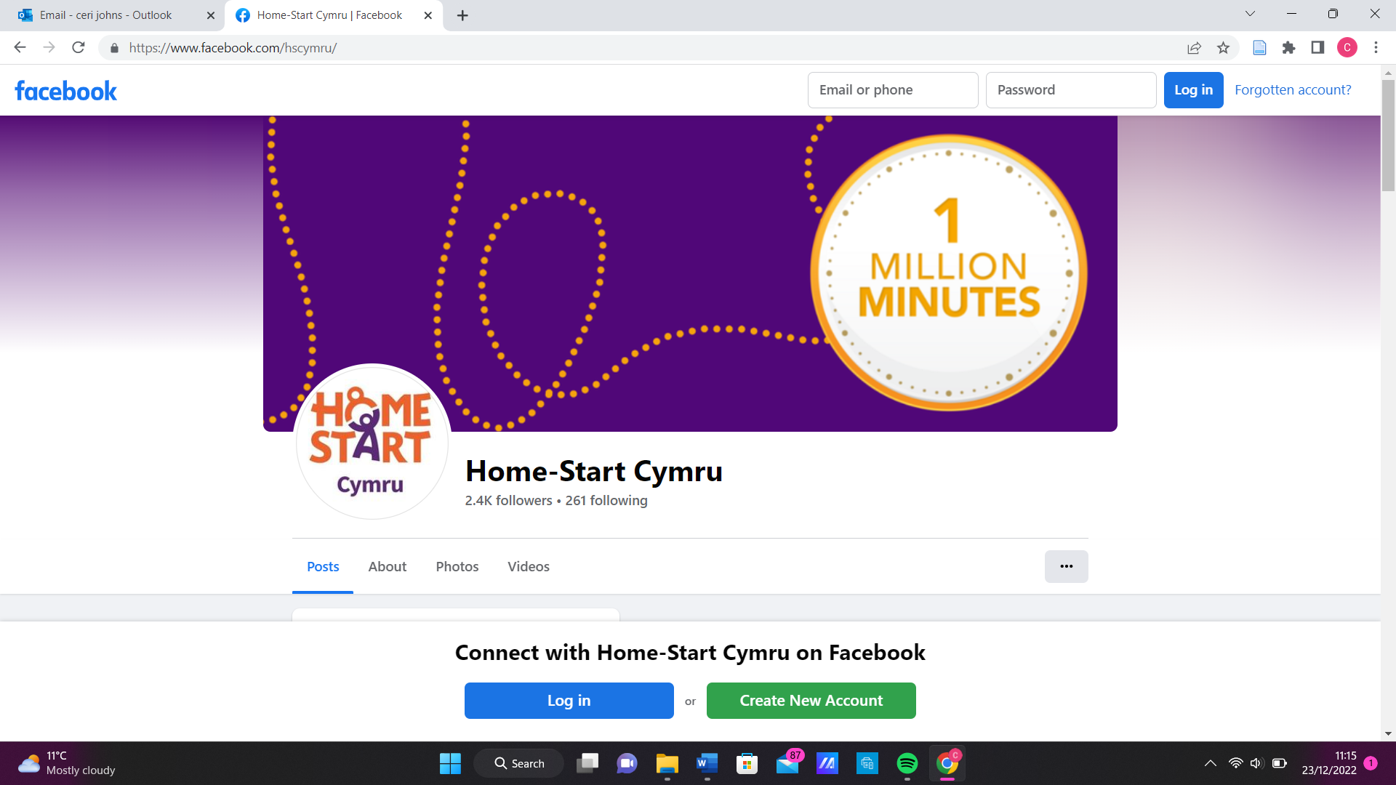
https://www.facebook.com/hscymru/

https://homestartcymru.org.uk/

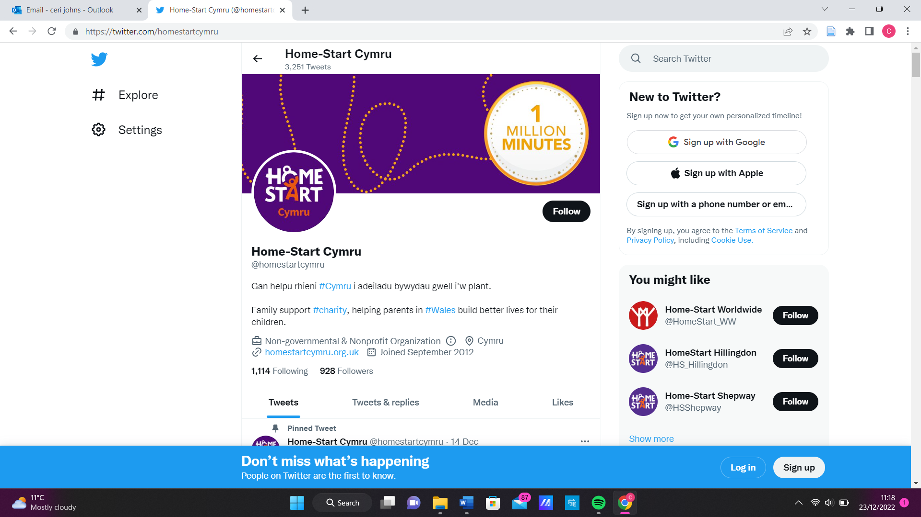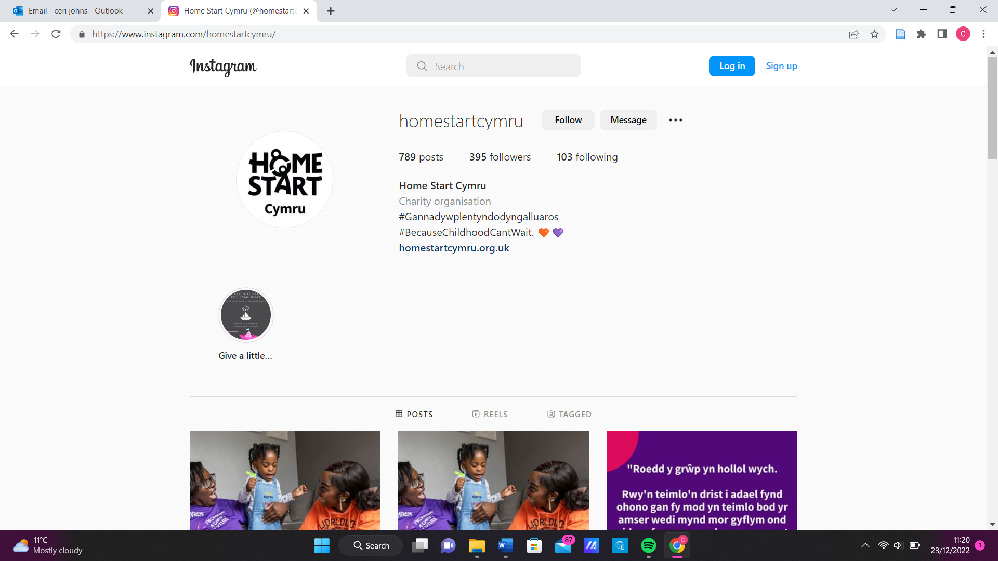
https://twitter.com/homestartcymru
https://www.instagram.com/homestartcymru/

- Annual Report.
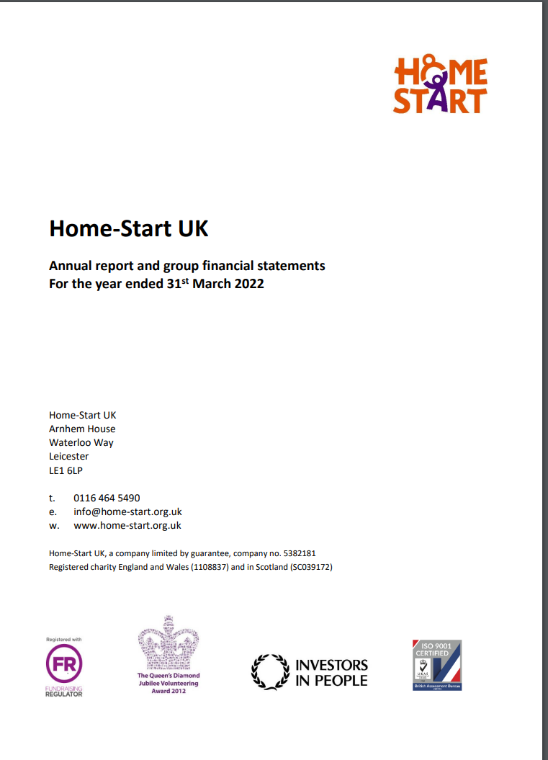
This annual report outlines the achievements of Home-Start Cymru in supporting families through Covid-19. It also announces the launch of ‘Together with families’ strategic framework that outlines the vision of Home-Start over the next five years.
https://www.home-start.org.uk/Handlers/Download.ashx?IDMF=3c86a00c-6da0-4998-a944-5b8672747e82

- Example of a volunteer diary sheet.
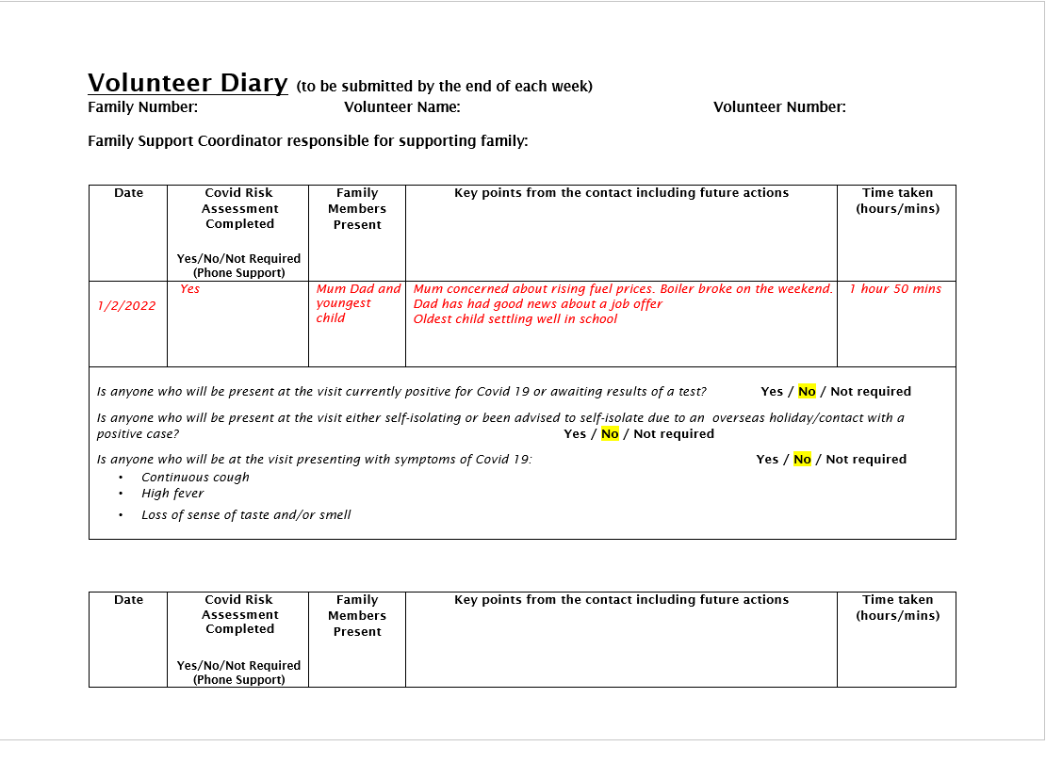
Example of a volunteer diary sheet that is completed after every visit and sent to my area co-ordinator for any follow up.

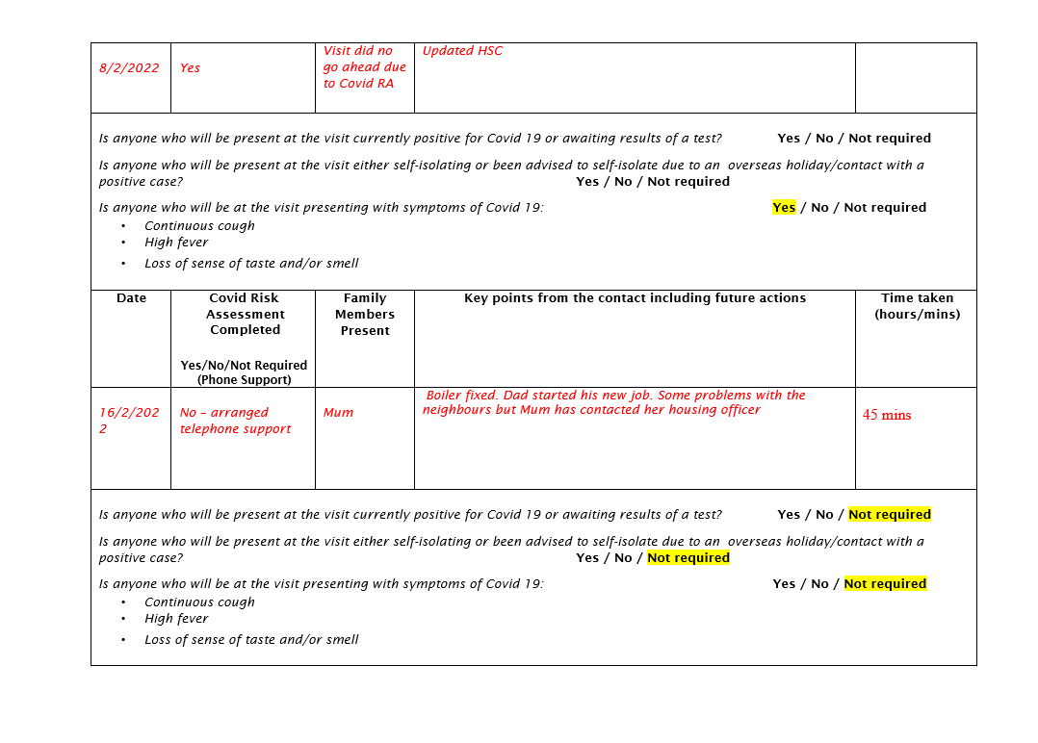
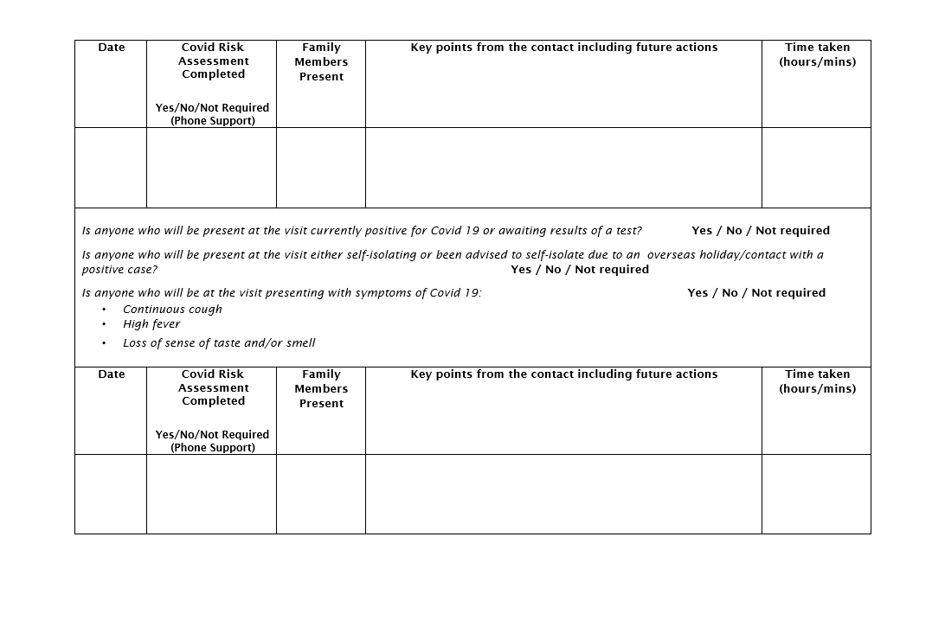
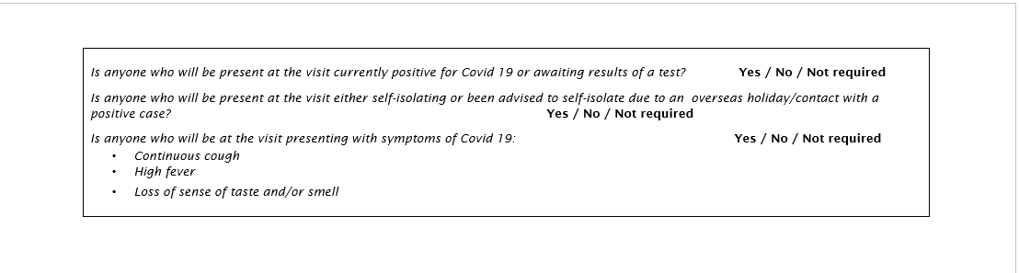

- Policies and Procedures.

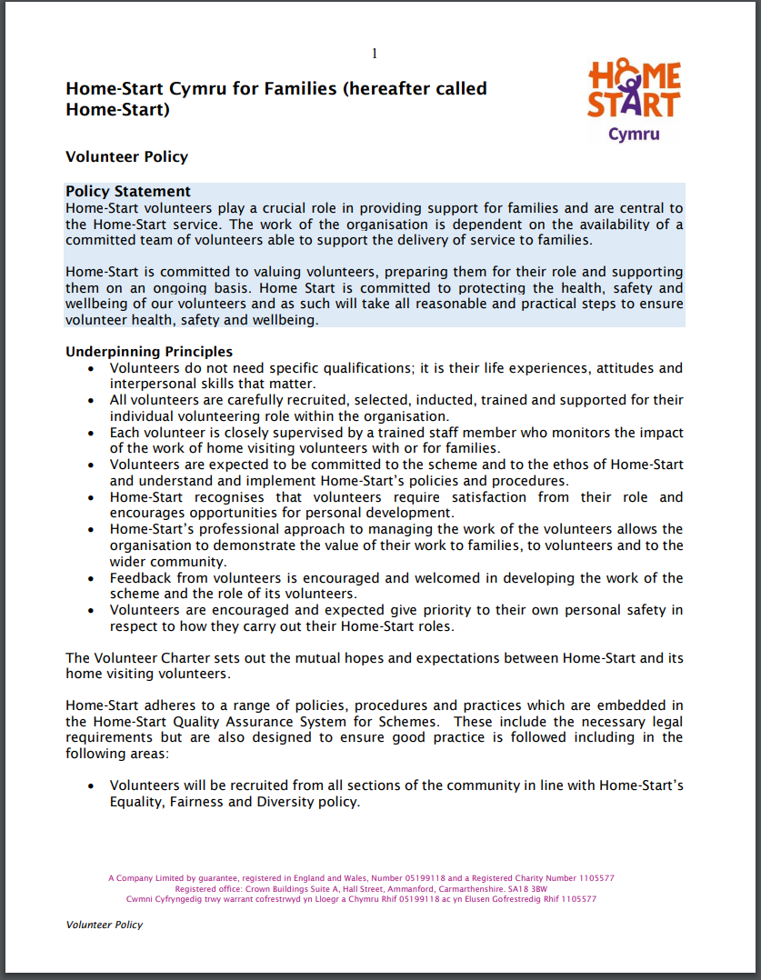
Once I had begun my training I was given the volunteer policy and the volunteer guidance booklet for reference. Any questions were answered during the training sessions.

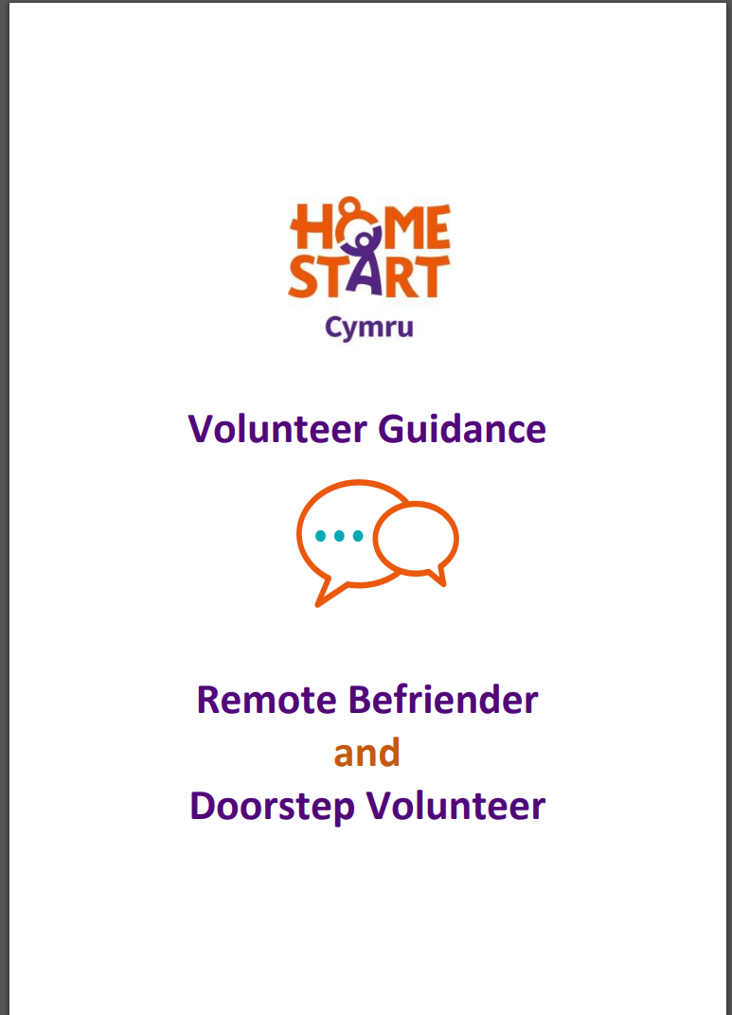
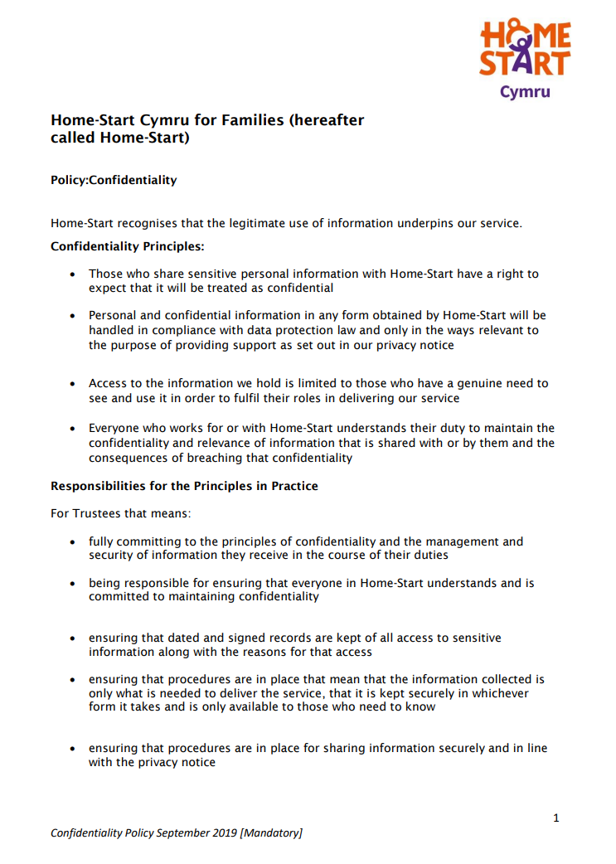
file:///C:/Users/cerij/Documents/Ceri/HomeStart%20Cymru/Confidentiality%20Policy%202020.pdf
Link for the full Confidentiality policy.

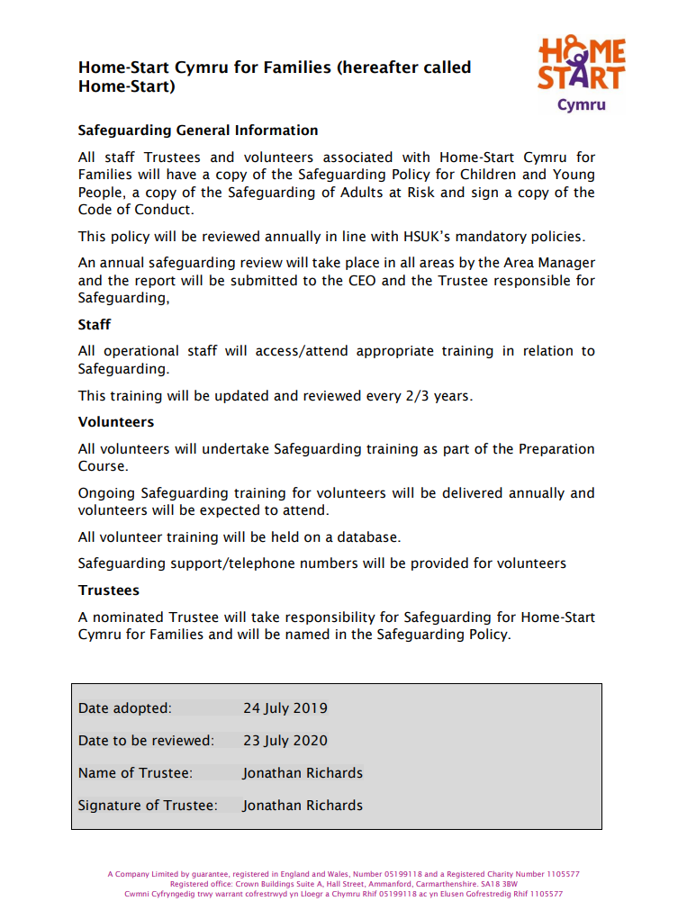
file:///C:/Users/cerij/Documents/Ceri/HomeStart%20Cymru/Safeguarding%20%20-%20General%20Info.pdf
Link for the full general safeguarding policy.

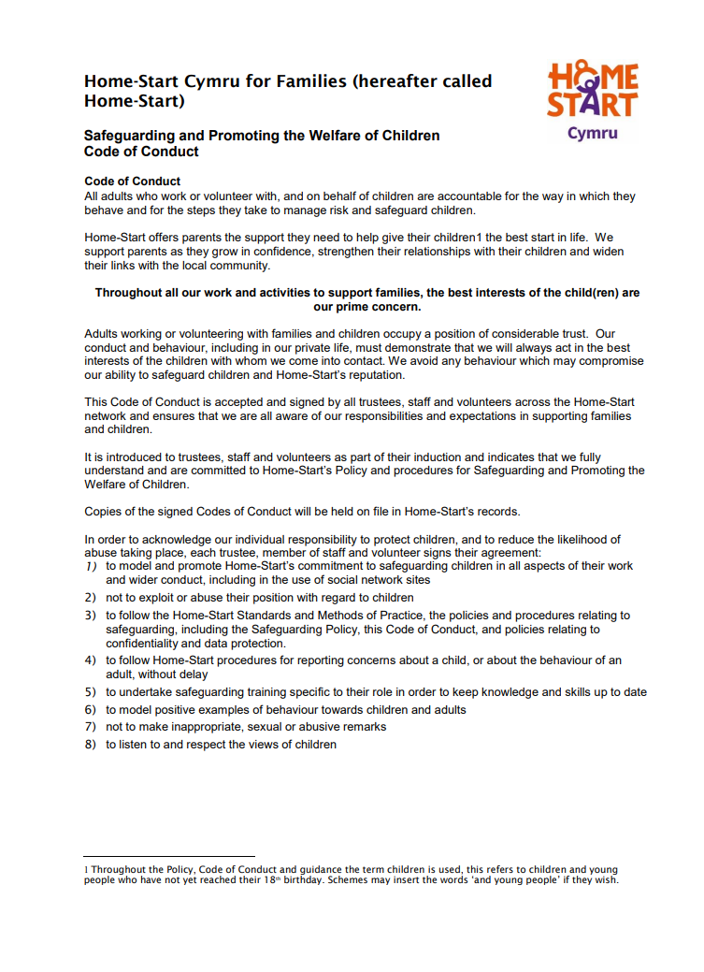
file:///C:/Users/cerij/Documents/Ceri/HomeStart%20Cymru/Safeguarding%20-%20Code%20of%20Conduct.pdf
Link for the full Safeguarding and promoting the welfare of children policy.

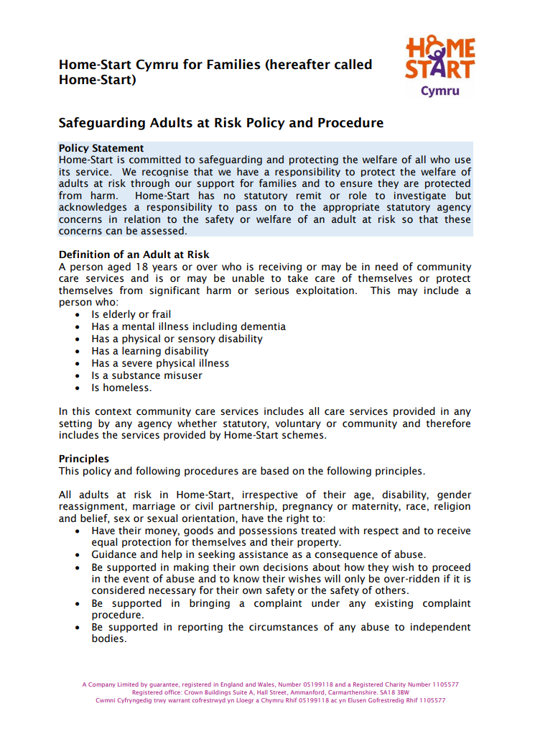
file:///C:/Users/cerij/Documents/Ceri/HomeStart%20Cymru/Safeguarding%20Adults%20at%20Risk.pdf
Link to the Safeguarding Adults at Risk Policy and Procedure.
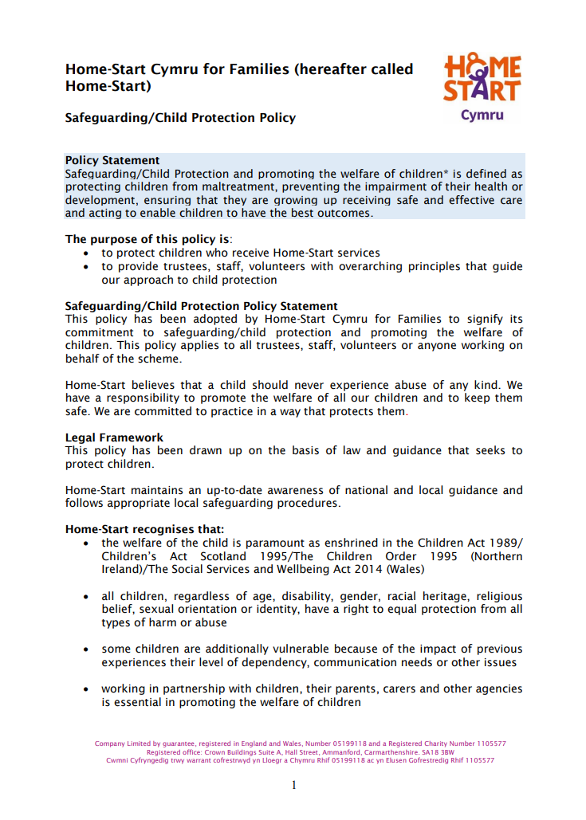
file:///C:/Users/cerij/Documents/Ceri/HomeStart%20Cymru/Safeguarding%20Children.pdf
Link for the full Safeguarding and Child Protection Policy.

- Additional Information.
A new initiative that Home-Start Cymru are promoting is support for dads by dads. https://homestartcymru.org.uk/dadmatterscymru/

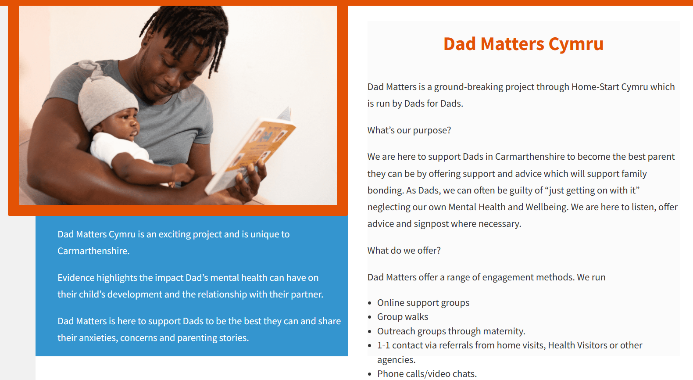

Appendices.

Appendix 1.
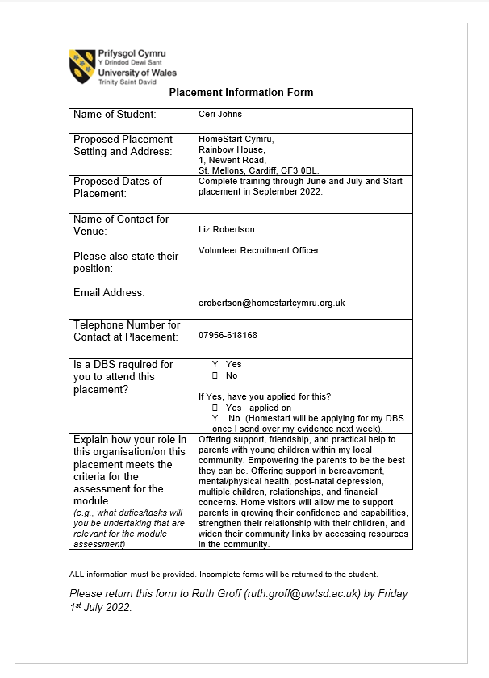
Appendix 2.
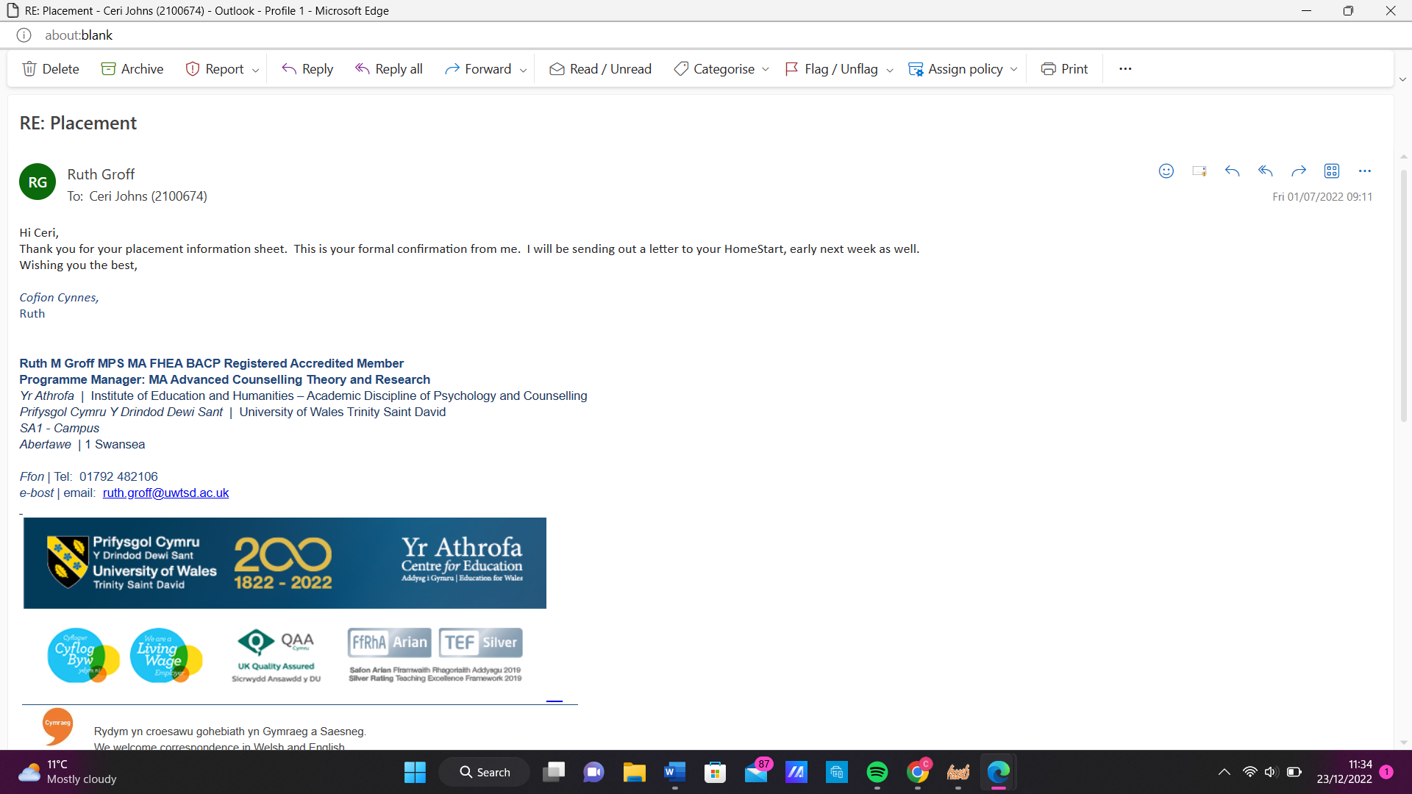

Appendix 3.
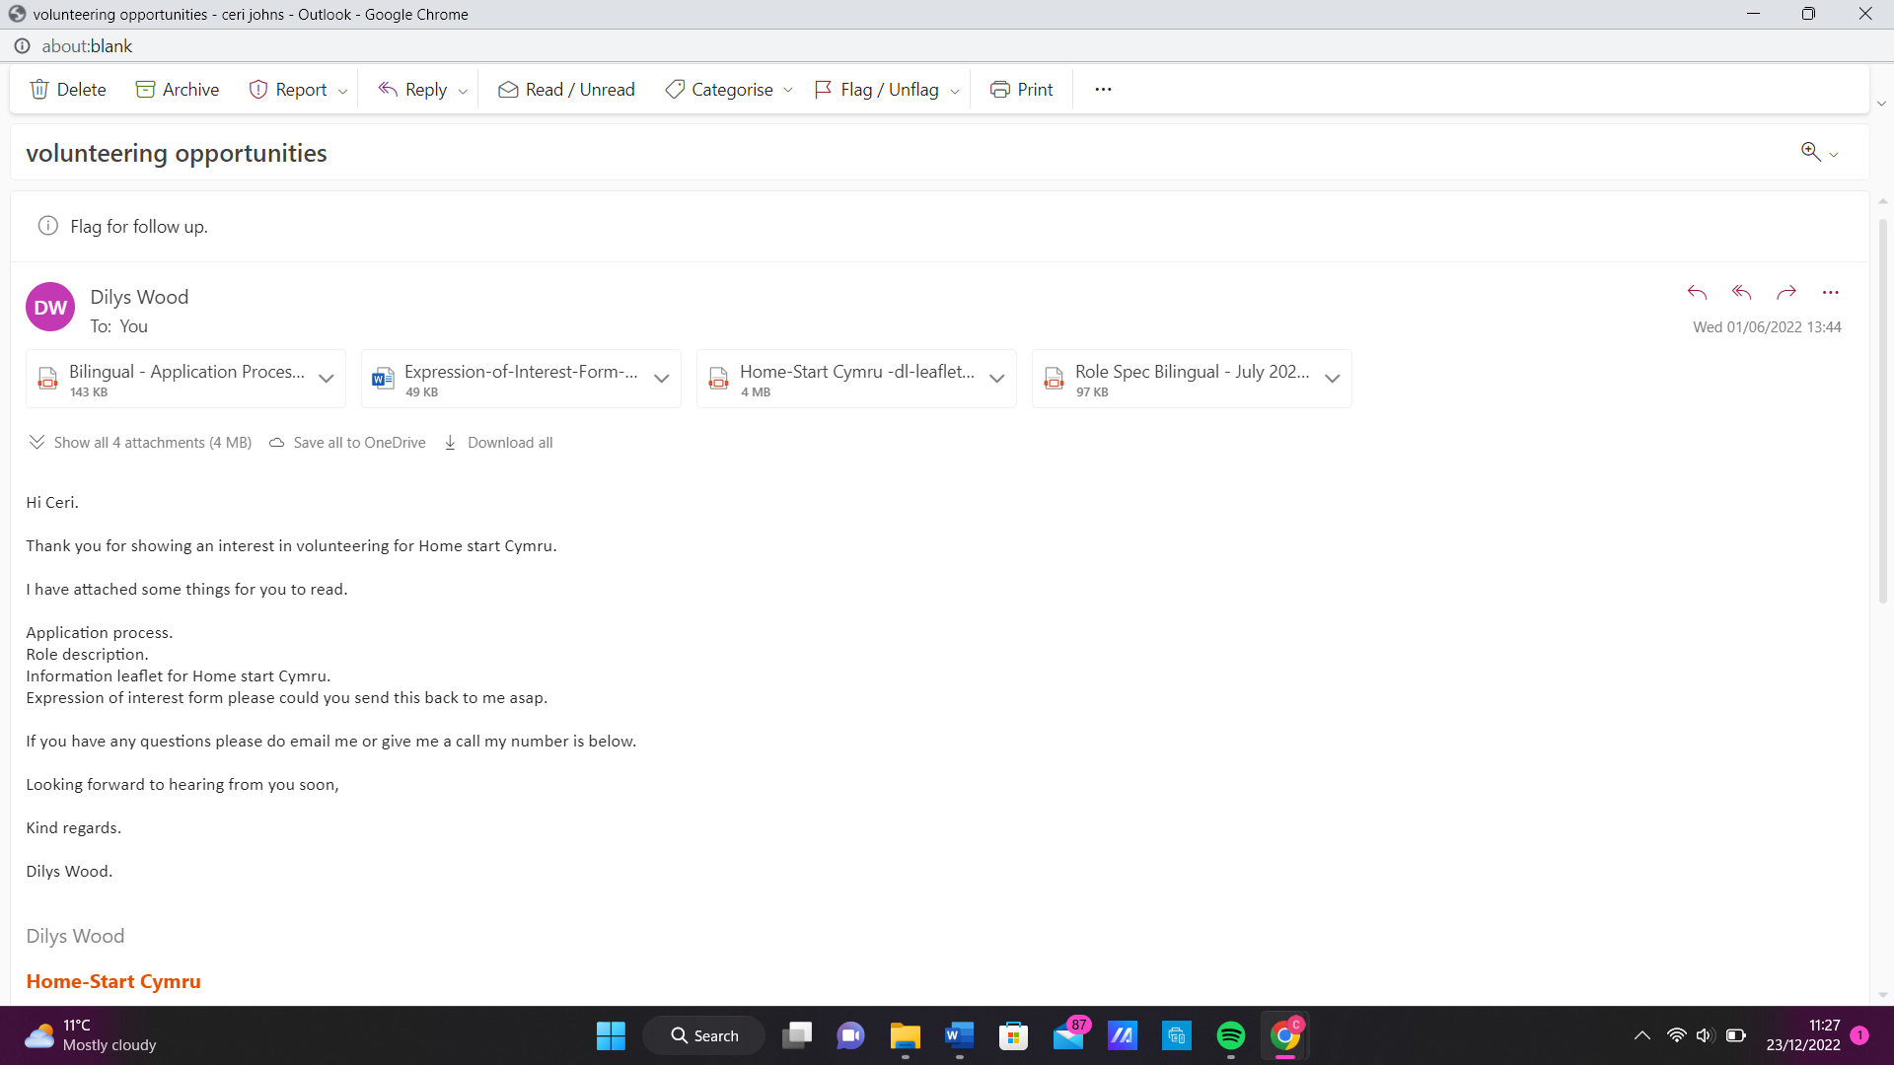
Appendix 4.
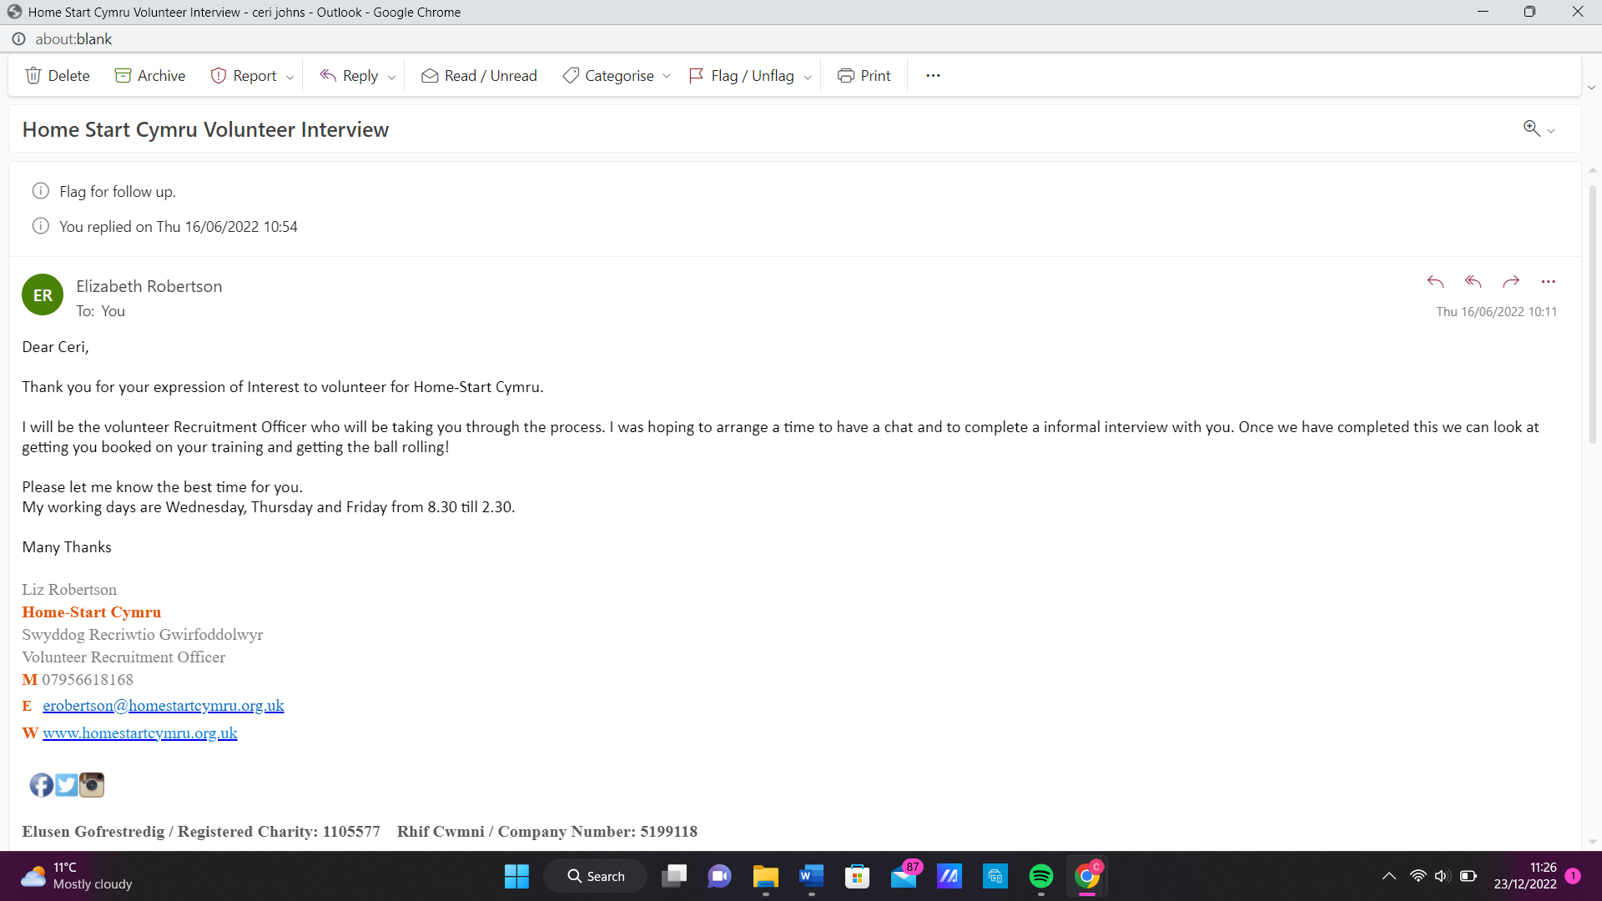

Appendix 5.
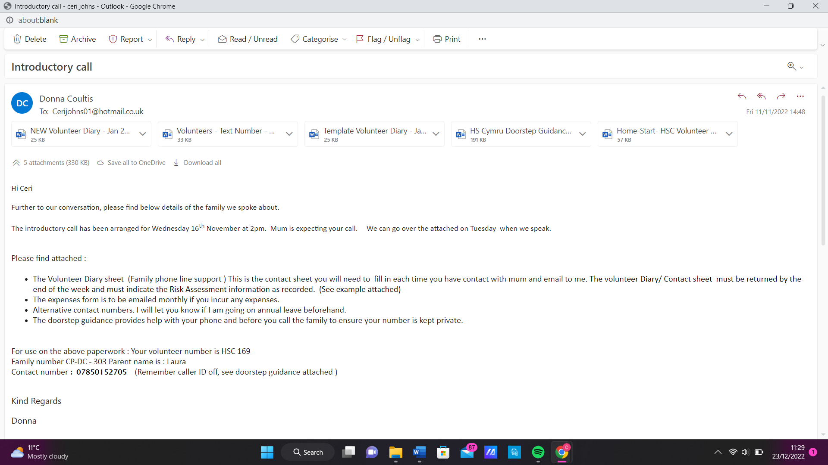
Appendix 6.
Date. | Details. | Time spent.
17/6/2022 | Informal phone interview. | 30 minutes.
23/6/2022 | Completed DBS on Zoom with the Volunteer recruitment officer. | 30 minutes.
21/7/2022 | Online training sessions 5 and 6. | 3 hours.
3/8/2022 | Online training sessions 3 and 4. | 3 hours.
4/8/2022 | Online training sessions 1 and 2. | 3 hours.
4/10/2022 | Online meeting with area coordinator. | 30 minutes.
11/11/2022 | Phone call discussion with coordinator about possible family matches. | 30 minutes.
16/11/2022 | Introductory call to the family. No answer but tried multiple times. | 15 minutes.
18/11/2022 | Check in call with coordinator. | 10 minutes.
23/11/2022 | Introductory call with family. | 10 minutes.
25/11/2022 | Check in call with coordinator. | 10 minutes.
9/12/2022 | Check in call with coordinator. | 10 minutes.
16/12/2022 | Check in call with coordinator. | 10 minutes.
 |  | Total -
 |  | 12 hours.

References.

Facebook. (n.d.). Home-Start Cymru. https://www.facebook.com/hscymru/
Fearon, R. P., & Roisman, G. I. (2017). Attachment theory: Progress and future
directions. Current Opinion in Psychology, 15, 131–136. https://doi.org/10.1016/j.copsyc.2017.03.002
Home-Start Cymru. (2022). Annual Report and Group Financial Statements for the
year ending 31stMarch 2022. https://www.home-start.org.uk/Handlers/Download.ashx?IDMF=3c86a00c-6da0-4998-a944-5b8672747e82
Home-Start Cymru. (2022). Because childhood can’t wait.
https://homestartcymru.org.uk/
Home-Start Cymru. (2022). Dad Matters Cymru. https://homestartcymru.org.uk/dadmatterscymru/
Home-Start Cymru. (2022). Volunteer for Home-Start Cymru. https://www.home
-start.org.uk/volunteering
Hoon, S., & Wilkins, P. (2018). Adult Learning and the Advantages of the Online
Learning Experience. Westcliff International Journal of Applied Research, 2(2), 31–36. https://doi.org/10.47670/wuwijar201822PWSH
Instagram. (n.d.). Home-Start Cymru. https://www.instagram.com/homestartcymru/
Rathunde, K., & Isabella, R. (2020). Engaging Parents About the Importance of Play:
The Impact of a Brief, Arts‐Informed Community Presentation. Family Relations, 69(2), 351–364. https://doi.org/10.1111/fare.12422

