Module: Introduction to Web and Database Concepts

Module code: ACCA4023
Assignment Title: HTML & CSS Web Development
Student Name: Benjamin Gaylard
Student ID Number: 2003557

Table of Contents
Introduction 4
Requirements 5
Brief Introduction 5
Purpose 5
Subject Matter 5
Intended Target Audience 5
Implementation 6
Screen Grabs of all website pages 6
Validation 11
Screenshots 11
Page One 11
Page Two 12
Page Three 12
Page Four 14
Page Five 14
Page Six 15
Page Seven 16
CSS Validation 17
Main CSS for design 17
CSS for Contact us form 17
Error Messages 17
Evaluation 19
Website usability, accessibility, and search engine optimization 19
Website usability 19
Accessibility 19
Search Engine Optimisation 20
References 21
Appendices 23
Home Page 23
About Page 24
Culture and Heritage Page 26
History 30
Events and Festivals 32

Introduction
During this assignment, I was tasked with designing and producing a working website using Hypertext Markup Language (HTML) and a cascading style sheet (CSS).
HTML stands for Hypertext Markup Language [1]. It is a programming language used to create and structure digital documents such as websites, web applications, and webpages. HTML uses markup tags to define various elements of a webpage, such as headings, paragraphs, images, links, and more. The structure and content of a webpage are determined by the HTML code, which is interpreted by web browsers like Chrome, Firefox, and Safari, allowing users to view and interact with a webpage.
CSS, or Cascading Style Sheets, is a style sheet language used to describe the presentation of a document written in a markup language such as HTML or XML [2]. CSS is designed to enable the separation of presentation from content, including layout, colours, and fonts [3]. This makes it easier to create and maintain web pages, as the content and presentation can be stored in separate files. CSS can be used to control the appearance of all aspects of a web page, from the layout of the content to the style of the fonts and colours [4].

Requirements

Brief Introduction
The website is dedicated to showcasing the beautiful country of Wales. Here, you will find comprehensive information on the history, culture, and attractions of this unique and wonderful destination. Our aim is to provide an immersive and educational experience for tourists, history enthusiasts, and anyone with an interest in Wales. Whether you're planning a trip or simply seeking to expand your knowledge, our website offers a wealth of information that is both informative and engaging. Come and explore Wales with us.

Purpose
The purpose of this website is to provide comprehensive and engaging information about Wales to its target audience. This includes highlighting the country's rich history, diverse culture, and top attractions, with the aim of educating and inspiring visitors to learn more about this fascinating part of the world. Whether you're planning a trip to Wales or just want to deepen your understanding of the country, this website is designed to be a valuable resource for you.

Subject Matter
The subject matter of this website is Wales and its related topics. This includes, but is not limited to, its history, culture, attractions, geography, and people. The website will delve into various aspects of Wales, from its ancient past to its modern-day offerings, to provide a comprehensive and well-rounded understanding of the country for its target audience.

Intended Target Audience
The intended target audience for this website is anyone with an interest in Wales, including tourists, history enthusiasts, and people looking to learn more about this fascinating country. Whether you're planning a trip to Wales, studying its history, or simply want to know more about its culture and people, this website is designed to cater to your needs and provide valuable information that is both informative and enjoyable to read.

Implementation

Screen Grabs of all website pages
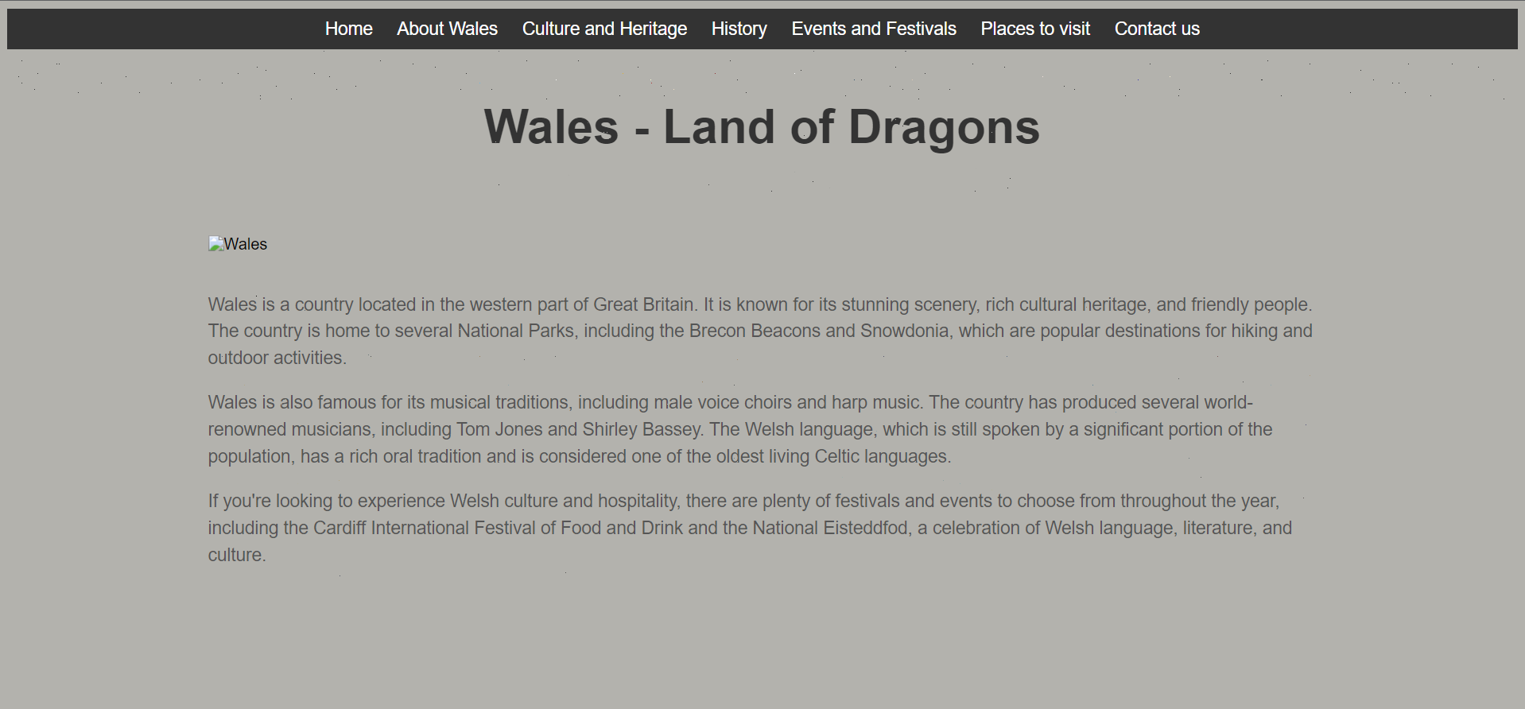
Figure 1 - Home Page (First Page)
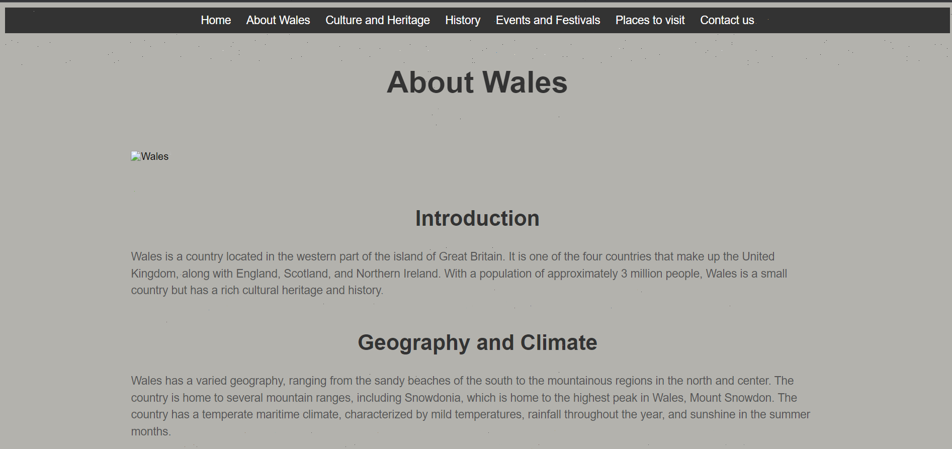
Figure 2 - About Wales Page (Second Page)
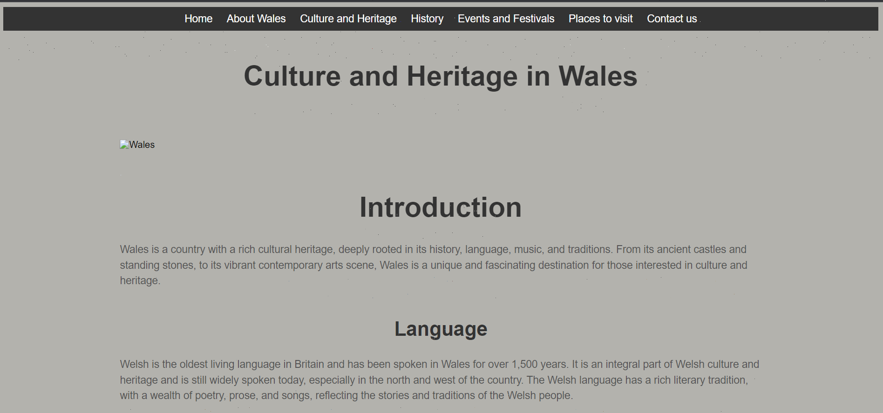
Figure 3 - Culture & Heritage in Wales Page (Third Page)
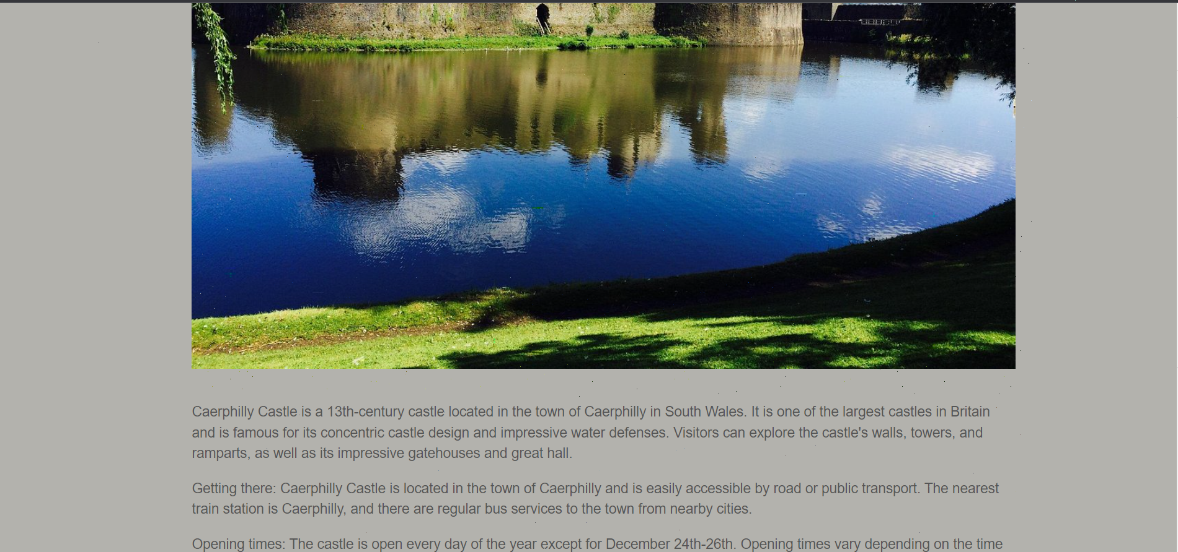
Figure 4 - Culture & Heritage in Wales Page (Third Page)
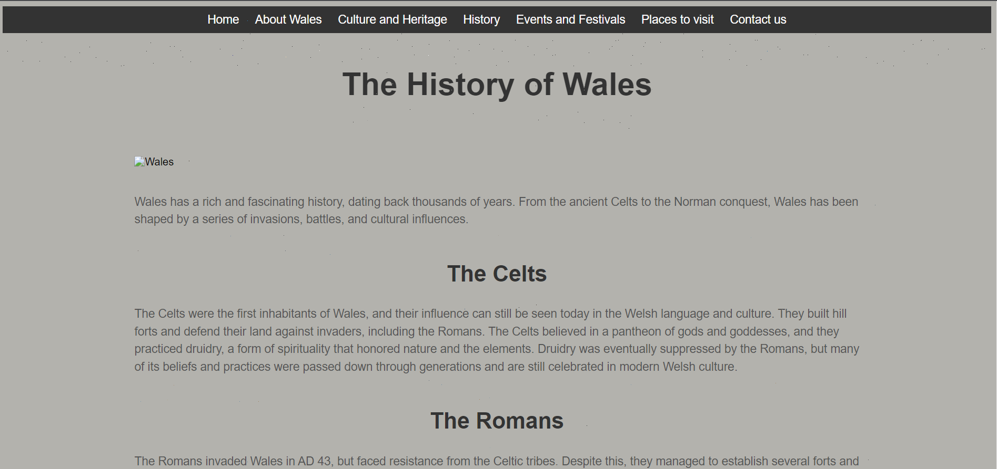
Figure 5 - History of Wales (Page Four)
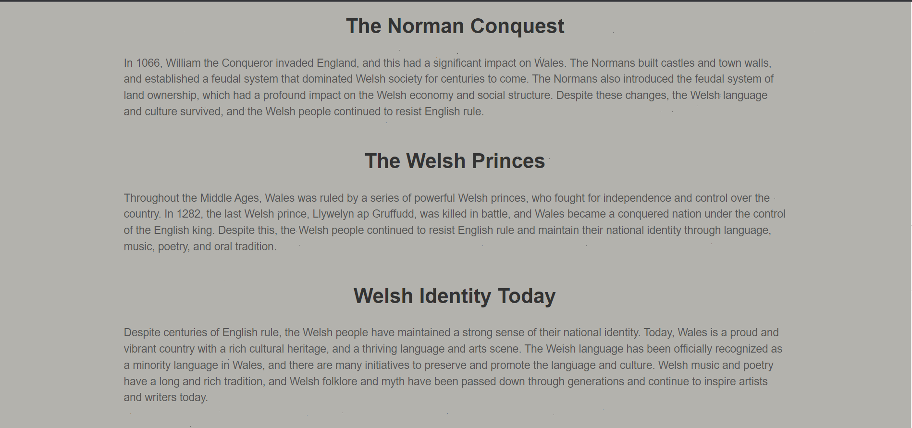
Figure 6 - History of Wales (Page Four)
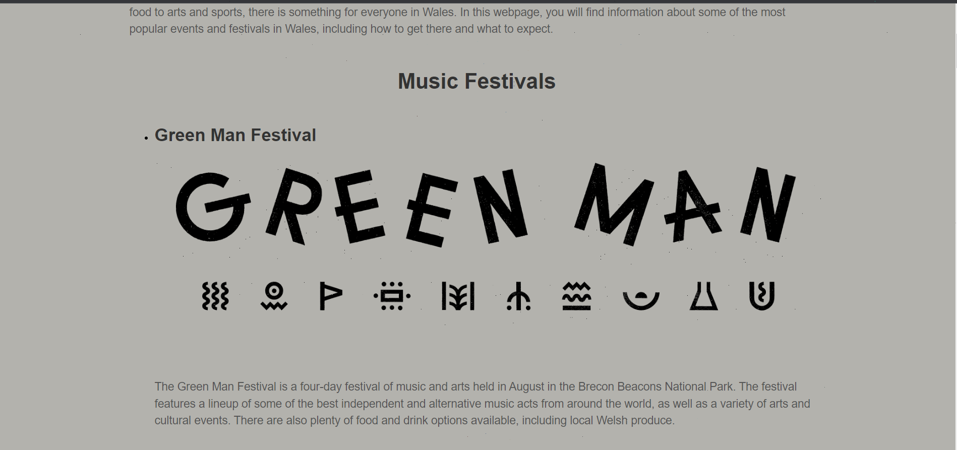
Figure 7 - Events and Festivals (Page Five)
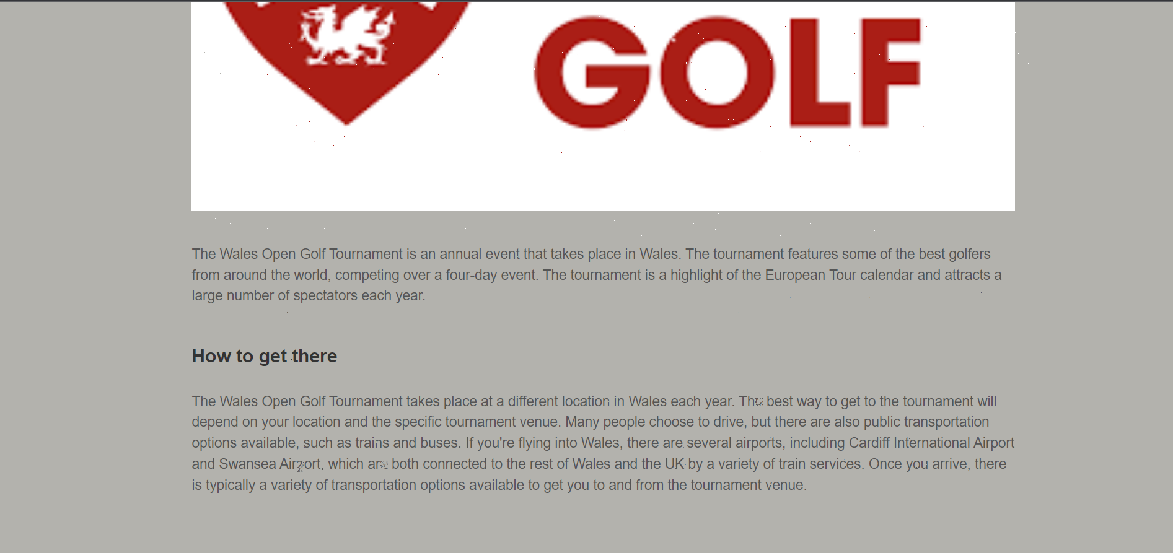
Figure 8 - Events and Festivals (Page Five)
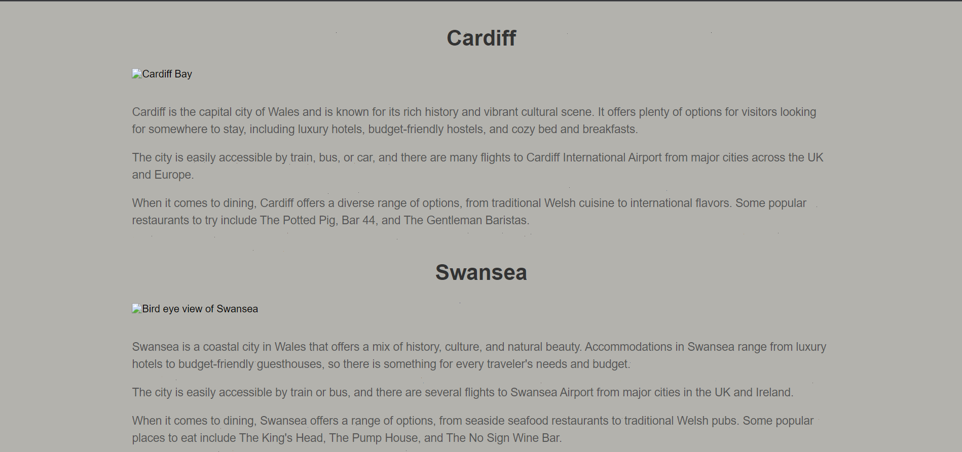
Figure 9 - Places to visit (Page Six)
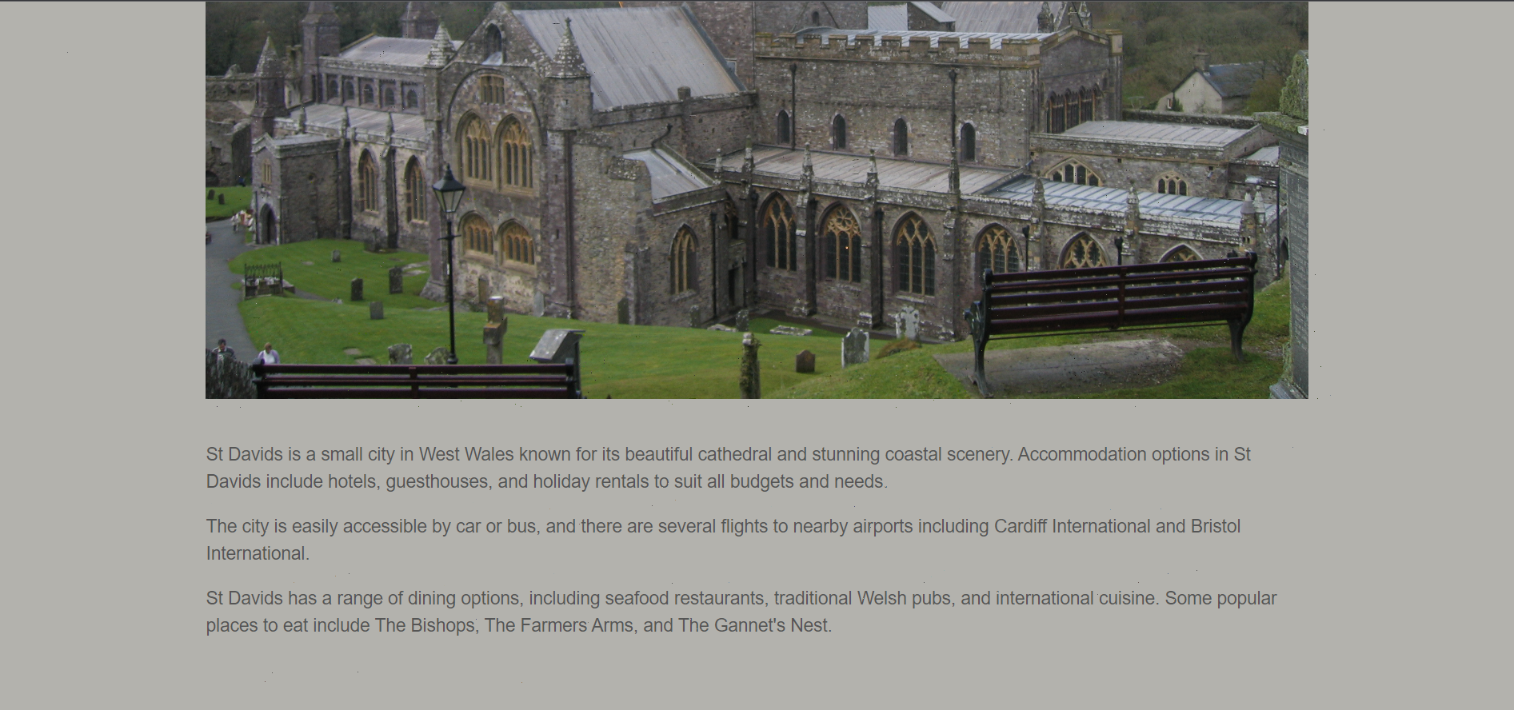
Figure 10 - Places to visit (Page Six)
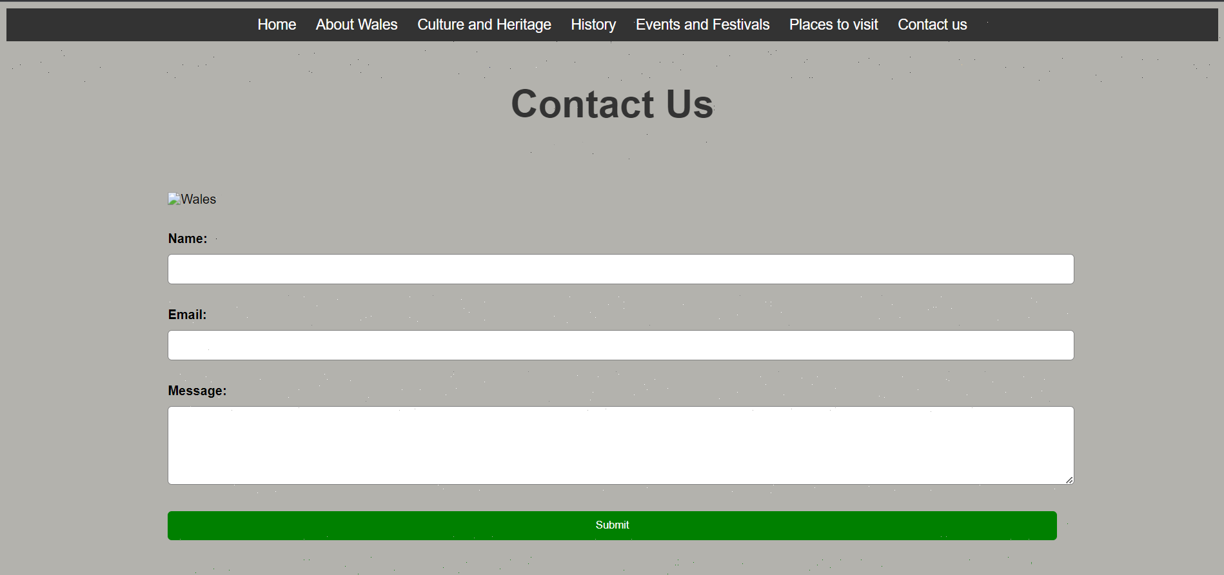
Figure 11 - Contact us Form (Page Seven)

Validation

Screenshots

Page One
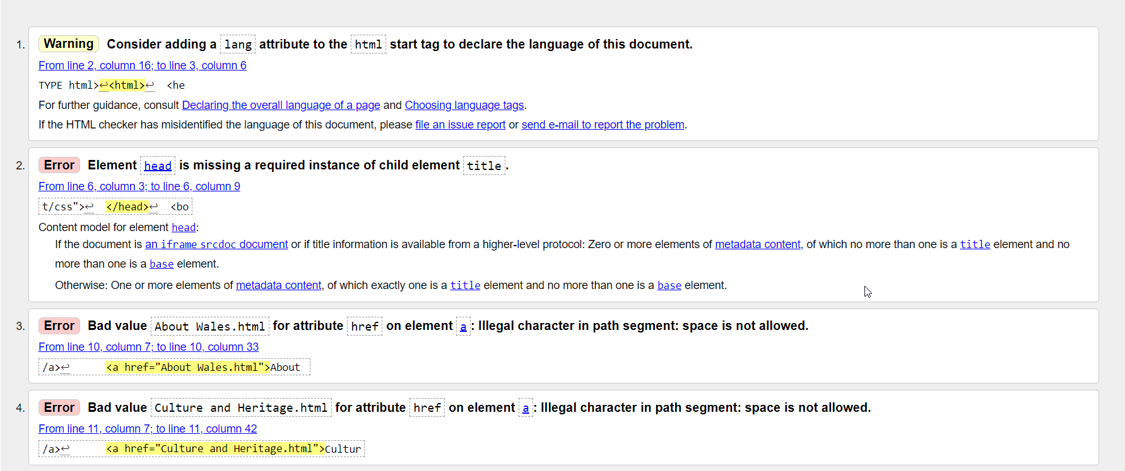
Figure 12 - Validation Results from page one
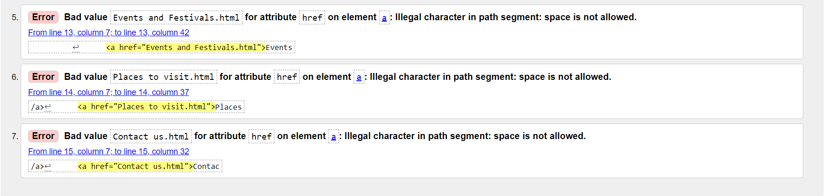
Figure 13 - Validation Results from page one (Continuation)

Page Two
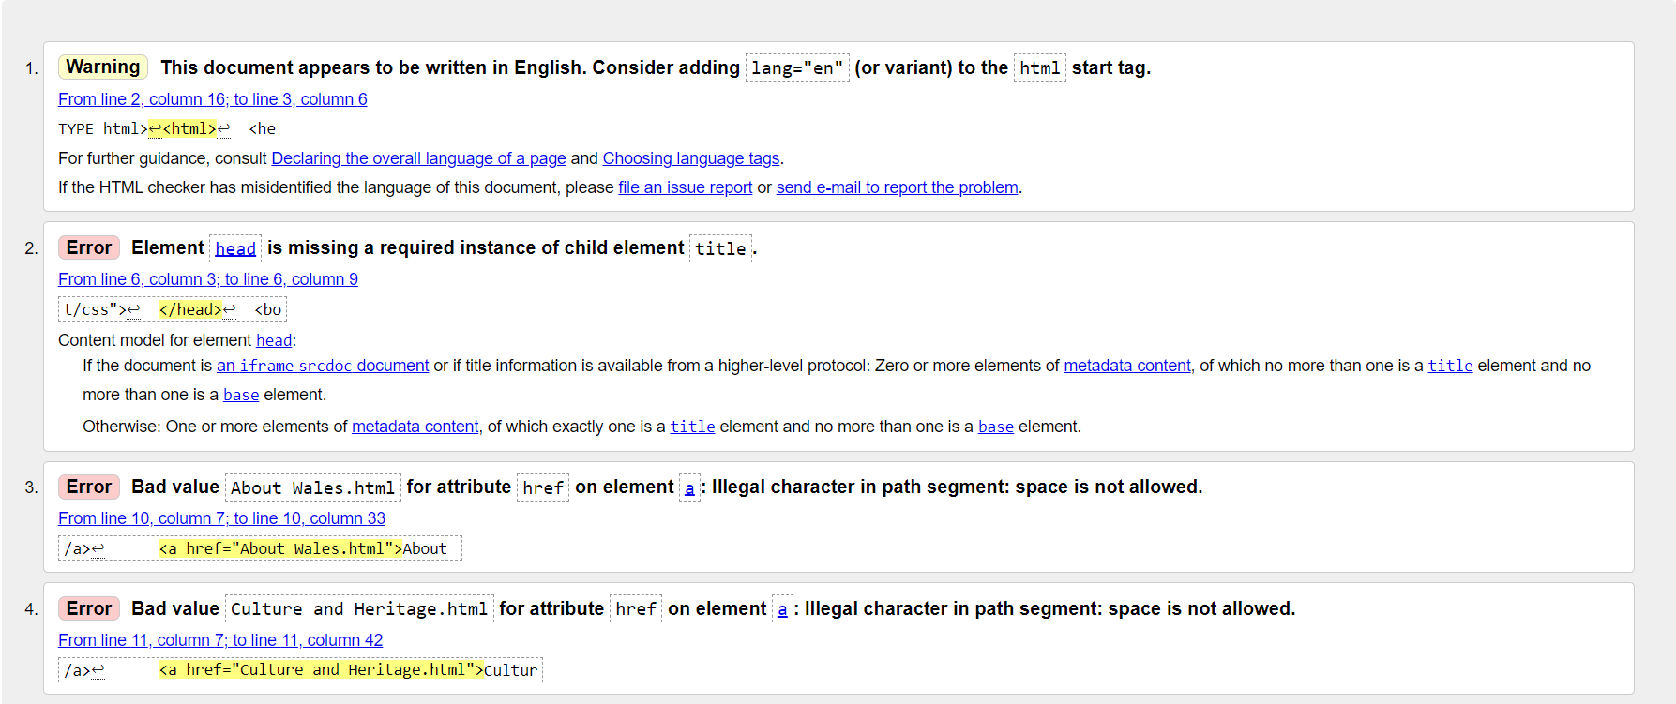
Figure 14 - Validation Results from page two
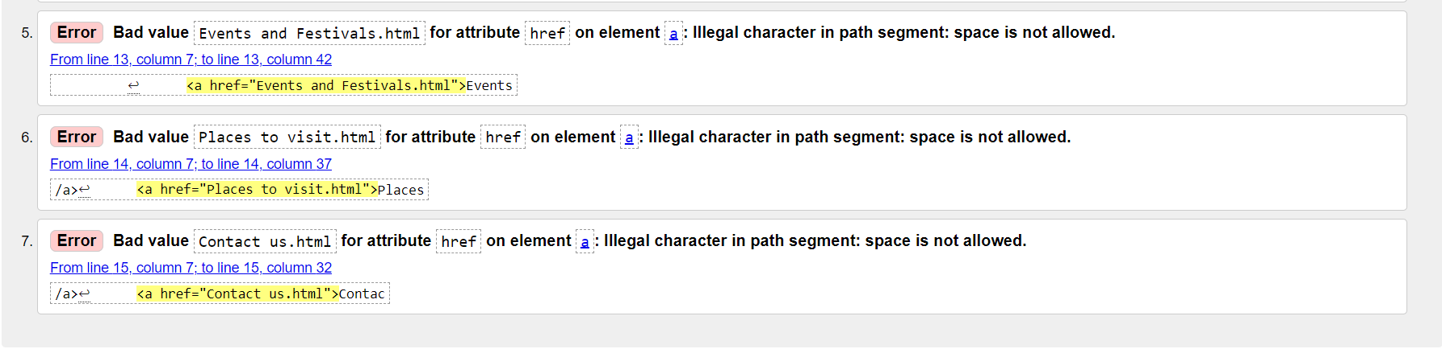
Figure 15 - Validation Results from page two (continuation)

Page Three
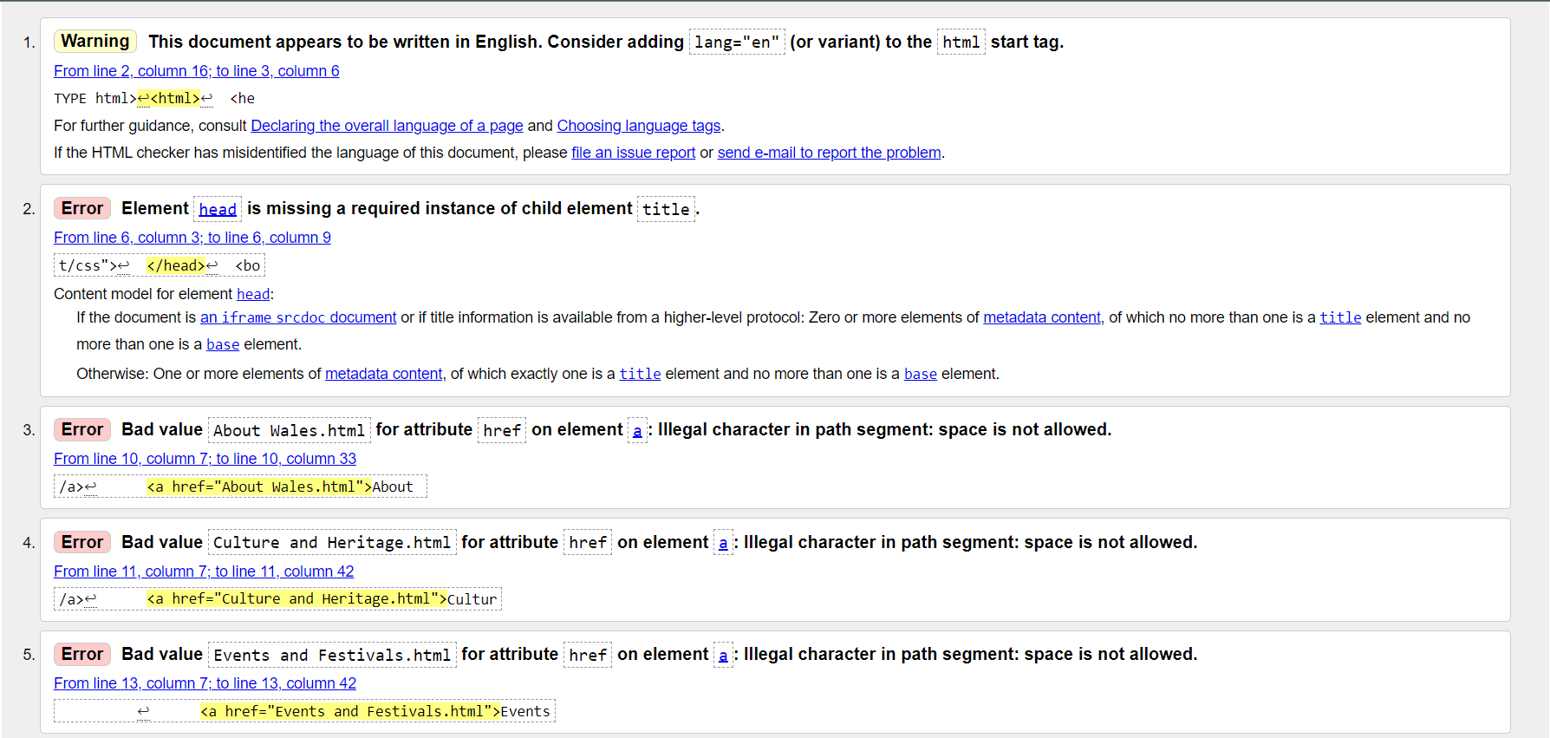
Figure 16 -Validation Results from page three
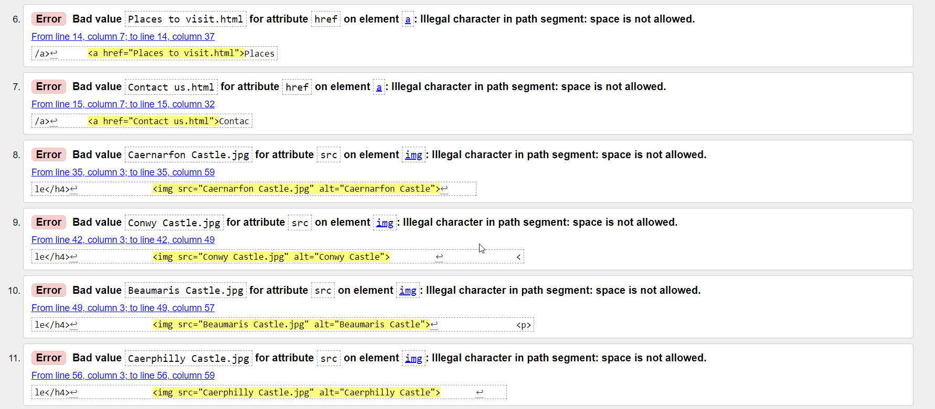
Figure 17 - Validation Results from page three (continuation)
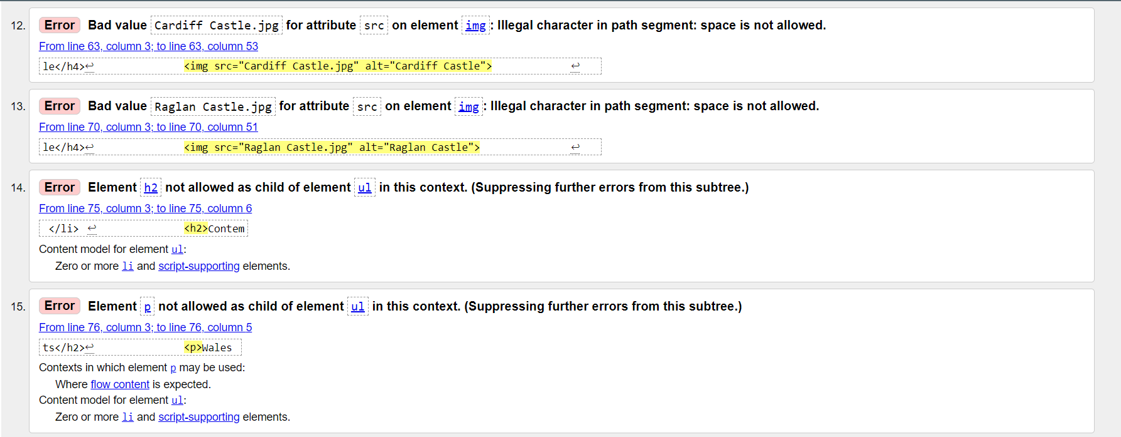
Figure 18 - Validation Results from page three (continuation)
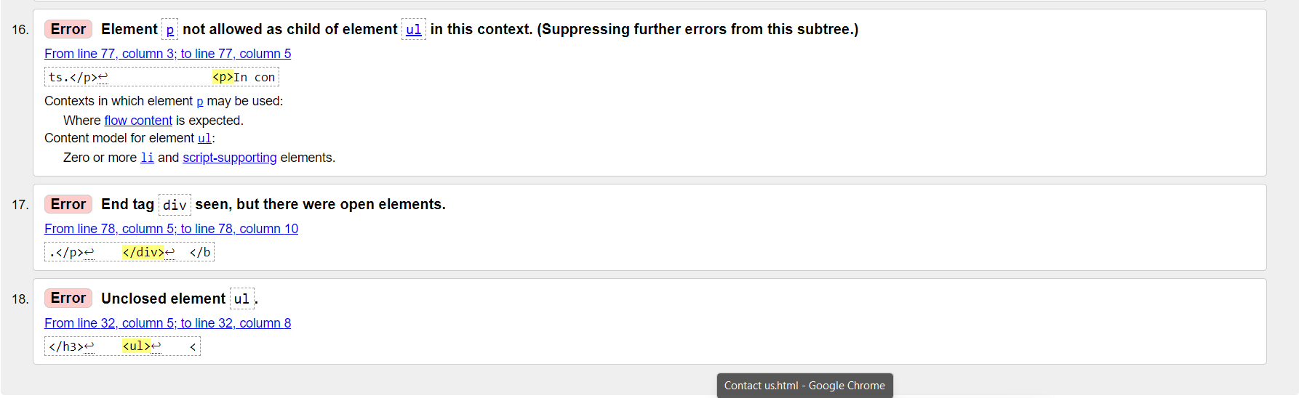
Figure 19 - Validation Results from page three (continuation)

Page Four
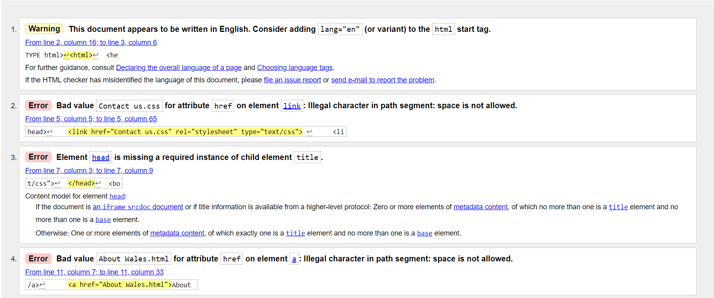
Figure 20 - Validation Results from page four
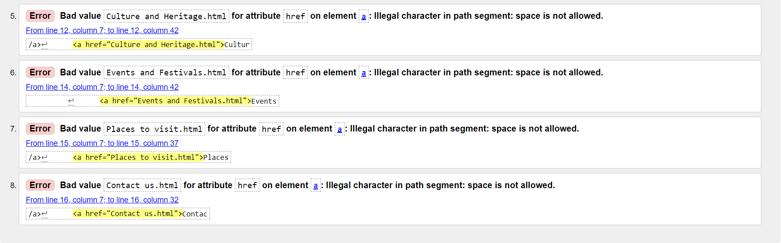
Figure 21 - Validation Results from page four (continuation)

Page Five
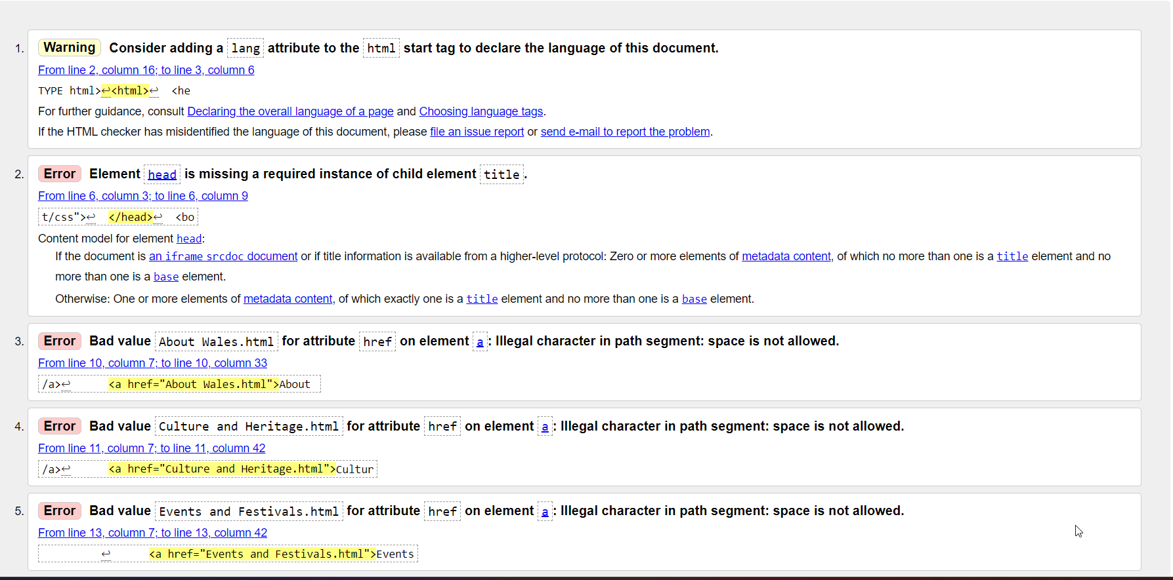
Figure 22 - Validation results from page five
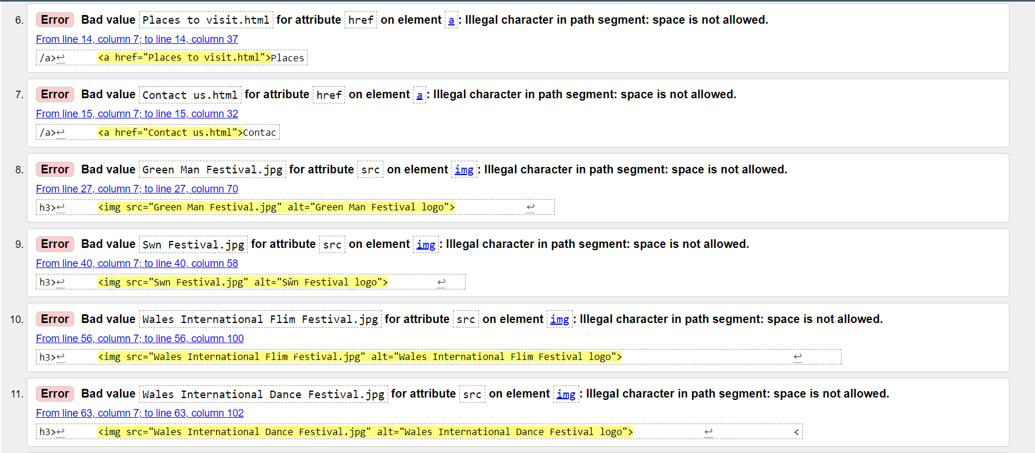
Figure 23 - Validation results from page five (continuation)
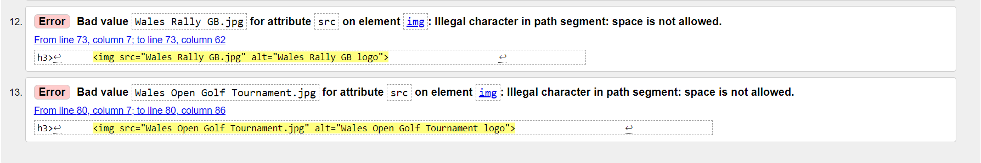
Figure 24 - Validation results from page five(continuation)

Page Six
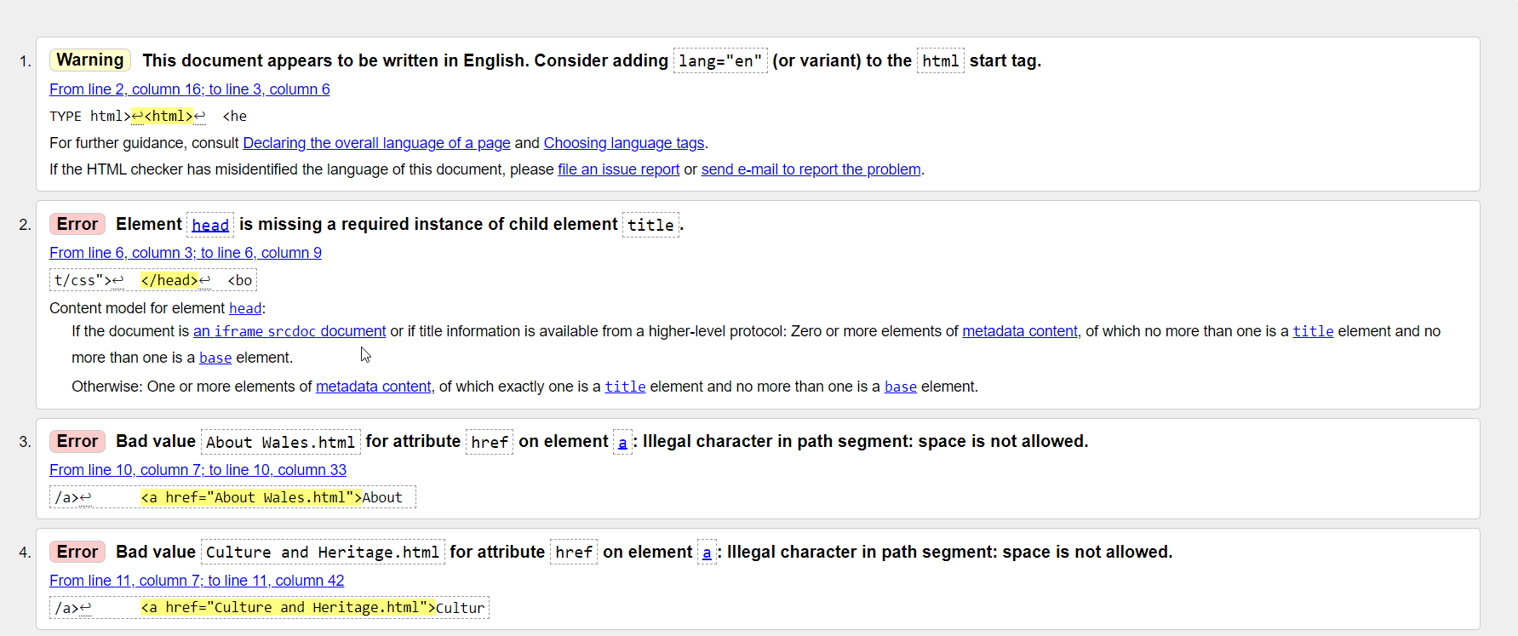
Figure 25 - Validation results for page six
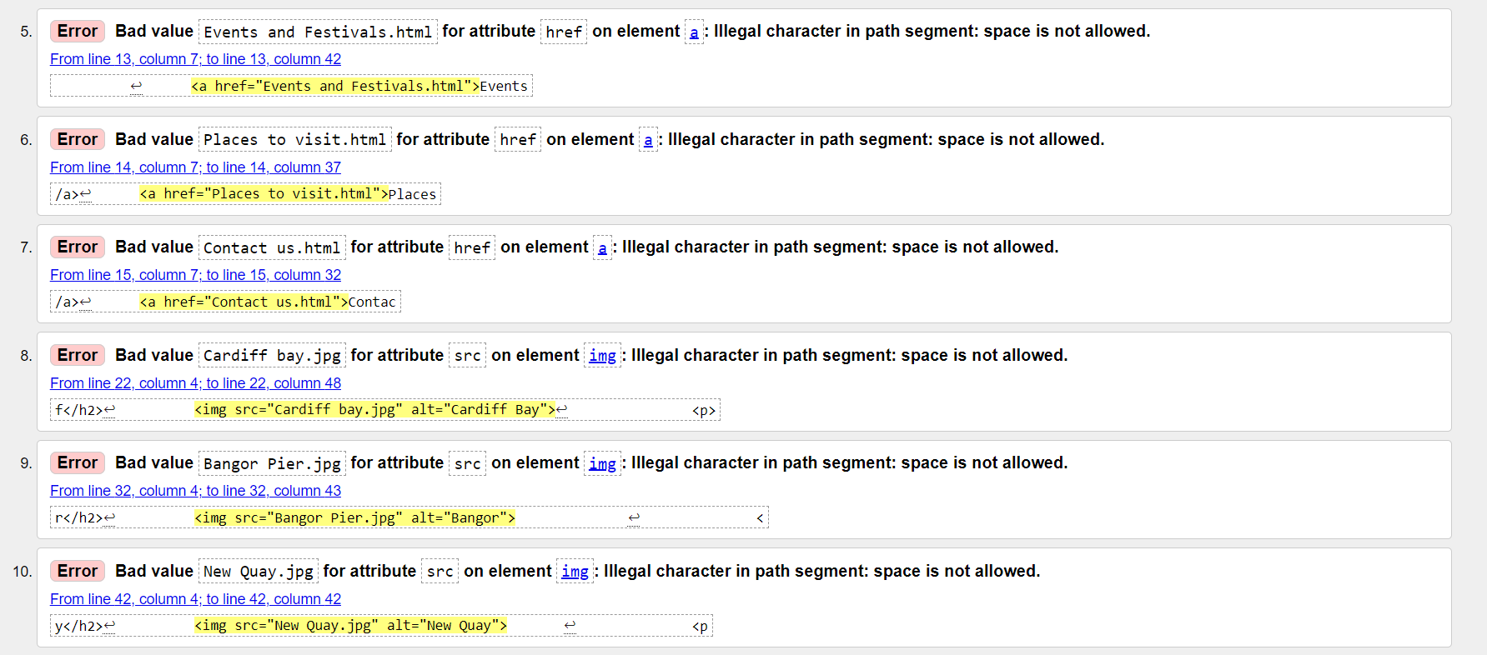
Figure 26 - Validation results for page six (continuation)

Page Seven
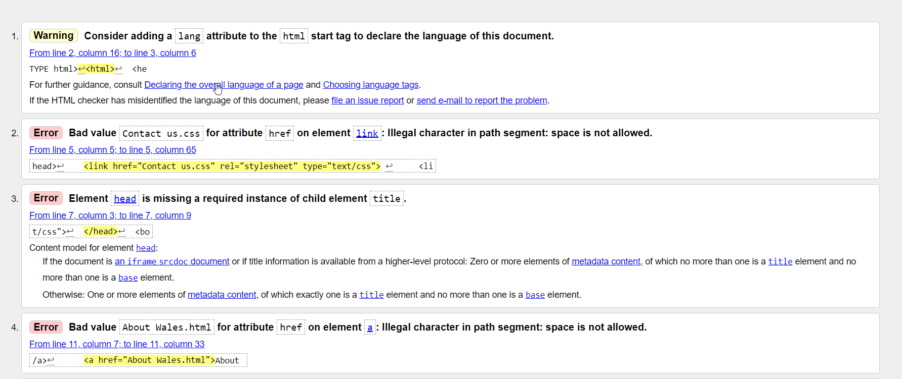
Figure 27 - validation results for page seven
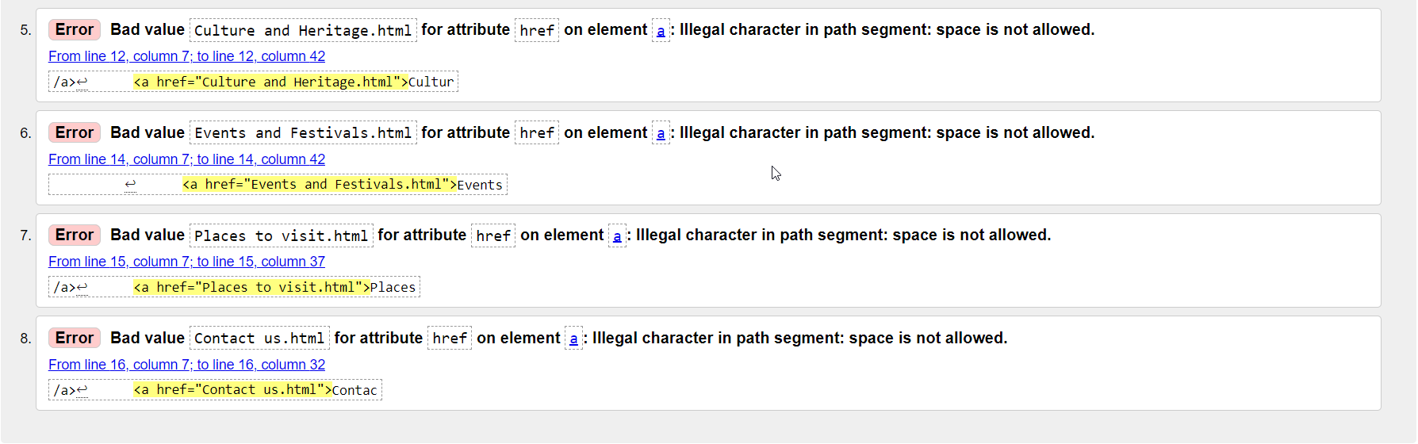
Figure 28 - validation results for page seven (continuation)

CSS Validation

Main CSS for design
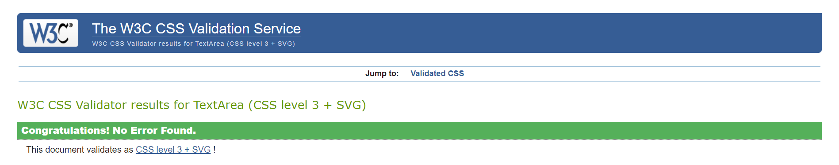
Figure 29 - Validation results for design of webpage

CSS for Contact us form
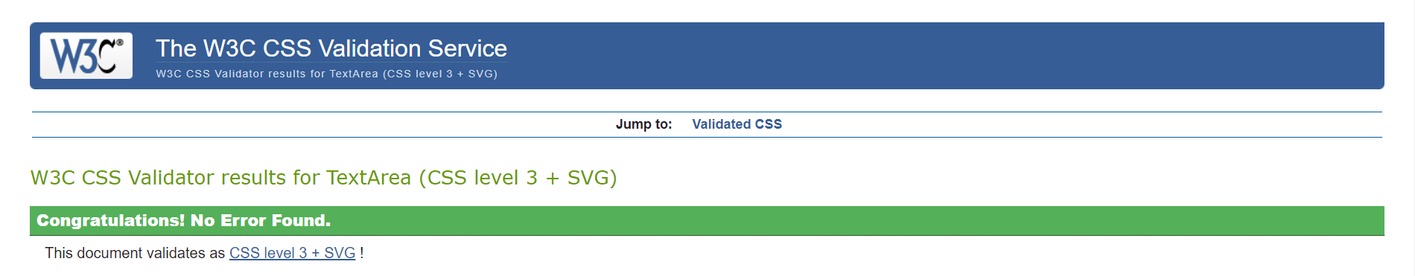
Figure 30 - Validation results for design of contact us form.

Error Messages
Warning: Consider adding a lang attribute to the html start tag to declare the language of this document.
The html start tag does not have a lang attribute. This means that the browser does not know what language the document is in. It is recommended to add a lang attribute to the html start tag, and set the value to the language of the document [5].

Error: Element head is missing a required instance of child element title.
The head element does not have a title element. This means that the document does not have a title. It is recommended to add a title element to the head element, and set the value to the title of the document [6].

Error: Bad value About Wales.html for attribute href on element a: Illegal character in path segment: space is not allowed.
The value of the href attribute on an element is "About Wales.html". This is not a valid value, because it contains a space. The space is not allowed in path segments. It is recommended to remove the space from the value of the href attribute [7].

Error: Element h2 not allowed as child of element ul in this context.
This error is caused by the fact that a heading element (h1, h2, h3, etc.) cannot be nested inside a list element (ul). To fix this error, simply remove the h2 element from the list [8].

Error: Element p not allowed as child of element ul in this context.
This error is caused by the fact that a paragraph element (p) cannot be nested inside a list element (ul). To fix this error, simply remove the p element from the list [9].

Error: End tag div seen, but there were open elements.
This error is caused by the end tag for the div element was encountered before all of the open elements within the div were closed. To fix this error, simply close all of the open elements within the div before closing the div itself [10].

Error: Unclosed element ul.
This error occurs because the ul element was not closed properly. By closing the ul element to repair this problem [8].

Evaluation

Website usability, accessibility, and search engine optimization

Website usability
This refers to the ease with which users can navigate and interact with a website. It is an essential aspect of website design that aims to create a positive user experience. A website that is easy to use and navigate enhances user satisfaction, improves engagement, and increases the chances of retaining visitors [11].
The primary goal of website usability is to ensure that users can achieve their objectives efficiently and effectively. To achieve this goal, website designers need to consider various factors, such as the layout, navigation, content, and accessibility. A well-designed website should provide a seamless user experience and make it easy for users to find what they are looking for [12].
One of the key benefits of website usability is that it can help to increase conversion rates. When users find a website easy to use and navigate, they are more likely to take the desired action, such as making a purchase, filling out a form, or subscribing to a newsletter. A website that is difficult to use, on the other hand, can lead to frustration and abandonment, which can negatively impact conversion rates [13].
Example study: A study by Nielsen Norman Group evaluated the usability of 51 different e-commerce websites. The researchers found that websites with good usability had higher conversion rates and generated more revenue. Specifically, they found that websites with clear product descriptions, easy-to-use shopping carts, and prominent calls to action were more successful in converting visitors into customers [14].

Accessibility
Accessibility is a crucial aspect of web development that ensures that websites, applications, and other digital tools are usable by all individuals, including those with disabilities. Web accessibility enables people with disabilities to effectively use the internet and access digital content, which is essential for their social and economic participation [15].
Web developers play a significant role in creating accessible digital experiences for everyone. They must understand the guidelines and standards set by the Web Content Accessibility Guidelines (WCAG), which provide a framework for making web content more accessible. Developers must also use web development tools and technologies that support accessibility, such as HTML and CSS [16, 15].
There are several reasons why web accessibility is critical in web development. Firstly, it ensures that people with disabilities have equal access to information and services online. Secondly, it improves the usability and user experience for all users, including those without disabilities. Thirdly, it helps organizations comply with legal requirements related to accessibility [15] [16].
Example study: A study by Joseph G. Featherston and Robert M. Siegfried examined the accessibility of US colleges and universities. They found that many websites lacked basic accessibility features, such as alternative text for images and headings, and lacked compliance with accessibility guidelines. The researchers concluded that improving website accessibility was crucial for ensuring equal access to information and services for people with disabilities [17].

Search Engine Optimisation
Search Engine Optimisation (SEO) is a technique used to increase the quantity and quality of traffic to a website through organic search results. SEO plays a vital role in the digital marketing world as it helps in improving the online visibility and search engine ranking of a website [18].
The primary goal of SEO is to make your website more visible to potential customers who are searching for your products or services online. By optimizing your website, you can improve its ranking on search engine results pages (SERPs), and increase the chances of your website appearing at the top of search results for relevant keyword searches [19].
SEO involves various techniques such as keyword research, on-page optimization, off-page optimization, and link building. Keyword research involves identifying the most relevant keywords and phrases that potential customers are using to search for products or services in your industry. On-page optimization involves optimizing the website's content, meta tags, and other elements to make it more search engine friendly [20].
Example study: A study by Cho, Garcia-Molina, and Page proposed a new algorithm for ranking web pages based on their relevance to a user's search query. The researchers found that their algorithm provided more accurate and relevant results than existing algorithms. This study demonstrated the importance of search engine ranking algorithms in improving the effectiveness of search engines [21].

References

[1] | Mozilla, “HTML,” n.d.. [Online]. Available: https://developer.mozilla.org/en-US/docs/Web/HTML. [Accessed 1 May 2023].
[2] | W3 School, “CSS Introducation,” n.d.. [Online]. Available: https://www.w3schools.com/css/css_intro.asp. [Accessed 1 May 223].
[3] | Mozilla, “What is CSS,” n.d.. [Online]. Available: https://developer.mozilla.org/en-US/docs/Learn/CSS/First_steps/What_is_CSS. [Accessed 1 May 2023].
[4] | Z. Philip, “How To Style Text Elements with Font, Size, and Color in CSS,” 24 November 2020. [Online]. Available: https://www.digitalocean.com/community/tutorials/how-to-style-text-elements-with-font-size-and-color-in-css. [Accessed 04 May 2023].
[5] | W3C, “HTML5: Language declaration,” 2011. [Online]. Available: https://www.w3.org/TR/html5/syntax.html#the-doctype. [Accessed 14 May 2023].
[6] | W3C, “HTML5: The title element,” 2011. [Online]. Available: https://www.w3.org/TR/html5/document-metadata.html#the-title-element. [Accessed 14 May 2023].
[7] | W3C, “HTML5: The a element,” 2011. [Online]. Available: https://www.w3.org/TR/html5/text-level-semantics.html#the-a-element. [Accessed 14 May 2023].
[8] | W3C, “HTML5: The ul element,” 2011. [Online]. Available: https://www.w3.org/TR/html5/grouping-content.html#the-ul-element. [Accessed 14 May 2023].
[9] | W3C, “HTML5: The p element.,” 2011. [Online]. Available: https://www.w3.org/TR/html5/grouping-content.html#the-p-element. [Accessed 14 May 2023].
[10] | W3C, “HTML5: The div element.,” 2011. [Online]. Available: https://www.w3.org/TR/html5/grouping-content.html#the-div-element. [Accessed 14 May 2023].
[11] | J. Nielsen , “Usability 101: Introduction to Usability,” 3 January 2012. [Online]. Available: https://www.nngroup.com/articles/usability-101-introduction-to-usability/. [Accessed 14 May 2023].
[12] | S. Krug, Don't Make Me Think, Revisited: A Common Sense Approach to Web Usability (3rd ed.), New Rider, 20114.
[13] | C. Mogilner, “The Impact of Usability on Conversions: Evidence from Eye Tracking,” Journal of Retailing, vol. 91, no. 2, pp. 235-245, 2015.
[14] | J. Nielsen , “Ecommerce Usability Improvements,” 23 October 2011. [Online]. Available: https://www.nngroup.com/articles/ecommerce-improvements/. [Accessed 14 May 2023].
[15] | W3C Web Accessibility Initiative (WAI), “Introduction to Web Accessibility,” n.d.. [Online]. Available: https://www.w3.org/WAI/fundamentals/accessibility-intro/. [Accessed 14 May 2023].
[16] | W3C Web Accessibility Initiative (WAI), “WCAG 2 Overview,” n.d.. [Online]. Available: https://www.w3.org/WAI/standards-guidelines/wcag/. [Accessed 14 May 2023].
[17] | R. M. Siegfried and J. G. Featherston, “Are College Home Pages More Accessible? A Longitudinal Study of the Accessibility of United States College Home Pages,” in Proceedings of the Conference for Information Systems Applied Research, Baltimore, Maryland USA, 2014.
[18] | Google, “Search Engine Optimization (SEO) Starter Guide,” n.d.. [Online]. Available: https://developers.google.com/search/docs/fundamentals/seo-starter-guide. [Accessed 14 May 2023].
[19] | N. Patel, “What is SEO? Your Complete Step-By-Step Guide,” NP Digital, n.d.. [Online]. Available: https://neilpatel.com/what-is-seo/. [Accessed 14 May 2023].
[20] | Search Engine Journal, “SEO for Beginners: An Introduction to SEO Basics,” n.d.. [Online]. Available: https://www.searchenginejournal.com/seo/#download-ebook. [Accessed 14 May 2023].
[21] | J. Cho, L. Page and G.-M. Hector, “Efficient Crawling Through URL Ordering,” 1998. [Online]. Available: http://oak.cs.ucla.edu/~cho/papers/cho-order.pdf. [Accessed 14 May 2023].

Appendices

Home Page

<!DOCTYPE html>
<html>
<head>
<link href="style.css" rel="stylesheet" type="text/css">
</head>
<body>
<div class="navbar">
<a href="Home.html">Home</a>
<a href="About Wales.html">About Wales</a>
<a href="Culture and Heritage.html">Culture and Heritage</a>
<a href="History.html">History</a>
<a href="Events and Festivals.html">Events and Festivals</a>
<a href="Places to visit.html">Places to visit</a>
<a href="Contact us.html">Contact us</a>
</div>

<h1>Wales - Land of Dragons</h1>
<div class="container">
<img src="wales.jpg" alt="Wales">
<p>
Wales is a country located in the western part of Great Britain. It is known for its stunning scenery, rich cultural heritage, and friendly people. The country is home to several National Parks, including the Brecon Beacons and Snowdonia, which are popular destinations for hiking and outdoor activities.
</p>
<p>
Wales is also famous for its musical traditions, including male voice choirs and harp music. The country has produced several world-renowned musicians, including Tom Jones and Shirley Bassey. The Welsh language, which is still spoken by a significant portion of the population, has a rich oral tradition and is considered one of the oldest living Celtic languages.
</p>
<p>
If you're looking to experience Welsh culture and hospitality, there are plenty of festivals and events to choose from throughout the year, including the Cardiff International Festival of Food and Drink and the National Eisteddfod, a celebration of Welsh language, literature, and culture.
</p>
</div>
</body>
</html>

About Page

<!DOCTYPE html>
<html>
<head>
<link href="style.css" rel="stylesheet" type="text/css">
</head>
<body>
<div class="navbar">
<a href="Home.html">Home</a>
<a href="About Wales.html">About Wales</a>
<a href="Culture and Heritage.html">Culture and Heritage</a>
<a href="History.html">History</a>
<a href="Events and Festivals.html">Events and Festivals</a>
<a href="Places to visit.html">Places to visit</a>
<a href="Contact us.html">Contact us</a>
</div>

<h1>About Wales</h1>
<div class="container">
<img src="wales.jpg" alt="Wales">
<h2>Introduction</h2>
<p>Wales is a country located in the western part of the island of Great Britain. It is one of the four countries that make up the United Kingdom, along with England, Scotland, and Northern Ireland. With a population of approximately 3 million people, Wales is a small country but has a rich cultural heritage and history.</p>

<h2>Geography and Climate</h2>
<p>Wales has a varied geography, ranging from the sandy beaches of the south to the mountainous regions in the north and center. The country is home to several mountain ranges, including Snowdonia, which is home to the highest peak in Wales, Mount Snowdon. The country has a temperate maritime climate, characterized by mild temperatures, rainfall throughout the year, and sunshine in the summer months.</p>

<h2>Culture and History</h2>
<p>Wales has a rich cultural heritage, including its own language, music, and folklore. The Welsh language is still widely spoken in Wales today and is an important part of the country's cultural identity. Welsh music, which has its roots in the country's medieval bardic tradition, is also an important part of Welsh culture. The country has a long history, dating back to prehistoric times, and has been an important part of the history of the British Isles. It has played a significant role in several key events in British history, including the Norman Conquest and the Industrial Revolution.</p>

<h2>Sports and Tourism</h2>
<p>Wales is renowned for its sports, particularly rugby. The national rugby team, the Welsh Rugby Union, has a strong following both within Wales and internationally, and the sport is a major part of Welsh cultural identity. In recent years, Wales has also become known for its scenic beauty, attracting tourists from all over the world. Visitors to Wales can enjoy the country's stunning coastline, mountains, and countryside, as well as its rich cultural heritage, including its castles, museums, and historic sites.</p>

<h2>Economy</h2>
<p>Wales has a diverse economy, with industries ranging from manufacturing to tourism. The country is home to several large companies, including Airbus, which has a significant presence in Wales. The country's scenic beauty and rich cultural heritage make it a popular tourist destination, and tourism is a major contributor to the Welsh economy. Other important industries in Wales include financial services, technology, and life sciences.</p>

</div>
</body>
</html>

Culture and Heritage Page

<!DOCTYPE html>
<html>
<head>
<link href="style.css" rel="stylesheet" type="text/css">
</head>
<body>
<div class="navbar">
<a href="Home.html">Home</a>
<a href="About Wales.html">About Wales</a>
<a href="Culture and Heritage.html">Culture and Heritage</a>
<a href="History.html">History</a>
<a href="Events and Festivals.html">Events and Festivals</a>
<a href="Places to visit.html">Places to visit</a>
<a href="Contact us.html">Contact us</a>
</div>

<h1>Culture and Heritage in Wales</h1>
<div class="container">
<img src="wales.jpg" alt="Wales">
<h1>Introduction</h1>
<p>Wales is a country with a rich cultural heritage, deeply rooted in its history, language, music, and traditions. From its ancient castles and standing stones, to its vibrant contemporary arts scene, Wales is a unique and fascinating destination for those interested in culture and heritage.</p>
<h2>Language</h2>
<p>Welsh is the oldest living language in Britain and has been spoken in Wales for over 1,500 years. It is an integral part of Welsh culture and heritage and is still widely spoken today, especially in the north and west of the country. The Welsh language has a rich literary tradition, with a wealth of poetry, prose, and songs, reflecting the stories and traditions of the Welsh people.</p>
<h2>Music</h2>
<p>Music is an important part of Welsh culture, with a rich tradition of singing and playing instruments. The harp is the national symbol of Wales, and the country has a long history of harp music, from medieval times to the present day. Welsh folk music is still widely performed and enjoyed today, and the country has produced many famous musicians, including Tom Jones and Shirley Bassey.</p>
<h2>Traditions</h2>
<p>Wales has a rich tradition of folklore and festivals, many of which are still celebrated today. The country is famous for its Eisteddfod, a festival of Welsh culture that has been held annually for over 800 years. The Eisteddfod features music, dance, poetry, and drama competitions, as well as other events and performances, and is a showcase for the best of Welsh cultural heritage.</p>
<h2>Castles and Standing Stones</h2>
<p>Wales is home to many ancient castles and standing stones, many of which are now tourist attractions. Castles such as Caernarfon, Conwy, and Beaumaris are some of the finest examples of medieval military architecture in Europe, and standing stones such as Stonehenge and the stones at Avebury are among the most mysterious and intriguing prehistoric monuments in the world.</p>
<h3>List of Castles and Standing Stones</h3>
<ul>
<li>
<h4>Caernarfon Castle</h4>
<img src="Caernarfon Castle.jpg" alt="Caernarfon Castle">
<p>Caernarfon Castle is a magnificent medieval castle located in the town of Caernarfon, on the coast of North Wales. It was built by King Edward I in the 13th century and is one of the finest examples of medieval military architecture in Europe. Visitors can explore the castle's many towers and ramparts, as well as its well-preserved chapel and royal palace.</p>
<p>Getting there: Caernarfon Castle is located in the town of Caernarfon and is easily accessible by road or public transport. The nearest train station is Caernarfon, and there are regular bus services to the town from nearby cities.</p>
<p>Opening times: The castle is open every day of the year except for December 24th-26th. Opening times vary depending on the time of year, so it is best to check the official website for the latest information.</p>
</li>
<li>
<h4>Conwy Castle</h4>
<img src="Conwy Castle.jpg" alt="Conwy Castle">
<p>Conwy Castle is another magnificent medieval castle, located in the town of Conwy on the north coast of Wales. It was also built by King Edward I in the 13th century and is one of the best-preserved castles in Europe. Visitors can explore the castle's walls, towers, and ramparts, as well as its impressive gatehouses and great hall.</p>
<p>Getting there: Conwy Castle is located in the town of Conwy and is easily accessible by road or public transport. The nearest train station is Conwy, and there are regular bus services to the town from nearby cities.</p>
<p>Opening times: The castle is open every day of the year except for December 24th-26th. Opening times vary depending on the time of year, so it is best to check the official website for the latest information.</p>
</li>
<li>
<h4>Beaumaris Castle</h4>
<img src="Beaumaris Castle.jpg" alt="Beaumaris Castle">
<p>Beaumaris Castle is a 13th-century castle located in the town of Beaumaris on the Isle of Anglesey, off the coast of North Wales. It is one of the finest examples of medieval military architecture in Europe and is widely regarded as the greatest castle built by King Edward I. Visitors can explore the castle's walls, towers, and ramparts, as well as its impressive gatehouses and great hall.</p>
<p>Getting there: Beaumaris Castle is located in the town of Beaumaris and is easily accessible by road or public transport. The nearest train station is Bangor, and there are regular bus services to the town from nearby cities.</p>
<p>Opening times: The castle is open every day of the year except for December 24th-26th. Opening times vary depending on the time of year, so it is best to check the official website for the latest information.</p>
</li>
<li>
<h4>Caerphilly Castle</h4>
<img src="Caerphilly Castle.jpg" alt="Caerphilly Castle">
<p>Caerphilly Castle is a 13th-century castle located in the town of Caerphilly in South Wales. It is one of the largest castles in Britain and is famous for its concentric castle design and impressive water defenses. Visitors can explore the castle's walls, towers, and ramparts, as well as its impressive gatehouses and great hall.</p>
<p>Getting there: Caerphilly Castle is located in the town of Caerphilly and is easily accessible by road or public transport. The nearest train station is Caerphilly, and there are regular bus services to the town from nearby cities.</p>
<p>Opening times: The castle is open every day of the year except for December 24th-26th. Opening times vary depending on the time of year, so it is best to check the official website for the latest information.</p>
</li>
<li>
<h4>Cardiff Castle</h4>
<img src="Cardiff Castle.jpg" alt="Cardiff Castle">
<p>Cardiff Castle is a medieval castle located in the heart of the city of Cardiff, South Wales. It has a rich history, having been used as a Roman fort, a Norman castle, and a Victorian mansion. Visitors can explore the castle's impressive walls and towers, as well as its grand interiors, including the ornate banqueting hall and opulent apartments.</p>
<p>Getting there: Cardiff Castle is located in the city center of Cardiff and is easily accessible by road or public transport. The nearest train station is Cardiff Central, and there are regular bus services to the castle from nearby cities.</p>
<p>Opening times: The castle is open every day of the year except for December 24th-26th. Opening times vary depending on the time of year, so it is best to check the official website for the latest information.</p>
</li>
<li>
<h4>Raglan Castle</h4>
<img src="Raglan Castle.jpg" alt="Raglan Castle">
<p>Raglan Castle is a 15th-century castle located near the village of Raglan in South Wales. It is known for its impressive gatehouse and Great Tower, as well as its well-preserved interiors and beautiful gardens. Visitors can explore the castle's many rooms and towers, as well as its extensive grounds and formal gardens.</p>
<p>Getting there: Raglan Castle is located near the village of Raglan and is easily accessible by road. There are several car parks nearby, and the nearest train station is Abergavenny, from where there are regular bus services to the village.</p>
<p>Opening times: The castle is open every day of the year except for December 24th-26th. Opening times vary depending on the time of year, so it is best to check the official website for the latest information.</p>
</li>
<h2>Contemporary Arts</h2>
<p>Wales is also home to a thriving contemporary arts scene, with many galleries, museums, and performance spaces showcasing the work of local and international artists. From cutting-edge contemporary art to traditional crafts, Wales has something to offer everyone interested in the arts.</p>
<p>In conclusion, Wales is a country with a rich and diverse cultural heritage, reflecting its history, language, music, and traditions. From ancient castles and standing stones to contemporary arts, there is something for everyone to enjoy in this fascinating and unique country.</p>
</div>
</body>
</html>

History Page

<!DOCTYPE html>
<html>
<head>
<link href="Contact us.css" rel="stylesheet" type="text/css">
<link href="style.css" rel="stylesheet" type="text/css">
</head>
<body>
<div class="navbar">
<a href="Home.html">Home</a>
<a href="About Wales.html">About Wales</a>
<a href="Culture and Heritage.html">Culture and Heritage</a>
<a href="History.html">History</a>
<a href="Events and Festivals.html">Events and Festivals</a>
<a href="Places to visit.html">Places to visit</a>
<a href="Contact us.html">Contact us</a>
</div>

<h1>The History of Wales</h1>
<div class="container">
<img src="wales.jpg" alt="Wales">
<p>Wales has a rich and fascinating history, dating back thousands of years. From the ancient Celts to the Norman conquest, Wales has been shaped by a series of invasions, battles, and cultural influences.</p>
<h2>The Celts</h2>
<p>The Celts were the first inhabitants of Wales, and their influence can still be seen today in the Welsh language and culture. They built hill forts and defend their land against invaders, including the Romans. The Celts believed in a pantheon of gods and goddesses, and they practiced druidry, a form of spirituality that honored nature and the elements. Druidry was eventually suppressed by the Romans, but many of its beliefs and practices were passed down through generations and are still celebrated in modern Welsh culture.</p>
<h2>The Romans</h2>
<p>The Romans invaded Wales in AD 43, but faced resistance from the Celtic tribes. Despite this, they managed to establish several forts and build roads throughout the country. The Roman period marked the beginning of a cultural exchange between the Celts and the Romans, and many aspects of Roman life, such as religion, language, and governance, were adopted by the Welsh people.</p>
<h2>The Norman Conquest</h2>
<p>In 1066, William the Conqueror invaded England, and this had a significant impact on Wales. The Normans built castles and town walls, and established a feudal system that dominated Welsh society for centuries to come. The Normans also introduced the feudal system of land ownership, which had a profound impact on the Welsh economy and social structure. Despite these changes, the Welsh language and culture survived, and the Welsh people continued to resist English rule.</p>
<h2>The Welsh Princes</h2>
<p>Throughout the Middle Ages, Wales was ruled by a series of powerful Welsh princes, who fought for independence and control over the country. In 1282, the last Welsh prince, Llywelyn ap Gruffudd, was killed in battle, and Wales became a conquered nation under the control of the English king. Despite this, the Welsh people continued to resist English rule and maintain their national identity through language, music, poetry, and oral tradition.</p>
<h2>Welsh Identity Today</h2>
<p>Despite centuries of English rule, the Welsh people have maintained a strong sense of their national identity. Today, Wales is a proud and vibrant country with a rich cultural heritage, and a thriving language and arts scene. The Welsh language has been officially recognized as a minority language in Wales, and there are many initiatives to preserve and promote the language and culture. Welsh music and poetry have a long and rich tradition, and Welsh folklore and myth have been passed down through generations and continue to inspire artists and writers today.</p>

</div>
</body>
</html>

Events and Festivals Page

<!DOCTYPE html>
<html>
<head>
<link href="style.css" rel="stylesheet" type="text/css">
</head>
<body>
<div class="navbar">
<a href="Home.html">Home</a>
<a href="About Wales.html">About Wales</a>
<a href="Culture and Heritage.html">Culture and Heritage</a>
<a href="History.html">History</a>
<a href="Events and Festivals.html">Events and Festivals</a>
<a href="Places to visit.html">Places to visit</a>
<a href="Contact us.html">Contact us</a>
</div>

<h1>Events and Festivals</h1>
<div class="container">
<img src="wales.jpg" alt="Wales">
<h2>Introduction</h2>
<p>Wales is a country that celebrates its rich culture and history through a variety of events and festivals throughout the year. From music and food to arts and sports, there is something for everyone in Wales. In this webpage, you will find information about some of the most popular events and festivals in Wales, including how to get there and what to expect.</p>
<h2>Music Festivals</h2>
<ul>
<li>
<h3>Green Man Festival</h3>
<img src="Green Man Festival.jpg" alt="Green Man Festival logo">
<p>The Green Man Festival is a four-day festival of music and arts held in August in the Brecon Beacons National Park. The festival features a lineup of some of the best independent and alternative music acts from around the world, as well as a variety of arts and cultural events. There are also plenty of food and drink options available, including local Welsh produce.</p>
<h4>How to get there:</h4>
<p>The Green Man Festival takes place in the Brecon Beacons National Park in Wales. The nearest airport is Cardiff International Airport, which is approximately a 1-hour drive away. There is also a train station in Abergavenny, which is approximately a 30-minute drive from the festival site. Once you arrive, there are shuttle buses available to take you to and from the festival site.</p>
</li>
<li>
<h3>BBC Radio 1's Big Weekend</h3>
<p>BBC Radio 1's Big Weekend is a two-day music festival featuring some of the biggest names in pop and alternative music. The festival is held in different locations in Wales each year, and is one of the largest free music festivals in the UK. In addition to the music, there are also a variety of food and drink stalls, games, and other activities available for festival-goers to enjoy.</p>
<h4>How to get there:</h4>
<p>The location of BBC Radio 1's Big Weekend changes each year, so it is best to check the festival's website for specific details. In general, the festival is located in a major city or town in Wales and is easily accessible by train or bus. There may also be shuttle buses available from nearby airports or train stations. Once you arrive, there is typically a variety of transportation options available to get you to and from the festival site.</p>
</li>
<li>
<h3>Sŵn Festival</h3>
<img src="Swn Festival.jpg" alt="Sŵn Festival logo">
<p>Sŵn Festival is a three-day music festival showcasing the best of Welsh and international music. The festival takes place in the heart of Cardiff and features a lineup of up-and-coming and established music acts, as well as a variety of other cultural and arts events. There is also a range of food and drink options available, including local Welsh cuisine.</p>
<h4>How to get there:</h4>
<p>Sŵn Festival takes place in the center of Cardiff, the capital city of Wales. Cardiff has its own airport, Cardiff International Airport, which is approximately a 20-minute drive from the city center. There is also a train station in Cardiff, which is connected to the rest of Walesand the UK by a variety of train services. Once you arrive in Cardiff, the festival site is easily accessible by foot or public transportation, such as buses or trains. There may also be shuttle buses available from nearby airports or train stations.</p>
</li>
</ul>
<h2>Arts and Cultural Festivals</h2>
<ul>
<li>
<h3>Wales International Documentary Festival</h3>
<p>The Wales International Documentary Festival is an annual event showcasing the best of Welsh and international documentary films. The festival takes place in Cardiff and features a variety of film screenings, workshops, and other events related to the documentary film genre. There is also a range of food and drink options available, including local Welsh cuisine.</p>
<h4>How to get there</h4>
<p>The Wales International Documentary Festival takes place in Cardiff, the capital city of Wales. Cardiff has its own airport, Cardiff International Airport, which is approximately a 20-minute drive from the city center. There is also a train station in Cardiff, which is connected to the rest of Wales and the UK by a variety of train services. Once you arrive in Cardiff, the festival site is easily accessible by foot or public transportation, such as buses or trains. There may also be shuttle buses available from nearby airports or train stations.</p>
</li>
<li>
<h3>Wales International Film Festival</h3>
<img src="Wales International Flim Festival.jpg" alt="Wales International Flim Festival logo">
<p>The Wales International Film Festival is an annual event showcasing the best of Welsh and international film. The festival takes place in different locations in Wales each year, and features a variety of film screenings, workshops, and other events related to the film industry. There is also a range of food and drink options available, including local Welsh cuisine.</p>
<h4>How to get there</h4>
<p>The location of the Wales International Film Festival changes each year, so it is best to check the festival's website for specific details. In general, the festival is located in a major city or town in Wales and is easily accessible by train or bus. There may also be shuttle buses available from nearby airports or train stations. Once you arrive, there is typically a variety of transportation options available to get you to and from the festival site.</p>
</li>
<li>
<h3>Wales International Dance Festival</h3>
<img src="Wales International Dance Festival.jpg" alt="Wales International Dance Festival logo">
<p>The Wales International Dance Festival is an annual event showcasing the best of Welsh and international dance. The festival takes place in different locations in Wales each year, and features a variety of dance performances, workshops, and other events related to the dance industry. There is also a range of food and drink options available, including local Welsh cuisine.</p>
<h4>How to get there</h4>
<p>The location of the Wales International Dance Festival changes each year, so it is best to check the festival's website for specific details. In general, the festival is located in a major city or town in Wales and is easily accessible by train or bus. There may also be shuttle buses available from nearby airports or train stations. Once you arrive, there is typically a variety of transportation options available to get you to and from the festival site.</p>
</li>
</ul>
<h2>Sports Festivals</h2>
<ul>
<li>
<h3>Wales Rally GB</h3>
<img src="Wales Rally GB.jpg" alt="Wales Rally GB logo">
<p>Wales Rally GB is an annual rally event that takes place in Wales. The rally features some of the best drivers and cars from around the world, competing over a series of stages and special stages throughout Wales. The event is a highlight of the World Rally Championship calendar and attracts a large number of spectators each year.</p>
<h4>How to get there</h4>
<p>Wales Rally GB takes place in different locations throughout Wales each year. The best way to get to the rally will depend on your location and the specific rally stages. Many people choose to drive, but there are also public transportation options available, such as trains and buses. If you're flying into Wales, there are several airports, including Cardiff International Airport and Swansea Airport, which are both connected to the rest of Wales and the UK by a variety of train services. Once you arrive, there is typically a variety of transportation options available to get you to and from the rally stages.</p>
</li>
<li>
<h3>Wales Open Golf Tournament</h3>
<img src="Wales Open Golf Tournament.jpg" alt="Wales Open Golf Tournament logo">
<p>The Wales Open Golf Tournament is an annual event that takes place in Wales. The tournament features some of the best golfers from around the world, competing over a four-day event. The tournament is a highlight of the European Tour calendar and attracts a large number of spectators each year.</p>
<h4>How to get there</h4>
<p>The Wales Open Golf Tournament takes place at a different location in Wales each year. The best way to get to the tournament will depend on your location and the specific tournament venue. Many people choose to drive, but there are also public transportation options available, such as trains and buses. If you're flying into Wales, there are several airports, including Cardiff International Airport and Swansea Airport, which are both connected to the rest of Wales and the UK by a variety of train services. Once you arrive, there is typically a variety of transportation options available to get you to and from the tournament venue.</p>
</li>
</ul>
</div>
</body>
</html>

Places to visit Page

<!DOCTYPE html>
<html>
<head>
<link href="style.css" rel="stylesheet" type="text/css">
</head>
<body>
<div class="navbar">
<a href="Home.html">Home</a>
<a href="About Wales.html">About Wales</a>
<a href="Culture and Heritage.html">Culture and Heritage</a>
<a href="History.html">History</a>
<a href="Events and Festivals.html">Events and Festivals</a>
<a href="Places to visit.html">Places to visit</a>
<a href="Contact us.html">Contact us</a>
</div>

<h1>Places to visit</h1>
<div class="container">
<img src="wales.jpg" alt="Wales">
<h2>Cardiff</h2>
<img src="Cardiff bay.jpg" alt="Cardiff Bay">
<p>Cardiff is the capital city of Wales and is known for its rich history and vibrant cultural scene. It offers plenty of options for visitors looking for somewhere to stay, including luxury hotels, budget-friendly hostels, and cozy bed and breakfasts.</p>
<p>The city is easily accessible by train, bus, or car, and there are many flights to Cardiff International Airport from major cities across the UK and Europe.</p>
<p>When it comes to dining, Cardiff offers a diverse range of options, from traditional Welsh cuisine to international flavors. Some popular restaurants to try include The Potted Pig, Bar 44, and The Gentleman Baristas.</p>
<h2>Swansea</h2>
<img src="Swansea.jpg" alt="Bird eye view of Swansea">
<p>Swansea is a coastal city in Wales that offers a mix of history, culture, and natural beauty. Accommodations in Swansea range from luxury hotels to budget-friendly guesthouses, so there is something for every traveler's needs and budget.</p>
<p>The city is easily accessible by train or bus, and there are several flights to Swansea Airport from major cities in the UK and Ireland.</p>
<p>When it comes to dining, Swansea offers a range of options, from seaside seafood restaurants to traditional Welsh pubs. Some popular places to eat include The King's Head, The Pump House, and The No Sign Wine Bar.</p>
<h2>Bangor</h2>
<img src="Bangor Pier.jpg" alt="Bangor">
<p>Bangor is a historic city in north Wales known for its picturesque setting and strong Welsh heritage. Visitors can choose from a variety of accommodations, including hotels, guesthouses, and bed and breakfasts, to suit their budget and preferences.</p>
<p>Bangor is accessible by train, bus, or car, and there are several flights to Liverpool John Lennon Airport, which is about an hour's drive away.</p>
<p>When it comes to dining, Bangor offers a mix of traditional Welsh cuisine and international options. Some popular places to eat include Sarnies, The Marram Grass, and Sospan.</p>
<h2>Aberystwyth</h2>
<img src="Aberystwyth.jpg" alt="Aberystwyth">
<p>Aberystwyth is a charming coastal town in West Wales known for its Victorian architecture and stunning seafront. Accommodation options include hotels, guesthouses, and holiday rentals to suit all budgets and needs.</p>
<p>The town is easily accessible by train or bus and there are several flights to nearby airports including Cardiff International and Birmingham International.</p>
<p>Aberystwyth has a range of dining options, from traditional Welsh pubs and seafood restaurants to international cuisine. Some popular places to eat include The Borth Kitchen, The Old Collage, and Trawsnewid.</p>
<h2>New Quay</h2>
<img src="New Quay.jpg" alt="New Quay">
<p>New Quay is a picturesque fishing village in West Wales known for its gorgeous coastal scenery and charming Welsh architecture. Accommodation options include holiday rentals, bed and breakfasts, and guesthouses.</p>
<p>New Quay is easily accessible by car or bus, and there are several flights to nearby airports including Cardiff International and Swansea Airport.</p>
<p>When it comes to dining, New Quay offers a variety of seafood restaurants and traditional Welsh pubs. Some popular places to eat include The Crab Shack, The Dolphin Inn, and The Tafarn Sinc.</p>
<h2>St Davids</h2>
<img src="St Davids.jpg" alt="St Davids">
<p>St Davids is a small city in West Wales known for its beautiful cathedral and stunning coastal scenery. Accommodation options in St Davids include hotels, guesthouses, and holiday rentals to suit all budgets and needs.</p>
<p>The city is easily accessible by car or bus, and there are several flights to nearby airports including Cardiff International and Bristol International.</p>
<p>St Davids has a range of dining options, including seafood restaurants, traditional Welsh pubs, and international cuisine. Some popular places to eat include The Bishops, The Farmers Arms, and The Gannet's Nest.</p>
</div>
</body>
</html>

Contact Us Page

<!DOCTYPE html>
<html>
<head>
<link href="Contact us.css" rel="stylesheet" type="text/css">
<link href="style.css" rel="stylesheet" type="text/css">
</head>
<body>
<div class="navbar">
<a href="Home.html">Home</a>
<a href="About Wales.html">About Wales</a>
<a href="Culture and Heritage.html">Culture and Heritage</a>
<a href="History.html">History</a>
<a href="Events and Festivals.html">Events and Festivals</a>
<a href="Places to visit.html">Places to visit</a>
<a href="Contact us.html">Contact us</a>
</div>

<h1>Contact Us</h1>
<div class="container">
<img src="Wales.jpg" alt="Wales">
<form method="post" enctype="text/plain">
<label for="name">Name:</label>
<input type="text" id="name" name="name"><br><br>
<label for="email">Email:</label>
<input type="email" id="email" name="email"><br><br>
<label for="message">Message:</label>
<textarea id="message" name="message" rows="5"></textarea><br><br>
<input type="submit" value="Submit">
</form>
</div>
</body>
</html>

CSS for the form
<style>
form {
width: 50%;
margin: 0 auto;
padding: 20px;
border: 1px solid gray;
border-radius: 10px;
}

label {
font-weight: bold;
margin-top: 10px;
display: block;
}

input[type="text"],
input[type="email"],
textarea {
width: 100%;
padding: 10px;
margin-top: 10px;
border: 1px solid gray;
border-radius: 5px;
}

input[type="submit"] {
width: 100%;
padding: 10px;
margin-top: 10px;
background-color: green;
color: white;
border: none;
border-radius: 5px;
cursor: pointer;
}
</style>

CSS for the Style
body {
font-family: Arial, sans-serif;
background-color: #b3b2ad ;
}

h1 {
text-align: center;
font-size: 48px;
color: #333;
margin-top: 50px;
}

h2 {
text-align: center;
font-size: 34px;
color: #333;
margin-top: 50px;
}

h3 {
font-size: 28px;
color: #333;
margin-top: 50px;
}

h4 {
font-size: 24px;
color: #333;
margin-top: 50px;
}

.container {
width: 80%;
margin: 0 auto;
text-align: left;
padding: 50px;
box-sizing: border-box;
}

img {
width: 100%;
height: auto;
margin-bottom: 20px;
}

p {
font-size: 18px;
line-height: 1.5;
color: #555;
}

.navbar {
background-color: #333;
padding: 10px;
text-align: center;
}

.navbar a {
color: #fff;
text-decoration: none;
margin: 0 10px;
font-size: 18px;
}

