

Student name: Catalin Sion
Student ID: 2611669

Assessment 1 – Reading Task T
PART 1: Upload your photo of your A3 in-class notes here:
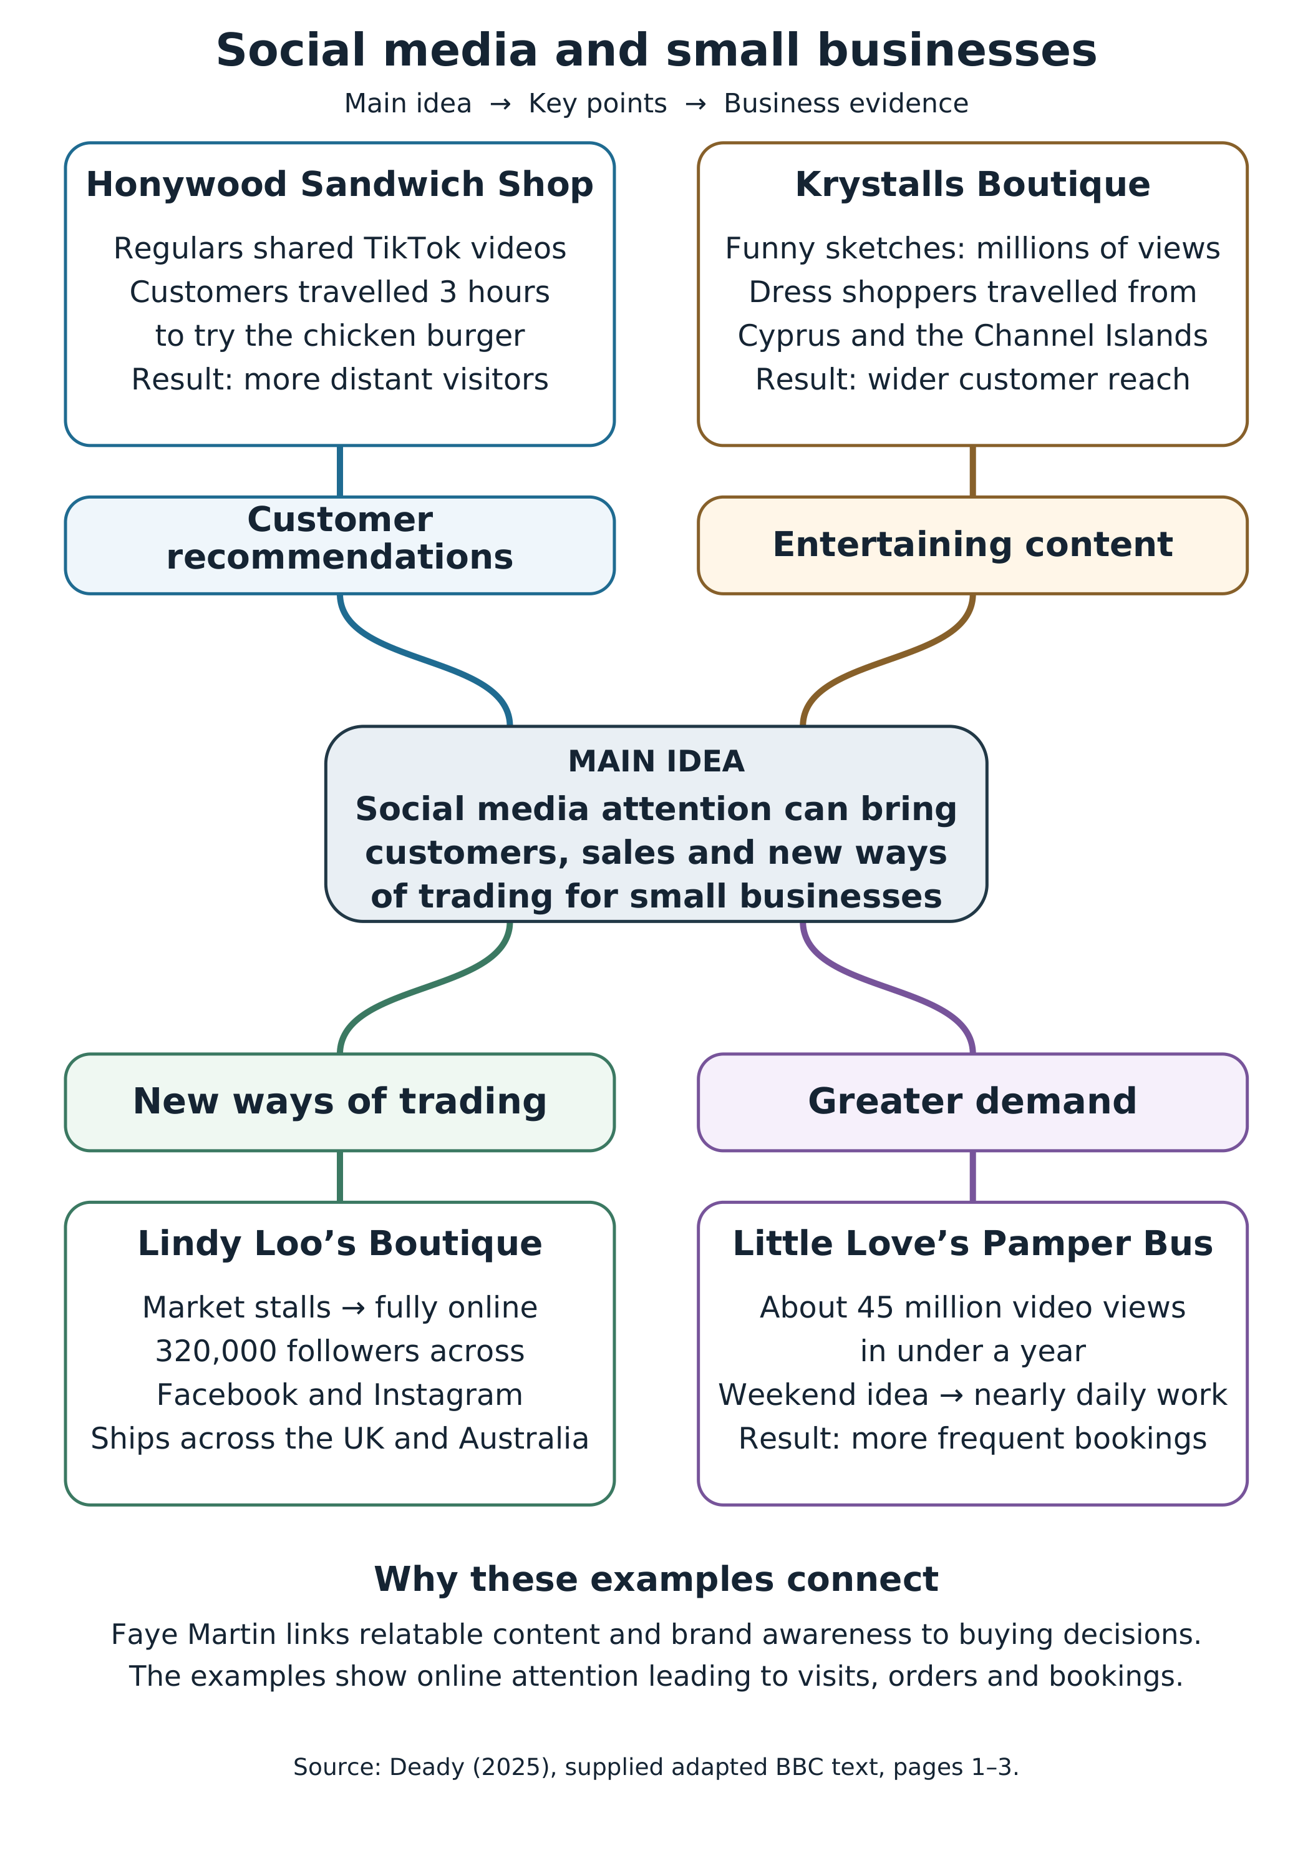
PART 2:
1. What is the main idea of the whole text?
The general concept is that Social media can help small business owners find customers, boost their sales and alter the way they do business (Deady, 2025).
2. What is one key point that supports the main idea, and which specific example from the text shows this?
One of the major things to note is that the posts that customers make on social media can drive visitors to a business from a much greater distance. In Basildon some people went to Honywood Sandwich Shop to eat the chicken burger after users uploaded videos of the product, as online reviews can help customers choose where to eat (Deady, 2025).
3. What is a different key point that supports the main idea, and which specific example from the text shows this?
Another interesting aspect is that social media can alter the way that an owner sells his products. Linda Hunter took Boutique from the market stalls to an all digital trading platform with videos posted, now delivering clothes throughout the UK and Australia reflecting the market's reach beyond its local customers (Deady, 2025).
4. Which part of the text do you think is most important, and why?
I believe the most important part is what Faye Martin said about relatable content because this is what is bringing the business stories together and what may cause people to purchase. The fact that Krystalls Boutique's humorous sketches caught the attention of Cypriots and Channel Islanders (Deady, 2025) makes sense when considering her message to create brand awareness in everyday situations.
Reflection
5. What did you find difficult in this task (including in-class components), and why was it difficult?
It was hard to distinguish the main idea from the business situations in the individual responses because there were a few business situations that shared similar benefits and it was easy to repeat the same idea with another benefit in the answers.
6. What helped you with this difficulty, and how did it help you?
The mind map was structured using the key features of the main idea, key point and example, and this helped me to establish links between each business and relate it to a wider message and select two separate ideas to answer for.
Supporting reading
Social media marketing links content to customer feedback and sales, offering valuable context for the examples of social media marketing used in business in the article (Albrecht, Green and Hoffman, 2023). Advice on organic growth includes ways that unpaid recommendations can help raise awareness and trust (Business.gov.uk, n.d.). Instagram training involves establishing a business presence and content planning, and visual note making leverages keywords and connections to structure content (Meta Blueprint, 2023; University of Leeds, n.d.).

References
Albrecht, M.G., Green, M. and Hoffman, L. (2023) ‘16.2 Social media and mobile marketing’, Principles of Marketing. Houston, TX: OpenStax. Available at: https://openstax.org/books/principles-marketing/pages/16-2-social-media-and-mobile-marketing (Accessed: 24 October 2026).
Business.gov.uk (n.d.) Using social media to promote and sell internationally. Available at: https://www.business.gov.uk/export-from-uk/learn/categories/prepare-sell-new-country/digital-marketing/using-social-media-to-promote-and-sell-internationally/ (Accessed: 24 October 2026).
Deady, E. (2025) ‘Viral chicken shop draws customers from hours away’, BBC News, 19 October. Adapted text supplied for this assessment as If you post it, they will come: The businesses turning likes into livelihoods. Available at: https://www.bbc.co.uk/news/articles/cm2701py5npo (Accessed: 24 October 2026).
Meta Blueprint (2023) Instagram marketing, 1 May. Available at: https://www.facebookblueprint.com/student/collection/507784-instagram-marketing (Accessed: 24 October 2026).
University of Leeds (n.d.) Note making techniques. Available at: https://library.leeds.ac.uk/info/1401/academic-skills/85/note-making/3 (Accessed: 24 October 2026).

