Coursework Title
Module Name: Computer Architecture & OS
Module Code: ACCA4022
Student Name: Marcus Gilkes
Student ID: 2529012
Lecturer Name: Dr MD Shantanu Islam

Submission date: 22/07/2026

Contents
Introduction 3
Key functions of general Operating Systems 4
Task management: 4
Application/Program Management: 5
File/Directory Management: 6
Device Management: 7
Security Management: 7
Use of Windows OS CLI commands 8
Example 1: dir 8
Example 2: cd 9
Example 3: mkdir 9
Example 4: rmdir 10
Example 5: rename 10
Example 6: ipconfig 11
Example 7: netstat 11
Example 8: systeminfo 12
Example 9: tasklist 12
Example 10: ping 13
Use of Linux OS CLI commands 13
Example 1: pwd 14
Example 2: su 14
Example 3: ls 14
Example 4: cd 15
Example 5: mkdir 15
Example 6: rmdir 16
Example 7: touch 16
Example 8: echo and cat 17
Example 9: ifconfig 17
Example 10: whoami and date 18
Use of Windows OS scripts 18
Example 1: 19
Example 2: 19
Use of Linux OS scripts 20
Example 1: 20
Example 2: 21
Conclusion 22
References 23
Appendices 24

Introduction

Operating systems are essential software components that manage computer hardware, software resources, and user interaction. They provide the foundation for running applications, managing files, allocating memory, controlling devices, and maintaining system security [1]. Modern operating systems such as Microsoft Windows and Linux support multitasking, resource management, graphical and command-line interfaces, and automation through scripting.

This report explores the key functions of general operating systems, including task management, application management, file and directory management, device management, and security management. It then examines the use of command-line interface commands in both Windows and Linux, demonstrating how these tools support system navigation, file handling, network configuration, and process monitoring [2]. Finally, the report discusses Windows Batch scripting and Linux Bash scripting, showing how scripts can automate repetitive tasks and improve efficiency in system administration [3].

Key functions of general Operating Systems
General operating systems perform a range of essential functions that allow computer systems to operate efficiently, securely, and reliably. These functions include task management, application management, file and directory management, device management, and security management. By coordinating hardware, software, and user activity, the operating system acts as an interface between the user and the computer system [5].

Microsoft Windows is a widely used example of a general-purpose operating system. It provides graphical tools, system utilities, networking features, and security controls that allow users to manage everyday computing tasks. In this section, Windows is used to demonstrate how the main operating system functions support system performance, user productivity, and secure computing environments [6].

These functions allow the operating system to link users, application software, and computer hardware. Without this management, users would need to control hardware resources manually, which would be inefficient and difficult. By managing processes, memory, files, devices, and security automatically, the operating system maintains performance, usability, reliability, and consistency across the computer system.

Task management:
Task management controls the execution of processes and applications. The operating system allocates processor time, manages multitasking, schedules processes, and switches between tasks so that multiple programs appear to run at the same time [7].

Windows Task Manager allows users to monitor applications, background processes, CPU usage, memory consumption, disk activity, and network performance. It also enables users to terminate unresponsive applications and identify processes using excessive resources, making it useful for troubleshooting slow performance [8].

Effective task management improves responsiveness, performance, and stability by ensuring that applications share system resources appropriately and that no single program consumes excessive resources [7].

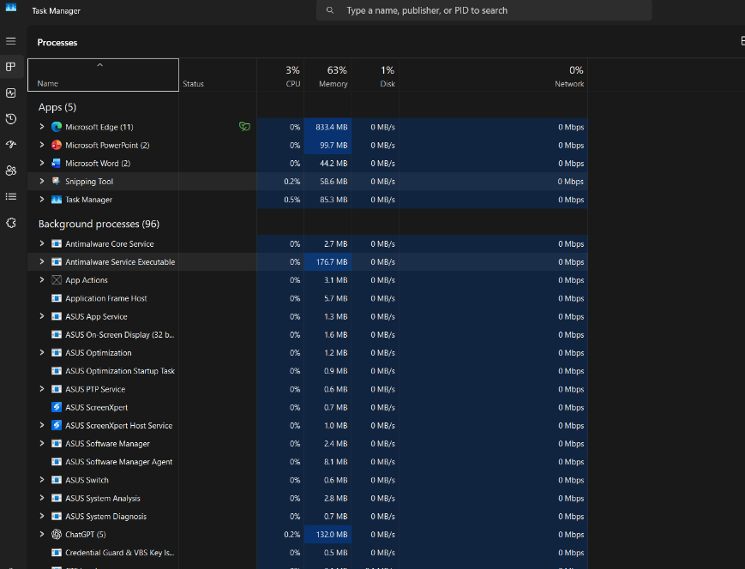
Figure 1: Screenshot of task management

Application/Program Management:
Application management enables users to install, run, update, monitor, and remove software in Windows. The operating system provides the memory, processor time, storage access, and permissions needed for applications to function correctly, while also helping prevent conflicts and support system stability [6].

Windows tools such as Settings, Control Panel, Task Manager, and Apps & Features allow users to manage installed applications, configure default programs, control startup apps, and monitor software performance. These tools help remove unnecessary software and maintain an efficient computing environment [5].

Effective application management improves productivity, compatibility, and security by ensuring software is updated, configured, and managed appropriately, while reducing performance issues caused by unnecessary background applications [6].

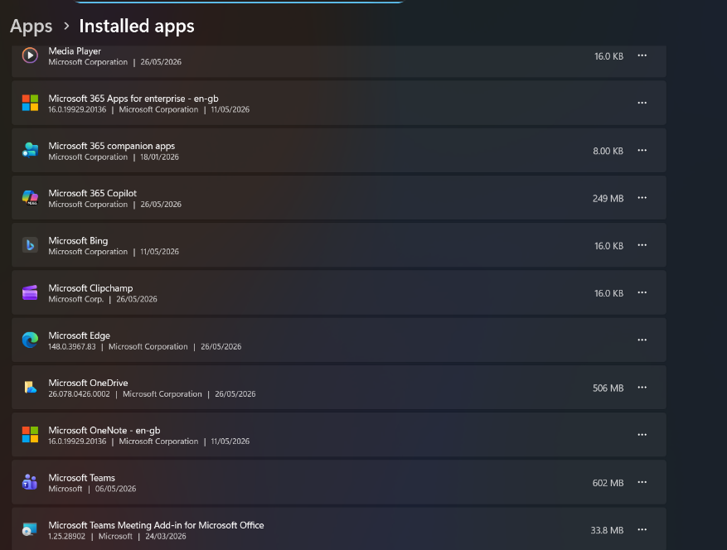
Figure 2: Screenshot of application management

File/Directory Management:
File and directory management enables users to organise, store, retrieve, and manage information on computer systems. Operating systems provide structured file systems for creating folders, naming files, arranging data into directories, and controlling how information is saved and accessed. This improves organisation, security, and the ability to locate information quickly [2].

Windows uses the NTFS file system, which provides advanced features such as file permissions, encryption, compression, and disk quotas. Users can create, copy, move, rename, and delete files and folders through File Explorer or command-line tools such as dir, copy, move, and del [9]. These tools allow both graphical and command-line methods of managing stored data, which is useful for everyday users as well as system administrators.

Effective file and directory management supports data protection, organisation, and efficient storage use. It helps prevent misplaced files, reduces duplication, and allows access permissions to protect sensitive data, especially in multi-user systems.

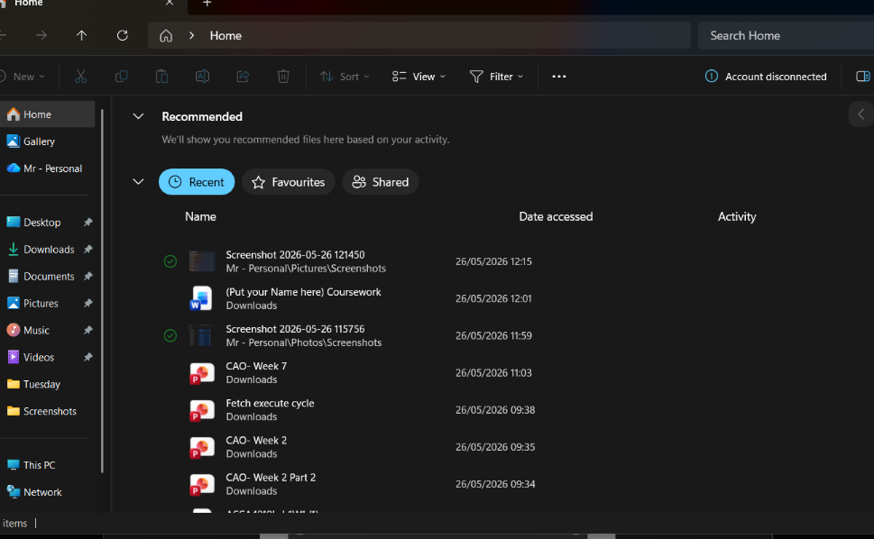
Figure 3: Screenshot of file management

Device Management:
Device management enables Windows to communicate with hardware such as printers, keyboards, storage devices, network adapters, and monitors through device drivers [3]. Device Manager allows users to view hardware, update drivers, troubleshoot problems, and disable malfunctioning devices, while Plug and Play automatically detects and configures compatible hardware. Effective device management supports hardware compatibility, system stability, and reliable performance [3].

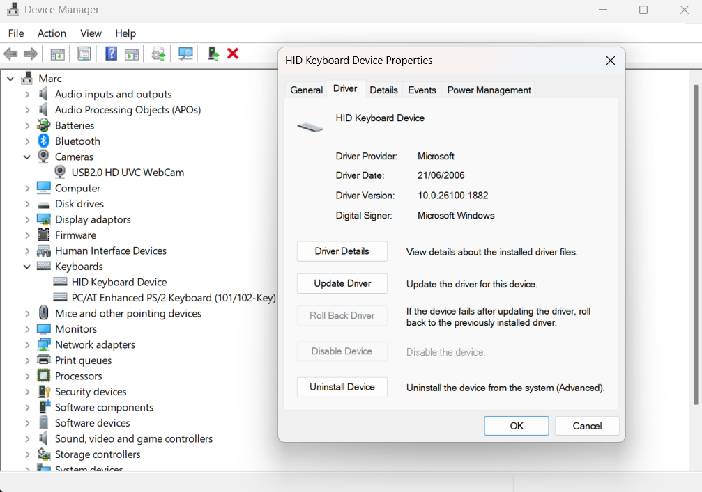
Figure 4: Screenshot of device management

Security Management:
Security management protects computer systems, user accounts, applications, and data from unauthorised access and cyber threats. Windows provides features such as Microsoft Defender Antivirus, Windows Firewall, BitLocker encryption, and User Account Control (UAC) to reduce malware, unauthorised access, and other security risks [9]. These features can be monitored and configured through the Windows Security application.
Effective security management helps maintain the confidentiality, integrity, and availability of information. It reduces exposure to cyberattacks and provides a safer environment for users, applications, and stored data [9].

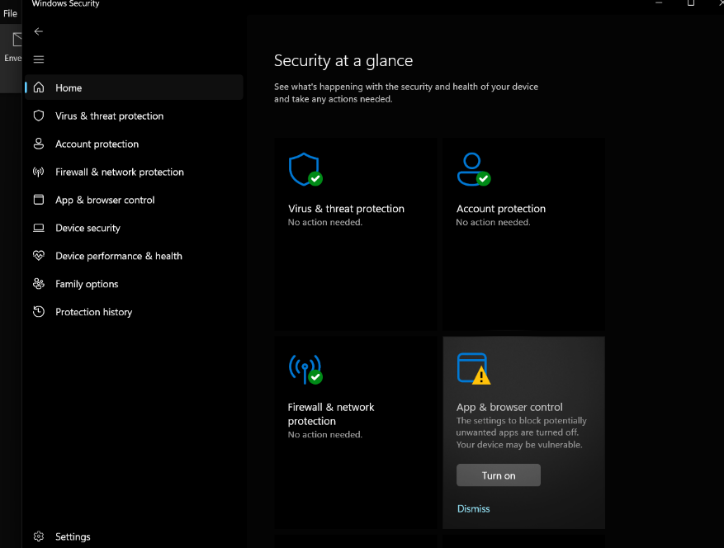
Figure 5: Screenshot of security management

Use of Windows OS CLI commands
The Windows Command Line Interface (CLI) provides a text-based environment for file management, network troubleshooting, process monitoring, and system administration. Command Prompt and PowerShell improve efficiency by allowing users to perform tasks quickly through commands [4].

Example 1: dir
The dir command displays files, folders, sizes, and modification dates in the current directory, helping users view and manage stored information efficiently.

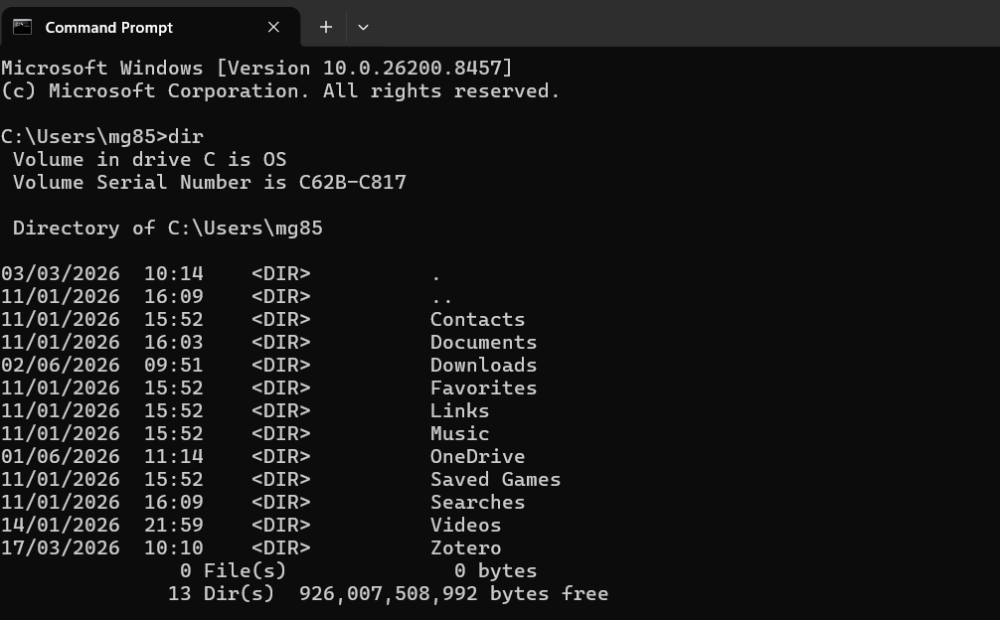
Figure 6: Dir

Example 2: cd
The cd command changes the current working directory and demonstrates how users navigate through the Windows file system from the command line.

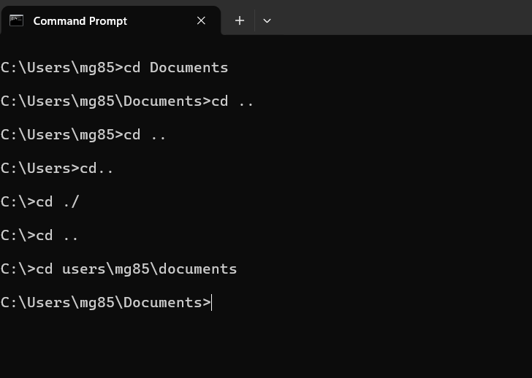
Figure 7: cd

Example 3: mkdir
The mkdir command creates a new directory or folder, and the output confirms that the folder has been created successfully.

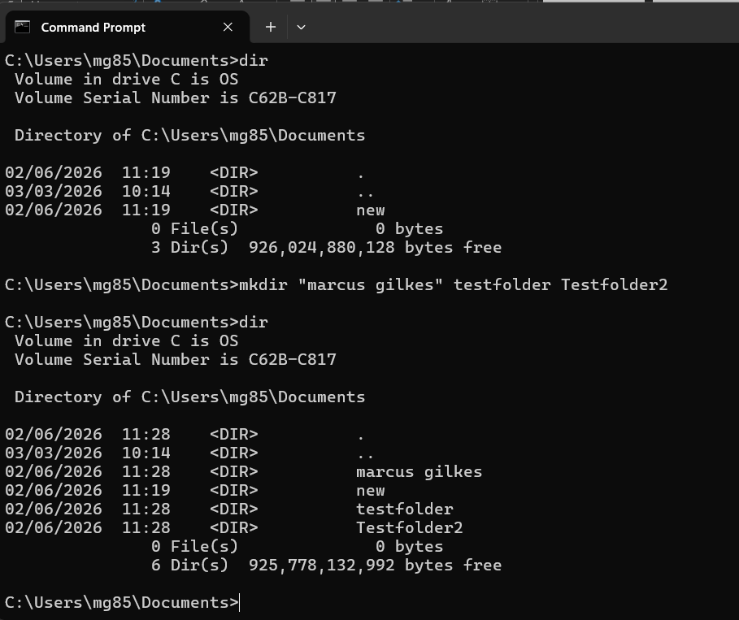
Figure 8: mkdir

Example 4: rmdir
The rmdir command removes an existing empty directory. The output shows that the selected folders have been deleted successfully from the current working directory.

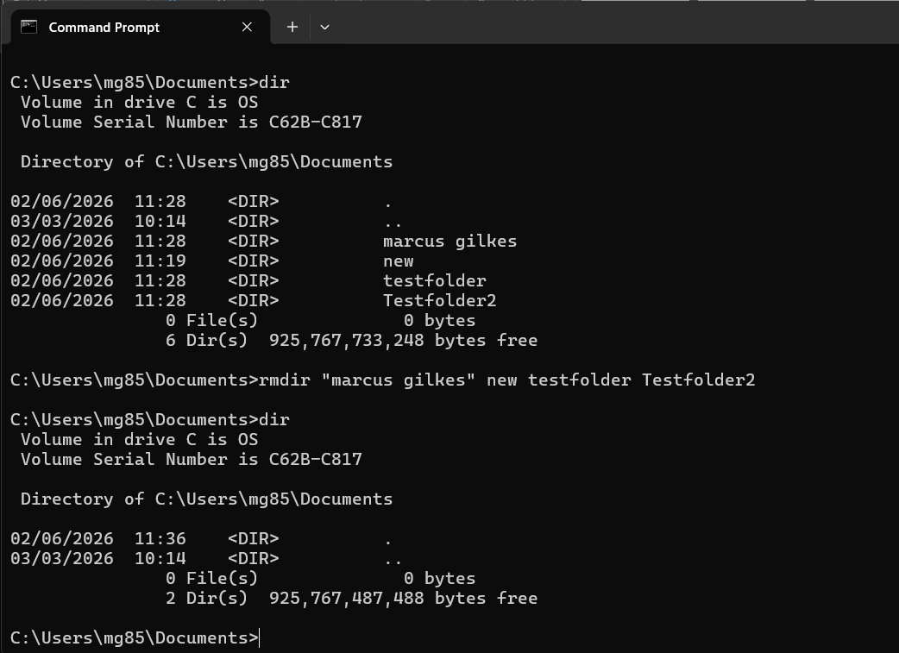
Figure 9: Rmdir

Example 5: rename
The rename command changes the name of a file or folder. The output demonstrates that the folder name has been updated while the contents remain unchanged.
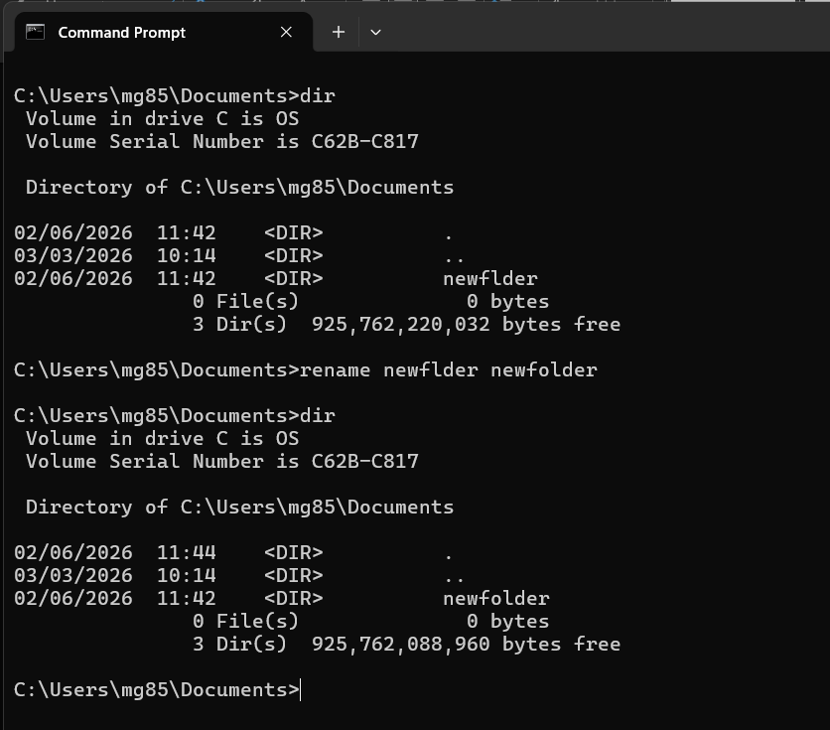
Figure 10: rename folder

Example 6: ipconfig
The ipconfig command displays network configuration details, including IP address, subnet mask, and default gateway, which are useful for troubleshooting connectivity issues.

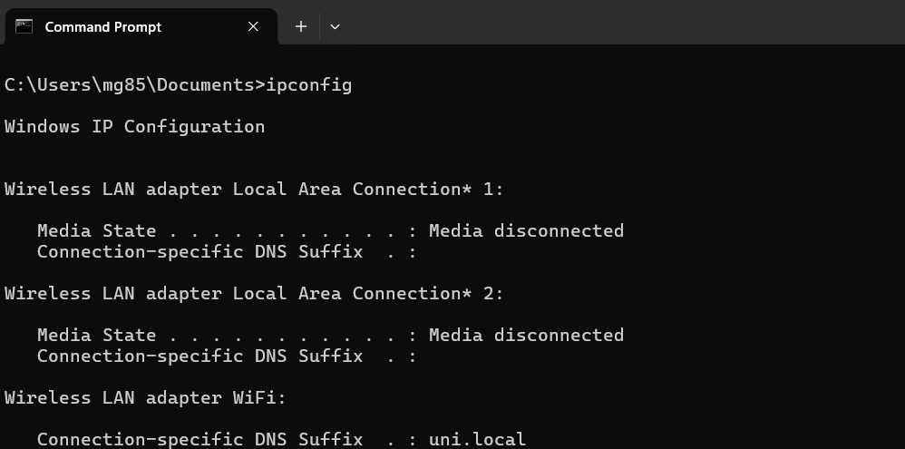
Figure 11: Ipconfig

Example 7: netstat
The netstat command displays active network connections and listening ports. The output helps administrators monitor network activity and identify communication between the computer and remote systems.
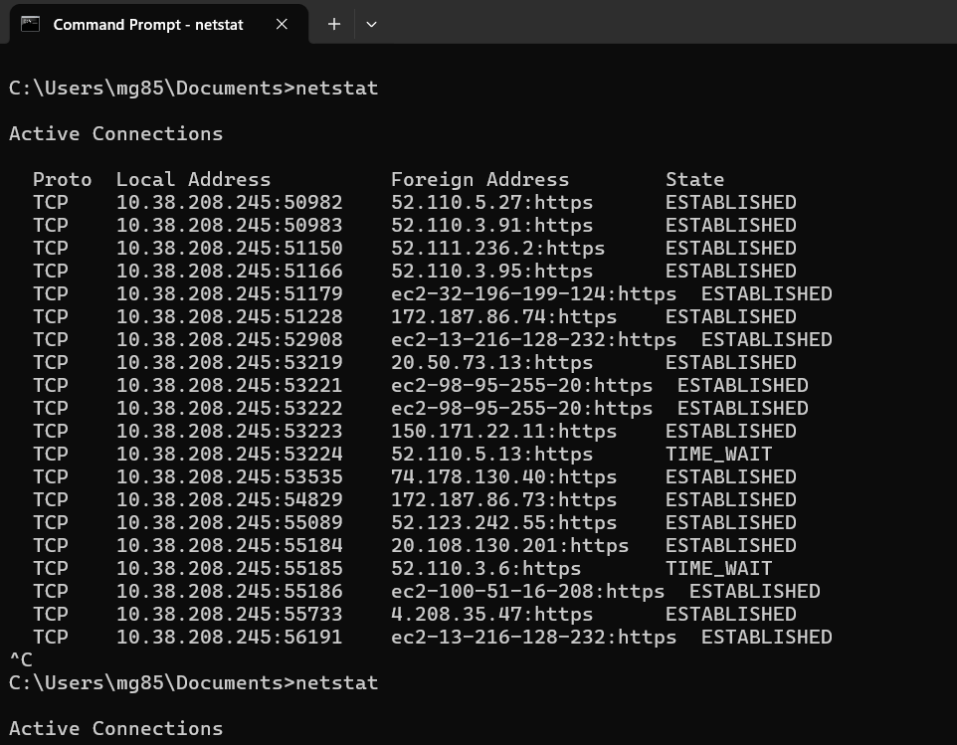
Figure 12: Netstat

Example 8: systeminfo
The systeminfo command displays system details such as operating system version, processor information, memory capacity, and configuration settings.

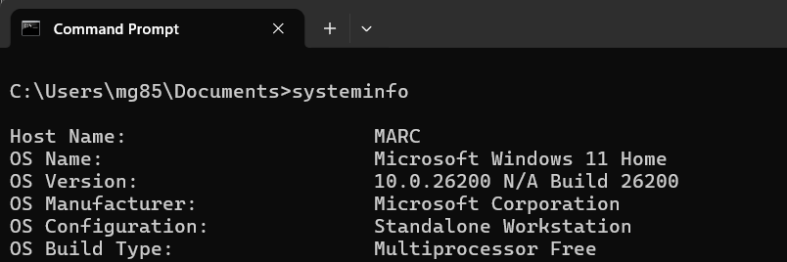
Figure 13: Systeminfo

Example 9: tasklist
The tasklist command displays running processes, including process names, process identifiers (PIDs), and memory usage.

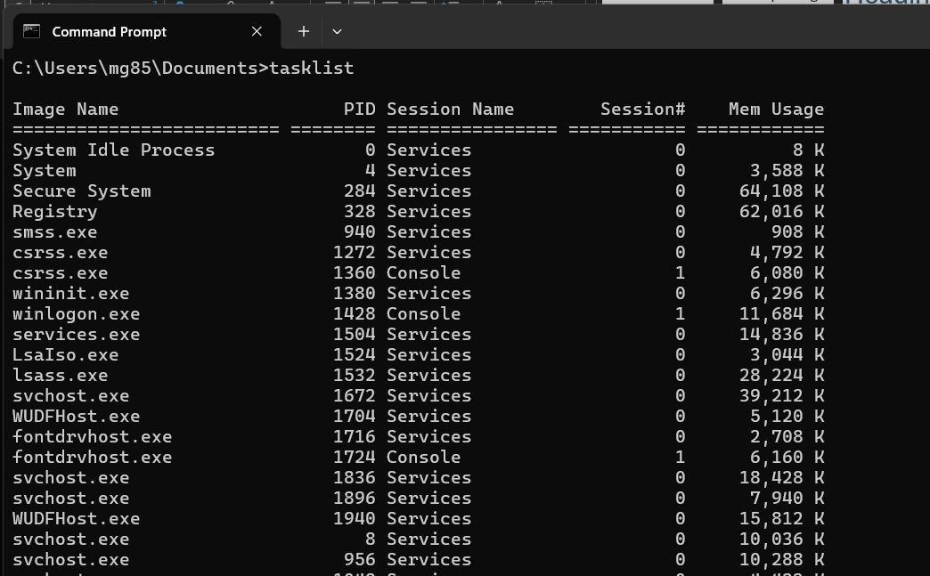
Figure 14: Tasklist

Example 10: ping
The ping command tests communication between network devices. The output displays response times and packet statistics, helping users verify network connectivity and diagnose communication issues.
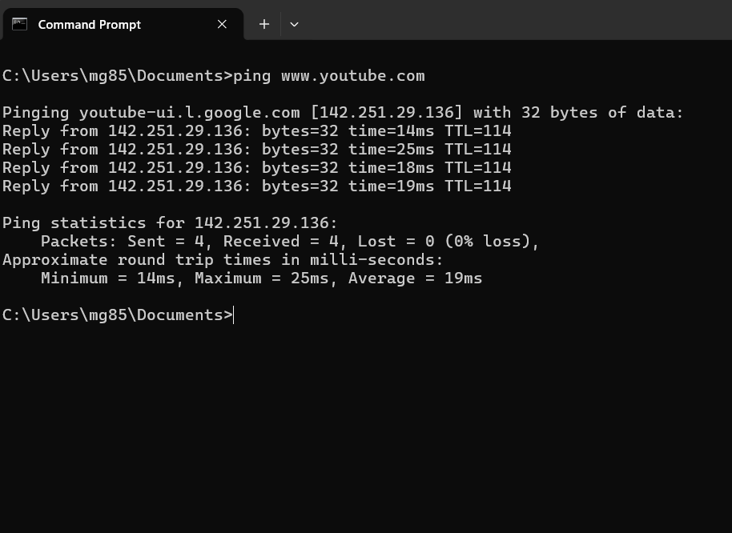
Figure 15: Ping

Use of Linux OS CLI commands
The Linux Command Line Interface provides direct access to operating system functions and administrative tools. Commands allow users to manage files, processes, users, and network settings efficiently, making the CLI widely used for troubleshooting and automation [6], [10].

Example 1: pwd
The pwd command displays the current working directory. The output shows the complete path of the directory where the user is currently operating.

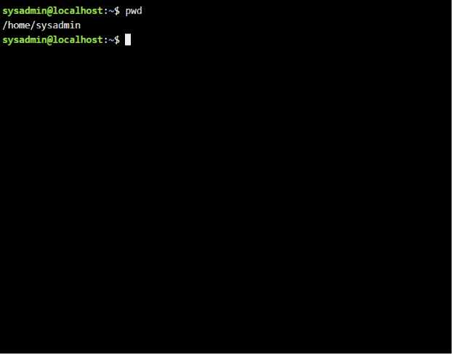
Figure 16: Pwd (present working directory)

Example 2: su
The su command allows a user to switch to another user account after successful authentication.

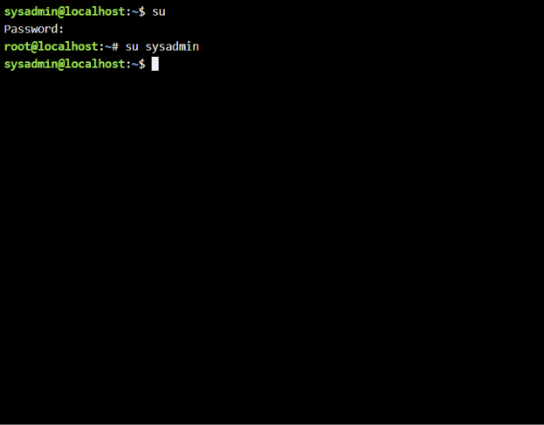
Figure 17: SU switch user

Example 3: ls
The ls command lists files and directories stored within the current location. The output displays file names, folders, and additional information when options are used.

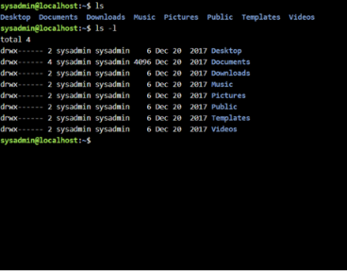
Figure 18: ls

Example 4: cd
The cd command changes the current directory location. The output confirms navigation to the Desktop folder and demonstrates movement through the Linux file system.

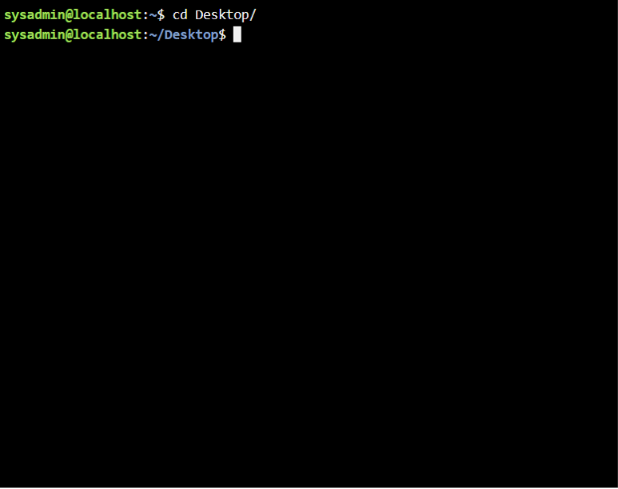
Figure 19: cd command

Example 5: mkdir
The mkdir command creates a new directory. The output confirms that the folder named "new" has been created successfully within the current location.
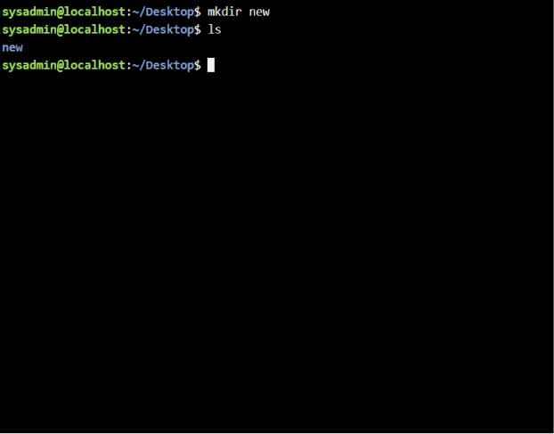
Figure 20: mkdir

Example 6: rmdir
The rmdir command removes an empty directory. The output demonstrates that the folder has been deleted successfully from the file system.

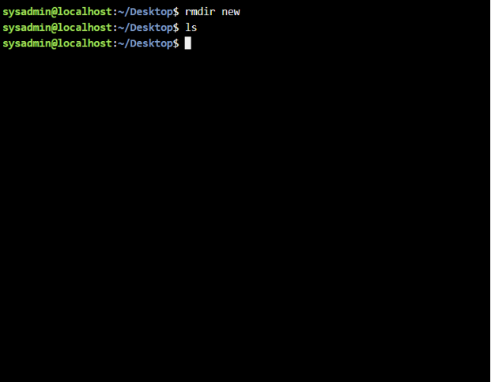
Figure 21: rmdir

Example 7: touch
The touch command creates a new empty file. The output confirms the creation of the file and displays it when the directory contents are listed.
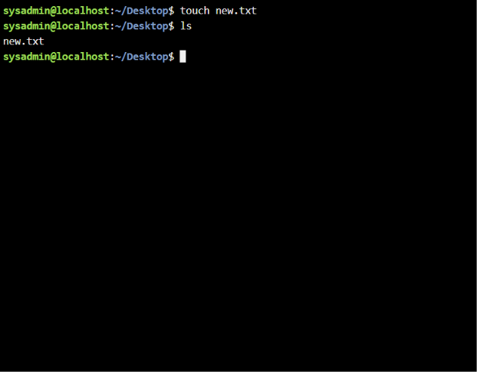
Figure 22: Touch

Example 8: echo and cat
The echo command writes text to a file, while cat displays the file contents. The output demonstrates basic file creation and content viewing operations.

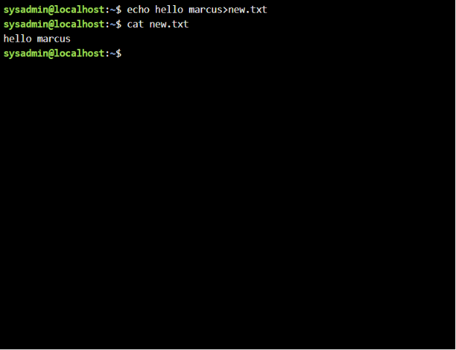
Figure 23: echo and cat.

Example 9: ifconfig
The ifconfig command displays network interface configuration details. The output shows IP addresses, network masks, and interface status information.
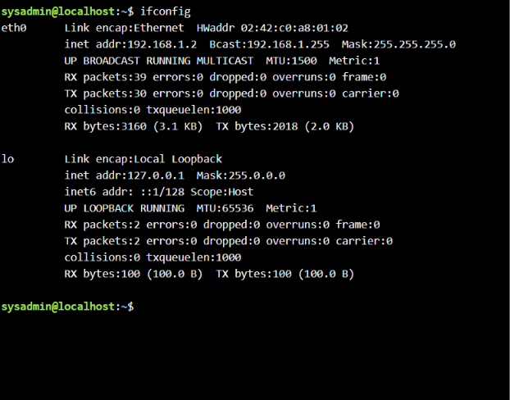
Figure 24: ifconfig

Example 10: whoami and date
The whoami command displays the currently logged-in user, while date displays the current system date and time. These commands provide useful system information.

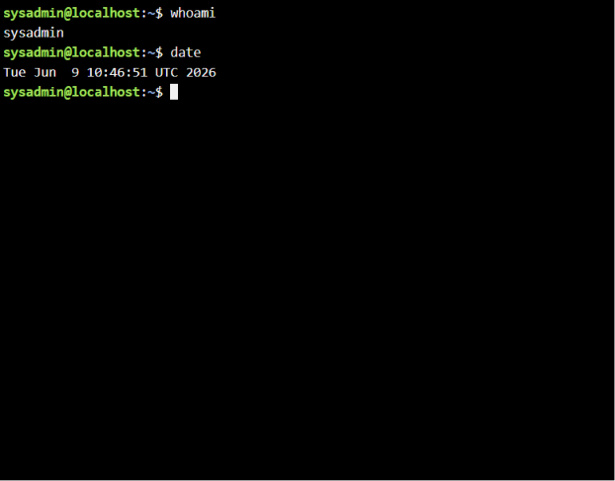
Figure 25: whoamiI and date.

Use of Windows OS scripts
Batch scripting automates repetitive tasks in Windows. Batch files contain commands that run automatically and can support calculations, file management, user interaction, and administration, improving efficiency and reducing manual effort [5].

Example 1:
This Batch script demonstrates variables, user input, conditional statements, and decision-making. It asks for the user’s age using set /p, stores the value in a variable, and uses an IF statement to check whether the user is 18 or above. The output displays the relevant eligibility message based on the condition. This shows how Batch scripts can validate input and automate simple rule-based decisions.

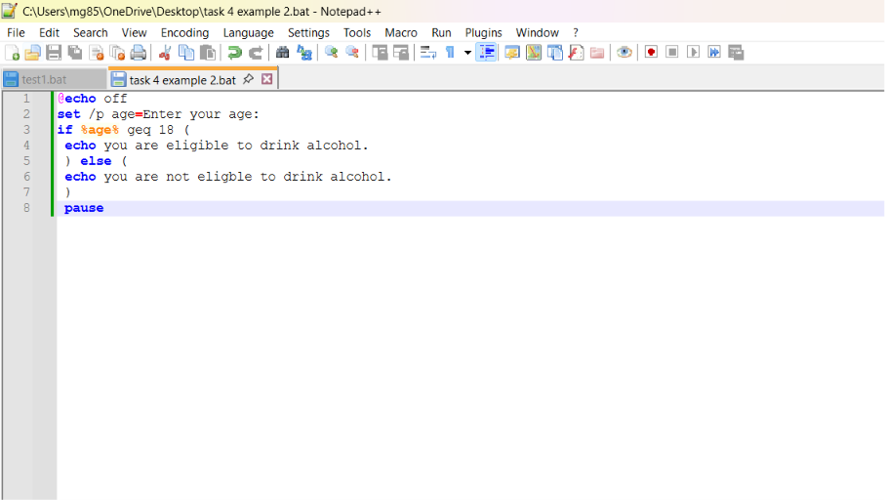
Figure 26: Script of adding
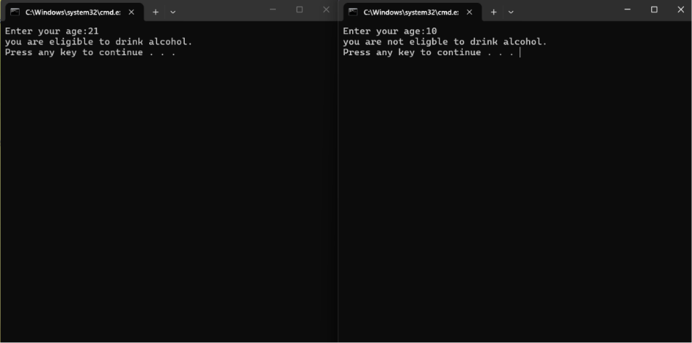
Figure 27: Output of script

Example 2:
This script uses variables and conditional statements to determine voting eligibility. The user enters their age, which is stored in a variable, and an IF statement compares it against the legal voting age. The output confirms whether the user is eligible. This demonstrates how Batch scripts can process user input, apply rules automatically, and reduce manual intervention in validation tasks.

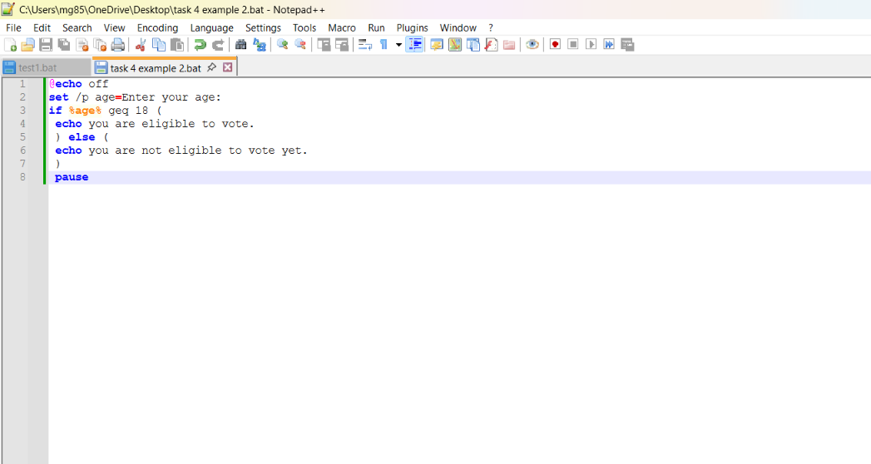
Figure 28: script input
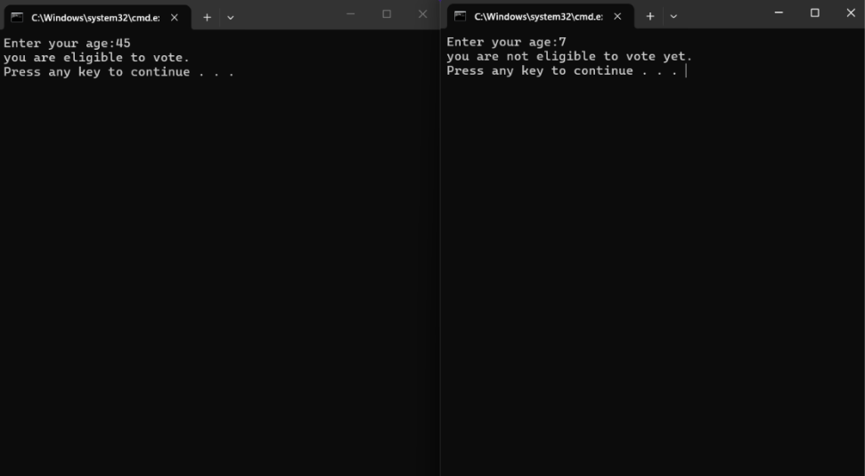
Figure 29: script output

Use of Linux OS scripts
Bash scripting is a powerful automation tool used in Linux operating systems. Bash scripts allow administrators to automate repetitive tasks, process user input, perform calculations, and manage files efficiently. Bash scripting improves productivity and is widely used for system administration, monitoring, and automation tasks [6].

Example 1:
This Bash script demonstrates variables, user input, and arithmetic operations. It asks the user for two numbers using read, stores them in variables, adds them using Bash arithmetic syntax, and displays the result with echo. The output confirms that the input was processed correctly. This shows how Bash scripts can automate calculations and support reusable administrative or data-processing tasks.

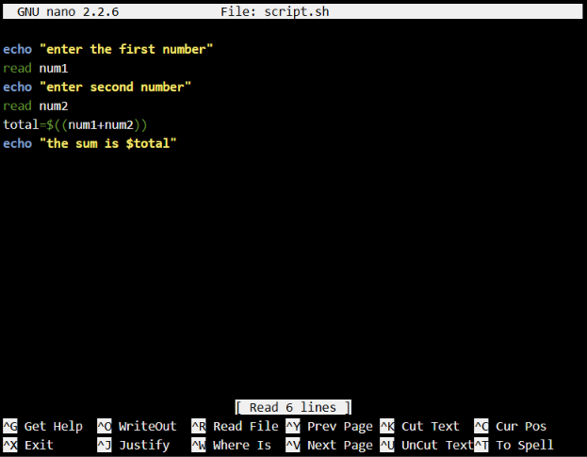
Figure 30: script
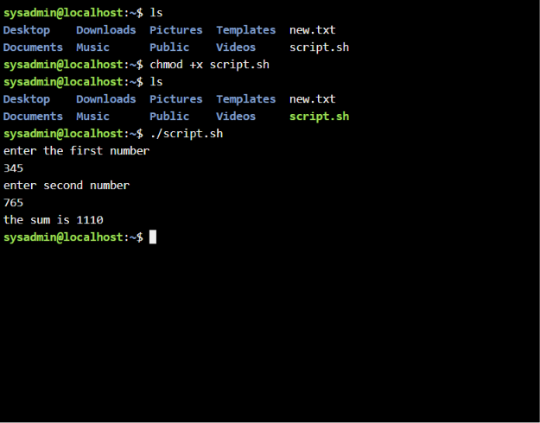
Figure 31: bash script output

Example 2:
This Bash script demonstrates loops in Linux scripting. It asks the user for a number, stores it in a variable, and uses a for loop to repeat according to the value entered. The output shows the loop counting through the specified range. This demonstrates how loops automate repetitive tasks such as file processing, monitoring, and administration.
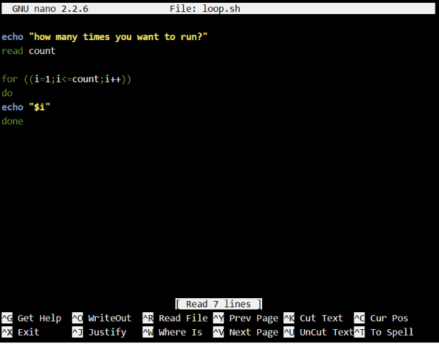
Figure 32: script loop input
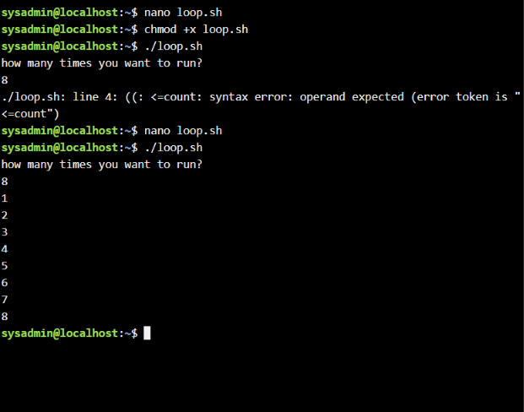
Figure 33: loop output

Conclusion
This report examined the key functions of operating systems and demonstrated how Windows and Linux provide tools for managing processes, applications, files, devices, security, users, and network resources. It showed that operating systems play an essential role in coordinating hardware and software while providing users with practical tools for system management. The command-line examples demonstrated how both Windows and Linux can be used to complete file management, navigation, networking, and system information tasks efficiently. The scripting examples also showed how Batch and Bash scripts can automate repetitive activities, process user input, and reduce manual effort.

Overall, the practical use of commands and scripts helped develop a greater understanding of operating system management, troubleshooting, and automation architecture techniques. These skills are valuable for system administration because they support efficient problem-solving, improve productivity, and provide a foundation for future careers within the computing industry.

References
[1] A. Silberschatz, P. B. Galvin and G. Gagne, Operating System Concepts, 10th ed. Hoboken, NJ, USA: John Wiley & Sons, 2018.
[2] W. Stallings, Operating Systems: Internals and Design Principles, 9th ed. Harlow, England: Pearson Education Ltd., 2018.
[3] Microsoft Corporation, “Windows Documentation,” Microsoft Learn. [Online]. Available: https://learn.microsoft.com/en-us/windows/. [Accessed: 14-Jul-2026].
[4] Microsoft Corporation, “Windows Commands,” Microsoft Learn. [Online]. Available: https://learn.microsoft.com/en-us/windows-server/administration/windows-commands/. [Accessed: 14-Jul-2026].
[5] Microsoft Corporation, “PowerShell Documentation,” Microsoft Learn. [Online]. Available: https://learn.microsoft.com/en-us/powershell/. [Accessed: 14-Jul-2026].
[6] The Linux Foundation, Introduction to Linux, Linux Foundation Training. [Online]. Available: https://training.linuxfoundation.org/. [Accessed: 14-Jul-2026].
[7] Red Hat, “Red Hat Enterprise Linux System Administrator's Guide,” Red Hat Documentation. [Online]. Available: https://access.redhat.com/documentation/. [Accessed: 14-Jul-2026].
[8] Canonical Ltd., “Ubuntu Server Guide,” Ubuntu Documentation. [Online]. Available: https://ubuntu.com/server/docs. [Accessed: 14-Jul-2026].
[9] National Cyber Security Centre, “Cyber Security Principles,” NCSC. [Online]. Available: https://www.ncsc.gov.uk/. [Accessed: 14-Jul-2026].
[10] IBM Corporation, “Linux Commands Reference,” IBM Documentation. [Online]. Available: https://www.ibm.com/docs/. [Accessed: 14-Jul-2026].

Appendices
Online Course name: Online Course Name: Linux Unhatched (Cisco Networking Academy).


Figure 34: Certificate of completion

