BMSW5104: Managing projects in the organisation

Table of Contents
Introduction 3
Part 1: Project management 3
1. Project risk management 3
2. Project time management 6
3. Plan, monitor and control 7
Part 2: Project Implementation 8
1. Kotter’s 8 Steps 8
2. Greiner’s Life Cycle Model 10
3. Stakeholder Identification 11
4. Stakeholder Mapping 13
Part 3: Personal development 14
1. Gibbs’ reflective cycle 14
2. Team skills 15
3. Personal development plan 17
Conclusion 17
References 18

Introduction
Project management can be considered as an application of skills, tools, knowledge and techniques to perform the project activities effectively to meet its objectives and requirements. During the pandemic due to the outbreak of covid-19, many organisations have faced severe challenges to do the business operations efficiently that bring the requirement of project management tools to improve the overall business process. The report has aimed to present a critical evaluation of different project management tools and techniques that will be useful to improve the training project in the business environment of Tesco, a leading retailer in the UK during the pandemic.
Tesco Plc is a British retailer store ranking as the third-largest retailer as per gross revenue (Tesco PLC, 2021). From the beginning Tesco has set its messaging similar good products at an affordable price which made the consumers relate with the brand as it offered more economical options. Annually Tesco invests a huge amount of capital for their television, print, and radio marketing, along with that one of the most popular marketing strategies within the organization is various types of sales promotion (Tesco PLC, 2020). Since the ’90s Tesco has focussed on being known for its cost-effective and economic pricing under the ‘Tesco Value’ term, in the later years under the term ‘Tesco finest’ it started selling premium products, telling their customers they can buy anything from under one roof for the price they are capable of spending (Tesco PLC, 2020).
The report will produce a detailed analysis and discussion on different project management tools including waterfall and agile methodology that will be essential for developing the project in the context of Tesco. Moreover, the Kanban project management tool and project life cycle will be also evaluated to create an implementation and communication plan for the project among the stakeholders.

Part 1: Project management

1. Project risk management
Risk management plan: A risk management plan is important to identify the potential risks while implementing a training project in a diverse workforce. The plan includes risk assessment, analysis and potential measures to mitigate the risk while executing the project (Muriana and Vizzini, 2017). It helps to investigate risk related to the required technological equipment in the training project implementation in Tesco. It refers to the ongoing process throughout the project life cycle including risk management planning, evaluating, monitoring and control. The plan has the purpose to identify major risks in the training project and monitor and control all the events that can have a negative effect on the certain project in Tesco.
Identify risk: During the project life cycle, risk identification includes the process of determining the disc that is likely to make a severe impact on the project and documentation of each characteristic. In the training project of Tesco, the project manager has the responsibility to identify potential risk and throughout all the stages of the project life cycle, the team members are assigned in specific areas with appropriate responsibility to report any identification of risk to the project manager (Willumsen et al., 2019). The process is implemented for identifying and documenting the potential risk factors during the development of the risk register. The project team of Tesco must have the awareness of all the new risk factors with the project manager of the training project where the manager has the responsibility to determine if there is any newly identified risk event that needs further evaluation. During the pandemic due to Covid-19, the employment rate in Tesco has severely reduced and due to the immense and consumer preference for e-commerce; the company has to involve in new technological equipment that requires appropriate training projects for the existing employees (Firmenich, 2017). Here, added workload and less awareness of technological advancements have been identified as the major risk in the training project of Tesco.
Risk register: Risk register refers to the official documentation and record of identified risk in the project life cycle where the risk factors are recorded as potential threats. The register includes the risk identification number and project manager who will manage and control the threat. Kanban tool is a widely used project management technique that helps to register the potential risk and analyse them to mitigate the risk (Crispim et al., 2019). In the training project of Tesco, the identified risk of workload and limited technological awareness is recorded in the risk register by using Kanban tool.
Risk analysis: Risk analysis is a significant process to ensure the success of a project. There are two when established risk analysing methodologies that include qualitative and quantitative methods. The qualitative risk analysing method is most subjective compared to the quantitative method. Qualitative trend is focused on risk identification to determine the likelihood of risk occurrence during the project and its impact on the overall implementation (Liu et al., 2017). The analysing results are documented in the risk assessment matrix to communicate the threats with the stakeholders engaged. On the other hand, quantitative risk analysis method is quite objective and it mostly implements verifiable data to evaluate the impact of the risk identified in terms of resource consumption, project schedule, cost and scope. The Kanban project management tool is a flexible technique to analyse the identified risk and manage them within the project schedule and estimated budget (Lytvyn et al., 2017).
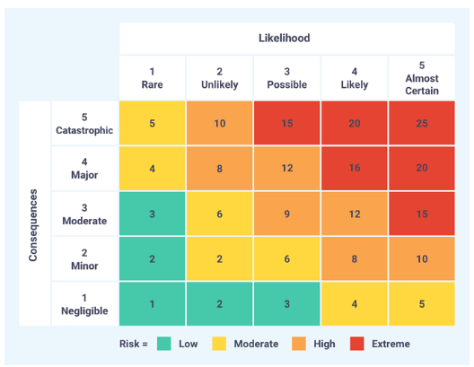
Figure 1: Risk assessment matrix
(Source: Liu et al., 2017)
Risk response: After developing the risk probability and assessment matrix in the training project of Tesco, risk response strategies are implemented to mitigate or avoid them so that the threats have minimum impact on the overall project life cycle (Keshk et al., 2018). The risk probability has been measured through the qualitative approach using agile methodology as the project management tool. It will help the managers of Tesco prioritise time management technique and discuss the risks on regular meetings to avoid delay of the project schedule.
Mitigate and control risk: The agile risk management approach indicates the most appropriate response strategy in order to control the occurrence of the risks and mitigate them to prevent their negative impact on the project. The Agile training will be beneficial to enhance project performance by making the employees aware of the basic concept of the project management tool and implement proper strategies to control and mitigate the risks (Zuo and Zhang, 2018).

2. Project time management
Plan schedule management: Plan schedule management refers to the process of developing the policies and required procedures to document the project planning, managing and executing the schedule (Sanghera, 2019). It has the purpose to ensure that the project is completed within the estimated schedule and it provides proper direction to the team members on how the activities can be managed throughout the project life cycle. For implementing a training project in Tesco, an agile project management tool has been used to create an iterative format for project scheduling (Jiakai et al., 2019). Due to less presence of the employees during the lockdown for the outbreak of Covid-19, the training project has been scheduled through digital platforms and the company has to invest in technological advancement due to the restrictions of visiting the physical stores.
Plan activities: In the training project, the management of Tesco must determine the requirements and databases and align them with the project schedule. It has to revise the risk assessment matrix to complete the activities within time (Liu et al., 2018). By creating time frame objectives, it can ensure full completion of each task in a timely manner.
Plan resources: The resource plan is referred to the ultimate guide for determining and collecting all the necessary resources required to complete the project. For the training project in Tesco, human resource, financial sources, technological information and project management tools are the major resources. Then, the resources are scheduled by using a Gantt chart and identifying resource costs, the management team reviews the deliverable budget after getting the approval from the risk management team and communicating with the stakeholders (Umbrico et al., 2018).
Milestones: In the training project of Tesco, milestones are needed to be established as the realistic ones to achieve them within the estimated project schedule. The benchmark will provide motivation to the team members and encourage them to complete all the milestones in a timely manner (Kovacs et al., 2017). Risk assessment and budget deliverable are considered as the milestones for the training project. Moreover, communicating with the stakeholders regarding the milestones and communicating with the risk management team are also recognised as major milestones for completing the project.
Monitoring and controlling: Monitoring and controlling each task during the time management process in a project life cycle is significant to maintain the efficiency and performance of all the employees involved in the process (Fortino et al., 2018). It also helps to anticipate any further risk and failure while executing the project.

3. Plan, monitor and control
Monitoring and reviewing the project milestones is mostly involved in the identification of critical path activities along with the other major decision points in the project life cycle (Clark, 2019). The project milestones identified in the previous stage of time management process off the training project in Tesco can be monitored by using Gantt chart or milestone slip chart. Monitoring the milestone with the project schedule against the tolerances will enable the project manager to identify the corrective action and escalator slippage within the team (Obradovic et al., 2018). The tolerances can be established based on project cost and scope.
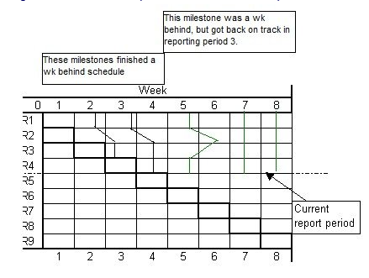
Figure 2: Milestone slip chart
(Source: Obradovic et al., 2018)
Project status reports can be considered as a significant tool to plan, monitor and control the communicating progress within the project team. The report identifies the current status of the milestones, activities, potential risk and schedule. Monitoring and control at all the stages in the project life cycle enable the team members and managers to make effective decisions and capture all the required changes that can have a severe impact on the project (Kortelainen, 2017).

Part 2: Project Implementation
In the pandemic of COVID-19, to develop training for the employees of Tesco a suitable plan should be prepared. This plan can be prepared using Kotter’s 8 steps for and Greiner’s Life Cycle.

1. Kotter’s 8 Steps
The project of training can be organised following the 8 steps proposed by John Kotter to solve the risk factors.
Creating a sense of urgency
This step is important to identify the threats to the project and the effect that may come up in future. This is important to note that the problems related to the high investment of money should be identified. After that, the opportunities should be examined in the most possible ways (Tahir, 2019). This issue should be discussed with the stakeholders of the company. For proper training of the employees for the COVID situation all the people of the company should be involved.
Forming Powerful Guiding Coalitions
The leaders of Tesco capable of bringing changes in the company and should be involved in the process of training. A change coalition should be formed in the team. The weak areas are to be identified at this step in the coalition teams. Tesco should include the influential people of the various departments in the training project.
Developing vision
A vision needs to be created as to how the employees should be trained. To create the vision, the central values of Tesco should be added (Tan et al., 2019). Market research data, forecasts, business trends and so on should be added to the vision.
Communicating change vision
The vision is to be communicated through problem-solving, decision-making and actions. The members of the project should communicate with the employees about their training.
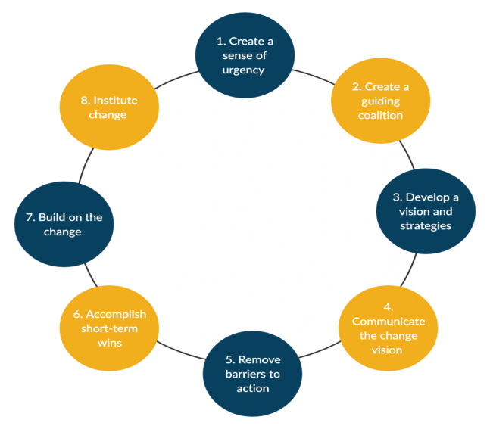
Figure 3: Kotter’s 8 steps model
(Source: Athuraliya, 2021)
Removing barriers
Identification of the barriers is important. In this project, the barriers to the project may be irregularity of employees and maintenance of sustainable projects goals. These should be removed using reward systems and policies (Buzan and Whitehead, 2021).
Attain short-term wins
The project is to be broken down into parts to achieve short-term wins. The training project can be broken down into days of training. Each day can be a short-term goal to achieve a short-term win.
Build on change
Tesco managers should understand what is right and what is wrong in the project. This will help them to develop improvement. The weak notes should be improved and the positive notes should be strengthened (Tahir, 2019).
Make change stick
The changes should be adopted wholeheartedly for the success of the company. The results should be induced for betterment. The COVID-19 norms should be utilised well in the training project.

2. Greiner’s Life Cycle Model
Greiner’s life cycle has six stages that are important to understand why a crisis is arising and how to mitigate them.
Creativity
To develop the training project, it is important for Tesco leaders to have creative ideas in order to train the employees. The leaders need to be innovative in their approach to the project. This stage can mark the advent of a leadership crisis. There is a high possibility that there will be a shortage of leaders for a company like Tesco that is spread in the whole world.
Direction
To get rid of this leadership crisis, Tesco needs to hire more managers for the training project. The managers need to be professionally trained with proper knowledge regarding the COVID-19 norms and rules. This can generate an autonomy crisis as new managers in Tesco will also hold the same power and designation (Potherca, 2020).
Delegation
This autonomy crisis can be solved with a delegation of work among the managers rightfully. This will require the higher officials of Tesco to form a perfect structure that will go deeper into the roles and responsibilities of the managers. This can give rise to a control crisis with problems in the delegation.
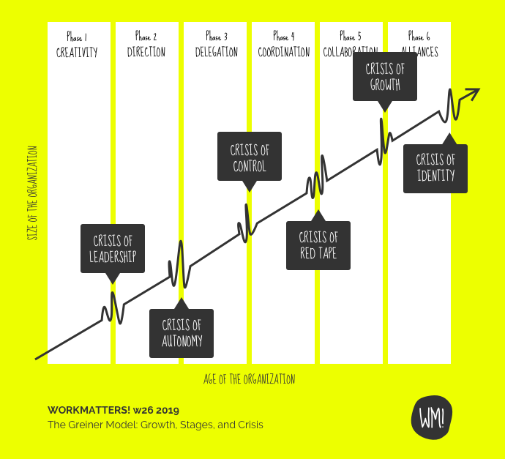
Figure 4: Greiner’s Life Cycle Model
(Source: Holmer, 2019)
Coordination
To solve the issue of control crisis, Tesco needs to be more active in coordinating and communicating between teams. Reporting should be the primary advisor to the managers. Too much reporting will create a red-tape crisis in the bureaucracy. This can be caused due to the higher amount of face-off between one another.
Collaboration
The red tape crisis can be solved through a collaborative attitude in human relation. The company should make efforts to connect the people in multiple dimensions Greiner, A., 2019. This can be done using matrix management. Reward systems are a good idea for the development of individual performance. This will, however, create a growth crisis because individuals will be more interested in their individual growth than the growth of the organisation.
Alliances
The internal growth crisis can be solved externally. Mergers and acquisitions can be pursued for mitigating the growth crisis. The managers should be partnering with one another in the work. Tesco should provide partnership work between the managers so that there is an overall growth of the organisation and the project can be completed without any hazard.

3. Stakeholder Identification
For communication of the project plan with the stakeholders of Tesco, it is important to identify the stakeholders first. The communication strategy of Tesco for the training project is the identification of stakeholders and interaction with them.
Internal stakeholders
Tesco has its internal stakeholders as the people who are involved in the internal environment of the company. The internal stakeholders include managers, shareholders, employees, board and executive officials (Eskerod and Larsen, 2018). The board of Tesco is formed by chief executives, chairman, non-executive directors and chief financial officers. They form an essential part of the company as they constitute the internal stakeholders. The internal stakeholders of Tesco have the right to the decision making of the company.
External stakeholders
The external stakeholders of Tesco form the external environment. These people are involved in the outer activities of the company. The external stakeholders of Tesco are its creditors, suppliers, customers, pressure groups, the governments and local communities. They are not involved in the decision-making of the company (Hillson, 2020). They do not form the company’s internal activities.
The stakeholders of the company can be divided into four quadrants on their role. These roles help the managers of the training project to understand the responsibilities of the stakeholders.
Players - Players are stakeholders who have high interest and high power. The shareholders, board of directors and the managers of Tesco hold this place. These people take important decisions regarding strategies for the project.
Subjects - The stakeholders called subjects are the suppliers and employees of Tesco. These stakeholders have high interest and low power (Lynch, 2018). These stakeholders are part of the decision-making but cannot influence them. They are the real fighters who make the decisions turn into actions.
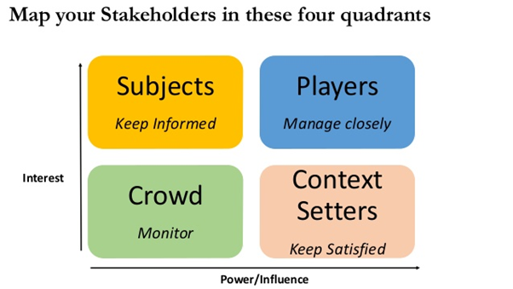
Figure 5: Stakeholder Analysis Mapping
(Source: Raum, 2018)
Crowd - The crowd involves the government and local communities who have low interest and low power. No decisions of the company are dependent on them and they are also not interested in the decision-making of the company.
Context-setters - Context-setters have low interest and high power. The customers of Tesco are the context-setters. They have little interest in the working of the company. However, they can influence the business.

4. Stakeholder Mapping
After the identification of the stakeholders, the project managers need to communicate with the internal and external stakeholders depending on their influence and interest. The stakeholders can be divided into four roles depending on their responsibilities.
Keep informed is the quadrant that has employees and suppliers of Tesco. The employees should be communicated the most regarding the project because they will have to work in the company. The suppliers are engaged in supplying raw materials to the company (Rahman, 2019). Thus, suppliers should also be aware of the new project. The new project of training in Tesco will require the company to supply raw materials such as masks and sanitisers for the new normal.
The monitor is the quadrant for the monitoring done by the government and the local communities. These stakeholders do not work in Tesco. They have certain laws and social norms respectively. Tesco will have to abide by the laws and regulations of these stakeholders. These stakeholders should be communicated regarding the proper maintenance of the system in the project.
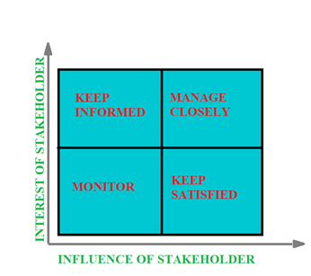
Figure 6: Stakeholders Analysis Mapping
(Source: Kremmer, 2019)
Manage closely is the quadrant that goes to the shareholders and executive boards and directors. This is the most important stakeholder group that takes part in the project. The shareholders of Tesco have the right to the shares of the company (Boaz et al., 2018). The executive board formed with directors and managers will look into the right execution of the work for the project. All the processes and operations regarding the project will be managed by the executive board.
Keep satisfied is the quadrant for the customers, creditors and pressure groups. The customers should be satisfied with the new training project of the employees. The customers should be communicated well regarding the importance of this training project (Schmidt et al., 2017). This social message should be forwarded to all the stakeholders of this quadrant so that they become satisfied with this new venture of Tesco.

Part 3: Personal development

1. Gibbs’ reflective cycle
Gibbs’ reflective cycle is a widely used theoretical approach to analyse a certain experience and critically evaluate the personal and professional ability. The model was developed in 1988 to produce a guideline to critically assess an experience (He et al., 2018). Here, the model has been used to analyse my skills to manage the training project in Tesco in light with the Covid-19 crisis.
Description- The reflective discussion is developed from my experiences and learning journey while managing the training project in Tesco during Covid-19 crisis. I also got to know that the project management exercise plays a vital role in the success and improvement of my skills and abilities.
Feeling- There were several things which I did not know about successful project management. It was quite a good feeling to increase my knowledge. Also that knowledge gave me so much motivation to work on this topic for further evaluation. I feel satisfied by this certain increase of my knowledge and a deep evaluation of my skills as a project manager.
Evaluation- There were a lot of good things from this experience. Firstly, I have gained my knowledge which is the best thing from this experience. Secondly, I collected information about leadership, project budget, scheduling, risk management and communication with the stakeholders. However, the skills of identifying and managing risk and decision-making skills can be recognised as my weaknesses as a project manager. The overall experience improved my leadership qualities for a structured environment.
Analysis- I assume that the entire gain of knowledge will help me a lot for any future employment. The learning of the experience is going to be very useful for my professional life. This experience has given me a fluent knowledge of project management, crisis handling, training, time management, all the terms and conditions during project life cycle, and how a team can work through various difficulties. However, the inappropriate clarification of how risks can be identified and managed by an organization becomes a lack of my ability as a manager.
Conclusion- From this experience, I have gained a huge number of lessons that are related to project management. In this reflection practice, I have included all the positive sides of my experiences from the experience as well as the negative side too. I face some obstacles while putting all the information I gathered like lack of clarity of the risk management and decision making strategies. Thus, I can say that I overall have the skills and abilities to perform my roles and responsibilities as a project manager however; I have to improve the skills that I have lacked during the project implementation.
Action plan- If I need to perform as a project manager again or any other projects, I will definitely keep an eye on my obstacles that I have faced while implementing the training project. I will gather every possible data related to risk management. I will absolutely think over the required skills that I need for improving my risk taking and managing ability. I have the plan to attend some seminars on risk management and undertake short-term course for improving my decision-making skills. I have a plan to attend workshops and different project surveys to improve my team-working abilities as well.

2. Team skills
Belbin's typology of team role can be considered here to evaluate the skills and abilities of managing the project after collecting the feedback from other team members. The team roles are mostly designed to predict the success factors of managing a team while implementing in a project (Paulamaki, 2018). It recognises the skills required for a strong team that have diverse characteristics and personality traits. Belbin described team role as an approach to behave and communicate with the other team members in an appropriate way (Diab-Bahman, 2021). The team roles provide a pattern of interrelated behaviour that helps to analyse a person's behaviour and skills to communicate other team members and facilitate the team progress.
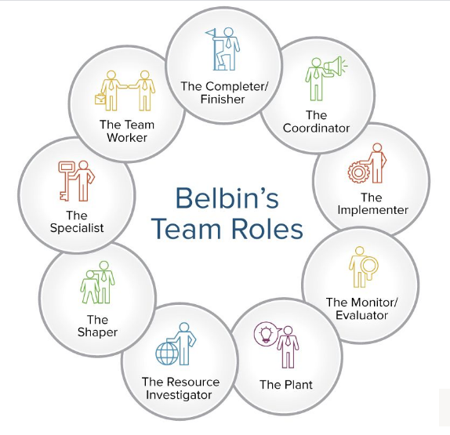
Figure 7: Belbin’s team roles
(Source: Diab-Bahman, 2021)
The approach enables me to analyse self knowledge from the experience and adjust required behaviour based on the demands in a certain situation such as the requirement of training project in Tesco during Covid-19 crisis. Considering Belbin's team roles, I have analysed that I have the characteristics related to the people oriented roles such as coordinator, team worker and resource investigator. I have performed the role of a coordinator in the project management process with confidence and effectiveness as I have the skills of delegation and clarifying the project goals and scope that can be considered as my strengths. However, sometimes I became manipulative as a chairman that can be recognised as allowable weakness. As a team worker, I was quite cooperative and participated in all the meetings and conferences with the stakeholders. Based on the feedback from my colleagues, I have an effective listening skill and I have tried to respect the opinion of others as well. However, I became indecisive in some situations that indicate lack of appropriate decision-making skill. As a resource investigator, I have communicated and explored all the opportunities that can be beneficial to ensure efficiency in the project management process (Driskell et al., 2017). After implementing Belbin's team roles, I have observed that I have the ability and skills of an efficient project manager however; I need to improve some of my skills to ensure success in my future employment.

3. Personal development plan
Skills/ Objectives | Required time scale | Required actions | Future implications
Decision-making skills | 6 months | By participating in workshops, studying and practising decision-making styles of famous leaders | It will help me to make appropriate decisions while managing a project and it will also improve my problem-solving ability
Improving communication with the stakeholders | 6 months | By participating in seminars and workshops and attending teamwork to build communication skills | I have identified communication skills as my strengths based on the experience and collecting feedback from my colleagues and team members. However, I must improve the skills for maintain a long-term impression and motivate others to engage in the successful project implementation
Table 1: Self-development plan
(Source: Developed by the learner)

Conclusion
In conclusion, it can be stated that in order to ensure a successful project implementation during the Covid-19 crisis, project risk management, scheduling and implementing proper project management tools are essential. The project implementation plan through Kotter’s 8 steps shows that the project requires the right communication and vision. The Greiner’s Life Cycle model shows that there will be some crisis in the project but they can be handled properly by having the right plan. The most important stakeholders of Tesco are its executive board of directors and managers who will examine the whole project. The report states that all the stakeholders should be informed and satisfied so that they can monitor and manage the work properly with appropriate skills and team roles.

References
Athuraliya, A., 2021. Kotter's 8 Step Change Model: A Comprehensive Step-by-Step Guide. Creately Blog. Available at: https://creately.com/blog/diagrams/kotters-8-step-change-model/ [Accessed April 9, 2021].
Boaz, A., Hanney, S., Borst, R., O’Shea, A. and Kok, M., 2018. How to engage stakeholders in research: design principles to support improvement. Health Research Policy and Systems, 16(1), pp.1-9.
Buzan, S. and Whitehead, M.T., 2021. Moving communication and collaboration online: making changes for home-based learning with Kotter’s 8-Step Process.
Clark, A., 2019. PROJECT MANAGEMENT PROCESS GROUPS: IMPROVING PLANNING, MONITOR AND CONTROL OF IT PROJECTS (Doctoral dissertation, American Public University).
Crispim, J., Silva, L.H. and Rego, N., 2019. Project risk management practices: the organizational maturity influence. International journal of managing projects in business.
Diab-Bahman, R., 2021. The Impact of Dominant Personality Traits on Team Roles. The Open Psychology Journal, 14(1).
Driskell, T., Driskell, J.E., Burke, C.S. and Salas, E., 2017. Team roles: A review and integration. Small Group Research, 48(4), pp.482-511.
Eskerod, P. and Larsen, T., 2018. Advancing project stakeholder analysis by the concept ‘shadows of the context’. International Journal of Project Management, 36(1), pp.161-169.
Firmenich, J., 2017. Customisable framework for project risk management. Construction Innovation.
Fortino, M.H., Silva, J.M.D., Santos, M.L.D., Neto, M.A. and Leal, M.M., 2018. Theoretical framework for Risk management monitoring, review and improvement process of FLOSS applications using key risk indicators-KRI at a public agency. In XII Simposio de Informática en el Estado (SIE 2018)-JAIIO 47 (CABA, 2018).
Greiner, A., 2019. Public debt in a descriptive endogenous growth model.
He, K.N., Parkinson, L. and Doyle, A.K., 2018. Gibbs’ Reflective Cycle.
Hillson, D. (2020). PRACTICAL PROJECT RISK MANAGEMENT : the atom methodology. S.L.: Berrett-Koehler.
Holmer, A., 2019. The Greiner Model: Growth, Stages, and Crises. Medium. Available at: https://medium.com/workmatters/1-2-3-ideas-on-the-greiner-growth-model-the-what-how-and-why-cdd370fc53a8 [Accessed April 9, 2021].
Jiakai, X., Wen, Z. and Gang, C.E.N., 2019, August. Design of Intelligent Personal Schedule Management System. In 2019 14th International Conference on Computer Science & Education (ICCSE) (pp. 168-171). IEEE.
Keshk, A.M., Maarouf, I. and Annany, Y., 2018. Special studies in management of construction project risks, risk concept, plan building, risk quantitative and qualitative analysis, risk response strategies. Alexandria engineering journal, 57(4), pp.3179-3187.
Kortelainen, J., 2017. Performance Testing Smart Metering Systems: Tools, Automated Tests and Reporting.
Kovács, G., Yussupova, N. and Rizvanov, D., 2017. Resource management simulation using multi-agent approach and semantic constraints. Pollack Periodica, 12(1), pp.45-58.
Kremmer, H., 2019. Stakeholder Mapping Matrix in Stakeholder Management. projectcubicle. Available at: https://www.projectcubicle.com/stakeholder-mapping-stakeholder-management/ [Accessed March 13, 2021].
Liu, J., Jin, F., Xie, Q. and Skitmore, M., 2017. Improving risk assessment in financial feasibility of international engineering projects: A risk driver perspective. International Journal of Project Management, 35(2), pp.204-211.
LIU, W.G., Xue, S.H.E.N. and WU, T.Q., 2018. Analysis of Common Project Schedule Management Methods. DEStech Transactions on Social Science, Education and Human Science, (emass).
Lynch, R., 2018. Strategic management. Pearson UK.
Lytvyn, V., Vysotska, V., Veres, O., Rishnyak, I. and Rishnyak, H., 2017, September. The risk management modelling in multi project environment. In 2017 12th International Scientific and Technical Conference on Computer Sciences and Information Technologies (CSIT) (Vol. 1, pp. 32-35). IEEE.
Muriana, C. and Vizzini, G., 2017. Project risk management: A deterministic quantitative technique for assessment and mitigation. International Journal of Project Management, 35(3), pp.320-340.
Obradović, V., Todorović, M. and Bushuyev, S., 2018, September. Sustainability and agility in project management: contradictory or complementary?. In Conference on Computer Science and Information Technologies (pp. 522-532). Springer, Cham.
Paulamäki, E., 2018. Valued Manager Through Belbin Team Roles.
Potherca, 2020. The Greiner Company Growth Model. Medium. Available at: https://medium.com/@potherca/the-greiner-company-growth-model-ccc7e252b492 [Accessed April 9, 2021].
Rahman, M., 2019. Stakeholders of Tesco (An analysis of Tesco's stakeholders). howandwhat. Available at: https://howandwhat.net/stakeholders-of-tesco-an-analysis-of-tescos-stakeholders/#:~:text=The%20main%20internal%20stakeholders%20of%20Tesco%20are%20employees%2C,very%20vital%20for%20Tesco%2C%20so%20are%20the%20managers. [Accessed April 9, 2021].
Raum, S., 2018. A framework for integrating systematic stakeholder analysis in ecosystem services research: Stakeholder mapping for forest ecosystem services in the UK. Ecosystem services, 29, pp.170-184.
Sanghera, P., 2019. Planning for Project Schedule Management. In PMP® in Depth (pp. 155-197). Apress, Berkeley, CA.
Schmidt, J., Drews, P. and Schirmer, I., 2017. Digitalization of the banking industry: A multiple stakeholder analysis on strategic alignment.
Tahir, U., 2019. Kotter's 8 Steps Model of Change Management. CMI. Available at: http://changemanagementinsight.com/kotters-8-steps-model-of-change-management/#:~:text=Kotter%E2%80%99s%208%20Steps%20Model%20of%20Change%20Management%201,of%20Kotter%E2%80%99s%20Change%20Model.%20...%20More%20items...%20 [Accessed April 9, 2021].
Tan, T.K., Gn, Y.M. and Goh, S.Y., 2019. ESRA19-0096 Implementing a regional anaesthesia (RA) time-out procedure (TO) in our hospital: applying kotter’s ‘8 step change management’(a management model).
Tesco PLC (2020). Annual Report and Financial Statements 2020 Serving shoppers a little better every day. Contents. [online] . Available at: https://www.tescoplc.com/media/755761/tes006_ar2020_web_updated_200505.pdf./[Accessed 8 Mar. 2021].
Tesco PLC. (2020). Annual Report 2020. [online] Available at: https://www.tescoplc.com/investors/reports-results-and-presentations/annual-report-2020/ [Accessed 8 Mar. 2021].
Tesco PLC. (2021). Home. [online] Available at: https://www.tescoplc.com/ [Accessed 8 Mar. 2021].
Umbrico, A., Cesta, A., Mayer, M.C. and Orlandini, A., 2018, June. Integrating resource management and timeline-based planning. In Proceedings of the International Conference on Automated Planning and Scheduling (Vol. 28, No. 1).
Willumsen, P., Oehmen, J., Stingl, V. and Geraldi, J., 2019. Value creation through project risk management. International Journal of Project Management, 37(5), pp.731-749.
Zuo, F. and Zhang, K., 2018. Selection of risk response actions with consideration of secondary risks. International Journal of Project Management, 36(2), pp.241-254.

