Marriott Placement Learning Log

Rohan Dubrey (1905715)

Week 1:

Friday 17th January (09:00/18:00hrs)– Saturday 18th January 2020 (09:00/17:45hrs)

Department: Leisure/Spa

Work Undertaken:

- Answering telephone calls
- Checking in leisure members
- Taking cash payment
- Competently conducting pool test on numerous occasions
- Folding of towels
- Cleaning of leisure facility
- Greeting guests
- Leisure tour for guest
- Taking bookings on spa reception concept computer system
- Cash taken from leisure to accounts
- Emergency closure and draining of jacuzzi
- Alarm reset
- Instructing guest on the proper use of digital lockers
- Collection of fruits from Kitchen for guests
- Inputting spa rota onto the backend of spa system software diary
- Inputting therapist columns with designated breaks on concept
- Organising guests consultation forms

Self-Appraisal

Strengths:

Surprisingly, the week has exceeded my expectations. The level of detail shown in explaining and adapting to my learning style as a kinetic learner proved rather essential. The methods used were picked upon rather quickly, giving me the opportunity for progressing onto competently completing sole tasks.

Essentially, the placement proves that listening attentively and asking lots of questions can be very rewarding. Note-taking skills acquired previously, have also proved quite useful in aiding to remember things taught along the placement journey, enabling me to be more confident when dealing with guests.

I have learnt to greet and tour guests around the facility, along with checking in leisure members using their membership cards. I was refreshed in carrying out a pool test, which brought me back on track with regulations. Alongside checking-in members, I have learnt to take cash and card payments. I have learnt how to compile staff rota and add to the backend of the system, making it visible for the receptionist to book treatments for guests within the spa.
I have also learnt how to shut-down the plant system and drain the water from the jacuzzi, placing appropriate signs for health and safety reasons. I have learnt to answer the telephone and transfer calls, with the help of a sheet of extension numbers that were provided to me.

Weaknesses:

The main challenge came from not being able to answer all the questions over the phone from guests or potential guests. Also confirming over the phone, treatments and spa packages previously reserved by guests, proved challenging with the colour codes, having to search the system. However, doing this repetitively will resolve the challenge.

Lost Opportunities:

Staff went above and beyond to include me in tasks undertaken. Staff would also wait on me to complete a previous task to include me into their task so I would not lose out on opportunities to learn more. Staff were quite patient and hands-on in training me to industry standards, then standing aside allowing me to complete the task solely. I have also invested in extra hours, putting in overtime to avoid lost opportunities.

Plans for next week:

- Gaining more knowledge to deal with telephone queries solely.
- Booking in spa guests within therapists slots on the system via telephone request.
- Practice more on finding spa and leisure services previously reserved.

Appendixes:

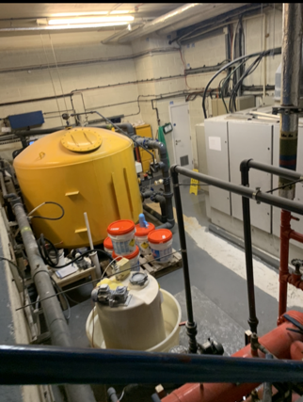
Pool Plant Room, going in to do PH minus level checks (17.1.2020).

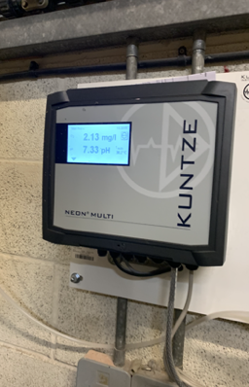

Taking readings from Plant Room (17.1.2020)

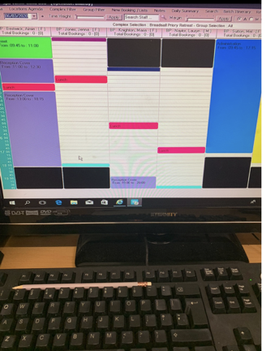

Adding staff rota to system diary pt1 (18.1.2020)

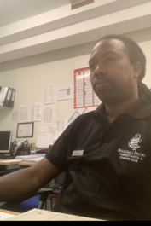
Adding staff rota to system diary pt2 (18.01.2020)

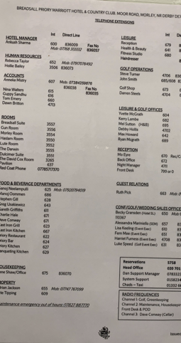

Marriott Breadsall Priory in house transfer sheet.
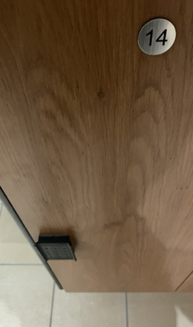
Digital locker system

