Tuesday | May 25 2021 |  |  |  | Feature Article
Saints and Winners
 | How did a Hindu holy man and a Muslim boxer enchant the World at the same time by promoting peace?
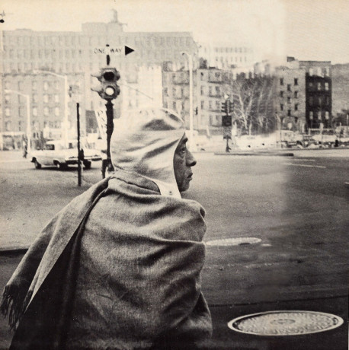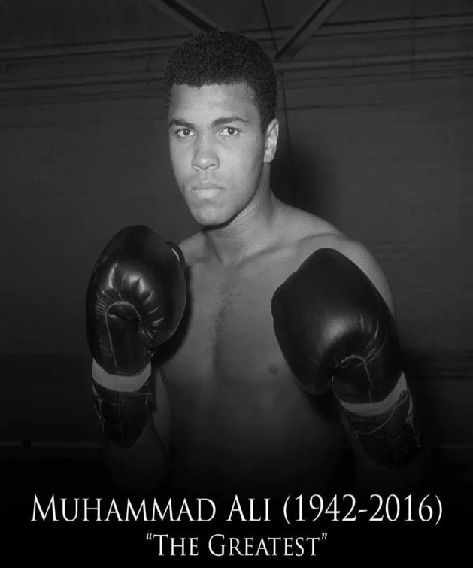  A.C. Bhaktivedanta Swami Maharaja  (1896 – 1977) A.K.A Prabhupada |  |  |  | Fighter, philanthropist & political activist.  There is no denying the charisma of Muhammed Ali. He was born into a poor family from Louisiana. Growing up in poverty forced him to examine his position in society as a young black man. He quickly realised being black meant proving twice as hard that you were good enough for the job. One of his most famous quotes is, “I am the greatest, I said it before I knew it.” In 1965 he rejected his birth name of Casius Clay as a slave name and continued to tell the world of his extraordinary talents and courageous activism. The press for many years refused to acknowledge him as Muhammed Ali which added to his enigmatic persona.  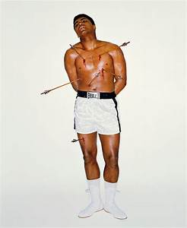  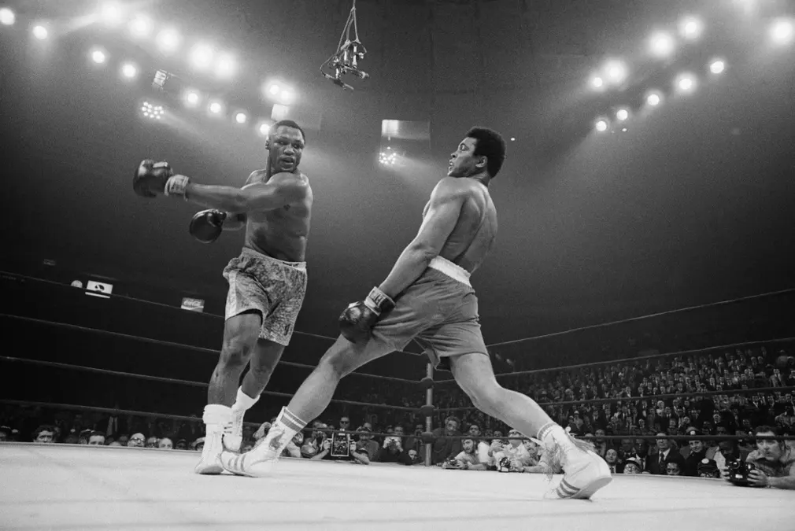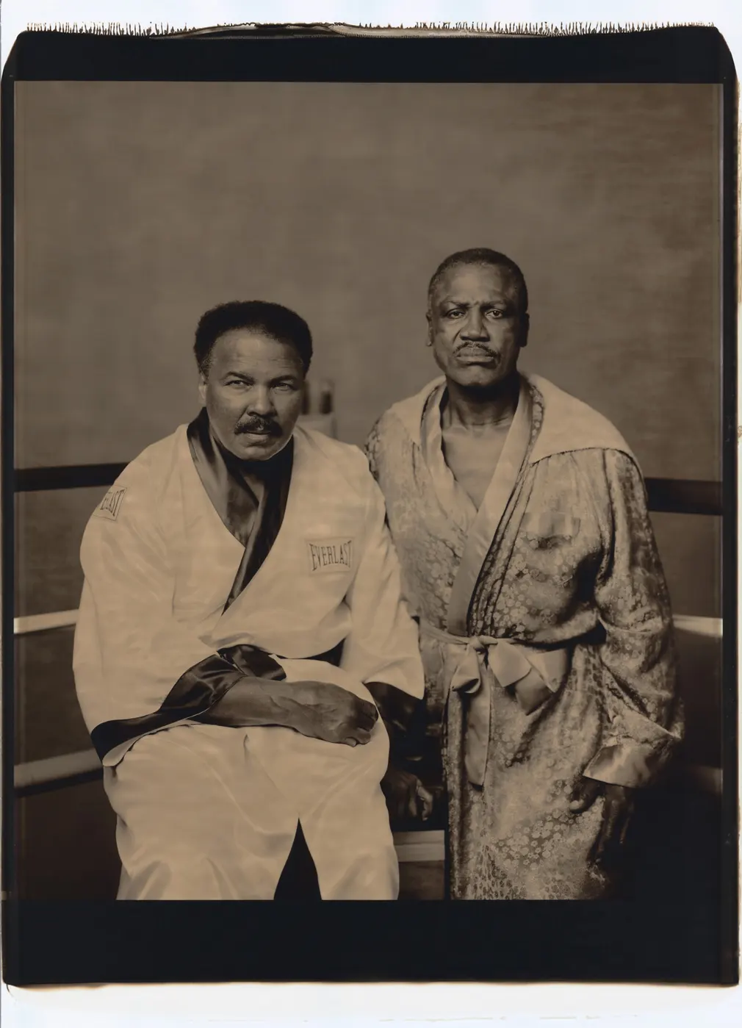  Spiritual leader, pacifist &  Political and Cultural Contexts.  Right Place at the Right Time = Charismatic Entrance  Martin Luther King Jr gave his “I have a dream” speech in 1964 the same year Casius clay became world heavy weight champion and changed his name to Muhammed Ali. In 1965 Lyndon B Johnson signed the voting act that banned racial discrimination within voting practices. This was the perfect time for a strong, confident young black man to step forward in the mainstream media. Ali’s integrity was underestimated until he refused to fight in the Vietnam war in 1967. He was given a 3-year boxing ban and a five-year prison sentence that was later revoked, after many years of appeal. His fearless challenging of inequality and white oppression gave credence to his charismatic leadership and his political activism inspired the next generation of disaffected youth.  humanitarian.  Swami Maharaja or Prabhupada as he is more affectionally known, was born into an affluent devout Hindu family in Kolkata. At the age of 70 he faithfully followed his spiritual master’s instruction and came to the West to preach Krishna consciousness, initiating over five thousand disciples during the 60s and 70s. Other sadhus had already attempted this instruction and failed. However, Swami Maharaja came at a time when the baby boomers were fully embracing youth culture. The self-destruction of the LSD counterculture was looking for an alternative to tradition and hedonism. Everything Prabhupada preached he practiced, and this authenticity appealed to a generation disenchanted with power hungry politicians.  Both Ali and Swami Maharaja had peaceful confident visions for the future. Their words encouraged a generation of willing followers to be the best version of themselves ready to serve God and humanity. Their courage to openly share their benevolent visions and the authentic truth of their lives fascinated a public jaded by duplicity. Challenging the status quo seems to be a seductive quality to most followers of charismatic personas, regardless of whether the leader is operating for good or for bad. Deciding if the leader’s motives are good or bad depend on contemporary ethics. Hitler for example was a charismatic savior to the German people in 1939, but a brutal anti-Semite according to contemporary ethics.  The authenticity and shelter he presented was very seductive for many disaffected youths that were searching for an alternative to ‘church on Sunday with mum and dad.’  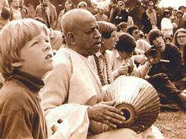  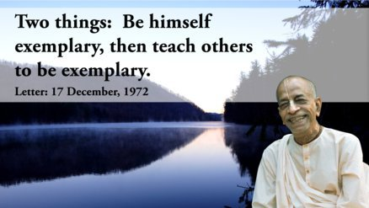  LEFT: Swami Prabhupada singing in Tomkins square Gardens with many followers in New York in 1967. The first time Prabhupada sang there in 1965 he sat alone.  BELOW: Anti-war protesters (New York 1967) demonstrating their disenchantment with world leaders and global conflict.  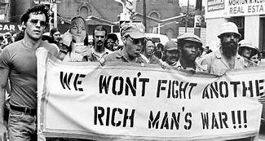  T
Pictured on the left is Hindu holy man Bhaktivedanta Swami Maharaja. Pictured on the right is once World Champion boxer Muhammed Ali.
Charisma for sale
Can charisma be taught and sold?
Some people naturally have a special power that makes them able to influence other people and attract their attention and admiration. What is this special power and how do we obtain it?  Both Ali and the Maharaja were such opposites in adulthood and childhood, so when defining charisma, the answer does not lie in the family history or routine of the charismatic. It would appear to be a mysterious essence that only the bold and the beautiful possess, making them catnip for insignificant others in search of guidance. Perhaps the similarities between these two men will lead us to the formula for charisma. Both men were deeply religious, consistently authentic, politically objective, and confident. Could it be that charismatic leaders emerge when there is a demand for challenging the status quo?  Pictured left: Ali and Joe Frazier having ‘the fight of the century’ in 1971. Pictured far left, Ali (seated) and Frazier in 2003. Ali remained charismatic long after he retired. In 1999 the BBC named him Sports Personality of the century. |  | 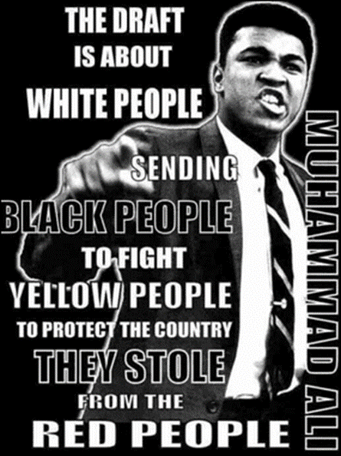
The Beatles engaging in a publicity stunt with Muhammed Ali in Miami 1964.
“Hello there, Beatles! We oughta do some road shows together. We’ll get rich!” (Muhammed Ali)

The world champion fighter converted to Islam and gave the same message of peace and unity as the Hindu Holy man. Brown and black men dictating to white people what contemporary society should and shouldn’t focus on was unheard of in the 1960’s. Young intellectuals from racially diverse communities wanted a change from the white privilege that controlled the world economy. Young people no longer wished to be defined according to their financial status. Black power and God consciousness via non-Christian faiths were center stage just waiting for charismatic leaders to fall like ripe fruit from the sky. Max Weber stated that charisma is, “mostly seen within the religious realm,” both were deeply religious which supports this theory. However, only one of these men was a religious leader and both became charismatic leaders for their promotion of equality, and peace via religious practices.
Celebrity Endorsement.
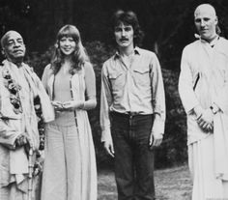
Modern day pop puppeteer, Simon Cowell believes charisma is something that can be cultivated and sold. Year after year Cowell takes young talent and successfully builds a charismatic persona around their musical abilities, enabling the whole package to become a brand. Store bought charisma requires the cooperation of both the press and the public. This is nothing new, George Martin did the same for the Beatles, and once the Beatles boy band brand was born, everyone was all aboard the Yellow Submarine. By the time Prabhupada had arrived in New York the Beatles were worldwide famous and bass guitarist George Harrison became Prabhupada’s disciple (pictured above; George Harrison, 3rd left, his wife, Prabhupada and an ISKCON devotee. Prabhupada offered all his spiritual knowledge entirely for free and asked for nothing in return except the chanting of the following mantra: Hare Krishna Hare Krishna, Krishna Krishna, Hare Hare, Hare Rama Hare Rama, Rama Rama, Hare Hare. The mantra is said to contain mystical vibrations that reveal the meaning of life.
Eastern mysticism was very fashionable and so were the Beatles. In 1966 John Lennon made his controversial comment “we are more popular than Jesus” but later apologized for this statement, perhaps after realizing a large portion of his USA fan base were part of the Christian community. In the same way it is possible that Prabhupada realized he would need the backing of popular youth culture to grab the attention to promote world peace via Radha & Krishna (Hindu Goddess and God of unadulterated love).
Muhammed Ali was an advocate of the civil rights movement and Islamic ethics. This inspired young black males to turn towards the civil rights movement for protection and the Islamic brotherhood for moral and spiritual guidance. Authentic displays of compassion that disregard personal cost have an uplifting effect in a world full of insincerity and conflict. Ali’s refusal to fight in the Vietnam war, despite the major the consequences and impact this had on his reputation and career, is an example of his authenticity. Muhammad Ali was a controversial celebrity, famous outside the ring for his political activism and religious values. He also courted fame by appearing in press conferences with other celebrities, like the Beatles. The boy band and the boxer appeared together in mainstream publications, boosting the popularity of both parties. The Beatles were also considered charismatic, is it possible that mixing in charismatic circles increases a person’s charismatic potency? Perhaps the achievements of the charismatic inspire others to achieve their full potential or perhaps money smells money? Both personalities went above and beyond what they set out to do, Ali and Prabhupada were perceptive enough to see the power of their position and chose to use it to promote world peace.

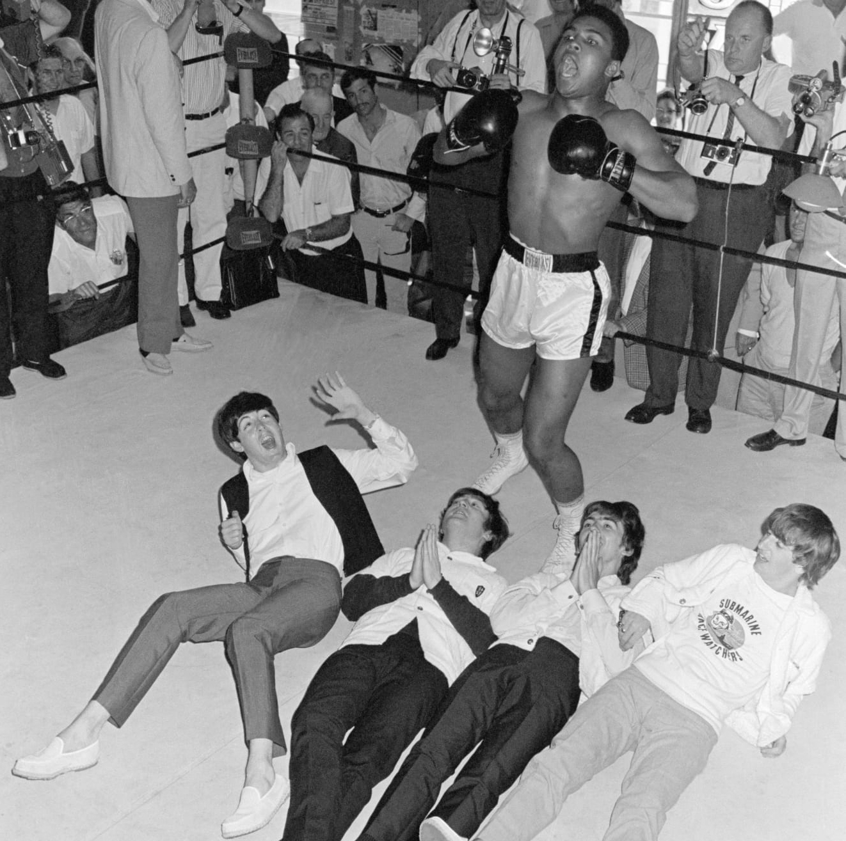

Charisma in a can.
Charismatic flavours can be replicated artificially, but natural charisma comes with a courage rarely seen in most humans. Some use their courage for personal gain, and some use their courageousness for altruistic purposes. Historically, many humans that have stood by their unwavering truths, to enforce social justice or tyranny, have been proverbial lambs to the slaughter. However, soldiers of truth possess the strength to stand alone, and this is what makes them figures of love, hate and ridicule. A sigh of relief echoes across humanity when someone is prepared to step forth and carry the sword of truth. |  |  | For most of society the sword is too heavy. Most examples of charismatic leaders are negative and destructive, however, the two personalities featured used their charisma to propagate peace, and equality. The world is always a brighter and more adventurous place when charismatic leaders guide us towards our individual courage and compassion. Whilst Weber’s theories have extensively impacted on anthropological approaches towards the relationship between religion and political economy, they do not enable us to bottle charisma. They allow us to identify attributes needed for personalities to become influential.
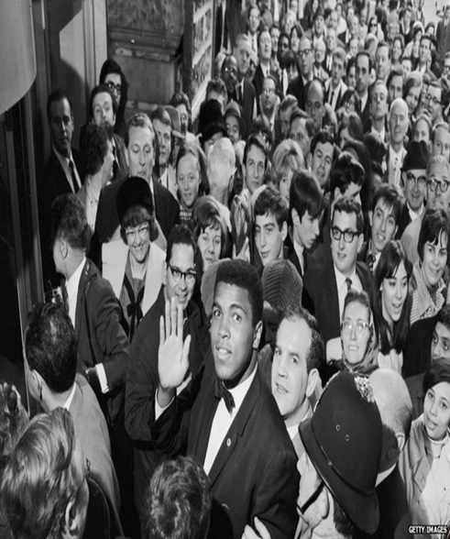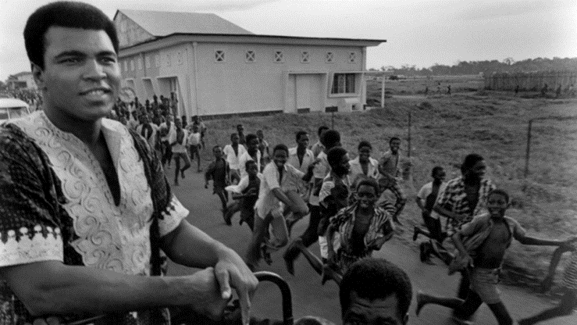
Zaire 1974
Broadway 1964


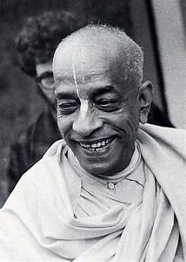
Prabhupada died in 1977 but is still internationally renowned as the charismatic eternal servant of the Hindu Goddess and God of love (Radha and Krishna).

