
Cloud Computing
University of Wales Trinity Saint David London

Cloud Computing Architecture (CCA)
(ACCA5025)

Contents
Introduction 3
Virtual machine 3
Virtual Hard Drives: 5
Resource group 5
Virtual Network and Network Security Groups: 8
Creating and Managing VMs: 11
Additional Exercise: 17
Conclusion 19
References 20

Figure 1- student account 4
Figure 2- home Window Microsoft Azure 4
Figure 3- Create resource group. 6
Figure 4-resource group was successful. 7
Figure 5-Resource group details 7
Figure 6 Virtual networks 9
Figure 7- Create virtual network. (A location region will be selected in our case is UK South) 9
Figure 8-IP address settings 10
Figure 9 IP address 10
Figure 10 vNet was successful. 11
Figure 11-HOME Page 12
Figure 12- In this screenshot we can show the subscription and the name for the resource group (Assessment2-cca) and the name for Virtual Machine (VM1) 13
Figure 13- Create username and password. 13
Figure 14- Subnets 14
Figure 15- Submit inbound ports. 14
Figure 16- Subscription price/hr 15
Figure 17-Deployment is in progress. 15
Figure 18- VM was Successful. 16
Figure 19 VM 2 16
Figure 20- Validation failed. 17
Figure 21- Server manager dashboard 18
Figure 22-Nginx 18

Introduction

Based on new knowledge acquired in the first assignment following the scenario I realised the theoretical part in which I had the following conclusions through Infrastructure as a Service (IaaS), Platform as a Service (PaaS), and Software as a Service (SaaS) models, cloud computing offers a few advantages including scalability, cost savings, flexibility, and greater productivity. SaaS is best for businesses that want to use software applications without having to manage and maintain them, while PaaS is best for organizations that want to concentrate on developing and deploying applications rather than worrying about the underlying infrastructure. IaaS is best for organizations that need complete control over their infrastructure. Each approach, however, has disadvantages, including the requirement for control when firms outsource the management of their IT, vendor lock-in, and security issues. Thus, it is crucial to weigh the advantages and disadvantages of each service type and take high availability into account for businesses that require their services to be accessible around-the-clock with little to no downtime. After all these analyses, we will perform the practical part in this assessment in Microsoft Azure.

Virtual machine

A virtual machine (VM) is a computer system that can run an operating system and applications just like a physical computer does through software. The Azure interface, Azure CLI, PowerShell, or Azure SDKs are all ways to create and manage virtual machines in Azure. Virtual hard drives, network ports, public IP addresses, and vNets are just a few of the resources that come with constructing a virtual machine. Azure is a cloud service created by Microsoft for testing and managing applications and numerous services through Microsoft datacentres on the web hosted by Azure it is very flexible and offers 24/7 technical support. Therefore, the backup and disaster recovery tool is Azure. Azure offers the option to have the functionality so we need we will create a virtual machine to test the efficiency and popularity of this tool. [1]
I took the following procedures to build and manage VMs in Azure:
The first step is to create virtual machines is create account.
Link with practical part: https://youtu.be/s8eFp63OgkE
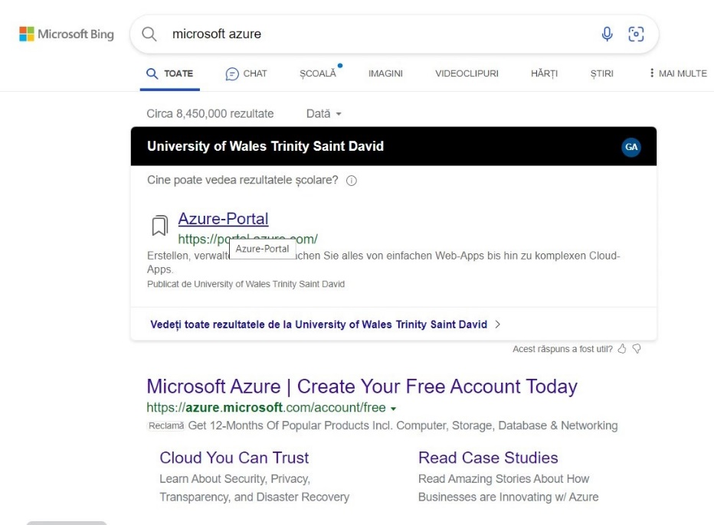
Figure 1- student account
In the practical parts I created an account using the university account thus I received a free amount for each student having this benefit.
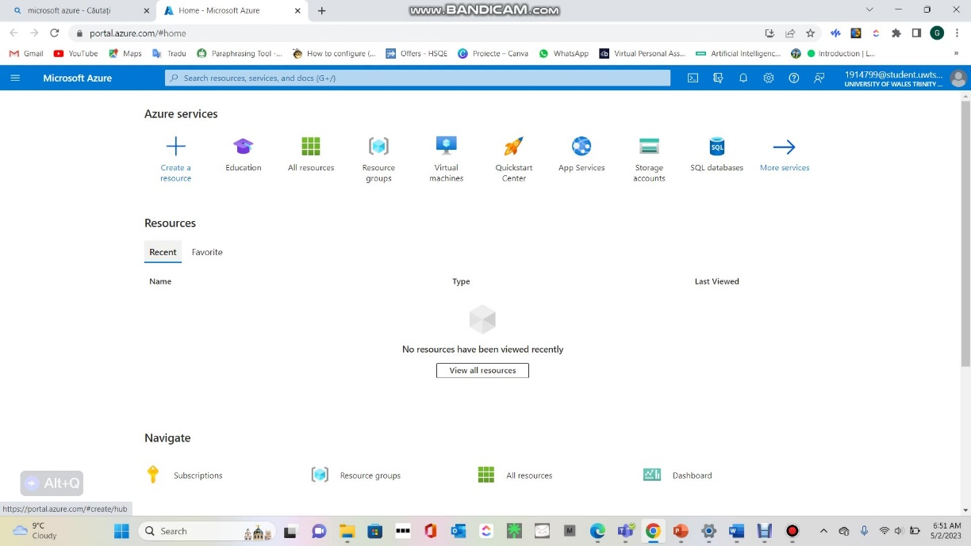
Figure 2- home Window Microsoft Azure
The first page is a home page from here we can very easily create virtual machine, resource groups or network group etc.

Virtual Hard Drives:

A virtual hard drive is a file that represents the operating system, programmes, and data on a virtual machine (VM). Virtual hard drives in Azure are kept as VHD or VHDX files in Azure Blob storage. Virtual hard drives can be created and managed via the Azure interface, Azure CLI, PowerShell, or Azure SDKs. Virtual Hard Drives (VHDs) are a feature of Microsoft Azure that allows users to create and manage virtual disks in the cloud. VHDs can be attached to virtual machines (VMs) or used as storage containers for data. VHDs can also be copied, moved, or deleted as needed. [2]
VHDs are like physical hard disks, but they have some advantages and disadvantages. Some of the advantages are:
- VHDs can be resized, encrypted, or backed up easily.
- VHDs can be created from existing disk images or snapshots.
- VHDs can be shared across multiple VMs or regions.
- VHDs can be stored in different types of storage accounts, such as standard or premium.
Some of the disadvantages are:
- VHDs have a performance overhead compared to physical disks.
- VHDs have a maximum size limit of 4 TB.
- VHDs have a higher cost than physical disks.

Resource group

A resource group in Microsoft Azure is a conceptual container for a collection of connected resources, including virtual machines, storage accounts, virtual networks, and more. Resource groups are used to organize resources and manage them collectively as a single unit. More exactly utilising resource groups can streamline management, organize resources, limit access to resources, apply policies and governance guidelines, and control resource costs. It is simpler to deploy, monitor, and manage resources when they are managed as a single unit by grouping related resources into resource groups. Additionally, you can apply policies and governance guidelines to group resources to make sure they adhere to compliance standards, and you can track and manage resource costs more conveniently.
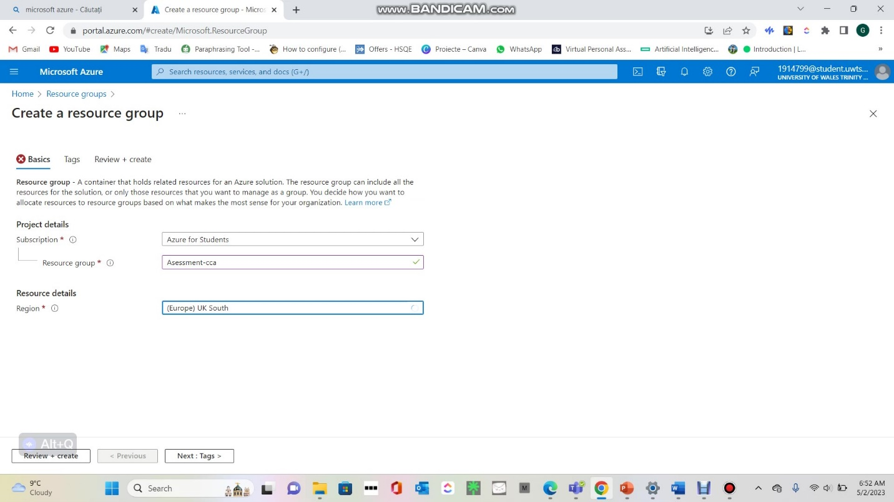
Figure 3- Create resource group.

The name and location where the resources will be deployed are specified when you create a resource group. The group's resources must all be in the same area. To make it easier for you to locate and manage resources. You can store and manage your resources in one of the many regions of Azure that are available globally. In our case is South of UK. (This option is recommended for easy operation). Is possible optionally select tags for the resource group.
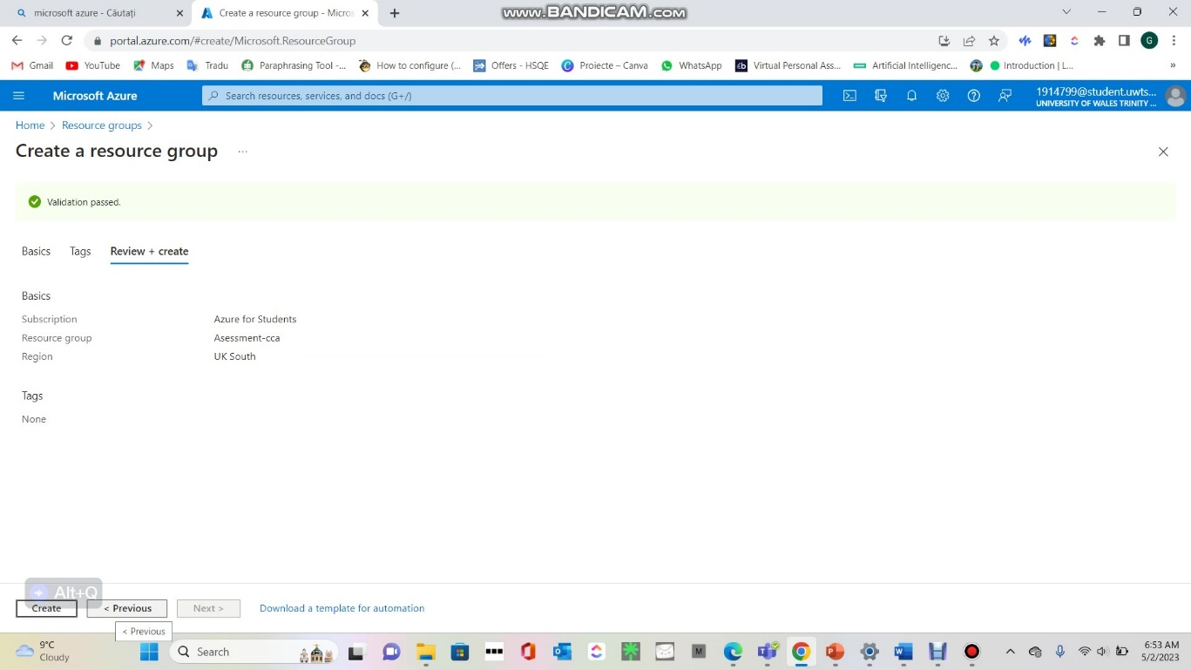
Figure 4-resource group was successful.
Overall, resource groups provide a way to organize and manage resources in Azure, making it easier to deploy and manage complex applications and environments.
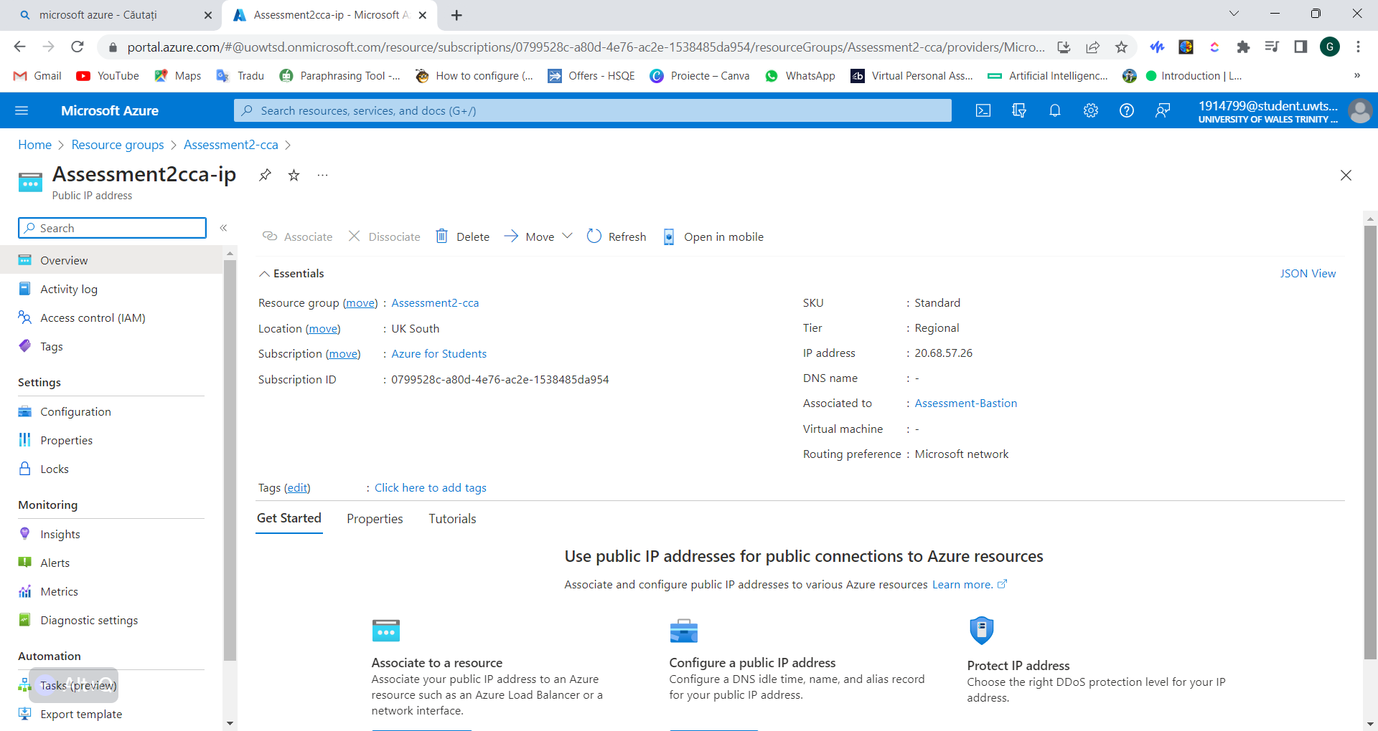
Figure 5-Resource group details

Virtual Network and Network Security Groups:

A virtual network, or vNet, enables you to safely link Azure resources, such as virtual machines and Azure services, together. Isolation, segmentation, and control over network traffic between resources are provided by vNets. Using the Azure portal, Azure CLI, PowerShell, or Azure SDKs, you can create and manage Virtual Network. [3]
A network security group (NSG) is a virtual firewall that manages network traffic going to and coming from virtual machines (VMs). Based on IP addresses, protocols, and ports, network traffic can be filtered using this tool. [4] A virtualization platform, such as VMware NSX or Azure Network Security Group, can be used to establish and manage NSGs. A firewall called a Network Security Group (NSG) manages the inbound and outgoing network traffic to a virtual machine. NSGs may be connected to a network interface or a virtual network. The NSG is applicable to all resources within a vNet when it is associated with that vNet. The NSG is applicable to a particular VM when connected to a network interface. Using the Azure portal, Azure CLI, PowerShell, or Azure SDKs, you can create and manage NSGs. A network security group (NSG) is a feature of Azure that allows you to filter network traffic to and from Azure resources. You can use an NSG to deny access to the database server in Azure by applying a security rule that blocks inbound or outbound traffic on a specific port, protocol, or IP address range. For example, you could create an NSG with a rule that denies inbound traffic on TCP port 1433, which is used by SQL Server, from any source to the database server's network interface or subnet. This way, only authorized clients can connect to the database server. To create an NSG and a security rule, you can use the Azure portal, PowerShell, or Azure CLI. You can also modify or delete an NSG, and its rules as needed. [3]
In below will be screenshots how to create and configure a vNet and its subnets
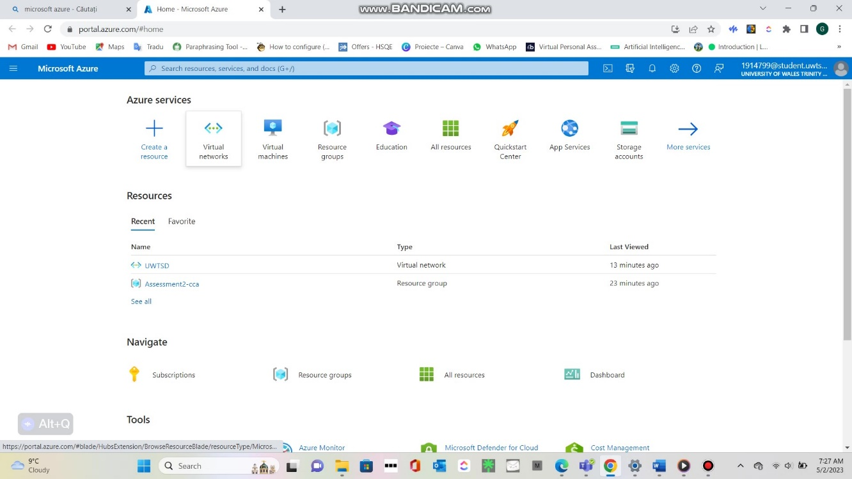
Figure 6 Virtual networks
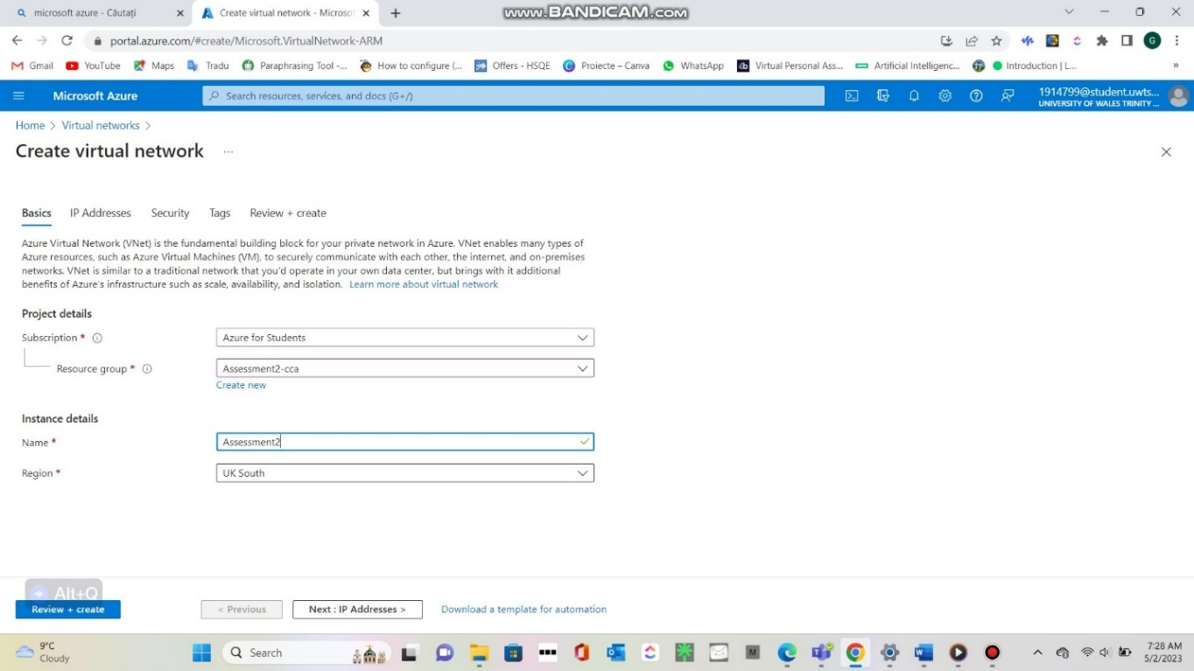
Figure 7- Create virtual network. (A location region will be selected in our case is UK South)
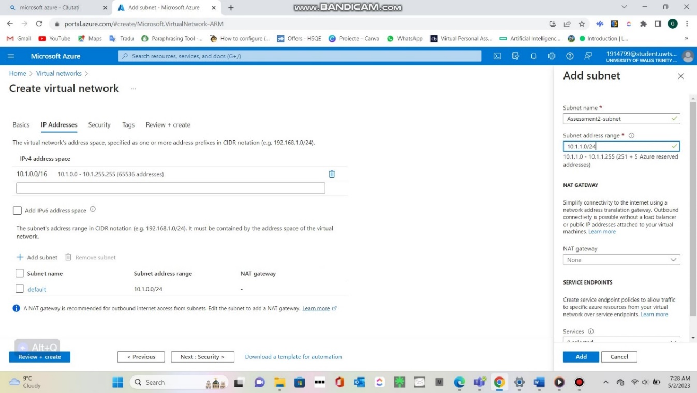
Figure 8-IP address settings
All the resources in a Virtual Network have access to the internet by default. Giving a resource a public IP address or using a public load balancer will enable inbound communication.
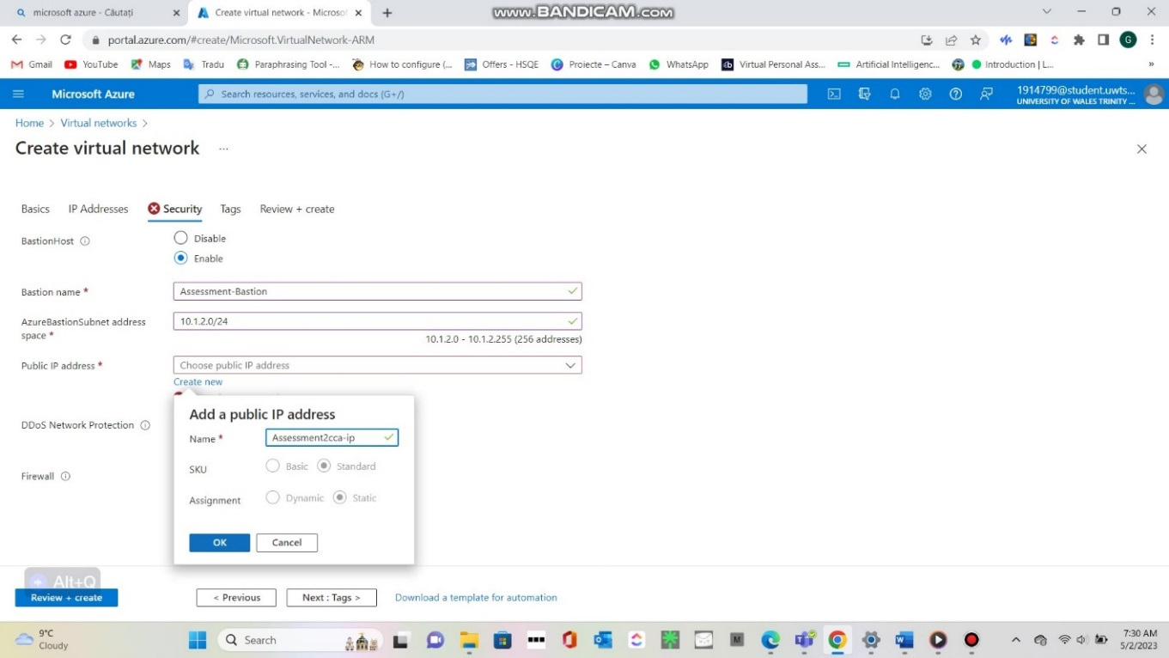
Figure 9 IP address
A public IP also allows for the management of outgoing connections.
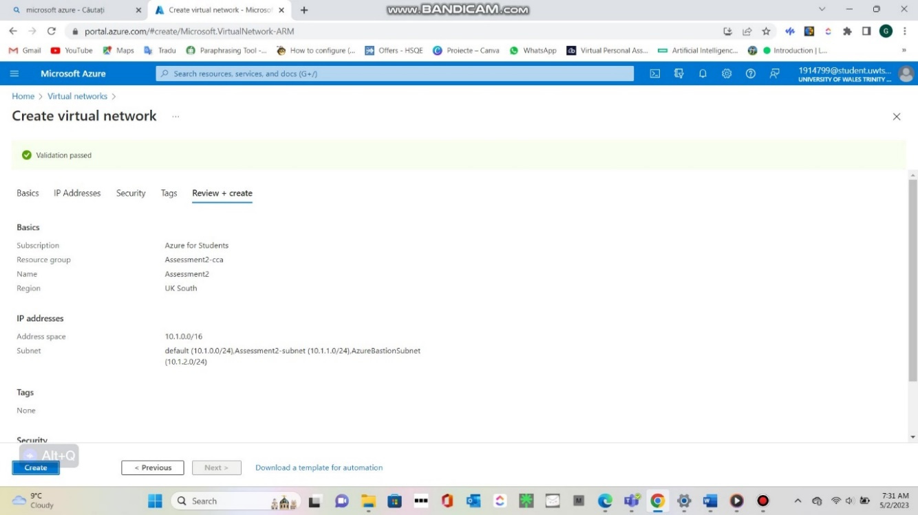
Figure 10 vNet was successful.
When a vNet is formed, services and virtual machines (VMs) within it can connect with one another directly and securely in the cloud.

Creating and Managing VMs:

A virtualization platform, like Hyper-V or vSphere, can be used to generate and manage virtual machines (VMs). Configuring the virtual hardware, installing the operating system and programs, and setting up the network are all steps in the creation of a virtual machine (VM). A management console, which enables administrators to carry out operations including starting and stopping the VM, adding or deleting virtual hardware, and adjusting network settings, can be used to administer a VM once it has been built.
A virtual machine can be started, stopped, restarted, and resized as part of maintaining it in Azure. You can also manage the virtual hard discs, network interfaces, and NSGs for the VM. Here is a short description and screenshot of the Azure portal's VM management section:
- Sign into the Azure portal and select Create a resource.
- Choose a virtual machine image from the Azure Marketplace or your own custom image.
- Configure the basic settings for your virtual machine, such as name, region, size, and authentication method.
- Optionally, you can customize the disk, networking, management, and advanced settings for your virtual machine.
- Review and create your virtual machine. You can monitor the deployment status on the notifications area.
- Once the virtual machine is created, you can connect to it using Remote Desktop Protocol (RDP) or Secure Shell (SSH), depending on the operating system and authentication method you chose.
- To manage your virtual machine, you can use the Azure portal, Azure PowerShell, Azure CLI, or Azure REST API. You can perform actions such as start, stop, restart, resize, backup, and delete your virtual machine. [5]
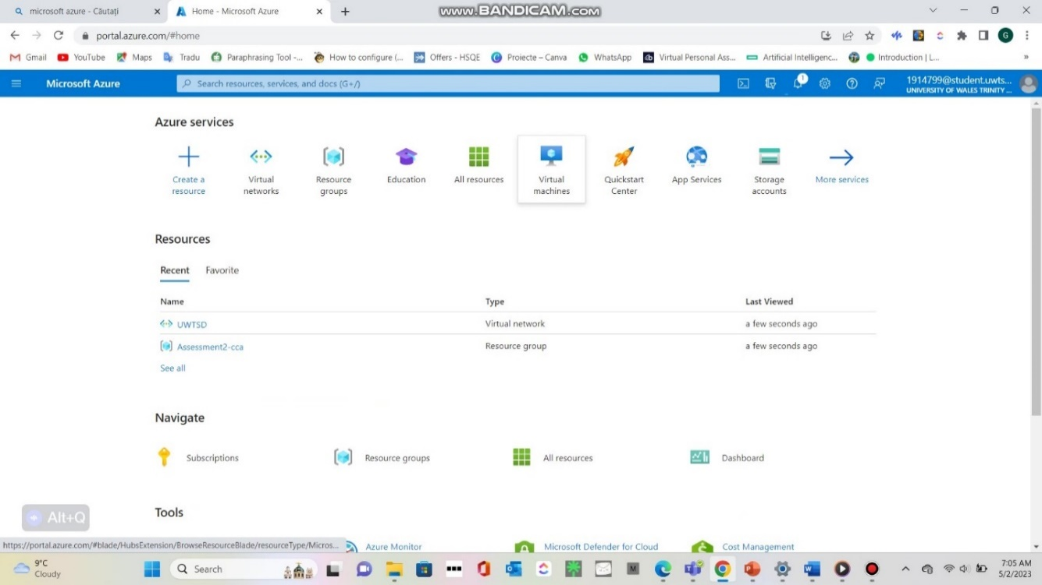
Figure 11-HOME Page
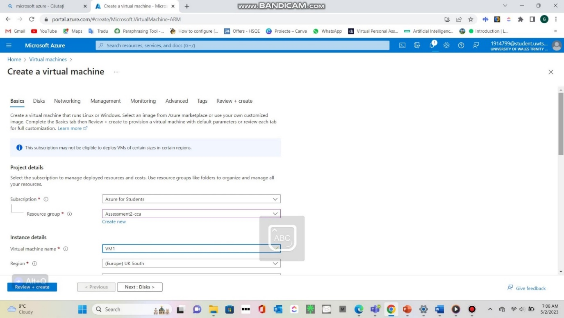
Figure 12- In this screenshot we can show the subscription and the name for the resource group (Assessment2-cca) and the name for Virtual Machine (VM1)
Select the Azure subscription that you want to use, Name of the virtual machine: Give your VM a name and we select Region: Decide the Azure region you wish to deploy your virtual machine to.
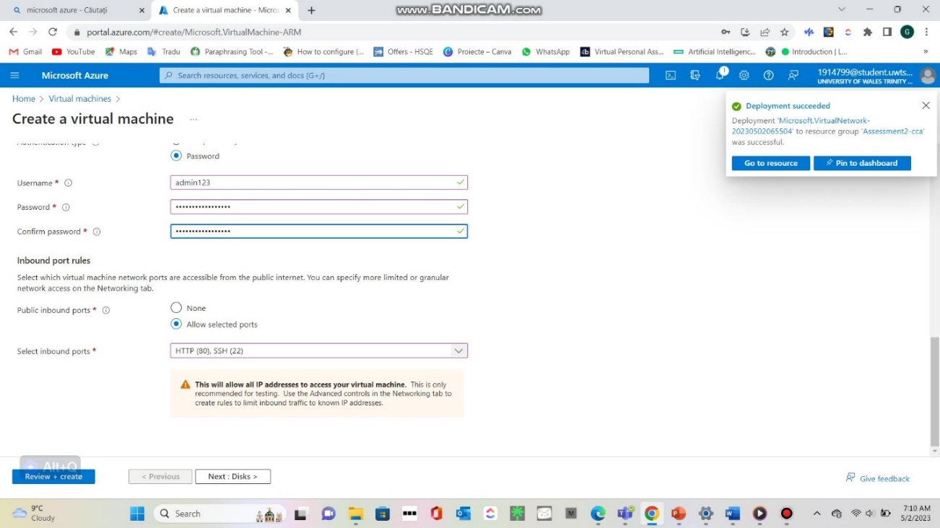
Figure 13- Create username and password.
In this screenshot we choose password-based authentication and Size: Based on the demands of your workload, select the VM's size.
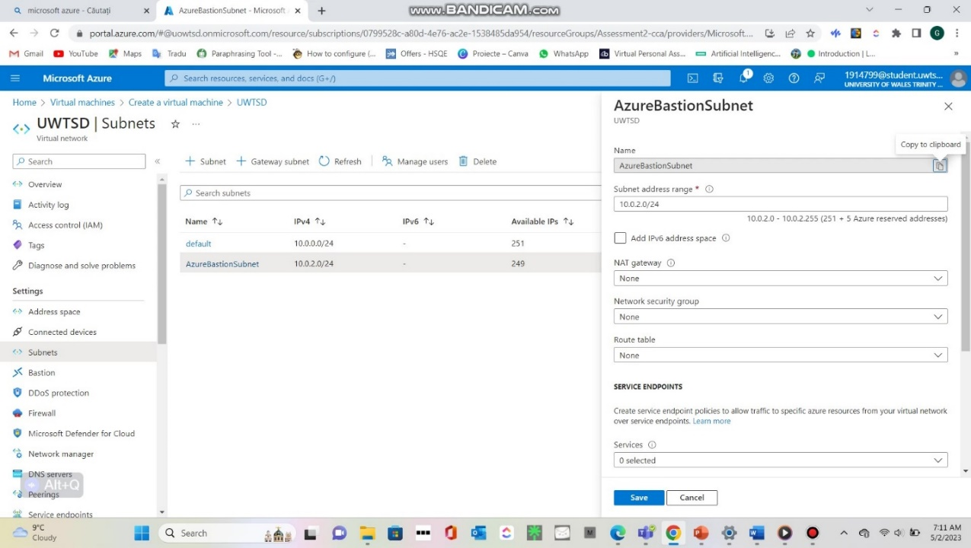
Figure 14- Subnets
Select the options for availability that best meet your needs.
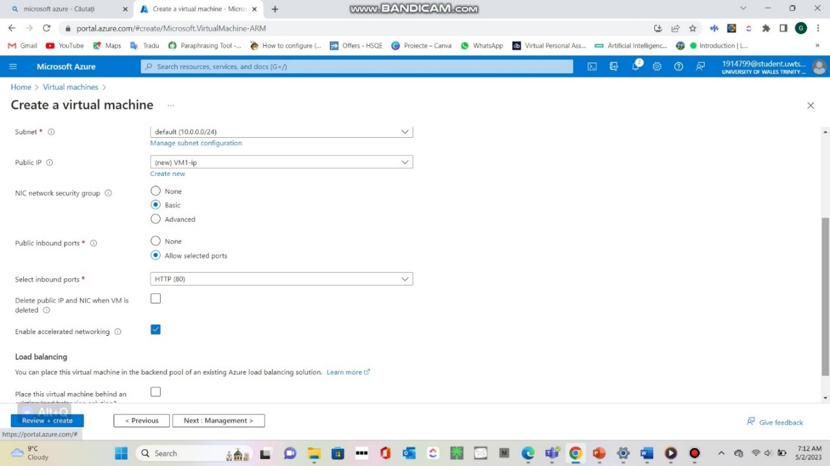
Figure 15- Submit inbound ports.
Choose between HTTP key authentication.
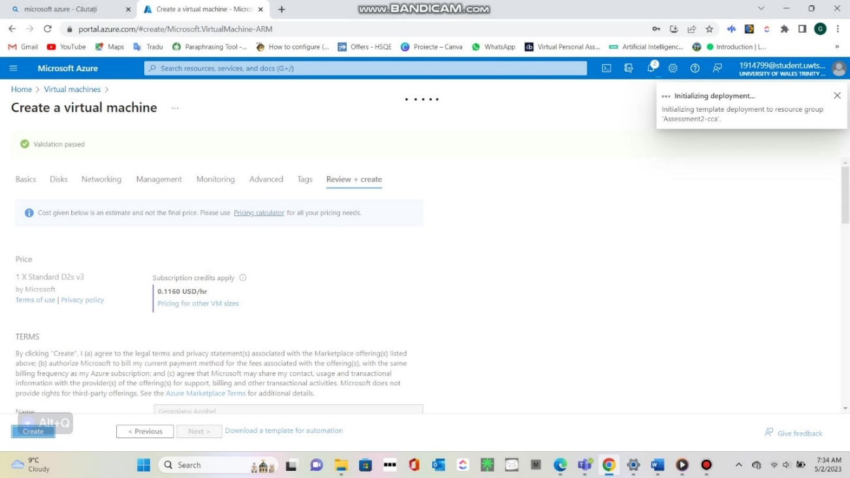
Figure 16- Subscription price/hr

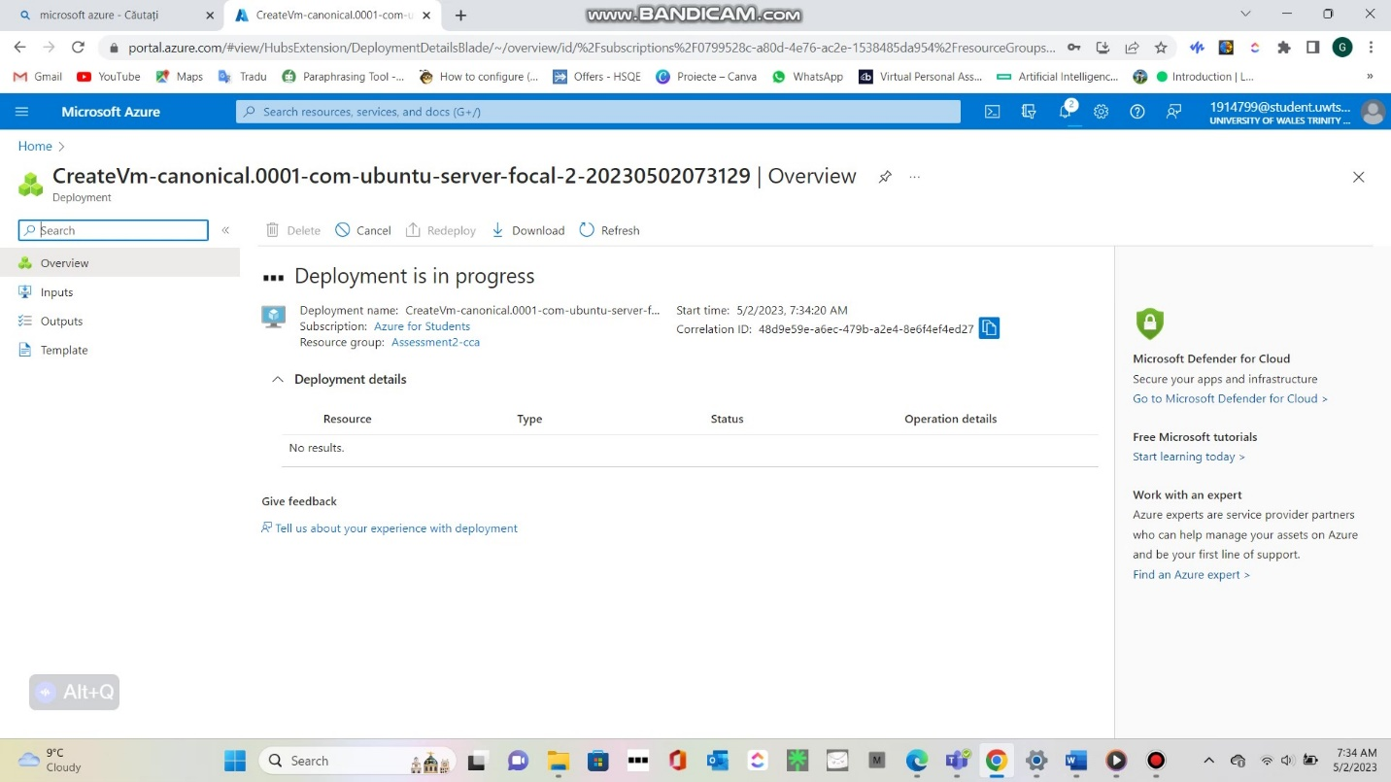
Figure 17-Deployment is in progress.
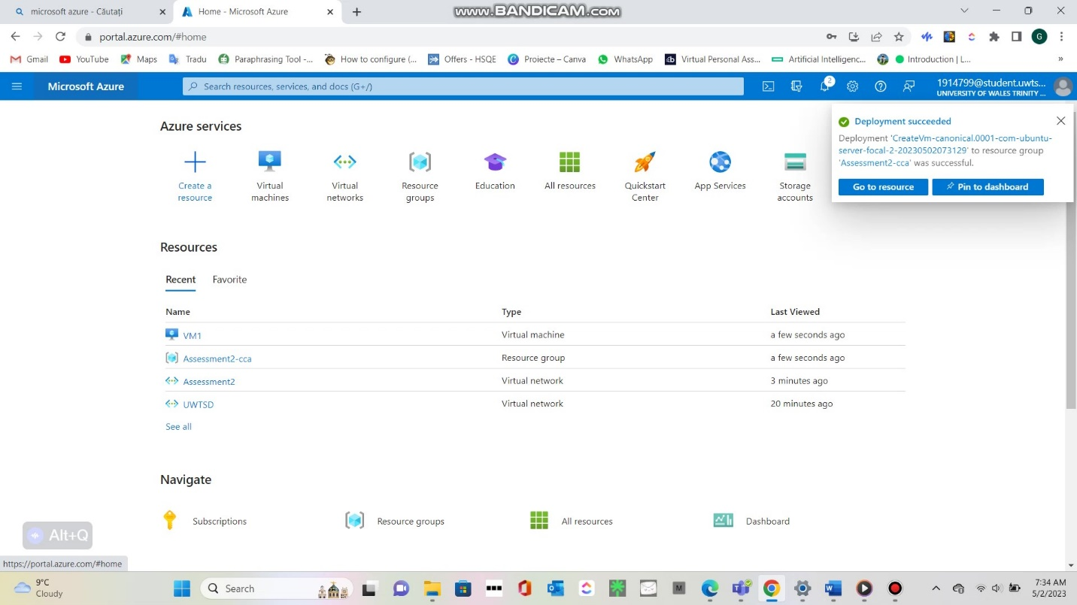
Figure 18- VM was Successful.
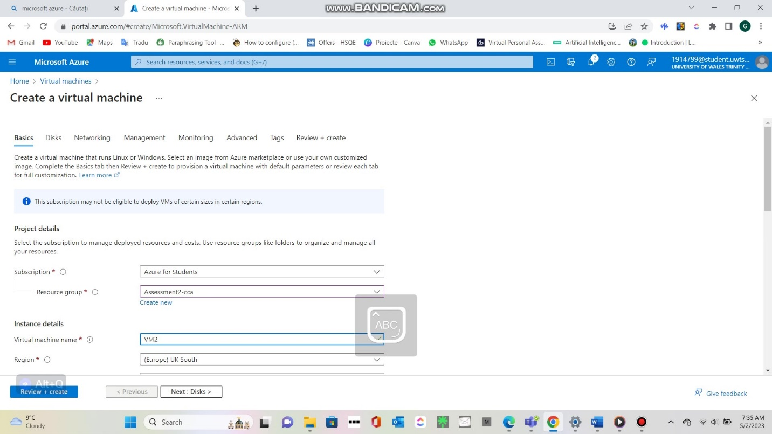
Figure 19 VM 2
We create VM2 we fallow the same what I did with VM1. In this case in final part unfortunately my subscription does not allow the creation of this VM.
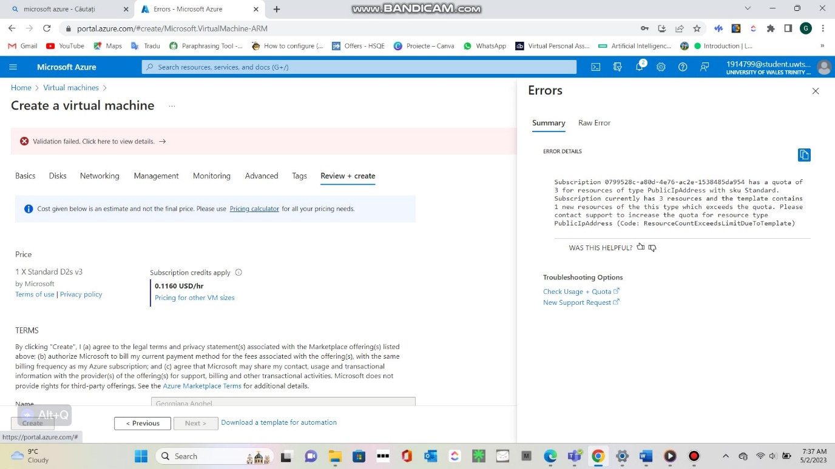
Figure 20- Validation failed.

Additional Exercise:

Due to the amount allocated being insufficient, I would like to explain in the additional exercise how the connection between the two virtual machines is made and what is Nginx webserver and how can install it. To connect two virtual machines (VMs) in Microsoft Azure, you need to create a virtual network (VNet) and assign each VM to a subnet within the VNet. A VNet is a logical representation of a network in the cloud that allows you to isolate and secure your resources. You can use the Azure portal, PowerShell, or CLI to create a VNet and attach VMs to it. Once the VMs are connected to the same VNet, they can communicate with each other using their private IP addresses. You can also configure network security groups (NSGs) to control the traffic between the VMs and other resources. [6]
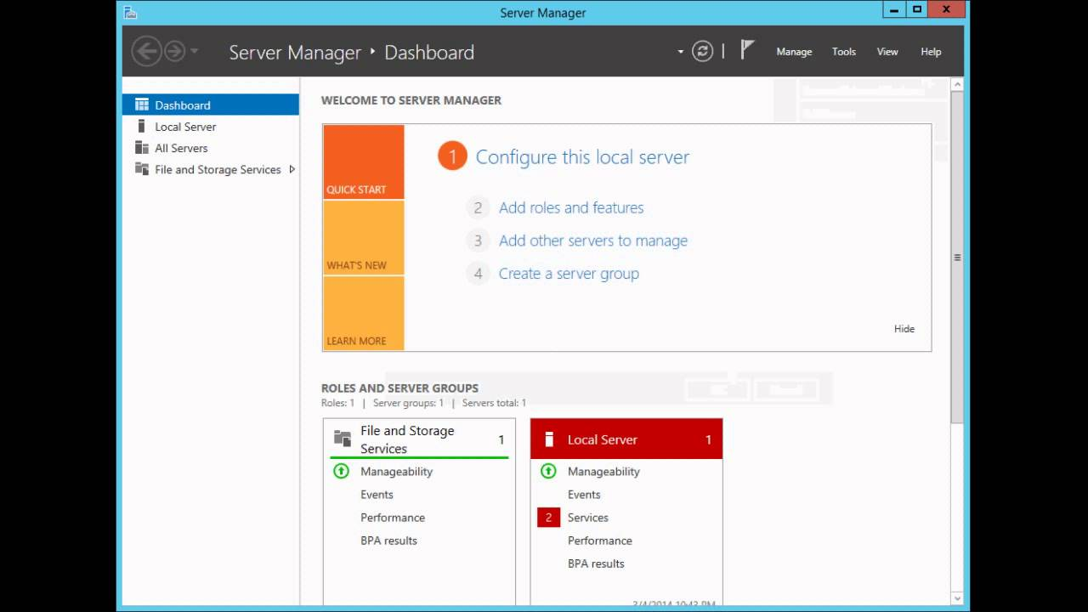
The connexion between 2 virtual machines in our case will be realised HTTP and you may manage your server environments with the help of Server Manager. Your Windows Server virtual machines (VMs) in Azure can be managed through Windows Admin Centre. A browser-based graphical user interface called Windows Admin Centre offers updated versions of well-known applications including Server Manager and the Microsoft Management Console (MMC) tools. [7]
Figure 21- Server manager dashboard
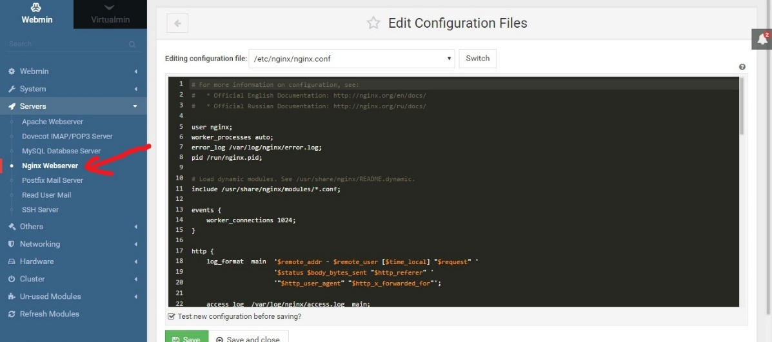
Figure 22-Nginx
Nginx is a web server and reverse proxy software that can handle high-performance and high-concurrency web applications. It can also be used as a load balancer, HTTP cache, or mail proxy. Nginx can run on various operating systems, including Linux, Windows, macOS, and BSD. Nginx in Microsoft Azure is a solution that enables users to deploy and run Nginx on Azure virtual machines (VMs) or containers. Users can choose from different Nginx versions and configurations and customize their Nginx settings according to their needs. Users can also integrate Nginx with other Azure services, such as Azure Load Balancer, Azure Application Gateway, Azure Monitor, and Azure Security Center. Nginx in Microsoft Azure is a suitable option for users who want to leverage the benefits of both Nginx and Azure for their web applications. Users can enjoy the speed, reliability, and flexibility of Nginx, as well as the scalability, security, and convenience of Azure.

Conclusion

In conclusion, Azure VMs can be built and managed using the Azure interface, Azure CLI, PowerShell, or Azure SDKs. Virtual hard drives, network interfaces, public IP addresses, and vNets are some of the resources that are attached to a VM when it is created. NSGs offer firewall security, while vNets offer isolation and control over network traffic. In Azure, you can create secure and effective VMs by properly configuring these resources. To sum up, a virtual machine (VM) in Microsoft Azure is a strong tool that enables users to execute operating systems and applications on the cloud in a manner like that of a real computer. The Azure CLI, PowerShell, Azure SDKs, and the Azure interface are just a few of the interfaces that Azure provides for creating and managing VMs. Virtual hard drives, network ports, public IP addresses, and vNets are just a few of the resources needed to create a VM. These resources can be grouped together and managed for easier management. Azure's resource groups make it simpler to deploy and manage complex apps and environments by offering a means to organize and manage resources.
So, through all this demonstration the practical application of cloud computing and virtualization in the context of backup and disaster recovery are absolutely necessary for any company. right now, cloud computing is a powerful and flexible technology that can increase productivity, scalability, and security of the enterprise, as well as reduce costs and environmental impact. However, it also requires careful consideration of the trade-offs between control and convenience, as well as the potential risks of vendor lock-in and data breaches. Therefore, companies should evaluate their needs and goals before choosing a model and cloud service provider. Through practical application we created 2 virtual machines through a step-by-step manual that includes screenshots that explains how to set up a Virtual Network and Virtual Machines in Azure. The manual addresses issues including setting up a vNet, defining IP address preferences, and controlling virtual machines using a management console. Through all these screenshots I have demonstrated the ease with which a virtual machine can be created and managed.

References

[1] | R. Jennings, Cloud Computing with the Windows Azure Platform, Birmingham: Wrox Press, 2009.
[2] | “Virtual machine and disk performance,” Microsoft 2023, 13 12 2022. [Online]. Available: https://learn.microsoft.com/en-us/azure/virtual-machines/disks-performance. [Accessed 02 05 2023].
[3] | “View the topology of an Azure virtual network,” Microsoft 2023, 13 April 2023. [Online]. Available: https://learn.microsoft.com/en-us/azure/network-watcher/view-network-topology. [Accessed 01 05 2023].
[4] | “What is a network group in Azure Virtual Network Manager?,” Microsoft 2023, 22 03 2023. [Online]. Available: https://learn.microsoft.com/en-us/azure/virtual-network-manager/concept-network-groups. [Accessed 02 05 2023].
[5] | “Generate and store SSH keys in the Azure portal,” Microsoft 2023, 27 04 2023. [Online]. Available: https://learn.microsoft.com/en-us/azure/virtual-machines/ssh-keys-portal. [Accessed 02 05 2023].
[6] | Microsoft, “How to use SSH keys with Windows on Azure,” Microsoft 2023, 15 03 2023. [Online]. Available: https://learn.microsoft.com/en-us/azure/virtual-machines/linux/ssh-from-windows. [Accessed 03 05 2023].
[7] | J. Krause, Mastering Windows Server 2019 : the complete guide for IT professionals to install and manage Windows Server 2019 and deploy new capabilities, Birmingham ; Mumbai : Packt, 2019.

