Digital Skills and Research Methods
Topic: Impact of Covid-19 on the employees of NHS in the UK

Name: Stefan Mihai Ciolan
Student ID: 2118520
Teacher Name: Abdi Rahman
Course Name: Digital Skills and Research Methods
Course Code: BMSW4003

Abstract
The following research report has discussed the influence of the recent pandemic on the employees of NHS in the UK. Research aim and objectives have been made on the basis of the selected topic. The way the researcher has prepared the whole research is included in the methodology section. Research questions, methods and ethical considerations have also been explained in this context. The results and discussion part included various numerical data and information regarding the topic.

Table of Contents
Introduction 4
The research aims and objectives 5
Research design 6
Results 8
Discussion 18
Conclusion 19
References 20
Appendix 22

Introduction
The following research report will be based on the influence of the recent pandemic on the employees of NHS in the United Kingdom. The employees of NHS of the UK faced various issues during the period of a pandemic. The UK has relied significantly on the healthcare workers of the NHS due to the impact of the pandemic. The research aim and objective will be prepared in this context on the basis of the selected topic. Moreover, the research methodology section will include the research questions, research methods as well as ethical considerations. Primary data collection will be used in order to gather data about the topic. Moreover, it can be done by the researcher through the help of surveys and questionnaires. The chapter discussion will evaluate the results of the primary analysis.

The research aims and objectives
Aim
To understand the impact of a pandemic on the NHS's employees in the UK.
Objectives
1. To analyse the impact of a pandemic on the NHS's employees in the United Kingdom.
2. To evaluate the issues faced by the employees of NHS due to the outbreak of the pandemic.
3. To figure out the strategies implemented by the employees of NHS in order to overcome the issues faced during to the pandemic.

Research design
According to Liamputtong, (2020), the Research design is basically illustrated as the overall approach in order to conducting the research projects. It is one of the logical plans for answering research questions through data analysis, collection, discussion and interpretation. By making this, the researcher can make sure the results and outcomes cover all the problems of the research effectively and selecting the accurate type is important (Rezigalla, 2020).
Research questions
1. What is the impact of the pandemic on the employees of NHS?
2. What are the issues faced by the NHS’s employees due to the outbreak of the pandemic?
3. What are the strategies implemented by the employees of NHS in order to mitigate the issues faced due to the pandemic?
Research Methods
Research Methods are basically defined as the process, techniques and processes used in the data collection process in order to gather new information about the topic and make the whole project in a systematic and structured way. Developing the whole research method is a very much important aspect of the research design (Lê and Schmid, 2022). While planning the methods, there needs to take two decisions. One of them is the way to collect data and the selection of the methods basically depends on the research questions. The researcher can use quantitative data in which utilisation of statistical analysis needs to use in order to test the relationship between different variables. In addition to that, the researcher can also use qualitative data which is helpful for the researcher as it is flexible and can conduct with different small samples. In addition to that, the researcher has used the primary data collection tool in order to gather data about the research (Harris et al., 2019). The individual has made a survey by making questionnaires on the basis of the given topic. The response to the survey can be made by the employees of NHS that help the researcher to gather various important information regarding the topic. Apart from that, the researcher can also use descriptive research as it helps the researcher to illustrate existing situations without evaluating the relationships between various variables (Strijker et al., 2020).
Ethical considerations
It is one of the most significant components of any research. If the researcher fails to follow any specific code of conduct while preparing research can invalidate the findings as well as weaken scientific integrity. Researchers need to uphold ethical considerations in order to fulfil the whole research in an effective and smooth way. Ethical considerations are significant as it helps to promote research objectives that include avoidance of knowledge, truth and error. Ethical considerations forbid false misrepresentation ad interpretations of fact in order to deliver conclusions from the research that undertakes (Bloomfield and Fisher, 2019). In addition to that, it is useful in order to promote collaboration, mutual respect and trust since research include cooperation between different people and the researcher. A cohesive atmosphere is adopted by various ethical considerations that make sure all the parties are included throughout the whole research. There are various ethical issues such as voluntary participation, anonymity, the potential for harm, informed consent, and confidentiality. Researchers need to make sure that all the necessary aspects have to maintain while conducting the whole research (Sileyew, 2019).

Results
Primary data analysis
1. Does Covid-19 put a huge effect on the employees of the National Health Services (NHS)?
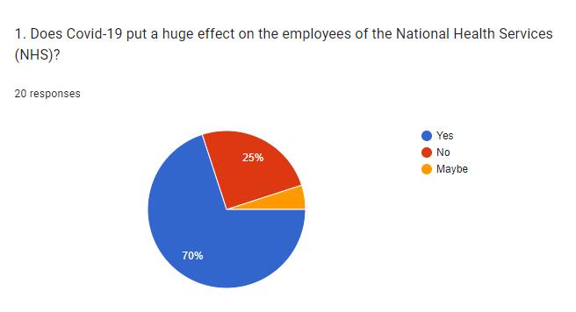
Figure: Survey questions
Source: Google forms
Illustration
The above survey question asks that is there is any effect of the pandemic on the employees of NHS. On the behalf of the particular question, about 70% of the employees of the respective governmental business say that they have faced huge impacts of the same. Out of the other employees, about 25% of them choose the option of ‘no’ and the rest of them chose the option of maybe, which is about 5% (Propper et al., 2020).
2. What are the issues faced by the employees of NHS due to the pandemic situation?
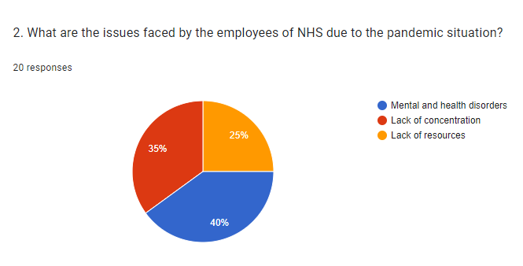
Figure: Survey questions
Source: Google forms
Analysis
This particular question in the above section highlights the issues faced by the employees of NHS due to the pandemic situation. There were three different options which dictates three different issues. One of them is the issues regarding mental and heal disorders, which has been opted for by 40% of the employees. In contrast to this, about 25% of the employees have been facing a lack of resources during the specific period. Along with this, the rest of the employees which is about 35% of them were facing a lack of concentration in the workplace (Propper et al., 2020).
3. Did the impact of the Covid-19 pandemic affect the performance of NHS employees?
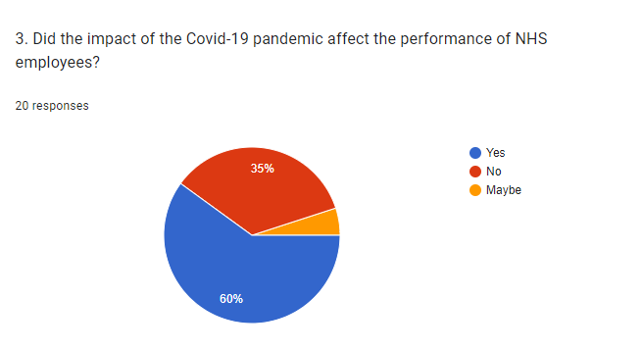
Figure: Survey questions
Source: Google forms
Illustration
There is always a question on the performance when it comes to the pandemic situation affecting any business. Therefore, the above-highlighted question is regarding the same. It asks about the pandemic situation affecting the performances of specific employees. In this context, the employees answered yes, whose percentage is about 60%. On the other hand, only 35% of them said the pandemic has not affected their performances. Leaving the 5% of the employees, who are not sure about their performance, whether it has been affected or not (Collin et al., 2021).
4. Does the impact of the Covid-19 pandemic reduces the productivity of NHS employees?
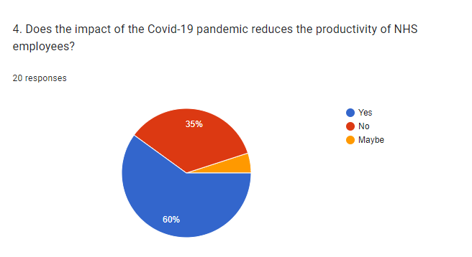
Figure: Survey questions
Source: Google forms
Analysis
The above question is a bit similar to the previously asked question. This one is regarding the impact on the productivity of the employees, whether it has reduced due to the pandemic or not. Similar to the responses to the previous question, about 60% of the employees said their productivity has been affected. Other than this, about 35% and 5% of the rest of the employees chose the option of no and maybe respectively (Collin et al., 2021).
5. How much did the pandemic affect the employees of the NHS in the UK?
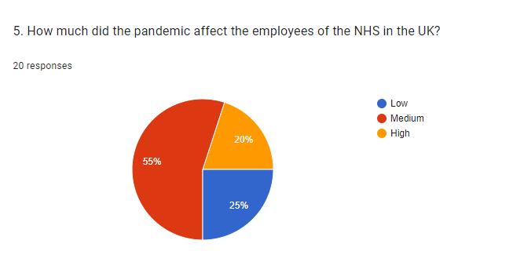
Figure: Survey questions
Source: Google forms
Illustration
This particular question of the survey asks for the impact of the pandemic on the employees in a different way. Here, 55% of the employee have chosen the medium impact and 25% of them have gone for the low impact. Moreover, about 20% of the employees chose the high-impact option (Hong et al., 2021).
6. Is there any initiative, the government took to help overcome the unfortunate situation for the employees of National Health Services?
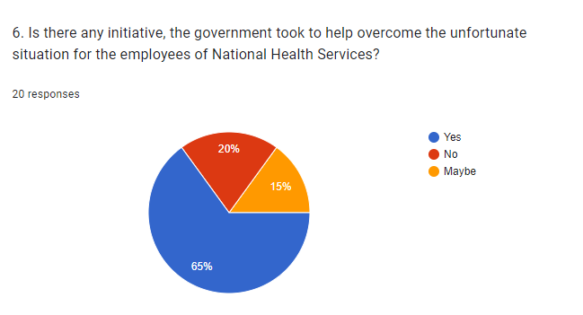
Figure: Survey questions
Source: Google forms
Analysis
Here, it has been asked that is the government helped the NHS employees during the pandemic to overcome the unfortunate situation. In that aspect, about 65% of the employees have said that the government has undoubtedly helped them to overcome the pandemic situation. Out of the rest, about 20% and 10% of the employees said no and maybe respectively (Hong et al., 2021).
7. What kind of help did the government offer to the employees of NHS?
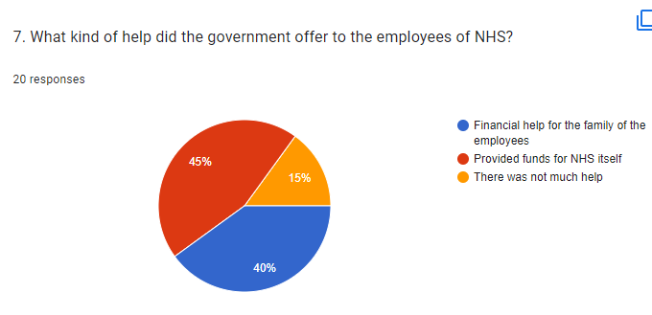
Figure: Survey questions
Source: Google forms
Illustration
The NHS is mainly run by the government of the respective country to help the general public. Here, 45% of employees have said that the government has helped by providing funds for the company. On the other hand, about 40% of the employees are saying the government has helped with financial backup for the families of the respective employees (Newman et al., 2022).
8. How did the employees of NHS mitigate the pandemic situation?
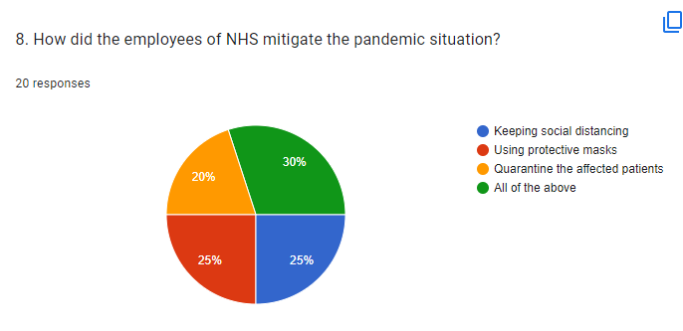
Figure: Survey questions
Source: Google forms
Analysis
According to the above-mentioned survey question, 20% of the employees are saying that they have quarantined the affected patients during the pandemic. Moreover, about 25% of the employees of NHS are saying that they used protective masks at all times to mitigate the pandemic. On the other hand, 25% of them have chosen the option of keeping social distancing. Furthermore, about 30% of the employees said that they have used all the above-mentioned protective measures to deal with the pandemic (Newman et al., 2022).
9. What did the NHS offer to the general public of the United Kingdom?
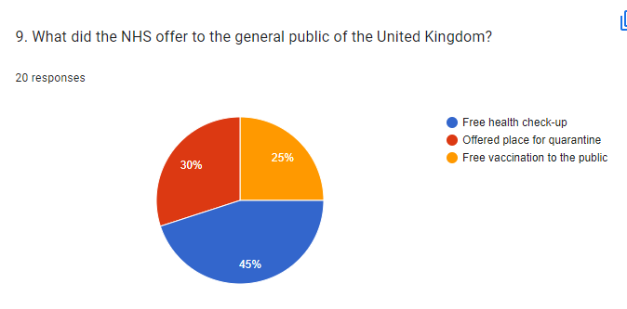
Figure: Survey questions
Source: Google forms
Illustration
Along with the other questions, there is another survey question which asks about the elements that the National Health Services have offered to the general public of the company. Here, about 45% of responses have been recorded regarding free health check-ups for the public. People have also felt satisfied with the service of quarantine space for the affected people. Other than this, about 25% of the employees felt quite encouraged when NHS started providing free vaccines for them (Gilleen et al., 2021).
10. How much will you rate the strategies implemented by the employees of NHS to overcome the pandemic situation?
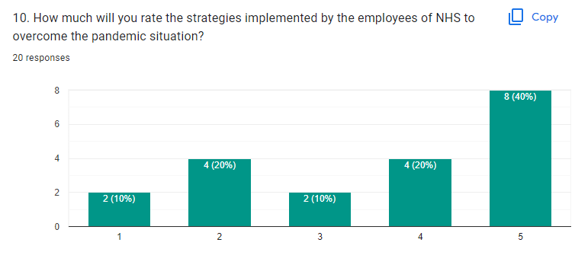
Figure: Survey questions
Source: Google forms
Analysis
This last question asks for a rating on behalf of the strategies implemented by the NHS. In this context, about 40% of the employees voted for a 5 rating. There are multiple other responses as well for 1, 2, 3 and 4 as well which are from 10%, 20%, 10% and 20% of the employees from the rest respectively (Gilleen et al., 2021).

Discussion
NHS mainly stands for National Health Service which operates in different countries and is mainly a government-funded business. They mainly provide assistance to the general public of the respective country. According to the above survey, it can be seen that the employees of the NHS have suffered a lot during the pandemic situation and also struggling in the post-pandemic situation in the UK (Rainbow and Dorji, 2020). There were multiple strategies as well which were implemented by the employees of National Health Services, among which the highest priority was to take safety measures at the workplace. They used multiple measures such as using masks all the time and keeping a certain distance between all the people and some others. Therefore, the above-highlighted aspects can now effectively satisfy the topic which is related to the impacts of a pandemic on the employees of National Health Services in the United Kingdom (Burns et al., 2021).

Conclusion
The above research project has reflected the chosen topic which is the impacts of a pandemic on the employees of NHS (National Health Services) in the United Kingdom. The aim, objectives and research questions have also been provided in the above project which the researcher has approached to answer. The research project also highlights the research design and research methods with ethical considerations. Later, primary analysis has been done with the help of a survey and questionnaire, which would help the researcher to answer the specific research questions. Those particular survey results have been displayed and some discussion has been the same regarding the impact of a pandemic.

References
Bloomfield, J. and Fisher, M.J., (2019). Quantitative research design. Journal of the Australasian Rehabilitation Nurses Association, 22(2), pp.27-30.
Burns, E.S., Pathmarajah, P. and Muralidharan, V., (2021). Physical and psychological impacts of handwashing and personal protective equipment usage in the COVID‐19 pandemic: A UK based cross‐sectional analysis of healthcare workers. Dermatologic Therapy, 34(3), p.e14885.
Collin, V., O´ Selmo, E. and Whitehead, P., (2021). Psychological distress and the perceived impact of the COVID-19 pandemic on UK dentists during a national lockdown. British Dental Journal, pp.1-8.
Gilleen, J., Santaolalla, A., Valdearenas, L., Salice, C. and Fusté, M., (2021). Impact of the COVID-19 pandemic on the mental health and well-being of UK healthcare workers. BJPsych open, 7(3), p.e88.
Harris, D.E., Holyfield, L., Jones, L., Ellis, R., Neal, J., Harris, D.E., Holyfield, L., Jones, L., Ellis, R. and Neal, J., (2019). Research methods. Spiritually and developmentally mature leadership: Towards an expanded understanding of leadership in the 21st century, pp.57-65.
Hong, J.S., Sheriff, R., Smith, K., Tomlinson, A., Saad, F., Smith, T., Engelthaler, T., Phiri, P., Henshall, C., Ede, R. and Denis, M., (2021). Impact of COVID-19 on telepsychiatry at the service and individual patient level across two UK NHS mental health Trusts. BMJ Ment Health, 24(4), pp.161-166.
Lê, J.K. and Schmid, T., (2022). The practice of innovating research methods. Organizational Research Methods, 25(2), pp.308-336.
Liamputtong, P., (2020). Qualitative research methods.
Newman, K.L., Jeve, Y. and Majumder, P., (2022). Experiences and emotional strain of NHS frontline workers during the peak of the COVID-19 pandemic. International Journal of Social Psychiatry, 68(4), pp.783-790.
Propper, C., Stoye, G. and Zaranko, B., (2020). The wider impacts of the coronavirus pandemic on the NHS. Fiscal Studies, 41(2), pp.345-356.
Rainbow, S. and Dorji, T., (2020). Impact of COVID-19 on medical students in the United Kingdom. Germs, 10(3), p.240.
Rezigalla, A.A., (2020). Observational study designs: synopsis for selecting an appropriate study design. Cureus, 12(1).
Sileyew, K.J., (2019). Research design and methodology (pp. 1-12). Rijeka: IntechOpen.
Strijker, D., Bosworth, G. and Bouter, G., (2020). Research methods in rural studies: Qualitative, quantitative and mixed methods. Journal of Rural Studies, 78, pp.262-270.

Appendix
Questionnaire
1. Does Covid-19 put a huge effect on the employees of the National Health Services (NHS)?
Yes
No
May be
2. What are the issues faced by the employees of NHS due to the pandemic situation?
Mental and health disorders
Lack of concentration
Lack of resources
3. Did the impact of the Covid-19 pandemic affect the performance of NHS employees?
Yes
No
May be
4. Does the impact of the Covid-19 pandemic reduces the productivity of NHS employees?
Yes
No
May be
5. How much did the pandemic affect the employees of the NHS in the UK?
Low
Medium
High
6. Is there any initiative, the government took to help overcome the unfortunate situation for the employees of National Health Services?
Yes
No
Maybe
7. What kind of help did the government offer to the employees of NHS?
Financial help for the family of the employees
Provided funds for NHS itself
There was not much help
8. How did the employees of NHS mitigate the pandemic situation?
Keeping social distancing
Using protective masks
Quarantine the affected patients
All of the above
9. What did the NHS offer to the general public of the United Kingdom?
Free health check-up
Offered place for quarantine
Free vaccination to the public
10. How much will you rate the strategies implemented by the employees of NHS to overcome the pandemic situation?

