Introduction
This report is designed to demonstrate a clear understanding of a needs analysis or community profile of an identified group or geographical location. It will outline and identify potential issues or gaps in current services provision that may be detrimental to the group/ location identified. Throughout this project relevant data and statistics as well as other means of information will be gathered and identified to help support the facts and figures provided.

For the second half of the report a plan of action will be developed as well as being analyzed. It will aim to determine the benefits of the potential project as well as consideration factors such as logistical arrangements, facilitations, leadership and funding sources. The project should then eventually identify how it will impact upon the chosen group and affect mobillisaiton. Towards the end a concussion will be conducted gathering all the findings and through backs this project might have.
I have decided to focus my project on unemployment and poverty in Wales.

‘’How and why has unemployment and poverty in risen throughout the years’’

The reason that I have decided to focus my project on unemployment and poverty in Wales is because it is a huge issue that Wales is facing today that many people are coming face to face to. The age range that I will be looking into throughout this report is a mix of both children and adults. The reason that I be will be looking at these age ranges is because many children and adults are losing or lost their jobs due to this pandemic that leads them into going into poverty that also links into children going through poverty.
If we were to look at unemployment and poverty in Wales in a big picture, we will find that there are many gaps missing in each corner one of which includes proving extra support, help and a one to one. As we all know unemployment is a big issue in Wales today, but why? Why are the unemployment rates so high? Are there enough jobs out there? Or is it because the people are not qualified? Moving onto the poverty issue in Wales, poverty affects both children and adults. Questions to be asked here is, why are they going into poverty? Is there enough support to help those in need? How does poverty affect a person’s health and wellbeing?
Throughout this report an objective measure will be undertaken by data being collected through measuring things, data that is analyzed through numerical statistical measures. This report will also be collecting data through the qualitative method approach, where the method is concerned with exploring facts about the social situation.
These mixed method approaches are effective as they provide a fix and measurable reality. A time sample observation would also be effective for this needs analysis as it allows time for observation and seeing what’s actually is happening, ‘’ Time sampling is an efficient method of data collection which allows the measurement of discrete behaviors, such as vocalization, and provides information on the frequency and sequencing of behavior’’ (child, adolescent and family development, 2012).

Employment rates in Wales
Firstly, lets start by defining what employment is and what are the current rates Wales stand by today? The current employment rate in Wales has significantly fallen, while levels across the whole of the UK remain the same over the years.
Some statistics that I came across was that the employment rates in Wales were recently 74.0%, that adds up to 0.9% down on the quarter and 1.5% down just this year. The UK employment rate was 76.6%, this adds up to 0.2% up on the quarter and 0.4% up this year.
There were roughly 1.5 million of people in employment in Wales during December to February 2020, that went down to 36,000 that rounded up to 2.4% from the same period of time a year earlier (Statistical Bulletin, 2020). Statistics showed that Wales, Scotland and London around the UK that saw a huge fall in the employment rates that also compared to last year.
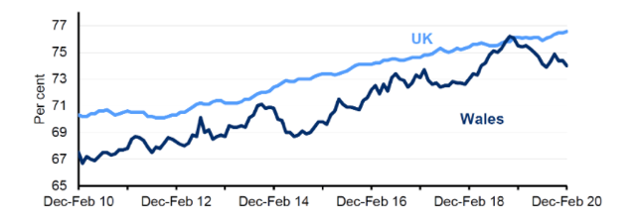
‘’The employment rate in Wales itself was 74.7% and 76.1% across the UK’’ (BBC NEWS et al 2019) What does that tell us? It tells us that Wales is currently at its lowest in the employment rates (BBC NEWS, 2019).

Unemployment rates in Wales
Moving onto the unemployment rates in Wales. Unemployment or joblessness is seen as a situation where people are actively looking for a job but not being able to be employed whether its physically or mentally (Brock, 2021).

Brock described unemployment as ‘’Unemployment is when someone could work and wants to work but is unable to find a suitable job’’ (Brock et al 2021).

The unemployment rates in Wales has gradually been falling since the early 2010s. From December to February 2020, there were roughly 56,000 unemployed people, that later then fell down to 15,000 down from the same period of year earlier. This is an economically active population rate of 3.7% down 0.8% compared to previous years.
In general, the welsh unemployment rate has followed the UK rate. However, the welsh unemployment rate fell below the UK rate from August to October 2019 and has since stayed below it. In the United Kingdom, the number of unemployed people rose by 22,000 to 1.4 million during the same period of time (Statistical Bulletin, 2020).
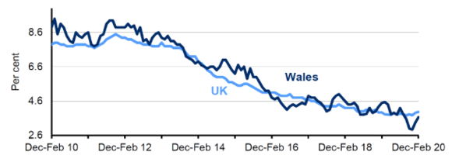
The level of unemployment dropped in two of the three economic regions in Wales in 2019. Unemployment dropped by 6,900 in south East Wales, that rose by 500 people in North Wales and remained broadly similar in mid and South West Wales compared to other years.

The unemployment rate decreased in South East Wales by 0.9% during the same time and remained relatively constant in mid and South West Wales (Statistical Bulletin, 2020). The unemployment rate rose fairly by 0.2% in North Wales. In South East Wales, the unemployment rate remained consistently higher than in the other areas, and until the last quarter, North Wales consistory had the lowest unemployment rate (Statistical Bulletin, 2020).
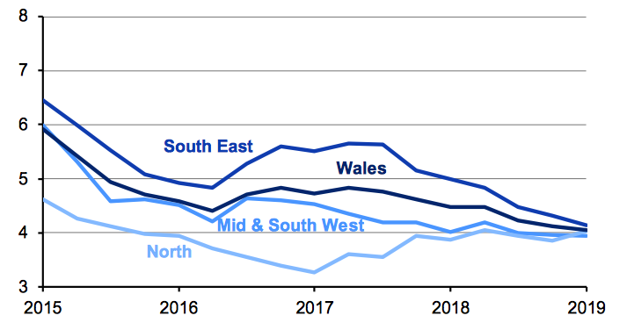

Unemployment in wales for July to September 2020 has currently jumped to 4.6%, a bump up of 28,000 comparisons with April and June. As well as rates for people that are not available to work has increased 1.1% that incudes working age people who might be a full time careers or students, on long term sick or have taken an early retirement (Statistical Bulletin, 2020).

As reported by Owen 2020 Wales has shown the largest growth in joblessness out of the whole of the UK, with a jump to 4.6%. There were more than 15,000 people counted as jobless in the periods of March to May (BBC News, 2020). This also compared with unemployment people in Wales that has risen significantly over the past years from 74.6% to 72.1%. More and more people are loosing or lost their jobs.

He also stated that,
‘’ There were 1,452,000 people in work from June to August and 466,000 people who were deemed economically inactive’’ (BBC News et al 2020).

There were roughly 782,000 jobs in Wales lost since the start of the pandemic. Around 33,000 people were dropped from payrolls at UK employers last month, as the pandemic continues to weigh on the economy. It helped push the unemployment rate to 4.8%, up to 0.9% on a year earlier, according to official estimates (BBC News, 2020).

The office for National statistics revealed that payroll employment was lower in October that it had been in September, and has dropped by 782,000 since march this year, when the pandemic started. The number of people claiming universal credit or job seekers allowance, either because they are unemployed or in a low paid job, has gradually gone up to 1.4 million across the whole of the UK (BBC News, 2020).

During Owen Davies interview with the BBC cast he told them that when Covid – 19 hit hard, both him and his wife decided to quit their jobs to keep both themselves and family members safe. He also described that finding finding a job six months later was pretty hard for him and his wife. Till this day they are both unemployed claiming universal credit yet no earnings coming in (BBC News, 2020).
Stated that although even before the coronavirus outbreak there were almost a quarter of people in Wales living in poverty, rounded to 700,000 living an insecure and unhealthy lives. Children living in poverty alone was even higher with 3 in 10. The reason that poverty rates are extremely high in Wales is because it has the lowest pay for people in every sector than the whole of the UK. At the beginning of the coronavirus outbreak, there were more than a third of jobs went to furlough as well as local areas facing a higher risk of losing their furlough jobs altogether (BBC News, 2020).
So how does unemployment really affect someone’s wellbeing? It has repeatedly been found that unemployment has a negative effect on a number of health outcomes. Reviews have also found many connections between unemployment and self wellbeing, similar to mental heath relationships occurring, including depression, anxiety and self esteem.
Without employment how can someone provide for their family? and not fall into poverty. Research has showed that this is a big question on many minds. How do we become a friendly community helping support each over? Firstly, we need to find a way in removing the barriers.

Barriers that may include:
- Age
- Criminal records
- Disabilities
- Education
- Disadvantaged violence
- Gaps in employment
- Housing issues or homelessness
- Mental illnesses
- drug and or alcohol abuse

The barriers to moving out of poverty includes employment that links to the research above, educational failure, poor health and family stability. It is clear that once all these barriers are overcome, then those people who lived in poverty are unlikely to slip back into it.

To overcome these barriers, I would suggest that the government provides extra help and support for those seeking employment. Making it clear and aware that they don’t need to be embarrassed, ashamed to seek help.

Ways to overcomes these barriers can be:
- having a good positive attitude in getting help and finding work.
- Provide counselling, transitional and assistance services if they require them to find employment.
- If necessary, take part in a drug, alcohol and mental health rehab.
- Look into support services available (Kotva, 2013).

Working Wales community
Communities for work is a programmed service that is designed by the Welsh Government that is also supported by the European Social Fund.
It’s a community based counseling service that helps increase the employability of these individuals who are currently not in employment.
Communities for work provide a huge amount of support on building on individual’s confidence, help gain work experiences, help learn new skills and re-write the individuals CV (Welsh Government, 2020).
The government helps those people who are unemployment and finding it difficult to find a job by having an open door at the job centre where everyone is welcomed. Its aim and purpose is to help people find work through services such as job hunting programs and external job vacancies to help people of working age find employment as soon as possible, while it also provides financial support to those eligible job hunters. Figures showed that there were roughly 76,072 of people receiving universal credits in Wales by the begging of January until December (Farell-Roig, 2019).
Community engagement, Definition of community engagement ‘’Rural community development is planned intervention to stimulate social change for the explicit purpose of the ‘betterment of the people’ and so development is ultimately a normative activity based on someone’s ‘vision of what might be or ought to be’’ (Summers et al 1986).
Defining community is not as straight forward as one might think. Community has been defined in many ways and there’s no single or correct definition. Community means different things to different people. Perhaps you thought of community as a geographical region for example someone’s neighborhood or a town or city. Some see community as peers of the same age or ethnicity or gender.
Others sees a community as a shared interest like playing football or sewing. At its sense of core community is having a sense of belonging and being part of something. When communities come together to address certain issues this is what is called community engagement.
There are many benefits for participating and being part of a community engagement efforts. Community engagement helps empowers those people to take responsibility for the things happening in their own community.
Being part of a community also encourages community members to address the needs that are directly relevant to their neighborhood or to their community. When people participate in community engagement activities they are able to contribute to and act change in their community rather than pacify accepting the circumstances under which they live. On the other hand, being apart of a community has a few major drawbacks one of which includes having a huge responsibility that limits an individual in having that full freedom due to the expectations of the community.

There are two types of community one of which is the ‘Homegenous or Monocultural’ that is basically a group of people who enjoy the same level of statuses and then there’s the ‘Heterogeneous or Multicultural’ that’s members of different activities and priorities within the community. There are many benefits and limitations to both types of community. The benefits of the monocultural type of community is that it creates a place for individuals to freely express themselves, interests and hobbies.
Some disadvantages of this type of community is that a rise of potential issues arising between one other due to the time spent in the community as well as having disagreements. Some of the multicultural type of community benefits is that everyone can come together as a big group from a different race and background. Some of the disadvantages of this community type is that not all individuals can get along with one another than can cause disagreements and stress. Although both types of communities have its pros and cons I personally think that the monocultural community type is much stronger this is because it brings everyone together as a whole.
A community is a group of people that come together as a whole to share common interests, beliefs, values and help work together to accomplish common goals. A community is also individuals who are alike in some sort of way, who feel a sense of belonging and get each over in that group (Nina, 2018).
Many people like belonging to groups. When belonging to a community, we automatically have a group of people caring for one anther, helping and supporting each other.

Poverty
One of the main responsibilities that the government has is to educate, train and prepare people for the world of work ahead and remove any barriers which may prevent them from doing so, this is so people can make a contribution offering to society and their community.
Today Wales has a reasonability low level of unemployment, although levels of economic inactivity have remained pretty high. Poverty is still a big issue in welsh society, but there is strong evidence that suggest employment has effectively helped provide the most epic way out of poverty. But the question is, how can someone get out of poverty if there are no employment vacancies.
It is extremely important to note that there is a growing problem of in-work poverty in Wales, so it is therefore vital to increase the employability and skills of an individual with a view of ensuring in work success and reducing the risk of living in poverty for a household (Welsh Government, 2018).

Its intolerable that more and more working families are swept into poverty today, so the right thing to do is to remove this essential ambition to eliminate in work poverty.
With more working families struggling to make ends meet, people are unsatisfied with the inability of policies to unlock the employment, investment and opportunities required for the prosperity of their families and local economies (Anderson, 2019).

Poverty is described to be essential resources that are well below an individual’s minimum needs.

‘’Poverty is about more than just money, but a lack of money is the defining feature of being poor. Poverty is a very real issue in the UK today’’ (Child poverty action group et al 2021).

Poverty is a big issue affecting millions and millions of people in Wales. To simplisse poverty, this is when an individual’s needs are no being meet effectively for example, not being able to heat home, having clean clothes and putting food on the table as well as not being able to pay rent or buying the essentials for yourself or your family.
As well as the amount of stress it causes to people can sometimes lead to a more serious problem that deprive people of the chance to play a full part in society today.

A report that Steffan Evans published in March 2020 on poverty in Wales suggested that there was an overall reduction from 24% to 23%, with a similar decrease in number of children of 29% to 28% and working age adults from 23% to 22%, living in poverty, through retirees remain unchanged at 19%.
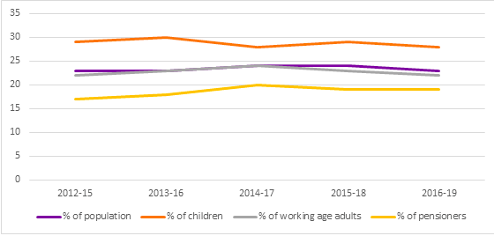

Since 2012 to 2015, the overall poverty rate in Wales has remained constant, with the poverty rate still remaining reasonably stable over this entire period of time. While this means that the situation in Wales is not worsening, it also implies that things are not necessarily getting better either (Evans, 2020).
The End child poverty network that is short for (ECPN) Cymru, that is organized, run and controlled on a daily basis by children in Wales, is a group of organizations focusing on the eradication of child poverty in Wales.
They work closely with the government and local parents to help support that no child is living in poverty by 2020. There steering committee is made up of stakeholders from both the voluntary and legislative industries, and the network itself is becoming an increase support member of a wide variety of agencies (Children in Wales, 2014).
They believe that this programme of action for tacking poverty in Wales should be underpinned by the United Nations Convention (UNCRC) and that delivering the child’s rights agenda in Wale is one of the key points to success in tacking child poverty. Representation from both the voluntary and regulatory sectors is part of its steering committee and network has an increasingly supportive membership of a wide cross section of agencies (Children in Wales, 2014).
Every child and young person in Wales has the all and full right to a good quality education that motivates them and gives them the opportunity to recognize their full potential. In education all children and young people should also have the opportunity to be included, respected and challenged.
The Welsh Government should make sure that every child and young person has the chance to notice their potential through education. This should include continuous action to try and break the unacceptably strong link between poverty and low attainment, that blocks many children in Wales from seeing their potential and filling their right to education (Children in Wales, 2014).
As stated by the UNCRC article 12 stated that
‘’Allow pupils to be involved in making decisions, planning and reviewing actions that affect them’’ (Children in Wales et al page 6, 2014).
They are currently working on achieving:
- Increased public and professional awareness of child poverty in Wales public and professional support for child poverty reduction initiatives
- Ensure that policies are lead to the eradication of child poverty in Wales are in effect at all levels of government (Children in Wales, 2014).
Evidence suggests that food poverty in Wales is a rising issue for low-income families in Wales, underlined by the rise in food bank development across Wales and in the number of families accessing food supplies in crisis situations.
Although food banks in the current economic environment serve a much-needed emergency role, the Welsh Government should establish a comprehensive social policy response to the food poverty issue in Wales (Children in Wales, 2014).
The Welsh Government should:
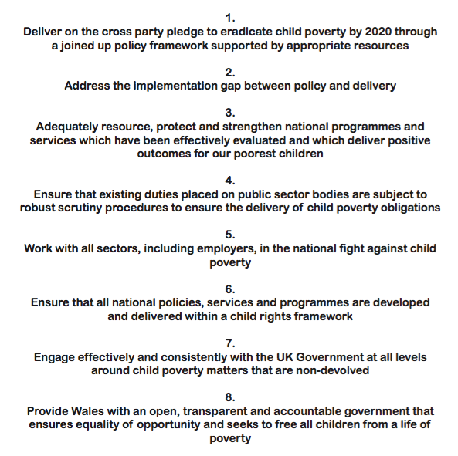

Communities in school 2015 seen poverty as an obstacle to learning in the classroom, according to a national survey of teachers, that also listed student behavior and a lack of parent involvement as big problems in their school.
A survey was conducted and there were 700 online survey feedback by the communities in the school and public opinion campaigns that found out there were 88% who identified poverty in their schools as a major meaningful issue in their school. As well as according to the poll, there were roughly 92% of respondents that identified student indifference as disruptive and discovered there was a lack of parental involvement (Communities in schools, 2015).
In Wales there are many different agencies working in partnership with the schools once of which includes ‘the magic breakfast club’.
Since 1998, the first ever breakfast club that was supported by ‘Kellogg’s was first established in the UK, from then ‘Kellogg’s has allowed more than 2,500 school breakfast clubs enabling them to open their doors by offering cash grants, donations of food, equipment as well as training for school members staff.
Supporting higher potential gains in deprived regions both nutritionally and academically. In the ‘Magic breakfast club’ programme the breakfast club component aims to focus on schools in areas that are in greatest need of, where statistics showed there were more than 30% of children are entitled to free school dinners.

The continued commitment of the Welsh Government to free school breakfasts, they remain concerned that 29% of schools still do not have free breakfast coverage and there is no clear plan with targets or priorities to ensure that free breakfasts are universally accessible as a policy for all primary school age children.

This is seen as a big gap in Wales as research has been proven that breakfast is one of the most important meal this is because a good breakfast kick starts the body metabolism that the process in which the body converts the fuel in food to energy.
Skipping breakfast can sometimes make the children feel tired, restless and irritable. Especially in the morning children need to refuel their body for the day ahead as well as their mood and energy can drop significantly by midmorning if they don’t eat at least a small morning meal (Mary, 2015).
To overcome this barrier an outcome-focused action plan should be developed by the Welsh Government which strengthens its commitment to the Free Breakfast scheme and which includes realistic targets towards raising the universal participation of all primary schools and works to increase the implementation of the free breakfast scheme in schools currently participating for children in low-income families.

Another barrier and gap that I came across while researching this charity is trying to remove the additional costs of education. All financial barriers to education should be removed.
In the sense of unprecedented strains on family budgets. The welsh government should make sure that schools and local authorities continue to help children living in poverty by eliminating the cost of education in compliance with their responsibility to children and families.
Both children and young people regularly report how poverty can limit their ability to fulfil them in participating in school activities by losing out on costly field trips and events planned both in and out of school hours this can also hinder their opportunity to engage and be apart of that community.
To overcome this barrier, the Welsh Government should ensure that all schools comply completely with the standards of equal opportunities and that no extra expenses are incurred for school events and necessary items such as equipment and materials for art and sports essentials.
Financial obstacles to the involvement of children and young people contribute to them feeling stigmatized and feeling different this could have an increase of potential bullying from taking place.

So how is poverty measured in the UK?
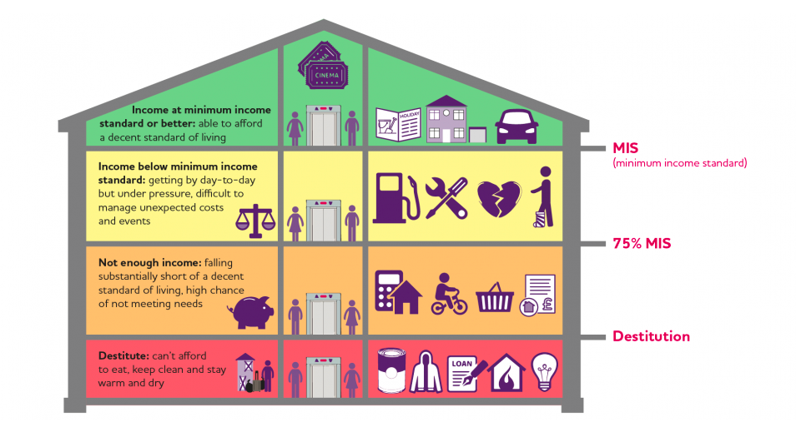
There is no best way to actually measure poverty. Poverty is such a huge and complex issue that needs a range of different measures telling us different things. Levels of poverty

Every year the government publishes a survey showing the income poverty that the UK calls household below average income.
This survey showed clear guidelines as well as a set to the poverty line in the UK at 60% of the average UK households income.

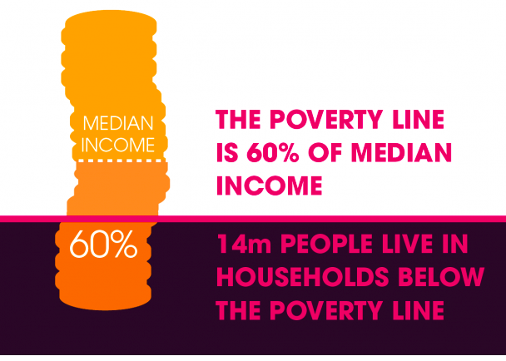

To put this in simple words the government basically suggest if a household’s income is less than 60% of average, then the HBAI contemplates them to be living in poverty.
This is the concept of relative poverty; this is because absolute poverty is where the income of a household is less than 60% of the average in 2011 (Child poverty action group 2021).

The study showed that one in five that’s 22% of households in the UK have an income that is below the poverty line, this is after their housing costs are taken into consideration. The government also discovered that there were 30% of children who live in households below the poverty line, that is almost as double the poverty rate for pensioners (Child poverty action group 2021).
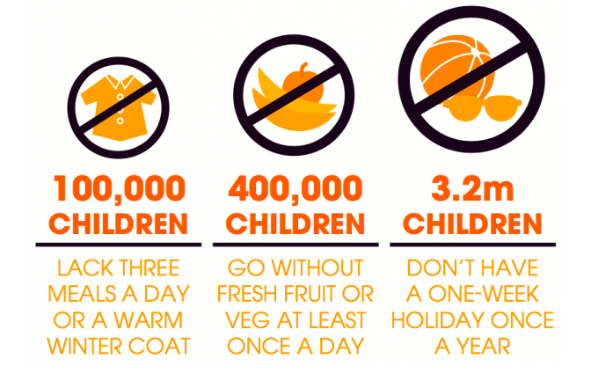

The policy and social exclusion survey (1983-2011) developed the public perspective of socially recognition fundamentals as well as how many households are going without these essentials.

Modest wage rises minimize hardship rapidly and efficiently. Child poverty was 400,000 lower in 2001 than it was in the 1999 and extreme deprivation among out of work families nearly halved, from four in 10 in just two years to less than one quarter (Child poverty action group 2021).

Conclusion
Overall from all the data and statistics collected, is it clear that the unemployment and poverty rates in Wales are extremely high and has been high for many years. To overcomes the barriers, provide for both the unemployment and poverty rates we need to all work together as a community to overcome them. As previously stated Wales was one of the highest area rate in the whole of the UK for their unemployment and poverty rates. The Welsh Government is working in partnership to help overcome the rates from rising.

Reference list
Anderson,. H and Masters,. C. (2019) ‘In work poverty’ [Online] Available at: https://www.jrf.org.uk/press/jrf-responds-labour-partys-pledge-eliminate-work-poverty?gclid=CjwKCAiAi_D_BRApEiwASslbJ5dDZYE5U8W-JrMbwVhEWeT9hkj1lMIB3mM0hEEsSo3RVJsuntELQhoCkUQQAvD_BwE (Accessed on: 10/01/2021)
BBC News (2020) ‘Unemployment rate in Wales’ [Online] Available at: https://www.bbc.co.uk/news/uk-wales-54513353 (Accessed on: 06/01/2021)
BBC NEWS (2019) ‘Employment number of people in work in Wales falls’ [Online] Available at: https://www.bbc.co.uk/news/uk-wales-49647279 (Accessed on: 13/01/2021)
Brock,. T. (2021) ‘Unemployment’ [Online] Available at: https://www.thebalance.com/what-is-unemployment-3306222 (Accessed on: 02/01/2021)
Child poverty action group (2021) ‘What is poverty’ [Online] Available at: https://cpag.org.uk/child-poverty/what-poverty?gclid=CjwKCAiAl4WABhAJEiwATUnEF1nreEOHG5JaQwmxDj0Vc2ud9J143dHs0US9owJVamaT8KZkkiQrWhoCnQoQAvD_BwE (Accessed on: 13/01/2021)
Communities in schools (2015) ‘Poverty a barrier to learning’ [Online] Available at: https://www.communitiesinschools.org/news/2015/06/poverty-barrier-learning/ (Accessed on: 13/01/2021)
Evans,. S. (2020) ‘poverty in Wales’ [Online] Available at: https://www.bevanfoundation.org/commentary/poverty-in-wales-what-does-the-latest-data-say/ (Accessed on: 10/01/2021)Simon,. N. (2018) ‘The Art of relevance’ [Online] Available at: http://www.artofrelevance.org/2018/02/20/how-do-you-define-community/ (Accessed on: 05/01/2021).
Farell-Roig,. E (2019) ‘Swansea job centre’ [Online] Available at: https://www.walesonline.co.uk/news/wales-news/stories-people-who-visited-swansea-15826671 (Accessed on: 11/01/2021)
Kotva,. C. (2013) ‘Barriers to employment’ [Online] Available at: https://jobseekerslife.wordpress.com/2013/01/29/what-are-barriers-to-employment/ (Accessed on: 13/01/2021)Welsh Government (2018) ‘employability’ [Online] Available at: https://gov.wales/sites/default/files/publications/2018-04/employability-plan.pdf (Accessed on: 05/01/2021)
Mary,. L. and Gavin,. MD (2015) ‘Importance of breakfast’ [Online] Available at: https://kidshealth.org/en/parents/breakfast.html (Accessed on: 10/01/2021)
Statistical Bulletin (2020) ‘Economic statistics’ [Online] Available at: https://gov.wales/sites/default/files/statistics-and-research/2020-04/key-economic-statistics-april-2020-052.pdf (Accessed on: 05/01/2021)
Welsh Government (2020) ‘communities for work’ [Online] Available at: https://workingwales.gov.wales/how-we-can-help/learning-new-skills/communities-for-work (Accessed on: 10/01/2021)

