

University of Wales Trinity Saint David
Bilingual Student Chatbot for support services

Ataur Rahman
Independent Project - Proposal
Dr. Seena Joseph
Word Count:2263
Due Date
20th October 2025

Contents
Introduction 1
Background to proposed research. 2
Key Developments 2
Trends 3
Technologies 3
Research Gap 3
Aim and Objectives of my project 4
Research Methodology 5
5.1 | Methods 5
5.2 Materials 5
Project Planning 7
References 8

Introduction

Due to recent events in the modern world, the use of Artificial Intelligence has expanded and developed for multi-use purposes, however education institutions have now recently started to take this step as well. These institutions now seek to use Artificial Intelligence to improve students’ engagements and modernizing the assistance tools to help support their students. This project that I will be creating will aim to create a bilingual chatbot which support both the Welsh and English language. This chatbot assistant will help provide answers to students seeking academic support such as timetables, materials, navigation and wellbeing support and other necessary services.
The main functionality of this chatbot will be its language detection which will be picked up in the chat automatically without having the students set it manually. This projects mainly support educational institutions in Wales helping them preserve the Welsh Language Standards policy in which ensure student who speak Welsh/English will have equal access information and support in both main language in Wales.
The chatbot uses a 24/7 bilingual system that helps support student with any education and wellbeing queries. This system will reduce pressure on student support services staff , by helping the deliver efficient and effective responses which will result in user satisfaction. The project aims to preserve Welsh Language culture allowing its design to support accessibility and operational assistance for those students in need of academic support.
This project in the long term will be expandable with connections with educational institutions in Wales and also be allowed to be integrated in their own existing platforms such as Moodle, Microsoft Teams or even a dedicated student mobile app. This proposed project idea will help put a step towards education boards implementing the use of AI to aid their students which are of in need of academic support.

Background to proposed research.

The field of Artificial Intelligence (AI) in education has significantly advanced through the uses of chatbots, which has been recently driven more by natural language processing (NLP), machine learning, and the ability to become to conversational agents. This project aims to sustain the Welsh Language Standard policy. As a researcher, I will thoroughly investigate the project key areas which include development, trends, technologies, and gaps that can be found in the research. I will be using various of academic resource, which will be to help source findings of insufficient bilingual support for minority languages like Welsh in context.

Key Developments
In recent years, the development of Artificial Intelligence (AI) is steadily increasing in education as they were driven by advancements in natural language processing (NLP), machine learning, and conversational agents. From the literature insights, the development started during the 1960s, ELIZA and other such system were the first chatbots to employ pattern-matching technologies to generate simple dialogues [1], to more complex systems that use large-language models (LLMS) for context-responsive interactions [2].ESL students were able to access resource during the COVID-19 pandemic thank to Vyawahare and Chakradeo’s development of DialogFlow based chatbot technology [3]. Chang, Cheng [4] created a system that use CLU and knowledge bases to increase query accuracy. LUIS and QnA Maker were used to generate precise bilingual answers. The study by Mayormente, Subhashini [5] concentrated on developing multilingual chatbots for English instruction using Support Vector Machines (SVM) and tokenisation systems, which yielded adaptive outcomes but were unable to detect automatically. Apostol’s Messenger-based help desk system [6] decrease the time it took to respond to IT queries, resulting in 94.4% user satisfaction.
Furthermore, according to Lee, Hung [7],used Retrieval-Augmented Generation (RAG) to offer reliable solutions that reduce Large Language Models (LLM’s) errors during technical support operations. Xatkit was a system created by Daniel, Cabot [8] to create system that facilitates the rapid development of chatbots and generates systems that can efficiently manage various input types and scale. In another academic source, the production of bilingual Telugu and English content, Das, Sreeja [9] aimed to streamline user interaction on college websites. This did not only improve accessibility however it also reduced response times. Also, with the use of VectorShift AI, it provided accurate responses based on contextual understanding. Van and his research team [10] , concentrated on creating scalable university admission counselling systems that embedded workflows that enhanced student confidence and decision-making while providing personalised assistance via Large Language Model (LLM)-based Retrieval-Augmented Generation (RAG).

Trends
From the literature reviews, trends towards scalable and multimodal chatbots have been assessed and implemented to enhance user engagement, efficiency, and accessibility across diverse applications. Integrations towards educational platforms such as Moodle can be made easier by the low-code framework like Xatkit [8].The development of the global chatbot market has also been predicted to reach $2 billion by 2024, which is driven by education and customer service applications [8]. However, these projections were surpassed as the global market projection resulted in a staggering $8.6 billion in the year 2024 and projected to $11.14 billion in 2025 which highlights a 29.5% CAGR increase in this global chatbot market [11]. From the literature we see that advancements of multilingual outputs through prompt engineering allows chatbot deliver exact responses which help respect cultural difference and help maintain relevant context in multiple languages [7]. Multilingual output has been enhanced by the using prompt engineering. These trends help promote effective user-friendly AI tools that are beneficial to scalable Welsh and English systems.

Technologies
From identifying the literature, we can see technologies systems do operate by combining CLU technology which knowledge bases such as LUIS and QnA Maker [4].Users using these technologies can access two languages through the Google Translate API, which is a supporting bilingual feature [4]. The Support Vector Models (SVM) are used to determine the intentions of the user in various languages [5].

Research Gap
The existing literature reveals a lack of bilingual chatbot development for minority languages. Despite laws requiring equal access in Wales, the majority of research concentrates on dominant languages such as English [3, 5, 9, 10], paying little attention to languages like Welsh. Due to their lack of integrated language recognition systems platforms like Moodle, which are educational learning management systems, have to primarily operate in English. The existing system currently prevents Welsh-speaking students from obtaining academic support through resources like timetables and wellbeing materials unless they perform manual switching. Although Retrieval-Augmented Generation (RAG) and prompt engineering have the potential to advance technical and language fields [2, 7], their application in bilingual education chatbots for minority languages is still poorly understood, which limits their ability to reduce workloads and ensure constant availability [6].

Aim and Objectives of my project

The aim of this project is to help design and implement a bilingual Welsh-English chatbot that is able to provide a set of equitable academic functions such as wellbeing support, access to resources and provide a systematic user accessibility through automatic language detection and 24/7 accessibility for Welsh and English.

The objective of the project is to aim to create a fully functional chatbot where student in Wales can use this and allow it to be implemented in their education and academic needs. To get to the final objective, we will need achieve smaller but fundamental objectives.
These following objectives are.
- Conduct A User Needs Assessment – Which will identify the requirements of this chatbot through either survey or focus groups, targeting at least 50 participants from Welsh Educational institutions by December 2025, which inform functionality (e.g. timetables, wellbeing resources)
- Developing an Automatic Detection System – The purpose of this objective will be to build a Natural Language Processing (NLP) system which will identify English and Welsh languages automatically. The goal requires the system to reach 90% accuracy in language detection by February 2026. The system will function as an automatic tool to identify between English and Welsh languages through its design and evaluation.
- Integration with Educational Platforms – This is to create a multilingual chatbot which will be driven by an API allowing the integration with learning management systems, which will allow real-time access to course materials and wellbeing resources in both languages with a functional prototype by March 2026.
- Implementation of a 24/7 Accessibility Feature – To incorporate Retrieval Augmented Generation and cloud-based hosting which can ensure that this chatbot can be working continuously, context-aware support for academic queries and wellbeing assistance and testing for an uptime of 99.9% April 2026.
- Evaluation of User Experience and Optimization – This is to assess testing with at least 30 Welsh and English-speaking students, assessing the accuracy of the automatic language detection, accessibility and user satisfaction and refining the chatbot based on feedback May 2026

Research Methodology
To achieve this project objectives the development of a bilingual Welsh English chatbot requires both qualitative and quantitative techniques, assuring to balance metrics with user insights and fitting the need for both performance and cultural acceptability. This method's success can be identified to the way it pairs numerical performance metrics with human experience data which can be used to create an educational environment that supports students who speak Welsh. The software development lifecycle (SDLC) and action research framework are used in the chatbot's development process to generate numerous design and testing phases that take stakeholders input into account. The research approach makes it possible to create a working system that can be quickly tailored to meet Welsh educational standards.

5.1 | Methods
The project bases it is work on a purposeful approach to creating a practical chatbot for students which can help over of theorical concepts, due to this student support levels can be expected to be delivering higher results because of this advancement. The research method I will be following for this project is to conduct both survey and focus groups which help tailor stakeholder needs and feedback for this chatbot which will make it more efficient when creating a Welsh language chatbot for student, faculty, and staff. The research plan follows the software development cycle (SDLC) through its iterative process of planning, design, implementation and evaluation which produces a functional prototype that adapts to stakeholder feedback. The data that will be projected to be collected to help support this project can 50 students that have conducted a survey and 10-15 participants for focus groups. Later, 30 students can be appointed to the usability testing to help gather further feedback which will have a diverse of Welsh and English perspectives. After these data collection methods are used we will implement this into analysis to help gather quantitative metrics which can be of user satisfaction, uptime records and response times. Whilst, for qualitative analysis they will be validating effectiveness and inclusiveness of the chatbot.

5.2 Materials
As this project requires data from educational institutions it will be harder to gain access to but to counter-act this point I will be generating a similar scenario and using an exemplary educational structure to help gather both primary and secondary data. For data collection methods I will be using tools such as Google Survey or Microsoft Forms and focus group can be also done in a Zoom meeting. For usability testing we can capture the stakeholders’ feedback with feedback forms which can help generate quantitative and qualitative insights. All data collected will need support objectives so it will need to be assessed with tools to ensure accessibility and bilingual context are working and taking place. For ethical reasons, the data collected can be consented at the beginning of forms and documentation to ensure I have approval to help support this project, however measures such as encrypted storage and anonymized data will help secure student data and project security. Deletion of this data will be initiated within 12 months to also comply with GDPR.

Software tools consist of the following.
- Programming Languages: Python for Natural Language Processing chatbot logic, JavaScript (Angular) framework to help integrate with education platforms
- Libraries: Natural Language Toolkit (NLTK) which include tokenization, stemming and part of speech tagging, SpaCy which is pre-trained models that can be optimized for language detection and TensorFlow which will be used to build and train RAG models
- Request (API): A python library for making requests to HTTP and integrating the chatbot with platforms allowing it to fetch real time data
- PyTorch: A deep learning framework to TensorFlow which will help facilitate experimentation with custom RAG models
- Statistical/Data Analysis Software: Power BI or SPSS for quantitative data and recording tools OBS and Zoom for virtual tests
Lastly, to run this project hardware will be necessary to facilitate the needs for this project to stay up. These hardware requirements are;
- Graphic Processing Unit (GPU): Nvidia RTX 3060 (12GB) for Natural Language Processing (NLP)
- Server: AWS EC2 (2vCPUs ,8GB RAM) for 24/7 hosting or Azure Virtual Machines B2s instance scalable for user load
- Cloud Computing: AWS S3 for storage or Azure Blob Storage for data storage, leveraging cloud elasticity for real-time responses
To justify this selection for the project material requirements, are that the GPU handles language models and AWS/Azure Cloud help ensure that scalability and reliability [11]

Project Planning
To plan this project I decided to implement a timeline to help support key stages of events and design,development,implementation and evaluation following the software development lifecycle (SDLC).
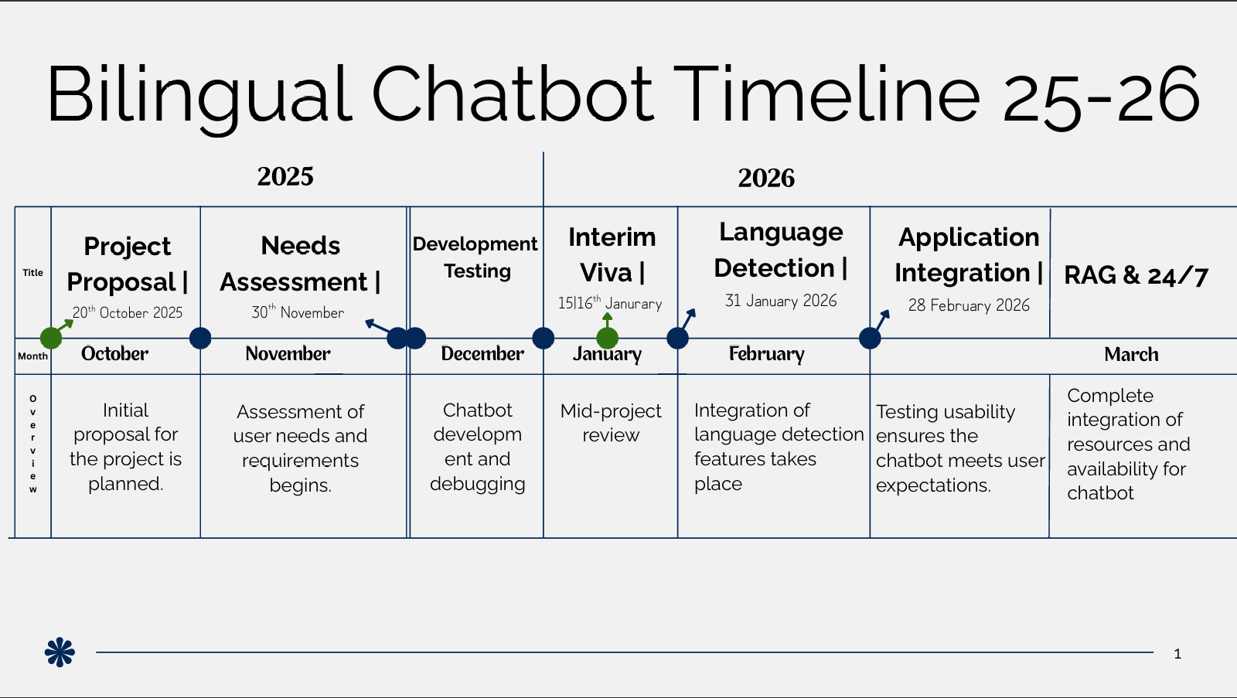
Figure 1 - Bilingual Chatbot Timeline 1/2

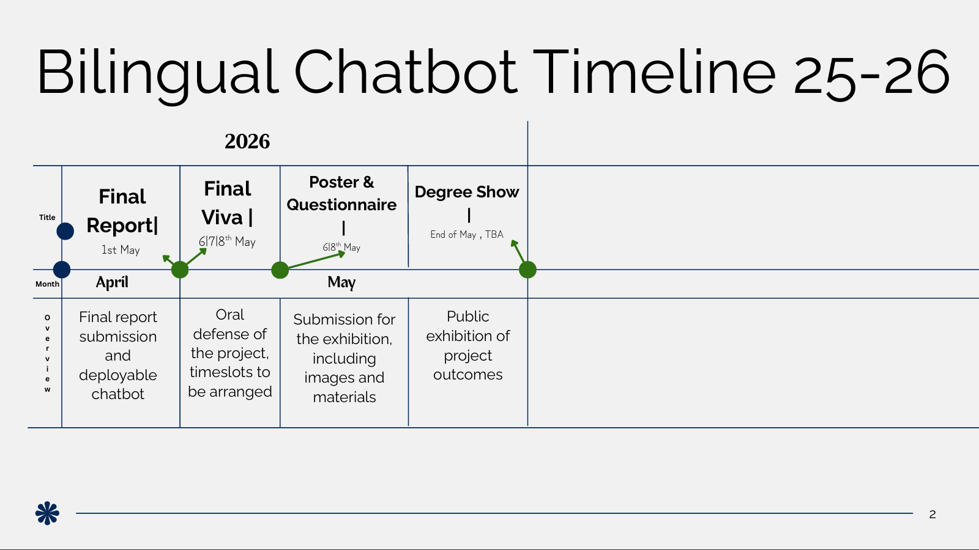
Figure 2 - Bilingual Chatbot Timeline 2/2
References
[1] Shimichev and Rotanova. Shimichev and Rotanova. Chatbot technology as an artificial intelligence tool in foreign language education. Chatbot technology as an artificial intelligence tool in foreign language education. 2023 International Conference on Quality Management, Transport and Information Security, Information Technologies (IT&amp;QM&amp;IS) 2023 International Conference on Quality Management, Transport and Information Security, Information Technologies (IT&amp;QM&amp;IS) pp. 97. pp. 97. 2023. . DOI: 10.1109/itqmtis58985.2023.10346566.
[2] Park, An. Park, An. A study on performance improvement of prompt engineering for generative AI with a large language model. A study on performance improvement of prompt engineering for generative AI with a large language model. JWE JWE pp. 1187. pp. 1187. 2024. . DOI: 10.13052/jwe1540-9589.2285.
[3] Vyawahare and Chakradeo. Vyawahare and Chakradeo. Chatbot assistant for english as a second language learners. Chatbot assistant for english as a second language learners. 2020 International Conference on Convergence to Digital World - Quo Vadis (ICCDW) 2020 International Conference on Convergence to Digital World - Quo Vadis (ICCDW) pp. 1. pp. 1. 2020. . DOI: 10.1109/iccdw45521.2020.9318672.
[4] Chang, Cheng. Chang, Cheng. Customer service chatbot enhanced with conversational language understanding and knowledge base. Customer service chatbot enhanced with conversational language understanding and knowledge base. 2022 IEEE 4th Eurasia Conference on IOT, Communication and Engineering (ECICE) 2022 IEEE 4th Eurasia Conference on IOT, Communication and Engineering (ECICE) pp. 231. pp. 231. 2022. . DOI: 10.1109/ecice55674.2022.10042940.
[5] Mayormente, Subhashini. Mayormente, Subhashini. Design and evaluation of a multilingual chatbot for interactive english language learning. Design and evaluation of a multilingual chatbot for interactive english language learning. 2024 International Conference on Data Science and Network Security (ICDSNS) 2024 International Conference on Data Science and Network Security (ICDSNS) pp. 1. pp. 1. 2024. . DOI: 10.1109/icdsns62112.2024.10691022.
[6] ApostolApostolImpact of knowledge-based help desk system: Facebook messenger chatbot for student IT support at pamantasan ng lungsod ng valenzuela. Impact of knowledge-based help desk system: Facebook messenger chatbot for student IT support at pamantasan ng lungsod ng valenzuela. 2025 10th International Conference on Information and Network Technologies (ICINT) 2025 10th International Conference on Information and Network Technologies (ICINT) pp. 153. pp. 153. 2025. . DOI: 10.1109/icint65528.2025.11030886.
[7] Lee, Hung. Lee, Hung. Development of an RAG-based LLM chatbot for enhancing technical support service. Development of an RAG-based LLM chatbot for enhancing technical support service. TENCON 2024 - 2024 IEEE Region 10 Conference (TENCON) TENCON 2024 - 2024 IEEE Region 10 Conference (TENCON) pp. 1080. pp. 1080. 2024. . DOI: 10.1109/tencon61640.2024.10902801.
[8] Daniel, Cabot. Daniel, Cabot. Xatkit: A multimodal low-code chatbot development framework. Xatkit: A multimodal low-code chatbot development framework. IEEE Access IEEE Access 88pp. 15332. pp. 15332. 2020. . DOI: 10.1109/access.2020.2966919.
[9] Das, Sreeja. Das, Sreeja. Intelligent bilingual chatbot for enhanced user engagement on college websites. Intelligent bilingual chatbot for enhanced user engagement on college websites. 2025 3rd International Conference on Disruptive Technologies (ICDT) 2025 3rd International Conference on Disruptive Technologies (ICDT) pp. 939. pp. 939. 2025. . DOI: 10.1109/icdt63985.2025.10986747.
[10] Van, Do. Van, Do. AI-powered university admission counseling: A use case of large language models in student guidance. AI-powered university admission counseling: A use case of large language models in student guidance. IEEE Trans. Learning Technol. IEEE Trans. Learning Technol. 1818pp. 856. pp. 856. 2025. . DOI: 10.1109/tlt.2025.3604096.
[11] LiuLiuInnovative chatbot technologies and trends. Innovative chatbot technologies and trends. Atlantis Highlights in Intelligent Systems Atlantis Highlights in Intelligent Systems pp. 249. pp. 249. 2024. . DOI: 10.2991/978-94-6463-490-7_27.

