Programme: BSc Health and Social Care Module: Principles of Health and Social Care Practice Module code: BMHP5016

Evaluation of Person-Centred Care and Partnership Working in Health and Social Care
Programme: BSc Health and Social Care
Module: Principles of Health and Social Care Practice
Module code: BMHP5016
Date: 17 November 2025

Illustration symbolising partnership working and person-centred care.

Table of Contents
Evaluation of Person-Centred Care and Partnership Working in Health and Social Care 1
1. Introduction 2
2. Definition and Key Features of Person‑Centred Care 2
3. Benefits and Limitations of Person‑Centred Care 3
Chart: Benefits and Limitations of Person‑Centred Care 5
4. Theoretical Framework: Biopsychosocial Model and Personhood Theory 6
5. Ethical Fundamentals in Health and Social Care 8
6. Partnership Working: Concepts and Practice 9
Chart: Benefits and Challenges of Partnership Working 11
7. Application in a Practical Setting 12
8. Policy and Legislation 13
9. Recommendations for Future Development 15
10. Conclusion 16

1. Introduction
Person-centred care (PCC) and partnership working (PW) are key social and health care concepts. Person-centred care emphasises service users' distinct rights, wants, and preferences. Helpers must understand clients' talents, life stories, and aspirations to adapt their assistance. Professionals, organisations, service users, and carers collaborate to plan and deliver coordinated care. Considering that no single professional group can cover all a person's needs, especially those with long-term illnesses, problems, or complex social situations. Well-functioning partnerships promote care consistency, ensure that care plans are based on the person's goals, and ensure that services work together. This UK study examines PCC and PW in health and social care. The essay discusses PCC's merits and downsides, its theory models, the morality of practice, teamwork, and how these ideas might be applied. The effects of UK policy and law are discussed, along with potential growth recommendations. To provide context, the debate uses scholarly literature, policy papers, and practice recommendations.

2. Definition and Key Features of Person‑Centred Care
Person-centred care implies treating individuals as equals, adapting treatment to their needs, and empowering them by identifying their talents and helping them make good decisions. Professionals should prioritise the person's stories, values, and objectives over the diagnosis in person-centred care. It also means professionals should promote mutual respect in therapy. PCC emphasises collaborative decision-making and reliable information so patients can participate in their care. The patient, family, and professional team decide on medications, care, and other life decisions. PCC promotes freedom, choice, respect, equality, rights, privacy, partnership, and individuality. Services should be flexible and sensitive to individual requirements rather than bureaucratic. This could be letting a care home resident pick when to wake up and what to do during the day or giving a long-term patient the knowledge and skills to manage their health (NHS England, 2023).
Institutions employed paternalistic or task-oriented methods of care, where patients had to follow routines and had little input in life decisions. PCC differs. PCC is part of a greater drive for human rights in health and social care, which views people as citizens with rights rather than service recipients. There is additional evidence that feeling heard and involved improves treatment outcomes, satisfaction, and retention. To obtain informed consent, person-centred services adapt their communication style, utilise simple language, and provide support. When someone lacks mental capacity to make decisions, experts involve family members or chosen advocates and make the best judgements while prioritising their wants and feelings.
3. Pros and disadvantages of person-centred care?
Further research shows that PCC has several benefits. PCC fosters trust and good treatment partnerships by focused on individual needs. Services users report increased independence, confidence, and satisfaction and are more willing to ask for help. Access Group claims person-centred care gives people more freedom and options, putting their health and daily lives in their hands. PCC promotes independence by equipping people to do as much as possible themselves. This can increase self-esteem and reduce powerlessness. When working with PCC, people feel respected and have a say in important decisions. It makes them happier and healthier. Sharing decisions makes it easier to follow treatment programs because people are more willing to do what they helped make (Government Equalities Office, 2010).
Better health results can be achieved using PCC. Personal care plans that address medical, psychological, and social needs typically address deeper issues like homelessness, loneliness, and joblessness. A holistic evaluation may reveal unanticipated requirements and enable fast response, preventing catastrophes and reducing unplanned hospital stays. Person-centred solutions help people recover by leveraging their abilities and the community's assets. PCC helps people with chronic disorders including diabetes and mental health concerns practice self-care, reducing the need for emergency help.
Although PCC offers certain benefits, it also has drawbacks. Person-centred care has many flaws, according to Sladdin et al. PCC may increase your business's expenditures. Customising services for each person may require additional staff time, training, and resources, increasing service costs. Second, some groups may accidentally be excluded. People who aren't excellent at speaking, have cognitive issues, or originate from disadvantaged groups may have trouble saying what they want or being fully involved in decision-making. Third, focussing on what the service user wants can neglect the staff's well-being and personality. If they always put others first without enough aid, carers may develop compassion fatigue. Fourth, promoting independence may increase dangers, such as when service users refuse to use a cane. These scenarios require practitioners to balance duty of care with autonomy, which can cause ethical conflict (Care Quality Commission, 2008).
PCC can also be difficult to implement in large systems. An organization's routine-based culture may resist change. Staff may lack the skills or trust to collaborate. Heavy caseloads and little time can make connecting with people difficult. System-wide efficiency and personal freedom may conflict. Standardised care pathways and individualised plans may conflict. Recognising these constraints helps services reduce PCC's drawbacks and maximise its benefits. Training, supervision, co-production, and staffing are examples.

Chart: Benefits and Limitations of Person‑Centred Care
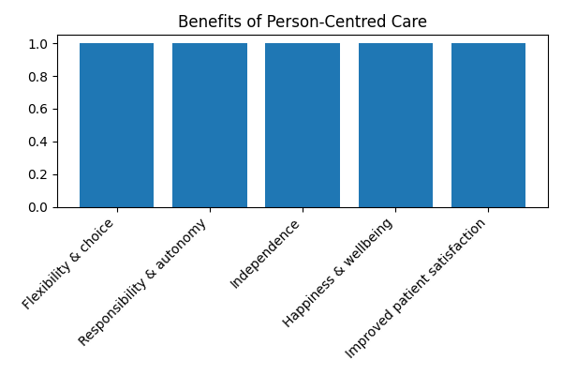
Benefits of person‑centred care.
The bar chart above summarises key benefits of person‑centred care identified in the literature. Each bar represents a category of benefits, including flexibility and choice, autonomy and responsibility, independence, wellbeing and patient satisfaction. These categories reflect the holistic improvements experienced by service users under person‑centred approaches (HF Online, 2023).
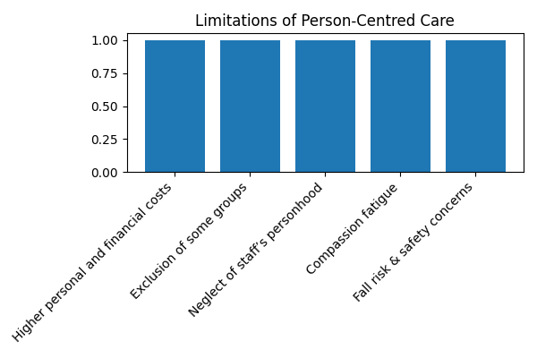
Limitations of person‑centred care.
PCC's key issues are higher personal and financial costs, leaving out groups, not caring about workers as people, compassion fatigue, and more safety concerns, as seen in the second chart. Knowing about these issues allows companies to prevent them.
4. Personhood Theory and Biopsychosocial Model
A theoretical framework helps us understand PCC. George Engel and John Romano developed the biopsychosocial paradigm in the 1970s, which states that biological, psychological, and social variables interact to generate health and disease. This paradigm considers how thoughts, feelings, behaviours, relationships, the environment, and society affect health, not simply the body. Without poverty, housing, prejudice, or work, mental and physical health can improve more than medical care. In practice, the biopsychosocial paradigm requires doctors to obtain complete histories of a patient's physical, mental, and socioeconomic health to create comprehensive treatment regimens (National Health Service, 2023).
Based on this paradigm, person-centred care addresses physical and psychological needs. In addition to medication, a therapist treating depression would consider the patient's culture, family, and living situation. The approach emphasises self-awareness, trust, and collaboration between doctors and patients. It recognises that people know a lot about their lives and situations, which helps plan care.
Tom Kitwood's memory care personhood theory supports this. Kitwood remarked that people can give or take away someone's personhood—their place or standing—based on their interactions and social settings. He said each dementia patient was unique and significant and listed five psychological needs: comfort, attachment, inclusion, work, and identity. Carers must recognise, negotiate, facilitate, and validate people to meet these requirements. Not recognising personality can cause "malignant social psychology," which makes dementia patients lose their identity and worsen quickly. Kitwood's philosophy requires us to protect personhood through respectful interactions and vital activities. These beliefs fit PCC's goal of respecting and preserving patients' identities throughout care (National Health Service, 2019).
Liberal psychologist Carl Rogers developed person-centred therapy, which underpins PCC. Rogers believed people naturally want to improve. Therapeutic connections require precise empathy, congruence (being authentic), and unconditional positive respect, he stated. A therapist must be honest and transparent with their client to be congruent and understand their feelings and experiences to have proper empathy. Unconditional good regard involves accepting a customer without judgement. The comfortable environment allows people to discuss their thoughts and learn about themselves, which aids healing and progress. Psychotherapy developed these concepts, but they can be utilised in different health and social care contexts to assist practitioners build trust and promote people's autonomy.
5. Health and social care ethics basics
PCC and PW must be delivered according to human rights-based morality. Autonomy is the right to choose. Practitioners must provide accurate information, communicate clearly, and respect people's choices to accept or refuse interventions to enable informed consent. Professionals should help, not hurt, people. Known as beneficence and non-maleficence. Justice includes equal access to resources and no discrimination. Services shouldn't disadvantage people by age, disability, colour, gender, or financial status. By maintaining secrets, personal information and faith are protected (Blackburn Anglican, 2025).
UK laws and standards legitimise these ideas. The Mental ability Act 2005 prohibits those without mental ability from making their own decisions unless proven differently. It also compels their representatives to make judgements in their best interests and select the least restrictive option. It enables people choose a trusted person as their permanent power of attorney or hire a self-employed mental capacity advocate. UK law includes respect, fairness, decency, and equality under the Human Rights Act 1998. Those who depend on others appreciate fair treatment while seeking assistance. The Equality Act 2010 prohibits discrimination based on protected qualities and requires groups to promote equality. These standards help practitioners offer ethical PCC and form ethical partnerships.
Ethical implies considering team health and happiness. Carers should be recognised and encouraged to avoid compassion fatigue and burnout. Employers should provide professional development, reflective supervision, and emotional support. Liberty and safety are typically considered when making ethical decisions. Talking to experts and getting ethical advice can help teams solve complex cases. Professionals must understand power dynamics and always listen to service users. Open, honest, and responsible behaviour fosters trust and ethics (Picker Institute, 2023).
6. Partnership concepts and instances
Partnership working involves workers, service users, carers, and communities planning and providing care. It knows complicated requirements require cross-organizational solutions. Good relationships have shared goals, respect, openness, decision-making, and clear communication. Working together may improve care, speed up assistance, make care more specific, reduce staff and service user stress, and make problem-solving easier, according to HF Online. When professionals coordinate their plans and share their knowledge, they may uncover gaps, reduce duplication, and ensure interventions function effectively together. Partnerships keep service users connected and simplify multi-service use.
Inter-professional, multi-agency, and co-production relationships exist. Integrated care systems (ICSs) in England are a large collaboration. Since 2022, 42 ICSs have coordinated NHS, local government, NGO, and other partners to plan and finance. They want to enhance health, reduce inequality, increase output, and build the economy. A long-term strategy is created by each integrated care team and implemented by a board. Place-based partnerships in neighbourhoods adapt services to local requirements, and provider collaboratives bring together similar service providers to reduce differences and improve performance (Alonzi, 2007).
Multidisciplinary teams (MDTs) help people collaborate. MDTs include doctors, nurses, social workers, occupational therapists, mental health professionals, and chemists. Their monthly meetings plan and coordinate care. Many general practice MDTs serve difficult patients. They exchange real-time information, learn about each other's careers, and plan families. An MDT may discuss a frequent hospital visitor and arrange medical reviews, social care assessments, housing support, and volunteer referrals. This group method addresses all of the person's issues and tells everyone their role. MDTs need a goal, competent leadership, a variety of vocations, and the necessary tools to succeed. Service users and carers must participate in talks to ensure care plans match the person's wishes.
Partnerships have benefits and drawbacks. Poor communication can lead to misunderstandings and wasted work. Different groups' priorities, norms, and performance goals may conflict, making collaboration difficult. If there are historical conflicts or power imbalances, people may not trust each other. Limited resources, tight schedules, and incompatible IT solutions can also hinder collaboration. Role confusion and question about responsibility can occur in complex settings when roles overlap. Clear procedures, goals, roles, information sharing agreements, and time spent creating relationships will help you overcome these issues (The Health Foundation, 2024).

Chart: Benefits and Challenges of Partnership Working
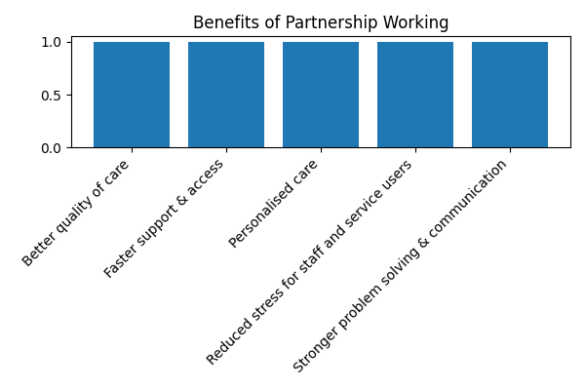
Benefits of partnership working.
The above bar chart summarises key benefits of partnership working, illustrating how collaboration leads to better quality of care, faster support, personalised care, reduced stress and stronger problem solving.
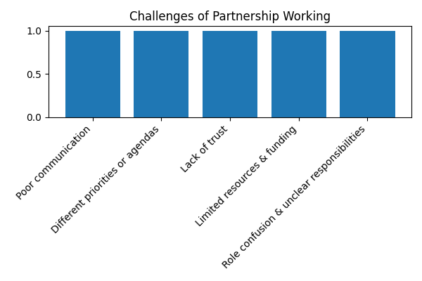
Challenges of partnership working.
The second chart shows collaboration issues. Bad communication, differing goals, lack of trust, lack of resources, and uncertainty over responsibilities are some. Realising these issues is the first step to solving them (Holt, 2017).
7. Real-World Use
A community mental health team that treats individuals with serious and long-term mental health concerns is an example of PCC and PW. Service users generally have several mental, physical, and social demands. Person-centred care requires carers to know each person's history, present, and future aspirations and involve them in care planning. Biological aspects (such drug side effects and physical health problems), psychological factors (like trauma, coping abilities, and self-belief), and social factors (like housing, work, and family relationships) are considered while helping someone. Practitioners collaborate on individual recovery plans. This plan may involve treatment, medication, peer support, job training, and social prescribing (art groups, volunteering). The person's cultural and social background and goals, such as living in their own house, reconnecting with friends and family, or obtaining work, are considered.
This scenario requires teamwork. MDT members include doctors, mental health nurses, social workers, physical therapists, psychologists, peer support workers, housing officers, and volunteers. Regular MDT meetings allow everyone to share knowledge, discuss risks, plan care, and make choices. Service users and carers are welcome to attend these meetings and voice their concerns. A service user may indicate that nervousness prevents them from attending hospital meetings. The team could then schedule home or virtual consultations. A social worker may investigate housing or benefits issues, while an occupational therapist works on daily living skills and job ambitions. Peer support workers share their experiences and offer healing suggestions. Volunteers promote local events. This collaborative approach promotes sobriety, social inclusion, and recovery. It reduces unnecessary work and coordinates actions (Yao and Kabir, 2023).
Problems arise. At work, professionals may have conflicting goals (medical stability vs. social inclusion) or policies. Lack of resources like subsidised housing or therapy wait lists can derail plans. Without shared records and terminology, communication may break down. The team develops clear communication guidelines, distributes digital data, names a care supervisor, agrees on goals, and frequently monitors progress to address these issues. Regular supervision and reflective practice meetings help with ethical issues and person-centred ideals. Let service users sit on service review panels to make government more responsible and ensure services match user demands.
8. Regulations
UK policy and law allow PCC and PW. The Care Act 2014 is a key adult social care law. It mandates that professionals include people in evaluations and decisions and promotes empowerment, prevention, proportionality, partnership, and responsibility. Our government should promote happiness and assist people achieve their aspirations. The Act emphasises collaboration with the person, family, and others (Social Care Institute for Excellence, 2023).
Health and Social Care Act 2008 Regulation 9 (Regulated Activities Regulations) requires professionals to provide care that fulfils people's needs and respects their choices. Despite mental incapacity, providers must engage with the person to make acceptable modifications. All health and social care practitioners must follow this person-centred practice norm.
The Health and Social Care Act 2012 requires Clinical Commissioning Groups (now Integrated Care Boards) to involve patients in service decisions. The Care Act 2014 requires local governments to involve persons and carers in care reviews, assessments, and plans. These duties ensure companies hire and run with PCC and teamwork (Sladdin, Ball, Bull and Chaboyer, 2020).
The NHS Long Term Plan promises customised care, shared decision-making, and increased service integration. It emphasises a new relationship between individuals and professionals in which people have more influence over their care and services are better organised. Social prescribing, customised health budgets, and customised support plans are examples of customised treatment. It should help millions. Integrated care systems (ICSs) legalise partner collaboration. NHS organisations, local governments, and other partners collaborate on plans and budgets. The combination of these rules makes PCC and PW permissible.
Important laws include the Mental Capacity Act 2005, Human Rights Act 1998, and Equality Act 2010 (see "ethical fundamentals"). These rules safeguard rights, prohibit discrimination, and compel experts to involve people in decisions and tailor services to their requirements (Care Quality Commission, 2025).
9. Future growth suggestions
1. Train and assist workers. Provide continuous PCC, trauma-informed care, communication, and cultural competence training to your personnel. Supervisors should provide reflective practice and emotional support to avoid compassion fatigue and show staff they are valued.
2. Strengthen collaboration. Users and workers should participate in service planning, delivery, and evaluation. Co-production ensures diverse perspectives on services and reduces exclusion. Set up advisory groups and fund peer initiatives (Training Express, 2024).
3. Facilitate knowledge sharing and technology utilisation. Create electronic health and social care records that MDT members can examine with permissions and safety precautions. Digital technologies should enable real-time discussion and let service users view and edit their records. Technology may reduce unnecessary effort, improve teamwork, and empower people.
4. Help the community with extra tools. Fund community-based housing, job programs, social prescribing, peer support networks, and public transportation for everyone. Long-term cost savings from preventative, person-centred, and integrated care should be considered in funding models. Integrating health and social care budgets could reduce uncoordinated spending (Local Government Association, 2023).
5. Advocate for coordinated care leadership. Create top integrated care system and MDT posts and help people work. Leaders should promote collaboration, conflict resolution, and people-first values. Leadership training helps managers operate in groups and use complex systems.
6. Monitor and rate results. Use person-centred outcomes including quality of life, wellbeing, contentment, autonomy, and community involvement. Gather and review resource use, health, and social data. Use your knowledge to improve things and share it with others (Physiopedia, 2025).
7. Allow everyone in. Try to engage neglected groups. Make sure PCC and PW help everyone, including people with communication issues, learning disabilities, ethnic minorities, and rural residents. This can be done through outreach, community relationships, and culturally sensitive services.
10. Teamwork and person-centred care are crucial for effective, fair, and caring health and social care. Person-centred care values individuality, autonomy, and humanism. It empowers service users and recognises their life expertise. PCC follows the biopsychosocial model and the theory of personhood, which hold that biological, psychological, and social aspects affect health and happiness and that being a person depends on relationships. Integrated care systems and interdisciplinary teams bring together people with diverse abilities to address complex needs, improve continuity, and reduce inequality. Each technique has pros and cons, such as a lack of resources, communication concerns, moral dilemmas, and staff burnout. Community resources, training, co-production, digital integration, leadership, and results can promote person-centred, collaborative care in health and social care. PCC and PW may continue to change and satisfy the needs of many individuals by following policies and laws and promoting respect and equality (Care Quality Commission, 2024).

References:
- Access Group (2020). Person-centred care: definition, benefits and values. Available at: https://www.theaccessgroup.com/uk/news/post/person-centred-care/ (Accessed: 17 November 2025).
- Ames, S. (2019). ‘The value given and presupposed in person-centred dementia care’, OBM Geriatrics, 3(3), pp. 1–17. Available at: https://www.sciencedirect.com/science/article/pii/S2688580819300348 (Accessed: 17 November 2025).
- Care Quality Commission (2008). Regulation 9: Person-centred care. Available at: https://www.cqc.org.uk/guidance-providers/regulations-enforcement/regulation-9-person-centred-care (Accessed: 17 November 2025).
- Care Quality Commission (2024). Human rights and health care. Available at: https://www.cqc.org.uk/guidance-providers/human-rights-healthcare (Accessed: 17 November 2025).
- Future Hospital Journal (2016). Person-centred care: what is it and how do we get there? Available at: https://www.rcpjournals.org/content/futurehospj/3/2/114 (Accessed: 17 November 2025).
- Government Equalities Office (2010). Equality Act 2010. Available at: https://www.gov.uk/guidance/equality-act-2010-guidance (Accessed: 17 November 2025).
- HF Online (2023). What is partnership working in health and social care? Available at: https://www.healthcareonline.org/partnership-working-health-social-care (Accessed: 17 November 2025).
- Kitwood, T. (1992). ‘Towards a theory of personhood in dementia care’, D-Care Training Module. Available at: https://dementiacarenet.org/uploads/kitwood-theory-personhood.pdf (Accessed: 17 November 2025).
- Local Government Association (2023). Statutory duties for involvement. Available at: https://www.local.gov.uk/statutory-duties-involvement (Accessed: 17 November 2025).
- National Health Service (2019). NHS personalised care: NHS Long Term Plan. Available at: https://www.england.nhs.uk/long-term-plan/personalised-care/ (Accessed: 17 November 2025).
- National Health Service (2023). Mental Capacity Act 2005 overview. Available at: https://www.nhs.uk/conditions/social-care-and-support-guide/making-decisions-for-someone-else/mental-capacity-act/ (Accessed: 17 November 2025).
- NHS England (2023). What are integrated care systems? Available at: https://www.england.nhs.uk/integratedcare/what-is-integrated-care/ (Accessed: 17 November 2025).
- Physiopedia (2025). Biopsychosocial model. Available at: https://www.physio-pedia.com/Biopsychosocial_Model (Accessed: 17 November 2025).
- Sladdin, P., Ball, L., Bull, C. and Chaboyer, W. (2020). ‘Paradoxes of person-centred care’, Nursing Open, 7(3), pp. 833–841. Available at: https://onlinelibrary.wiley.com/doi/full/10.1002/nop2.429 (Accessed: 17 November 2025).
- Social Care Institute for Excellence (2023). Multidisciplinary teams working for integrated care. Available at: https://www.scie.org.uk/integrated-care/multi-disciplinary-teams (Accessed: 17 November 2025).
- Training Express (2024). Care Act 2014 principles. Available at: https://www.trainingexpress.co.uk/blog/knowledge-base/care-act-2014/ (Accessed: 17 November 2025).
- Verywell Mind (2025). Understanding the biopsychosocial model of health and wellness. Available at: https://www.verywellmind.com/what-is-the-biopsychosocial-model-5206763 (Accessed: 17 November 2025).
- Yao, L. and Kabir, R. (2023). ‘Person-centred therapy (Rogerian therapy)’, StatPearls Publishing. Available at: https://www.ncbi.nlm.nih.gov/books/NBK538338/ (Accessed: 17 November 2025).
- Blackburn Anglican (2025). Partnership working in health and social care. Bridge Support. Available at: https://bridgesupport.org/partnership-working-in-health-and-social-care/ (Accessed: 17 November 2025).
- Holt, K. (2017). ‘A call for collaboration on respectful, person-centered health care in family planning and maternal health’, Reproductive Health, 14(1), p. 20. DOI: 10.1186/s12978-017-0280-6 (Accessed: 17 November 2025).
- Equality and Human Rights Commission (2010). The Equality Act 2010: Guidance. Available at: https://www.equalityhumanrights.com/en/equality-act-2010-guidance (Accessed: 17 November 2025).
- Alonzi, A. (2007). ‘Mental Capacity Act 2005’, BMJ, 335(7632), pp. 1203–1204. DOI: 10.1136/bmj.39448.537620.94 (Accessed: 17 November 2025).
- Picker Institute (2023). The Eight Principles of Patient-Centered Care. Available at: https://www.oneviewhealthcare.com/insights/eight-principles-patient-centered-care/ (Accessed: 17 November 2025).
- The Health Foundation (2024). Four principles of person-centred care. Available at: https://www.health.org.uk/publications/person-centred-care-principles (Accessed: 17 November 2025).
- Care Quality Commission (2025). Person-centred care - Assessment framework. Available at: https://www.cqc.org.uk/guidance-providers/person-centred-care (Accessed: 17 November 2025).

