

Marketing Fundamentals

Samsung - the role of marketing and stakeholder engagement

ASSESSMENT TYPE: Assignment 2

MODULE CODE: LCBB4004
LECTURER: Ze Zook
PROGRAMME: BA Business Management

Submited by: Stanislava Dimitrova Pehlivanova
Student number: 2011780
Level 4 Term 2 Group 1

2 | P a g e
“In submitting this work, I affirm that my work adheres to the scholarly and intellectual standards of honesty and
integrity. I affirm that this work is my work only and that in the preparation of this work I have not consulted any
person. I affirm that I have not plagiarised or misrepresented the ideas or language of someone else as my own and
that I have fully and accurately attributed any ideas or text of others to the sources and documented each source”.

CONTENT

Introduction ………………………………………………………… 4
About Samsung ………………………………………………... 4
The role of marketing ………………………………………………. 4
The impact of marketing on consumers ……………………….. 4
Business strategy of Samsung …………………………………. 6
The Ansoff Matrix for Samsung ……………………………….. 7
Stakeholder engagement and their impact on the marketing activities of an organization ………………………………………… 8
Internal Stakeholders …………………………………………... 8
External Stakeholders …………………………………………. 8
Conclusion …………………………………………………………… 10
Bibliography …………………………………………………………. 11

Introduction

Over the past 10 years, we have seen the tendency of companies from different industries to undergo continuous changes due to the need for continuous improvement. This trend will continue with greater force in the coming years as global growth rates and attempts at creativity and innovation from different industries increase. The attempts of companies not only to retain, but also to increase their positions require them to adjust to new realities and adapt to them. This requires them to focus on studies related to new market opportunities that lead to growth and accelerated development. An effective answer to the challenges facing businesses is the application of marketing. By its very nature, it is a management-led process that identifies, forecasts and meets the requirements of the customer mass in order to contribute dividends.
To look at the role of marketing and its influence on customers, we will review one of the leading electronics companies – Samsung.

About Samsung

Samsung is a South Korean company that laid its foundations in 1938. With its initial activity, it functioned as a grocery store. And he's currently one of the world's leading electronics companies. She manages to achieve this with her innovative approach and orientation to her assortment clients. Its aspiration is towards the innovative product, fully developed for the convenience and comfort of the user.
An example that can be given from Samsung's history of marketing approach is around the 1990s, when Samsung struggled in the chip market, as competition in this particular period was fierce, and there was a decline in the sale of brand products. The CEO's decision is to develop promotional and innovative marketing strategies. Its goal is to build for its customers products that outperform others and help build a reputation and image for the company as a stylish brand. The company's target group for the development of innovative products has a target market – the younger generation and customers with more opportunities.

1.The role of marketing

The impact of marketing on consumers

Companies' awareness of the need for marketing is growing and necessary. And in order to achieve the goals of the companies, it is necessary to develop a marketing concept that is more effective than that of its competitors in creating, delivering and shaping the value of the customer for its particular market. For this purpose, it is necessary:
- Target market;
- Customer needs;
- Integrated marketing;
- Profitability;
It is of great importance and a lot of effort that is constantly made to identify customers, what needs they have and how to provide them with an experience that will drive them to purchase. In recent years we have witnessed how organizations try to create positive feelings in their customers and thus build a connection between the brand and the customer, the goal is to create a different set of feelings that purely psychologically affect the mind of the client, which in turn into longing and empathy.
And in order to create a successful business, it is necessary to create a distinctive brand that gives it uniqueness. This can be achieved by creating a specific design (word, character, symbol and some combination) that will give the company an identity and make it distinctive from those of competition.
Samsung’s main tactic is precisely in this regard – to be able to display its brand in accordance with the company's marketing plan. This comes after a thorough examination of consumer behaviour to build a clear image of the brand to help it identify it.
Logo:
In 1993. Samsung is making an extension, and it also has to accept a corporate identity. This also leads to a change of the brand logo. Instead of a thick Samsung inscription with red stars, it changes to a white Samsung inscription with a blue background that has the shape of an ellipse.

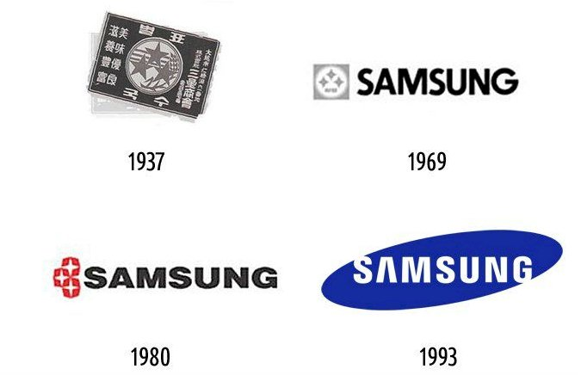
Figure 1.

Business strategy of Samsung

Over the years, the company has been a great success in its sales growth and is one of the few companies that has achieved this globally and has held on all these years. It continues to look for new markets as the main strategies Samsung uses for its growth are two:
- Focus on product quality – in order for a long time on the market it is necessary to prove it and strengthen it with reliable products, leading to customer security to the brand. That's why the company emphasizes this by drawing on customer experience and feedback. When quality drops and the user is redirected to a competitive brand, that's why it's important for Samsung to maintain the level of their products and services. Of course, competitors (as an example of smartphones – Apple) are also aggressively emphasizing the quality of their products, which is why Samsung is investing heavily to make its products more sustainable and environmentally friendly. The impact they have on nature is also a sign of the quality that the customer values. This wits also brings positives for the image of the brand as a whole.
- Focus on product quality – in order for a long time on the market it is necessary to prove it and strengthen it with reliable products, leading to customer security to the brand. That's why the company emphasizes this by drawing on customer experience and feedback. When quality drops and the user is redirected to a competitive brand, that's why it's important for Samsung to maintain the level of their products and services. Of course, competitors (as an example of smartphones – Apple) are also aggressively emphasizing the quality of their products, which is why Samsung is investing heavily to make its products more sustainable and environmentally friendly. The impact they have on nature is also a sign of the quality that the customer values. This wits also brings positives for the image of the brand as a whole.
Samsung is constantly striving to keep its portfolio attractive to the customer. The innovation that Samsung last introduced on its smartphones is the first folding smartphone in 2019. – Samsung Galaxy Fold. It can be used as a smartphone and also as a tablet. Another innovation is the first phone to use a 5G network. If the company had not made efforts to bring innovative technologies (the result of research) to whether it would have maintained its position and would have quickly surrendered to its main competitor in this field – Apple.

The Ansoff Matrix for Samsung:

Market Penetration: by its very nature, market penetration is when the company is focused on selling a product on an existing market.
Samsung is taking this step by advertising its products in existing markets, but the strategy also has a discount or discount on the product at this point. This is a tactic that the company used shortly before launching a new product. In this way, the company increases its market share and manages to get rid of excess inventory before the next version.
The company is typical of its large marketing campaigns using a different type of media to make it easier for its potential customers. All this is in the company's quest to increase its sales.

Market Development: this is when the business seeks to sell pre-existing products in new markets.
Of course, this is one of the strategies Samsung strives to pursue – to look for new markets for its products. This mainly happens geographically by entering new countries that it has not yet reached. To make it even more effective, it uses celebrities from that country to advertise its products.

Product Development: this growth strategy is used by developing new products or modifying existing products and placing them on existing markets.
Samsung has produced a variety of smartphone models and regularly updates their versions. In the same way it copes with the other products that the company produces. As one of the market leaders, the company constantly strives to refine its products and develop completely new ones. That's why Samsung puts a lot of money into research and development.

Diversification: when applying companies by placing new products in new markets. This is a little risky approach, since there the business still has no impressions and no experience. Since.
Samsung has the most diverse portfolio has reached quite wide horizons and has connected with a variety of industries from different countries. The company has always explored the possibility of new horizons and is looking for industries that are less developed but with the potential to enter them.

2.Stakeholder engagement and their impact on the marketing activities of an organization

By its very nature, the party concerned may be any natural person or group who is interested in a particular company and may also influence or be affected by its activities. Practice shows that it is good to identify stakeholders at an early stage.
Interested parties shall be divided into:
- Internal Stakeholders – these are those individuals or groups that participate in the management of the company itself. They are directly affected by the activities of the enterprise as they are direct participants. They themselves can also influence their actions of the organization.
The internal stakeholders are:
- Employees– the persons who work in the company and who are paid for it; Managers – the people who manage the different departments in the organization;
- Owners – persons who own or have a share of the organization itself;
- Board of Directors – the persons who run the company;
- External Stakeholders – these are the parties that are not involved in the management of the organization, but may be indirectly affected by it – they are part of the business environment.
External stakeholders are:
- Customers – they are the main part that the business has to comply with, as they are also the consumers of the offered product or service;
- Suppliers – are those who provide the necessary raw materials or equipment necessary to the organization;
- Intermediaries – they are the ones who make the connection between the organization and potential clients;
- Creditors – these are persons or financial institution, thanks to which funds are allocated for the activities of the organization;
- Competitors – the persons or organizations that are direct rivals of a company to reach its markets or even to supply resources;
- Government – part of the rules that the organization complies with are set precisely by the government and it must comply with them;
- Society – the organization is part of the society with which it must comply;
Managing these stakeholders is a step that needs to be taken as early as the company's bud, ensuring that the projects and objectives of the organization will succeed. That is why an analysis of the stakeholders themselves is also being carried out so that the organisation can take adequate measures to them in time and make contact to bring them together.
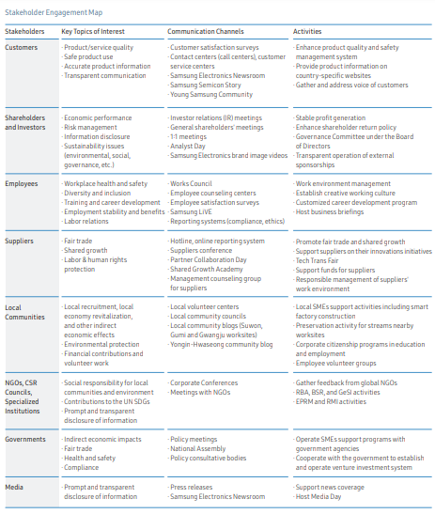

Samsung wants to have a close relationship with one of the stakeholders, and for this purpose has developed and selected different strategies. A system for managing knowledge to stakeholders has been established and one way to obtain up-to-date information is to actively meet them. In this way, the organization can make important decisions and overcome misunderstandings and conflicts with its stakeholders.
Samsung has open and direct communication with employees as well as its customers. With these actions, the company strives to improve its service. An effective role for this leads the active surveys that the company leads for satisfaction.
Another strategy for the company is to reduce energy consumption by 10% - a strategy tied to government policies. With the research that Samsung leads and allows it to directly influence its external stakeholders, such as – customers, suppliers, creditors, etc. The company helps its suppliers by providing them with ideas for innovation to improve their production and their different types of operations.
With its knowledge management system, Samsung allows its customers to evaluate the quality of their products. Each stakeholder has a list of advantages, which includes understanding their problems and needs, improving communication and commitment to them.
The communication process to each of Samsung's stakeholders is as follows:
- Planning: in order to be able to define its clear strategy, vision and objectives to stakeholders, the company actively communicates with them;
- Prioritisation: once the objectives have been set, management is committed to selecting priorities with which to maintain a strong relationship;
- Implementation: To perform tasks to stakeholders, the company uses methods and a variety of tools to manage its projects;

Research is used to gather information to provide feedback, as well as customer activity and usability tests. All these methods help to collect feedback from users, which helps the company to trigger if a problem is detected related to some of its products, quality or even some of its features.

Good communication and communication between the organisation and stakeholders is of utmost importance for a number of reasons. Relations with internal stakeholders are important as the company itself relies on them to carry out the different types of operations. The symbiosis between the company and its employees is of utmost importance in order to achieve the goals of the business. Relations with external stakeholders are also no less important, as they can indirectly affect the business itself. A good example would be the mood of the customer and its reorientation to a competitive brand, as well as a change in practices by suppliers. The relationship between business and internal and external stakeholders and their management are key to the success of any business.

Conclusion
During all these years of existence on the market Samsung has managed not only to keep as a brand, but also to prove and establish itself as a leader with the help of various marketing strategies. Its strategies and relationships with stakeholders are highly developed, indicating that the company has good governance and its intention to develop and expand its market share is perfectly reasonable and achievable. Samsung continues to hold its image to a high level, evolving and adapting constantly to new challenges and competition.

Bibliography

- By Alexandra Twin (2020) Marketing
Available from: https://www.investopedia.com/terms/m/marketing.asp
[accessed: 27.04.2021]
- By Peter Bondarenko., Samsung South Korean company
Available from: https://www.britannica.com/topic/Samsung-Electronics
[accessed: 28.04.2021]
- Philip Kotler and Gary Armstrong (2017). Principles of Marketing (17th Edition) [online] Published by Pearson, Pp76-77
- Tutor2u. Ansoff Matrix
Available from: https://www.tutor2u.net/business/reference/ansoffs-matrix
[accessed: 29.04.2021]
- Samsung (2020) About us
Available from: https://www.samsung.com/levant/aboutsamsung/home/
[accessed: 27.04.2021]
- Samsung (2021) On main Approaches to Sastainability
Available from: https://www.samsung.com/uk/aboutsamsung/sustainability/report-and-policy/
[accessed: 29.04.2021]
- By Jason Fenando (2021) Stakeholders
Available from: https://www.investopedia.com/terms/s/stakeholder.asp#:~:text=A%20stakeholder%20is%20a%20party,employees%2C%20customers%2C%20and%20suppliers.
[accessed: 29.04.2021]

- Samsung (2020) Sustainability report 2020
Available from: https://images.samsung.com/is/content/samsung/p5/uk/aboutsamsung/pdf/Sustainability_report_2020_en_F.pdf
[accessed: 30.04.2021]
- Lectures of Marketing Fundamentals 2021 – by Ze Zook

