PCEE 4007 – Design of Electrical Installations


HNC Electrical and Electronic Engineering
James Stevens

Table of Contents

Section A
Section B
Section C
Reference List
Bibliography

Cover image courtesy of Instrotech, as viewed on https://instrotech.com/fluke-1662.html?msclkid=7f2736fb897418fdc62754fbb65b6017&utm_source=bing&utm_medium=cpc&utm_campaign=Shopping%20-%20All%20Products&utm_term=1102300487369&utm_content=Ad%20group%20%231 06 of February 2022
Section A
Q1.
An existing electrical installation working within a sales office containing a ring final circuit with six single-lamp 58 watts luminaires will produce the following load:
$$Total Consumption=6 x 58=348W$$
Therefore $Total Load \left(A\right)= \frac{Total Consumption}{Rated Voltage}= \frac{348}{230}=$1.50A

It is proposed that the existing single-lap luminaires will be replaced with twin-lamp luminaires. This will have the following effect on the above calculations:
$$Total Consumption=12 x 58=696W$$
Therefore $Total Load \left(A\right)= \frac{Total Consumption}{Rated Voltage}= \frac{696}{230}=$3.03A

As can be seen, the proposed alteration will generate a doubling of the loading on this ring final circuit. It is stated that the circuit protective device conforms to BS3036 standards. As such, this rewirable fuse will have a load rating of 5 amps. This device will continue to serve the needs of the proposed changes to this circuit. In addition, if the installation has been completed to the correct standards, the conductor will have been appropriately sized when considering the maximum loading on the circuit. Proper consideration will also have been placed when sizing the circuit protective device, as well as the voltage drop caused by the distance of conductor, in addition to the resistive effects of running the conductor through the insulated cavity above the sales office. It will, however, be necessary to confirm that the correct cross-section conductor has been installed prior to commencing work to ensure the safe operation of the installation.

Q2. a)
Removal of the partition wall between the sale’s manager’s office and the manager’s secretary’s office will require the removal or relocation of two twin switched socket outlets. To achieve this, the location and path of the conductors running through this partition must be identified and mapped. The electrical installation should then be electrically isolated, with the appropriate lock-out procedures being undertaken to prevent accidental re-energising of the installation whilst work is being undertaken.
The conductor servicing the two twin sockets should be traced back to a location sufficiently remote from the portion of the partition to be removed. The conductor should then be severed at this point and made safe by terminating within a new junction box. It should then be safe to remove the two sockets and conductors from the partition wall. Any other conductors found to be running through this partition should also be re-routed at this point. The installation should then be re-tested to ensure its safety prior to removing the lock-outs.

Q2. b)
The removal of the partition wall will involve more than one trade. As such, to ensure the safe and timely completion of the project, effective lines of communications must be established and maintained for the duration of the task. It will be necessary to discuss the task at hand, list the necessary tasks required before completion, apportion the work to the appropriate trades, agree a timescale for each of the tasks and an order of sequence in which they will need to be undertaken. This plan will require continuous monitoring and amendment as required, with further discussion between the trades essential to completing the project in a professional manner.

Q2. c)
The plan discussed in sub-section b) above might be successfully achieved through several methods. If only a few individuals are involved in the project, or if the scale of the project is sufficiently small, then an informal discussion may have the desired outcomes. However, most projects involving more than one trade will benefit from a more formal process as is the case in this project.
A Gannt chart is a useful process-planning tool in which tasks are identified and ascribed a time-period in which they are to be completed. They are then ordered relative to one another in a graphical form by importance or by priority. This gives a visual and mental aid to the participants in the project as to the progress of the project, their part in the project, and aid in ensuring the continued progress of the project.
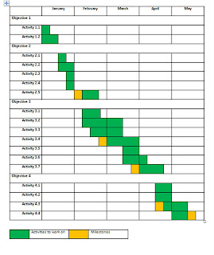
Example Gantt Chart, provided courtesy of https://nicandrohonoursproject.blogspot.com/2010/12/gantt-chart-updated.html

Often a Gantt chart, or a flow chart, is the visual representation of prior planning and analysis of the project such a critical path analysis. This is a method that looks at the project as a series of interdependent tasks. That is to say that each task is reliant in some way on the others, and that some will require completion before another can be undertaken. For example, in this project it would be inadvisable to permit the removal of the partition prior to commencing the electrical isolation of the socket outlets. So it should be set out and agreed on analysis that the electrical work is conducted as a matter of priority before the partition is removed.

3. a)
When tasked with calculating the costs of replacement of the luminaires in the sales office, firstly the cost of the new units in pace of the old should be considered. Costs of disposal of the old units should not be overlooked. The standards and types of luminaires available may have changes since the original installation, and so costing improved units with diffusers should be considered, thus giving the client some choice in the method and standard to which the task will be completed.
In addition, as work completed is to be undertaken during normal working hours, consideration should be made to the likely cost-effect of interrupting the supply of lighting in the sales office. For example, will temporary lighting be required whilst the work is being undertaken. The time duration of this task will also have a direct impact on this cost, over and above the labour costs, if it is deemed necessary to relocate the normal work activities in the sales office to another location.

3. b)
Costs associated with the replacement of the socket outlets in the partition wall will necessarily involve the purchasing of new units and disposal of the old. It has not been defined for what applications these sockets are likely to be used. However, it would be prudent to consider costing in materials required to install a new radial and ring final circuit. With greater volume of conductor required, the latter will be of greater cost but will render a higher load-carrying capacity and a more utile and safer option for the client. Supplementary supplies such as fixings and small electrical fittings (junction boxes, connector blocks, cable clips, conduit etc) should also be costed.
Labour costs will form another significant cost component, and should be quoted as a fixed price or at an hourly rate. The latter may be more appropriate if the task can be completed quickly or if the constraints of working during normal working hours may place an undue pressure on any fixed schedule.
Other costs associated with completing the task during normal working hours must be considered. Power to the circuit will have to be isolated for the duration of the task. This will disturb the normal activities of the office and so provision must be made. For example, costing for the hire of a generator or uninterrupted power supply may be required if sensitive electrical equipment such as computing equipment cannot be left without power. Further consultation with the client will be required prior to completion of a firm costing.

Section B
Q4.
Current transformers are used in situations where load-sensitive equipment is being used in conjunction with high-load applications. Metering equipment falls into this category. Current transformers allow the meter to monitor the flow of electricity into the installation whilst being electrically isolated from the potentially destructive high loads drawn by the installation. Consider the diagram below:
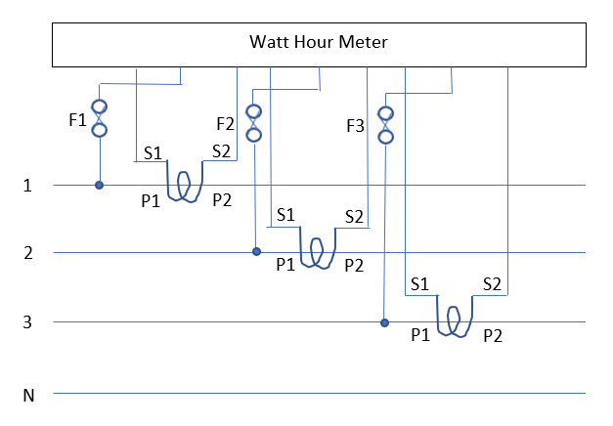

5. a)
Upon completion of the alterations, full commissioning tests will be required. Prior to the tests being undertaken, a “safe isolation procedure” (Linsley (2011), p279) must be in place. Full commission tests will include the testing of the continuity of protective conductors of the ring final circuits, insulation resistance testing, earth fault loop impedance testing, residual current device testing, and functional testing of the installation.

5. b)
Leads used in the commissioning tests must comply with the standards established in HSE GS38. Testing equipment must comply with the standards set out in BSEN 61010.

5. c)
Upon completion of the commissioning tests, a minor works certificate must be made out for the work undertaken on the lighting and sockets only. A full electrical installation certificate must also be completed which will contain within its schedules a list of all tests completed.

5.d)
The client must be the recipient of these certificates and test results at the completion of the task.

6.
The testing equipment used to complete these tests will include a low-resistance continuity tester (with an internal resistance of between 0 and 20 ohms (Ω)), an insulation resistance tester capable of testing between 0 and 500 MΩ, an earth fault loop impedance tester with a test range of 0 to 2000Ω, and an RCD tester capable of producing a fault path current of 300mA within 300ms.

7.
In the event of a failed test, immediate remedial action will be required. In the case of a newly commissioned installation, disturbed, loose or otherwise poor connections must be the prime area for investigation, starting with those elements of the installation that have been amended. If these are found to be in good order, then consideration must be made as to whether the protective conductor is sized sufficiently for the applied loads. If the circuit is radial, then alteration to a ring final circuit might be appropriate. Alternatively, installation of a mini circuit breaker (MCB) conforming to the standard BSEN 60898 should be considered, as this will necessarily have a higher load rating than the BS 3036 re-wirable unit in the original installation.

Section C
8.
The operation of the entire lighting system within a factory might be achieved by the conjunction of a key switch and contactor arrangement. Consider the diagram below:

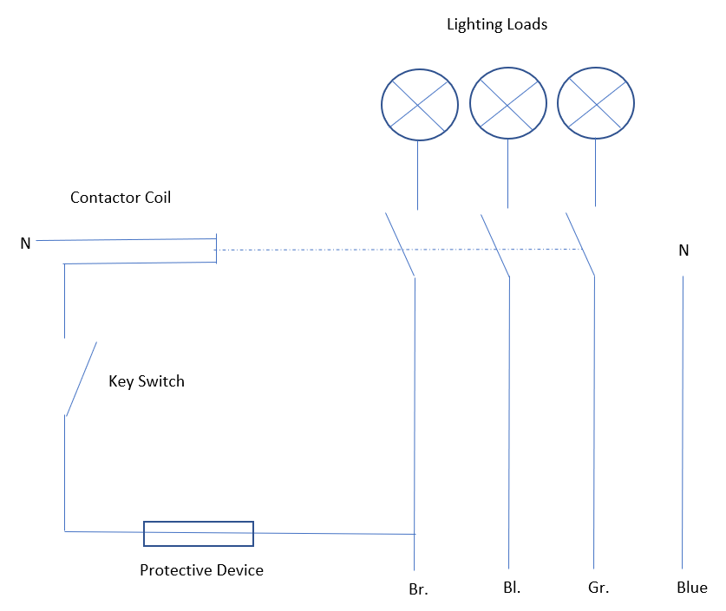
9.
Non-operation of fluorescent luminaires might be caused by failure of the lamp. This might be tested by placing within another fitting or replacing with a new lamp. Alternatively, the ballast may have failed. Once again this can be tested in another fitting or by replacing with a new unit. In addition, the supply to the fitting may be at fault. The voltage meter component of a low-impedance multi-meter, when applied to the supply conductor, will indicate if the supply is operative. If not, testing of the conductors, switches and protective devices associated with the circuit should be undertaken.

10.
Isolation of the supply to the office may have many negative implications for the users of the office space. Loss of work time is almost an inevitable consequence. To avoid this, the electrical contractor should consider costing and providing out of hours work to prevent overlap of downtime in the supply with the work of the office. Alternatively, the provision of alternative office space or an alternative power supply (via generator sets or UPS) should be considered.

11.
The diagram below depicts how it is possible to derive a 400V three phase four wire supply from an 11kV three phase three wire supply:

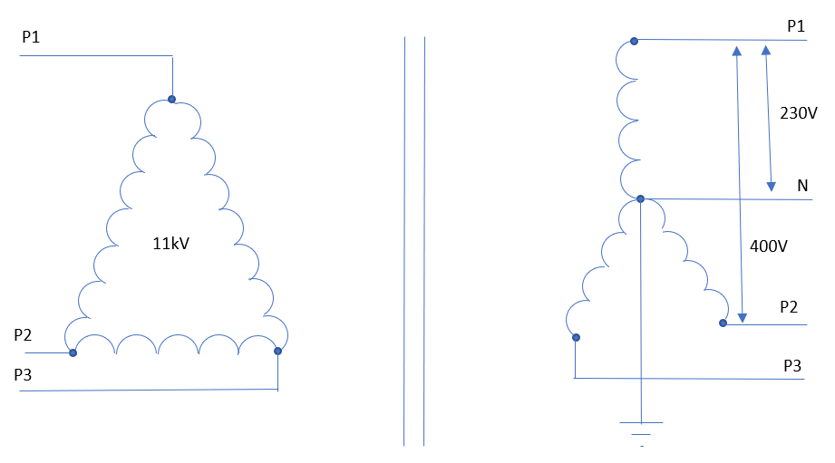
12.
The below diagram depicts how the supply from a three phase terra-neutral separate (TN-S) system might be arranged:

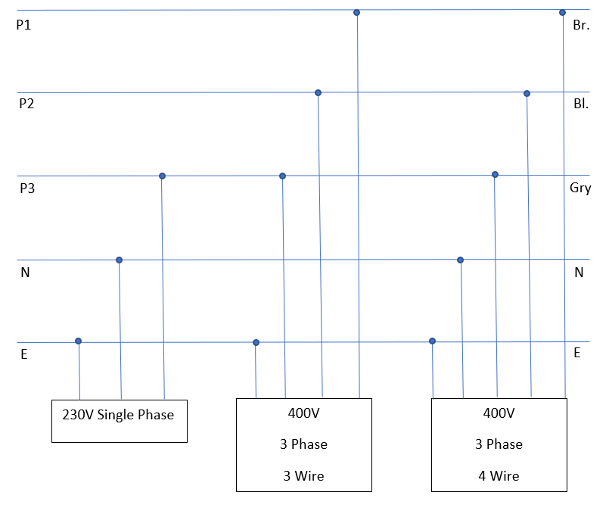

Reference List
Linsley, T. (2011) Basic Electrical Installation Work (Sixth Edition), Oxford, Newnes
British Standard BSEN 3036:1958 Semi enclosed electric fuses (ratings up to 100 amperes and 240 volts to earth, British Standards Institute
British Standard BS EN 61010-1:2010 Safety requirements for electrical equipment, British Standards Institute
Health and Safety Executive (2015) GS38 – Electrical test equipment for use on low voltage electrical systems (Fourth Edition)
British Standard BS 7671:2018 Requirements for Electrical Installations, British Standards Institute
British Standard BS EN 60898-2:2006 Electrical accessories – circuit breakers for overcurrent protection for household and similar installations – circuit breakers for a.c. and d.c. operation
Nicandro Pacitti (2010), Gantt Chart Updated [Online} available at https://nicandrohonoursproject.blogspot.com/2010/12/gantt-chart-updated.html [Accessed 31 January 2022]
Instrotech (2022), Fluke 1662 Multifunction Installation Tester [Online] available at https://instrotech.com/fluke-1662.html?msclkid=7f2736fb897418fdc62754fbb65b6017&utm_source=bing&utm_medium=cpc&utm_campaign=Shopping%20-%20All%20Products&utm_term=1102300487369&utm_content=Ad%20group%20%231 {Accessed 06 February 2022]

Bibliography
Bird, J. (2007) Electrical and Electronic Principles and Technology (Third Edition) Oxford, Newnes
Scaddan, B. (2019) 18th Edition IET Wiring Regulations – Electric Wiring for Domestic Installers (16th Edition) Oxford, Routledge

