
A Journey Through Emotions
Robilant + Voena Art Gallery 2021
Ba pRODUCT AND FURNITURE DESIGN
jULIA lOCKHEART
Sophie taylor 2000324
Word count=1355

Floor Plan
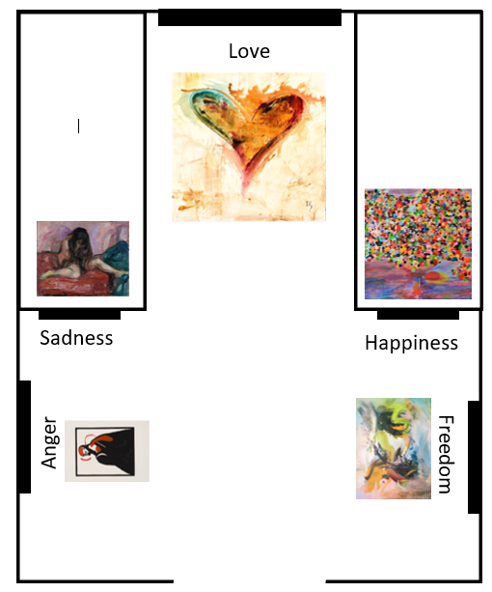

The “A Journey through emotions” exhibition is situated in the “Robilant + Voena Art Gallery” due to its dated look. There is a room within the gallery that is set out the exact way I want the layout of my exhibition to be. The design gives the individual a chance to choose a path of emotion whether it is on the left or the right. The right is a more positive outlook on “Love” hence why the emotions “Freedom” and “Happiness” are present, whereas on the opposite side is a contrast portraying a negative side to your emotions this is where “Anger” and “Sadness” lay. The purpose of love being the first thing you see in the centre of the room is to show that through either a positive or negative pathway “Love” will always play a part whether it is at the beginning in the middle or at the end. The exhibition is also a way of raising awareness for mental health, especially in our current circumstances I wanted to show that no-one means to have a mental health problem it’s the way they have been brought up or the experiences they have had, so I wanted to make it clear that although you could have a good or bad day at the end of it there will always be someone there who loves you or wants to help you which is “LOVE”.

Weeping Nude by Edvard Munch

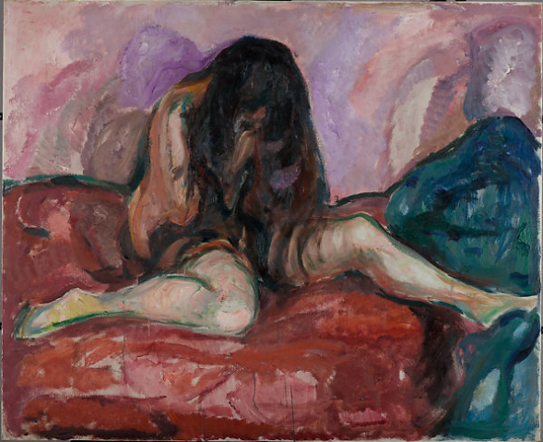

Figure 1 (Munch, 2013)

Sadness can be defined as "is a natural part of life and is usually connected with certain experiences of pain or loss or even a meaningful moment of connection or joy that makes us value our lives." (FirestonE Ph.D,2015).The painting by Edvard Munch is a clear portrayal of sadness the vulnerable girl curled up crying shows how sadness affects us all, similarly, and differently. He is playing on the position most humans make when they are upset, potentially for us to close the hole we feel when we are sad. “it may bring relief, pleasure, even happiness. Strange kind of sadness that brings pleasure” (Eaton, 1982). This quote is referring to the type of sadness this image is, it is not a bad experience of sadness as it is non direct, so we can look at the image and feel the emotions of the young woman, but it does not affect us in such a way that we must with draw ourselves. I chose sadness as it is a common emotion, we feel in our daily lives whether that is due to past events that bring back negative emotion or if it is an action someone has inflicted on us to make us feel sad. The placement of this piece is situated next to Anger as from Anger sadness tends to stem and grow into its own emotion. This painting playing a crucial part in the exhibition. The spectator is open to explore the different emotions this painting may influence; however, it is meant to portray sadness or any other negative emotion as it is placed on the negative side of the exhibition as it is the journey in which we can take to reach the emotion of love.

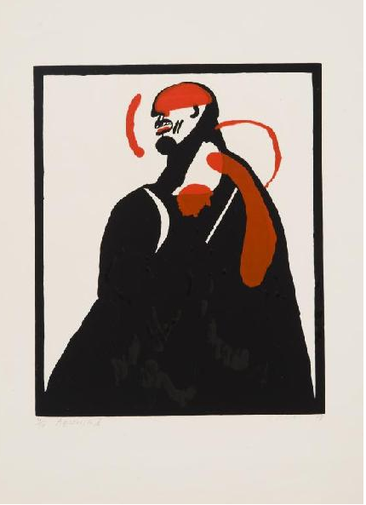
Aggression By Mikalojus Povilas Vilutis

Anger can be interpreted as “a natural, though sometimes unwanted or irrational, emotion that everybody experiences from time to time." (Skills you Need, 2011) Mikalojus’ use of colours is why I believe the painting is considered aggressive and exposes the anger within the image “The colour red was most associated with anger” (Sutton and Altarriba, 2015) in a study taken out about people relations with colour and emotions. Red being associated with anger. Which explains why red is the only vibrant colour present within this image. It allows people to interpret the image however they see it but draws them to a certain feeling. It is a participant in my exhibition as the subtle but intense it is sending and the emotion you feel is so deep it fits perfectly in the exhibition for the emotion it is representing, It allows the spectator to reach into their emotions and become aware of the anger they may have experienced or be experiencing, Therefore, it is making the piece relative to their lives and allows them to connect with the exhibition, allowing them to route back to love and sadness as they all link into one.

Figure 2 (Mikalojus Povilas Vilutis 1979)

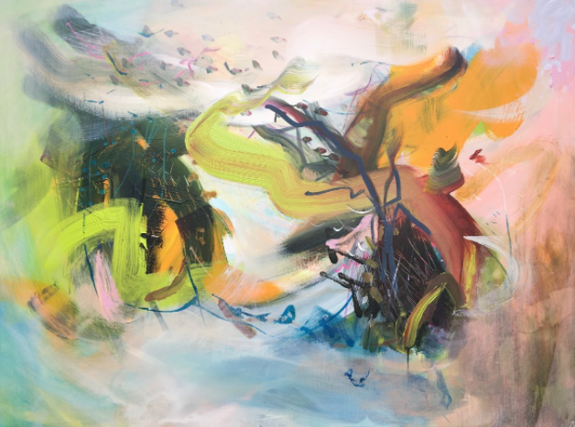
Song of the wind By Lesley Birch
Figure 3 (Lesley Birch)

Freedom can be described in many ways, however it can be defined as" being free from feeling like a victim of and controlled by our emotions" (Paul, 2010) This means to feel freedom you have to control the way external emotions influence you, the painting above clearly represents this as there is no pattern or structure which relates to feeling free as you aren’t controlled by anything instead you are the mixing of colours which can represent the different things you are feeling. This abstract art is attending my exhibition as I believe it is a clear representation and contrasts the other pieces of art, drawing the eye of the attendee. This painting is guiding the spectator to explore their sense of freedom within their lives and maybe helps them see that the negative side of their life can be overridden by the positives, making them mindful of their emotions and to appreciate the finer things in life.
Pure Joy and Happiness by Diana Scherpenisse
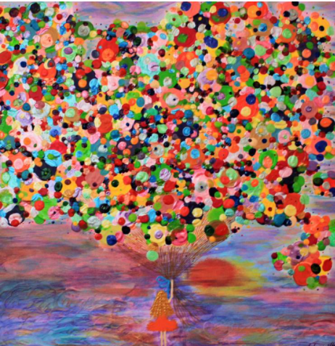

Figure 4(Diana Scherpenisse, 2018)

There is no correct definition of happiness due to it being dependant on the way different individuals interpret it. An example of a definition is “the experience of joy, contentment, or positive well-being, combined with a sense that one’s life is good, meaningful, and worthwhile" (Happiness, 2021). From the painting Diana Scherpenisse has created I feel it is full of colour and emotion, more towards happiness as it brings me back to my childhood roots and makes me acknowledge that before responsibilities and work happiness was present and still is present just under different circumstances. My intention then being that when people present at the exhibition, they feel a great deal of happiness as it is taking the back to a time where they were truly happy and had no worries. It is providing them with an experience they may not have felt or been aware of for quite some time, again making them mindful of emotions they may want to feel more often to better their life. The use of colours draws you into the image making it a vital piece in the exhibition for individuals to explore their sense of happiness.

Happiness inside me by Ivan Guaderrama
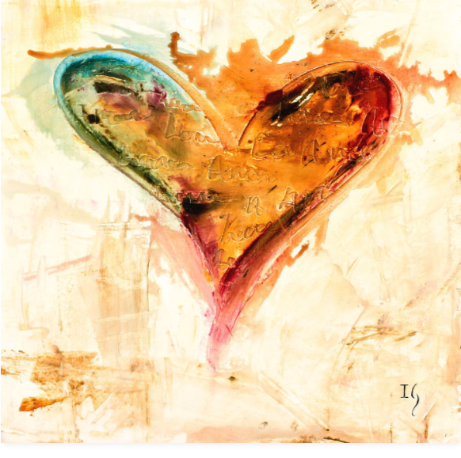
Love is an intense emotion that varies depending on the individual and situation, it can be described as "a set of emotions and behaviours characterized by intimacy, passion, and commitment. It involves care, closeness, protectiveness, attraction, affection, and trust. Love can vary in intensity and can change over time." (Cherry, 2020) Although love is an emotion it contains a variety of other sub emotions that add up. This piece by Ivan Guaderrama explores love in colours so I see it as the change in colours are the sub emotions then building up to create the one main emotion of love. I chose the image of the heart as it is recognisable worldwide as the symbol of love, making it the main piece within the exhibition, as all the emotions within the room create love and the journey, we take to find it whether its love for ourselves or for others. This piece is an incentive to those spectating the exhibition as they need to go through different paths to ultimately feel love, this is an emotion a lot of individuals desire as it gives you a sense of belonging, hence why it is placed where it is, so that when the individuals attending the exhibition have ventured through the other emotions within the room they will have mindfully reached into their own emotions and will hopefully see how they too can reach love.
Figure 5 (Ivan Guaderrama)

The background of this exhibition

This exhibition was created in such a way that individuals who attended found their peace and saw how their emotions are combined to create another emotion such as love. It was intended to remind people that no matter what they do not need anyone to make them happy or sad or angry etc, but that they can deal with it themselves and love themselves. The journey taken through the exhibition is like a self-reflection on the present time in the individual’s life so they can see what the negatives and positives are within their life, it can be said the exhibition acts as a self-realisation therapy whilst using artwork to encourage them to understand how they feel about certain experiences that they encounter. Which may help them in the future to handle their emotions but to also reject any external negativity so that they can live a happy life. This enables individuals who are struggling to feel their emotions due to poor mental health reconciliate who they are and how to combat their thoughts and feelings towards themselves and others.

Bibliography

Cherry, K., 2020. What is love.
[online] Very Well Mind.
Available at: https://www.verywellmind.com/what-is-love-2795343#:~:text=Love%20is%20a%20set%20of,and%20can%20change%20over%20time.
[Accessed 11 April 2021]

Eaton, M., 1982. A strange Kind of Sadness.
The Journal of Aesthetics and Art Criticism, 41(1), p.51.

FirestonE Ph.D, L., 2015. The value of sadness.
[Blog] Psychology Today UK, Available at: https://www.psychologytoday.com/gb/blog/compassion-matters/201507/the-value-sadness
[Accessed 14 April 2021].

Greater Good Magazine, 2021. Happiness.
[online] (1), p.1. Available at: <https://greatergood.berkeley.edu/topic/happiness/definition>
[Accessed 10 April 2021].

Paul, D., 2010. What is emotional freedom?.
[Blog] Inner Bonding, Available at: <https://www.innerbonding.com/show-article/2593/what-is-emotional-freedom.html#:~:text=Discover%20the%20secret%20of%20attaining,they%20don't%20control%20us.>
[Accessed 11 April 2021].

Skills you Need, 2011. What is anger?.
[online] p.2. Available at: https://www.skillsyouneed.com/ps/anger.html
[Accessed 15 April 2021].

Sutton, t. and Altarriba, J., 2015. Color associations to emotion and emotion-laden words: A collection of norms for stimulus construction and selection. p.2.

