

University of Wales Trinity Saint David
Welsh Institute of Sciences and Art (WISA)
Simon Rees (0151968)
MSc Cybersecurity and Digital Forensics
Digital Forensics (ACCA7031)

V33

Table of Contents

1. Introduction 1
2. Task 1 – DF Research 1
2.1 Current state of DF 1
2.2 Intersection of DF and Cybersecurity 2
2.3 Key Challenges in the field 3
2.3.1 Proving the authenticity of evidence 3
2.3.2 Preservation of Evidence 5
2.4 DFI Job Market 6
3. Task 2 - Evaluation of Open-Source and Commercial forensic tools 9
3.1 Cost 9
3.2 Support 10
3.3 Data set size and processing power 11
3.4 Modification 12
3.5 Collaboration 14
4. Conclusion 15
5. References 16
Appendices 30
Appendix 1: Brief Overview of Forensic Science 30
A1.1 Beginnings of modern-day Forensic Science 30
A1.2 Beginnings of Computer Forensics 30
Appendix 2: Data Acquisition 32
A2.1 Standard Operating Procedure (SOP) 32
A2.2 Ensuring Data integrity is maintained 32
A2.3 Ensuring Data authenticity 35
A2.4 Recovery of deleted files using file carving 36
Appendix 3: The Electronic Discovery (e-Discovery) and Electronic Discovery Reference Model (EDRM) 39
A3.1 Electronic Discovery (e-Discovery) 39
A3.2 Electronic Discovery Reference Model (EDRM) 40
A3.3 Legal hold 41
Appendix 4: Forensic Software Research 42
A4.1 Table of DF Image formats researched 42
A4.2 Autopsy Overview 42
A4.3 Forensic Toolkit (FTK) Overview 44
A4.4 Table of Software Tools researched 48
A4.5 Brief overview of a selection of tools researched 57
A4.6 Autopsy and FTK Collaboration (Formally 3.6 Collaboration) 61
Appendix 5: Challenges of Digital Forensics 63
A5.1 Creating a forensic copy without altering the data of the original drive 64
A5.2 Proving the integrity of the original drive 64
A5.3 Length of time it takes to analyse data 65
A5.4 Keeping up with the pace of technology 65
A5.5 Anti-Forensics 65
A5.6 Malicious Software 68
A5.7 Creating forensic copy of containerised systems 68
Appendix 6: DF Job Market Research 70
A6.1 JD Analysis 70
A6.2 Job Adverts researched 71
A6.3 Tools mentioned in JDs 76
A6.4 Qualifications mentioned in JDs 77
A6.5 Standards mentioned in JDs 79
A6.6 Security Clearance mentioned in JDs 80
A6.7 DF Accreditation: EX1 Digital Forensic Services Ltd 80
Appendix 7: Emerging Trends in Digital Forensics 82
A7.1 Artificial Intelligence (AI) and Machine Learning (ML) 82
A7.2 Cloud Forensics 82
A7.3 IoT Forensics 82
A7.4 Automated Forensic Tools 82
A7.5 Virtual Reality (VR) / Augmented Reality (AR) 83
Appendix 8: Challenges faced during assignment 84

I List of Figures
Figure 1: IR Process flowchart [7] 2
Figure 2: Completed Continuity of Evidence (CoE) tracking form [14] 4
Figure 3: Example of the DF Investigator Job Advert [19] 7
Figure 4: Autopsy User Documentation 10
Figure 5: FTK Support Portal and Documentation [38] 11
Figure 6: Autopsy Developer's guide [44] 12
Figure 7: Write Protect Registry Key added - Note Data shows 0x00000000 (0) - Signifying Write protect is OFF 34
Figure 8: Ensuring the WriteProtect registry key functions correctly 34
Figure 9: Continuity of Evidence (CoE)- UK or Chain of Custody (CoC)-USA form page1 [69] 35
Figure 10: Chain of Custody form page2 [69] 36
Figure 11: Deleted files being analysed in Autopsy 37
Figure 12: File Signature Analysis using a hex viewer tool HxD during Activity 3 38
Figure 13: Overview of e-Discovery solutions from Exterro 39
Figure 14: The ERDM Process [70] 40
Figure 15: Configuring the Ingest of Autopsy for Activity 1 43
Figure 16: Autopsy Data Analysis complete for Activity 1 44
Figure 17: FTK being used to analyse artifacts of an image [75] 45
Figure 18: Filtering evidence in FTK 45
Figure 19: The FTK Suite of products [76] 46
Figure 20: Screenshot of FTK Imager being used to Acquire data from a USB Pendrive during Activity 1 47
Figure 21: TSK tools being used for Activity 2 57
Figure 22: Using ExifTool to view Meta Data of a JPG image during Activity 1 58
Figure 23: Screenshot of Dumpzilla in use [118] 59
Figure 24: Ghiro Automated Image Analysis tool [105] 59
Figure 25: Ghidra analysis of a program file [120] 60
Figure 26: pdfinfo being used to access the Medadata of a PDF document during Activity 1 60
Figure 27: The Autopsy multi-user environment [47] 61
Figure 28: Screenshot of the Autopsy Multi-User function [48] 61
Figure 29: Screenshot of FTK Central [50] 62
Figure 30: Example of a hardware USB write blocker [18] 64
Figure 31: Screenshot of a Digital Hash created after Data Acquisition by FTK Imager whilst carrying out Activity 1 of the DF Module 65
Figure 32: OpenStego being used to embed a text file within an image file – with AES 128 Encryption being used [135] 67
Figure 33: Steganalysis tool StegoHunt [136] 67
Figure 34: Example of UKAS Accreditation document for ex1-forensics, Llanelli [171] 81
Figure 35: FTK System Requirements 84

II List of Tables
Table 1: Cybersecurity and DF techniques during an IR. 3
Table 2: Advantages of DF during IR process 3
Table 3: Five-step process used by DFIs 4
Table 4: Audit Log from Activity 1 of DF Module 5
Table 5: Order of Volatility [6] 6
Table 6: Further challenges identified 6
Table 7: Synopsis of requirements for job roles researched [19] [20] [21] [22] [23] [24] [25] [26] [27] [28] 7
Table 8: Costs for FTK Forensic Toolkit [34] 9
Table 9: Initial up-front and annual costs for FTK Forensic Toolkit [34] 9
Table 10: SLA Response Times according to ITIL 11
Table 11: Features of FTK Lab 12
Table 12: Analysis of Autopsy and FTK [51] 14
Table 13: EDRM steps and descriptions [6] [18] 40
Table 14: DF Image formats [6] 42
Table 15: FTK Suite of tools and brief description of features 46
Table 16: Exterro Suites available to customers 46
Table 17: Forensic Software Overview 48
Table 18: Services required for Autopsy multi-user environment 61
Table 19: FTK Central features [49] 62
Table 20: Possible malware types encountered by DFIs [6] 68
Table 21: Job roles researched [19] [20] [21] [22] [23] [24] [25] [26] [27] [28] 71
Table 22: Table of Tools listed in Job Advertisements 76
Table 23: List of Tools listed in Job Advert for Malware Forensic Examiner 76
Table 24: List of Tools listed in Job Advert for Forensic Digital Media Examiner 76
Table 25: Job requirements for Malware Forensic Examinator [139] [120] [114] 77
Table 26: Job requirements for Forensic Digital Media Examiner [140] [141] [142] [143] [144] 77
Table 27: DF Qualifications researched 78
Table 28: Standards required in JDs 79
Table 29: UK Security Vetting Levels 80

III List of Acronyms

Acronym | Meaning
AC | Accredited Check
ACPO | Association of Chief Police Officers
ADB | Android Debug Bridge
ADF | Advanced Digital Forensic
AI | Artificial Intelligence
AR | Augmented Reality
ASCLD | American Society of Crime Laboratory Directors
AWS | Amazon Web Services
CAINE | Computer Aided Investigative Environment
CCISP | Certified Information Systems Security Professional
CF | Computer Forensics
CFTT | Computer Forensics Tool Testing
CISA | Cybersecurity and Infrastructure Security Agency
CLI | Command Line Interface
CoC | Chain of Custody
CoE | Continuity of Evidence
CPS | Crown Prosecution Service
CTC | Counter Terrorist Check
DCO | Device Cover Overlay
DF | Digital Forensics
DFI | Digital Forensic Investigator
DFF | Docker Forensic Framework
DHCP | Dynamic Host Configuration Protocol
DNA | Distributed Network Attack
DNS | Domain Name Service
DR | Disaster Recovery
DV | Developed Vetting
EDRM | Electronic Discovery Reference Model
ELA | Error Level Analysis
eSC | Enhanced Security Check
FBI | Federal Bureau of Investigation
FDE | Full Disk Encryption
FSR | Forensic Science Regulators
FTK | Forensic Toolkit
GUI | Graphical User Interface
HDD | Hard Disk Drive
ID | Identity
IDS | Intrusion Detection System
IoT | Internet of Things
IR | Incident Response
ISO | International Organisation for Standardisation
ISFE | International Society of Computer Examiners
IT | Information Technology
IEEE | Institute of Electrical and Electronics Engineers
IPS | Intrusion Prevention System
ITIL | Information Technology Infrastructure Library
JD | Job Description
MFT | Master File Table
ML | Machine Learning
NIST | National Institute of Standards and Technology
NPA | National Police Agency
NSA | National Security Agency
NTFS | New Technology File System
OS | Operating System
PRTK | Password Recovery Toolkit
RAM | Random Access Memory
SC | Security Check
SLA | Service Level Agreement
SOP | Standard Operating Procedure
SSD | Solid State Drive
TOR | The Onion Router
TSK | The Sleuth Toolkit
UKAS | United Kingdom Accreditation Service
UKSV | United Kingdom Security Vetting
VA | Vulnerability Assessment
VM | Virtual Machine
VPN | Virtual Private Network
VR | Virtual Reality

Introduction

Our world is ever more reliant on Information Technology (IT) systems. Important financial transactions take place, and sensitive information is transferred daily. This gives cybercriminals numerous opportunities to carry out fraud or financial scams on unsuspecting victims.
Part one of this report aims to research the field of Digital Forensics (DF), the importance of DF today, and the relationship between DF and cybersecurity. It also aims to address key challenges faced by DF Investigators (DFI’s) and the DF job market.
Part two aims to evaluate open-source and commercial DF tools by using a multitude of resources including practical hands-on.
Part three will cover three simulated investigations, whereby data is acquired and analysed using forensically sound techniques. Finally leading to a presentation of the findings.
For further information on the beginnings of how DF came about see Appendix 1.

Task 1 – DF Research

Current state of DF

DF is critical in gathering evidence for law enforcement to bring cybercriminals to justice. According to the Cyber and Communications Forensics Unit of the Metropolitan Police “90% of crime now has a digital element to it” [1].
Techniques used by Cybercriminals evolve rapidly, seeking to exploit new vulnerabilities and to extort money from their victims [2].
DF is used by both law enforcement and organisations to investigate cybercrimes. They examine the digital evidence to determine what occurred, how the crime took place, and crucially the culprit. DF is the only method possible to gather evidence and build cases against cybercriminals utilising cryptocurrency [3] [4]. This trend is set to continue into the foreseeable future, making DF an increasingly valuable branch of forensic science [5].

Intersection of DF and Cybersecurity

Cybersecurity focuses on preventative/detective measures e.g. Vulnerability Assessments (VA), Intrusion Detection (IDS) and Prevention Systems (IPS) to either avoid or detect cyber-attacks. In contrast, DF focuses on data acquisition, analysis and forensic examination of data.
It is crucial to have knowledge of both especially during an Incident Response (IR) or Disaster Recovery (DR).
Figure 1 (Fig.1) illustrates the IR process. [6]:
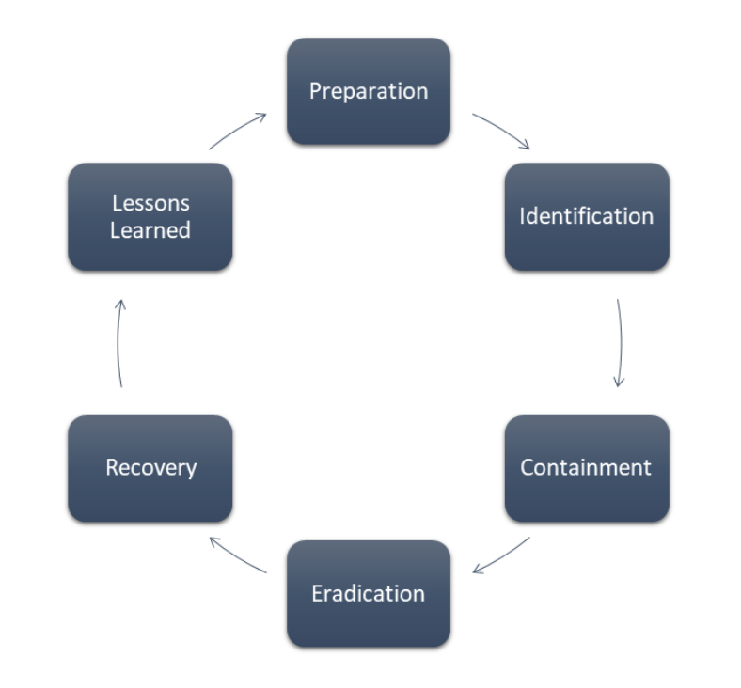
Figure 1: IR Process flowchart [7]

DF is extremely beneficial at different stages of the IR process, see Table 1:
Table 1: Cybersecurity and DF techniques during an IR.
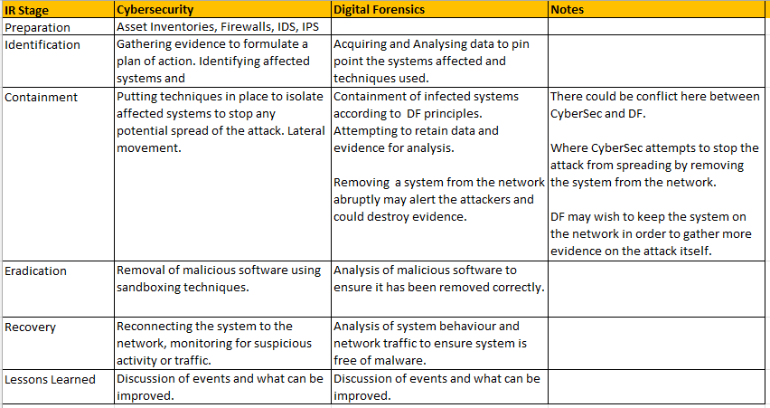

DF skills are crucial during a live IR to identify what actions are actively being carried out by hackers, what systems have been compromised and assist to devise a plan to restore services.
Table 2 Outlines the benefits of DF [8]:
Table 2: Advantages of DF during IR process
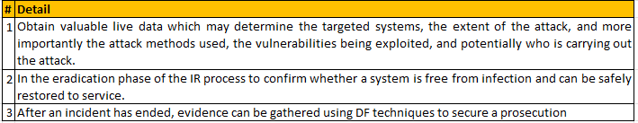

Key Challenges in the field

Proving the authenticity of evidence
The primary challenge of DF is ensuring the authenticity of a piece of evidence, especially if evidence is to be presented in a court of law.
To ensure the seizure of devices and onsite retrieval of evidence is collected in a forensically sound manner, a Standard Operating Procedure (SOP) is used [9] [10] [11] [12], See Appendix 2 for more information.
Table 3 shows the five-step process commonly used by DFIs [13]:
Table 3: Five-step process used by DFIs
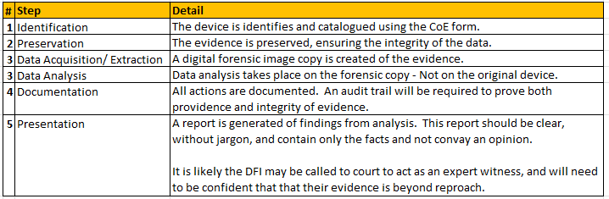

A crucial part of the SOP is using a Continuity of Evidence (CoE) tracking form. This form is used to log who seized the evidence when and where. It is then used to log the physical location of the evidence, who had access to it, where it was kept and when. Fig.2 shows a completed CoE form used for Activity 1 [6] [14].

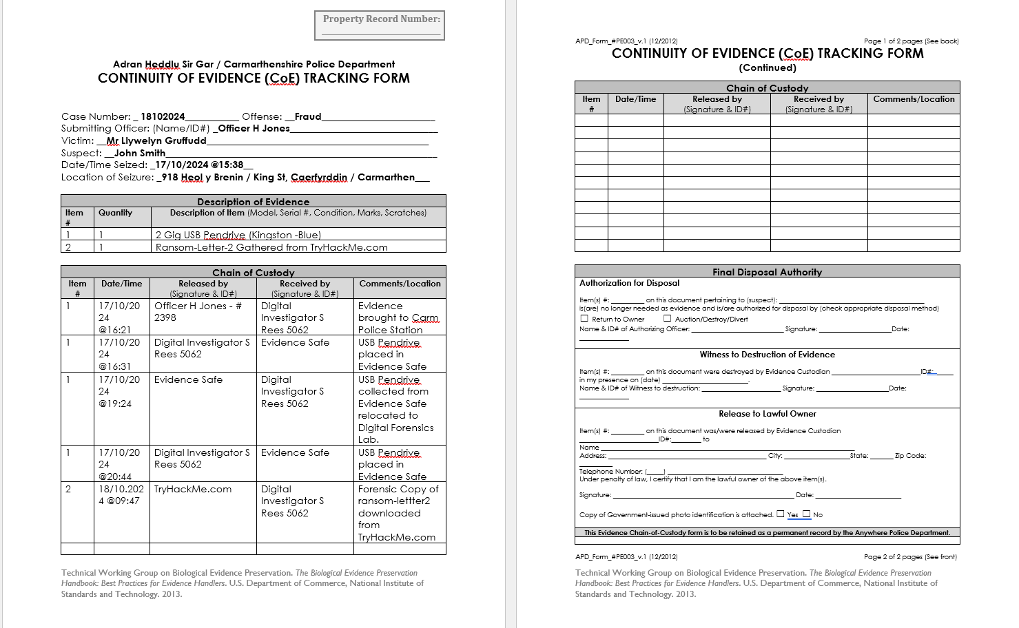
Figure 2: Completed Continuity of Evidence (CoE) tracking form [14]
Whilst the CoE tracking form provides an audit trail it does not provide a detailed log of work carried out by a DFI during the Data Acquisition or Data Analysis phases of an investigation.
In addition to the CoE tracking form it is a requirement of Principle 3 of the Association of Chief Police Officers (ACPO) Principles of Digital Evidence that an audit trail should be created to log all processes applied to the evidence [15] [16] [17].
Table 4 illustrates an audit log used during Activity 1.
Table 4: Audit Log from Activity 1 of DF Module
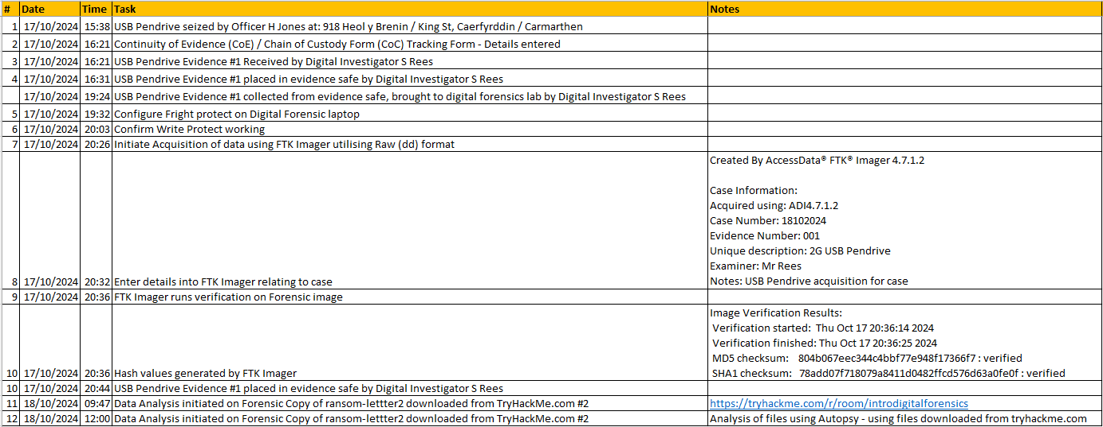
On completion of the investigation the CoE form has a section for disposal of the evidence, which catalogues whether the evidence was destroyed or released to its lawful owner.
Further information, see Appendices 2,3,5 and 7.

Preservation of Evidence

The Electronic Discovery process is used at all stages of the investigation and gives guidance on evidence preservation which includes the legal hold process, see Appendix 3.
Data is stored in many forms, and the length of time that data is accessible to a DFI can vary. Data stored on a hard drive can potentially remain accessible for a long period of time, this being non-volatile. Whereas data stored in the CPUs Cache or RAM, may only be accessible for a brief amount of time, and termed volatile.
DFIs use the Order of Volatility to prioritise the sequence of data acquisition beginning with the most volatile data first in order to preserve as much evidence as possible, see Table 5 [6] [18].
Table 5: Order of Volatility [6]
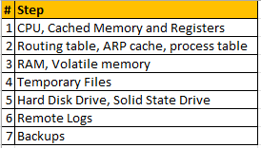
Table 6 shows further challenges identified:
Table 6: Further challenges identified
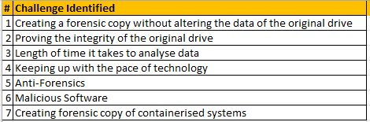
See Appendix 5 for further information of these challenges.

DFI Job Market

A search of DF roles was undertaken for this assignment, 5 national and 5 international roles were evaluated.
The main sectors seeking to employ DFIs are:
- Law Enforcement
- Government
- Financial Sector
- Law Firms
- Corporate Organisations

Fig.3 shows a job advertisement for a DFI in the UK.
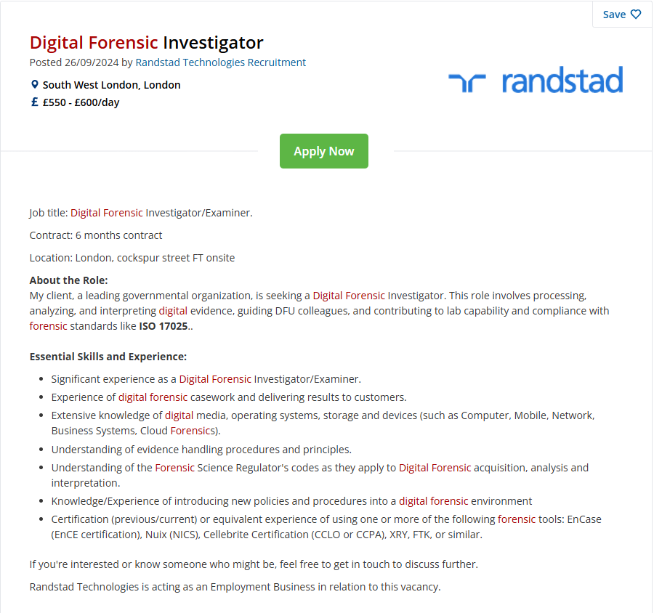
Figure 3: Example of the DF Investigator Job Advert [19]
Table 7 shows a synopsis of the experience and requirements of the Job Descriptions (JD).
Table 7: Synopsis of requirements for job roles researched [19] [20] [21] [22] [23] [24] [25] [26] [27] [28]
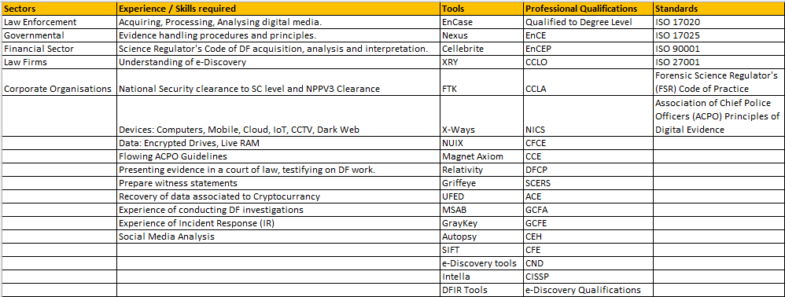
The professional qualifications and experience of tools for national and international DFI roles, were comparable. The only notable difference was that national roles required knowledge of International Organisation for Standardisation (ISO) standards and Forensic Science Regulator's (FSR) Code of Practice whilst international roles did not.
Further details on the Job Titles, Tools specified, Qualifications and Standards and the UK Accredited Services (UKAS) can be found in Appendix 6.

Task 2 - Evaluation of Open-Source and Commercial forensic tools
The National Institute of Standards and Technology (NIST) have a dedicated software quality testing group Computer Forensics Tool Testing Program (CFTT) that conduct rigorous testing on DF tools to ensure that the tools can produce evidence that is admissible in a court of law. [29] [30] [31].
Forty DF software tools were researched as part of this report, see Appendix 4. Autopsy (Open-Source) and Forensic Toolkit (FTK) (Commercial) were evaluated as they are comparable tools. Both FTK and Autopsy have been tested by the CCTF see Appendix 4.

Cost
Autopsy is free to download, with no associated costs which is ideal for organisations with limited financial resources [32].
FTK however, has cost implications. According to the Crown Prosecution Service (CPS) expert witness guidance, expert’s evidence must be reliable [33]. Therefore, it is crucial that FTK software maintenance and support costs are met annually, updates applied regularly to maintain the integrity of FTK.
(N.B. A trial version of FTK is free, but only for 30 days see Appendix 8).
Pricing for FTK Forensic Toolkit in Table 8:
Table 8: Costs for FTK Forensic Toolkit [34]
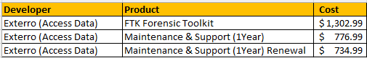
Initial and ongoing annual costs in Table 9.
Table 9: Initial up-front and annual costs for FTK Forensic Toolkit [34]
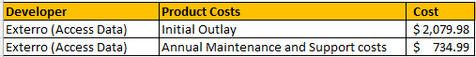

Support

Autopsy users rely upon a community of volunteer developers and other users for support. Autopsy is well documented, and most queries are answered using online resources see Fig.4.
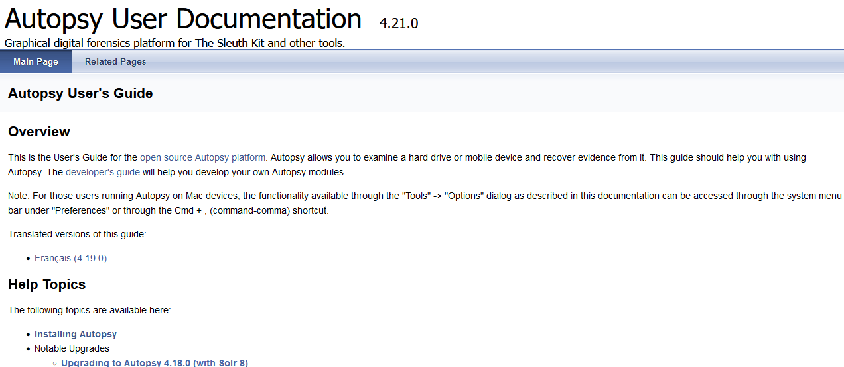
Figure 4: Autopsy User Documentation
If the documentation does not answer the DFIs query a blog/forum are available to pose questions [35] [36].
Autopsy has a support page allowing DFIs to report bugs and email queries to developers and users, however no response is guaranteed [37]. Commercial support is available, but this is a dead link.
Autopsy does not have a centrally managed Service Desk to assist and no time limit on when a response will be received [37]. This could be problematic during an investigation if there were a technical issue with Autopsy.
In comparison, FTK have a dedicated support portal, see Fig.5. FTK have online documentation giving DFIs support and guidance on software releases and installation. If an issue arises, the DFI can log into the support portal raising a ticket.
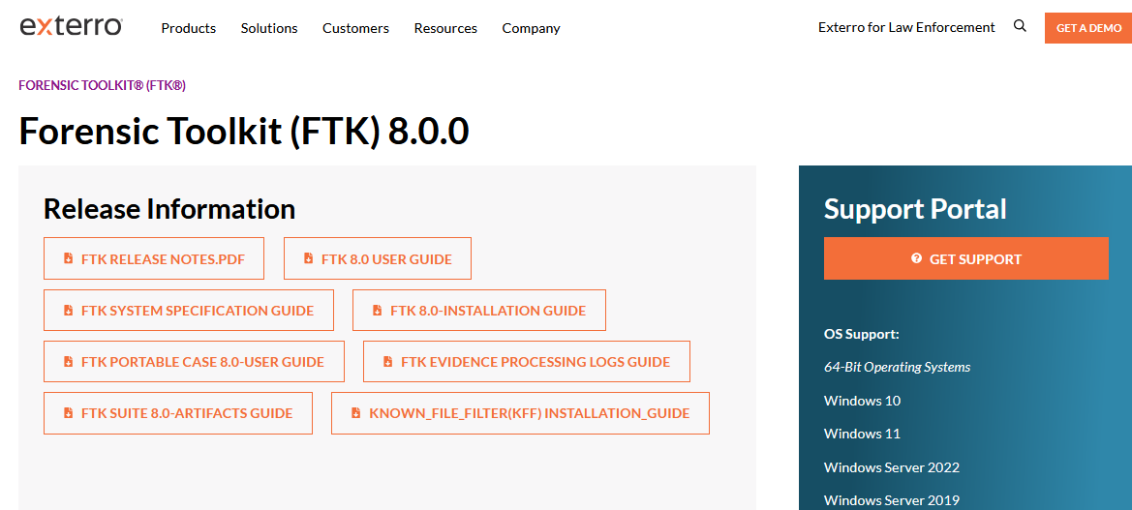
Figure 5: FTK Support Portal and Documentation [38]
FTK’s support contract includes a Service Level Agreement (SLA) stating response times of tickets depending on impact and urgency. Response and resolution times are based on Information Technology Infrastructure Library (ITIL) principles of providing IT support levels see Table 10 [39] [40].
Table 10: SLA Response Times according to ITIL
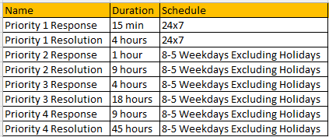

Data set size and processing power
Autopsy is unable to handle large images [41]. In contrast, FTK is designed to swiftly analyse large data sets using FTK Lab, a centralised lab environment [42], see Table 11:
Table 11: Features of FTK Lab
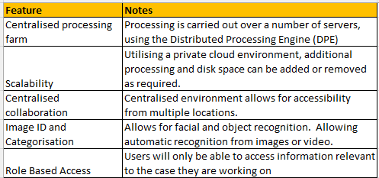

Using Autopsy to analyse large data sets is problematic if DFIs were under pressure to meet a court date. FTK Lab, can process large data sets within hours instead of days [42]. For example, the National Police Agency (NPA) processed 7 Terabytes of data within 2 hours [43].

Modification

Autopsy’s source code can be modified by DFIs/Developers. Fig.6 shows a screenshot of the online resource for developers to modify the internal Autopsy framework or add third party modules.
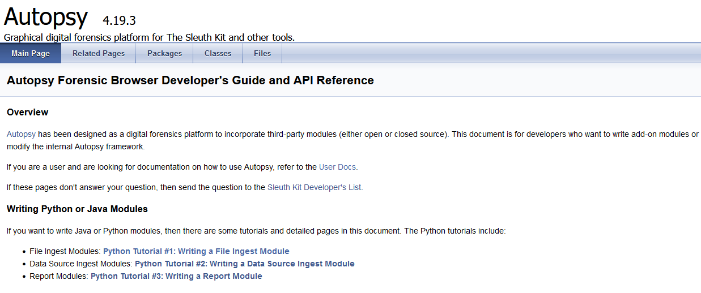
Figure 6: Autopsy Developer's guide [44]
This online resource [45] also has tutorials on how to write modules in Python which states the requirements as:
- Copy of Autopsy installed
- Text editor
- A copy of the source code from GitHub

The developer would be expected to write their module in Jython. This converts Python code into Java but has some library and versioning limitations [45]. Therefore, Autopsy is fully customisable, and additional modules can be created from scratch.
FTK is a closed source, proprietary software. Users do not have access to the source code and cannot make modifications [46]. Queries to Exterro regarding feature requests would be made via the support portal, but there would be no guarantee that these features will be implemented.
As cybercriminals are continually modifying techniques to avoid detection, FTK also needs to evolve. Evidence hidden using a new technique cannot be analysed. This reduces the likelihood of presenting all evidence before a court consequently affecting the judgement and possible prosecution.

Collaboration
Autopsy and FTK can be configured to allow multiple users to access the same case, see Appendix 4.
See Table 12 benefits and disadvantages.
Table 12: Analysis of Autopsy and FTK [51]
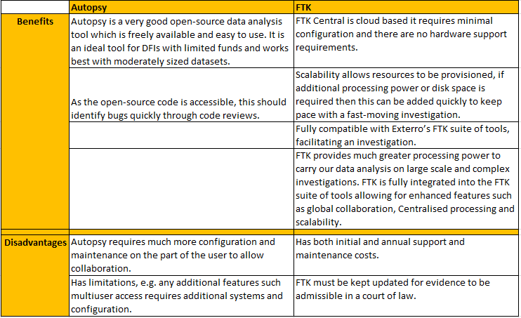
The CCTF have deemed both tools to be reliable and credible and are suitable for presenting evidence in a court of law.

Conclusion
DF is a fascinating subject. Tools and techniques can be applied by cybersecurity professionals to assist with IR, malware analysis, data recovery, and network traffic analysis.
DF is a crucial area of forensic science providing digital evidence to secure cases that otherwise may remain unsolved. Evidence collected by the DFI must maintain its integrity to ensure its admissibility in court. Using CoE forms and creating an audit trail is of paramount importance.
DFIs must work quickly whilst paying attention to detail. Data analysis takes a long time to complete and requires much disk space. By utilising multiple analysis tools on the same data yields better and more robust evidence as one tool may find artifacts that another may not. Autopsy and FTK, both had merits and drawbacks. [52] [53] [54] [55].
During the activities some open-source tools downloaded from the official developer’s website contained malware. This adds risks for DFIs and may result in jeopardising a case.
Anti-forensic techniques used by cybercriminals such as steganography, which DFIs must become familiar with using tools such as StegoHunt adds an extra dimension. The recent advancements in AI have been a double edge sword both being used by DFIs and cybercriminals alike [56].
It is a continual battle between DFIs and cybercriminals each attempting to gain the upper hand. It is the role of the DFI to attempt to stay one step ahead of the cybercriminals bringing them to justice.
To maintain an advantage over cybercriminals it will be essential for DFIs to work collaboratively between law enforcement agencies, financial organisation, AI providers and DF software developers. This will enable DFIs to provide feedback on new techniques being used by cybercriminals so that software can be improved.
Continual training and collaboration between all parties by attending conferences/symposiums so that knowledge and new techniques can be shared will be key to meet the everchanging field of DF.

References

[1] | I. Kennedy, “Presenting digital evidence in court,” British Computing Society - The Charted Institute for IT, 23 January 2023. [Online]. Available: https://www.bcs.org/articles-opinion-and-research/presenting-digital-evidence-in-court/. [Accessed 26 October 2024].
[2] | Shubham, R. Kumar, A. Aditya and B. D. Shivahare, “Cyber Crime Prevention and Techniques: A Comprehensive Survey,” IEEE - 3rd International Conference on Innovative Sustainable Computational Technologies (CISCT), vol. 10.1109, no. CISCT57197.2023.10351225, pp. 1-4, 2023.
[3] | Advanced Digital Forensic (ADF) Solutions, “The State of Digital Forensics,” Advanced Digital Forensic (ADF) Solutions, 30 December 2022. [Online]. Available: https://www.adfsolutions.com/news/the-state-of-digital-forensics?srsltid=AfmBOoqdvik69fo5T62JZPGjRPlJmiZjl-GL8rFNJXfo9CWLdf9BdeoE. [Accessed 7 October 2024].
[4] | K. S. Shindagi, K. V. Koppad, A. Jayakkanavar and S. V. Gorabal, “IEEE - A Comprehensive Survey of Cybercrime and Cybersecurity,” IEEE Fifth International Conference on Advances in Electronics, Computers and Communications (ICAECC), vol. 10.1109, no. ICAECC59324.2023.10560320, pp. 1-5, 2023.
[5] | C. Balarengadurai, C. D. Divya and C. Harshitha, “Survey on Cyber Crime Problems and Prevention,” IEEE - 2022 International Conference on Smart and Sustainable Technologies in Energy and Power Sectors (SSTEPS), vol. 10.1109, no. SSTEPS57475.2022.00039, pp. 117-121, 2022.
[6] | M. Chapple and D. Seidl, CompTIA Security+ Study Guide EXAM SA0-601, Hoboken: Sybex, 2021, pp. 2-4.
[7] | Halkyan Security, “Incident Response Phases,” Halkyan Security, 17 September 2019. [Online]. Available: https://www.halkynconsulting.co.uk/a/2019/09/incident-response-lessons-learned/. [Accessed 31 October 2024].
[8] | A. Khaitan, “Top 5 Trends For Digital Forensics in 2023,” The Cyber Express, 26 June 2023. [Online]. Available: https://thecyberexpress.com/top-5-trends-for-digital-forensics-in-2023/. [Accessed 8 October 2024].
[9] | Cybercrime Programme Office of the Council of Europe, “Standard Operating Procedures for the collection, analysis and presentation of electronic evidence,” Cybercrime Programme Office of the Council of Europe, 12 September 2019. [Online]. Available: https://rm.coe.int/3692-sop-electronic-evidence/168097d7cb. [Accessed 1 November 2024].
[10] | Interpol, “Global Guidelines For Digital Forensics Laboratories,” Interpol, May 2019. [Online]. Available: https://www.interpol.int/content/download/13501/file/INTERPOL_DFL_GlobalGuidelinesDigitalForensics&ved=2ahUKEwjE7LWItb2JAxXIT0EAHZ9gM3QQFnoECBgQAQ&usg=AOvVaw2-YSli34VmBgkrAsvFL_QR. [Accessed 1 November 2024].
[11] | N. Kumari, T. Sharma, A. K. Gupta and G. Dua, “IEEE - Taxonomy of Technical Challenges in Digital Forensics,” Seventh International Conference on Image Information Processing (ICIIP), vol. 10.1109, no. ICIIP61524.2023.10537638, pp. 454-458, 2023.
[12] | A. Asasfeh, N. A. Al-Dmour, A. Al Hamadi, W. Mansoor and T. M. Ghazal, “IEEEE - Exploring Cyber Investigators: An In-Depth Examination of the Field of Digital Forensics,” EEE Intl Conf on Dependable, Autonomic and Secure Computing, Intl Conf on Pervasive Intelligence and Computing, Intl Conf on Cloud and Big Data Computing, Intl Conf on Cyber Science and Technology Congress (DASC/PiCom/CBDCom/CyberSciTech), vol. 10.1109, no. DASC/PiCom/CBDCom/Cy59711.2023.10361449, pp. 84-88, 2023.
[13] | Q. R. McCluskey, M. M. Chowdhury, S. Latif and K. Kambhampaty, “Computer Forensics: Complementing Cyber Security,” IEEE International Conference on Electro Information Technology (eIT), vol. 10.1109, no. eIT53891.2022.9813886, pp. 507-512, 2022.
[14] | TryHackMe.com, “Intro to Digital Forensics,” TryHackMe.com, 2024. [Online]. Available: https://tryhackme.com/r/room/introdigitalforensics. [Accessed 17 October 2024].
[15] | Forensic Control, “ACPO Guidelines & Principles Explained,” Forensic Control, 26 November 2020. [Online]. Available: https://forensiccontrol.com/guides/acpo-guidelines-and-principles-explained/. [Accessed 10 October 2024].
[16] | G. Horsman, “ACPO principles for digital evidence: Time for an update?,” Forensic Science International, vol. 2, no. 100076, 2020.
[17] | P. Yapp, “Computer forensics and the ACPO guide,” Society for Computers & Law, 26 January 2021. [Online]. Available: https://www.scl.org/12161-computer-forensics-and-the-acpo-guide/. [Accessed 10 October 2024].
[18] | D. R. Hays, A practical guide to computer forensics investigations, Indianapolis, Indiana: Pearson, 2015.
[19] | cv-library.co.uk, “Digital Forensic Investigator,” cv-library.co.uk, 29 September 2024. [Online]. Available: https://www.cv-library.co.uk/job/222385976/Digital-Forensic-Investigator?hlkw=digital-forensic&sid=532f4753-9f90-4451-be28-242d0eef90f0. [Accessed 6 October 2024].
[20] | indeed.com, “Senior Digital Forensic Investigator,” indeed.com, 2024. [Online]. Available: https://uk.indeed.com/viewjob?jk=2971ba52a731a5c6&tk=1i9hbe2hvj0ii804&from=serp&vjs=3&advn=3376049105380031&adid=429815723&ad=-6NYlbfkN0AUKzL6VtxkOe52ZPEtpgGoxtFZdRrvVnFaPiB102N7O0BdNp0XBicuzzyWBTBiLq9eCtwB0G5hNde44kkuNtMeYt2CkeDJPql0qlx8uMpW9e6WKhYPj5HR-. [Accessed 6 October 2024].
[21] | UK Government - Department of Work and Pensions (DWP), “Computer Forensics Experts,” UK Government - Department of Work and Pensions (DWP), 30 September 2024. [Online]. Available: https://findajob.dwp.gov.uk/details/15323447. [Accessed 6 October 2024].
[22] | totaljobs.com, “Forensic Digital Media Examiner,” totaljobs.com, 2024. [Online]. Available: https://www.totaljobs.com/jobs/?sourceOfSearch=offline103362105. [Accessed 6 October 2024].
[23] | Thames Valley Police, “Digital Forensic Investigator - Digital Forensics,” Thames Valley Police, n.d. [Online]. Available: https://thamesvalleypolice.tal.net/vx/mobile-0/appcentre-External/brand-3/candidate/so/pm/6/pl/1/opp/11417-Digital-Forensic-Investigator-Digital-Forensics-CTPSE/en-GB. [Accessed 6 October 2024].
[24] | forensicfocus.com, “Cyber Forensic Investigator,” forensicfocus.com, 5 September 2024. [Online]. Available: https://www.forensicfocus.com/jobs/#aHR0cHM6Ly9qb2JzLmZvcmVuc2ljZm9jdXMuY29tL2pvYi82MTkvY3liZXItZm9yZW5zaWMtaW52ZXN0aWdhdG9yLw==. [Accessed 8 October 2024].
[25] | cybersecurityjobsite-com, “Senior Consultant / Cyber & Digital Forensics,” cybersecurityjobsite-com, n.d. [Online]. Available: https://www-cybersecurityjobsite-com.translate.goog/job/5276664/senior-consultant-cyber-and-digital-forensics-m-w-d-/?_x_tr_sl=auto&_x_tr_tl=en&_x_tr_hl=en-US&_x_tr_pto=wapp. [Accessed 8 October 2024].
[26] | cybersecurityjobsite-com, “Specialist – Forensic Examiner (Malware Forensics), Digital Support Unit (AD6) - Interpol,” cybersecurityjobsite-com, 18 September 2024. [Online]. Available: https://www.europol.europa.eu/careers-procurement/open-vacancies/vacancy/876. [Accessed 8 October 2024].
[27] | adzuna.ca, “Senior Manager, (Cyber Forensic Investigations and Digital Evidence),” adzuna.ca, 2024. [Online]. Available: https://www.adzuna.ca/details/4886335651?i=NI9GHqyF7xGNurHG_Zm43g&se=NJiwJKuF7xG2MFZj-jhY4A&title=Senior_Manager&title=_(Cyber_Forensic_Investigations_and_Digital_Evidence)&v=258055EEF6D578C1A7D302A1806A7A3B8CD495A0. [Accessed 8 October 2024].
[28] | seek.com.au, “Digital Forensic Analyst,” seek.com.au, n.d. [Online]. Available: https://www.seek.com.au/job/79278305?type=standout&ref=search-standalone&origin=cardTitle#sol=3d9ec93db4508c1bb33c23b60b37c5b4dabd4105. [Accessed 8 October 2024].
[29] | B. Carrier, “Open Source Digital Forensics,” Sleuth Labs, 2023. [Online]. Available: https://www.sleuthkit.org/. [Accessed 5 October 2024].
[30] | National Institute of Standards and Technology - NIST, “Computer Forensics Tool Testing Program (CFTT),” National Institute of Standards and Technology - NIST, 15 November 2019. [Online]. Available: https://www.nist.gov/itl/ssd/software-quality-group/computer-forensics-tool-testing-program-cftt. [Accessed 2 Novermber 2024].
[31] | National Institute of Standards and Technology - (NIST), “Computer Forensic Tool Testing (CFTT) Reports,” National Institute of Standards and Technology - (NIST), 13 November 2023. [Online]. Available: https://www.dhs.gov/science-and-technology/nist-cftt-reports. [Accessed 2 November 2024].
[32] | sleuthkit.org, “Autopsy User Documentation 4.21. 0,” sleuthkit.org, 6 February 2024. [Online]. Available: https://sleuthkit.org/autopsy/docs/user-docs/4.21.0/index.html. [Accessed 15 October 2024].
[33] | Crown Prosecution Service (CPS), “Expert Evidence - Legal Guidence,” Crown Prosecution Service (CPS), 20 November 2023. [Online]. Available: https://www.cps.gov.uk/legal-guidance/expert-evidence. [Accessed 26 October 2024].
[34] | insight.com, “Access Data Forensic Toolkit,” insight.com, 2024. [Online]. Available: https://www.insight.com/en_US/shop/product/9901149/accessdata%20corp/9901149/AccessData-Forensic-Toolkit-license-1-license/?srsltid=AfmBOor-Qoto5GTvYWW5hj-oLi8cANEkQzn1355gB28nS74TsBd2jrJW. [Accessed 26 October 2024].
[35] | Autopsy.com, “Autopsy Blog,” Autopsy.com, 2024. [Online]. Available: https://www.autopsy.com/category/blog/. [Accessed 28 October 2024].
[36] | Sleuth Kit Labs, “Autopsy and Sleuth Kit Forum,” Sleuth Kit Labs, n.d. [Online]. Available: https://sleuthkit.discourse.group/. [Accessed 28 October 2024].
[37] | sleuthkit.org, “Sleuthkit and Autopsy Support Page,” sleuthkit.org, 2023. [Online]. Available: https://sleuthkit.org/support.php. [Accessed 29 October 2024].
[38] | Exterro, “FTK Forensic Toolkit - Release Information and Support Portal,” Exterro, 2024. [Online]. Available: https://www.exterro.com/ftk-product-downloads/forensic-toolkit-ftk-8-0-0. [Accessed 26 October 2024].
[39] | UK Government, “ITIL Service Management,” UK Government, n.d. [Online]. Available: https://www.applytosupply.digitalmarketplace.service.gov.uk/g-cloud/services/823881142522251. [Accessed 26 October 2024].
[40] | University of Texas, “Knowledge Base Article - Service Portal,” University of Texas, 2024. [Online]. Available: https://ut.service-now.com/sp?id=kb_article&number=KB0011708. [Accessed 25 October 2024].
[41] | D. Survana, K. M. Mahesh, M. Gupta, S. Gabburi, P. Honnavalli and V. M. Sapna, “IEEE: The Development of a Digital Forensic Framework for Ease of Forensic Analysis,” 12th International Symposium on Digital Forensics and Security (ISDFS), vol. 10, no. 1109, pp. 1-5, 2024.
[42] | Exterro, “FTK Lab - Digital Forensic Software & Toolkit,” Exterro, 2024. [Online]. Available: https://www.exterro.com/digital-forensics-software/ftk-lab. [Accessed 20 October 2024].
[43] | Exterro, “National Police Agency Becomes a Processing Powerhouse with FTK® Lab,” Exterro, 2024. [Online]. Available: https://www.exterro.com/resources/case-studies/national-police-agency-becomes-a-processing-powerhouse-with-ftk-lab. [Accessed 26 October 2024].
[44] | http://sleuthkit.org, “Autopsy Forensic Browser Developer's Guide and API Reference,” http://sleuthkit.org, 27 June 2023. [Online]. Available: http://sleuthkit.org/autopsy/docs/api-docs/4.19.3/. [Accessed 26 October 2024].
[45] | sleuthkit.org, “Python Tutorial #1: Writing a File Ingest Module,” sleuthkit.org, 27 June 2023. [Online]. Available: http://sleuthkit.org/autopsy/docs/api-docs/4.19.3/mod_python_file_ingest_tutorial_page.html. [Accessed 26 October 2024].
[46] | GCFGlobal, “Open source vs. closed source software,” GCFGlobal, n.d. [Online]. Available: https://edu.gcfglobal.org/en/basic-computer-skills/open-source-vs-closed-source-software/1/. [Accessed 26 October 2024].
[47] | B. Carrier, “Open Source Digital Forensic Tools - The legal argument,” Perdue University, n.d. [Online]. Available: https://digital-evidence.org/papers/opensrc_legal.pdf. [Accessed 2 November 2024].
[48] | M. Farnan, J. Pratt, A. David and M. Shakiba, “Digital Forensic Tools: Comparison of Autopsy TSK and Forensic Explorer,” IEEE International Conference on Information Technology, Electronics and Intelligent Communication Systems (ICITEICS), vol. 10.1109, no. ICITEICS61368.2024.10625076, pp. 1-5, 2024.
[49] | J. Mehta, Y. Bhadania, P. Shah and P. Prajapati, “IEEE - Comparative Study of Mobile Forensics Tools: Autopsy, Belkasoft X and Magnet Axiom,",” 5th International Conference on Electronics and Sustainable Communication Systems (ICESC), vol. 10.1109, no. ICESC60852.2024.10689971, pp. 1257-1263, 2024.
[50] | S. C. Nayak, V. Tiwari and B. K. Samanthula, “Review of Ransomware Attacks and a Data Recovery Framework using Autopsy Digital Forensics Platform,” IEEE 13th Annual Computing and Communication Workshop and Conference (CCWC), vol. 10.1109, no. CCWC57344.2023.10099169, pp. 605-6011, 2023.
[51] | A. Bhardwaj, R. K. Barik, G. Chhabra and K. Jha, “Forensic Investigations of Permanently Deleted Data from Recycle Bin,” IEEE - 10th International Conference on Computing for Sustainable Global Development (INDIACom), pp. 1418-1423, 2023.
[52] | D. Delija, G. Sirovatka and M. Žagar, “IEEE - Forensic Analysis of the NIST Hacking Case: Integrating Autopsy Tools and Artificial Intelligence in Teaching Digital Forensics,” 47th MIPRO ICT and Electronics Convention (MIPRO), vol. 10.1109, no. MIPRO60963.2024.10, pp. 1514-1519, 2024.
[53] | Undiscovered Scotland, “Joseph Bell,” Undiscovered Scotland, 2024. [Online]. Available: https://www.undiscoveredscotland.co.uk/usbiography/b/josephbell.html. [Accessed 20 October 2024].
[54] | F. Guy, “Forensics Science And Dr Joseph Bell:The Real Sherlock Holmes,” crimetraveller.org, 18 July 2023. [Online]. Available: https://www.crimetraveller.org/2015/07/forensics-science-dr-joseph-bell/. [Accessed 20 October 2024].
[55] | College of Policing, “Forensics,” College of Policing, 2024. [Online]. Available: https://www.college.police.uk/app/investigation/forensics. [Accessed 14 October 2024].
[56] | About Forensics, “Edmund Locard,” About Forensics, 2010. [Online]. Available: http://aboutforensics.co.uk/edmond-locard/. [Accessed 31 October 2024].
[57] | Champlain College Online, “The Evolution of Digital Forensics,” Champlain College Online, 12 February 2024. [Online]. Available: https://online.champlain.edu/blog/evolution-digital-forensics. [Accessed 6 October 2024].
[58] | Oxygen Forensics, “What is Digital Forensics,” Oxygen Forensics, 31 August 2023. [Online]. Available: https://oxygenforensics.com/en/resources/what-is-digital-forensics/. [Accessed 6 October 2024].
[59] | Cybersecurity Education Guides, “Great Rivalries in Cybersecurity: Cliff Stoll vs Markus Hess,” Cybersecurity Education Guides, 2024. [Online]. Available: https://www.cybersecurityeducationguides.org/cliff-stoll-vs-markus-hess/. [Accessed 6 October 2024].
[60] | Guinness World Records, “First incident of Cyber-espionage,” Guinness World Records, 2024. [Online]. Available: https://www.guinnessworldrecords.com/world-records/612868-first-incident-of-cyber-espionage. [Accessed 6 October 2024].
[61] | Mossé Cyber Security Institute, “Digital Forensics: Hashing for Data Integrity,” Mossé Cyber Security Institute, 2022. [Online]. Available: https://library.mosse-institute.com/articles/2022/05/digital-forensics-hashing-for-data-integrity/digital-forensics-hashing-for-data-integrity.html. [Accessed 10 October 2024].
[62] | CRU, “Write Blockers - CRU,” CRU, 2024. [Online]. Available: https://www.cru-inc.com/data-protection-topics/write-blockers/. [Accessed 15 October 2024].
[63] | Digital Intellegence, “Digital Intellegence - Write Blockers,” Digital Intellegence, 2024. [Online]. Available: https://digitalintelligence.com/store/t/solutions/forensic-imaging/write-blockers. [Accessed 15 October 2024].
[64] | N. Elmrabit, “Digital Forensic, Free Fright Blocker, Using Windows Registry, Software Write Blocker,” CyDig Cybersecurity Digital Forensics Education, 12 November 2022. [Online]. Available: https://www.youtube.com/watch?v=2mWUUOsu2Tg. [Accessed 7 October 2024].
[65] | J. Sachowski, Implementing Digital Forensic Readiness, O'Reilly, 2016.
[66] | ERDM.Net, “Current ERDM Model,” ERDM.Net, 2024. [Online]. Available: https://edrm.net/edrm-model/current/. [Accessed 4 October 2024].
[67] | G. Radu, “Incidents and Evidence: What you need to know,” UKP&I (Insurance Company), 10 March 2021. [Online]. Available: https://www.ukpandi.com/news-and-resources/articles/2021/incidents-and-evidence-what-you-need-to-know/. [Accessed 3 November 2024].
[68] | sleuthkit.org, “TSK Tool Overview,” sleuthkit.org, 13 January 2014. [Online]. Available: http://wiki.sleuthkit.org/index.php?title=TSK_Tool_Overview. [Accessed 29 October 2024].
[69] | C. Dodt, “Computer forensics: FTK forensic toolkit overview [updated 2019],” Infosec, 7 July 2019. [Online]. Available: https://www.infosecinstitute.com/resources/digital-forensics/computer-forensics-ftk-forensic-toolkit-overview/. [Accessed 4 October 2024].
[70] | Exterro, “Forensic Toolkit (FTK) - Digital Forensic Software Tools,” Exterro, 2024. [Online]. Available: https://www.exterro.com/digital-forensics-software/forensic-toolkit. [Accessed 20 October 2024].
[71] | Exterro, “Forensic Tool Kit (FTK) User Guide,” Exterro, 1 February 2021. [Online]. Available: https://www.google.com/url?sa=t&source=web&rct=j&opi=89978449&url=https://www.exterro.com/uploads/documents/FTK_7.4.2_UG.pdf&ved=2ahUKEwi1ope08p2JAxVvVUEAHYilCi0QFnoECB0QAQ&usg=AOvVaw0trhpliZRo7yD_7CD8HI_x. [Accessed 20 October 2024].
[72] | Exterro, “Exterro FTK Forensic Suite,” Exterro, 2022. [Online]. Available: https://go.exterro.com/l/43312/2022-08-11/f7pmny/43312/16602377273I1nKkoK/FTK_Suite_of_products_PB_Q3_2022_v1.pdf. [Accessed 22 October 2024].
[73] | Exterro, “FTK Imager - Forensic Data Imaging and Preview Solution,” Exterro, 2024. [Online]. Available: https://www.exterro.com/digital-forensics-software/ftk-imager. [Accessed 20 October 2024].
[74] | Exterro, “How to run FTK Imager from a flash drive (Imager Lite),” Exterro, 2024. [Online]. Available: https://www.exterro.com/ftk-product-downloads/how-to-run-ftk-imager-from-a-flash-drive-imager-lite. [Accessed 20 October 2024].
[75] | G. D. Sign, The Ultimate Kali Linux Book, Birmingham - Mumbai: Packt, 2022.
[76] | H. Sharma, Kali Linux - An Ethical Hacker's Cookbook, Birmingham - Mumbai: Packt, 2019.
[77] | Volatility Foundation, “The Volatility Foundation,” Volatility Foundation, 2024. [Online]. Available: https://volatilityfoundation.org. [Accessed 4 October 2024].
[78] | kali.org, “Memdump | Kali Linux Tools,” kali.org, 14 August 2024. [Online]. Available: https://www.kali.org/tools/memdump/. [Accessed 29 October 2024].
[79] | Microsoft, “ProcDump Sysinternals,” Microsoft, 11 March 2022. [Online]. Available: https://learn.microsoft.com/en-us/sysinternals/downloads/procdump. [Accessed 29 October 2024].
[80] | P. Harvey, “ExifTool by Phil Harvey,” ExifTool by Phil Harvey, 2024. [Online]. Available: https://exiftool.org/. [Accessed 20 October 2024].
[81] | Kali.org, “Dumpzilla Forensic Tool,” Kali.org, 15 March 2013. [Online]. Available: https://www.dumpzilla.org/. [Accessed 20 October 2024].
[82] | sans.org, “SIFT Workstation,” sans.org, 2024. [Online]. Available: https://www.sans.org/tools/sift-workstation/. [Accessed 10 October 2024].
[83] | caine-live.net, “CAINE Live USB/DVD,” caine-live.net, n.d. [Online]. Available: https://www.caine-live.net/. [Accessed 10 October 2024].
[84] | wireshark.org, “Wireshark - Go Deep,” wireshark.org, n.d. [Online]. Available: https://www.wireshark.org/. [Accessed 10 October 2024].
[85] | wireshark.org, “TShark Manual Page,” wireshark.org, n.d. [Online]. Available: https://www.wireshark.org/docs/man-pages/tshark.html. [Accessed 10 October 2024].
[86] | tcpdump.org/, “TCPDUMP & Libcap,” tcpdump.org/, 2024. [Online]. Available: https://www.tcpdump.org/. [Accessed 10 October 2024].
[87] | e-forensic services inc, “EnCase Forensic Suite,” e-forensic services inc, 2024. [Online]. Available: https://e-forensic.ca/products/encase-forensic-suite/. [Accessed 20 October 2024].
[88] | kali.org, “Bulk-Extractor - Kali Linux Tools,” kali.org, 6 August 2024. [Online]. Available: https://www.kali.org/tools/bulk-extractor/. [Accessed 11 October 2024].
[89] | kali.org, “Foremost,” kali.org, 11 March 2024. [Online]. Available: https://www.kali.org/tools/foremost/. [Accessed 11 October 2024].
[90] | netresec.com, “NetworkMiner,” netresec.com, n.d. [Online]. Available: https://www.netresec.com/?page=NetworkMiner. [Accessed 11 October 2024].
[91] | x-ways.net, “WinHex: Hex Editor & Disk Editor, Computer Forensics and Data Recovery Software,” x-ways.net, 26 October 2024. [Online]. Available: https://www.x-ways.net/winhex/. [Accessed 26 October 2024].
[92] | asrdata, “ASR Data,” asrdata, 2024. [Online]. Available: asrdata.com. [Accessed 16 October 2024].
[93] | ASR Data, “SAW | ASR Data,” ASR Data, 2024. [Online]. Available: http://www.asrdata.com/?page_id=48. [Accessed 16 October 2024].
[94] | ASR Data, “SmartMount | ASR Data,” ASR Data, 2024. [Online]. Available: http://asrdata.com/?page_id=42. [Accessed 16 October 2024].
[95] | Magnet Forensics, “Magnet Axiom | Digital Forensics,” Magnet Forensics, 2024. [Online]. Available: https://www.magnetforensics.com/products/magnet-axiom/. [Accessed 31 October 2024].
[96] | Magnet Forensics, “Magnet Nexus,” Magnet Forensics, 2024. [Online]. Available: https://www.magnetforensics.com/products/magnet-nexus/. [Accessed 31 October 2024].
[97] | Magnet Forensics, “Magnet Griffeneye,” Magnet Forensics, 2024. [Online]. Available: https://www.magnetforensics.com/products/magnet-griffeye/. [Accessed 31 October 2024].
[98] | Magenet Forensics, “Magenet Graykey,” Magenet Forensics, 2024. [Online]. Available: https://www.magnetforensics.com/products/magnet-graykey/. [Accessed 31 October 2024].
[99] | Cellebrite, “Data Collector,” Cellebrite, 2024. [Online]. Available: https://cellebrite.com/en/digital-collector/. [Accessed 3 November 2024].
[100] | Cellebrite, “Cellebrite UFED,” Cellebrite, 2024. [Online]. Available: https://cellebrite.com/en/ufed/. [Accessed 3 November 2024].
[101] | ghiro.org/, “Ghiro - automated digital image forensic tool,” ghiro.org/, n.d. [Online]. Available: https://getghiro.org/. [Accessed 6 October 2024].
[102] | MSAB, “XRY - Mobile Data Forensic Phone Extraction and Recovery,” MSAB, 2024. [Online]. Available: https://www.msab.com/product/xry-extract/?gad_source=1&gclid=EAIaIQobChMIneqLktfAiQMVLZVQBh2kNyUGEAAYASAAEgIiefD_BwE. [Accessed 18 October 2024].
[103] | MSAB, “XAMIN - Mobile Forensic Data Analysis Software,” MSAB, 2024. [Online]. Available: https://www.msab.com/product/analyze/. [Accessed 3 November 2024].
[104] | MSAB, “XEC - Digital Evidence Management Software,” MSAB, 2024. [Online]. Available: https://www.msab.com/product/manage/. [Accessed 3 November 2024].
[105] | NUIX, “NUIX Discover Technology,” NUIX, 2924. [Online]. Available: https://www.nuix.com/technology/nuix-discover. [Accessed 3 November 2024].
[106] | man7.org, “dd - Linux Manual Page,” man7.org, March 2024. [Online]. Available: https://man7.org/linux/man-pages/man1/dd.1.html. [Accessed 3 November 2024].
[107] | Chrysocome.net/, “Chrysocome.net - Main Page,” Chrysocome.net/, n.d. [Online]. Available: http://www.chrysocome.net/. [Accessed 3 November 2024].
[108] | Hex-Rays, “ida-pro,” Hex-Rays, 2024. [Online]. Available: https://hex-rays.com/ida-pro. [Accessed 3 November 2024].
[109] | National Security Agency (NSA), “Ghidra,” National Security Agency (NSA), n.d. [Online]. Available: https://ghidra-sre.org/. [Accessed 16 October 2024].
[110] | O. Yuschuk, “OllyDbg v1.10,” OllyDbg, 21 April 2022. [Online]. Available: https://www.ollydbg.de/. [Accessed 19 October 2024].
[111] | Pegasus info corp, “Linux Man page for pdfinfo,” Pegasus info corp, 1999. [Online]. Available: https://www.pegasusinfocorp.com/web_development_knowledgebase/linuxman/man1544.htm. [Accessed 3 November 2024].
[112] | e-forensic services inc, “Intella - e-forensic services,” e-forensic services inc, 2024. [Online]. Available: https://e-forensic.ca/products/intella/. [Accessed 18 October 2024].
[113] | H. Menezez, “How to use FTK Imager Step-by-Step guide,” medium.com, 7 March 2024. [Online]. Available: https://medium.com/@herschel-menezes/how-to-use-ftk-imager-a-step-by-step-guide-7413623c471e. [Accessed 20 October 2024].
[114] | Kali.org, “Dumpzilla | Kali Linux Tools,” Kali.org, 11 March 2021. [Online]. Available: https://www.kali.org/tools/dumpzilla/. [Accessed 20 October 2024].
[115] | A. Tanasi and M. Buoncristiano, “What is Ghiro,” Ghiro, 2017. [Online]. Available: https://getghiro.org/. [Accessed 10 October 2024].
[116] | National Security Agency (NSA), “Ghidra,” National Security Agency (NSA), n.d. [Online]. Available: https://ghidra-sre.org/. [Accessed 19 October 2024].
[117] | sleuthkit.org, “Autopsy User Documentation 4.19.3: Setting Up Multi-user Cluster,” sleuthkit.org, 27 June 2023. [Online]. Available: https://sleuthkit.org/autopsy/docs/user-docs/4.19.3/install_multiuser_page.html. [Accessed 25 October 2024].
[118] | sleuthkit.org, “Autopsy User Documentation 4.0,” sleuthkit.org, 6 April 2016. [Online]. Available: https://sleuthkit.org/autopsy/docs/user-docs/4.0/install_multiuser_page.html. [Accessed 25 October 2024].
[119] | Exterro, “FTK Central,” Exterro, 2024. [Online]. Available: https://www.exterro.com/digital-forensics-software/ftk-central. [Accessed 20 October 2024].
[120] | Exterro, “FTK Central Product Brief,” Exterro, 2021. [Online]. Available: https://go.exterro.com/l/43312/2021-05-27/f5f83x/43312/1622133193sAu7DZ5Z/Product_Brief___FTK_Central.pdf. [Accessed 26 October 2024].
[121] | R. F. Abu, M. Jazzar, A. Eleyan and T. Bejaoui, “IEEE - SATA M.2 on Forensics: Trim Function Effect on Recovering Permanently Deleted Files,” International Conference on Smart Applications, Communications and Networking (SmartNets), vol. 10.1109, no. SmartNets58706.2023.10215536, pp. 1-6, 2023.
[122] | UK Government, “Forensic Science Providers: Codes of practice and conduct,” UK Government, 31 October 2021. [Online]. Available: https://www.gov.uk/government/collections/forensic-science-providers-codes-of-practice-and-conduct. [Accessed 4 November 2024].
[123] | Amazon Web Services (AWS), “Automated Forensics Orchestrator for Amazon EC2,” Amazon Web Services (AWS), 2024. [Online]. Available: https://aws.amazon.com/solutions/implementations/automated-forensics-orchestrator-for-amazon-ec2/. [Accessed 10 October 2024].
[124] | Brandefense, “The Future of Digital Forensics: Trends and Technologies,” Brandefense, 5 August 2024. [Online]. Available: https://brandefense.io/blog/drps/the-future-of-digital-forensics-trends-and-technologies/. [Accessed 10 October 2024].
[125] | Federal Bureau Investigation (FBI), “FBI Warns of Increasing Threat of Cyber Criminals Utilizing Artificial Intelligence,” Federal Bureau Investigation (FBI), 8 May 2024. [Online]. Available: https://www.fbi.gov/contact-us/field-offices/sanfrancisco/news/fbi-warns-of-increasing-threat-of-cyber-criminals-utilizing-artificial-intelligence. [Accessed 19 October 2024].
[126] | V. Horton, “Anti-Forensics: What it is, Examples and How to Defend Against it,” IT Governance, 30 May 2024. [Online]. Available: https://www.itgovernance.eu/blog/en/anti-forensics-what-it-is-examples-and-how-to-defend-against-it. [Accessed 15 October 2024].
[127] | CISOMAG, “6 Anti-Forensic Techniques That Every Digital Forensic Investigator Dreads,” CISO Mag, 16 September 2021. [Online]. Available: https://cisomag.com/6-anti-forensic-techniques-that-every-digital-forensic-investigator-dreads/. [Accessed 15 October 2024].
[128] | EC Council, “Five Anti-Forensic Techniques Used to Cover Digital Footprints,” EC Council, 24 March 2022. [Online]. Available: https://www.eccouncil.org/cybersecurity-exchange/computer-forensics/anti-forensic-techniques-used-to-cover-digital-footprints/. [Accessed 15 October 2024].
[129] | Kill Disk, “KillDisk: Disk Eraser, Wiper & Sanitizer,” Kill Disk, 2024. [Online]. Available: https://www.killdisk.com/eraser.html. [Accessed 15 October 2024].
[130] | DBAN, “Data Removal: Darik's Boot and Nuke - DBAN,” DBAN, 2024. [Online]. Available: https://dban.org/. [Accessed 15 October 2024].
[131] | Blancco, “Blancco - Drive Eraser,” Blancco, 2024. [Online]. Available: https://www.blancco.com/products/drive-eraser/. [Accessed 15 October 2024].
[132] | Blancco, “Everything You Need to Know About the DoD 5220.22-M Disk Wiping Standard & Its Applications Today,” Blancco, 18 May 2023. [Online]. Available: https://www.blancco.com/resources/blog-dod-5220-22-m-wiping-standard-method/. [Accessed 15 October 2024].
[133] | Verity ES, “What is a Host Protected Area (HPA),” Verity ES, n.d. [Online]. Available: https://verityes.com/support.verityes.com/knowledgebase.php?article=16. [Accessed 8 November 2024].
[134] | Blancco, “What are HPAs and DCOs and why to they matter?,” Blancco, 25 September 2017. [Online]. Available: https://support.blancco.com/pages/viewpage.action?pageId=66244. [Accessed 8 November 2024].
[135] | OpenStego, “OpenStego: How to use OpenStego,” OpenStego, 2021. [Online]. Available: https://www.openstego.com/. [Accessed 15 October 2024].
[136] | WetStone labs, “StegoHunt MP,” WetStone labs, n.d. [Online]. Available: https://www.wetstonelabs.com/stegohunt-steganography-detection/. [Accessed 8 November 2024].
[137] | A. Al-Sabaawi, “Digital Forensics for Infected Computer Disk and Memory: Acquire, Analyse, and Report,” IEEE - Asia-Pacific Conference on Computer Science and Data Engineering (CSDE), vol. 10.1109, no. CSDE50874.2020.9411614, pp. 1-7, 2020.
[138] | W. Mendes, “Forensic Investigation in Docker Environments: Unraveling the Secrets of Containers,” eForensics Magazine and Courses, 14 March 2024. [Online]. Available: https://eforensicsmag.com/forensic-investigation-in-docker-environments-unraveling-the-secrets-of-containers/. [Accessed 8 October 2024].
[139] | IDAPro, “ida-pro,” hex-rays, 2024. [Online]. Available: https://hex-rays.com/ida-pro. [Accessed 19 October 2024].
[140] | Adobe, “Explore Premier Pro Features,” Adobe, 2024. [Online]. Available: https://www.adobe.com/uk/products/premiere/features.html. [Accessed 19 October 2024].
[141] | Adobe, “Adobe Audition | Audio recoring and editing software,” Adobe, 2024. [Online]. Available: https://www.adobe.com/uk/products/audition.html. [Accessed 19 October 2024].
[142] | Native Instruments, “iZotope | Plugins for Audio Restoration, Mixing, Mastering and More,” Native Instruments, 2024. [Online]. Available: https://www.izotope.com/?srsltid=AfmBOoq4csS15ksMjBRAxHyHDjOsm58o_kb9iE4o8aPa8-QzLXOcqcv-. [Accessed 19 October 2024].
[143] | apple.com, “Final Cut Pro for Mac - Apple (UK),” Apple, 2024. [Online]. Available: https://www.apple.com/uk/final-cut-pro/. [Accessed 19 October 2024].
[144] | Avid Technology Inc, “Avid Media Composer - Video Edting Software for Mac and PC,” Avid Technology Inc, 2024. [Online]. Available: https://www.avid.com/media-composer. [Accessed 19 October 2024].
[145] | S. Bowcut, “What to look for in a Digital Forensics certification,” cybersecurityguide.org, 16 January 2024. [Online]. Available: https://cybersecurityguide.org/programs/cybersecurity-certifications/digital-forensics/. [Accessed 27 October 2024].
[146] | Exterro, “Exterro - ACE,” Exterro, 2024. [Online]. Available: https://training.exterro.com/courses/exterro-ace. [Accessed 26 October 2024].
[147] | Exterro, “Exterro - FTK Core,” Exterro, 2024. [Online]. Available: https://training.exterro.com/courses/forensic-toolkit-101-yq18. [Accessed 26 October 2024].
[148] | EnCase, “EnCase Training and Certifications,” EnCase, 2024. [Online]. Available: https://www.opentext.com/learning-services/learning-paths-encase-certifications. [Accessed 27 October 2024].
[149] | Cellebrite , “Cellebrite Certified Operator,” Cellebrite , 2024. [Online]. Available: https://cellebrite.com/training/cellebrite-certified-operator/. [Accessed 27 October 2024].
[150] | digitalshield.net, “Cellebrite Ultimate Certification CCLO & CCPA,” digitalshield.net, 2024. [Online]. Available: https://digitalshield.net/events/cellebrite-ultimate-certification-ccloccpa-course-2. [Accessed 27 October 2024].
[151] | isfce.com, “Certified Computer Examiner,” isfce.com, 2024. [Online]. Available: https://www.isfce.com/certification.htm. [Accessed 27 October 2024].
[152] | iacis.com, “IACIS Certification/,” iacis.com, 2024. [Online]. Available: https://www.iacis.com/certification/. [Accessed 27 October 2024].
[153] | giac.org, “GIAC Certified Forensic Analyst - GCFA,” giac.org, 2024. [Online]. Available: https://www.giac.org/certifications/certified-forensic-analyst-gcfa/. [Accessed 27 October 2024].
[154] | giac.org, “GIAC Certified Forensic Examiner - GCFE,” giac.org, 2024. [Online]. Available: https://www.giac.org/certifications/certified-forensic-examiner-gcfe/. [Accessed 27 October 2024].
[155] | dfcb.org, “DFCP Information,” dfcb.org, 2024. [Online]. Available: https://dfcb.org/dfcp-learn-more/. [Accessed 27 October 2024].
[156] | Federal Law Enforcement Training Centres, “Seized Computer Evidence Recovery Specialist,” Federal Law Enforcement Training Centres, 2024. [Online]. Available: https://www.fletc.gov/seized-computer-evidence-recovery-specialist. [Accessed 27 October 2024].
[157] | EC-Council , “Computer Hacking Forensic Investigator - CHFI,” EC-Council , 2024. [Online]. Available: https://www.eccouncil.org/train-certify/computer-hacking-forensic-investigator-chfi/. [Accessed 27 October 2024].
[158] | EC-Council, “Certified Ethical Hacker - CEH,” EC-Council, 2024. [Online]. Available: https://www.eccouncil.org/train-certify/certified-ethical-hacker-ceh/. [Accessed 27 October 2024].
[159] | EC-Council, “Network Security Certification,” EC-Council, 2024. [Online]. Available: https://www.eccouncil.org/train-certify/certified-network-security-course/. [Accessed 27 October 2024].
[160] | cybersecuritytrainingcourses.com, “Certified Fraud Examiner - CFE,” cybersecuritytrainingcourses.com, 2024. [Online]. Available: https://www.cybersecuritytrainingcourses.com/course-details/3667/certified-fraud-examiner-cfe-/. [Accessed 27 October 2024].
[161] | isc2.org, “Certified Cyber Forensics Professional - Retired,” isc2.org, 11 January 2018. [Online]. Available: https://community.isc2.org/t5/Exams/Certified-Cyber-Forensics-Professional-certification/td-p/16073. [Accessed 27 October 2024].
[162] | isc2.org, “Certified Information Systems Security Professional - CISSP,” isc2.org, 2024. [Online]. Available: https://www.isc2.org/certifications/cissp. [Accessed 27 October 2024].
[163] | niccs.cisa.gov, “Certified Digital Forensics Examiner - CDFE,” niccs.cisa.gov, 2024. [Online]. Available: https://niccs.cisa.gov/education-training/catalog/mile2/certified-digital-forensics-examiner-cdfe. [Accessed 27 October 2024].
[164] | Initernational Standards Organisation (ISO), “ISO/IEC 27001:2022,” Initernational Standards Organisation (ISO), 2024. [Online]. Available: ISO/IEC 27001:2022. [Accessed 18 November 2024].
[165] | International Standards Organisation (ISO), “ISO/IEC 1720:2012,” International Standards Organisation (ISO), 2012. [Online]. Available: https://www.iso.org/standard/52994.html. [Accessed 4 November 2024].
[166] | International Standards Organisation (ISO), “ISO/IEC 17025,” International Standards Organisation (ISO), 2017. [Online]. Available: https://www.iso.org/ISO-IEC-17025-testing-and-calibration-laboratories.html. [Accessed 4 November 2024].
[167] | International Standards Organisation (ISO), “ISO/IEC 27037:2012,” International Standards Organisation (ISO), 2012. [Online]. Available: https://www.iso.org/standard/44381.html. [Accessed 4 November 2024].
[168] | International Standards Organisation (ISO), “ISO 9001:2015,” International Standards Organisation (ISO), 2015. [Online]. Available: https://www.iso.org/standard/62085.html. [Accessed 4 November 2024].
[169] | American Society of Crime Laboratory Directors (ASCLD), “ASCLD - Forensic Research Committee,” American Society of Crime Laboratory Directors, 2024. [Online]. Available: https://www.ascld.org/forensic-research-committee/. [Accessed 4 November 2024].
[170] | UK Accreditation Service, “Forensic Science Addreditation,” UK Accreditation Service, 2024. [Online]. Available: https://www.ukas.com/accreditation/sectors/forensics/. [Accessed 4 November 2024].
[171] | United Kingdom Accreditation Service (UKAS), “Schedule of Accreditation,” United Kingdom Accreditation Service (UKAS), 20 September 2023. [Online]. Available: https://www.ukas.com/download-schedule/20885/Testing/. [Accessed 4 November 2024].
[172] | UK Government, “United Kingdom Security Vetting: Applicant,” UK Government, 26 July 2024. [Online]. Available: https://www.gov.uk/guidance/united-kingdom-security-vetting-applicant . [Accessed 4 November 2024].
[173] | UK Government, “National Security Vetting: Clearance Levels,” UK Government, 23 September 2024. [Online]. Available: https://www.gov.uk/government/publications/united-kingdom-security-vetting-clearance-levels/national-security-vetting-clearance-levels. [Accessed 4 November 2024].
[174] | C. Itodo, S. Varlioglu and N. Elsayed, “Digital Forensics and Incident Response (DFIR) Challenges in IoT Platforms,” 4th International Conference on Information and Computer Technologies (ICICT), vol. 10.1109, no. ICICT52872.2021.00040, pp. 199-203, 2021.
[175] | N. Nelufule, M. Masango, P. Senamela, H. Mawela, M. Latakgomo and P. Moloi, “Digital Forensics: A Survey of Emerging Threats, Challenges, and Opportunities in Smart Grids,” IEEE - 12th International Conference on Smart Energy Grid Engineering (SEGE), vol. 10.1109, no. SEGE62220.2024.10739495, pp. 109-114, 2024.
[176] | K. Yasar and R. Sheldon, “What is Virtual Reality,” Tech Target, 2024. [Online]. Available: https://www.techtarget.com/whatis/definition/virtual-reality. [Accessed 13 October 2024].
[177] | Advanced Digital Forensic (ADF) Solutions, “Digital Forensics in VR: Investigating Crimes & Analyzing Data,” Advanced Digital Forensic (ADF) Solutions, 19 June 2023. [Online]. Available: https://www.adfsolutions.com/adf-blog/digital-forensics-in-virtual-reality-investigating-crimes-and-analyzing-data-in-virtual-worlds-using-digital-forensic-software?srsltid=AfmBOoqIRDKSB0eR-7D3q6Bz3umglu81iuEzSBJjmbUlAQuWnd0FDBQb. [Accessed 13 October 2024].
[178] | E. Raymer, Á. MacDermott and A. Akinbi, “Virtual reality forensics: Forensic analysis of Meta Quest 2,” Forensic Science International: Digital Investigation, vol. 47, no. 301658, 2023.
[179] | R. Joseph, “"Data Breaches: Public Sector Perspective",” IT Professional, vol. 20, no. 4, pp. 57-64, 2018.

Appendices

Appendix 1: Brief Overview of Forensic Science

A1.1 Beginnings of modern-day Forensic Science

Dr Joseph Bell (1837-1911) is widely considered to be the modern-day founder and pioneer of Forensic Science as we know it today.
Dr Bell would go on to become a lecturer at the University of Edinburgh.
Sir Arthur Conan Doyle a former student of Dr Bell (1877) would go onto to publish a book entitled “A Study in Scarlet” which would become the very first novel featuring the fictional character Sherlock Holmes. [57] [58]
One of the key theories in Forensic Science is Locard’s Exchange Principle which states Every contact leaves a trace. It was devised by Dr Edmund Locard (1877-1966), known as the Sherlock Holms of France. This exchange principle is central to Forensic Science and applies to Digital forensics [59] [60].

A1.2 Beginnings of Computer Forensics
This branch of forensic science dates to the late 70s and early 80s [61] [62]. The first recorded case where Computer Forensic (CF) techniques were used was between Cliff Stoll vs Markus Hess in 1986. Where Stoll carried out an investigation into digital espionage where American state secrets were stollen by Hess, a hacker from Germany. Hess would later be arrested and convicted for espionage using evidence gathered with DF techniques [63] [64].
Stoll would later go on to invent the Honeypot, which is a technique to detect and identify hackers [63].

Association of Chief Police Officers (ACPO) Principles of Digital Evidence (2012)
Principle 1: No action taken by law enforcement agencies, persons employed within those agencies, or their agents should change data which may subsequently be relied upon in court.
Principle 2: In circumstances where a person finds it necessary to access original data, that person must be competent to do so and be able to give evidence explaining the relevance and the implications of their actions.
Principle 3: An audit trail or other record of all processes applied to digital evidence should be created and preserved. An independent third party should be able to examine those processes and achieve the same result.
Principle 4: The person in charge of the investigation has overall responsibility for ensuring that the law and these principles are adhered to.

It should be noted that that current ACPO Principles of Digital Evidence was implemented in 2012. Some are now calling for an update to these principles [16]. A new set of Principles of Digital Evidence has been suggested, with a list of 8 new principles. But at the time of writing, these have not been adopted.

Appendix 2: Data Acquisition
In the field of digital forensics, it is crucial that during the Data Acquisition process, both the integrity and provenance can be proved without any shadow of a doubt. This is critical as data acquired using these methods can be put forward as evidence within a court of law, or presented to managers during a dispute, so it is imperative that the data is accurate.
A digital forensic copy (known as an image) of the original data is created via data acquisition tools.
The digital forensic copy (image) can now be investigated without any concerns of destroying the original source of the data stored on the device under investigation.
Only digital forensic copies of the source data can be admissible in a court of law is it creates an identical copy. This is a bit-by-bit duplicate copy of the original source, which includes data a structure, Meta data and timestamps, which are crucial to a case [6].
The copy function used by most of the public daily creates what is known as a logical copy, this creates a copy, but it is not identical to the original and is unsuitable for digital analysis.

A2.1 Standard Operating Procedure (SOP)
The purpose of a Standard Operating Procedure (SOP) is to provide guidance for DFIs when seizing, handling, retrieving, analysing and presenting of digital evidence. It gives guidance on how to secure a crime scene to preserve digital evidence and how to identify electronic evidence.
The guidance of a SOP is invaluable when a first responder is faced with a computer system which is currently running, giving guidance on the procedure required for live data acquisition. For example, where a document may be held in memory in a decrypted form, but only available on the hard drive in its Encrypted form.
A SOP ensures that the same set procedure is followed for each case so that all DFI no matter where they are located use the same process. This is crucial so that important steps are not missed while working with and handling digital evidence. [9] [10]

A2.2 Ensuring Data integrity is maintained
Data integrity ensures that the original data is collected is such a manner that it does not alter the original data stored on the device under investigation. Furthermore, the copy of the data used in the investigation is identical to the source data and can be proven in court.
To ensure this, two methods are used:
- A Digital Hash is mathematical algorithm created of the original data source under investigation prior to the data acquisition process taking place. This hash can be thought of as a digital fingerprint of the original data source.

This will produce a 32-digit hexadecimal number (i.e. fd33e6b329c982f3bfd663725127adcc) Any alteration to the original data source, even a single bit, will result in an entirely different hash being created. [65]

A variety of hashing algorithms can be used including MD5 and SHA1, even though these algorithms are now insecure for cybersecurity purposes, they can and are still be used for creating hashes in digital forensics to prove data integrity [6].

- Write Blockers are used during the data acquisition process. A write blocker can either be hardware or software and ensures that no data is altered on the source device during the data acquisition process [6] [66]. Physical write blockers can be very expensive ranging from $80 to over $5000 [67].

It is possible to create a home-made write blocker by enabling and disabling keys within the registry [68]. See Fig.7 below which shows this technique being used during Activity 1 of the Digital Forensics Module. Note: The WriteProtect value has been set to 0x00000000 (0), this signifies that the WriteProtect mode is currently disabled.

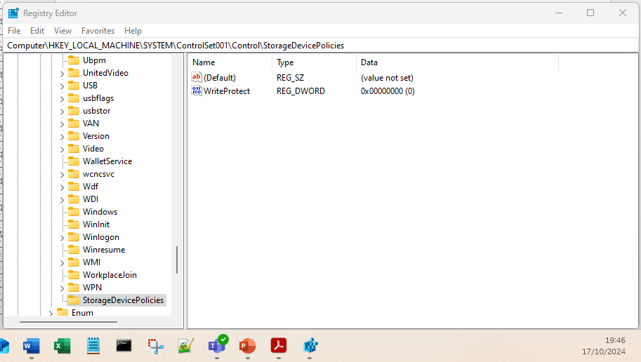
Figure 7: Write Protect Registry Key added - Note Data shows 0x00000000 (0) - Signifying Write protect is OFF
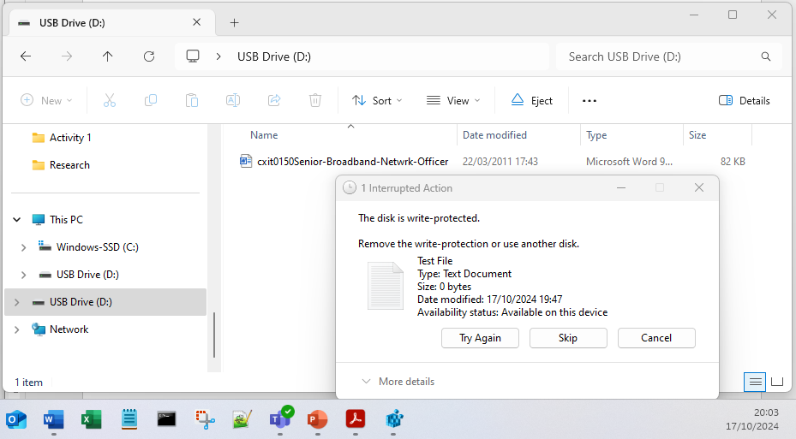
Figure 8: Ensuring the WriteProtect registry key functions correctly
The WriteProtect mode was tested by connecting a USB pendrive and attempting to write a small text file to it. It can be seen in Fig.8 above a dialogue box was displayed with a warning that “The disk is write-protected”. During Activity 1 both a video and step-by-step guide were produced detailing the configuration and implementation of the registry key write blocker, both are available upon request.

It should be noted that this home-made registry key write blocker is acceptable for a lab environment but would NOT be acceptable for a court of law and would make the evidence inadmissible. The recommended method is to use a recognised write blocker to ensure the integrity of evidence if it were to be presented in front of a court of law.

A2.3 Ensuring Data authenticity
As part of the data acquisition process, it is important that the evidence put forward can be proved to be authentic and is the original device being investigated. A Continuity of Evidence (CoE) (UK) or Chain of Custody form (CoC) (US) is used by law enforcement to document critical information relating to a particular piece of evidence such as details on the evidence and seizure methods. Importantly, this form also logs who had access to this device during the investigation. See Fig.9 which illustrates a chain of custody form.

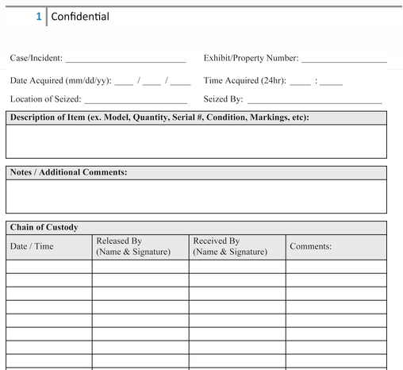
Figure 9: Continuity of Evidence (CoE)- UK or Chain of Custody (CoC)-USA form page1 [69]

Once the evidence is no longer required, it may be returned to the lawful owner or destroyed. This is also documented in the chain of custody form, illustrated in Fig.10.
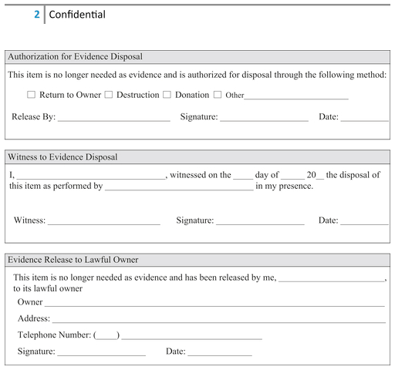
Figure 10: Chain of Custody form page2 [69]

A2.4 Recovery of deleted files using file carving
Once a file has been deleted the data is still present on the hard drive, during the file deletion process all that has happened is that the pointer is removed, and the space has been marked as unallocated so that it can be reused by the file system.
Tools such as Autopsy can use file carding techniques to read a digital image in its entirety which includes unallocated space. A DIFI using Autopsy can then analyse the file and restore it, if necessary, see Fig.11.
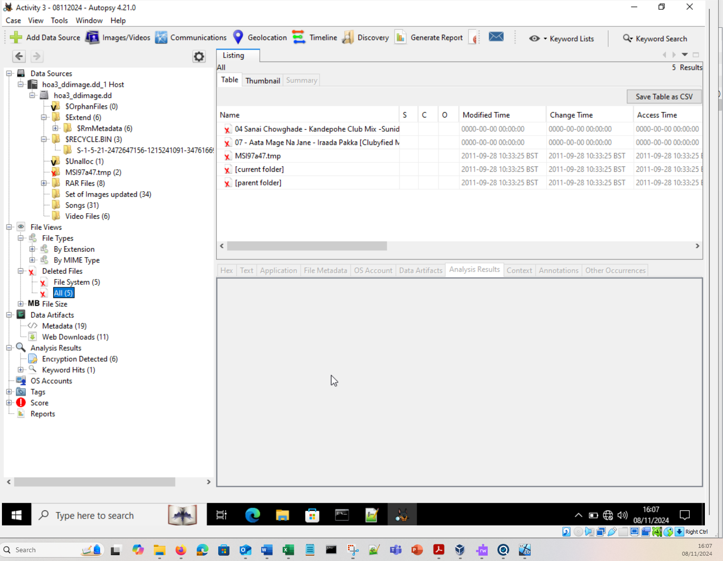
Figure 11: Deleted files being analysed in Autopsy

The process of file carving recovers files from fragments of data present in the unallocated space of a disk. The process of file carving can also be done manually, the process of doing this is outlined below:
Each file has a file signature and tail, see Fig.12 that shows the file signature of a .INFO file, which is a hexadecimal value of 0x 54 68 69 73 20 69 73 20. Searching for this file signature in the unallocated disk space using a hex viewer tool such as HxD, it is possible to manually copy this section of data recovering the file.

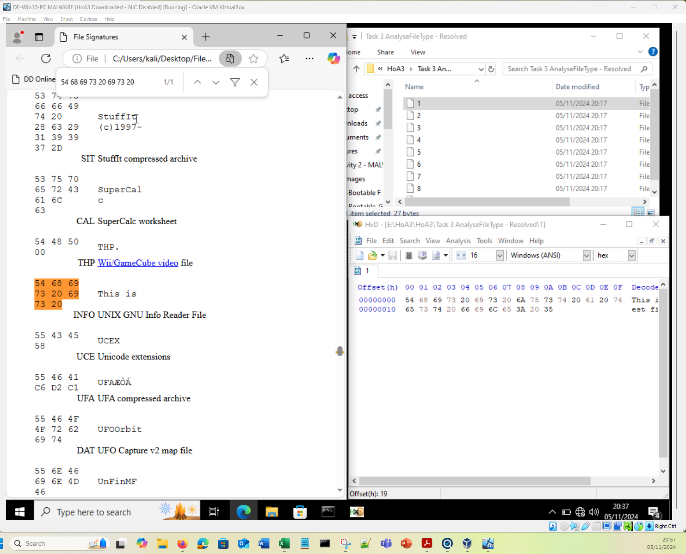
Figure 12: File Signature Analysis using a hex viewer tool HxD during Activity 3

Appendix 3: The Electronic Discovery (e-Discovery) and Electronic Discovery Reference Model (EDRM)

A3.1 Electronic Discovery (e-Discovery)
The E-Discovery process is used at every stage from initial investigation all the way through to the presentation of evidence in a court of law.
The E-Discovery process is used in identifying relevant data for a case. It also outlines the preservation of evidence where usually a legal hold is put in place. It gives guidance on the collection of the forensic evidence and describes how the evidence should be analysed to identify key elements. Finally, presentation of the evidence to a whomever requires it, this could be the management team of a business, or representatives of a court of law.

A3.1.1 e-Discovery Software
Developers such as Exterro, provide e-Discovery solutions to assist investigators, lawyers, and managers during the process. See Fig.13 below:
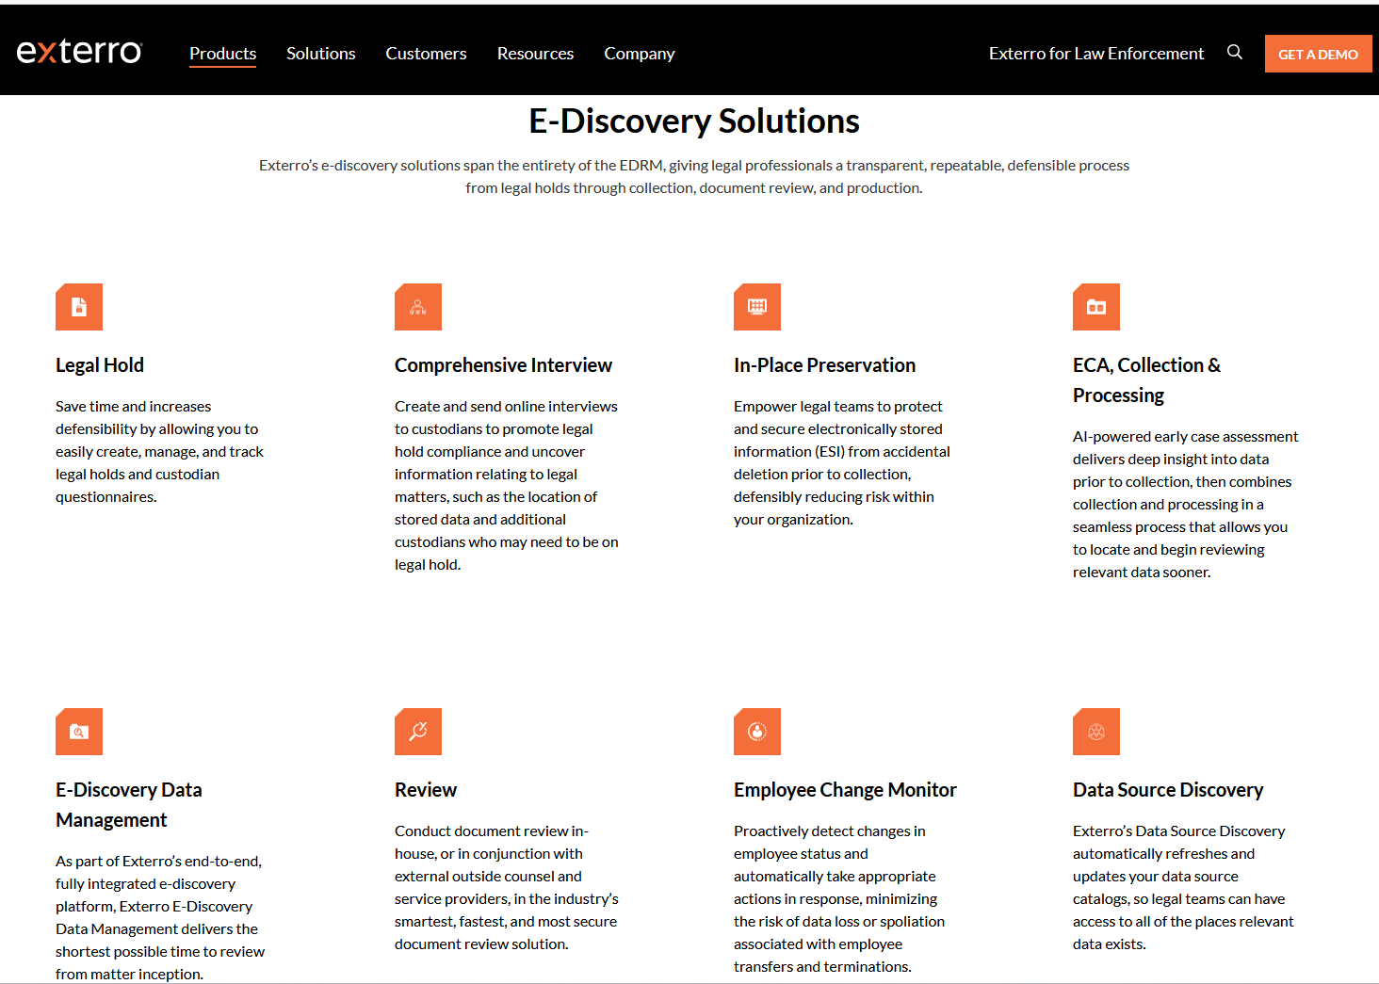
Figure 13: Overview of e-Discovery solutions from Exterro

A3.2 Electronic Discovery Reference Model (EDRM)
The EDRM is a model containing nine distinct steps used to carry out the e-Discovery process. Each step satisfies an important task of the e-Discovery process. See Table 13 outlining each step and giving a description of the task.
Table 13: EDRM steps and descriptions [6] [18]
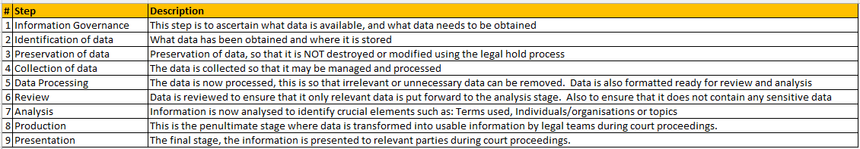

The ERDM model is visualised in Fig.14:
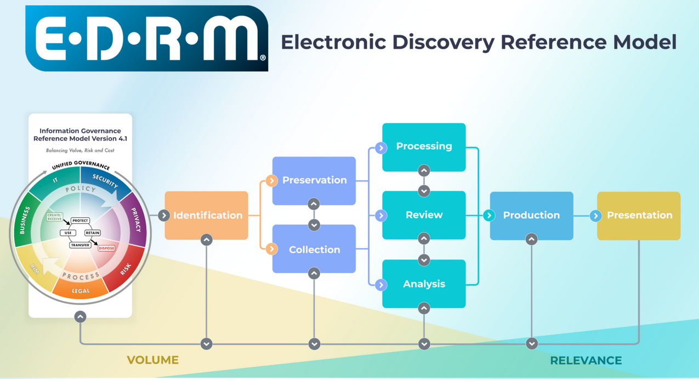
Figure 14: The ERDM Process [70]

A3.3 Legal hold
A Legal hold is used in the preservation step for the ERDM model. Also known as litigation hold, it is key concept in the preservation of evidence and relates not only to electronic evidence, such as hard drives, mobile devices or backups, but also extends to paper documents.
A legal hold is a legal notification to an organisation that they must preserve all data and paper records to prevent them from destroying or modifying any evidence that may be relevant to the case.
Contravening a legal hold notice would negatively impact the organisation’s case in a court of law as intentionally modifying or destroying evidence would be seen as “spoliation of evidence” “evidence tampering”. The legal hold would remain in place until the court case has been heard and a judgment made [6] [71].

Appendix 4: Forensic Software Research
There are several DF tools available to DFIs, a selection of which have been researched. During an investigation, it is key to use of multiple tools to Analyse the same data as one tool may pick up evidence that other tools might miss.

A4.1 Table of DF Image formats researched
Table 14 shows the variety of DF image formats some being open source are widely used and can be opened cross platform. While others are proprietary having been developed by commercial companies such as EnCase. These can generally be used with other developer’s tools, but this cannot be guaranteed.
Table 14: DF Image formats [6]
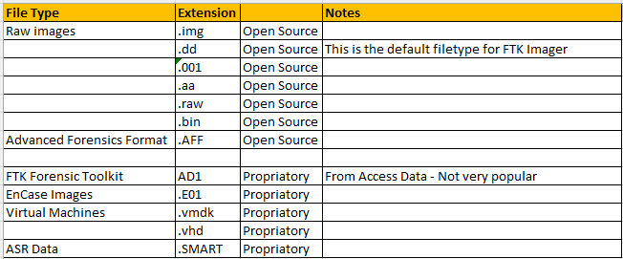

A4.2 Autopsy Overview
Autopsy developed by Sleuth Kit Labs, are the same developer of The Sleuth Toolkit (TSK), both of which are open-source. TSK is a collection of Command Line Interface (CLI) tools, The Sleuth Toolkit (TSK) [29] [72].
Autopsy was developed to sit on-top of TSK to provide a Graphical User Interface (GUI) [32].
Autopsy is a DF platform for analysing forensic images taken from a variety of sources such as PCs, Mobile devices, flash drives. It is freely available to download and user friendly.

After acquiring the image, the DFI uses the following process to Analyse the Data [32]:
- Create a case
- Select the appropriate image source(s)
- Configure the Ingest

The Ingest modules carry out the Data Analysis, the DFI can select or deselect ingest modules used during the data analysis. Examples of these modules include Hash Lookup, Email Parser and Encryption Detection. It is also possible to select the location of files that the ingest is ran on.
The more ingest modules and locations selected, then the longer the data analysis will take to complete.
See Fig.15 showing the Ingest being configured for Activity 1.
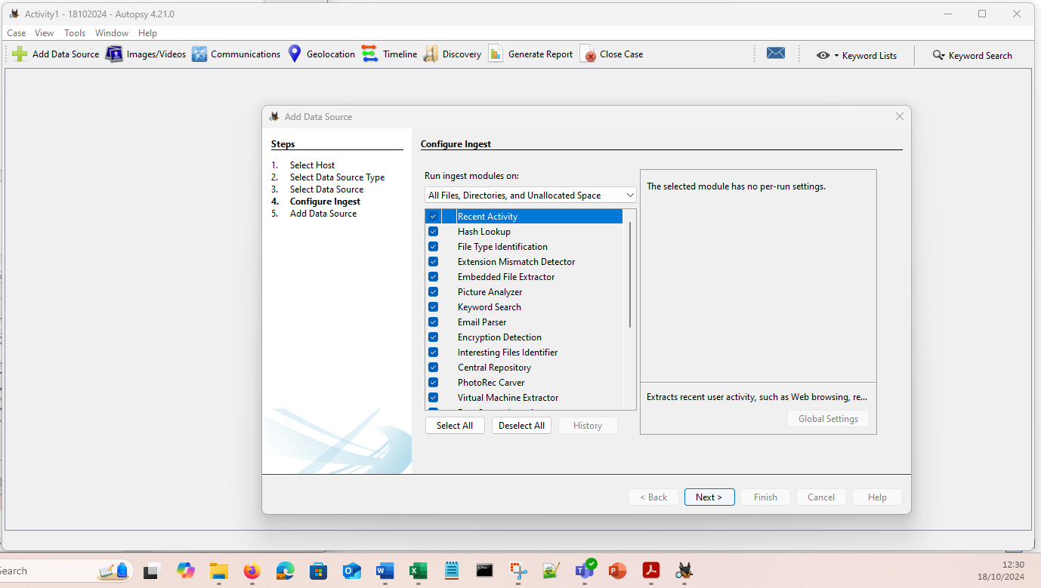
Figure 15: Configuring the Ingest of Autopsy for Activity 1

Fig.16 shows the result of the Data Analysis on the forensic image. It allows the DFI to analyse the data searching for digital evidence such as Metadata, keywords, and deleted files.
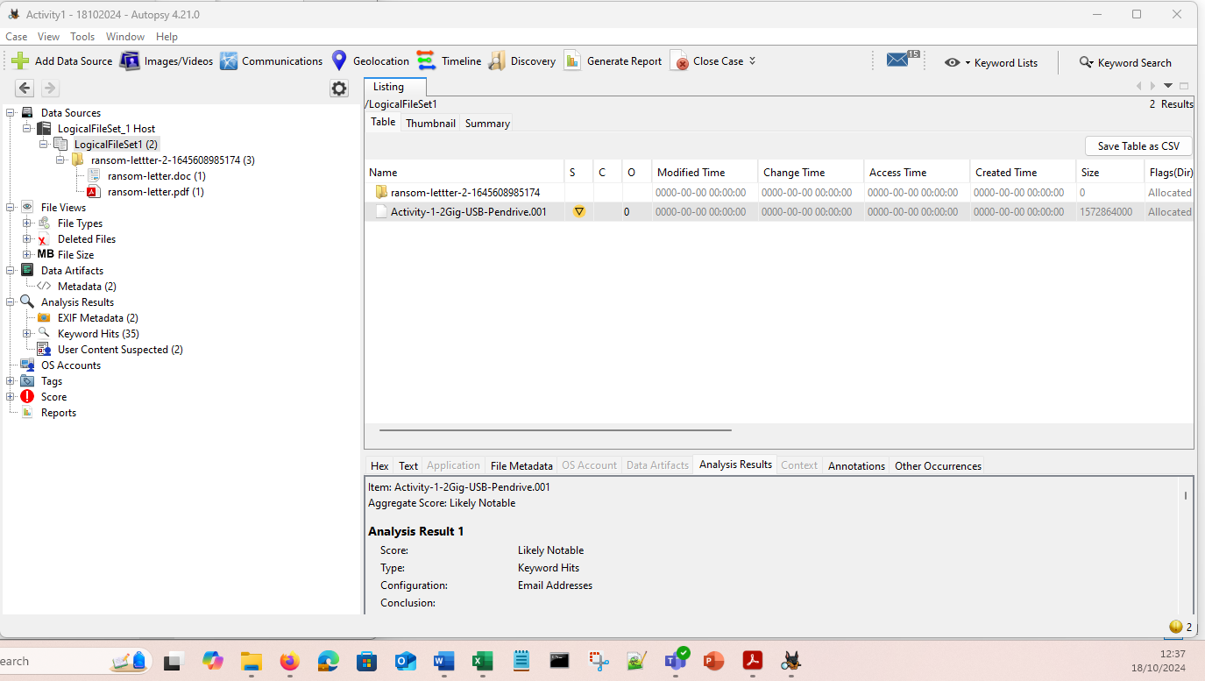
Figure 16: Autopsy Data Analysis complete for Activity 1
Having used both the Linux and Windows versions of Autopsy, it was discovered that the Windows variant was more user-friendly.

A4.3 Forensic Toolkit (FTK) Overview
Exterro’s FTK is a commercial digital forensic data analysis tool with a GUI, which is currently only available for Windows Operating System (OS).
FTK is a globally respected data analysis tool and is widely regarded and a one of the gold standards in the industry. This was apparent while conducting the job search in Task 1 as FTK appeared frequently in the JDs. This is due to FTK being recognised for its ability to analyse very large data sets swiftly and efficiently.
Once the image has been acquired, it can then be analysed for evidence relevant to the case [73] [74] [75]

See Fig.17 showing data analysis:
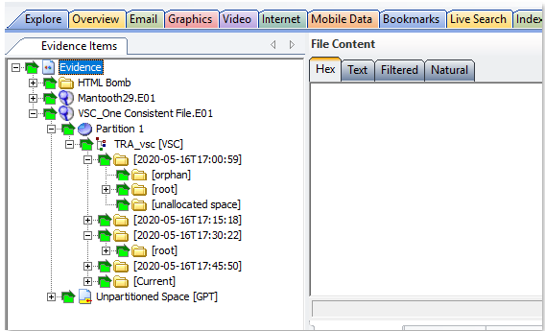
Figure 17: FTK being used to analyse artifacts of an image [75]
The artifacts are separated into different tabs along the top. The file structure shows the evidence items, this includes the Unpartitioned Space.
Data can be filtered to search for relevant evidence for the case, see Fig.18 filtering for Encrypted files.
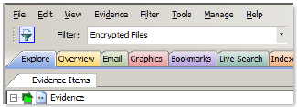
Figure 18: Filtering evidence in FTK
Encrypted files can then be passed to Exterro’s Password Recovery Toolkit (PRTK) or its Distributed Network Attack (DNA) tools which carry out a brute force attach on the encrypted files.
Exterro’s FTK Forensic Toolkit is one of the tools within its digital forensic suite. These tools are designed to work collectively and seamlessly to enhance the capabilities of the FTK Forensic Toolkit.
Please see Fig.19 and Table 15 below giving a brief overview of the tools available within the Digital Forensics suite:

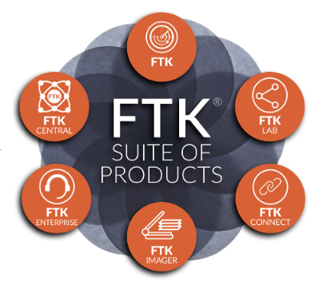
Figure 19: The FTK Suite of products [76]

Table 15: FTK Suite of tools and brief description of features
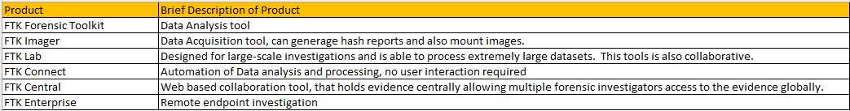

Exterro have several suites that are designed to be used collectively, the intention being their customers will be able to use the tools in conjunction with each other right through the investigation process. From the E-Discovery, where legal hold is put in place right at the start of the investigation, through to evidence seizure, data acquisition, data analysis and presentation of evidence, see Table 16.
Table 16: Exterro Suites available to customers
This modular approach appeals to organisations as they can procure these services over time.

FTK Imager is one of the suites of tools, used to acquire forensic images, this tool is freely available [77]. See Fig.20 showing Imager being used to acquire an image during Activity 1.
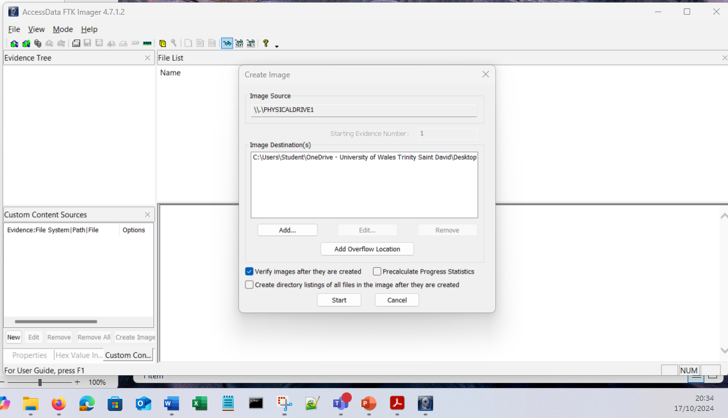
Figure 20: Screenshot of FTK Imager being used to Acquire data from a USB Pendrive during Activity 1

FTK Imager lite
FTK Imager lite was discontinued since the acquisition of Access Data by Exterro. However, Exterro provides guidance on how to run FTK imager from a flash drive [78].

A4.4 Table of Software Tools researched
Several DF software packages were researched as part of this assignment Table 17 below gives detail on the tools researched [31] [79] [80] [75] [77] [78] [72] [32] [81] [82] [83] [84] [85] [86] [87] [88] [89] [90] [91] [92] [93] [94] [95] [96] [97] [98] [99] [100] [101] [102] [103] [104] [105] [106] [107] [108] [109] [110] [111] [112] [113] [114] [115] [116] [117]:
Table 17: Forensic Software Overview
# | Tool | Developer | Description | Features | Comm/Open | Interface | Notes
1 | Forensic Tool Kit (FTK) | Access Data  Acquired by Exterro | * Complete Data Forensic Solution  * Collection of Data collection and Analysis tools | Data Carving  Data Visualisation  Email Analysis  File Decryption  Optical Character Recognition (OCR)  Web Viewer | Commercial | GUI | * High performance can reduce investigation times significantly.  * Single Central Database per case, enabling teams to work collaboratively.  * FTK is only available for Windows OS currently.
2 | FTK Imager | Access Data  Acquired by Exterro | Forensic Image Copier | * Copies HDD / SSD, CDs, USB  * Creates log of activities  * Creates Hash to ensure integrity of evidence | Commercial | GUI | The FTK Imager can save a forensic image in a variety of formats including dd and E01 formats.  RAW dd is the Autopsy standard whereas E01 is the EnCase standard and is used in law enforcement.  It is possible to convert between dd and E01 by using an ATRIO device.
3 | FTK Imager Lite | Access Data  Acquired by Exterro | Data Acquisition: Portable Forensic Image Copier | * Fits onto a USB drive  * Copies HDD / SSD, CDs, USB  * Creates log of activities  * Creates Hash to ensure integrity of evidence | Commercial | GUI | This is the Portable version of FTK imager. Unfortunately, this is no longer available. It appears this was discontinued after the acquisition by Exterro. There is however a method of installing FTK Imager onto a USB pen by following guidance on the Exterro website.  It is possible to convert FTK Imager to run from a USB pendrive.
4 | The Sleuth Kit (TSK) | Sleuth Kit Labs | Command Line forensic toolkit | Analyse Disk Images, Recover files. | Open-Source | CLI | * The Sleuth Kit (TSK) is utilised by Autopsy underneath its GUI.
5 | Autopsy | Sleuth Kit Labs | Forensic analysis toolkit | Analyse Hard Drives and mobile devices | Open-Source | GUI | Autopsy is the GUI that runs on top of the Sleuth Tool Kit (STK)
6 | Volatility Suite | Volatility Framework | Memory forensic analysis tool | Allows analysis of data in Volatile Random Access Memory (RAM) | Open-Source | CLI | The Volatility Suite allows in-depth research into system memory, OS internals, applications and malicious code.
7 | Memdump | Volatility Framework | Memory forensic analysis tool | This command captures the contents stored in RAM. | Open-Source | CLI | Part of the Volatility Framework - Available with Kali Linux
8 | Procdump | Microsoft | Memory forensic analysis tool | This command captures the information in the process memory. | Open-Source | CLI | Part of Microsoft Sysinternals. Captures memory that a process is using. Can include Credentials and Certificates.
9 | ExifTool | Phil Harvey | Meta Data Viewer and Editor | Exif can Read, Write and Create Meta Data, and can manipulate Metadata of files, Word, Video, Audio PDF etc. | Open-Source | CLI | Exif (Exchangeable Image File Format), freely available online. It can provide a great number of Metadata from an image.
10 | Dumpzilla | Kali | Browser analysis tool | Used to forensically examine browser data, including cookies. Stored password information. Browser history. Search engines used. | Open-Source | CLI | Specifically for Mozilla Firefox, iceweasel and seamonkey browsers.  Used to extract forensic information from these browsers.
11 | SIFT Workstation | Sans Tools (Rob Lee) | Collection of Forensic tools. | Analyse File Systems, Network Evidence, and Memory images. | Open-Source | GUI | Available as an OVA file, this provides a Ubuntu machine with Sift installed.  * It is also possible to download within the Linux OS, or available on Windows.
12 | Caine Forensics | Giovanni "Nanni" Bassetti | Linux Distribution, with GUI and several Forensic tools installed. | Live USB/DVD to provide a complete forensic environment. | Open-Source | GUI | Integrates Open-Source tools with a GUI. Computer Aided Investigative Environment (CAINE).  Can be thought of as: What Kali Linux is for hackers; Caine Forensics is for Digital Forensic investigators.
13 | Wireshark | Gerald Combs / Wireshark Foundation | Network Analysis tool / Packet analysis tool | Packet Capture, Packet filtering on capture, ring buffer to enable continuous capturing | Open-Source | GUI | *Wireshark is a powerful tool that allows Network Engineers to inspect network traffic.  * This can also be done live via Port Mirroring / SPAN ports.  * Packets can be filtered either when capturing the packets, this limits the file size and can narrow down the traffic captured to only the relevant packets, i.e. Dynamic Host Configuration Protocol (DHCP) packets if fault finding the DHCP process.  * Display filters are very useful when attempting to fault find an issue, they can be used to only display the relevant packets within a capture file. For example, Domain Name Service (DNS) packets if attempting to fault find a DNS server issue.
14 | TSHARK | Gerald Combs / Wireshark Foundation | Network Analysis tool / Packet analysis tool | CLI Packet Capture, Packet filtering on capture, ring buffer to enable continuous capturing | Open-Source | CLI | TSHARK is the CLI equivalent of Wireshark and is downloaded as part of the Wireshark install. Commands are used on the CLI to run packet captures. This means that TSHARK captures can be automated.
15 | TCP Dump | TCPdump team | Network Analysis tool / Packet analysis tool | CLI Packet Capture, Packet filtering on capture, ring buffer to enable continuous capturing | Open-Source | CLI | TCP Dump is a CLI tool that allows for packet capture. Filters can be entered on the CLI to minimise packets captured or display specific information. i.e. -A will display ASCII characters.  The TCPdump file can be saved as a .pcap file format, this will enable the Network Engineer to open the file in Wireshark so that further analysis can be carried out via the Wireshark GUI interface.
16 | EnCase Forensic Suite | Guidance Software | * Complete Data Forensic Solution  * Collection of Data collection and Analysis tools | Collects Data  Preserves Data  Analyses Data | Commercial | CLI | * Globally Respected Standard Forensic software. Used by law enforcement agencies worldwide.  * EnCase default file format is E01 - This is a standard file format used by many law enforcement agencies.  * EnCase FS supports the broadest range of file formats of any DF system  * EnScripts can be downloaded from the manufacturer to automate Data Analysis
17 | Bulk Extractor | Kali | Scans a forensic Image and extracts useful data | Data Analysis of Images recovers files and searches for interesting information. | Open-Source | CLI | Bulk Extractor can recover documents, images and video files. But in addition, can search for Credit Card Numbers, Email Addresses, Internet Searches etc.
18 | Foremost | Kali | Data Recovery | Uses File Carving techniques to recover data. Limited to certain file types. | Open-Source | CLI | Can recover lost files from either a forensic image (dd or E01) or directly from drive. This is done based on their header or footer data.
19 | NetworkMiner | Netresec | Network Analysis Tool provides a GUI of data which is above packet level | NetworkMiner can *Extract credentials, *Extract files,  *X.509 Certificates, *Decrypt TLS packets. | Both | GUI | This takes the network traffic data, either live or PCAP packet and can provide a graphical representation. It can also extract useful data such as credentials.
20 | WinHex | X-Ways | Data Acquisition & Recovery: WinHex can also edit data. | * Collect data from file systems and RAM.  * File comparison  * Data recovery  * Creates a Hash of the file system.  * Can edit the file system, | Commercial | GUI | WinHex can also create a hash of the file so that data integrity is maintained.
21 | SMART | ASR Data | Data Acquisition & Analysis | *Postmortem analysis on dead systems. | Commercial | GUI and CLI | A Suite of tools available for DFIs to carry out data Acquisition and Analysis.
22 | Smart Acquisition Workshop (SAW) | ASR Data | Data Acquisition & Analysis | * Runs on Windows, Mac and Linux OS.  * Improved performance when searching using EnCase or FTK  * Can be used in conjunction with SmartMount | Commercial | GUI | Creates forensic images from storage media.
23 | SmartMount | ASR Data | Image Mounting | * Can mount filesystems contained on logical / physical disk image files  *Behaves like regular volumes  * Browse volumes with any GUI Environment | Commercial | GUI | It can be used with a variety of image formats, including dd (RAW), E01, and virtual machines vmdk files.
24 | AXIOM | Magnet Forensics | Data Acquisition & Analysis | * Acquire and Analyse mobile, cloud and computer evidence in one package.  * Can be used with Magnet AI  * Use connections to piece how artifacts, people and devices relate to each other.  * Visualise events with Timelines  * Using Magnet Copilot, can use AI to identify deepfake media. | Commercial | GUI | Integrates with other Magnet forensic software, such as graykey.  It can be integrated with third party tools such as Cellebrite, and Oxygen.
25 | Nexus | Magnet Forensics | Remote Endpoint Collection and Analysis tool | *Multiple Endpoint analysis  *Detects Indicators of Compromise (IOCs)  *Acquire network activity, log files, live system artifacts.  * Live memory acquisition, RAM dumps | Commercial | GUI | Cloud based solution therefore no maintenance or updates required. Can be used within minutes by installing agents on the end PCs, minimal setup requirements.  Can be used for DF or Cybersecurity applications as IOCs are detected.
26 | Griffeneye | Magnet Forensics | Video & Image Data Acquisition & Analysis | *Utilises AI to process images and video  *Categorize media, such as narcotics  *Quickly find an match images and videos  * Facial recognition | Commercial | GUI | Giffeneye can be used to globally collaborate with investigators to share information via the Griffeneye Intelligence Database.  Griffeneye Enterprise allows investigators to centralise intelligence to carry out collaborative work.
27 | Graykey | Magnet Forensics | Mobile Forensics and Data Recovery Software | *Can provide same day access to iOS and Android devices.  * Unlocks mobile devices  * Decrypt content | Commercial | GUI | Graykey can be used to access Mobile devices, in often under an hour. Can provide access to mobile data including deleted data.  Can provide details on Pictures, videos, chat histories, location data and internet usage.
28 | Digital Collector | Cellebrite | Data Acquisition & Analysis | * Collect data from live systems  * Targeted data extraction (To Speed up the process)  * Volatile RAM Acquisition  * Supports MS and Apple Fusion File systems | Commercial | GUI | Live data acquisition of Windows and Apple systems. Allows for on-scene or in lab data acquisition. Carry out a triage, by determining whether relevant data exists on the system before imaging. Allows acquisition of Volatile memory, such as RAM.
29 | UFED (Unified Forensics Extraction Device) | Cellebrite | Mobile device data acquisition | *Supports wide range of mobile devices | Commercial | GUI | Available as software only or re-loaded onto a heavy-duty tablet or laptop.
30 | Ghiro |  | Data Analysis of Image files | * Fully Automated  * Capable of analysing many images providing metadata extraction, GPS location, file type analysis and hash match analysis. | Open-Source | GUI | Freely downloadable either as an application to run on Windows of Linux or as a virtual machine.  Automatically analyse images to detect potential modifications.
31 | XRY | MSAB | Mobile Forensics and Data Recovery | *Bypass locked devices.  *Decode digital evidence | Commercial | GUI | Windows based mobile device recovery platform. It is possible to extract and decode data from three mobile devices simultaneously.
32 | XAMIN | MSAB | Digital Forensic Analysis Solution | * Able to create profiles of suspects  *Supports numerous sources | Commercial | GUI | Able to search and filter a large amount of data to find crucial evidence. Can be used with XAMIN Viewer which is a free to download tool
33 | XEC | MSAB | Digital Forensic Management Solution | *Allows for collaboration  *Secured IT Communications | Commercial | GUI | DF management tool to assist with complex investigations. Track the progress of a case and can generate reports.
34 | NUIX Discover | NUIX | Data Acquisition & Analysis | *Can process large amounts of complex data  *Can identify patters quickly | Commercial | GUI | Available as an on-premises or cloud deployment. Can integrate seamlessly with other NUIX tools to provide an end-to-end solution of the e-Discovery process.
35 | dd | - | Data Acquisition and copying tool | *Bit by Bit forensic copier  *Can convert file formats | Open-Source | CLI | Very powerful CLI based tool that can be used to acquire DF images. It creates a bit-by-bit forensic image of the original device. Filters can be used while copying to reduce length of time of the data acquisition.
36 | IDA Pro | Hex Rays | Powerful disassembler, decompiler, debugger | *Supports wide range of processors and file formats  *Assist with reverse engineering via gooMBA  * Integrated Debugger | Commercial | GUI | Full software package is very expensive, free version available for education purposes.
37 | Ghidra | National Security Agency (NSA) | Software Reverse Engineering toolkit | *Malware analysis  *Static code analysis of malware | Open-Source | GUI | Freely downloadable from Github, one of many Open-Source projects developed by the National Security Agency (NSA).
38 | OllyDbg | OllyDbg | Assembler level analysing debugger | *Code analysis  *3rd Party plugins  *Traces program execution | Open-Source | GUI | Allows Dynamic and Static analysis, and modification of code.
39 | PDFInfo | - | Meta Data Viewer | *Prints out the contents of the \Info Directory | Open-Source | CLI | Linux command to display the Meta Data of PDF documents.
40 | Intella | e-Forensic Services | e-Discovery Tool | *Search images/files  * Redact files prior to exporting | Commercial | GUI | Range of e-Discovery solutions allowing for collaborative working.

A4.5 Brief overview of a selection of tools researched

A4.5.1 The Sleuth Toolkit (TSK)

TSK is a collection of CLI tools that allows a DFI to analyse disk images. Autopsy is the GUI interface for TSK, see Fig.21 [29] [72].
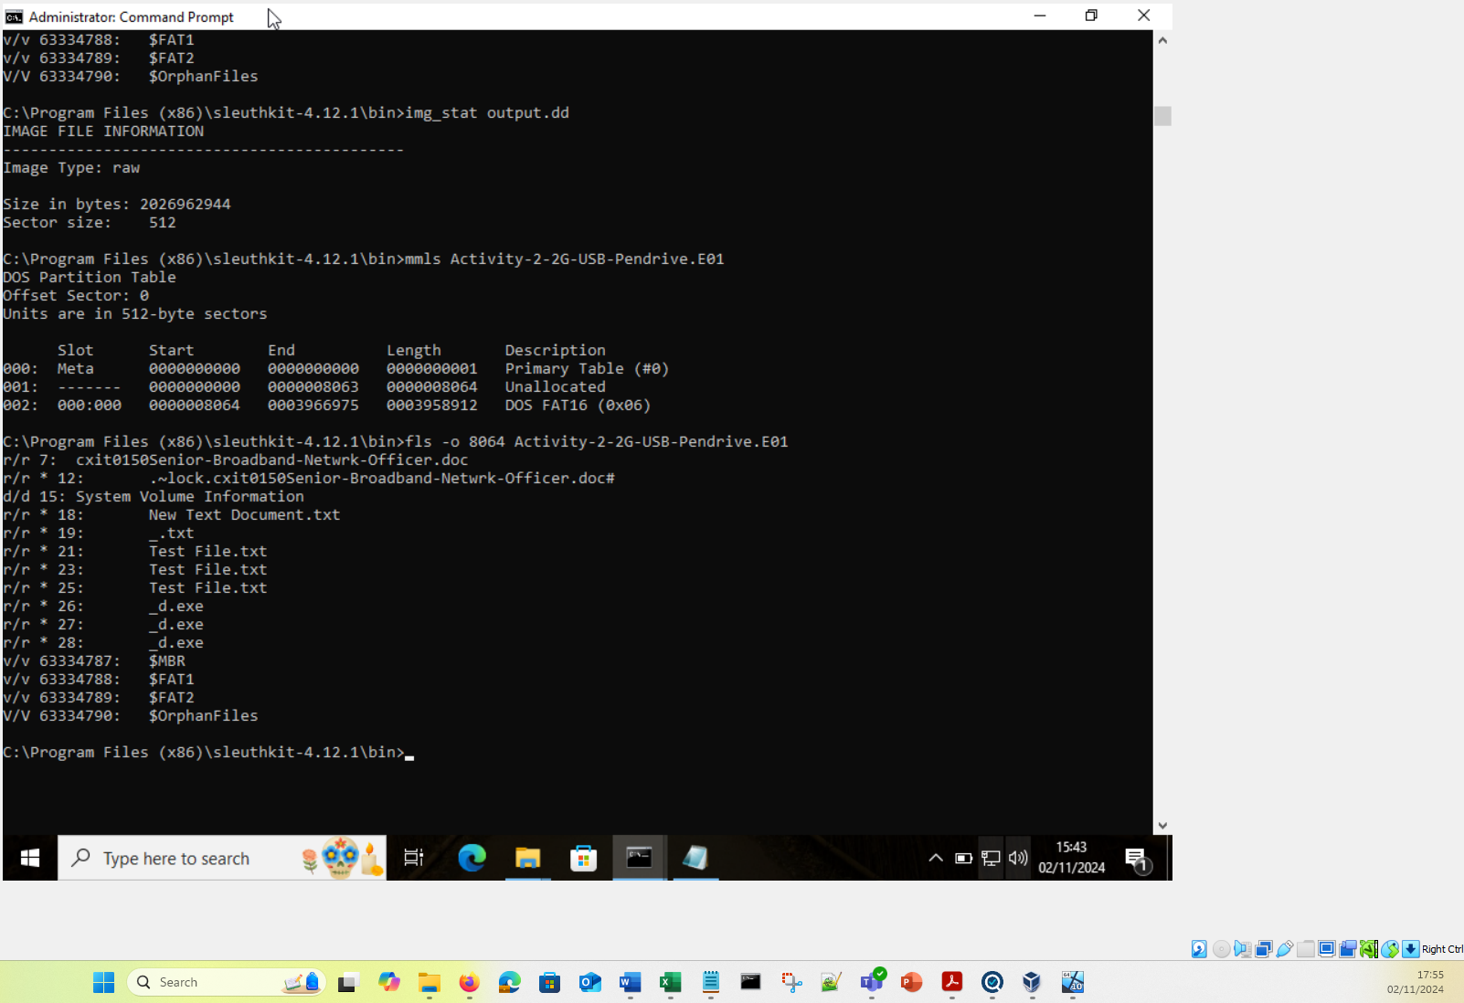
Figure 21: TSK tools being used for Activity 2

A4.5.2 EnCase Forensic Suite
The EnCase Forensic Suite is one of the most respected DF software solutions used by law enforcement globally. Its default file format is E01, which used extensively in the law enforcement. However, it is also able to support a broad range of other file formats. EnCase Forensic Suite is also able to support a wide range of industry standard encryption tools to execute data acquisition on encrypted systems [91] [6].
It is possible to download EnScripts from the manufacturer to automate Data Analysis tasks.

A4.5.3 ExifTool

The term ExifTool stands for (Exchangeable Image File Format), ExifTool can be used to view a great deal of Metadata from an image as shown in Fig.22 [84].
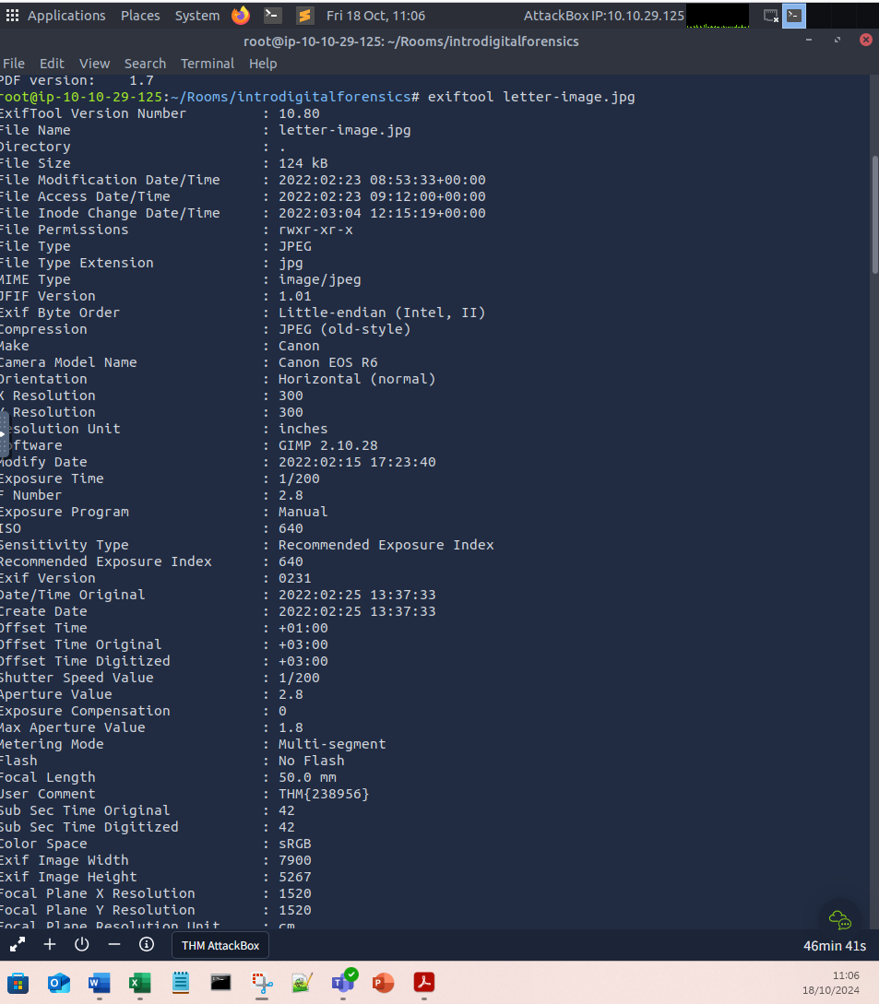
Figure 22: Using ExifTool to view Meta Data of a JPG image during Activity 1
Exiftool can be used to view GPS coordinates where a picture was taken, and to compare the metadata of two files for differences.

A4.5.4 Dumpzilla

Dumpzilla is a browser DF tool and can extract forensic data from Mozilla browsers such as Firefox [85] [118]. See Fig.23 below that shows session cookie information including the hash value.
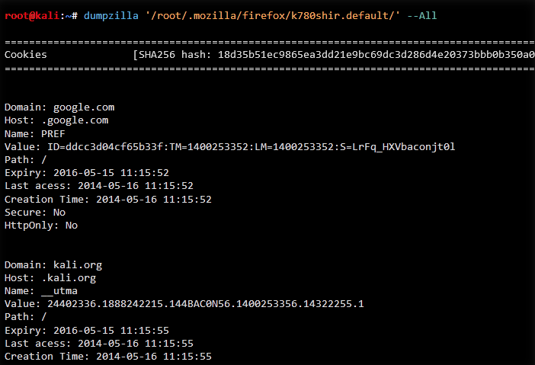
Figure 23: Screenshot of Dumpzilla in use [118]

A4.5.5 Ghiro
Ghiro is a web based automated image analysis tool. It can be used to extract metadata data from an image, also GPS coordinates of where the image was taken. Using Error Level Analysis (ELA) it is possible to detect whether the image has been modified which could be very useful in an investigation. See Fig.24 that shows a screenshot of Ghiro’s features. [105] [119]
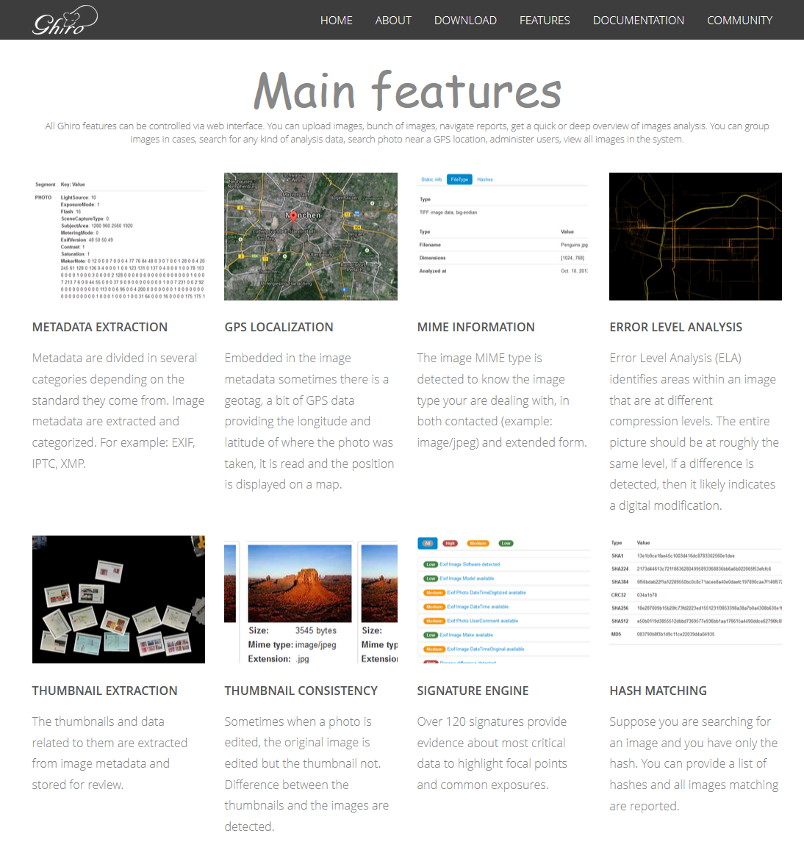
Figure 24: Ghiro Automated Image Analysis tool [105]

A4.5.6 Ghidra
Ghidra was developed by the National Security Agency (NSA) and is freely available to download. It allows programmers/developers to carry out static code analysis on malware to glean information on how it was written. [120] See Fig.25 that shows a screenshot of the Ghidra application carrying out static analysis.
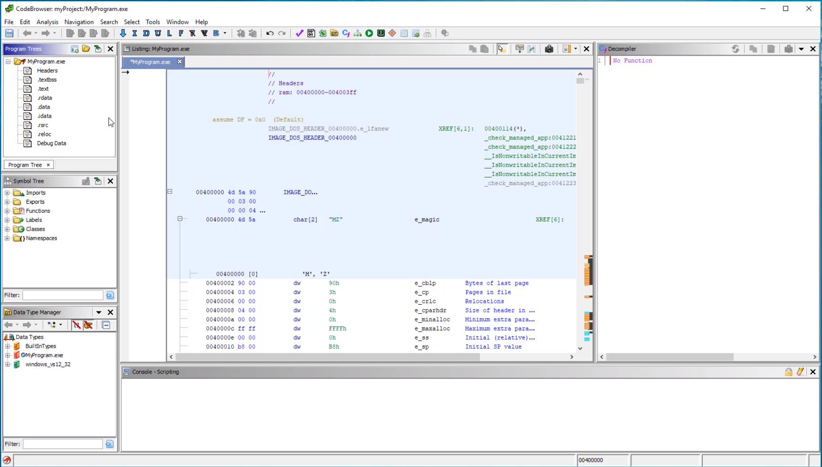
Figure 25: Ghidra analysis of a program file [120]

A4.5.7 PDFInfo
PDF Info is a Linux command that displays the Metadata of an Adobe PDF document. It outputs the contents of the \Info directory onto the screen. See Fig.26 below that shows the output of the PDFinfo command. [115]
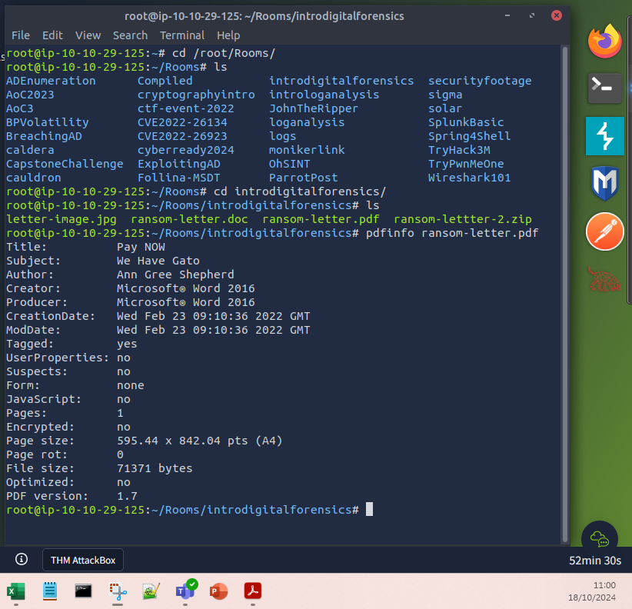
Figure 26: pdfinfo being used to access the Medadata of a PDF document during Activity 1

A4.6 Autopsy and FTK Collaboration (Formally 3.6 Collaboration)
Autopsy can be configured to allow multiple users to access the same case, however this requires additional systems to be setup and configured, see Table 18 [47]:
Table 18: Services required for Autopsy multi-user environment
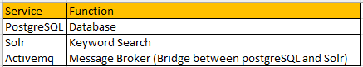
Fig.27 illustrates the multi-user environment.
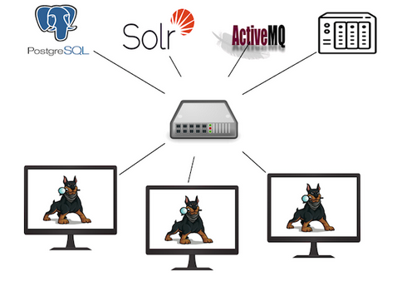
Figure 27: The Autopsy multi-user environment [47]
The onus is on the user to configure and maintain these services. A major disadvantage is if one of the dependencies has a vulnerability this will have a negative impact on any subsequent expert evidence provided in court [33].
Fig.28 screenshot of Muti-User configuration menu.
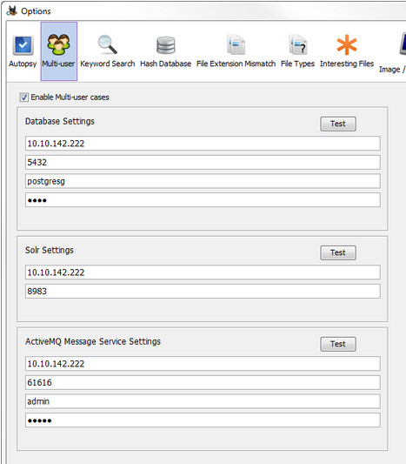
Figure 28: Screenshot of the Autopsy Multi-User function [48]
The FTK tool can be integrated seamlessly with FTK Central, a web-based collaboration tool. FTK central can be hosted in a cloud environment allowing for limitless scalability [49]. The features of FTK Central can be found in Table 19:
Table 19: FTK Central features [49]
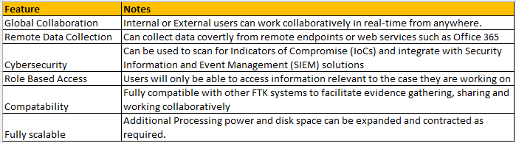

Fig.29 shows the FTK Central desktop.
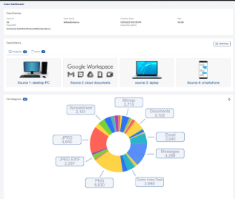
Figure 29: Screenshot of FTK Central [50]

Appendix 5: Challenges of Digital Forensics

A significant challenge in Digital Forensics is acquiring data without altering original drive.
During the data acquisition process, to maintain the integrity of the original drive write blockers are used. Write blockers can either be Hardware or Software and instruct the investigator’s PC not to write any data to the original drive.
It is possible to create a homemade software write blocker on a Windows PC. This can be done by creating two registry keys and then placing a shortcut on the desktop for each registry key.
One shortcut to disable writing and the other to re-enable writing.
Maintaining the integrity of the original drive is crucial as making any modifications or alterations to the stored data can make this evidence inadmissible in a court of law.
For DF evidence to be admissible in a court of law it is critical that the correct tools and techniques are used during the data acquisition process. If a laptop were being examined as part of an investigation it would be crucial to create a copy of the hard disk drive (HDD) or Solid-State Drive (SSD). This replicates the drive creating what is known as a forensic copy which includes meta data and timelines associated with the original HDD/SSD. If we were to simply attach an external HDD and copied the files using Microsoft’s OS to carry this task out, then a copy would indeed be created, but all the important data associated with the file would be lost. Therefore, data acquisition tools such as FTK Imager must be used to create a DF copy.
One specific challenge identifies with acquiring data from SSD’s is the Trim function, a feature designed to free up unallocated space quickly to allow data to be re-written. When the Trim function is enabled, then data analysis of deleted files is not possible [121].

The integrity of the forensic copy can be validated via hash algorithms. A Hash algorithm is a one-way function that generates an alphanumeric value that changes if the data is altered, even a simple case of opening an existing text file, pressing the space bar once and saving that change will produce an entirely different hash value. It is therefore crucial that a hash value is taken as the first step of a DF investigation. Once the forensic copy has been created, then a hash value can be generated on the copy and both hash values should match. This ensures that when evidence is presented in court the integrity of the data can be proved.
Virtual Machine (VM) it is possible to acquire data from a VM by creating a snapshot of that system, this is admissible in court.

A5.1 Creating a forensic copy without altering the data of the original drive

DFIs use Write blockers to stop the investigator’s PC writing any data back to the original drive whilst creating a forensic copy to ensure that the original drive maintains its integrity as advised by UK Government [6] [18] [122].
Fig.30 shows a USB write blocker as used by law enforcement and DFIs.

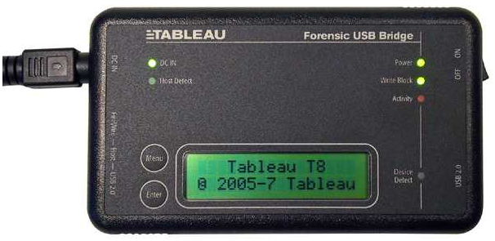
Figure 30: Example of a hardware USB write blocker [18]

A5.2 Proving the integrity of the original drive
It is critical to maintain the integrity of the original device. DFIs create a forensic copy of the original device to conduct their analysis as if the data becomes altered or corrupted during the analysis phase, the evidence obtained will be inadmissible in court.
To prove the forensic copy is identical to the original, DFIs create a digital hash of the original device prior to carrying out any investigative work see Fig.3. This can be thought of as a digital fingerprint and used to prove that the drive has remained unaltered [6].

Fig.31 shows Digital Hashes (MD5 and SHA1).
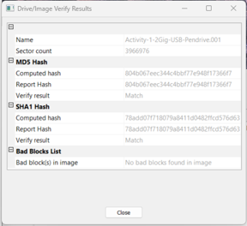
Figure 31: Screenshot of a Digital Hash created after Data Acquisition by FTK Imager whilst carrying out Activity 1 of the DF Module
This trend has given rise to automated forensics orchestrator system [123] this is discussed further in Appendix 7.

A5.3 Length of time it takes to analyse data
Data acquisition and analysis is a very labour-intensive process. With more systems being computerised the volume of data has increased significantly, increasing the length of time needed to acquire data [3]. This is an issue as time constraints may be in place, such as a court date being set. Also, the number of cases under investigation at one time could mean that the DFI does not have the opportunity to spend as much time on a case as required. Additionally, humans are fallible; a mistake could be made, or an all-important critical piece of evidence could be missed.
DFI are now using Artificial Intelligence (AI) and Machine Learning (ML) to facilitate data acquisition and analysis. AI can complete these repetitive tasks far quicker and more accurately than a human DFI [124].

A5.4 Keeping up with the pace of technology
With new systems being developed and implemented regularly, cybercriminals can use these technologies to carry out their crimes, whilst also finding vulnerabilities with current systems. A key example of this is the use of Artificial Intelligence (AI) and Machine Learning (ML) by cybercriminals to carry out their attacks [3] [125].

A5.5 Anti-Forensics
Criminals will attempt to cover their tracks if they are planning to carry out unlawful activities. From a DF perspective, this is known as Anti-Forensics. A quick search online will yield several techniques and even some websites that teach Anti-Forensic techniques for free.

Some common techniques used are [126] [127] [128]:
Virtual Private Networks (VPNs) - This creates and encrypted tunnel that the suspect can use to conceal data flowing in and out of a network .
The Onion Router (TOR) – To do this topic justice would require a report on its own. The TOR network was originally developed to provide anonymity to users. It is a network whereby data is passed between nodes by using several layers of encryption the path between sender and receiver remains anonymous. The TOR is frequently used criminals to hide their activities.
Timespomping – This is a technique to alter the time and date of files. This is done by altering the attributes of the Master File Table (MFT). The MFT is crucial part of the New Technology File System (NTFS). The suspect can then be used to conceal their activity on the PC.
Disk Wiping – This is a simple technique of destroying data using an application such as Kill Disk [129], DBAN [130] which is free (but does not provide data erasure to government standard) or the corporate version Blancco Drive Eraser [131] to wipe the disk.
There are several standards for wiping drives, the standard used by the US Government is DoD 5220.22-M [132].
Data Encryption – The general usage of encryption is to keep data confidential, but in this case, it is used to hamper an investigation, ensuring that the evidence is either difficult to obtain or unobtainable. It is possible to encrypt individual files, volumes or an entire device using Full Disk Encryption (FDE) [6].
Programme Packers – These tools are used to compress and then encrypt a file or application. Using this technique a suspect would hope that this evidence would evade the forensic investigator. Common applications used are UPX and MPRESS.
Hidden Files – Files can be hidden within the file structure, usually in the unpartitioned section or within the slack space of the disk. Another method used is to Fake a bad sector of the disk . A Host Protected Area (HPA) could be utilised to hide files, this area is usually inaccessible to users and is generally used by developers to store files that they do not want to be modified [133]. A Device Configuration Overlay (DCO) is similar concept, the hardware vendor may want the Hard Disk Drive (HDD) to appear as a standard size which is done via DCO, this could potentially leave a small amount of diskspace that could be used to hide files [134].
Steganography – This is a technique which can hide a file within another type of file. For example, it would be possible to hide a text file within a JPEG file. Using this technique crucial evidence can be hidden. Which is then also encrypted. OpenStego [135] is an example of a Steganography application, the suspect would simply select the two files as in the example seen below in Fig.32.
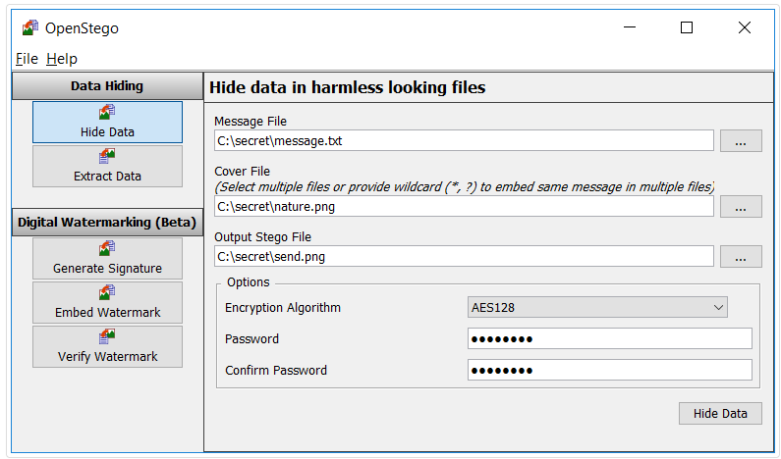
Figure 32: OpenStego being used to embed a text file within an image file – with AES 128 Encryption being used [135]
Steganography can be difficult to detect, there are however some indicators that steganography has been used such as a much larger file size than would be expected, or if the colours in an image where a bit distorted, or potentially a video no playing as expected [6].
Steganalysis tools are available that can detect Steganography and other data hiding programs that can be used to counter this such as StegoHunt, see a screenshot in Fig.33 [136]:
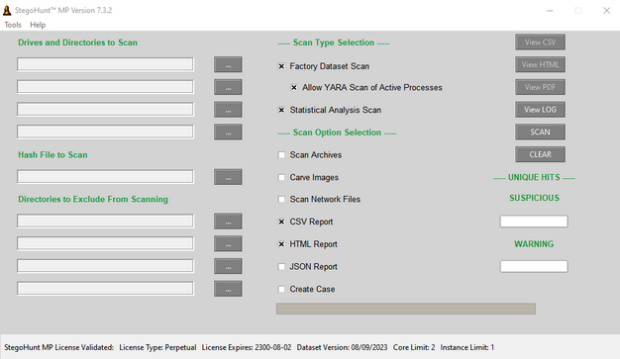
Figure 33: Steganalysis tool StegoHunt [136]

A5.6 Malicious Software
The Data Acquisition phase can be hampered by malware on the devices gathered during the seizure phase. When the data has been acquired the DFI should search for Malware as a priority. To maintain the integrity of the digital evidence [137].
Table 20 lists a selection of possible types of malwares that a DFI could encounter.
Table 20: Possible malware types encountered by DFIs [6]
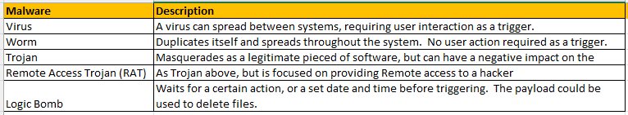

A5.7 Creating forensic copy of containerised systems

Containerised systems are now prevalent in the IT sector, as it allows developers to provide services in such a way that a container can easily be created, replicated, deleted as required. Additional containers can be created to meet demand and then deleted to save on resources and cost, all of which can also be automated. All these features being the main driving force behind their popularity.
However, the transient nature of containers and the ephemeral data they contain makes gaining digital forensic copies of containers and the data that they store very challenging.
Docker is a leader in the field of containerisation, it is an open-source platform that developers can use to create and manage containers. Docker is not only able to create containers, but also entire networks that can interact with containers on different hosts using an overlay network adding to the complexity of gathering DF evidence.
A solution to this problem has been developed in the form of the Docker Forensic Framework (DFF) [138]. The DFF allows investigators to gather evidence from the Docker system as part of an investigation.
The DFF is an open-source CLI tool that can be used to gather evidence in Docker environments. To gather the data, the Container Identity (ID) would be required.

Using the DFF it is possible to gain the following information [138]:
- Overview of the Docker Ecosystem
- A List of containers
- Container information
- List of Docker images
- Docker Networks
- Docker Volumes
- Docker Logs
- Memory Dump of the Docker container

The process to acquire container data is as follows:
- Create a Temporary Container
- Copying the Docker Image to the Temporary Container.

Once the Evidence has been gathered using DFF a Data analysis tools such as Autopsy can be used to analyse the data as they support digital forensic analysis on containers [138].

Appendix 6: DF Job Market Research

A6.1 JD Analysis
All JDs require candidates to be educated to Degree level, with additional professional qualifications all based around Cybersecurity, DF and technologies used.
The Senior Manager position required a Certified Information Systems Security Professional (CCISP) certification, this is a very sought-after qualification for senior Cybersecurity/DF managerial positions.
The UK based roles require additional knowledge or qualifications within the specified ISO standards. Other standards required were the Forensic Science Regulator’s (FSR) Codes of Practice and the ACPO Principles of Digital Evidence.
The Governmental roles also required Security Clearance approval giving an indication of the type of work to be carried out.
The JDs are very well paid, with salaries ranging from £600/day to AU$137k (£70k) annually.
There could be several factors as to why these jobs are so well paid:
- Specialist knowledge/skills/experience required for the DFI role
- The exponential growth of online services providing more opportunities to cyber-criminals creating more workload
- Shortage of DFIs in relation to sheer volume of casework
- Requirement of Security Clearance
- Meticulous/methodological approach to evidence gathering and handling
- Providing expert witness testimony in court proceedings
- Working in high stress environment with tight deadlines.

A6.2 Job Adverts researched

Table 21 below gives an overview of the Job adverts researched:
Table 21: Job roles researched [19] [20] [21] [22] [23] [24] [25] [26] [27] [28]
Website | Role | Country | Location | Experience / Skills required | Tools | Qualifications | Standards | Duration | Salary | Details of Employer
www.cv-library.co.uk | Digital Forensic Investigator/Examiner | UK | London | * Processing/analysing digital media. Devices Computers, Mobile, Cloud Forensics.  * Evidence handling procedures and principles.  Understanding of Forensic  * Science Regulator's Code of DF acquisition, analysis and interpretation. | EnCase, Nuxis, Cellebrite, XRY, FTK | EnCE, NICS, CCLO or CCLA | ISO 17025, ISO 27037 | 6 Mth Contract, FT Onsite | £600 /Day | Leading Government Organisation, Government
www.indeed.com | Senior Digital Forensic Investigator | UK | Manchester | * Understanding of eDiscovery  * 5 Years experience in DF casework within criminal Justice System  * National Security clearance to SC level and NPPV3 clearance  * Processing/analysing retrieving data from digital media. Devices Computers, Mobile, Cloud Forensics.  * Follow ACPO Guidelines  * Presenting Evidence in Criminal or Civil court. | EnCase, FTK, X-Ways, NUIX, Magnet Axiom, Relativity, Griffey, Cellebrite UFED, MSAB, XRY. | Degree level with professional qualifications at expert level for one of the tools listed. | ISO 9001, ISO 27001, ISO 17025, FSR Codes | Full Time, In Person | £50k /Annual | CYFOR - Nationwide support for Law firms, Corporate Organisations, Law Enforcement Agencies.
www.dwp.gov.uk | Computer Forensics Expert / Senior Digital Forensic Specialist | UK | London | * Extraction, Decoding and conversion of Digital Media  *Present finding to Head or unit  * Prepare witness statements, attend court of law to testify on DF work.  * Experience in Law Enforcement / Criminal Justice | EnCase, Nuxis, Cellebrite, XRY, FTK | EnCE, NICS, CCLO or CCLA | ISO 17025 and FSR Codes of Conduct | 6 Mth Contract, Hybrid | £600 /Day | UK Government, Serious Fraud Office (SFO) will work in the Digital Forensic Unit (DFU)
totaljobs.com | Forensic Digital Media Examiner | UK | Surrey | * Ensure exhibits are handled correctly, maintaining continuity and integrity  * Retrieve, convert, prepare, analyse, enhance video and audio material  * All actions are recorded and retained for Audit to fulfil criminal justice requirements | Adobe Premiere Pro, Audition, iZotope, Final Cut Pro, Avid Media Composer | Degree level, professional qualifications in Audio/Video | ISO 17025 and Forensic Science Regulator's (FSR) Code of Practice | Permanent, Full Time, In Person | £34k /Annual | Surrey & Sussex Police, Law enforcement
thamesvalleypolice.tal.net | Digital Forensic Investigator | UK | Newbury | * Recovery of data from computers, mobile devices, CCTV systems, cloud based systems.  * Conduct digital examination of seized computers and mobile devices.  * Use appropriate processes, methodologies, tools and techniques in accordance with ACPO guidance.  * Ensure all submitted items are under necessary authorisation and exhibit continuity procedures are adhered to.  * Examination of encrypted drives, containers, mobile devices and cloud-based services.  * Assist in open-source internet investigations - capture and recovery of data from the internet or cloud services.  * Live capture of RAM  * Use of Command Line (CLI) to extract and analyse data in and evidentially secure manner.  * Develop techniques or applications to recover data from unusual devices, such as games consoles and associated cloud platform.  * Recover data associated with cryptocurrency to facilitate recovery of funds.  * Extract data relating to the use of the Dark Web. | XWays, Axiom, Cellebrite, XRY, GrayKey | Vendor-Specific foundations level courses. (e.g. XFY Foundations). | ISO 17025/ISO 17020 and FSR Codes of Conduct, ACPO Guidance | Permanent, Full Time, In Person | £43k /Annual | Thames Valley Police, Law enforcement
forensicfocus.com | Cyber Forensic Investigator | USA | Oakland, California | *Minimum of 4 years’ experience  *Experience of conducting investigations in a corporate or law enforcement setting  * Prior testimony as an expert witness in court proceedings, and other forums. | EnCase Enterprise and FTK Enterprise | EnCE, CFCE, GCFA, CCE, DFCP, SCERS, ACE, EnCEP | ASCLD | Permanent, Full Time, Hybrid | Competitive | Kaiser Permanente, Finance Sector
www.cybersecurityjobsite.com | Senior Consultant / Cyber & Digital Forensics | Germany | Berlin | *Analysis, Identify Attack vector, reconstruct attacks  *Forensic Investigation, Evaluate data and logs,  * Incident Response, and monitoring | EnCase, FTK, Autopsy, SIFT | Degree level, Professional qualifications in Digital Forensic software | None | Permanent, Full Time, Hybrid | Competitive | Deloitte, Financial Sector
www.europol.europa.eu | Forensic Examiner (Malware Forensics) | EU | The Hague | * Perform Malware forensic analysis (static & dynamic)  * Experience of coding languages  * Experience of commercial & Open-Source forensic tools.  * Decoding network traffic | Forensic Tools: Commercial & Open-Source  Malware Analysis tools:  IDAPro, Ghidra, OllyDbg | Degree level, Professional qualifications in Digital Forensic software | None | Permanent, Full Time | €77k /Annual | Europol, Law enforcement
www.adzuna.ca | Cyber Forensic Investigator (Senior Manager) | Canada | Toronto | *10 Years experience in relevant field, with 5 years’ experience of Digital Forensics  *Incident Response, Forensic Investigation and Digital Evidence  * Support eDiscovery requests  * Conduct employee investigations  * Analyse data from various sources (PC, Mobile etc)  * SIEM and Data Loss Prevention (DLP) | EnCase, Cellebrite, e-Discovery tools Intella and other industry standard tools | Degree level, GCFE,GCFA,CHFI,CCE,CFC,EnCE,CFCE, CEH, CISSP, CND and e-Discovery qualifications | None | Permanent, Full Time | Competitive | TD Bank, Financial Sector
www.seek.com.au | Digital Forensic Analyst | Australia | Brisbane | * Identify, Acquire, Process, Analyse, Report on electronic evidence  * Knowledge of e-Discovery required  * Analyse data from computer devices, mobile devices  * Social Media Analysis | DFIR Tools | Degree level, Professional Qualifications: CFCE, CFE, GCFE, DFIR Industry certifications | None | Permanent, Full Time | AU$139k /Annual (Australian $) | ASIC, Financial Sector

A6.3 Tools mentioned in JDs
Tables 22 to 24 provides a list of tools mentioned in the JDs researched.
Table 22: Table of Tools listed in Job Advertisements
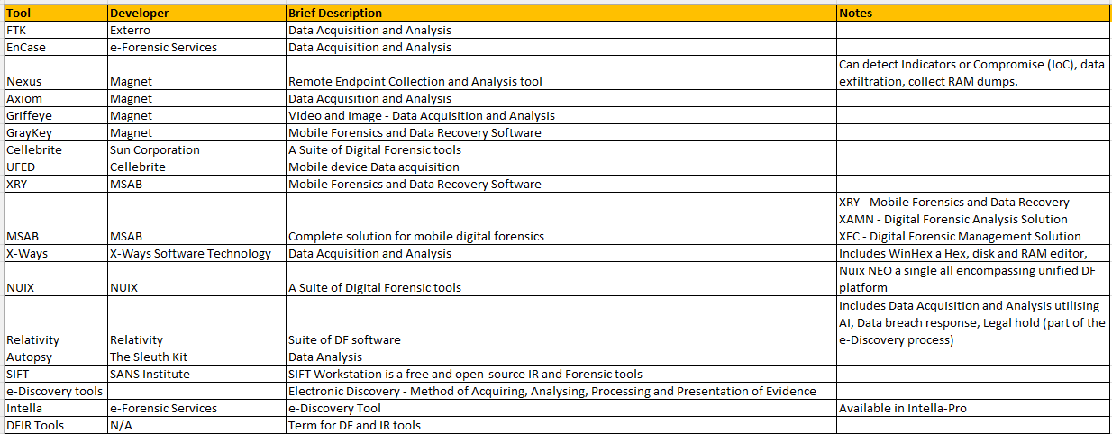

Table 23: List of Tools listed in Job Advert for Malware Forensic Examiner
It was noted that Ghidra is a software reverse engineering suite of tools developed by the National Security Agency (NSA).
The tools listed in Table 24 were not specifically designed for forensic analysis purposes. It appears they were generic Audio/Video editing software that can be utilised for DF purposes.
Table 24: List of Tools listed in Job Advert for Forensic Digital Media Examiner
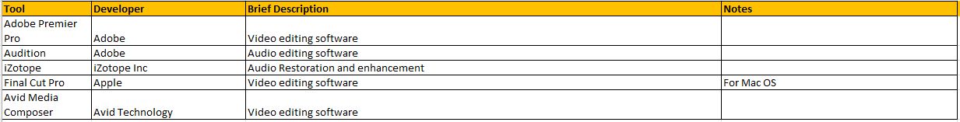

Tables 25 and 26 detail specific experience and knowledge for their respective roles. This shows that within the field of DF there are specialisms, requiring additional skills, experience and qualifications for these roles.
Table 25: Job requirements for Malware Forensic Examinator [139] [120] [114]
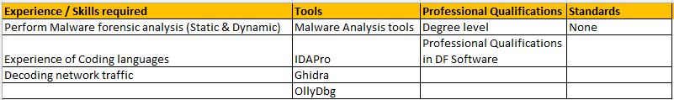

Table 26: Job requirements for Forensic Digital Media Examiner [140] [141] [142] [143] [144]
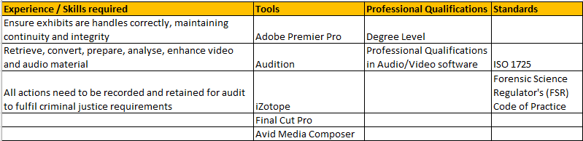

A6.4 Qualifications mentioned in JDs
The qualifications in the JDs were researched. These certifications require renewal generally after a 2/3-year period. The average cost of the certification was around $500. Generally, there were three levels of DF certification:
- Examiner These certificates tend to be entry level giving a good foundation of core knowledge.

- Analyst Analyst certification is the next level certification, providing further in-depth knowledge in the field of DF.

- Practitioner This is the higher certification, generally for DF analysts that have been in the role for several years and gained practical experience in the field of DF.

A DFI would need to gain these certifications to be considered an expert level witness the in the field of DF.
Continual certification and renewal would be an ongoing expense, but necessary to provide expert testimony in a court of law.

Tables 27 giving details on certification researched [145] [146] [147] [148] [149] [150] [151] [152] [153] [154] [155] [156] [157] [158] [159] [160] [161] [162] [163]:
Table 27: DF Qualifications researched
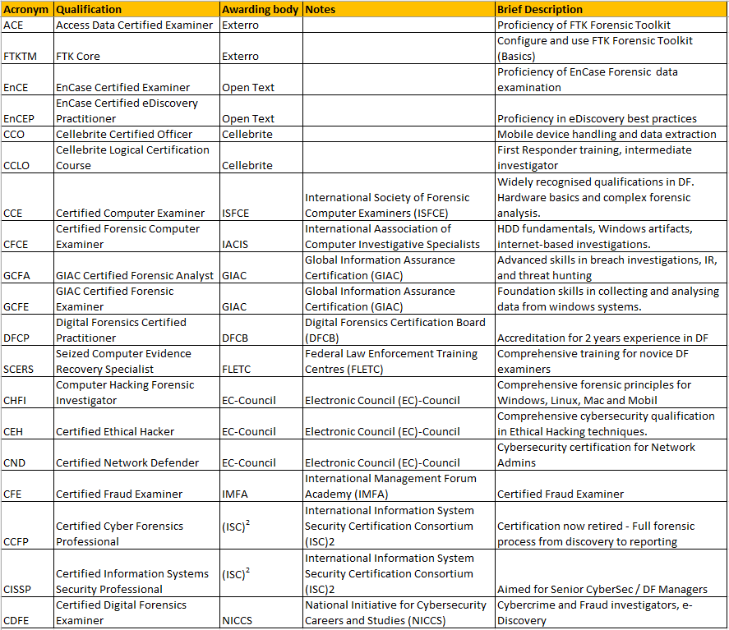

A6.5 Standards mentioned in JDs
Table 28 outlines the standards requirements for FDIs in the JDs [164] [165] [166] [167] [168] [122] [15] [169].
Table 28: Standards required in JDs
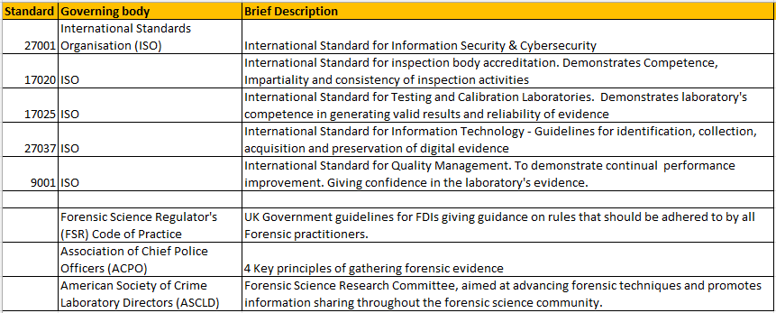

A6.6 Security Clearance mentioned in JDs
DFIs must have exceptional character as they hold a position of great responsibility. Depending on the job role they could have the ability to influence a legal case or be charged with confidential information that could be sold to a company’s competitor. Some DFIs work at government level and as part of their role will be privy to sensitive information that if leaked could impact national security. Therefore, applicants will require Security Clearance to be considered for these roles [10].
The UK Government issue guidance on UK Security Vetting (UKSV), see Table 29 below giving the various vetting levels [172] [173]:
Table 29: UK Security Vetting Levels
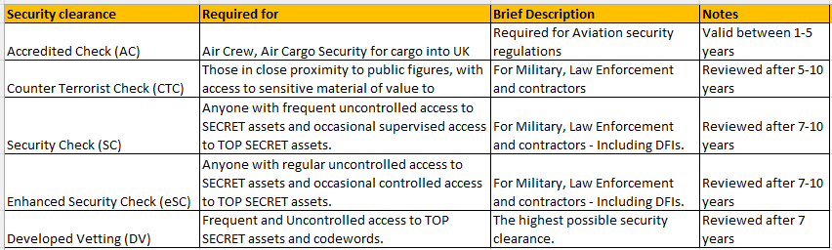
From the JDs researched DFIs may require SC or even eSC level of clearance depending on the nature of the work involved and exposure to sensitive material.

A6.7 DF Accreditation: EX1 Digital Forensic Services Ltd
The UK Accreditation Service (UKAS) provides accreditation for the forensic science sector. They regularly undertake assessments of forensic practitioners to ensure compliance with the standards listed in Table 26 [170]. The certificate outlines the types of products tested, the types of tests carried out and the tools used during testing.
Law enforcement use 3rd parties, such as EX1 Digital Forensic Services Ltd to keep up with pace of caseload. See Fig.34 which shows the UKAS certificate for EX1 Digital Forensic Services Ltd which is currently the only DFI company in Wales.

Fig.34 below showing the accreditation certificate for EX1 Forensics.
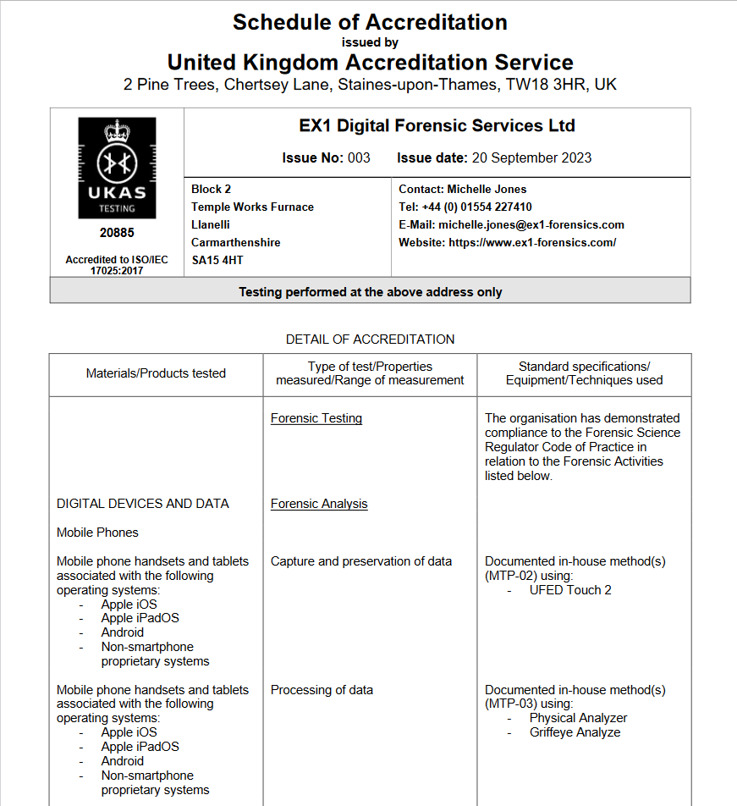
Figure 34: Example of UKAS Accreditation document for ex1-forensics, Llanelli [171]

Appendix 7: Emerging Trends in Digital Forensics
The below is a brief list of emerging trends within the field of DF [124].

A7.1 Artificial Intelligence (AI) and Machine Learning (ML)
Utilising AI, it is possible to analyse a large amount of data in a relatively short period of time in comparison to traditional methods with a human investigator. AI may also be more accurate where human investigators may miss certain key evidence due to tiredness or time pressures.
AI is very adept at recognising patterns; this can be used to great effect during an investigation. Certain procedures could be automated utilising AI, which would further speed up the progress of investigation.
ML is associated with AI and is focused on the AI system improving performance and accuracy while carrying out tasks so that they improve over time.

A7.2 Cloud Forensics
Many organisations are now utilising cloud technology as opposed to onsite systems. There are several factors to this trend, but they are mainly due to the cost savings, performance and resilience these systems provide. From a digital forensics’ perspective, this provides a challenging environment as data stored in the cloud can be volatile as virtual machines can be created and destroyed very quickly.
Several organisations may be utilising the same hardware in a multi tenancy platform making data acquisition from hardware difficult. Finally, jurisdiction can make investigations difficult, for example is a company is based in the UK, they utilise Amazon Web Services (AWS) with potentially global data storage in EU or USA where different laws apply.

A7.3 IoT Forensics
Internet of Things (IoT) allows companies to provide network connectivity to their product enhancing services to their customers. IoT / embedded devices have become very popular over the past decade and have proliferated both in the workplace and within the home being embedded within industrial systems, smart technology (such as TVs and Speakers) and in wearable technology. This is a challenge for Digital Forensic Investigators as these systems are diverse and can generate a large volume of data [174] [175].

A7.4 Automated Forensic Tools
Automated Digital Forensic tools can streamline an investigation so that repetitive tasks such as data acquisition can be carried out without human intervention.
An example of such a tool is Ghiro (Italian for Dormouse) [119], Ghiro is an open source, fully automated digital forensics tool specifically for image analysis. It can analyse many images providing metadata extraction, GPS location, file type analysis and hash match analysis.
AWS also provide an Automated Forensics Orchestrator system, utilising cloud infrastructure to conduct automated workflow for data acquisition [123]. This requires the digital forensic investigator to utilise an AWS EC2 instance to carry out their investigations. The main benefits of this system are
Automating digital forensics tasks, such as data acquisition and data analysis.
Utilising Orchestration, AWS’ cloud solution can scale appropriately to the task being carried out. Therefore, additional compute can be added or removed as required. Providing performance when necessary and removing cost whenever possible. Open source and third-party forensic tools can also be utilised within this platform.

A7.5 Virtual Reality (VR) / Augmented Reality (AR)
VR has become commonplace in the home since the introduction of affordable VR headsets. They provide the wearer access to a simulated three-dimensional (3D) environment. Whereas AR takes an image from the real world and overlays layer of interactive objects which the user can utilise to access further information. There is also a mixed reality which blends both VR and AR which can provide the benefits of both the real world and digital. These systems can provide an immersive and interactive environment for the user which can have many positive uses such as training, healthcare, education, entertainment to name a few [176].
Regrettably, the popularity of VR headsets has allowed cybercriminals to interact with their victims in real time. This provides the cybercriminal with another attack vector in which they can carry out illegal activities such as ID theft, cyberbullying and even reports of attacks on the user’s avatar which was very unsettling for the victim.
There have been reports of hackers utilising malware to exploit vulnerabilities in the VR system to perform further attacks. Social VR platforms, such as Meta’s “Meta Quest” allow their users access the “Metaverse” which is an online VR environment where users can socialise. This can be an area of concern that allow the cybercriminal to interact freely and exploit their victims to carry out nefarious activities [177] [178].
Acquisition and analysis of data in a forensically sound manner is crucial when carrying out investigation. Fortunately, there are digital forensic tools available to collect and analyse data from VR platforms which can aid with a digital forensic investigation. An example of this is Advanced Digital Forensic (ADF) Solutions “Digital Evidence Investigator”. This is an automated data acquisition tool that can gather data from a VR platform, analyse the data and present it to the investigator in a user-friendly environment [177].
Other tools that can be used are Android Debug Bridge (adb), this tool is used to interact with the VR headset itself and AXIOM Process by Magnet Forensics can be used for the data acquisition. The data obtained via the forensic investigation can link the VR headset to the owner, the locations of where the headset has been used, the applications installed and how the user has interacted with those applications. All of which could be crucial when law enforcement attempt to build a case [178].

Appendix 8: Challenges faced during assignment

Fig.35 shows the FTK Forensic Toolkit System requirements:
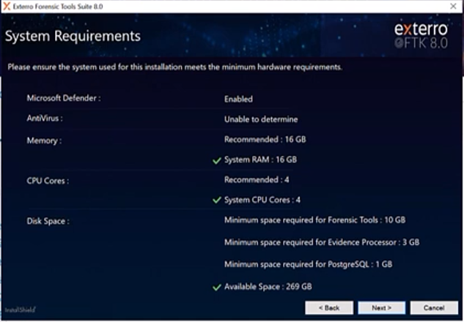
Figure 35: FTK System Requirements
While attempting to install a trial copy of FTK Forensic toolkit it was noticed that the minimum system requirements exceeded the capacity of the PC being used. It was possible to use FTK in the IQ205 lab for research and lab work, but as a remote student relied on FTK documentation and using Autopsy instead for Data Analysis.

