MANAGING PROJECTS IN THE ORGANISATION.
TASK 2- EVALUATION OF PROJECT MANAGEMENT PLAN (5104)
By: Javad khorramipour khoshdaregi (2030121)
Date:07/01/2024

Executive summary
The report summarises a project management plan called ‘healthy canteen’. The report summarises theories and models used for this project such as the theory of planning, stakeholder matrix, Gantt chart, work breakdown structure and many more. The report showcases the WBS structure where the ‘Healthyish Project’ has three major structures ‘planning’, ‘interior’ and ‘exterior’. The estimated project budget is £100,000.

Table of Contents
Introduction 4
Basic project outline/description/scope depending upon the project 4
Stakeholder analysis 5
WBS or work breakdown structure 6
Draft of resources/cost use 7
Consideration of resources 8
Project Schedule/Gantt Chart 8
Risk Assessment 10
Conclusion 10
Reference 11

Introduction
The purpose of the report is to discuss the project management plan related to healthy canteen. The report aims to take feedback from the pitch and evaluate this proposed project management plan. The report is going to discuss the scope of the project, analyse the key stakeholders, provide a work breakdown structure, draft the costs, and resources and outline the Gantt Chart. The report will also assess the risks related to the project. While discussing this, the report will introduce some project management techniques and tools and their usefulness related to the healthy canteen case scenario. The report will have prepared a plan for project implementation and authentic communication strategies.

Basic project outline/description/scope depending upon the project
The project management plan is to promote wellness via nutritious food choices. The purpose is to develop a healthy canteen. In this case, education related to healthy nutrition needs to be provided to build a well-being culture at work and in private life with a focus on building a productive and healthy environment. The vision of the project management plan is to provide food at affordable prices from controlled farms. The vision is to build emphasis on the health of guests of every age.
While discussing this project's scope the report implements the theory of planning. This theory consists of 10 core processes including scope definition, scope planning, resource planning, activity definition, activity duration estimation, activity sequencing, schedule development, cost estimating, project plan development and cost budgeting. All these are going to be discussed below. The project manager focuses on the farms or growers who overcome problems linked with highly complex and higher-value health crops. To build a healthy canteen, the project manager focuses on gathering organic foods from the farmers for the good health of employees. The project manager believes organic production supports risks related to public health. In this case, mounting evidence shows the food developed organically is rich in the nutrients that include iron, Vitamin C, phosphorus and magnesium, with minimum exposure to pesticide and nitrate residues in organically developed vegetables, grains and fruits compared to conventionally developed items (O’rinboev, 2023). The project manager also focuses on supplying these organic foods in bulk. This increases the opportunity for them to get at a cheap rate. The purpose of the project manager is to emphasise the health of people or guests of all ages. In the workplace, the motive of the project manager is to keep everyone fit to ensure building a productive environment. The project manager will encourage all the stakeholders to support the healthy canteen project plan and consume healthy foods for future benefits (Association, 2022).
The scope of this project plan is to keep the employees in good health. A healthy canteen can make the hydrated staffs more healthier. By consuming nutritious food, they can have better memory, improved reflexes and suffer fewer headaches. Consuming healthy food can keep them fit and they can generate a productive and healthy environment. The scope for the readers is to understand the benefits and importance of a healthy canteen in the work and the way the readers can also implement the same thing in their private life to keep themselves fit and healthy in upcoming days.

Stakeholder analysis
While discussing the stakeholders for this new project management, the report will implement a stakeholder matrix model. The model is implemented in the project management to support the review of the various project stakeholders to decide how perfectly coordinate things they value with the project. Every group or stakeholder can require a different strategy and a matrix can support the project manager in determining the perfect strategy for every group. A stakeholder map may support the project manager to understand the stakeholders who can create low and high impacts on the work and those with low or high interest in the work. In this manner, the project manager of this project may interact effectively with all of the project stakeholders- in a manner which works perfectly for them (Htoo et al. 2023).
Stakeholder mapping has major benefits like prioritising stakeholders and categorising the stakeholders effectively. This mapping can help the users understand the relevance of every stakeholder group and the focus of every stakeholder group. This tool ensures every relevant stakeholder is considered and visualises the resources used. This tool indicates how perfectly each stakeholder can interact and also alerts the major conflict at the beginning. However, this tool/model has been criticised a lot. This is because stakeholder priorities can change over time. For this reason, this is vital to monitor the local socio-political climate and act depending on that. Several stakeholders can not respond properly to the project, and act as critics or blockers.

Power-Interest Grid
High | Keep satisfied | Manage Closely
Power | - Investors  - Managers  - Staffs | - Suppliers  - Council
Power | Monitor | Keep Informed
Power | - Competitors in the market | - Local peoples
Low | Interest | High

Table 1: Stakeholder matrix for this project management plan
(Source: Created by the learner)
The above table of stakeholder matrix considers 4 stages such as ‘keep satisfied’, ‘manage closely’, ‘monitor’ and ‘keep informed’. As per the above table, it is determined that key stakeholders for this project management of ‘Healthy Canteen’ are investors, employees, managers, suppliers, council, competitors and local people. As per the power-interest grid, investors, employees and managers belong to the ‘Keep satisfied’ group because they have low interest but high power. Suppliers and councils belong to the ‘Manage Closely’ stage because they have high interest but low power. Competitors belong to the ‘Monitor’ stage because they have low power and low interest. Local people belong to the ‘Keep Informed’ stage because they have high interest but low power.

WBS or work breakdown structure
Work breakdown structure or WBS is a tool which utilises the technique and is one of the vital documents related to project management. This integrates schedule, cost and scope baseline singlehandedly ensuring that the project plan is in alignment. WBS is also considered as the deliverable-oriented hierarchical work decomposition to be executed by the project team. Two WBS types include Phase-based and deliverable-based (Weng, 2023). The highly preferred and common approach is deliverable-based. The major difference between the two approaches are Elements determined in the initial level of WBS. The WBS is implemented for several different things. Primarily, this serves as the planning tool to support the project team plan and organise and define the scope with deliverables. WBS is implemented as an initial source of cost and schedule estimate activities. However, the largest contribution to the project is implementation as the description of all of the work and as a controlling and monitoring tool. The benefits of WBS are this organises and defines the work needed and offers a visual of the whole scope. This may be implemented to determine potential scope risks while this has the branch and is not effectively defined. This facilitates fast schedule development by allocating effort estimates to particular sections of WBS. However, WBS has several disadvantages rigidity in planning, time-consuming to update and create, over-detailing and complexity. The WBS has disadvantages like reliance on the primary assumptions, challenges in accommodating the scope changes, resource allocation issues and potential for misalignment with the agile methodologies (Work Breakdown Structure, 2023).
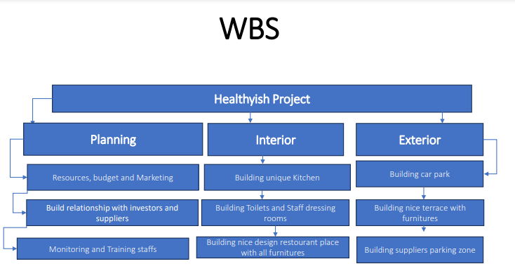
Fig 1: Work Breakdown Structure
(Source: Created by the learner)
As per the above figure, it is determined that planning, interior and exterior are the three key stages for the ‘Healthyish Project’. In planning, the project manager of this project management plan needs to develop marketing, budget and resources. The project manager also focuses on developing relationships with the suppliers and investors to keep the project operation running smoothly. Even the project manager before implementing the project management plan needs to train and monitor staff. In the Interior stage, the project stakeholders have to focus on developing a unique kitchen option. They also have to develop the staff dressing and toilets rooms and also develop a nice design place for the restaurant with all items of furniture. In the exterior stage, the project stakeholders need to focus on developing the car park option and developing a nice terrace with furniture. The stakeholders also need to focus on developing parking zones for suppliers.

Draft of resources/cost use
The key resources used for this project management plan ‘Healthyish Project’ are delivery personnel, chefs, equipment and restaurant space. These resources are allocated to 5 major stakeholders such as customers, communities, financiers, employees and suppliers. The other resources for this ‘Healthyish Project’ can be raw materials, vehicles for transport, cartoons and many more.
The costs for this project management depend upon new deliverables, staff changes, price changes and additional requirements. The cost will also depend upon the raw materials, transport costs, payments of suppliers, and many more. The estimated budget for this ‘Healthyish Project’ will be £100,000. The cost will also include project approval, interior-exterior works, building, design of the menu, interview new staff/initiate working and training/monitoring the staff.

Consideration of resources
The resources are considered depending upon ‘quality’, ‘budget’ and ‘communication’. The purpose of communication is to share data updates and effective progress with the stakeholders. The project manager of the ‘Healthyish Project’ to interact with all the stakeholders needs to be involved in building clear communication channels and effectively defining the reporting structures. On the other hand, quality depends upon the defining criteria of quality, implementing the measures of quality control through the lifecycle of a project and conducting the activities of quality assurance. Even the budget includes staff changes, price changes, new deliverables and additional requirements. All these areas are the key consideration when the project management of the ‘Healthyish Project’ is going to select the resources.

Project Schedule/Gnatt Chart
‘The Gantt Chart’ is also considered a tool of project management which illustrates the work finished over the period in the relation to time planned for this work. This normally includes two major sections include left side outlines the tasks list, at the time of right side has the tieline with the schedule bars which visualise work. Gantt charts are supportive of scheduling and planning projects. They support the users in evaluating how long the project will take, identifying the resources required and the plan order in which the users will finish the tasks. They are also supportive of managing the dependencies among the tasks. This project management tool is supportive due to they observe the progress and activities of the project. This tool shows the way work on the project may only start after other tasks have been finished. The managers may apply the data to effectively understand the project challenges and make major decisions about the way to take the project ahead (Ghorbani, 2023).
The advantages of Gantt Charts are offer a high-level overview and allow effective tracking. Even the benefits of Gantt Charts are also increase productivity, manage complex data and illustrate dependencies and overlaps. The advantages of Gantt Charts are managing complex data, balancing several projects and motivating the group members. Even the Gantt Chart also sets realistic expectations and deadlines. On the other hand, the Gantt Chart also has several disadvantages. It is time-consuming to update the chart and needs maximum effort to manage and create the chart. Even every task is not that visible in the single view of the Gantt and requires clicking and scrolling buttons to observe the remaining tasks. The Gantt Chart stacks also represent the time and not the working hours. Gantt charts become confusing and complex. For a big project, a Gantt Chart with several subtasks and tasks may become complicated (Meardon, 2024).
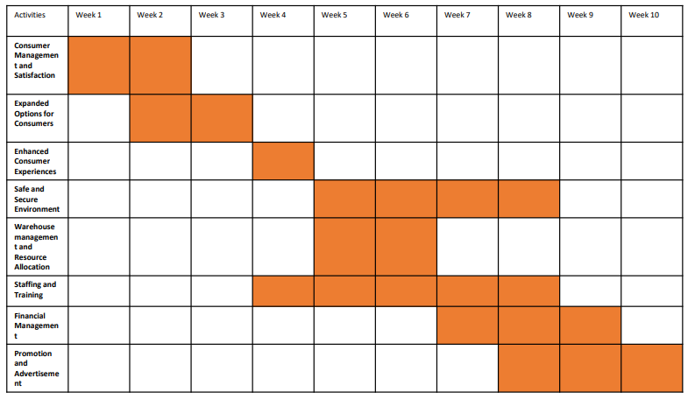
Fig 2: Gantt Chart for ‘Healthyish Project’
(Source: Created by the learner)
The above chart describes the number of weeks required to complete all the activities selected for this ‘Healthyish Project’. The above chart showcases the total 10 weeks required to complete these activities. It can take 2 weeks for consumer satisfaction and management. The weeks are week 1 and week 2. The expanded options for customers' activities are included in week 2 and week 3. In week 4 activities like enhanced customer experiences will be completed. From week 5 to week 8, the project stakeholders will complete a secure and safe environment. On weeks 5 and 6 the activity like resource allocation and warehouse management will be completed. From week 4 to week 8, training and staffing activities will be completed. From week 7 to week 9, the financial management activity will be completed. The project manager is going to complete the advertisement and promotion from week 8 to week 10.

Risk Assessment
The risk assessment of the project is the formal effort to determine and analyse risks which the project faces. Initially, groups determine all possible risks of projects. Secondly, they identify the potential and likelihood impact of all the tasks. At the time of the assessment of project risk, the groups analyse both negative and positive risks.
In terms of risk management for the ‘Healthyish Project’, running the restaurant may bring a lifetime of both financial and personal rewards. This may be a regular issue, requiring the manager or owner to face several risks. The risk can be managed in terms of food handling, property damage, worker safety and equipment maintenance. On the other hand, people can be managed by reducing turnover, improving consumer experience and increasing morale. Managing restaurant employees is vital due to effective management supports groups to operate efficiently and smoothly.
The execution of this project management can be done by focusing on the interaction with the stockholders. Interaction with the stockholders is a major success and is important for the restaurant. The 5 major stakeholders are suppliers, staff, communities, financiers and customers. After the completion and submission of the project, the project manager needs to recap the project and focus on the goals the stakeholders of this project have achieved. Depending upon the success criteria, the project manager of ‘Healthyish Project’ will close the loop-project deliverables.

Conclusion
The report concludes with the ‘Healthyish Project’ where the healthy canteen will be developed in the workplace to maintain a healthy and productive environment for employees. While discussing the scope of this project the project will implement the theory of planning. The report details the stakeholder matrix model to determine staff, managers, investors, suppliers, competitors, local people are the key stakeholders of this ‘Healthyish Project’. The report concludes managers and staff belong to ‘keep satisfied’ and suppliers and council belong to ‘Manage Closely’. In this project, WBS implements three parts of the project including planning, interior and exterior. The estimated project budget will be £100,000. The major resources for this project are customers, financiers, communities, suppliers and staff. The report details the project will be completed within week 10. The report details risks that can be assessed by determining and analysing risks that the project faces.

Reference
Association, O.T. (2022) Health benefits of organic, OTA. Available at: https://www.ota.com/health-benefits-organic#:~:text=Not%20only%20does%20organic%20production,and%20grains%20when%20compared%20to (Accessed: 06 January 2024).
Ghorbani, A., (2023). A review of successful construction project managers’ competencies and leadership profile. Journal of Rehabilitation in Civil Engineering, 11(1), pp.76-95. https://scholar.google.com/scholar?as_ylo=2023&q=project+management+tools&hl=en&as_sdt=0,5
Htoo, T.T., Dodanwala, T.C. and Santoso, D.S., (2023). Project management maturity and performance of building construction projects in Myanmar. Practice Periodical on Structural Design and Construction, 28(1), p.04022070. https://scholar.google.com/scholar?as_ylo=2023&q=project+management+tools&hl=en&as_sdt=0,5
Meardon, E. (2024) Gantt charts, Atlassian. Available at: https://www.atlassian.com/agile/project-management/gantt-chart#:~:text=What%20is%20a%20Gantt%20chart,schedule%20bars%20that%20visualize%20work. (Accessed: 06 January 2024).
O’rinboev, A., (2023). STRATEGIC PROJECT MANAGEMENT FOR SCIENTIFIC WEB APPLICATIONS: LESSONS LEARNED AND FUTURE TRENDS. Current approaches and new research in modern sciences, 2(9), pp.9-13. http://econferences.ru/index.php/canrms/article/view/8368
Weng, J.C., (2023). Putting Intellectual Robots to Work: Implementing Generative AI Tools in Project Management. NYU SPS Applied Analytics Laboratory. https://archive.nyu.edu/bitstream/2451/69531/2/Putting%20Intellectual%20Robots%20to%20Work%20-%20Implementing%20Generative%20AI%20Tools%20in%20Project%20Management%20White%20Paper%20By%20Conor%20Weng%20%20.pdf
Work Breakdown Structure (2023) Work breakdown structure, workbreakdownstructure.com. Available at: https://www.workbreakdownstructure.com/ (Accessed: 06 January 2024).

