

Module: Service Logistics (M6X01294)

Programme: Bsc (Hons) Logistics and Supply Chain Management

Student: Jodi Emanuelli

Student Number: P093663

Lecturer: Irina Neaga

Executive summary
In this report, the manufacturing industry is used to examine the implementation of lean. The way in which lean tools, based on the five lean principles by Womack and Jones (2014), are utilised throughout the manufacturing industry, are used to demonstrate the benefits to an organisation and the possible disadvantages. Brush Switchgear is used as a case study and real-life example to support the information included and to highlight the use of value stream mapping, as an essential element of lean manufacturing. The analysis in this report is encapsulated in the conclusion.

1
Table of contents
1. INTRODUCTION 3
2. MAIN BODY 4
2.1 Lean Manufacturing 4
2.2 Seven wastes of Lean …………………………..………………………………………… 4-5
2.3 Lean Tools ……………….…………………………………………………………………… 5
3 Brush Switchgear ………………………..……………………………………………….. 5-6
3.1 Five Principles of Lean …………………………………..………………………………. 6
3.2 Value ……………………………………………………….………………………………….. 6-7
3.3 Value Stream …………..…………………………………………………………………… 7-8
3.4 Flow …………..…………..…………………………………………………………………… 8-9
3.5 Pull ………………………..…………………………………………………………………… 9-10
3.6 Perfection ….…………..…………………………………………………………………… 10-11
3.7 Future State Map .…..…………………………………………….……………………… 11-12
4.0 Conclusion 13
References

2
- Introduction
Customised products, depicted in Twenty-first century manufacturing, has resulted in complicated systems for mass producing products. Globally competitive and customer focused markets resulted in major challenges for organisations, as they searched for new strategies to support their rise in the evolving market picture. Some organisations failed to grow due to their lack of comprehension of a new type of consumer and cost practices. Bhamu (2014) claims that to overcome this situation and to become more profitable, many manufacturers turned to “lean manufacturing” (LM).
Bhamu (2014) states that manufacturers can gain a competitive edge by employing lean manufacturing strategies, as they are enhancing both productivity and quality whilst lowering costs. Implementing lean manufacturing has many quantitative advantages, such as, inventory, lead time and cycle time, and a range of qualitative advantages, such as, job satisfaction and effective communication.

Within this report, Brush Switchgear is used as a case study to critically evaluate its implementation of lean thinking and management tools for continuous improvement.

3
2.1 Lean Manufacturing
Lean manufacturing is aimed at continuous improvement, with the determined quest and eradication of waste. ‘Muda’, Japanese for waste, is used to describe any process in the production system which is failing to increase the value of the final product. The idea of lean is founded on the principle of best value for the customer. Therefore, a lean manufacturing organisation applies systems and a set of tools that allows them to remove non-value-added waste and repeatedly improve processes. “It is important to note that lean is focused on improving the quality of products, as well as stability of processes. It is not just about churning things out more quickly, but about looking at ways to improve both the product and the system wherever this is possible” (can Akdeniz, 2015).
Successful methods utilised by the Japanese car manufacturers, Toyota, resulted in lean manufacturing. This was achieved with reduced human effort and investment, lower inventory and defects together with a greater range of products. The Machine that changed the world, by J Womack and D Jones, ensured that the term, lean manufacturing, became known Worldwide.

2.2 Seven wastes of lean
According to Womack and Jones, it is essential when developing a successful organisation to eradicate wasteful activities, an idea that is a fundamental part of lean. Eliminating waste is a concept the Toyota production system developed and Taiichi Ohno was responsible for creating robust and well-organised processes in the production system. Taiichi Ohno identified three obstacles, wasteful activities, overburden and unevenness, which would impact negatively on an organisations effective work process. In lean manufacturing, waste expends resources and has no value to the end customer. Organisations focus on lowering waste whenever conceivable and thus recognise opportunities for enhancing their overall performance. However, not all wasteful activities can be removed as some are essential. Through research and practice, Taiichi Ohno classified the seven types of waste.
Overproduction: Producing surplus to customer requirements or producing earlier than necessary. This impedes the flow of goods and results in disproportionate lead and storage time. Consequently, this could impact on the early detection of defects and quality of products.
Waiting: This waste is pertinent to lead time, as it impacts on flow and the lack of value added, and directly effects customer satisfaction. Personnel waiting for work is waste and the goal would be to lessen waiting to zero.
Motion: Pointless motions is applicable to both machinery and work force. The human element relates to work-place efficiency, for high quality and productivity, and the machine element refers to inferior work-place layout which could result in waste of movement.

4
Transportation: Movement of products, in or out of inventory or from one process stage to the next, is non-value-added waste that can be reduced but never completely removed. However, this doubling handing is a waste that impacts on both product quality and productivity.
Over processing: Waste in terms of work failing to generate additional value or generating more value than the customer requires, thus increasing organisation costs. In addition, personnel over processing could be carrying out value added tasks.
Inventory: Waste generated by unprocessed inventory including, materials not being processed, storage, work in progress, raw materials, transporting of inventory and capital. Excess inventory can camouflage the earlier wastes of producing the inventory.
Defects: A product not meeting required specifications in terms of design or customer expectation. Defective products need to be substituted and this leads to additional work, with the possibility of losing customers. The resources applied to the defective product are therefore waste and there was possibly waste at other stages in the process.

2.3 Lean Tools
Lean manufacturing utilises lean tools, which are strategies and processes. These tools enable organisations to detect problems, and solve these problems, during the production process. (Arora, 2016). The way in which these problems are both detected and resolved will impact positively on the efficiency of the procedure. Various adaptable lean tools, used by a range of organisations, can assess and react to circumstances in a precise way that will support the aim to reduce waste and thus see an increase in profits.
To achieve optimal results, there are a wide range of lean tools available and varying groupings of strategies can be utilised. This report will focus on the lean tools recognised as Value Stream Mapping (VSM) and Kanban. To comprehend the suitability of these tools, and to appreciate the ways in which they can be applied, the case study in this report will focus on the way in which the lean tools have been implemented and developed within the despatch department of Brush Switchgear.

- Brush Switchgear
“Brush Switchgear is a leading manufacturer of highly reliable indoor and outdoor medium voltage switchgear. They focus on the integration of all functions across the supply chain from raw materials right through to the distribution of goods. With over 130 years’ expertise, Brush Switchgear has a reputation for innovation, first class product performance and delivering high service standards to customers in the major utilities, industrial, transport and infrastructure sectors across the world” (BrushSwitchgear, 2020).
Brush Switchgear aimed to produce a sustainable, competitive advantage by implementing,
5
from the start, a lean manufacturing approach. This approach enabled them to adopt a systematic process for reducing waste during the manufacturing stage. However, Brush Switchgear ensured that they maintained a degree of control over the production process and product quality. This had a positive impact on their effectiveness and efficiency, credibility and a rise in their share of the market.
  - Five Principles of lean
Brush Switchgear applied the five principles of lean to their process to support them in carrying out value stream mapping and Kanban. In the book, “The Machine That Changed the World” Womack and Jones identified the five principles of lean manufacturing. The five principles, Value, Value Stream, Flow, Pull and Perfection, are deemed a formula for enhancing workplace efficiency.
  - Value
According to Womack and Jones (2014), Value is the important beginning for lean thinking and can be characterised by the end consumer. It is imperative that value must begin by trying to exactly state value in terms of explicit goods with explicit competencies on offer at explicit costs following communication with exact consumers, thus avoiding waste.
The jobs carried out in Brush Switchgear, based on the lean principle value, can be categorised into three groupings.
- Value added tasks are those that consumers are willing to pay for that add value
- Nonvalue added but necessary tasks may not add value that consumers would pay for, but they are necessary
- Nonvalue added (waste) are tasks that have no value and are not necessary and should be recognised and removed.
Brush Switchgear are aware of the need to diminish nonvalue added tasks, decrease nonvalue added but necessary and increase the ratio of value-added time. In order to achieve this, Brush Switchgear use a workflow map to identify the seven wastes within their work processes and a visual representation of the procedures, conclusions or jobs undertaken to attain set outcomes. Below is an example of the workflow map carried out in the despatch department at Brush Switchgear.

6
Figure 1. Workflow Map (BrushSwitchgear, 2020)

An analysis of the workflow map demonstrates that 17.7 percent of the tasks performed in the despatch department, whilst packing units, are non-value-added tasks.
According to Tyagi et al. (2015), The information in the workflow map above is collated from observing each step of the process on the shop floor and classifying each action as value added, non-value added but necessary or non-value added. This can also be referred to as Gemba, that is, moving through the process with the workers supporting them in identifying and resolving issues. One of the advantages of Gemba is that it supports continuous improvement and process standardisation. Another advantage is that all members of the team’s efforts are affiliated, which improves the effectiveness of the workforce and provides the opportunity for determining improvement.

  - Value stream
After Brush Switchgear identified the value, the next stage in the lean process they progressed to, was the value stream. The value stream is the actions needed to get a product from the raw material stage to the end consumer (Zahrotun, 2018). To eliminate waste in the process, Brush Switchgear mapped the value stream in order to verify which processes did and did not add value, by utilising the lean tool Value Stream Mapping (VSM).
7
VSM is a visual tool, comprising of icons and symbols, which displays the appropriate system on one page. A value stream comprises of the necessary information, materials, and system needed to manufacture a specific product. Brush Switchgear use VSM to diagnose, implement and maintain a lean approach, as this tool can diminish the length of time from order to delivery of a product. Brush Switchgear use VSM as part of their lean initiative, as it emphasises waste and the negative impact waste has on performance and flow (Faulkne, 2014).
Below is an example of Brush Switchgear’s current stream map (CSM). This map detailed the current operating conditions in the production process from start to finish. This meant that issues were identified, and waste analysed.
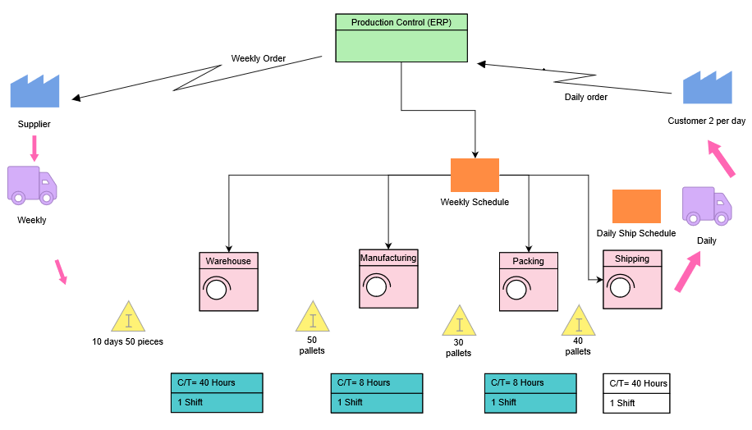
Figure 2. CSM (BrushSwitchgear, 2020)

The current state map at Brush Switchgear demonstrates that the complete cycle time from customer order to despatch is twenty-two days. It also highlights that the business is holding excess inventory, resulting in high costs for the organisation and the potential risk of loss and damages. The map illustrates that Brush Switchgear needs to reduce their inventory levels and speed up cycle time by reducing the waste, in order to meet customer demand.

  - Flow
According to Bicheno (2004), The next stage in the process is to formulate the value-creating steps flow. Flow can be defined as the way in which work progresses smoothly through a system. Good flow is when the system is moving at an even pace in a predictable manner. Bad flow means the work is intermittent and any interruption in the flow results in the possibility of an increase in waste.
To ensure enhanced value to consumers and a more dependable delivery, Brush Switchgear
8
aims for consistent flow. Nakao-San, a Japanese sensei recognised the seven flows of lean. These are the flows of raw material, work-in-process, finished goods, operators, machines, information and engineering. If these seven flows are successfully incorporated, there is a greater probability that the production of completed goods and services will need limited corrective action and that efficiencies are created (Bicheno, 2004).
The lean tool takt time is utilised at Brush Switchgear to ensure efficient flow through the process. “Takt time is the fundamental concept to do with the regular, uniform rate of progression of products through all stages from raw material to customer. Takt time is the drumbeat cycle of the rate of flow of products. Takt time is fundamental to flow and mapping of lean operations. It is the available work time divided by the average demand per day” (Bicheno, 2004).
Below is an illustration of how takt time is measured in the despatch department at Brush Switchgear.
Figure 3. Takt time (BrushSwitchgear, 2020)

This demonstrates that to meet customer demand of ten units per week, with the available workforce, the task of packing a unit would need to be completed in 3.8 hours. The workflow map in the previous section illustrates that packing a unit takes 8.4 hours. Therefore, Brush Switchgear are currently unable to meet customer demand.

  - Pull
Pull can be defined as the need to make merely what is required in response to customer demand. There are two levels of pull and to both, attention is essential. On one level, organisations would need to produce to a point and then react to consumer pull signal from then on. On another level, pull signs from an internal consumer are reacted to and this could be the next stage in the process in the case of Kanban. (WomackandJones, 2104).
The lean tool Kanban, a type of pull mechanism and signalling device, has been adopted by Brush Switchgear to regulate inventory levels and the production and provision of mechanisms. Therefore, Brush Switchgear can catagorise and examine the variations of the
9
Kanban. Different sorts of Kanban systems include, single card and dual card Kanban (Nicholas, 2018). Brush Switchgear use the product Kanban system, the most uncomplicated form of Kanban, as whenever a product is used it is simply replaced. However, if there is no alert, no authorisation takes place, thus there is no production.
At Brush Switchgear, packing materials are stored in bins on racks. When the bins are empty, they are placed on top of the racks and this is the notification to refill the bins with the parts from the back. Below is a representation of the Kanban system used at Brush Switchgear (BrushSwitchgear, 2017).
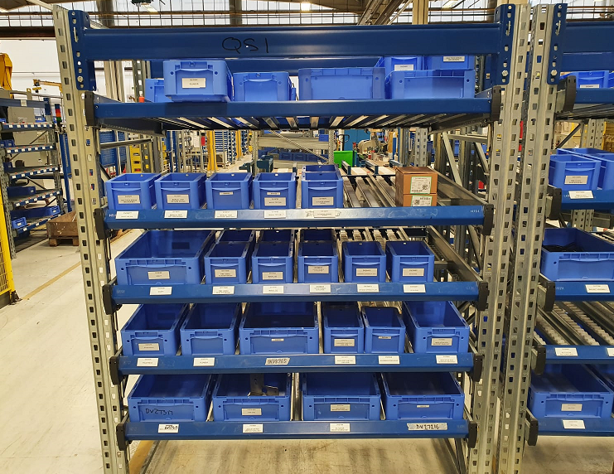
Figure 4. Kanban (BrushSwitchgear, 2020)

  - Perfection
The constant pursuit of perfection is the last principle of lean. Following the application of the first four principles, organisations aim for perfection as the actions in a value stream become more apparent. Referring to Womack and Jones, Gupta states that this principle urges management to constantly seek opportunities for improvement as there is an ongoing determination to reduce cost, time and mistakes in a value stream (Womack and Jones, 2014).
In today’s competitive and evolving market, continuous improvement is an invaluable tool as it enhances competitiveness through utilising knowledge and including organisations’ workforce. Brush Switchgear has developed cross-functional teams of people that meet weekly to create a Kaizen environment and focus on improving a targeted work area, in order to maintain standards. Team members are from different areas of work, on different levels within the organisation and chosen by the management (Marin-Garcia, 2018). This ensures a range of view- points and the discussion of issues affecting different departments.

10
Kaizen has a focus on recognising issues, and where these issues evolved from, the resolutions required to be implemented and the change in operational processes needed to safeguard against this issue reoccurring. To measure the effectiveness of kaizen, Brush Switchgear use Key performance indicators.
“Kaizen, understood as CI, it can be seen as the corporate capability that forms part of either total quality management (TQM) or some other kind of improvement and innovation program It is not a static concept, but one that evolves through several levels and specific behavior patterns emerge from each one while successfully implementing CI” (Marin-Garcia, 2018).

  - Future state map
Brush Switchgear produced their future state map (FSM) after completing all lean principles and removing non value-added waste where possible. FSM specifications are the ultimate targets to be achieved and the FSM shows the productivity based on the proposed changes and gaps in the CSM (King, 2017).
Below is and evaluation of the cycle time between the current state and the future state maps.

Figure 5. Takt Time (BrushSwitchgear, 2020)

This illustrates that non value-added time has decreased by 92 percent. This was achieved by removing certain steps out of the process, which could be carried out by other departments or could be eliminated from the process, and by moving all packing materials to one station. Therefore, a unit could now be packed in 7.5 hours. Although the NVA time has been removed, customer demand is still not met. Brush Switchgear recognised that to meet customer demand the workforce in the despatch department needed to be doubled, as shown in the table below (BushSwitchgear, 2020).

11
Figure 6. Takt time (BrushSwitchgear, 2020)

Based on the average cycle time in the above table, Brush Switchgear created the future state map displayed below.

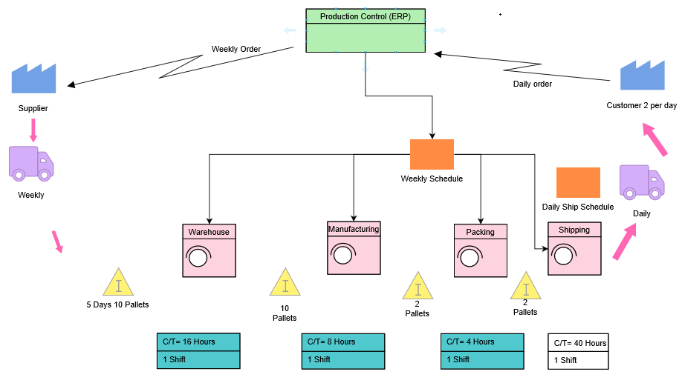

Figure 7. FSM (BrushSwitchgear, 2020)

12
- Conclusion
Research acquired for this report demonstrates that implementing lean impacts positively on raw materials to the end consumer, as verified by the success of Brush Switchgear as a global company. However, it must be acknowledged that there are negative impacts related to the implementation of lean in an organisation.
At Brush Switchgear since the implementation of lean, the advantages can be seen in numerous ways. There have been improvements made, as demonstrated in the rise in inventory accuracy from 58 to 94 percent and material shortages and delays have increased from 78 to 89 percent. In addition, inventory value has decreased by 18 percent and revenue has increased by 22 percent. This is evident as Brush Switchgear have greater free cash flow to develop new products and have taken the opportunity to make acquisitions and increase marketing activities. As a consequence of lean implementation, Brush Switchgear have developed a cost to produce benefit that delivers greater pricing flexibility, thus a gain in sales, and are able to better meet consumer demand. Disadvantages around the implementation of lean include, productivity and implementation costs, supply issue, the risk of customer dissatisfaction and a lack of acceptance of the new way of working by employees.

13
References
Abd El-Aty, A., Farooq, A., Barakat, A. and Etman, M., 2015. Implementation of Lean Manufacturing Principles in the Process Industry: A Case Study. Applied Mechanics and Materials, 799-800, pp.1431-1435.
Akdeniz, C. (2015). Lean Manufacturing explained
Arora, P., 2016. Application of lean principles/ lean management can improve. Indian Journal of Medical Microbiology, 34(2), p.259.
Bhamu, J. and Singh Sangwan, K. (2014). Lean manufacturing: literature review and research issues. International Journal of Operations & Production Management, 34(7), pp.876-940.
Bicheno, J., 2004. The New Lean Toolbox Towards Fast, Flexible Flow. Buckingham: PICSIE.
Brush.eu. 2020. Switchgear | BRUSH. [online] Available at: <https://www.brush.eu/switchgear> [Accessed 6 March 2020].
Čiarnienė, R. and Vienažindienė, M., 2012. LEAN MANUFACTURING: THEORY AND PRACTICE. ECONOMICS AND MANAGEMENT, 17(2).
Faulkner, W. and Badurdeen, F., 2014. Sustainable Value Stream Mapping (Sus-VSM): methodology to visualize and assess manufacturing sustainability performance. Journal of Cleaner Production, 85, pp.8-18.
Jones, D. and Womack, J., 2014. Lean Thinking. [Place of publication not identified]: Free Press.
KING, P., 2017. VALUE STREAM MAPPING FOR THE PROCESS INDUSTRIES. [Place of publication not identified]: CRC Press.
Liker, J., 2013. Toyota Way. New York: McGraw-Hill
Marin-Garcia, J., Juarez-Tarraga, A. and Santandreu-Mascarell, C., 2018. Kaizen philosophy. The TQM Journal, 30(4), pp.296-320.
Nicholas, J., 2018. Lean Production for Competitive Advantage. Boca Raton, FL: Productivity Press.
Smith A, T. (2015). Lean Thinking: An Overview. Industrial Engineering and Management,
Sundar, R., Balaji, A. and Kumar, R., 2014. A Review on Lean Manufacturing Implementation Techniques. Procedia Engineering, 97, pp.1875-1885.
Tyagi, S., Choudhary, A., Cai, X. and Yang, K., 2015. Value stream mapping to reduce the lead-time of a product development process. International Journal of Production Economics, 160, pp.202-212.

14
Wachche, N., 2016. Implementation of Lean Six Sigma Principles: Making Data Cleansing Lean. International Journal of Computer Applications, 141(14), pp.41-45.
Zahrotun, N. and Taufiq, I., 2018. Lean Manufacturing: Waste Reduction Using Value Stream Mapping. E3S Web of Conferences, 73, p.07010.

15

