International Business Communications
Assessment 2

Student Name: Veronica Nita
Student ID: 2123371
Module Code: LCBB6001
Lecture: Zainab Atta

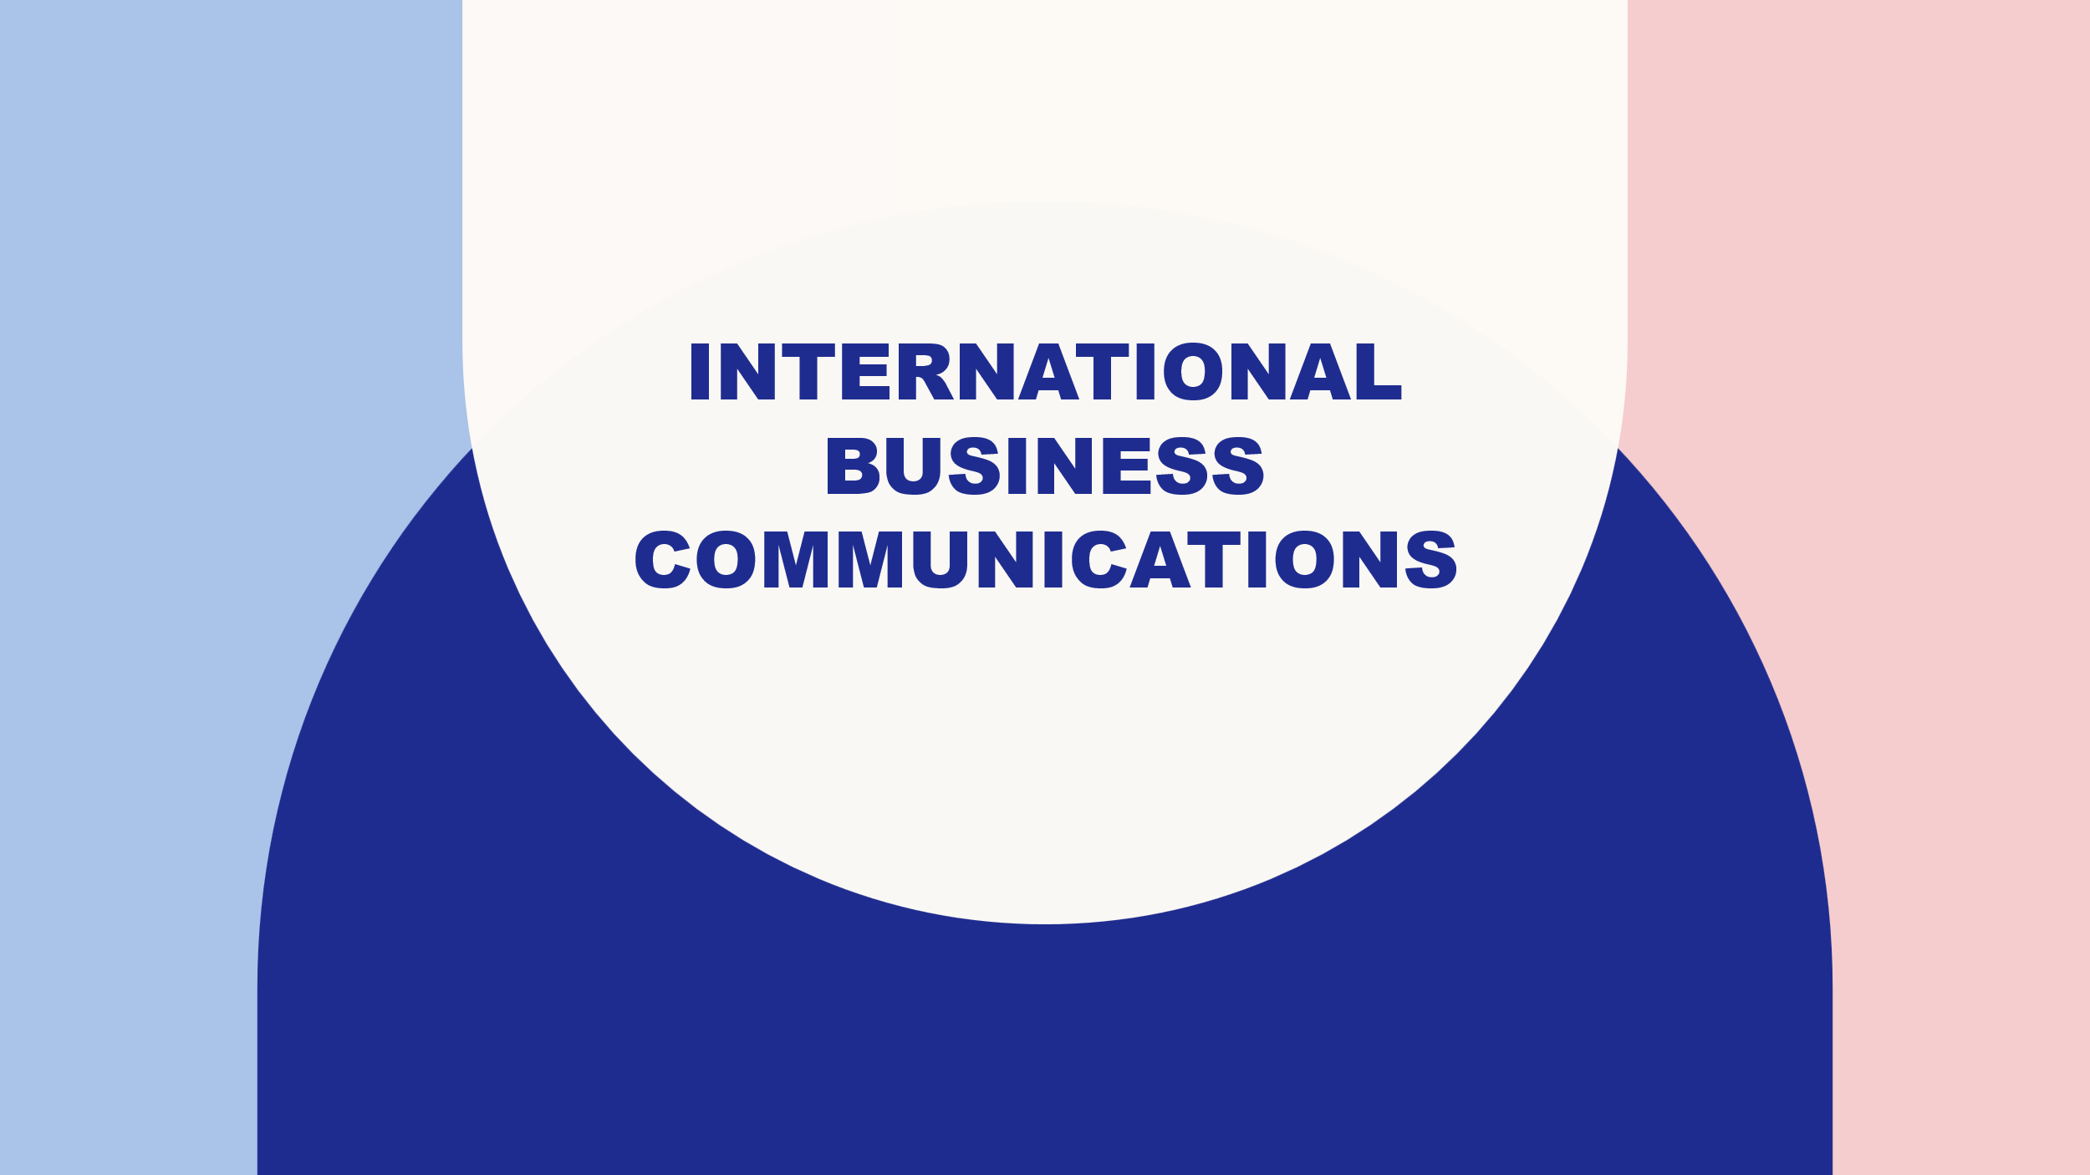
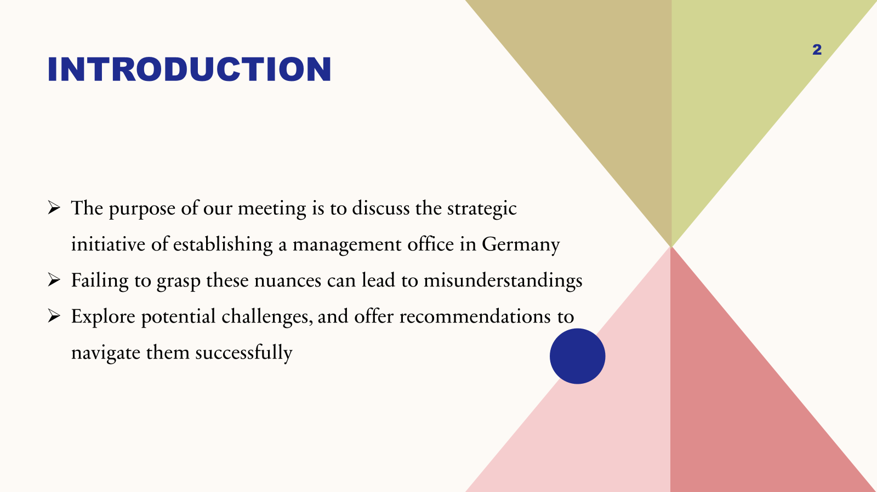
They are here today to talk about the grand plan to set up a German branch of our illustrious British multinational company's management office. Recognising the importance of recognising cultural variations is vital as we begin our growth journey. Culture has a significant impact on how people make decisions, how they communicate, and how businesses operate. It is possible to fail miserably in the new market if they do not comprehend these subtleties (Gudykunst & Kim, 2023). They will discuss the cultural differences between Germany and the United Kingdom, possible obstacles, and solutions in today's session. Our programme will include cultural differences, Hofstede's dimensions, problems, and practical solutions for adapting to other cultures. We will get into the specifics now.
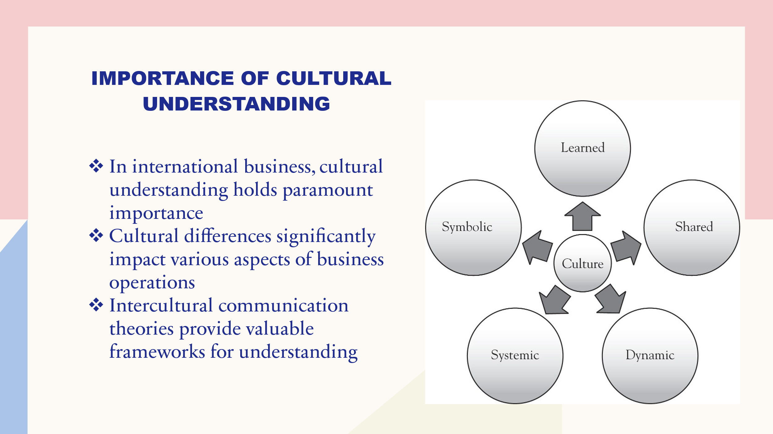
Cultural understanding is a very important part of international business because it has a big effect on how well or how poorly businesses do in foreign markets. Culture plays a big role in how businesses run, especially when it comes to communication, making decisions, and the success of the company as a whole. When people don't understand and react to cultural cues, it can lead to a chain of problems that make it hard for them to work together and finish tasks. Different cultural norms and views also affect how decisions are made, which in turn affects how relationships with stakeholders are built, how talks go, and how strategy planning is done. Understanding and navigating these subtleties is easier with the help of theories of international conversation (Schwartz, 2022). Hofstede's cultural factors, for instance, show how power gap, independence vs. unity, masculinity vs. gender, doubt avoidance, and long-term vs. short-term outlook are different in different societies. Using these ideas to change their strategy, communication methods, and management structures to fit the cultural setting of their target markets can help businesses run better and grow more likely.
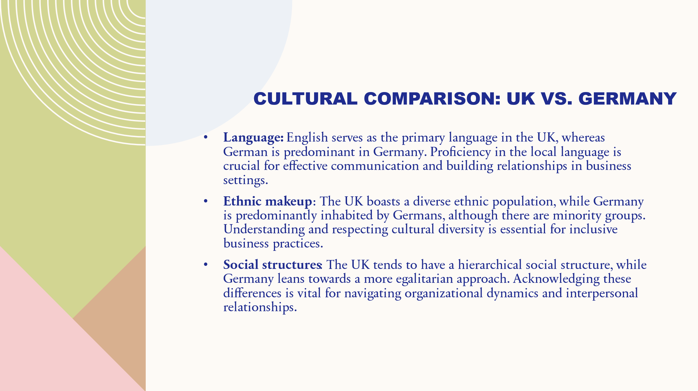
In the UK, English is the official language. In Germany, German is the language of business and government. To do well in business, people must be able to speak and connect with others in their native language. Different racial groups live in different parts of the UK. In Germany, on the other hand, most people are German and only a few are from smaller minority groups. Businesses that want to be more open to everyone need to understand and value the different kinds of people who live in their communities (Hofstede, Hofstede, & Minkov, 2019). Germany and the UK have different ways of running their own governments. That being said, Germany is more fair than the UK. To do work well in groups and with other people, it's essential to be able to tell the differences between things. In terms of religion, Christianity has a big impact on Germany, while religion has less of an impact on the UK. Religious customs and views can be taken into account and respected at work, which can lead to more polite talks. The UK's realistic and independent business mindset stands out compared to Germany's careful and consensus-based approach. Changing management styles and decision-making processes in the right way is key to working together well and meeting local needs.
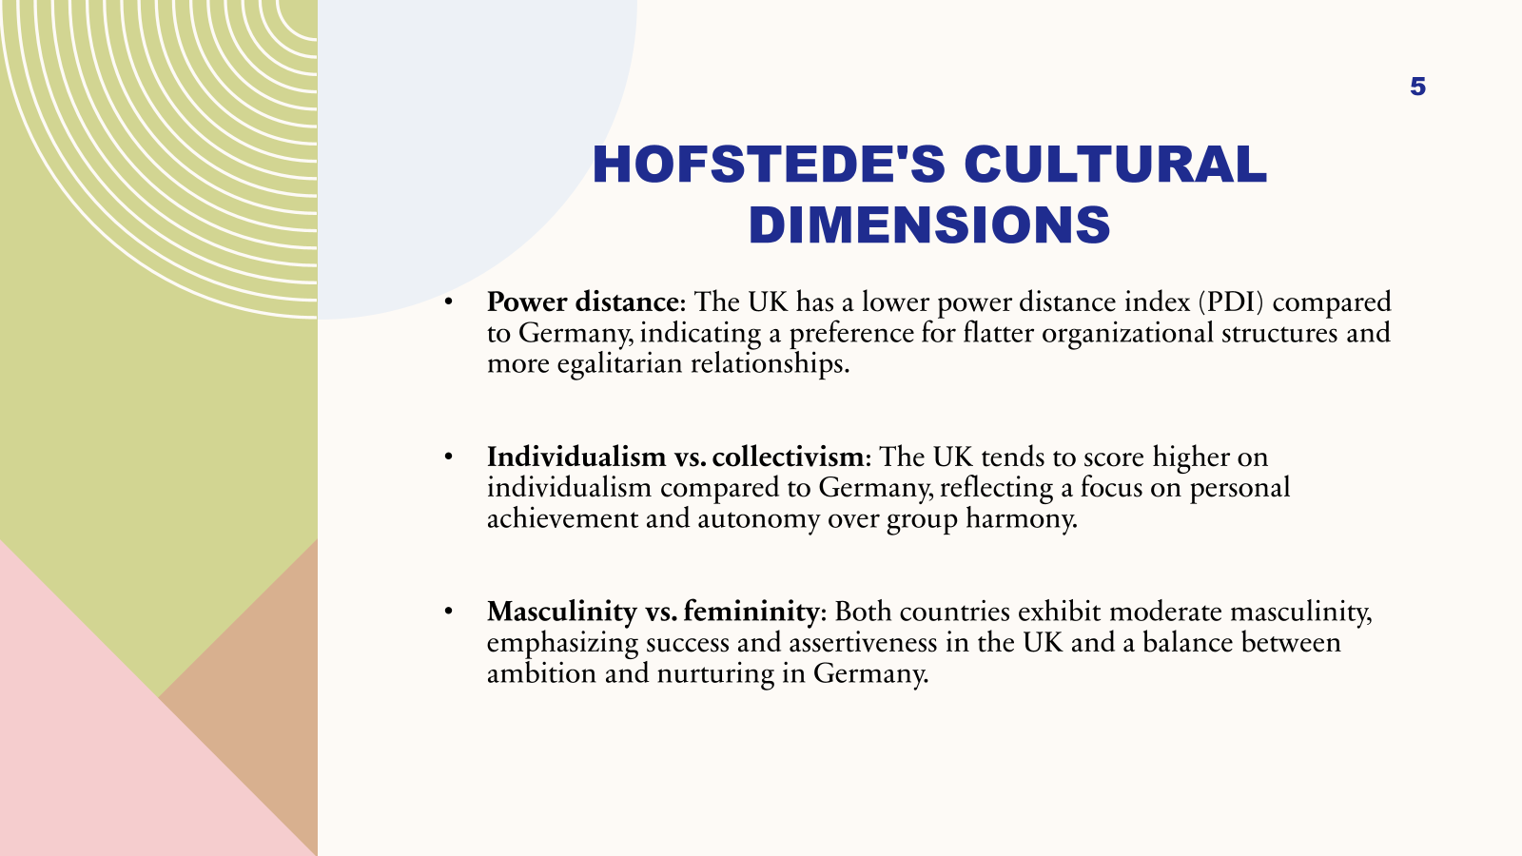
Hofstede's cultural aspects are the only way to understand how different cultures work in different places.
According to the power distance index (PDI), the UK values more equal links and flatter organisational structures than Germany. The UK has higher marks on the individualism scale than Germany. This means that its people value freedom and independence more than they value getting along with others. There is a good balance of desire and nurturing in Germany, while the UK puts a lot of stress on success and aggression (Hall, 2016). Both countries have a modest level of manhood. As they can see from their higher doubt avoidance scores than the UK, Germany seems to like rules, organisation, and careful planning when it comes to lowering risk. The fact that Germans value patience, saving, and investing in the future more than British people does suggests that they put more value on the long run. Because different cultural views and tastes affect how businesses run and how leaders make decisions, leadership styles, communication strategies, and decision-making processes need to be adaptable.
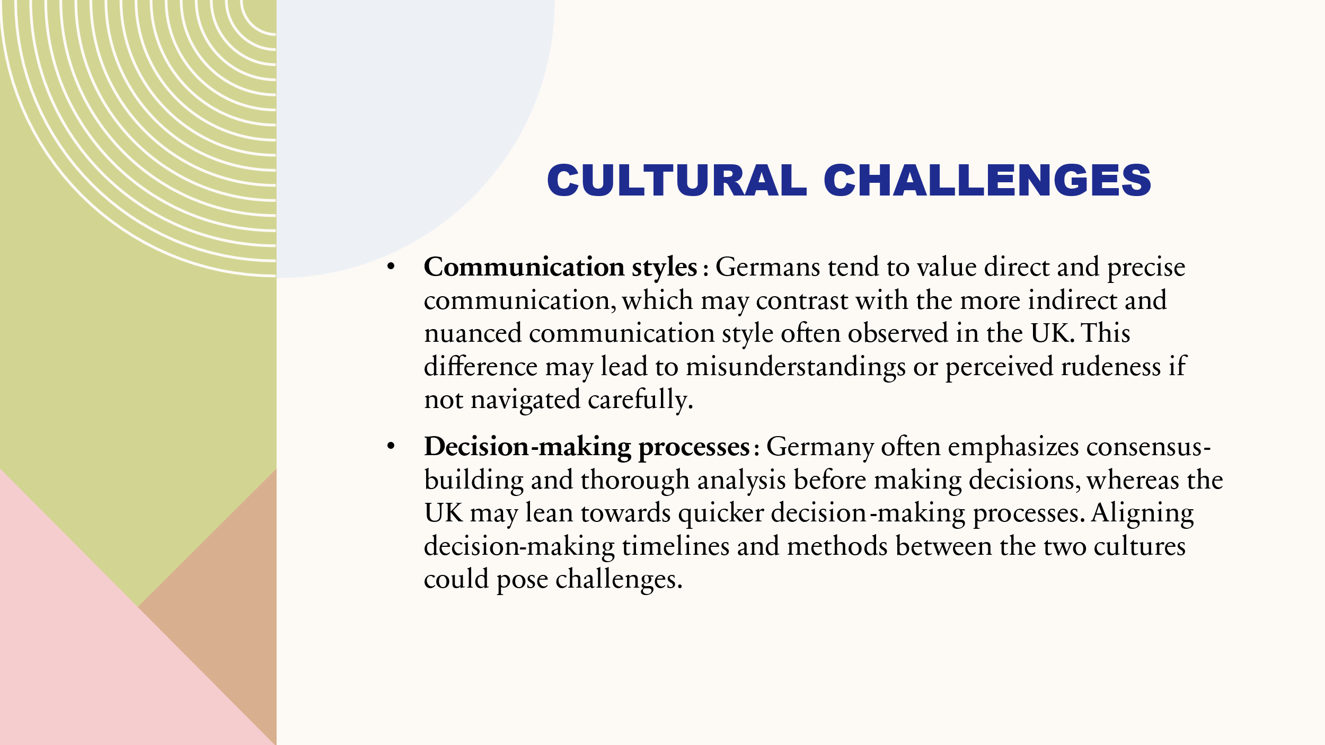
Germans value being honest and direct when they talk to each other, which may be different from the way people in the UK talk to each other, who tend to be more subtle and indirect. Not being careful with this difference could lead to confusion or the idea that someone is being mean (Adler, 2018). In contrast to Germany, where finding common ground and doing a lot of research are important, the UK's decision-making process may be more efficient and quick. It might be hard to get the two groups to agree on how to make decisions and when to do things. Germany has laws that control working hours and leisure time. This is because the country traditionally values a good mix between work and life. Since this is different from the way things are done at work in the UK, it could affect how happy and loyal employees are if it is not treated properly. German workplaces are more structured and hierarchical, which might not fit with British ones, which are more relaxed and flexible. Seeing and valuing these differences is important for good leadership and teamwork in the new management office.
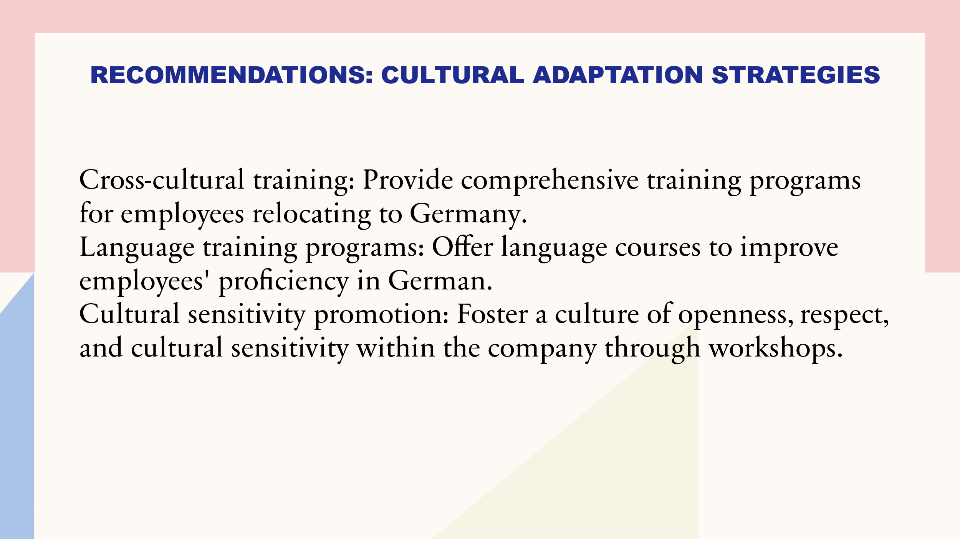
Culture-crossing training: Help workers who are going to Germany get used to German culture, business rules, and conversation norms by giving them full training courses. They will be better able to deal with cultural differences after this. Programmes that teach languages: Give employees German lessons to help them speak and understand the language better. This will make it easier for them to work with and talk to coworkers and clients in Germany (Thomas & Inkson, 2019). Promoting cultural sensitivity: Use classes, lectures, and diversity training to help the company develop an atmosphere of openness, respect, and cultural sensitivity. Tell the workers to be open to cultural differences and to deal with others with a positive attitude. Training programmes: Set up training programmes that pair up experienced UK workers with experienced German workers. This lets people share what they know, learn about other cultures, and get help figuring out how to do business in Germany. Cultural audits: Do cultural audits daily to find possible blind spots or places where cultural adaptation tactics could be better. Use the results to make sure that training programmes and policies are always in line with German culture and that they continue to be successful in the German market.
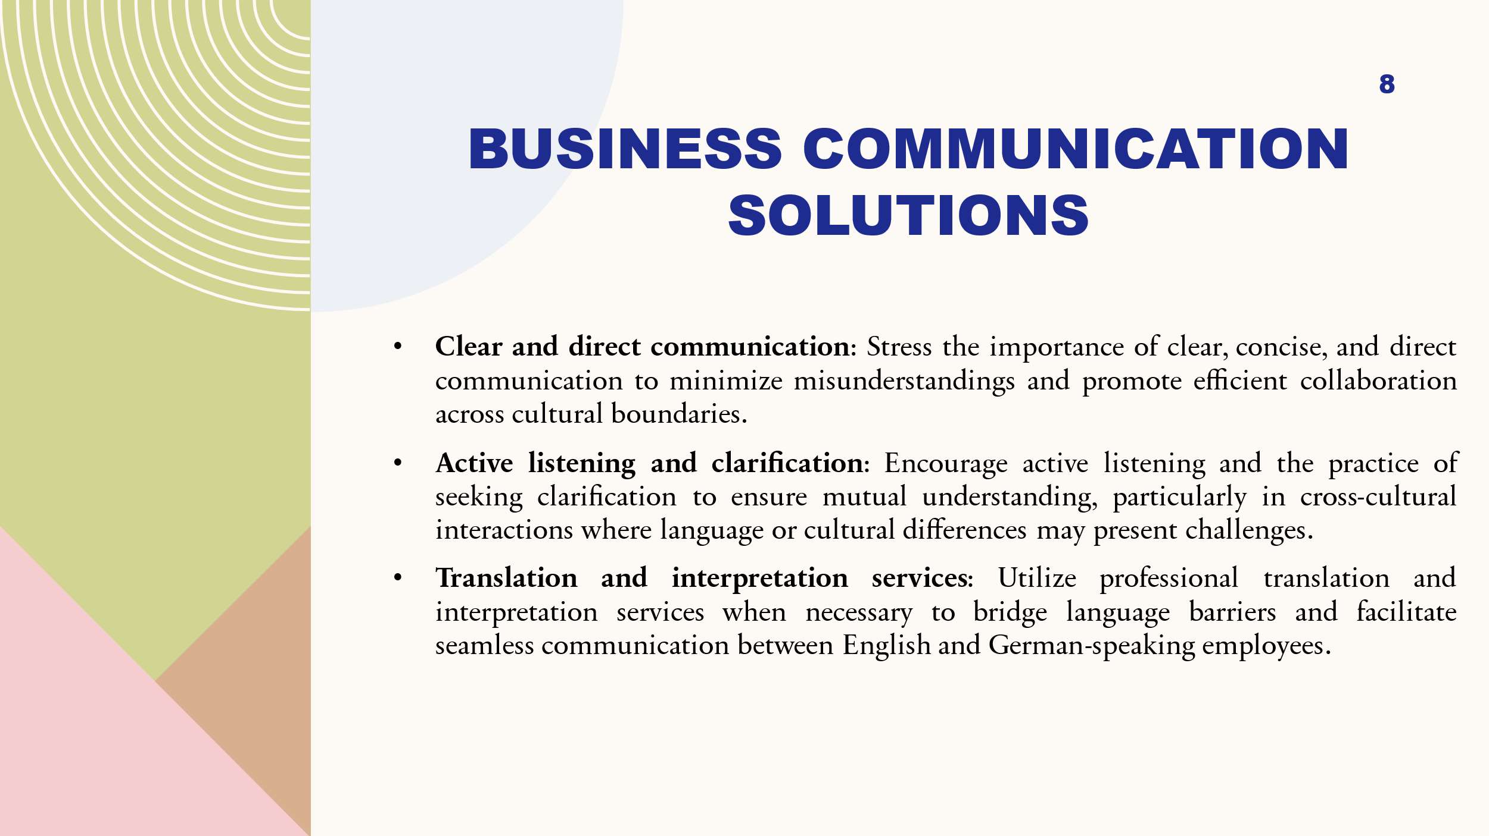
Clear and direct communication: Stress how important it is to communicate in a clear, concise, and direct way to avoid mistakes and make working together across cultural boundaries easier. Encourage active listening and the habit of asking for clarification to make sure everyone understands, especially when people from different cultures are talking to each other and language or cultural differences can make things difficult (Trompenaars & Hampden-Turner, 2017). Translation and interpretation services: When it's necessary to get around language obstacles, use professional translation and interpretation services to help them English- and German-speaking workers talk to each other without any problems. Feedback mechanisms: Use regular feedback mechanisms, like performance reviews or staff polls, to find out how well communication is working and fix any problems right away. This will make sure that communication routes keep getting better. Activities for cultural integration: To promote cultural integration and team harmony, hold team-building activities and social events that praise variety and help employees understand each other's cultures. This will help employees get along better with each other and work together better within the company.
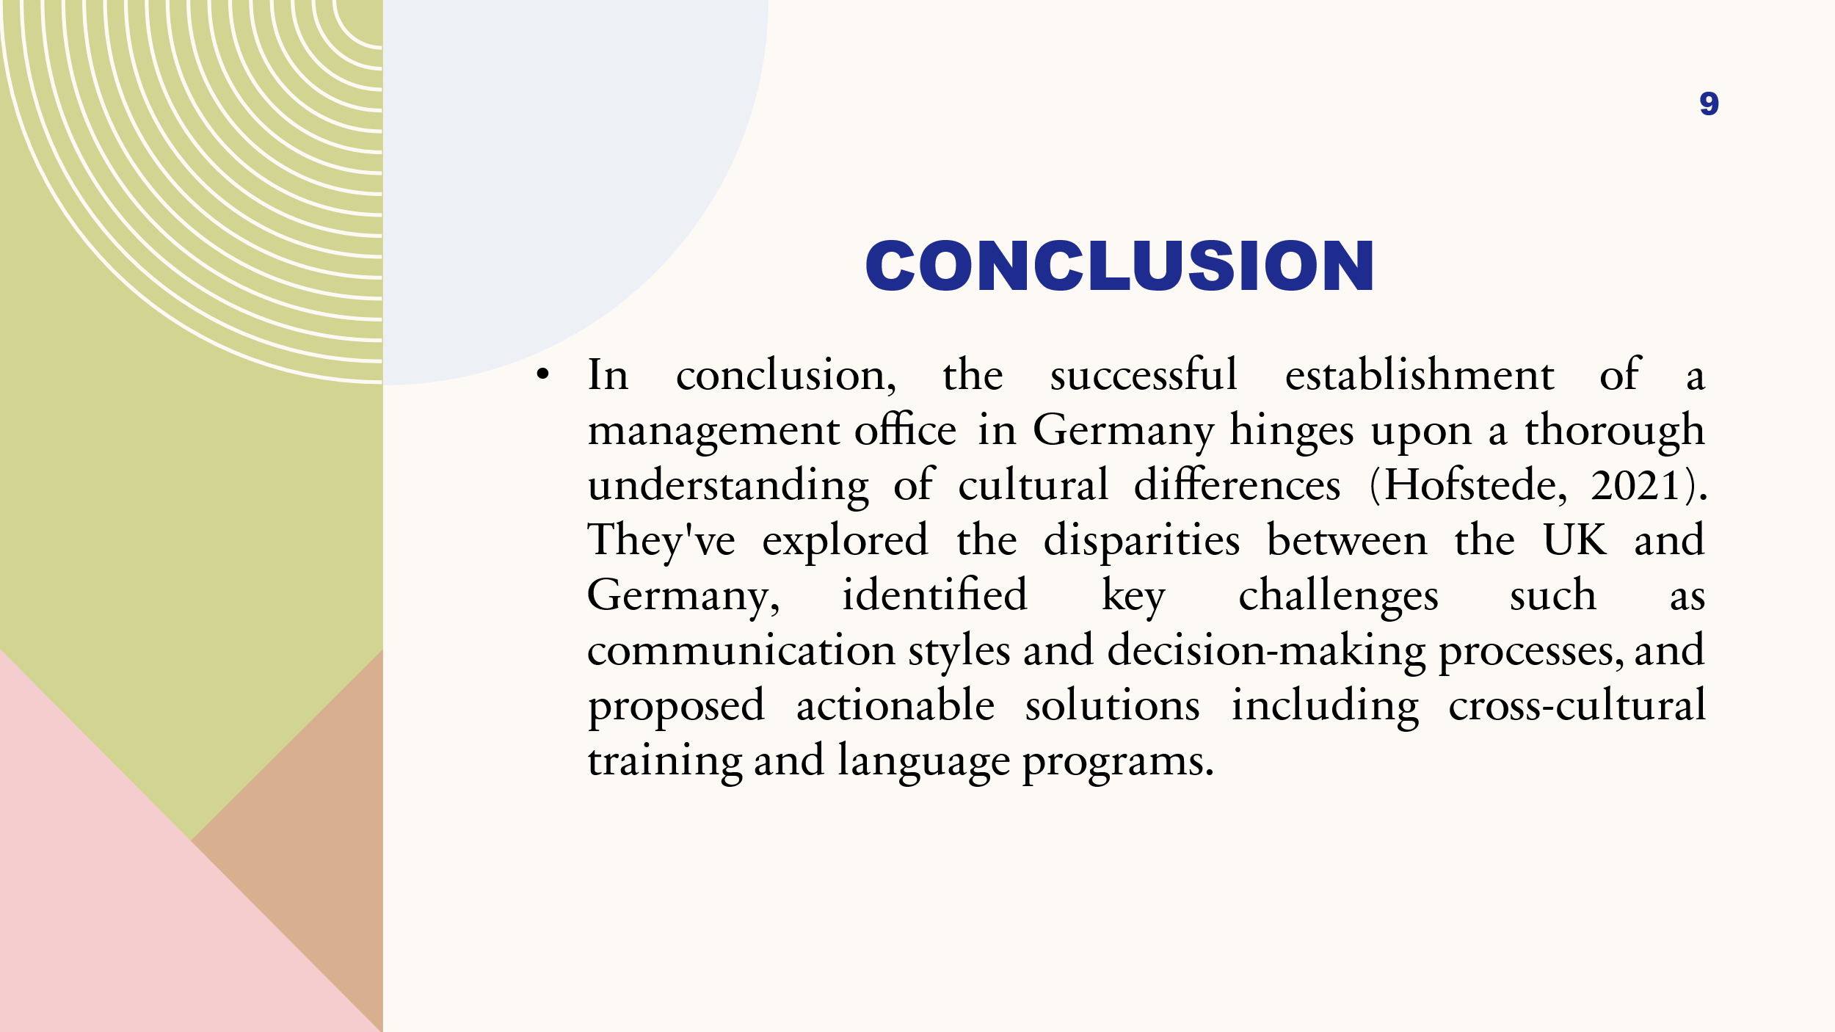
To sum up, opening a management office in Germany depends on having a deep understanding of how different cultures work. They looked into the differences between the UK and Germany, named some of the biggest problems, like how people talk to each other and make decisions, and suggested workable answers, like cross-cultural training and language programmes (Hofstede, 2021). Even with these problems, moving to Germany could have big benefits, such as opening up new markets and creating growth possibilities. Our company is dedicated to cultural adaptation and knows how important it is to create a welcoming and culturally aware workplace. We are sure that these ideas will help us deal with cultural differences, make good connections, and be successful in the German market. Thank for all the attention and help as we start this exciting new journey.



