Menu for Hotel Trinity

Student Name: Tudor Adrian Sau
Student Number: 2026591
Course Name: BMIH 4002 HOTEL PLACEMENT
Food & Beverage Operations
Lecturer: LAURENCE BLAKE
University of Wales Trinity Saint David

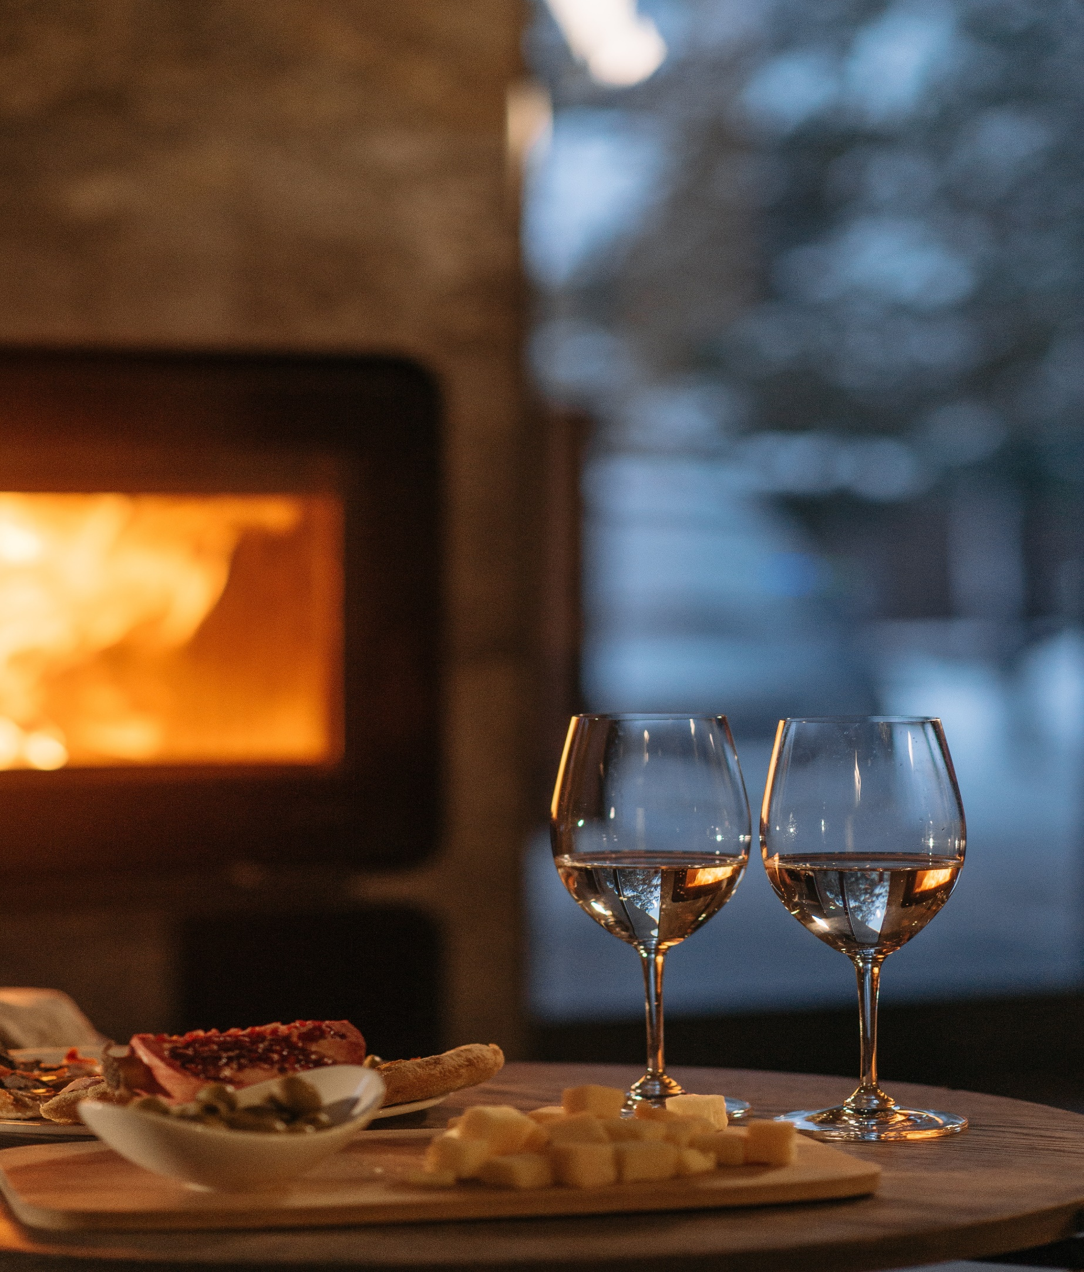
Hotel Trinity
Fish Stake
Tai Meshi Fillets
PaperCorn Crusted Fillet
Marinated Flank Steak
Sparkling
Carbernet
Pinot Grigio
Chardonnay
Menu One
Menu Two
Wine options
Wine options
Appetizers
Garlic Bread
Chunky Potato Bites
Cheesy Chestnut Fish Anzos

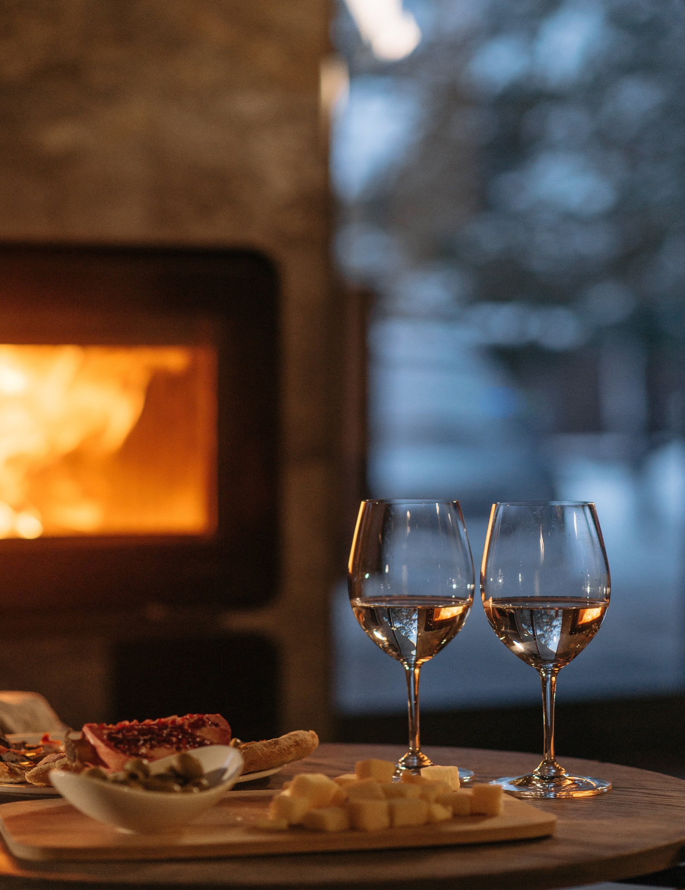
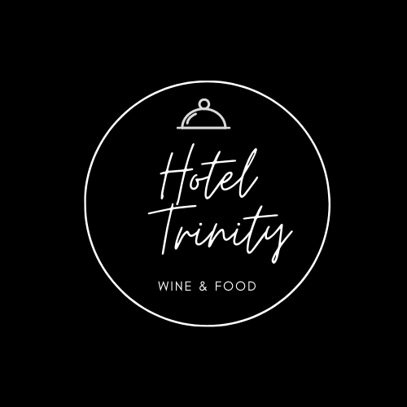
Order can be placed on the website, given Phone Number or directly in the restaurant on stated timings.

www.Hoteltrinity.com
Phone Number: 97463199-0-7
Location: 5th Street, Coast in Swansea, South Wales.

10 AM to 3 PM
6 PM to 10 PM
Timings For Order Placement

References

The Wine Cellar Group. 2022. Wine Pairing Tips for Beginners | Wine Pairing Guide | Wine Cellar Group. [online] Available at: <https://www.thewinecellargroup.com/wine- pairing-tips-for-beginners/> [Accessed 4 February 2022].
Danilyuk, P., 2022. [online] canva. Available at: <https://www.pexels.com/photo/photograph-of-wine-glasses-near-a-chopping-board-with-cheese-6667202/> [Accessed 4 February 2022].
Tasteatlas.com. 2022. 100 Most Popular Fish Dishes in the World. [online] Available at: <https://www.tasteatlas.com/100-most-popular-fish-dishes-in-the-world> [Accessed 4 February 2022].
Pinterest.com. 2022. [online] Available at: <https://www.pinterest.com/orodioliva/main-dishes-red-meat/> [Accessed 4 February 2022].

