Solutions to information security problems of CoffeeBlue company based on IT Security Framework
Jihang Zhang
Abstract
Now we have completed the second decade of the 21st century, and it has been decades since the birth of the Internet. However, the past decade can be said to be the decade with the fastest development of the Internet. 5G communication technology,Internet of things technology, big data and other new things have greatly improved the popularity of Internet technology. Both individuals and enterprises are inseparable from a variety of Internet technologies. When enterprises apply Internet technology to business and data, the most important problem is the security of all kinds of information and data in enterprises. If an enterprise does not have a mature mechanism or system to deal with security problems, it will face a devastating blow when enterprise data is attacked or leaked. Therefore, in this course paper, I introduced and studied three security framework models, and applied them to the specific case of CoffeeBlue to help the company to meet the needs of information system security, governance and compliance.
Keywords: Data security, governance and compliance; ISO 27000; ITIL; IPDRR; Security Management Models and Practices

Task 1
- Introduction
With the gradual maturity of 5G, Internet of things and other emerging technologies, we have gradually entered an era of interconnection of all things and highly developed information. It has been more than 50 years since the birth of the Internet, but only in recent years can we say that the Internet has really entered every corner of our life. In the past, only some high-tech companies used Internet technology to help them build information systems and analyze business data. In recent years, Internet technology has been more and more widely used, and most enterprises in traditional industries have also joined the ranks of using Internet technology. However, many enterprises have insufficient understanding of data security management and legal compliance. In modern society, for enterprises, data security is related to the survival and future development trend of enterprises. If an enterprise does not have a complete guarantee or emergency mechanism for its own data security, once data destruction or malicious disclosure occurs, it will bring incalculable losses to the enterprise and greatly reduce its competitiveness in the same industry. The past decade has been a golden development period for the global Internet industry. The business scale and traffic of various Internet companies have increased rapidly, resulting in many companies focusing on business logic and ignoring the importance of the most basic data security. In recent years, enterprise data security accidents occur frequently, some of which are human subjective factors, but some are caused by imperfect data security protection mechanism. To eliminate those subjective factors, we need to summarize these safety problems from a technical point of view and improve them to avoid similar accidents in the future.
Modern enterprises need to use Internet products in all aspects, such as employee information management system, enterprise fund management system, product transaction information platform, etc. When using these internet platforms, it is also accompanied by the generation of a large amount of data, so data security is an important issue that every enterprise must consider. In the past, due to the limitation of enterprise scale, many small and medium-sized enterprises usually stored data in local servers. However, as the enterprise scale became larger and larger, the enterprise data scale became larger and larger. Local servers can no longer meet the data storage needs of many enterprises. The concepts of cloud storage and cloud computing came into being. For large enterprises, they may buy special storage bases to build storage servers, while for small and medium-sized enterprises, making public cloud, private cloud or Internet data center is a more convenient and lower cost way.
Some people may have some misunderstandings. They think that as long as the hardware on which the data is stored is local, the data is very safe. In fact, it is the opposite. Data is different from the physical devices that store data. No matter whether the data is stored locally or on the cloud platform, the data can be transmitted through a network transmission. Take CoffeeBlue as an example. It is a traditional commodity sales enterprise, but now we can use Internet technology to build a complete information management system and online service platform for the company, and establish a perfect data security framework and emergency response mechanism. In the way of Internet cloud operation, coffee companies need an online trading operation platform, in which customers can register their account to become users, and then carry out online purchase and other services on the platform. The important data in the whole company system mainly include employee information, company bills, trade secrets, customer personal privacy, etc. If the company's system is leaked or hacked, it will have serious consequences for the company and customers. Not only the privacy of customers and employees will be violated, but also the interests of the company will be damaged. Therefore, first of all, technically, we should select the appropriate technical framework to back up the data remotely or locally; Secondly, there should be strict requirements on the company's internal employee system. Employees in different positions have different data security levels, and they should not be given too much data manipulation power to prevent huge losses caused by personal malicious or misoperation; Finally, we should establish an early warning mechanism for external security threats and introduce the firewall system. As long as there is a network interface with the public network, resources should be invested to monitor and protect against abnormal traffic. Therefore, in order to find a security framework suitable for the problem of CoffeeBlue company, in the next section, I study three security framework models and make some analysis and comparison.
- Security framework models
  - Information Organization for Standardization 27000 (ISO27000)
BS7799 standard was formulated by the British Standards Association in 1995, and then the ISO 17799 standard was formed after the adoption of ISO standard. After improvement, modification and repeated iterations, the current ISO27000 series standard system was formed. ISO27000 series standards are jointly formulated by the International Association for standardization and the International Electronic Technology Association. It is the general name of a series of international security system standards. The purpose is to provide guidance for the construction of information security management system for various industries. The standard mainly includes internet security technology, encryption technology, information privacy protection and other contents. Some standards related to information security management will be added every year. At present, 60 standard numbers are reserved for ISO27000 series standards, from ISO27000 to iso27059. Among these standards, ISO27001 is the core of the whole ISO series of standards, because the construction process of information security management system under all series of standards is formulated according to it.
New standards are added to the ISO 27000 series standard family every year. Up to now, more than 20 standards have been released, such as ISO 27000 and ISO 27001. At the same time, many standards are also being prepared and will be released in succession in the future. After years of development, ISO 27000 series standards have become a general safety standard widely accepted by various industries and organizations all over the world. Let's introduce several main standards. ISO 27000 basically expounds the concepts related to information security management system, including some terms and definitions related to ISMS; ISO 27001 is the core content of the whole series, which puts forward requirements for the structure and content of information security management system. Any security standard should meet its requirements. ISO 27002 introduces the methods and rules of establishing security system, and gives practical examples of information security system. ISO 27003 mainly includes guidelines on issues related to the establishment of information security management system, and provides suggestions and guidance for implementation, establishment, maintenance and improvement. ISO 27004 provides a series of indicators for measuring information security management system and evaluating implementation effect. ISO 27005 standard mainly puts forward some indicators for risk assessment and risk management in information management system. ISO 27006 puts forward entity requirements for the implementation of ISMS audit and certification.
The construction process of information security management system under ISO series standards is formulated according to ISO 27001. The following text introduces the main steps of construction. The first step is the preparatory work in the early stage. Firstly, the enterprise or organization needs to collect some background information, determine the background and characteristics of the system to be built, give a schedule of system establishment, and complete the division of labor of the personnel who build the safety system; The second step is to conduct a comprehensive risk assessment, summarize the assets, current disadvantages and threats of the enterprise or organization, and then make an overall risk assessment according to the summarized information; The third step is risk analysis, which aims to control the risks faced by the organization within a reasonable range and determine the control range of the safety system; The fourth step is to establish a security system, design the whole security framework according to the previously determined control scope of the management system, or improve the shortcomings of the existing security framework; The fifth step is to organize internal audit, and the internal managers of the enterprise evaluate the built security framework and improve the deficiencies; The sixth step is external audit, and external professionals are hired to conduct certification and evaluation of the security framework; The seventh step is continuous improvement. After the safety system is put into use, the above process is repeated irregularly to continuously improve the problems found.
    - Information security management system
Information security management system (ISMS) is a concept gradually formed in the development of ISO standard. It is establishedaccording to ISO27001. Isms is the standard for establishing and maintaining information security management system. In this standard, enterprises are required to formulate a reasonable security policy, control objectives through risk assessment, and clarify the management responsibilities of each department. After the security framework is established, it should start to run according to certain requirements and be continuously improved. Some documents will be generated during the security management of enterprises or organizations. These documents mainly describe the methods of risk management, risk control objectives and protected information and assets. The architecture design of information management system can be divided into the following four stages: the task of the first stage is to clarify the information security organization and formulate the information asset security policy; The task of the second stage is to develop an appropriate safety risk management plan. The third stage is to clarify the specific management points of information security and formulate security management specifications according to the points. The last is the fourth stage, which generates the record form file of the information security management system. Among them, the formulation of risk management plan in the second stage is a key step in the whole construction process. After the risk assessment, we should eliminate the hidden dangers existing in the enterprise organization and improve the safety system.
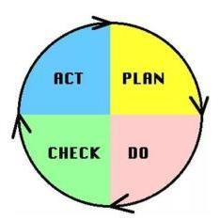
Figure 1. PDCA model
PDCA cycle method is used in the information security management system established according to ISO27001 standard. The full name of PDCA cycle is plan do check Act cycle, also known as Deming ring. PDCA is a cycle model, which is divided into four parts: P - (Plan), D - (Do), C - (Check), A - (ACT). Part P puts forward plans for the whole organization according to needs and objectives, and establishes a preliminary information security management system framework. Part D is the specific implementation of the proposed plan to put the safety management system into actual operation. Part C is to monitor the operation process of the system, check the operation effect, and find out the existing hidden dangers and problems. Part A is the continuous improvement of the information management system. If there are other problems to be solved, the system process will enter the next cycle. PDCA model is a common model in management. A complete cycle can be regarded as a management cycle in management. When an enterprise or organization carries out information management, it needs to go through countless management cycles from scratch and from existence to refinement. In the early management cycle, the management system will have many defects and problems, and then continuously realize self-improvement through operation implementation and error correction mechanism, and then enter the next cycle. In each cycle, we constantly find new problems and solve new problems at the same time. Through the continuous operation of PDCA cycle system, the management system of the enterprise has been continuously improved, and the information and asset security of the enterprise presents a spiral upward trend.
2.2 ITIL(Information Technology Infrastructure Library)
ITIL(information technology infrastructure library), is a standard widely used in the service management of the Internet industry. ITIL is a process based method, which applies the relevant systems and methods in management science to Internet business management, defines the standards of Internet service quality, and aims to meet the needs of Internet customers and how to make enterprises meet the needs of customers. In the late 1980s, the British national computer and Telecommunications Office formulated the ITIL standard, which has been used since four major versions. At present, the standard is managed by the British Department of Commerce. With more than 30 years of development and improvement, ITIL standard has gradually become a generally recognized operation and maintenance service framework standard in the Internet industry. It provides a perfect, rigorous and quantifiable Internet service standard for enterprises.
In the context of the vigorous development of the Internet industry, ITIL standard has been accepted by enterprises and organizations all over the world. However, ITIL is not a rigid standard. It does not have an absolute formal standard. In other words, it is a widely used standard in fact. In itil3 In version 0, a complete enterprise organization management cycle can be divided into the following five stages. The first stage is the strategic stage. The enterprise organization should look at the overall situation and formulate the enterprise development strategy at the strategic height. Then it is the design stage. According to the set development strategy, some enterprise management architecture levels and some implementation details are designed. The third stage is the transformation stage. The main task is to put the previous design into practice and materialize the Internet management system. The fourth stage is the operation stage. At this time, the whole enterprise IT management system has been formed and can be put into formal operation after debugging. The last stage is the improvement stage. After the operation of the management system, there will be various problems. Enterprises need to continuously improve various problems to make the IT management system as perfect as possible.
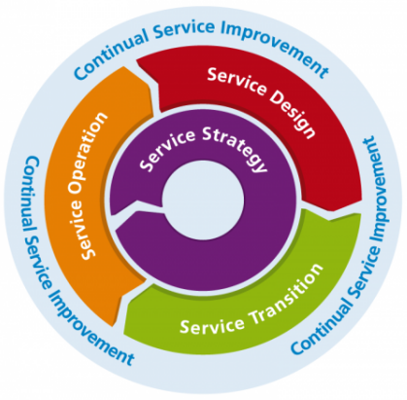
Figure 2. ITIL process sketch map
For an enterprise, using ITIL management system method, the whole enterprise information service framework can be divided into six parts: application management, security management, service management, business management, Internet basic framework management and Internet service continuity and availability management, in which service management is the core module of ITIL. The service management module includes one function and ten processes. They can also be divided into two process groups, one to provide business services for the system and the other to provide other support for the system. ITIL's core framework system is not difficult, but it needs to be fully understood when it is implemented. Enterprises should first carefully read the technical documents and guidelines of ITIL, cultivate a group of employees familiar with the information management process within the enterprise, and conduct ITIL certification examination after learning relevant knowledge; Secondly, enterprises need to establish a set of scientific processes, which can solve different problems step by step according to a similar process system in practice; Finally, enterprises need to choose appropriate software products. It management system software can be developed by enterprises themselves or purchased from software companies. When purchasing the management system, we should put forward personalized customization requirements according to the business characteristics, which is very important to achieve the goal of the management system.
2.3 IPDRR Security Framework
With the deepening of social digital transformation, network attacks are increasing and the destructive power is gradually increasing. The international security methodology is gradually evolving from "security defense against threats" to "business oriented security governance" (IPDRR, etc.). In 2014, NIST released three components of CSF (cyber security framework), and IPDRR is its core framework.
The IPDRR capability framework model includes five capabilities: risk identification, security defense, detection, response and recovery. From the model with protection as the core to the model with detection and business continuity management (resilience), it changes from passive to active, and finally achieves adaptive security capability. The following is a brief introduction to these five capabilities.
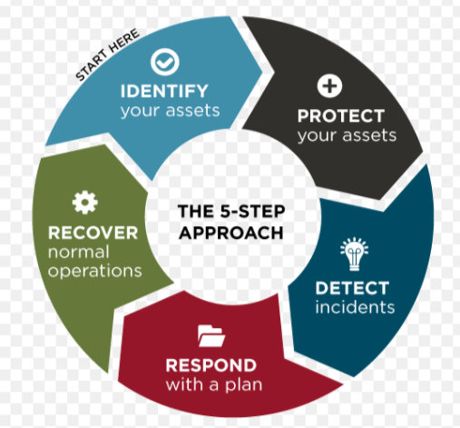
Figure 3. structure of IPDRR model
Identify: identifying network assets and risks refers to the understanding and confirmation of the security risks faced by enterprise systems, assets, data and networks.
Protect: protecting the enterprise network means developing and implementing appropriate security measures to ensure the provision of critical infrastructure services in the face of attacks.
Detect: attack detected. Monitor immediately when the attack occurs, monitor whether the business and protection measures operate normally, and formulate and implement appropriate actions to find network security events.
Response: respond to and handle events, which refers to taking appropriate actions for discovered network security events. The specific procedures are selected according to the impact degree of the event, mainly including event investigation, damage assessment, evidence collection, event reporting and system recovery.
Recover: recover the system and fix vulnerabilities. Restore the system to normal state, find the root cause of the event, and prevent and repair it.
The IPDDR model embodies the idea of security systematization, combines management with technology, makes full use of the long-term accumulation of the current "active defense in depth system, network trust system and dynamic security adaptive system", tries to establish a system that allows the attacker "unable to enter, destroy and escape", and establishes an environment that is not conducive to the survival of the attacker, Through the power of the system to reverse the attack and defense asymmetry, so as to effectively ensure the security of the core business of the system. The overall IPDRR is also the basic reference model for the establishment of security situational awareness system. The closed-loop security of IPDRR is realized through dynamic and continuous security detection, so as to provide users with a perfect security capability framework and support system.
2.4 Analysis and Comparison
ISO27000 series standard is a universal security standard widely used in the world. Like other standards, establishing the information security management structure under the ISO series standard system requires several conventional steps. However, the difference is that the standard regards the risk assessment and analysis as the most important part of the whole system construction. Only by determining a relatively reasonable risk control point can the safety of the whole system be controlled within a certain range.
ITIL defines the standard of information service quality, but it does not have a clear and fixed description document like some standards. ITIL is just a framework, which contains the best summary of each enterprise organization in practice. Each enterprise can design its own process according to its own practice and standard principles. Therefore, this is a flexible demonstration framework for information services. Enterprises and organizations can fill the framework with content that meets their own needs, and then get a set of visualization solutions.
IPDRR is a network security framework provided by NIST, which focuses on system network protection and vulnerability repair, and also covers some details when building a network security system. The system can take automatic protective measures to reduce the loss of the system before the enterprise artificially finds the loopholes or attacks of the system.
The above three security frameworks and service standards are widely used models in the world. Enterprises can choose the appropriate security framework according to their own needs to meet the personalized customization needs of customers and ensure the information security of enterprises and customers.
Task 2
Application of security framework in CoffeeBlue company
CoffeeBlue sells Blue Mountain Peak coffee from Jamaica, one of the best and most sought-after blends in the world. CoffeeBlue's coffee is famous all over the world. It uses the Internet cloud platform to provide products and services for the company's employees and customer service around the world. It is estimated that more than 95% of the company's business is conducted through the Internet and has a huge international customer base. Information security is an important area of the company. The current information security state of the company is in a chaotic state. It is necessary to establish an appropriate security framework to protect the private data of employees and customers and valuable intellectual property rights.
The security framework model of information management system proposed by CoffeeBlue company in this paper takes the IPDRR enterprise security framework as the theme, and refers to some processes and requirements in ISO27000 series standards and ITIL standards.The following figure is an introduction to the whole security framework.
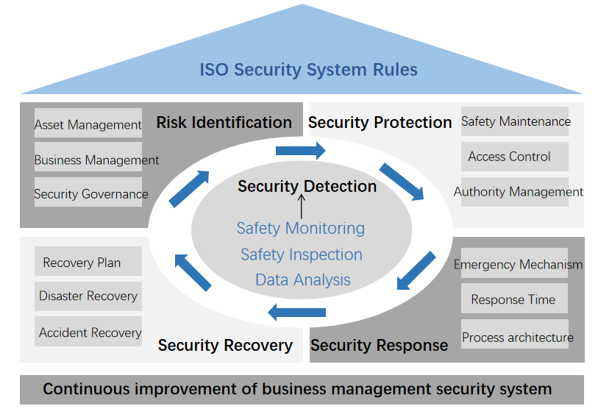
Figure 4. Security framework of CoffeeBlue company
As shown in the figure, the whole framework is designed according to the IPDRR security framework, which is divided into five parts: risk identification, security defense, security detection, security recovery and security response. Each part also contains some specific elements, and only a part of them are shown in the figure.
According to the design process of ITIL standard, the whole system is divided into strategy stage, design stage, transformation stage, operation stage and improvement stage in chronological order.
At the strategic stage, the company first formulates the future development plan, occupies a certain share in the world market and makes a breakthrough in the weak market of consumption. Then the importance and priority of customers are sorted according to the sales data of different regions of the company.
In the design stage, multiple system architectures should be designed at the same time, such as information security architecture, employee information platform, customer information platform, etc. The designed system shall be subject to quality supervision according to ISO27000 series standards, comply with local laws and regulations, and pay attention to the protection of customers' personal privacy information. The information security framework is designed according to the specific indicators of IPDRR framework.
In the transformation stage, all system design architectures are built in entity. Before formal operation, tests shall be conducted to test whether the whole system can run.
In the operation stage, the whole coffee sales business system of the company is put into formal operation. We evaluate the business service level with reference to the business management standards in ITIL. In terms of system security management practice, we use the circular process in the IPDRR security framework for risk management, and the security problems within the controllable range will be solved. In addition to the routine safety detection, safety protection, safety recovery and other processes, we also have emergency plan and protection mechanism. The company is equipped with a backup cloud server to back up real-time data, so that even if the information is damaged, the backup data can be accessed through a pre-defined interface. If the system recognizes that it is attacked by hackers, the system data will exist in the form of encryption, and the whole system will enter the protection state. The operation of the online business system will be suspended, and the data will not be changed until the engineer has checked the security problems.
In the improvement stage, we use the PDCA model in ISO27000 series standards for cyclic improvement. Each cycle process is a process of finding and improving problems. After many cycles, the information management system will enter a relatively stable state. At this time, we only need to do routine operation and maintenance work.
Through the study of three security framework models, this paper designs the above security framework system for the company's problems, which can protect the company's property and privacy information from theft, and effectively improve the business management level and the operation efficiency of the company.

Reference
- Siregar B,Wirtjes J S,Nababan E B,Fahmi. Development of a person’s facial expression recognition system using a convolutional neural network[J]. Journal of Physics: Conference Series,2021,1882(1)
- Ines Meriah,Latifa Ben Arfa Rabai. Comparative Study of Ontologies Based ISO 27000 Series Security Standards[J]. Procedia Computer Science,2019,160(C):
- Muhamad Khairulnizam Zaini,Mohamad Noorman Masrek,Mad Khir Johari Abdullah Sani. The impact of information security management practices on organisational agility[J]. Information and Computer Security,2020,ahead-of-print(ahead-of-print):
- V.S. Lakshmi,S. Deepthi,P.P. Deepthi. Collusion resistant secret sharing scheme for secure data storage and processing over cloud[J]. Journal of Information Security and Applications,2021,60:

