Student name: | Silvia Karova | Student ID number: | 2221481
Programme: | BA International Hotel Management
Module: | Food & Beverage Operations
Module code: | BMIH4002 | Contribution to  Overall Module Assessment (%): | 25%
Lecturer: | Muhammad Cassamo | Internal Verifier: | Charlotte Joyner
Assignment Title: | Assignment 2 Menu Engineering (Practical Task) | Word count (or equivalent): | Throughout practical placement work

Table of Contents
Part 1: Restaurant Concept 1
Part 2: Menu Design 3
References 5

Part 1: Restaurant Concept
The Hotel Trinity Hotel Chain has recently introduced Fusion Flavours, a novel restaurant concept that offers families an opportunity to indulge in a diverse and flavourful menu, thereby embarking on a gastronomic journey. Located in the bustling urban hub of the United Kingdom, this establishment endeavours to offer a welcoming and all-encompassing environment that accommodates patrons of every generation. Fusion Flavours provides catering services to a diverse group of discerning individuals who possess an appreciation for the culinary arts and actively seek out novel gastronomic experiences. The target customers comprise of individuals staying at hotels, corporate executives, community members, and visitors seeking to partake in an exceptional culinary encounter (Parkin and Attwood, 2022). By presenting a fusion-based approach. The objective is to appeal to individuals with a passion for gastronomy, who derive pleasure from discovering novel tastes and value the ingenuity and skill involved in the preparation of each culinary creation.
The menu offered at Fusion Flavours presents an array of alluring dishes that amalgamate global inspirations with a hint of novelty. To begin with, patrons may partake in the House Smoked Pacific Halibut, which is expertly complemented by zesty grapefruit, velvety avocado, crème fraîche infused with vodka, and presented on a scrumptious blini (Leung et al., 2020). The Herbed Polenta Cakes provide a vegetarian alternative, served with freshly made pesto and shaved Parmesan cheese, stimulating the palate with its infusion of herbs.
The main course features a Centre Cut Filet of Beef that is generously stuffed with Roquefort butter and served with a luscious Madeira wine sauce, thereby taking centre stage (Bergman et al., 2021). The gustatory experience of this delectable cuisine is enhanced by the addition of Pomme Anna, a traditional French potato dish, and vivid asparagus. The dish of Sunflower Seed Crusted Snapper, served with house-made spaetzle, Brussels seeds, Kalamata olives, and browned artichoke, presents a harmonious blend of diverse flavours and textures that is sure to delight connoisseurs of seafood.
At Fusion Flavours, the selections on the menu are made with the intention of composing a flavourful symphony that draws inspiration from across the world. We want to provide our customers a dining experience that is genuinely one of a kind and one that they will not forget by combining a variety of different culinary traditions (Liu et al., 2019). Every dish has been carefully selected to demonstrate the skill of fusion cooking, and as a result, our visitors will have the opportunity to go on a gastronomic excursion that honours the many culinary traditions of the globe.

Part 2: Menu Design
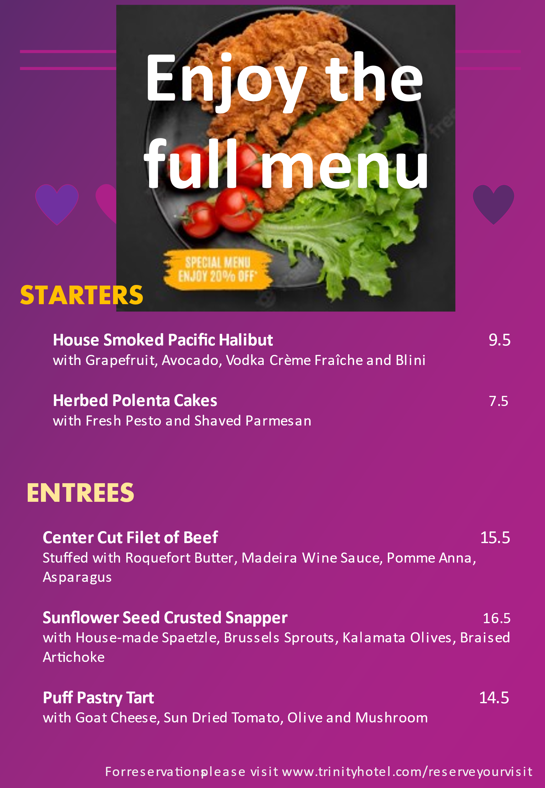

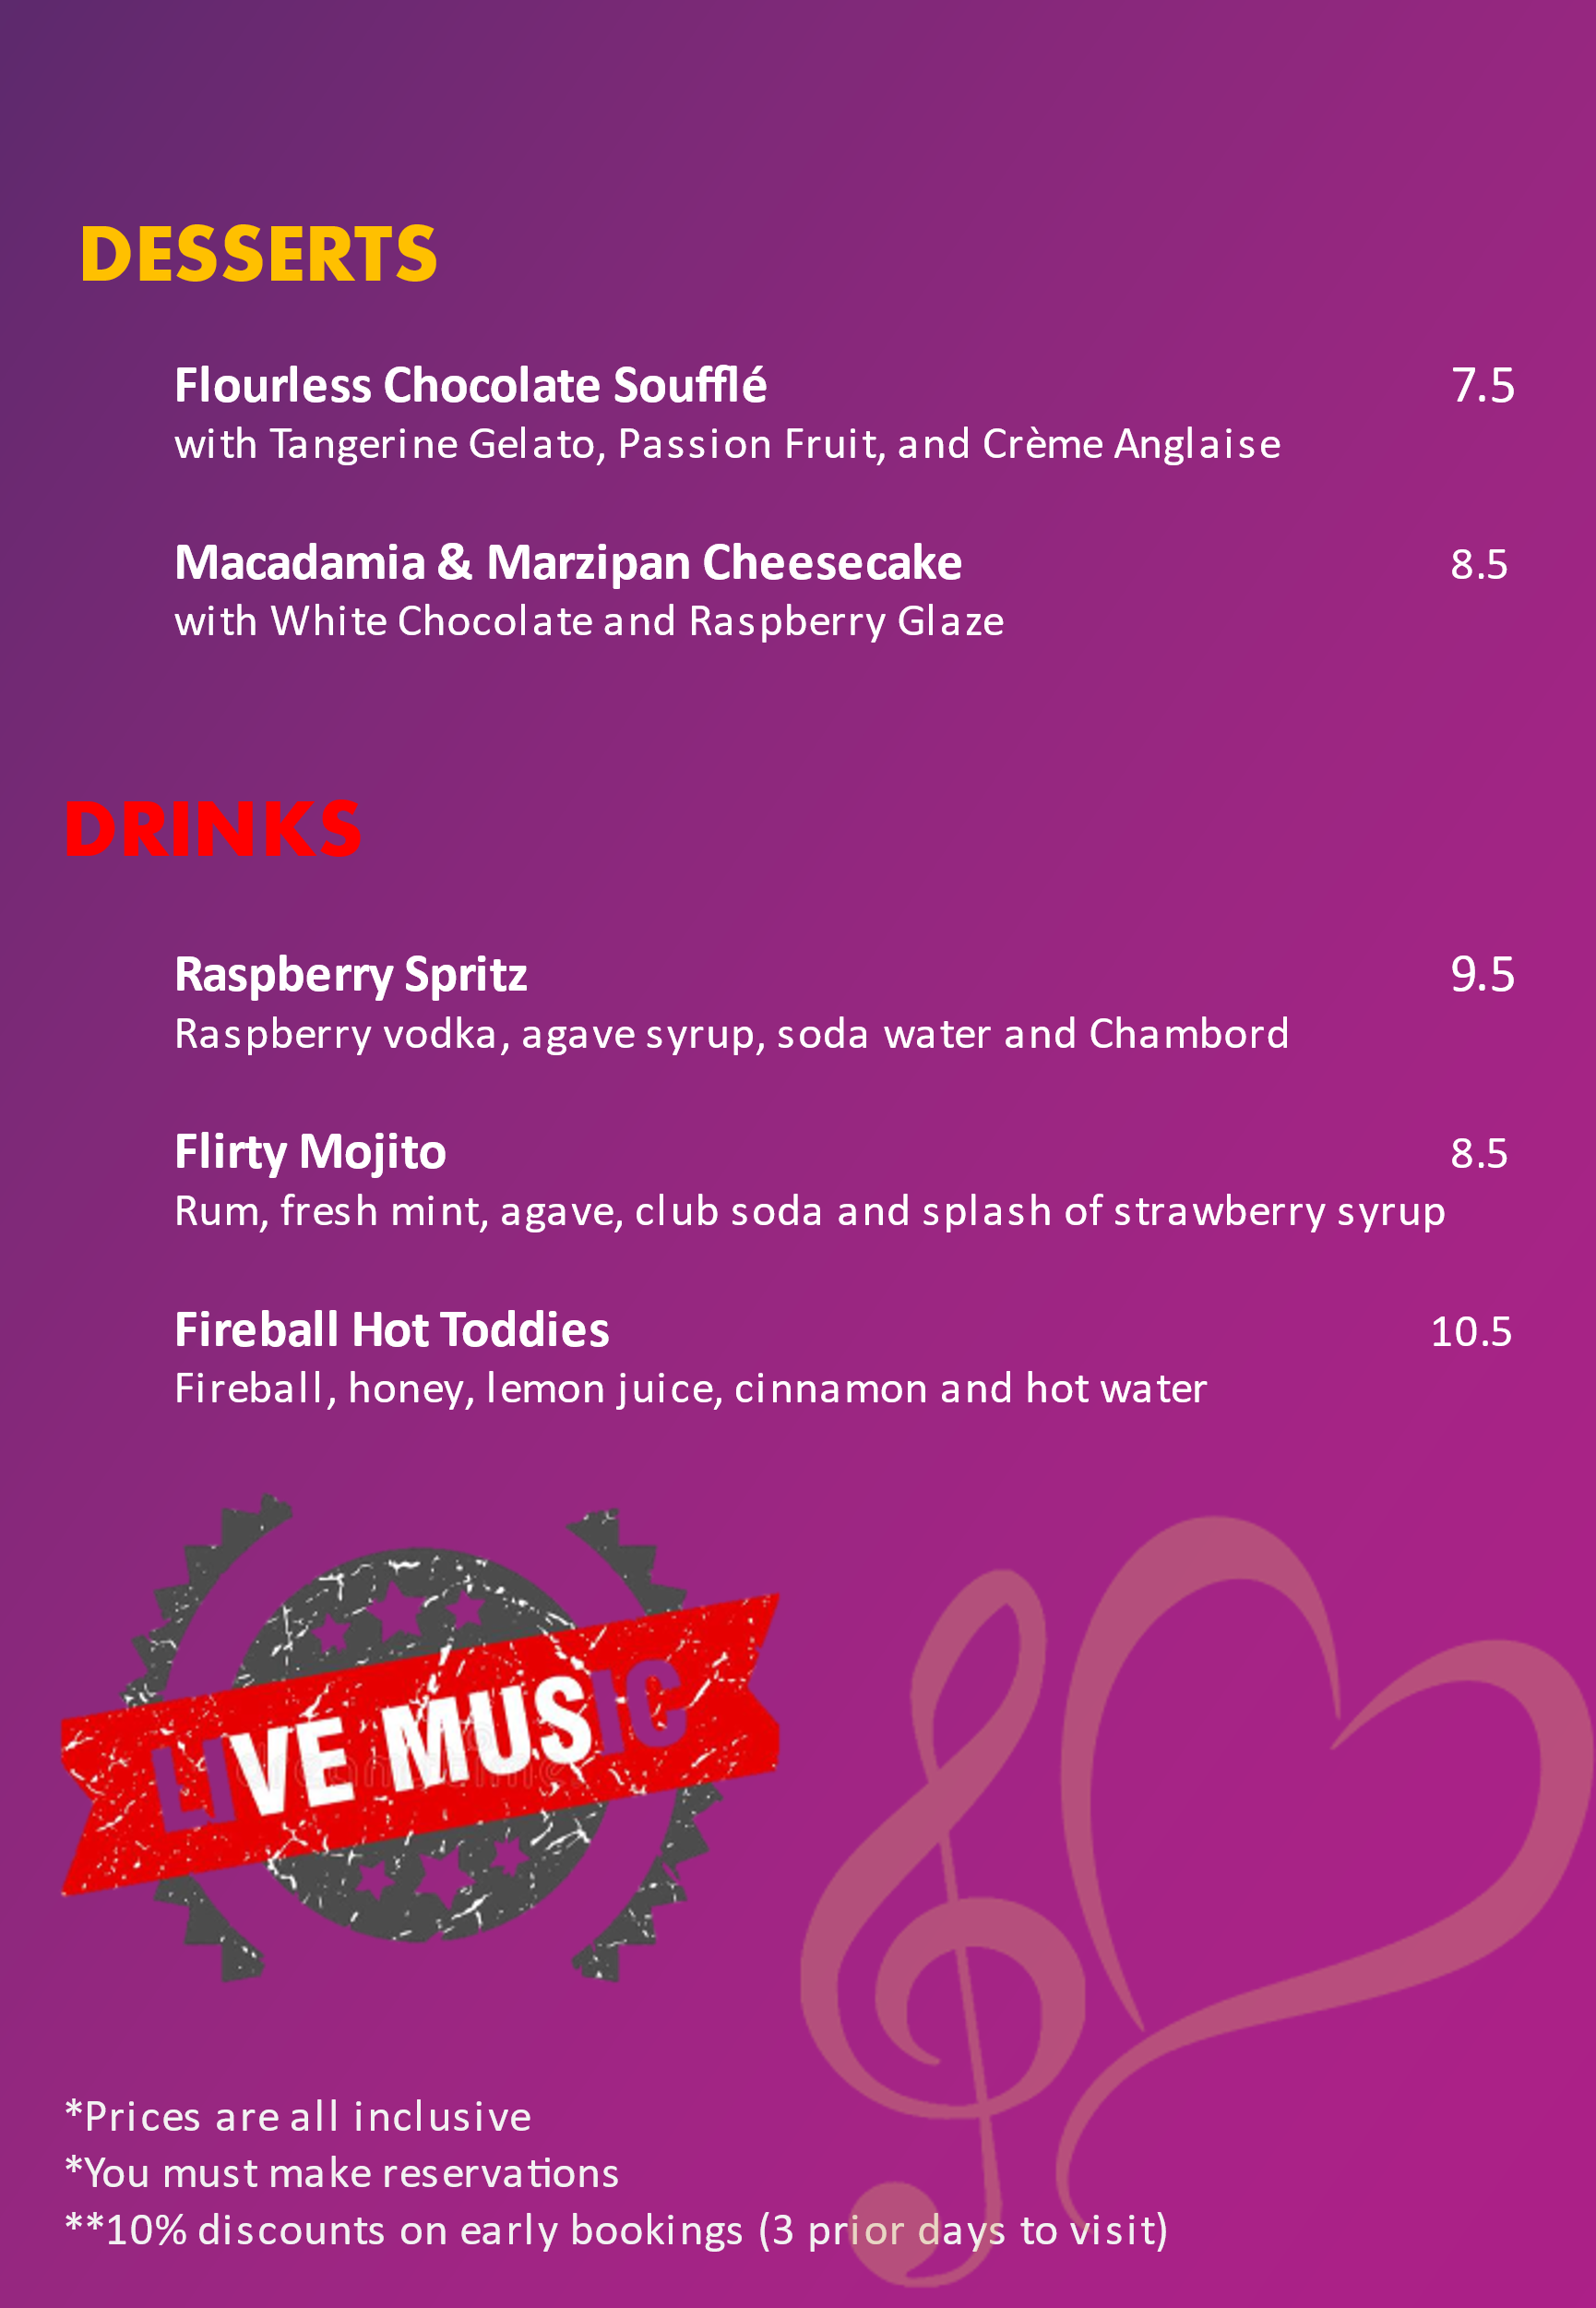

References


