Assignment 2: Written Document
Lecturer: Dr Mark Gallagher- Read
Student Name: Roni Akhtar
Student ID:2006645

Changemakers: Building your personal brand for sustainable employment
Module Code: BMHP5015_BIRM

Introduction
This written document will reflect key learning elements gained by completing Changemakers: Building a Personal Brand for Sustainable Employment. A summary of one topic from each unit will be addressed. Furthermore, will explore how my understanding of personal employability skills is compatible with the skills needed in a professional environment. To further understand my employability skills a personal development plan will be created to identify key skills required to be successful in my chosen field of work.
Unit 1, Topic 1 Ambition is Critical
If I was asked the question “what does ambition mean to you” previously I would have answered, “ambition is a determination to excel in something”. However, I now know it is a much deeper complex personality trait.
My understanding of ambition was basic, with the completion of this topic I have a greater understanding of the positive and negative implications of ambition. Burton, (2014) stated ambition consists of two elements, desire for achievement and the willingness to fulfil the achievement despite failure. This is the epitome of ambition and can be related to personal or professional life, ambition is key to building your personal brand as it helps establish the overall goal of one’s personal brand.
In contrast to Burton, (2014) Thomas Otway in 1680 quoted “Ambition is a lust that is never quenched but grows more inflamed and madder by enjoyment”, this suggests negative connotations of ambition. I found myself agreeing with Burton, (2014) because to build your personal brand and personal employability skills one needs to have the desire to attain their goal despite the risk of failure or criticism. However, Thomas Otway, (1680) quote resonated with me because ambition can be a vice if not managed accordingly as it can engulf other aspects of one’s life. Therefore, ambition is critical because it can be a vice or a virtue, it can lead to marginal gains or marginal losses.
Ambition is key to improving my employability skills because ambition paves the way to set goals and then look beyond that set goal. My set goal is to become a social worker. Therefore, I need to obtain a degree in health and social care, a postgraduate diploma in social work, and experience working with vulnerable families. While I am in the process to achieve this goal, I will be learning valuable employability skills such as active listening, counselling skills, patience, openness to change and knowledge of society and culture. Thus, possessing ambition starts a journey of acquiring numerous employability and personal skills along the way. It is important to note with ambition comes setbacks, having setbacks only fuels more determination to succeed and do better (Arruda, 2015).
Unit 2, Topic 1 No one is an Island
I believed I had sound knowledge when it came to networks, I understood the basic principle of being connected to other individuals however this module has taught me how to use networks to my advantage.
Networks are interconnected to anyone and everything, it has the potential to raise awareness of my brand, opportunities to collaborate with like-minded people and open doors for future employment. Eatough (2021) stated networking helps you engage with professionals at all levels and boost professional confidence. Hence why it is very important in today’s world to understand the full potential of networks as they can lead to opportunities that can change our professional and personal lives.
For me to benefit from networking, I first had to evaluate my network surrounding, this was done by asking myself questions like which resource will work well with me? Is it moving in the right direction? And is it value for money?
To further evaluate my network, I created a network map to visually see potential opportunities and weaknesses within my network. Once I established a strong tie, a weaker tie and a potential tie, I recognised that from indirect contact I found an opportunity to build a relationship with someone that can help me with my employability skills for my chosen field of work.
In today’s professional environment networking is key to our professional employability skills because it is a gateway to other professionals who directly influence my field of work as well as professionals from other industries. Through networking, I can gain employability skills that include personal communication, relationship management and professionalism and building connection with professionals from my chosen field. As my end goal is to become a social worker networking will allow me to build my personal brand and employability skills by collaborating with other professionals, building personal contacts and learning to evaluate a strong potential tie for future career prospects. This is vital for me because social workers collaborate with multi agencies therefore having a strong social network only adds to my employability skills.
Unit 3 Topic 1 Creating Your Own Luck
Luck is not a word I associated with a professional environment, I always believed in hard work and self-belief that created opportunities. This topic solidifies my opinion on luck however it did give me a different perspective on luck. Curious minds look beyond the obvious, they emerge themselves in difficult situations to discover opportunities and solutions, they make their luck. Kaplan (2018) stated curiosity plays a key role in turning bad moments into lucky moments because of their mindset in addressing an issue or a task. It is clear to see by actively being aware of unforeseen events and having a growth mindset we can turn situations into luck (positive outcome).
I have now come to understand people who make a conscious effort to look at a situation differently turn negatives into opportunities are considered lucky. Therefore, it is important to look from a different perspective when facing a challenge even if it takes you out of your comfort zone. I learned that by taking control of an uncomfortable situation and finding a solution, I am using “smart luck” to turn unexpected moments into positive outcomes through the actions I have taken (Busch,2020).
Below is the Cynefin Framework, I found this framework to be resourceful as it helps to understand complex situations and explore the effects of intervention strategies.

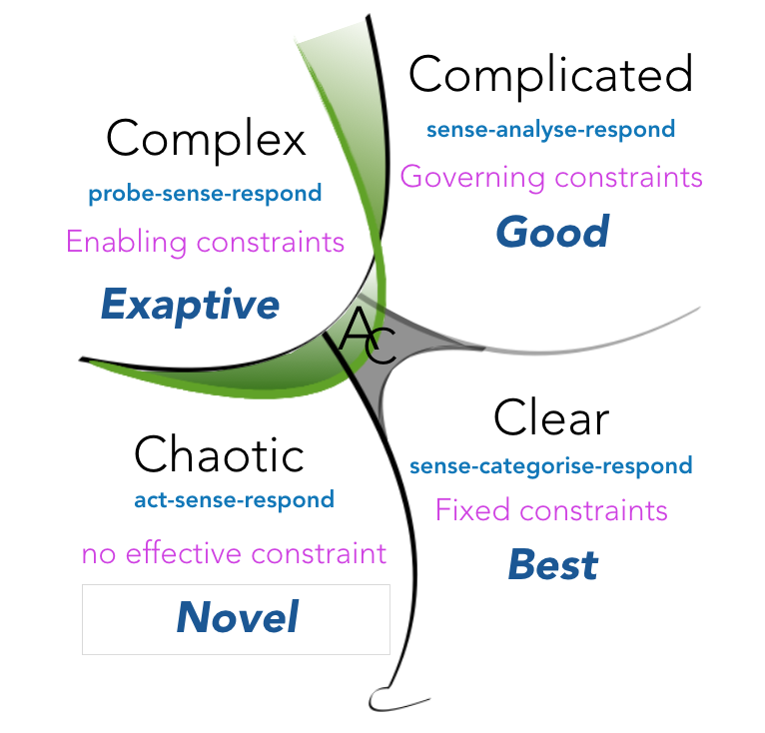
(Kurtz and Snowden, 2003)
A key employability skill is to have the capacity to overcome challenges and address difficult unprecedented circumstances. The topic Creating your luck has given me the tools and insight on how to deal with such challenges. By having a growth mindset and an eye to see the positives from the negatives is a crucial employability skill employers look for. A social worker looking for a serendipitous solution is a constant, it portrays that they do not have the answer for every eventuality but are prepared to use smart luck to overcome the given situation.
Unit 4 Topic 2 Passion and Perseverance
I found this topic relatable on a professional and personal level, passion and perseverance dictate the level of determination one has in respect of a challenge or a purpose. Nuss (2017) stated passion is a compelling emotion and perseverance is a constant persistence of action. I found Nuss’s (2017) statement to link to Angela Duckworth’s work regarding “The power of passion and perseverance”. Angela’s work suggests more grit you have (determination/passion) the grittier you are (Duckworth, 2013), I found this to ring true in all aspects of life, especially in a professional environment because work is measured or assessed. Furthermore, I learned resilience and sagacity (wisdom) can improve grit, failure builds resilience (Hill, no date) by failing we can learn more about ourselves or the purpose and find an alternative approach and become grittier. Additionally, the wisdom that we have been taught or learned through experience can also help us be grittier. One model I found interesting and have not come across before was the Four S Approach to Resilience created by Dr Lucinda Poole and Dr Hugo Albert. It is believed to develop resilience is to learn from your own past experience (Darvill, 2020).
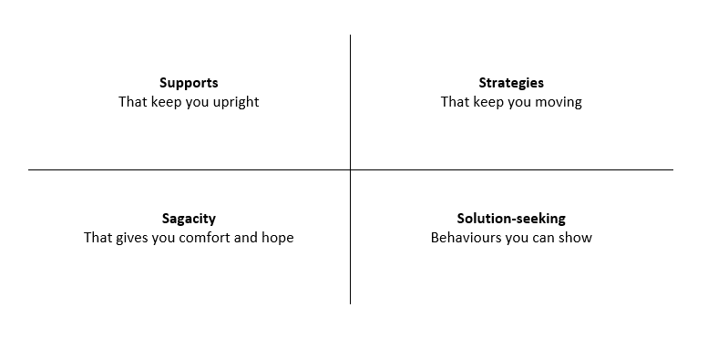
(Darvill, 2020)
I found this module to be a resourceful and practical tool as it helps you tackle current predicaments by delving into past challenges.
I believe passion and perseverance is a key employability skills in any profession, without passion and perseverance one will be unfulfilled and in doubt. Success in a professional environment is not easy, it takes time and perseverance to reach your goal, Long (2015) stated success does not come in a straight line, it is filled with twists and turns and failure only brings success. I believe working in a social work environment passion and perseverance will be tested daily as it is an emotionally overwhelming profession. However, having the passion, the grit to excel and the patience and determination will make a positive difference, but it will also prepare you to bounce back from failure.
Conclusion
Changemakers: Building a Personal Brand for Sustainable Employment module was insightful there were aspects of employment I did not consider before and some aspects I already knew of. I have a newfound understanding of the potential of ambition, the advantages of networking, the importance of a growth mindset and the potential of passion and perseverance regardless of failure or success. If I had to take away one thing from this module it is to have a positive psychological approach to failure because it will only lead to success with time and effort.
Below I have filled in a personal development plan with the employability skills I believe will help me with future employment.

Personal Development Plan (PDP)

SKILL | CURRENT  ABILITY | TARGET  ABILITY | DEVELOPMENT  OPPORTUNITY | CRITERIA TO JUDGE SUCCESS | TIME FRAME | EVIDENCE
Priority 1  Gain experience working with vulnerable families. | Currently, I have no experience working with vulnerable families | Experience working with vulnerable families and developing the following skills: Patience,  the ability to hide frustration or annoyance,  keeping calm in an emergency,  communication and  enthusiasm. | Within Birmingham, many charities work with vulnerable families. I have managed to get a placement with Muath Trust and have committed to one day a week to work with vulnerable families. | I know I have been successful is when I have gained the skills, I mentioned in target ability. Furthermore, when I see I have made a difference in a family’s life then I will know I have  been truly successful. | April 2022 to July 2023 | A letter of recommendation from the charity I will be working with.
Priority 2  Level 3 Safeguarding  Children (Designated Officer) course | Hold no certificate in safeguarding | To obtain a level 3 certificate in safeguarding children, having the ability to recognise suspected abuse and safeguard children from future harm. | Enrolling with CPD Online college. | I know I have been successful is when I know the following:  Safeguarding and the Law, Safeguarding structure, Types of abuse, Recognising risks, Reporting and responding to concerns, recording concerns and post referral. | June 2022 to  July 2022 | My CPD certificate.
Priority 3  Learning to write the Bengali language. | Currently, I speak fluent Bengali however my reading and writing skills are non-existent. | My target is to be able to read and write standard letters of communication. | Senior Women’s community in Selly Oak are teaching people to speak, read and write the language of their mother tongue. | I know I have been successful is when I can write a letter to my mother in Bengali. | 2 years’ time duration | Continuation of letters back and forth.

Reference List
Arruda, W. (2015) Why Failure Is Essential To Success. Available at: https://www.forbes.com/sites/williamarruda/2015/05/14/why-failure-is-essential-to-success/?sh=18b1f0237923 (Accessed: 30th March 2020).
Burton, N. (2014) Is ambition Good or Bad? Available at: https://www.psychologytoday.com/gb/blog/hide-and-seek/201411/is-ambition-good-or-bad (Accessed: 26th March 2022).
Busch, C. (2020) The Serendipity Mindset: The Art and Science of Creating Good Luck. Available at: https://nextbigideaclub.com/magazine/serendipity-mindset-art-science-creating-good-luck/24530/ (Accessed: 28th March 2022).
Darvill, L. (2020) A Note on Resilience and a Useful Model. Available at: https://www.linkedin.com/pulse/note-resilience-useful-model-lawrence-darvill (Accessed: 30th March 2020).
Duckworth, A. (2013) Grit: The power of passion and perseverance [Video]. Available at: https://www.ted.com/talks/angela_lee_duckworth_grit_the_power_of_passion_and_perseverance?language=en
(Accessed: 30th March 2020).
Eatough, E. (2021) What is networking and why is it so important? Available at: https://www.betterup.com/blog/networking#:~:text=Networking%20contributes%20to%20your%20social,Networking%20boosts%20your%20professional%20confidence (Accessed: 28th March 2022).
Hill, T. (no date) Building Resilience: Why Failure is Essential. Available at: http://timhillpsychotherapy.com/building-resilience/#:~:text=Our%20resilience%20is%20built%20when,resilience%20a%20little%20bit%20more (Accessed: 30th March 2022).
Kaplan, J. (2018) Curious Minds At Work. Available at: https://www.podchaser.com/podcasts/curious-minds-at-work-15686/episodes/cm-104-janice-kaplan-on-making-27992879 (Accessed: 28th March 2022)
Kurtz, C.F and Snowden, D.J (2003) “The new dynamics of strategy: Sense-making in a complex and complicated world”, IBM SYSTEMS JOURNAL, 42(3), pp.468. Available at: https://alumni.media.mit.edu/~brooks/storybiz/kurtz.pdf (Accessed: 28th March 2022).
Long, T. (2015) Passion and perseverance can be key to success. Available at: https://www.canr.msu.edu/news/passion_and_perseverance_can_be_key_to_success (Accessed: 30th March 2020).
Nuss, K. (2017) What's the Difference Between Passion and Perseverance? Available at: https://www.linkedin.com/pulse/whats-difference-between-passion-perseverance-kristen-baumert (Accessed: 30th March 2022).

